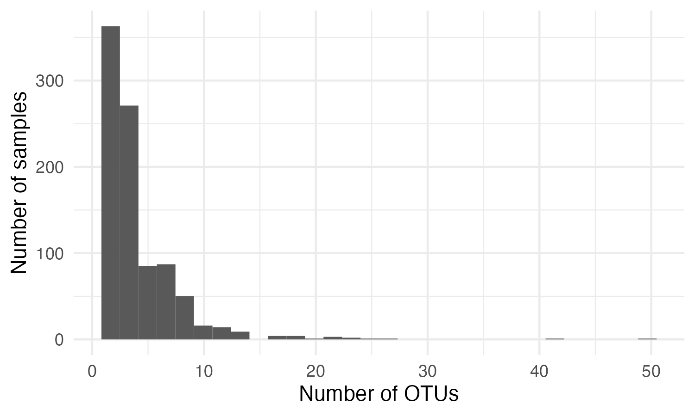
Figure 1. Histogram showing the number of OTUs found for each adult specimen. While the majority had one OTU, a large proportion retained more than one OTU.

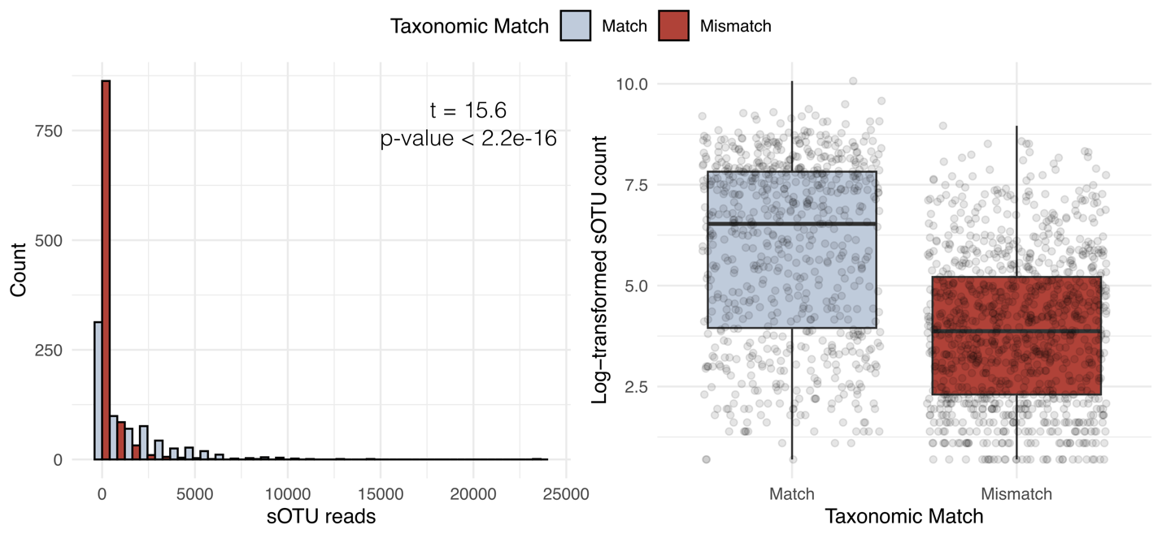
Figure 2. Histogram and boxplot with the number of reads for an sOTU that matches or does not match the taxonomy of an individual.
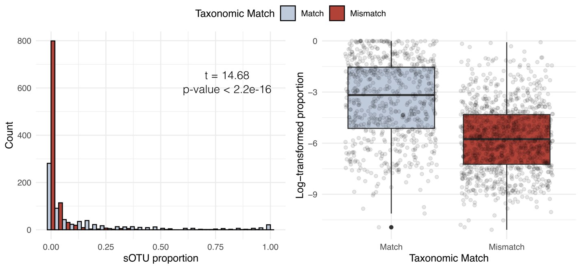
Figure 3. Histogram and boxplot showing the proportion of sOTU reads within an individual sample to the total sOTU reads across the library for matched and mismatched taxonomies.
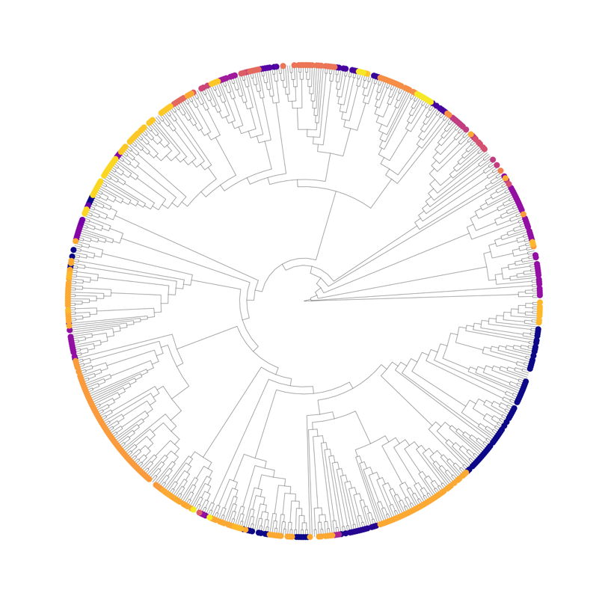
Figure 4. Maximum likelihood phylogeny of all samples. Color represents family.
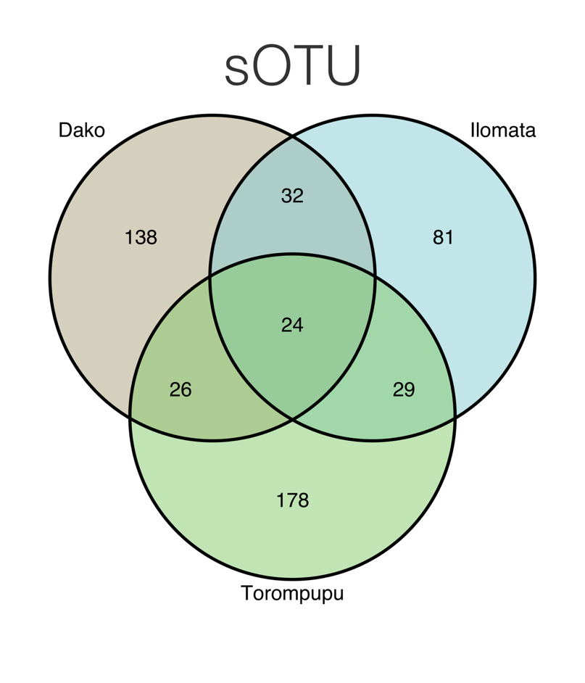
Figure 5. Venn diagram of the number of sOTUs shared between mountain.

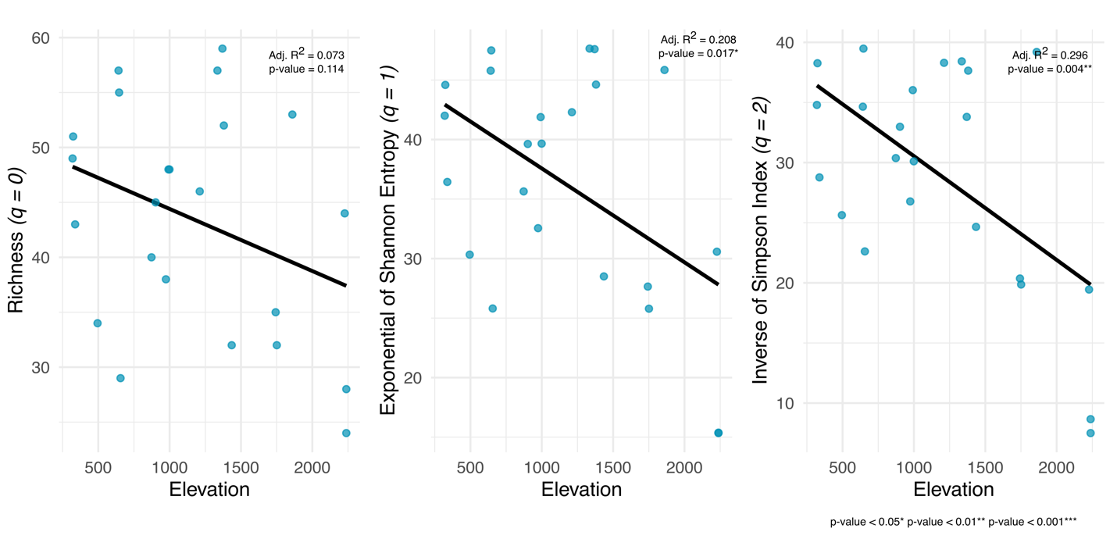
Figure 6. Fitted regression lines for Hill numbers (y) against elevation (x).

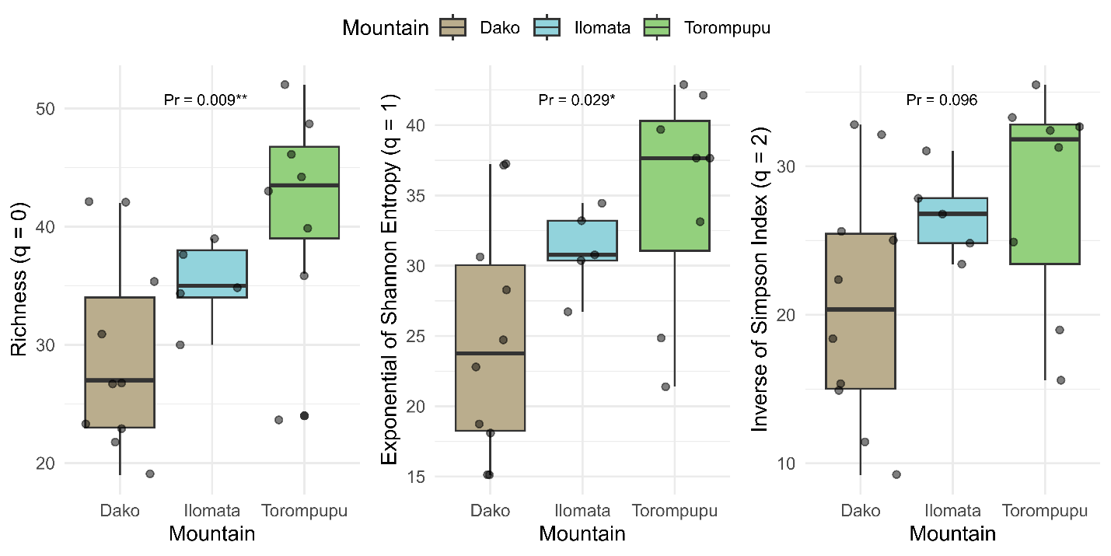

Figure 7. Hill values by mountain using q = 0, q = 1, and q = 2.
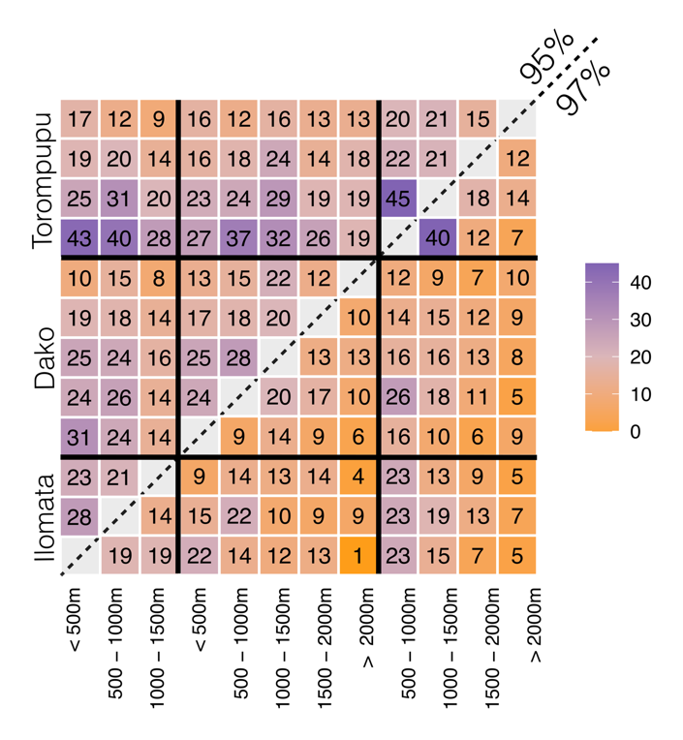
Figure 8. Number of shared clusters between elevation bands across all three mountains. The bottom right section shows shared 97% clusters while the top left section shows shared 95% clusters.

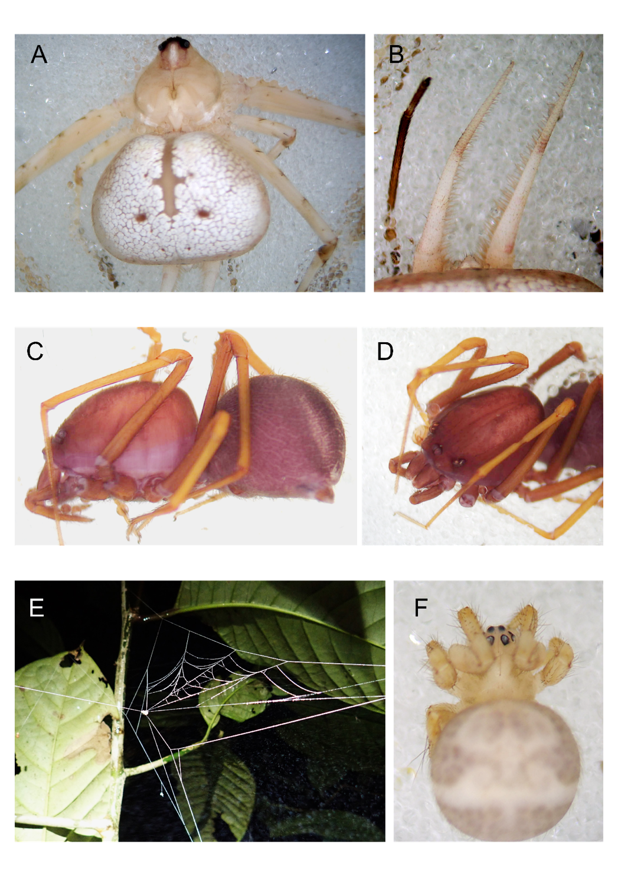
Figure 9. Three families (Hersiliidae, Scytodidae, and Theridiosomatidae) were not yet known from Sulawesi. Image A) shows a hersiliid specimen and B) the characteristic spinnerets of this family. Images C) and D) show a scytodid specimen, with the defining C) domed carapace and D) six eyes of this family. Image E) shows the distinctive cone-shaped ray web belonging to a F) theridiosomatid specimen.

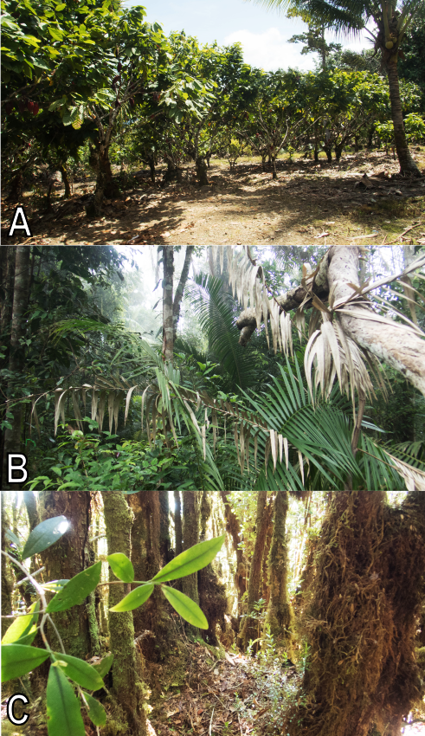
Figure 10. Examples of habitat at different sites from Gunung Dako – lowland cacao agroecosystem (350m), mid-elevation forest (1400m), and high-elevation mossy forest (2200m).
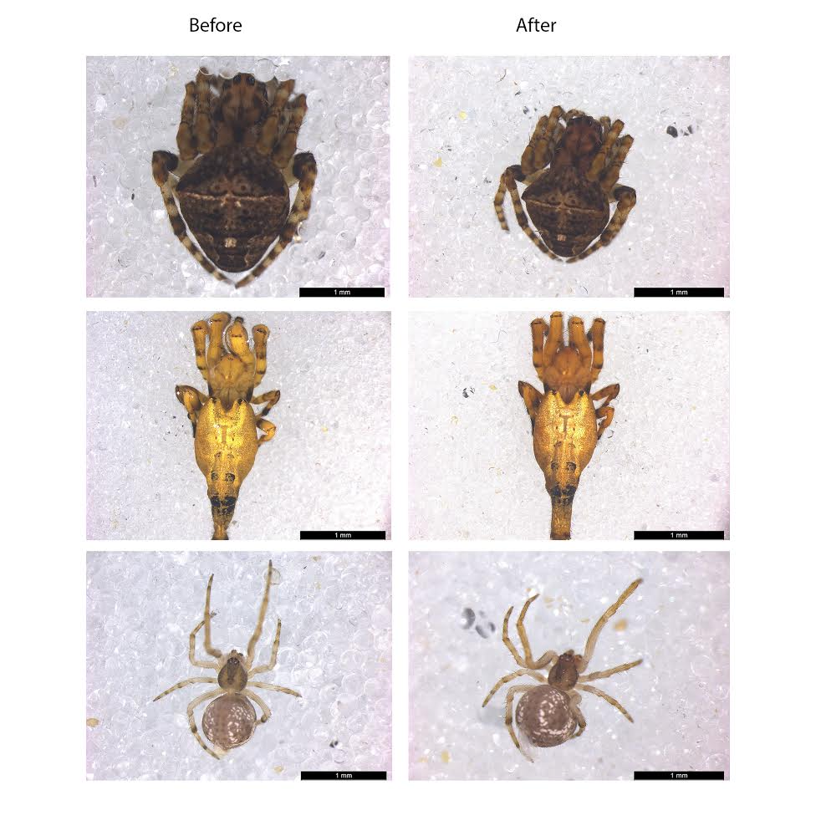
Figure 11. Little to no sample degradation occurred following 3-hour lysing for adult specimens, leaving important morphological characters intact for future morphological work. Level of degradation depended on degree of sclerotization as well as size.

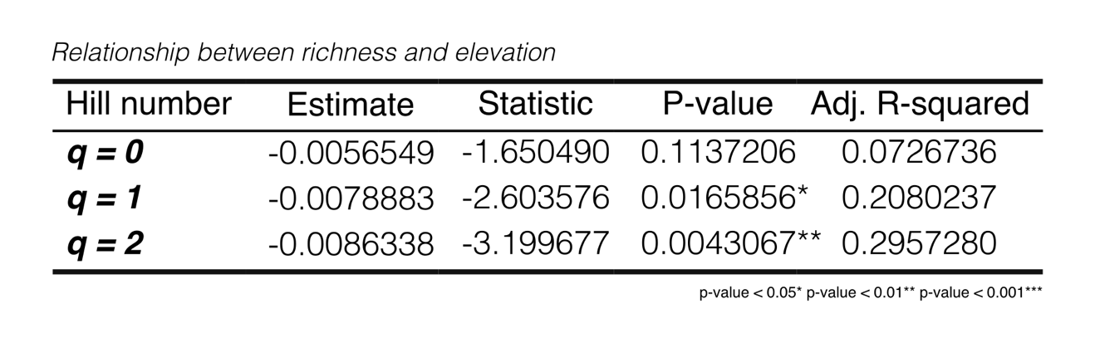
Table 1. Summary statistics from linear models assessing the association between elevation and richness based on three Hill numbers. At q = 1 and q = 2, the relationship is significant.

Table 2. Coordinates and elevation for sites on the three sampled mountains.
Mountain | Site | Latitude | Longitude | Elevation
Dako | DKA1 | 1.08846 | 120.8848 | 338
Dako | DKA2 | 1.0755 | 120.889 | 495
Dako | DKB1 | 1.06264 | 120.8986 | 974
Dako | DKB2 | 1.06212 | 120.8995 | 992
Dako | DKC1 | 1.05335 | 120.9087 | 1380
Dako | DKC2 | 1.05325 | 120.9099 | 1435
Dako | DKD1 | 1.0497 | 120.9168 | 1751
Dako | DKD2 | 1.05043 | 120.918 | 1743
Dako | DKE1 | 1.06016 | 120.9349 | 2238
Dako | DKE2 | 1.05991 | 120.9344 | 2238
Torompupu | TPPA1 | 1.40231 | 119.9455 | 642
Torompupu | TPPA2 | 1.40133 | 119.946 | 646
Torompupu | TPPA3 | 1.40321 | 119.9442 | 656
Torompupu | TPPB1 | 1.41847 | 119.9303 | 999
Torompupu | TPPC1 | 1.42122 | 119.8989 | 1370
Torompupu | TPPC2 | 1.42184 | 119.8963 | 1335
Torompupu | TPPD1 | 1.4182 | 119.8804 | 1860
Torompupu | TPPE1 | 1.41179 | 119.8674 | 2227
Ilomata | ILOA1 | 0.70341 | 123.1907 | 324
Ilomata | ILOA2 | 0.70129 | 123.1883 | 320
Ilomata | ILOB1 | 0.71615 | 123.1854 | 873
Ilomata | ILOB2 | 0.71681 | 123.1874 | 902
Ilomata | ILOC1 | 0.72815 | 123.1943 | 1211

