Supplementary Materials for
A Ring Model for Understanding How Interfacial Interaction Dictates the Structures of Protection Motifs and Gold Cores in Thiolate-Protected Gold Nanoclusters
Wen Wu Xu,†,§* Mengke Zheng,† Wenhua Han,† Pengye Liu,† Xiao Ceng Zeng,‡*
†Department of Physics, School of Physical Science and Technology, Ningbo University, Ningbo 315211, China
§Laboratory of Clean Energy Storage and Conversion, Ningbo University, Ningbo 315211, China
‡Department of Chemistry, University of Nebraska-Lincoln, Lincoln, Nebraska 68588, United States

AUTHOR INFORMATION
Corresponding Author
*W. W. Xu (xuwenwu@nbu.edu.cn) and X. C. Zeng (xzeng1@unl.edu)

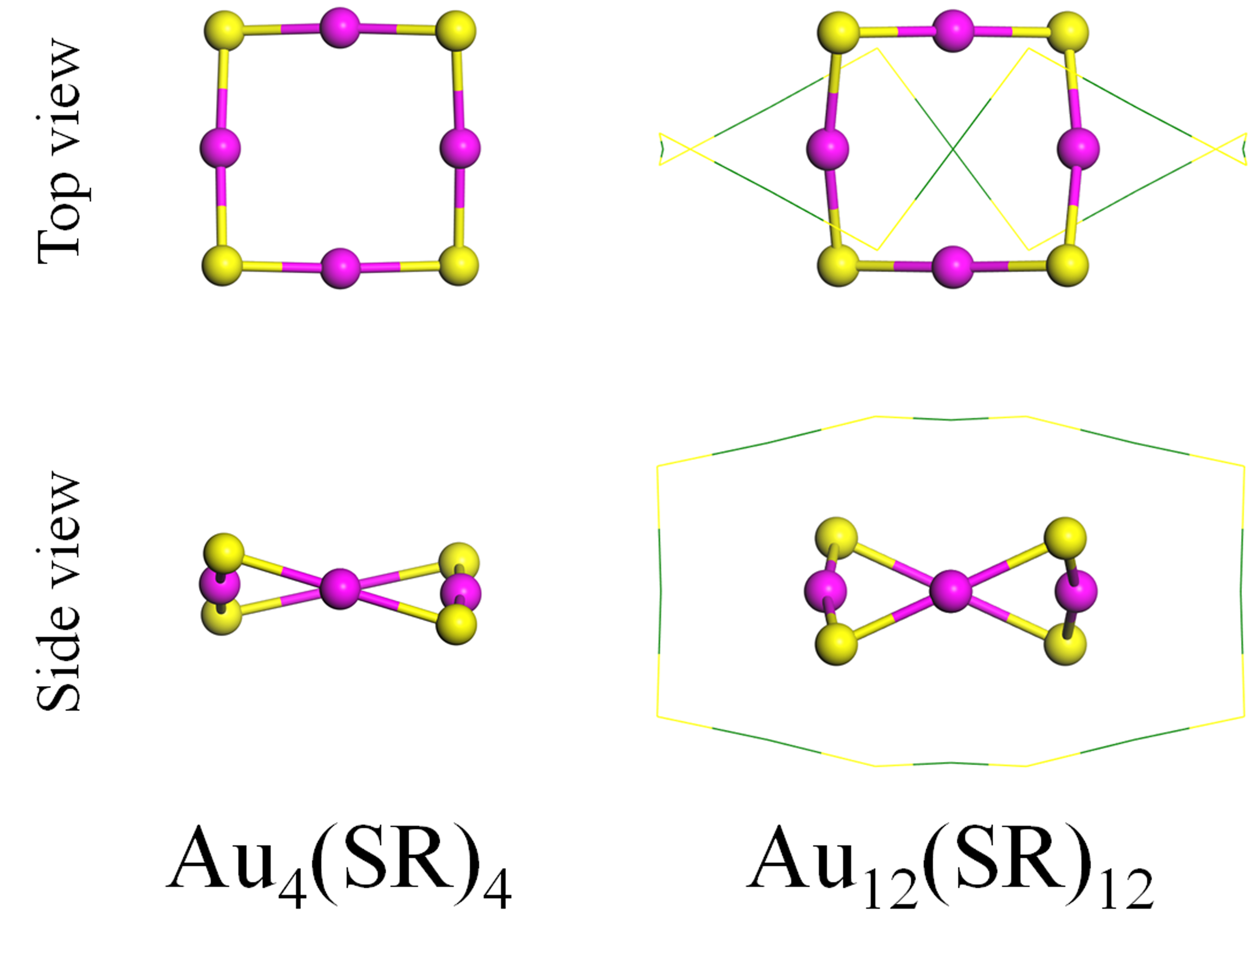
Figure S1. The top and side views of Au₄(SR)₄ and Au₁₂(SR)₁₂. The Au atoms in wine and S atoms in yellow in [Au₄(SR)₄] rings are represented by solid balls, and the other atoms are denoted by lines. Au: wine and dark green; S: yellow. The R groups are omitted for clarity.

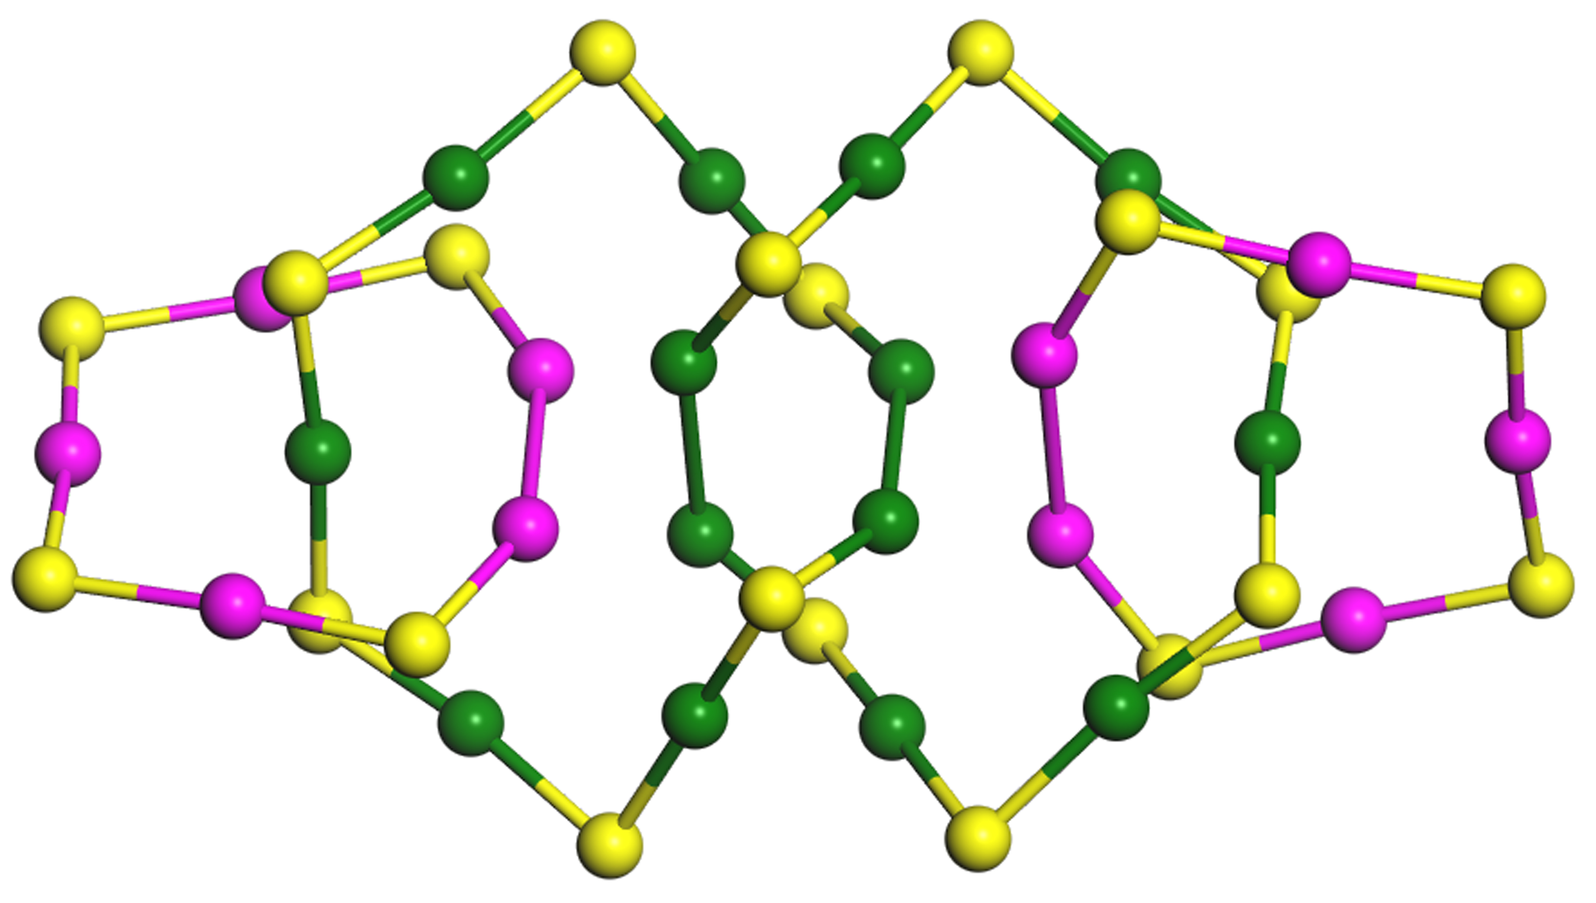
Figure S2. The theoretical structure Au₂₄(SR)₂₀ proposed to contain the interlocked [Au₅(SR)₄] and [Au₇(SR)₆] rings. Au: wine and dark green; S: yellow. The R groups are omitted for clarity.

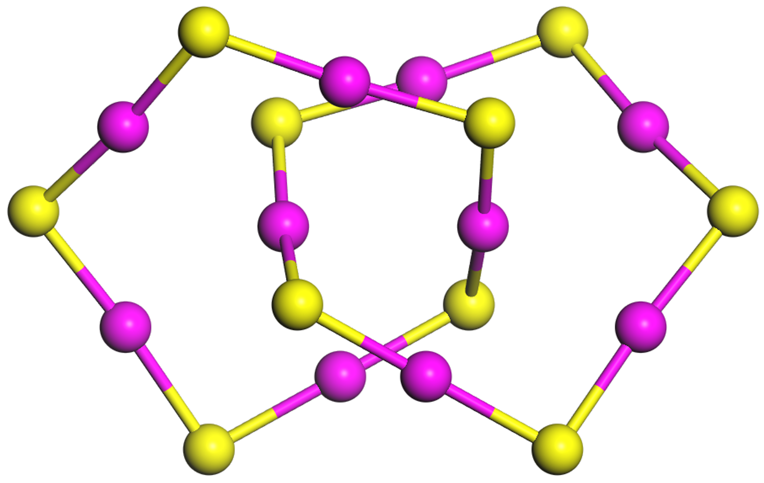
Figure S3. The Au₁₀(SR)₁₀ with two interlocked [Au₅(SR)₅] rings. Au: wine; S: yellow. The R groups are omitted for clarity.
Figure S4. The Au₂₄(SR)₂₀ and Au₂₈(SR)₂₀ with interlocked [Au₆(SR)₆] rings. Au: wine and dark green; S: yellow. The R groups are omitted for clarity.

Figure S5. The Au₁₂(SR)₁₂ with two interlocked [Au₆(SR)₆] rings. Au: wine; S: yellow. The R groups are omitted for clarity.
Figure S6. The top (lower panel) and side (top panel) views of the difference between [Au₇(SR)₄] and [Au₆(SR)₃] rings. The Au atoms in rings are represented in wine. Au: wine and dark green; S: yellow. The R groups are omitted for clarity.

Figure S7. The [Au₇(SR)₄] ring (wine gold atoms and yellow sulfur atoms) interlocking with another two rings (dark green gold atoms and yellow sulfur atoms). The atoms in rings are represented by solid balls, and the other atoms are denoted by lines. Au: wine and dark green; S: yellow. The R groups are omitted for clarity.
Figure S8. The top and side views of [Au₈(SR)₈] ring in Au₁₂(SR)₁₂. The Au atoms in wine and S atoms in yellow in [Au₈(SR)₈] ring are represented by solid balls, and the other atoms are denoted by lines. Au: wine and dark green; S: yellow. The R groups are omitted for clarity.
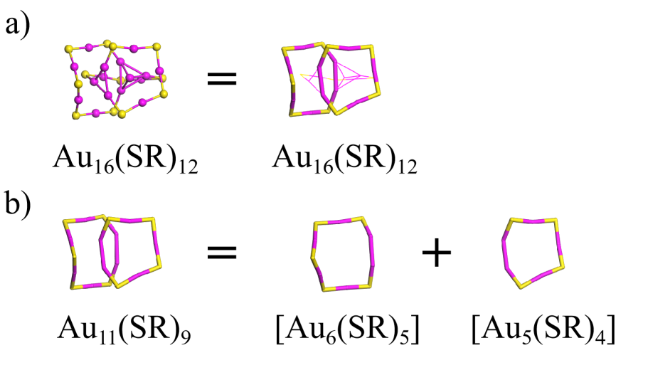
Figure S9. The structural decompositions of Au₁₆(SR)₁₂ into one [Au₆(SR)₅] and one [Au₅(SR)₄] rings. Au: wine; S: yellow. The R groups were omitted for clarity. (J. Am. Chem. Soc. 2018, 140, 10988–10994)
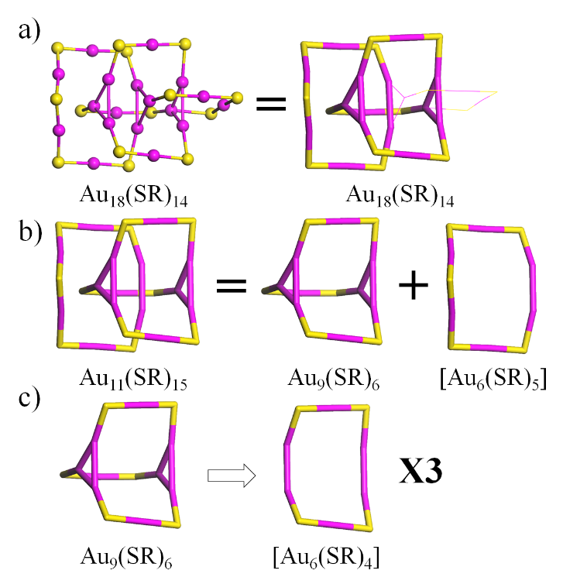
Figure S10. The structural decompositions of Au₁₈(SR)₁₄ into one [Au₆(SR)₅] and three [Au₆(SR)₄] rings. Au: wine; S: yellow. The R groups were omitted for clarity. (Angew. Chem. Int. Ed. 2015, 54, 3140–3144; Angew. Chem. Int. Ed. 2015, 54, 3145–3149)

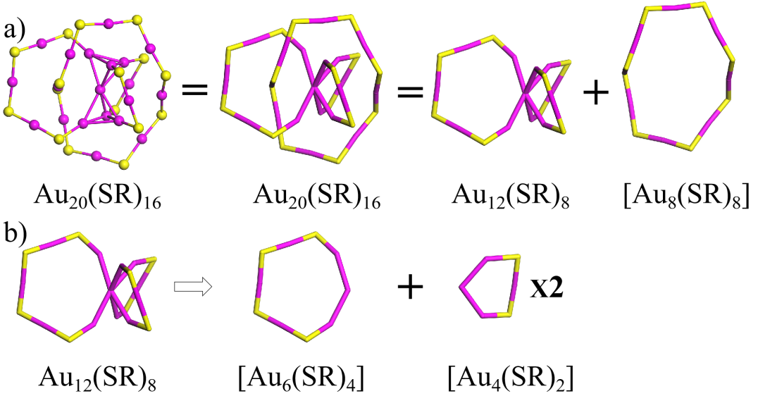
Figure S11. The structural decompositions of Au₂₀(SR)₁₆ into one [Au₈(SR)₈], one [Au₆(SR)₄], and two [Au₄(SR)₂] rings. Au: wine; S: yellow. The R groups were omitted for clarity. (J. Am. Chem. Soc. 2009, 131, 13619–13621)

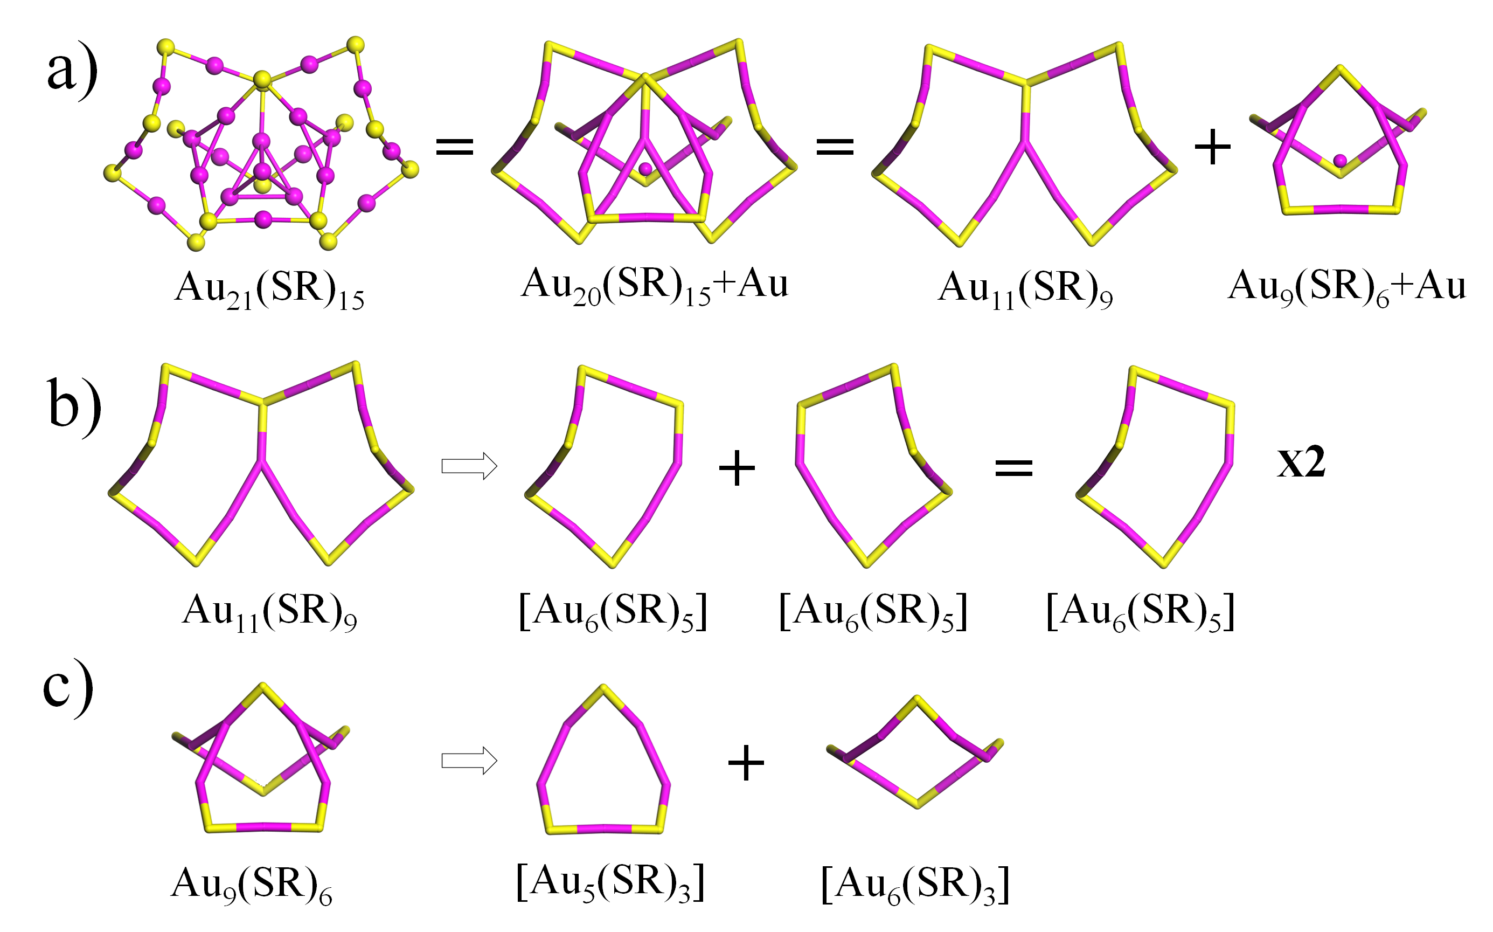
Figure S12. The structural decompositions of Au₂₁(SR)₁₅ into one [Au₆(SR)₃], one [Au₅(SR)₃], and two [Au₆(SR)₅] rings. Au: wine; S: yellow. The R groups were omitted for clarity. (J. Am. Chem. Soc. 2016, 138, 10754–10757)

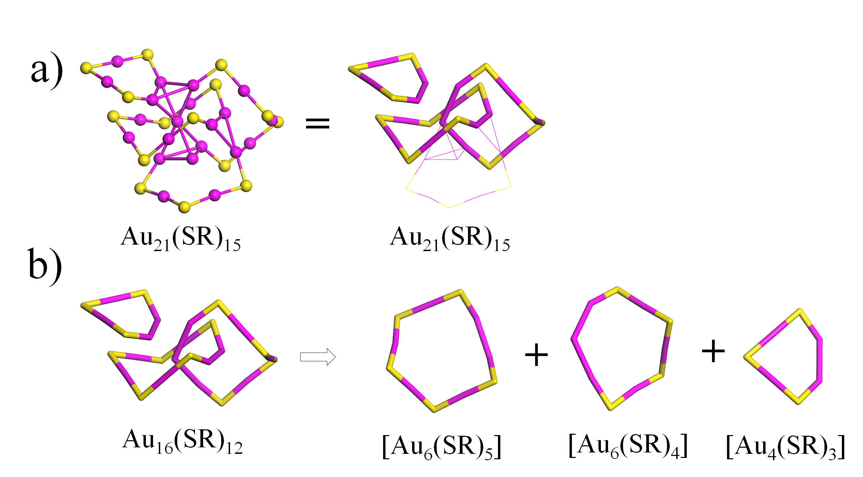
Figure S13. The structural decompositions of Au₂₁(SR)₁₅ into one [Au₆(SR)₅], one [Au₆(SR)₄], and one [Au₄(SR)₃] rings. Au: wine; S: yellow. The R groups were omitted for clarity. (J. Phys. Chem. C 2018, 122, 14898–14907)
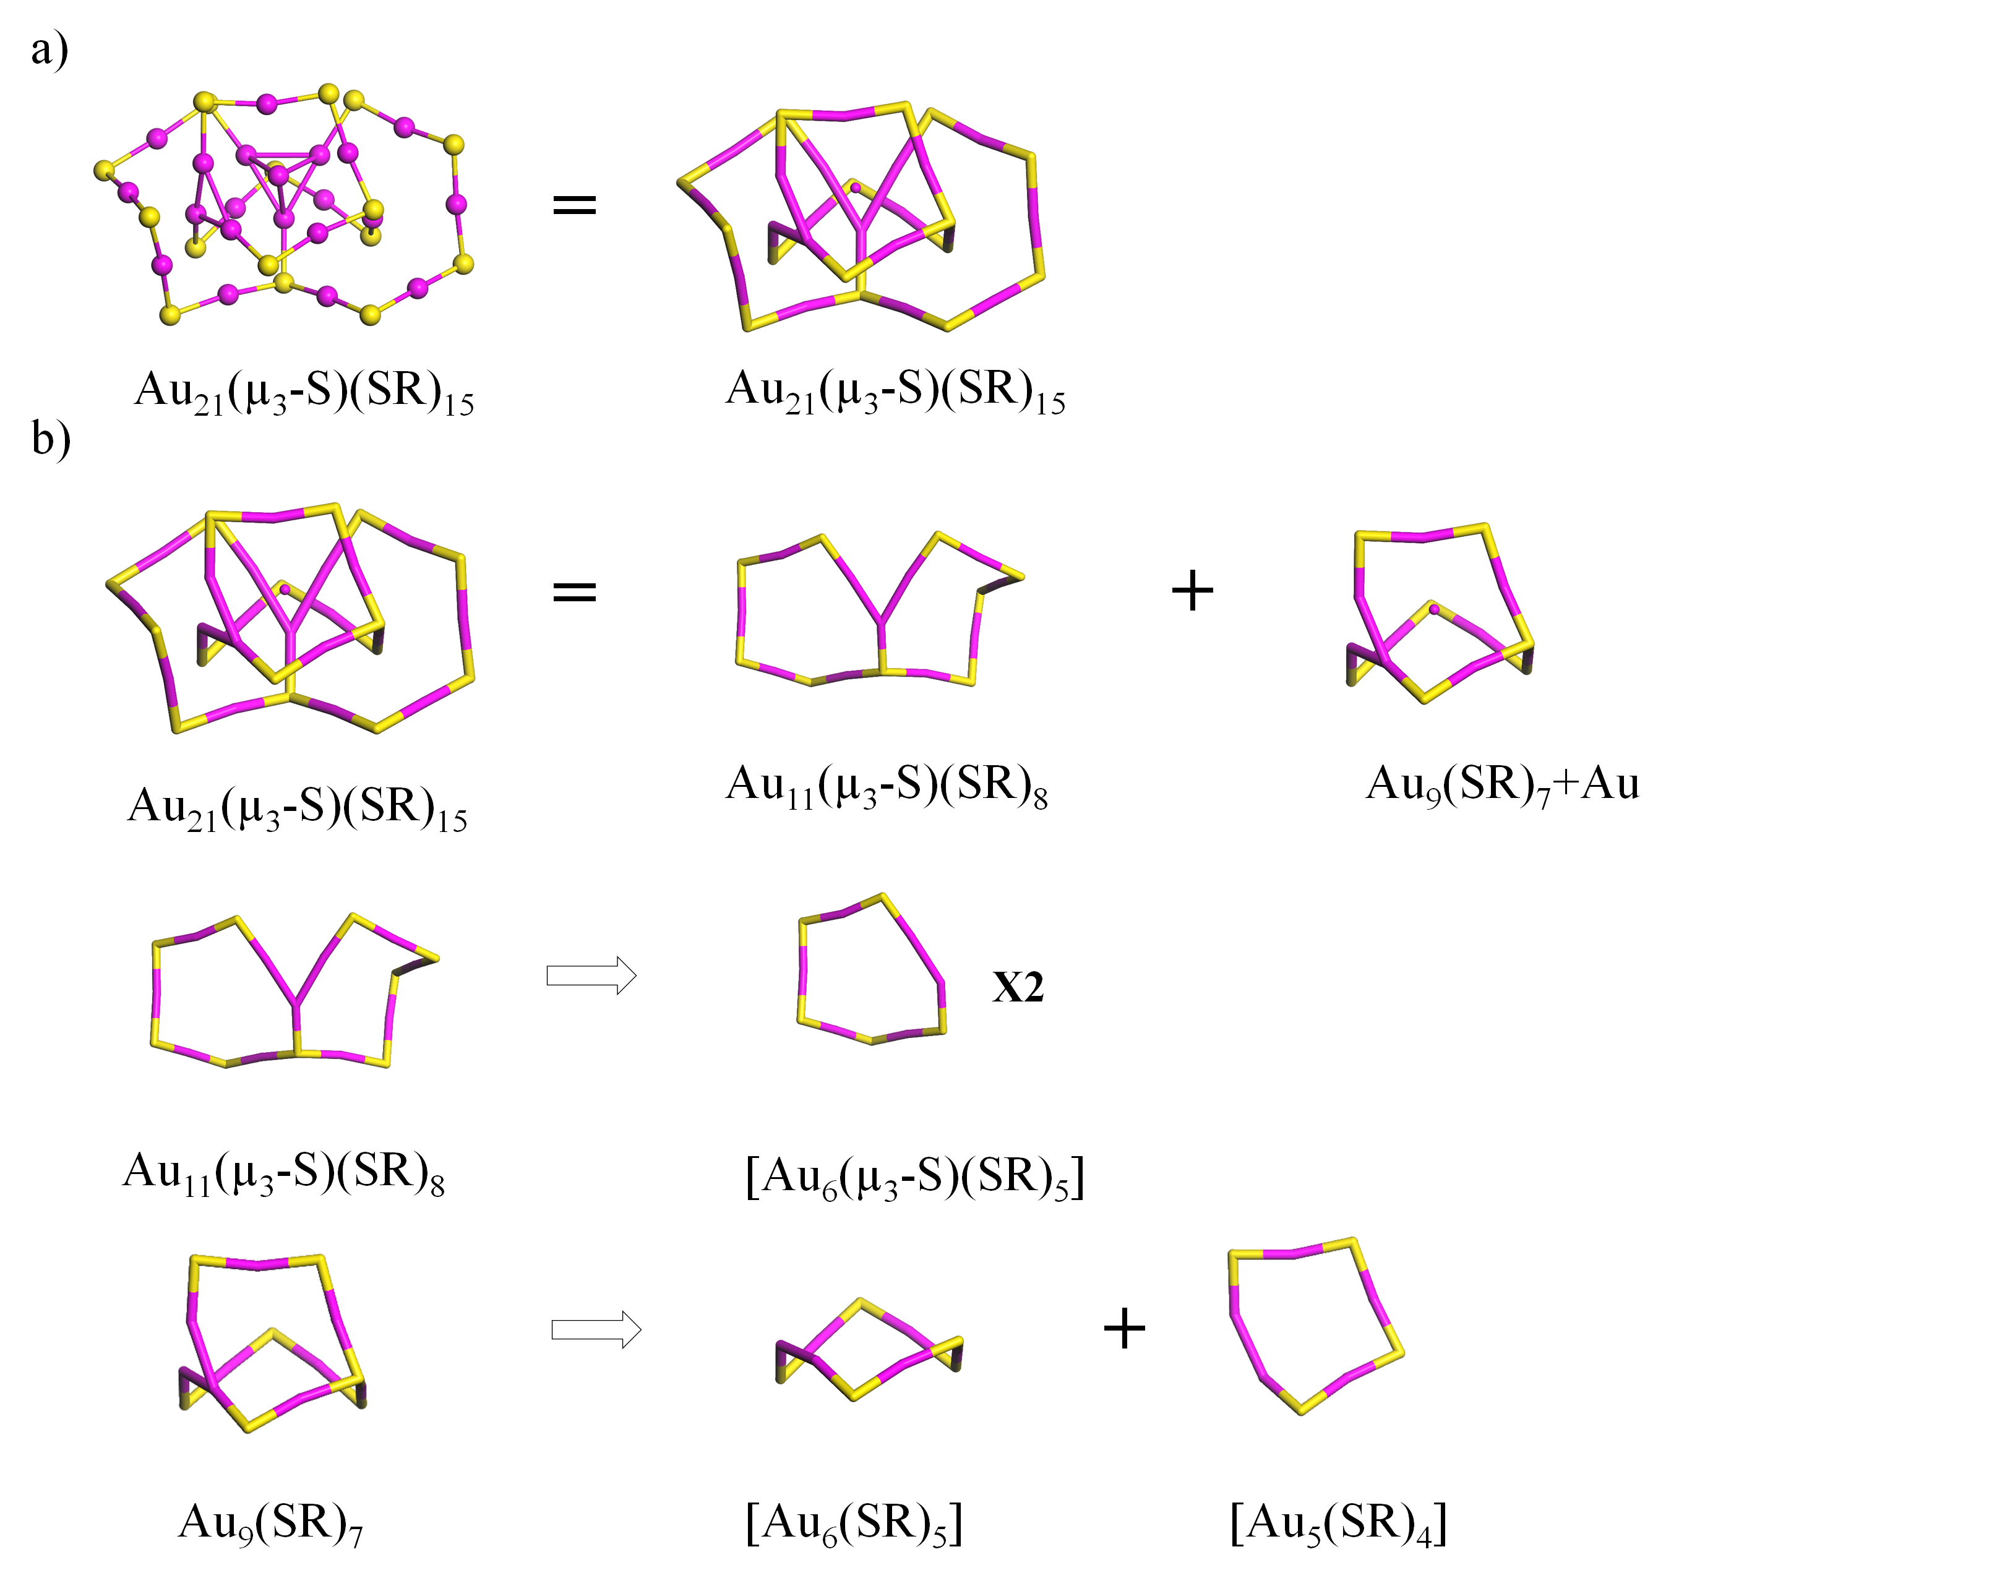
Figure S14. The structural decompositions of Au₂₁(µ₃-S)(SR)₁₅ into two [Au₆(µ₃-S)(SR)₅], one [Au₆(SR)₅], and one [Au₅(SR)₄] rings. Au: wine; S: yellow. The R groups were omitted for clarity. (J. Phys. Chem. C, 2017, 121, 10865–10869)
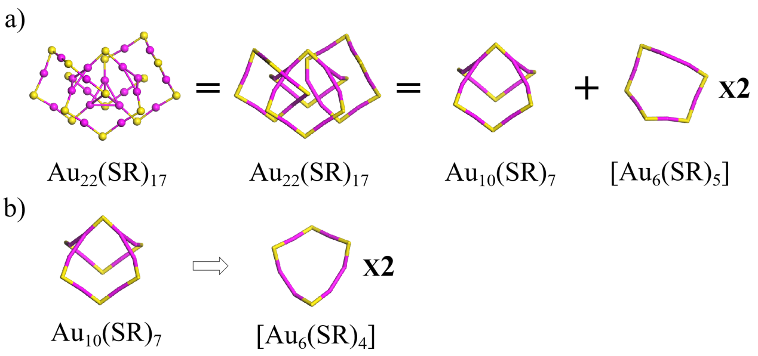
Figure S15. The structural decompositions of Au₂₂(SR)₁₇⁻ into two [Au₆(SR)₅] and two [Au₆(SR)₄] rings. Au: wine; S: yellow. The R groups were omitted for clarity. (Chem. Commun. 2020, 56, 2995–2998)
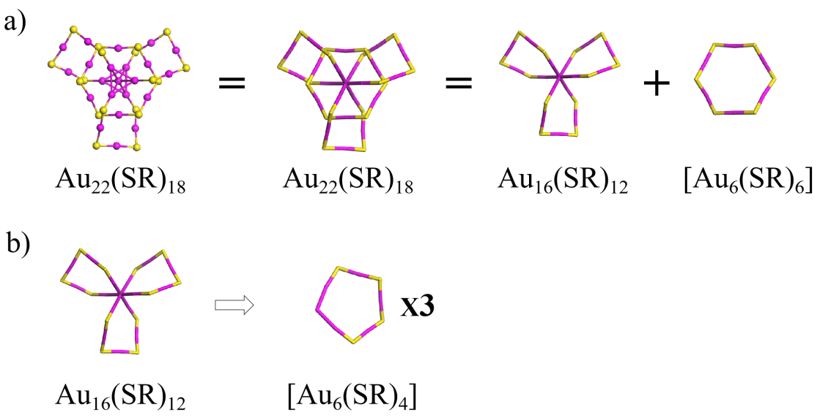
Figure S16. The structural decompositions of Au₂₂(SR)₁₈ into one [Au₆(SR)₆] and three [Au₆(SR)₄] rings. Au: wine; S: yellow. The R groups were omitted for clarity. (J. Phys. Chem. Lett. 2015, 6, 1390−1395)

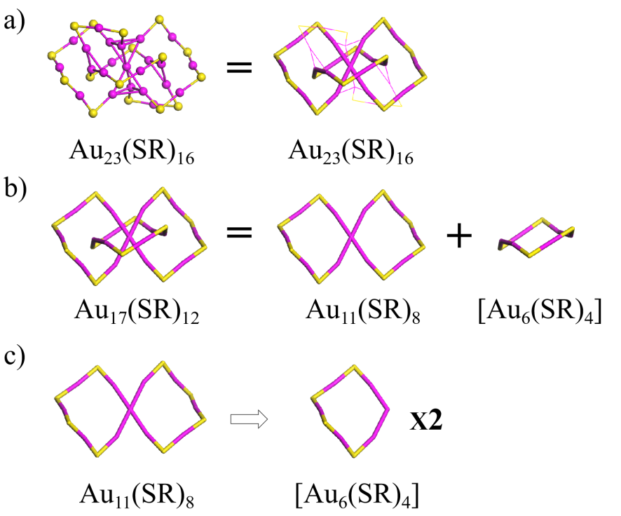
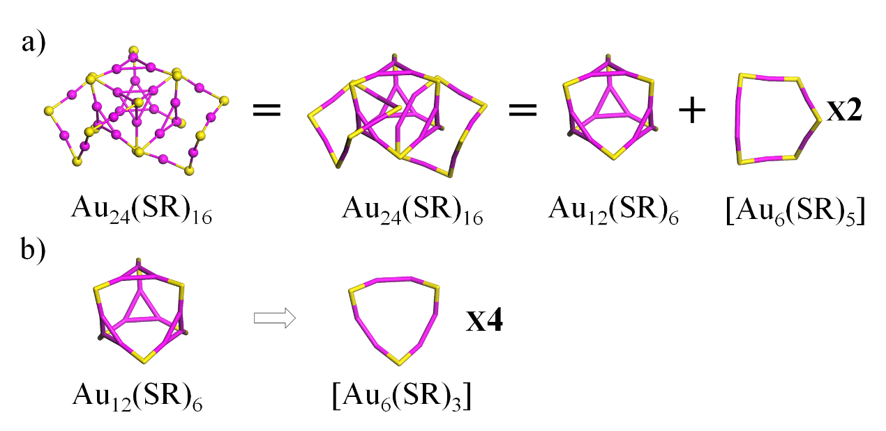
Figure S17. The structural decompositions of Au₂₃(SR)₁₆⁻ into three [Au₆(SR)₄] rings. Au: wine; S: yellow. The R groups were omitted for clarity. (J. Am. Chem. Soc. 2013, 135, 1826)
Figure S18. The structural decompositions of Au₂₄(SR)₁₆²⁻ into four [Au₆(SR)₃] and two [Au₆(SR)₅] rings. Au: wine; S: yellow. The R groups were omitted for clarity. (J. Phys. Chem. C 2020, https://doi.org/10.1021/acs.jpcc.0c03971)

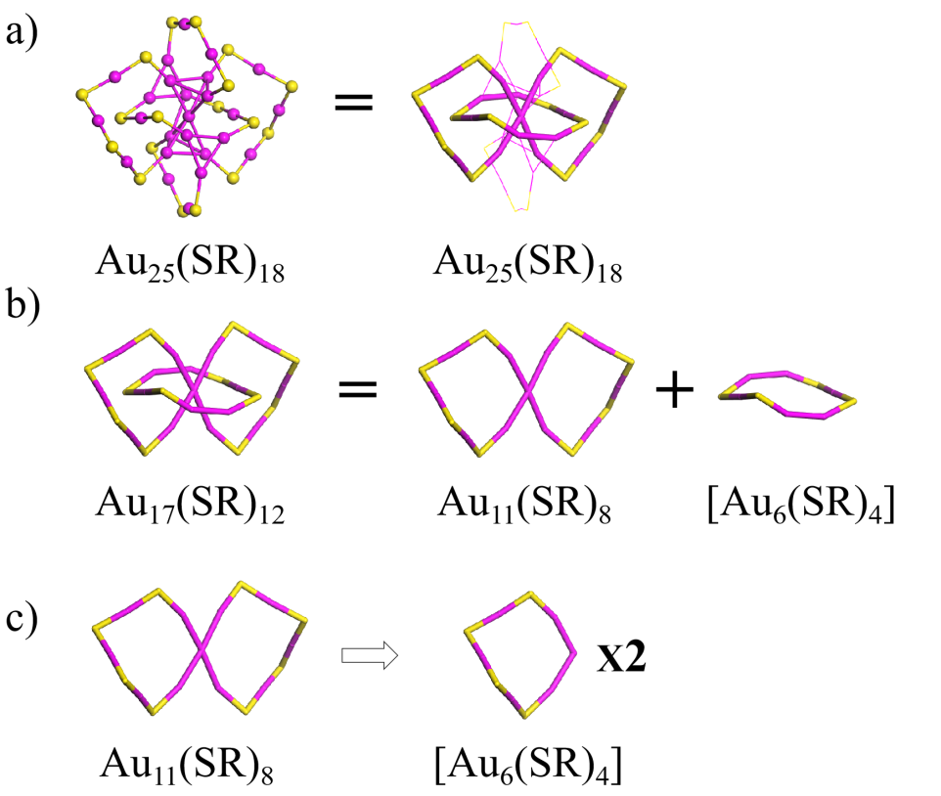
Figure S19. The structural decompositions of Au₂₅(SR)₁₈⁻ into three [Au₆(SR)₄] rings. Au: wine; S: yellow. The R groups were omitted for clarity. (J. Phys. Chem. C 2018, 122, 13199−13204)
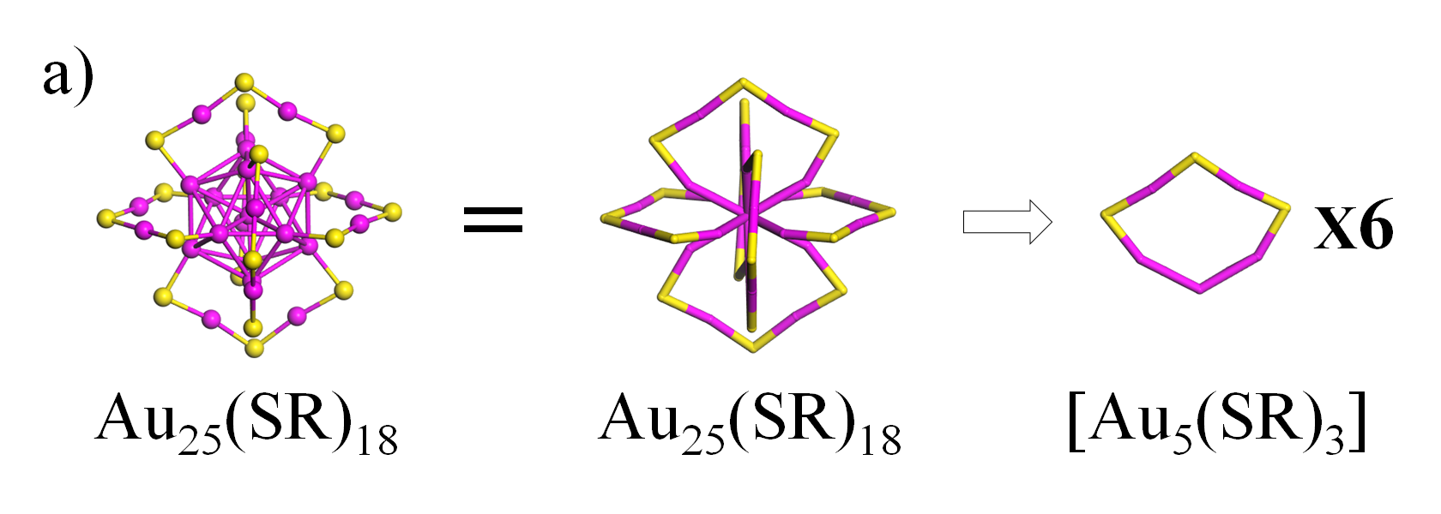
Figure S20. The structural decompositions of Au₂₅(SR)₁₈⁻ into six [Au₅(SR)₃] rings. Au: wine; S: yellow. The R groups were omitted for clarity. (J. Am. Chem. Soc. 2018, 130, 5883–5885; J. Am. Chem. Soc. 2018, 130, 3754–3755)

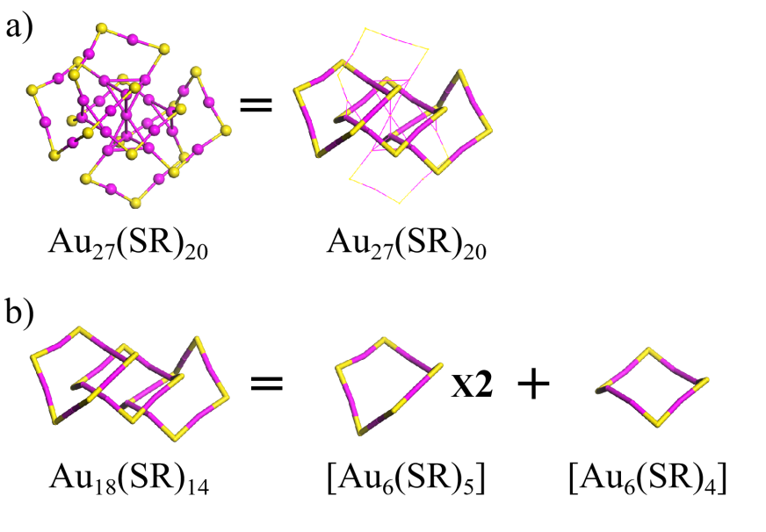
Figure S21. The structural decompositions of Au₂₇(SR)₂₀⁻ into one [Au₆(SR)₄] and two [Au₆(SR)₅] rings. Au: wine; S: yellow. The R groups were omitted for clarity. (Phys. Chem. Chem. Phys. 2020, under review)
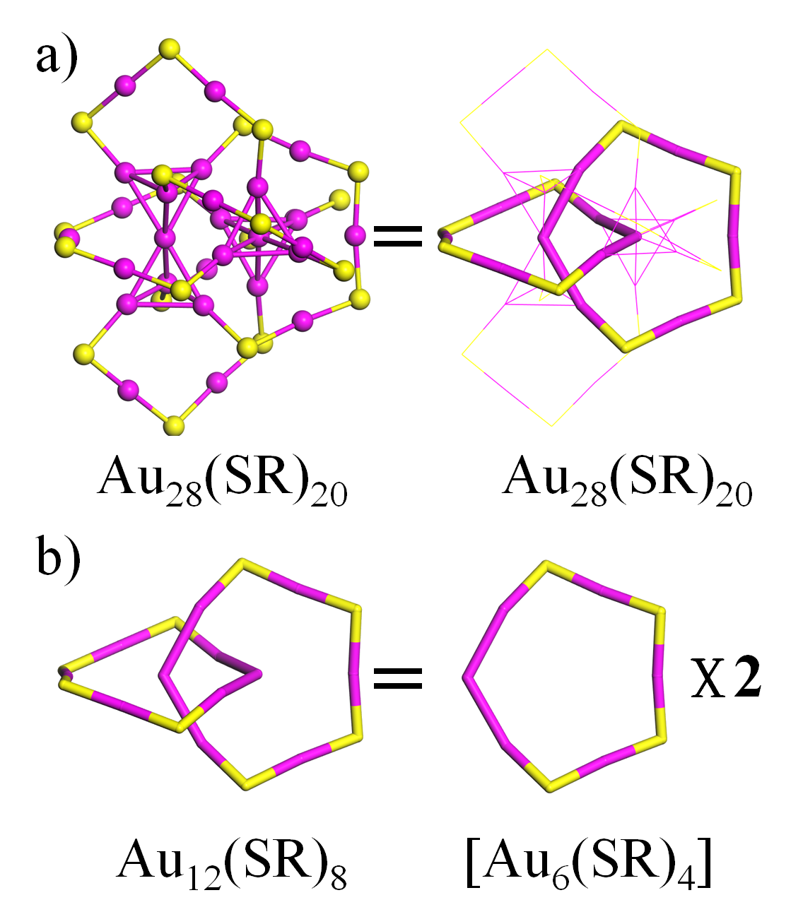
Figure S22. The structural decompositions of Au₂₈(SR)₂₀ into two [Au₆(SR)₄] rings. Au: wine; S: yellow. The R groups were omitted for clarity. (J. Am. Chem. Soc. 2013, 135, 10011−10013)

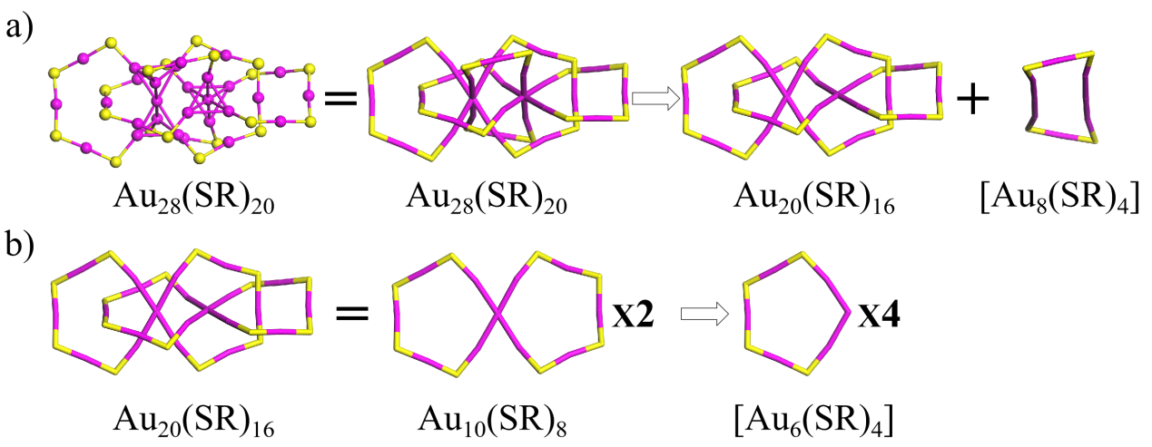
Figure S23. The structural decompositions of Au₂₈(SR)₂₀ into one [Au₈(SR)₄] and four [Au₆(SR)₄] rings. Au: wine; S: yellow. The R groups were omitted for clarity. (J. Am. Chem. Soc. 2016, 138, 1482−1485)
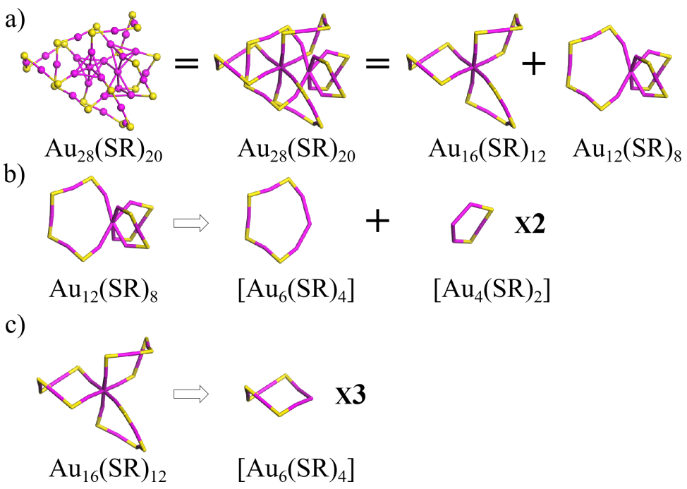
Figure S24. The structural decompositions of Au₂₈(SR)₂₀ into two [Au₄(SR)₂] and four [Au₆(SR)₄] rings. Au: wine; S: yellow. The R groups were omitted for clarity. (Nanoscale 2018, 10, 9476−9483)

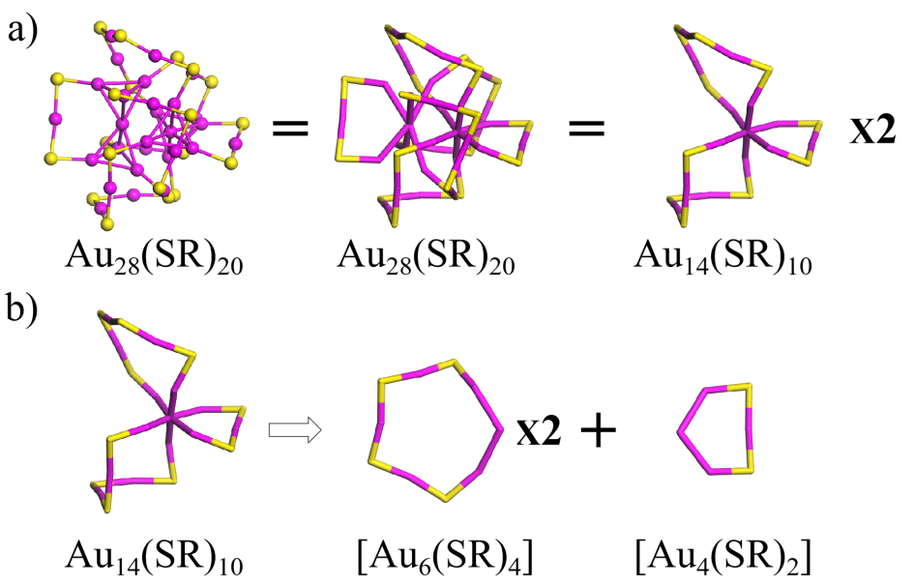
Figure S25. The structural decompositions of Au₂₈(SR)₂₀ into two [Au₄(SR)₂] and four [Au₆(SR)₄] rings. Au: wine; S: yellow. The R groups were omitted for clarity. (J. Phys. Chem. Lett. 2020, 11, 536−540)
Figure S26. The structural decompositions of Au₂₈(SR)₂₀ into one [Au₈(SR)₄], two [Au₆(SR)₅], and two [Au₄(SR)₃] rings. Au: wine; S: yellow. The R groups were omitted for clarity. (Nanoscale 2018, 10, 9476−9483)

Figure S27. The structural decompositions of Au₂₈(SR)₂₀ into two [Au₄(SR)₂], two [Au₆(SR)₃], and two [Au₆(SR)₅] rings. Au: wine; S: yellow. The R groups were omitted for clarity. (J. Phys. Chem. Lett. 2020, 11, 536−540)
Figure S28. The structural decompositions of Au₂₉(SR)₂₉ into three [Au₆(SR)₄], one [Au₆(SR)₃], and one [Au₅(SR)₃] rings. Au: wine; S: yellow. The R groups were omitted for clarity. (Nanoscale, 2017, 9, 2895–2902)

Figure S29. The structural decompositions of Au₃₀(SR)₁₈ into two [Au₆(SR)₄], two [Au₆(SR)₃], and two [Au₅(SR)₃] rings. Au: wine; S: yellow. The R groups were omitted for clarity. (J. Phys. Chem. C 2013, 117, 22094-22097)

Figure S30. The structural decompositions of Au₃₀(µ₃-S)(SR)₁₈ into one [Au₆(µ₃-S)(SR)₂], two [Au₆(SR)₄], one [Au₆(SR)₃], one [Au₅(µ₃-S)(SR)₃], and one [Au₅(SR)₃] rings. Au: wine; S: yellow. The R groups were omitted for clarity. (J. Am. Chem. Soc. 2014, 136, 5000−5005)

Figure S31. The structural decompositions of Au₃₂(SR)₂₁⁻ into two [Au₆(SR)₄] and two [Au₆(SR)₃] rings. Au: wine; S: yellow. The R groups were omitted for clarity. (Phys. Chem. Chem. Phys. 2020, under review)
Figure S32. The structural decompositions of Au₃₂(SR)₂₂ into two [Au₆(SR)₄], two [Au₆(SR)₃], and two [Au₅(SR)₃] rings. Au: wine; S: yellow. The R groups were omitted for clarity. (J. Phys. Chem. Lett. 2020, 11, 536−540)
Figure S33. The structural decompositions of Au₃₄(SR)₂₂ into three [Au₆(SR)₄], one [Au₆(SR)₂], and four [Au₄(SR)₂] rings. Au: wine; S: yellow. The R groups were omitted for clarity. (Nanoscale 9, 3742-3746 (2017))

Figure S34. The structural decompositions of Au₃₄(SR)₂₃⁻ into two [Au₆(SR)₄] and one [Au₆(SR)₃] rings. Au: wine; S: yellow. The R groups were omitted for clarity. (Phys. Chem. Chem. Phys. 2020, under review)

Figure S35. The structural decompositions of Au₃₆(SR)₂₄ into four [Au₆(SR)₃] rings. Au: wine; S: yellow. The R groups were omitted for clarity. (Angew. Chem. Int. Ed. 2012, 51, 13114–13118)

Figure S36. The structural decompositions of Au₃₆(SR)₂₄ into four [Au₆(SR)₃] and two [Au₄(SR)₂] rings. Au: wine; S: yellow. The R groups were omitted for clarity. (Nat. Commun. 2020, accepted)

Figure S37. The structural decompositions of Au₃₆(SR)₂₄ into five [Au₆(SR)₃], one [Au₆(SR)₂], and one [Au₄(SR)₂] rings. Au: wine; S: yellow. The R groups were omitted for clarity. (J. Phys. Chem. Lett. 2020, 11, 536−540)
Figure S38. The structural decompositions of Au₃₆(SR)₂₄ into two [Au₆(SR)₄], four [Au₆(SR)₂], and two [Au₄(SR)₂] rings. Au: wine; S: yellow. The R groups were omitted for clarity. (J. Phys. Chem. Lett. 2020, 11, 536−540)

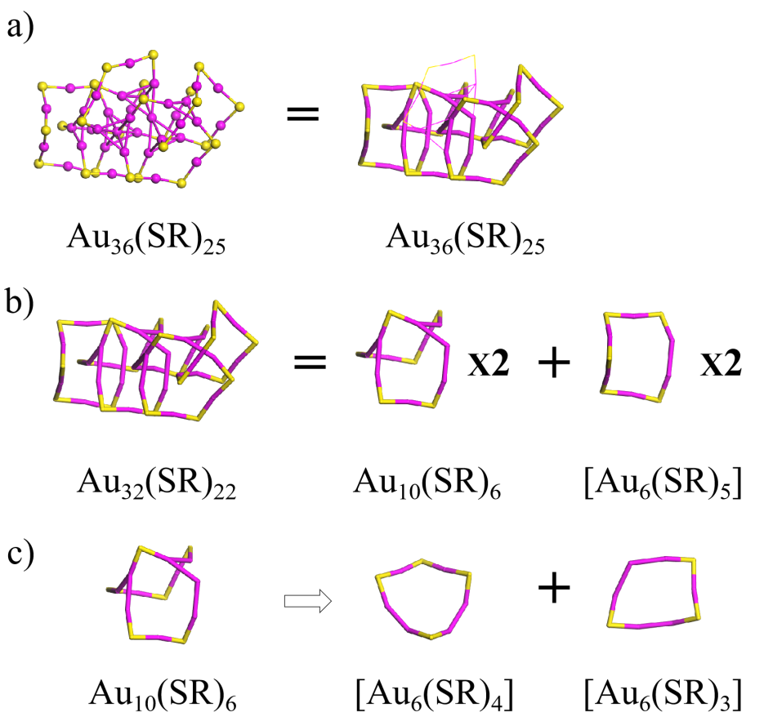
Figure S39. The structural decompositions of Au₃₆(SR)₂₅⁻ into two [Au₆(SR)₅], one [Au₆(SR)₄], and one [Au₆(SR)₃] rings. Au: wine; S: yellow. The R groups were omitted for clarity. (Phys. Chem. Chem. Phys. 2020, under review)

Figure S40. The structural decompositions of Au₃₈(μ₃-S)₂(SR)₂₀ into one [Au₈(SR)₂], one [Au₄(μ₃-S)₂(SR)₂], one [Au₄(SR)₂], two [Au₈(μ₃-S)₂(SR)₄], four [Au₆(SR)₃], and four [Au₅(SR)] rings. Au: wine; S: yellow. The R groups were omitted for clarity. (Angew. Chem. Int. Ed. 2015, 54, 9826–9829)
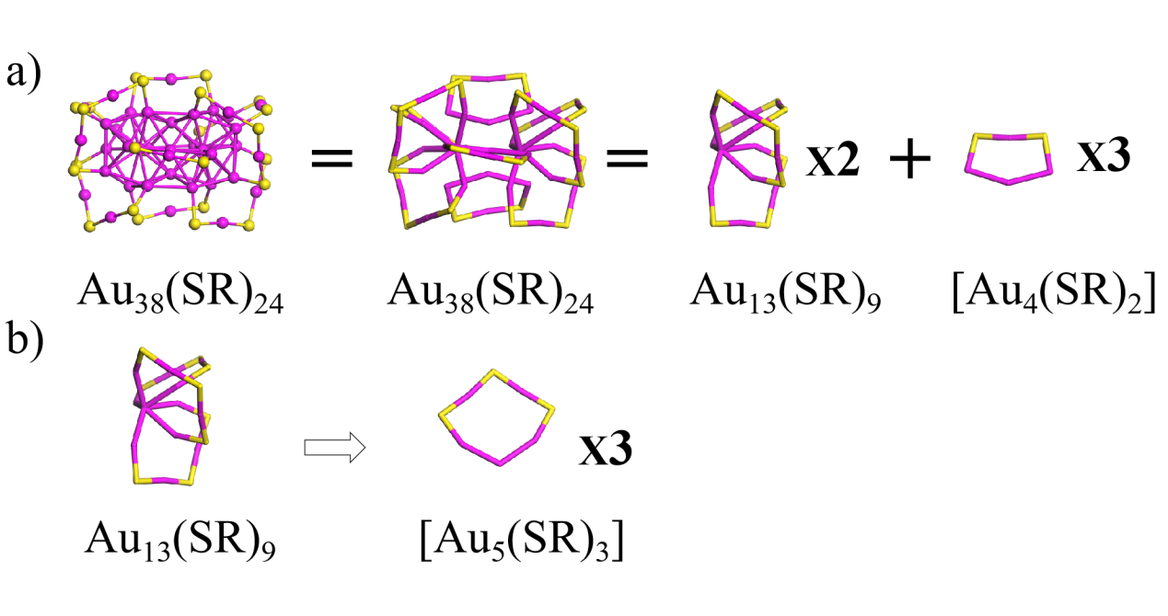
Figure S41. The structural decompositions of Au₃₈(SR)₂₄ into three [Au₄(SR)₂] and six [Au₅(SR)₃] rings. Au: wine; S: yellow. The R groups were omitted for clarity. (J. Am. Chem. Soc. 2010, 132, 8280–8281)

Figure S42. The structural decompositions of Au₃₈(SR)₂₄ into two [Au₇(SR)₅] , four [Au₅(SR)₂], and two [Au₅(SR)₂] rings. Au: wine; S: yellow. The R groups were omitted for clarity. (Nat. Commun. 2015, 6, 8667)

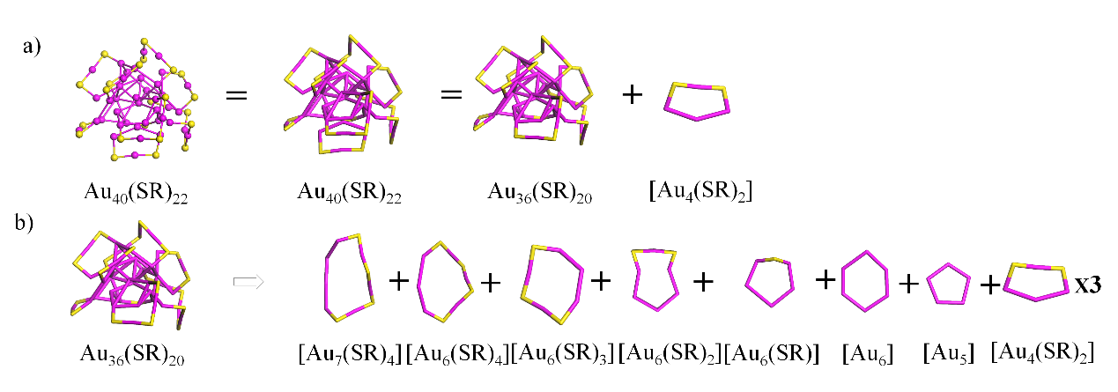
Figure S43. The structural decompositions of Au₄₀(SR)₂₂ into four [Au₄(SR)₂], one [Au₇(SR)₄], one [Au₆(SR)₄], one [Au₆(SR)₃], one [Au₆(SR)₂], one [Au₆(SR)], one [Au₆], and one [Au₅] rings. Au: wine; S: yellow. The R groups were omitted for clarity. (J. Am. Chem. Soc. 2020, 142, 973–977)
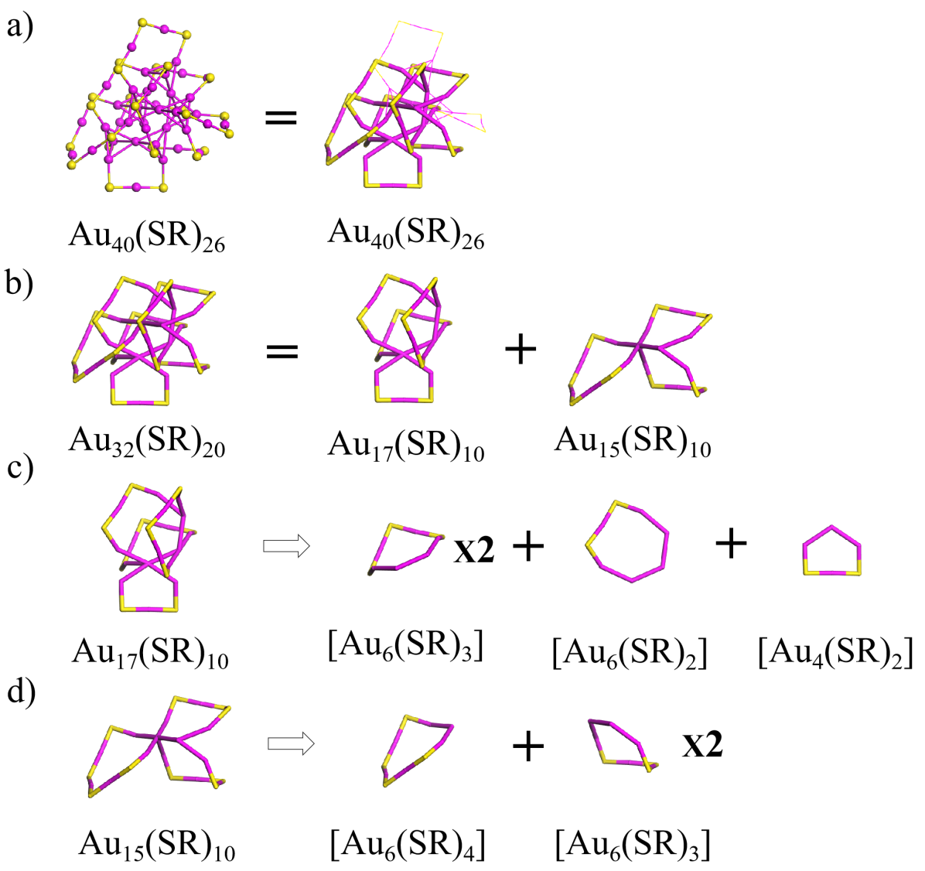

Figure S44. The structural decompositions of Au₄₀(SR)₂₆ into four [Au₆(SR)₃], one [Au₆(SR)₂], one [Au₄(SR)₂], and one [Au₆(SR)₄] rings. Au: wine; S: yellow. The R groups were omitted for clarity. (J. Phys. Chem. Lett. 2020, 11, 536−540)
Figure S45. The structural decompositions of Au₄₂(SR)₂₆ into four [Au₆(SR)₃] and two [Au₈(SR)₄] rings. Au: wine; S: yellow. The R groups were omitted for clarity. (Chem. Sci. 2018, 9, 2437)
Figure S46. The structural decompositions of Au₄₂(SR)₂₆ into six [Au₆(SR)₃] and one [Au₁₀(SR)₄] rings. Au: wine; S: yellow. The R groups were omitted for clarity.

Figure S47. The structural decompositions of Au₄₂(SR)₂₆ into four [Au₆(SR)₄] and four [Au₇(SR)₄] rings. Au: wine; S: yellow. The R groups were omitted for clarity. (Angew. Chem. Int. Ed. 2019, 58, 4510−4514)
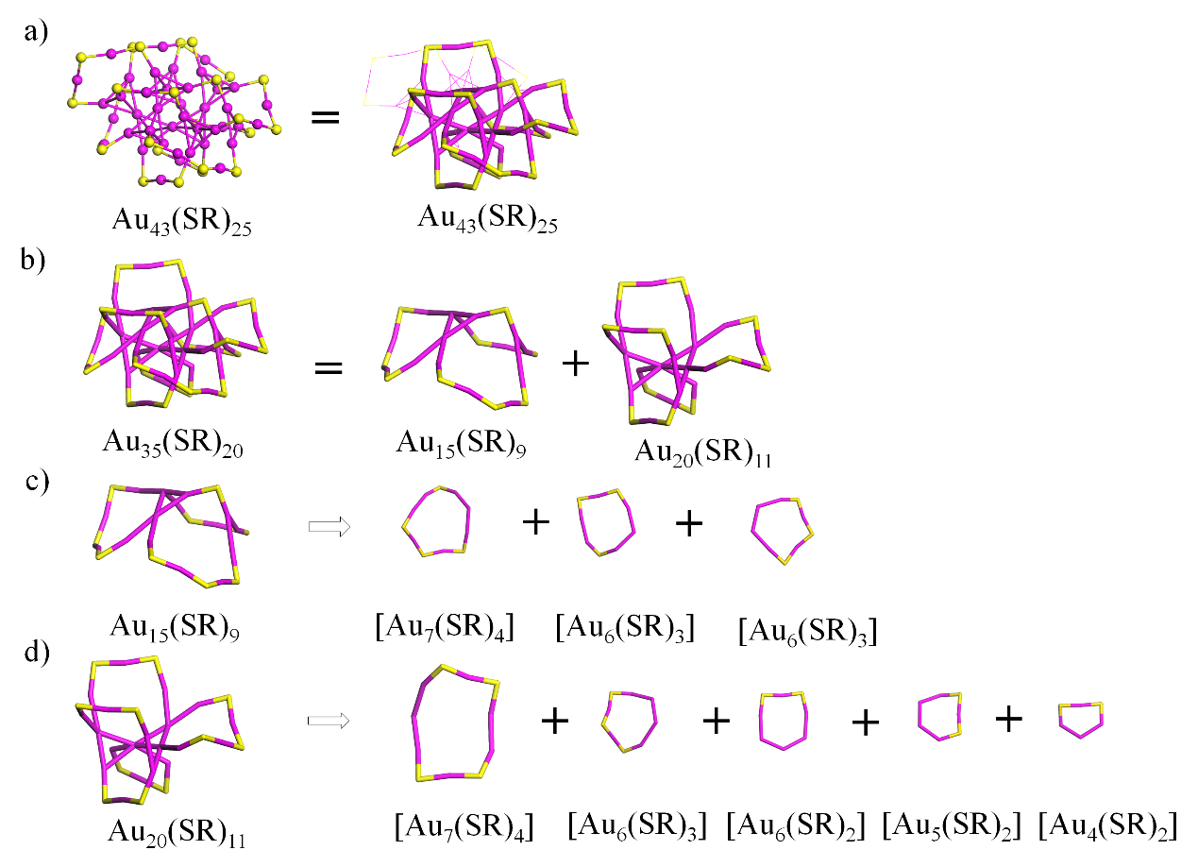
Figure S48. The structural decompositions of Au₄₃(SR)₂₅ into two [Au₇(SR)₄], three [Au₆(SR)₃], one [Au₆(SR)₂], one [Au₅(SR)₂], and one [Au₄(SR)₂] rings. Au: wine; S: yellow. The R groups were omitted for clarity. (J. Phys. Chem. Lett. 2017, 8, 5338–5343)
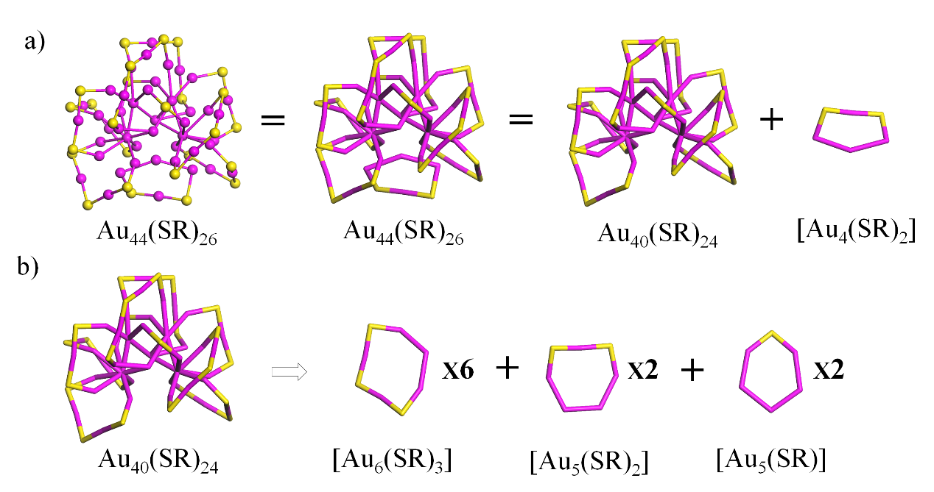
Figure S49. The structural decompositions of Au₄₄(SR)₂₆ into six [Au₆(SR)₃], two [Au₅(SR)₂], two [Au₅(SR)], and one [Au₄(SR)₂] rings. Au: wine; S: yellow. The R groups were omitted for clarity. (J. Am. Chem. Soc. 2016, 138, 10425–10428)

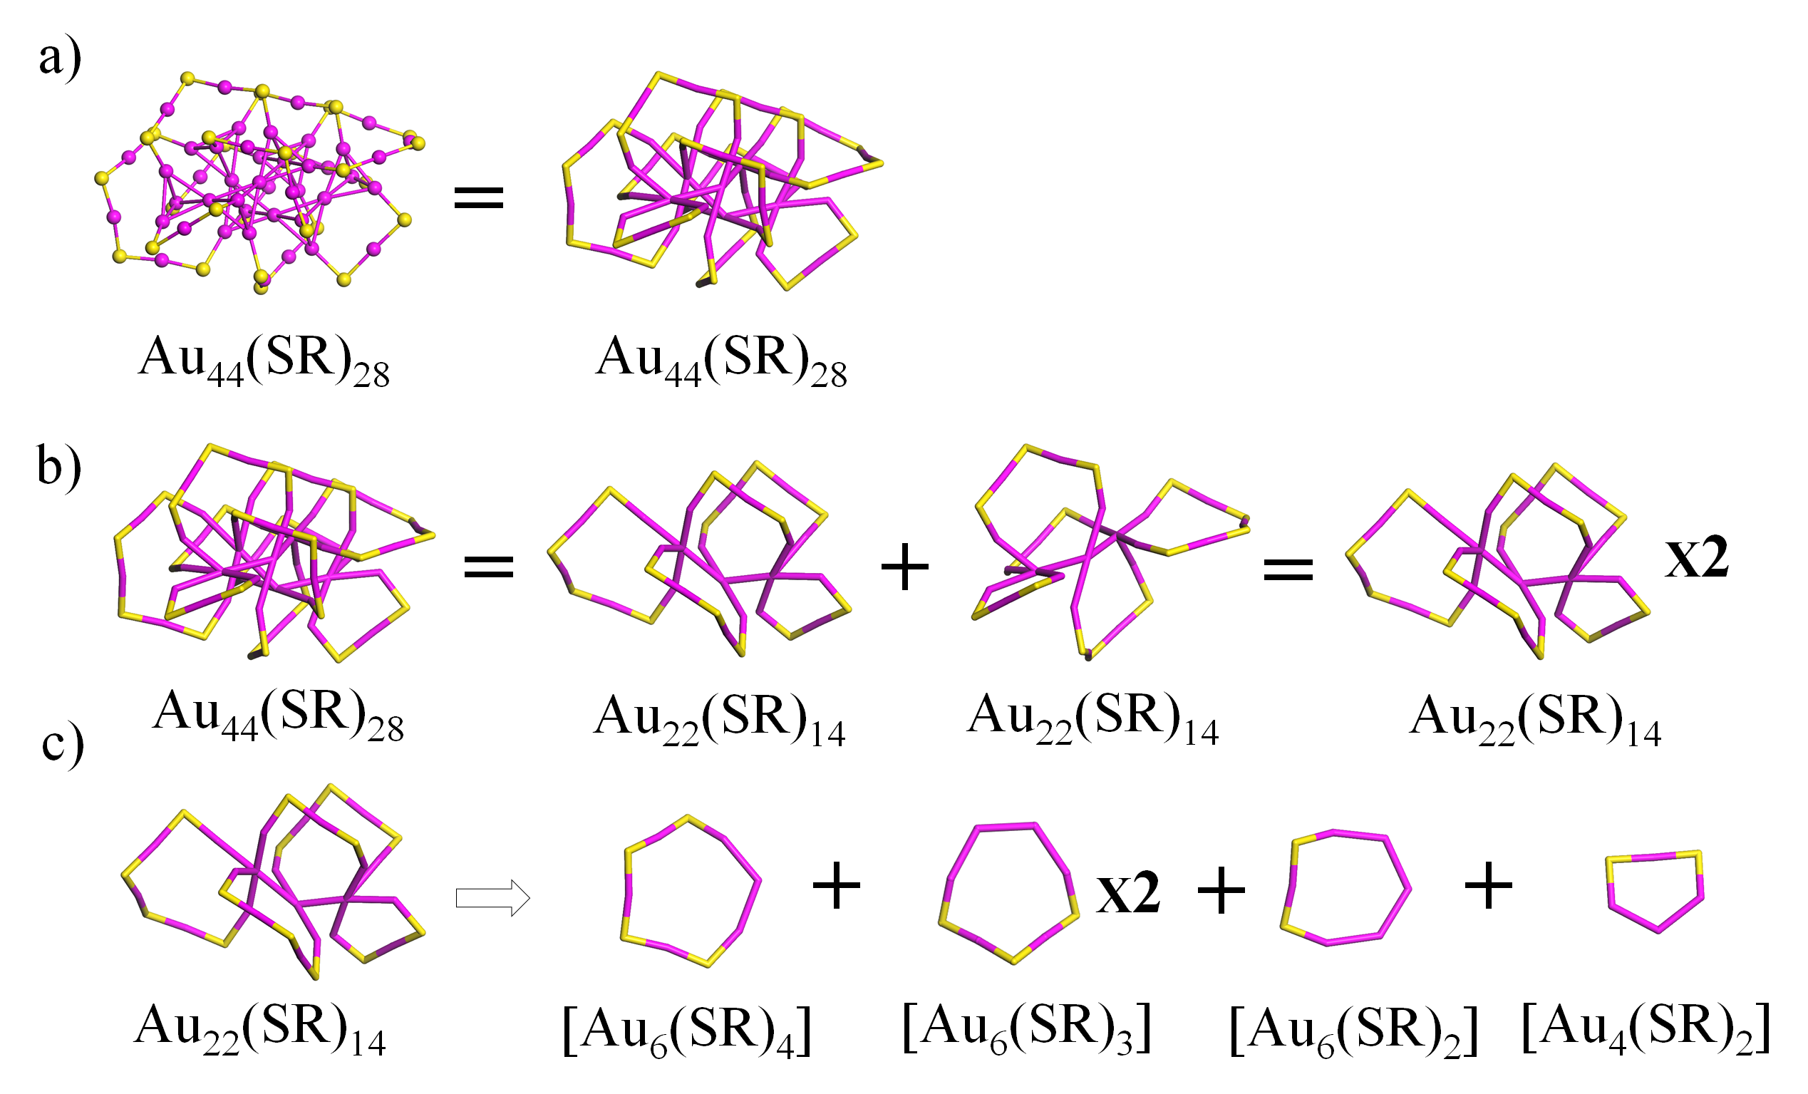
Figure S50. The structural decompositions of Au₄₄(SR)₂₈ into, two [Au₆(SR)₄], four [Au₆(SR)₃], two [Au₆(SR)₂], and two [Au₄(SR)₂] rings. Au: wine; S: yellow. The R groups were omitted for clarity. (J. Phys. Chem. Lett. 2020, 11, 536−540)

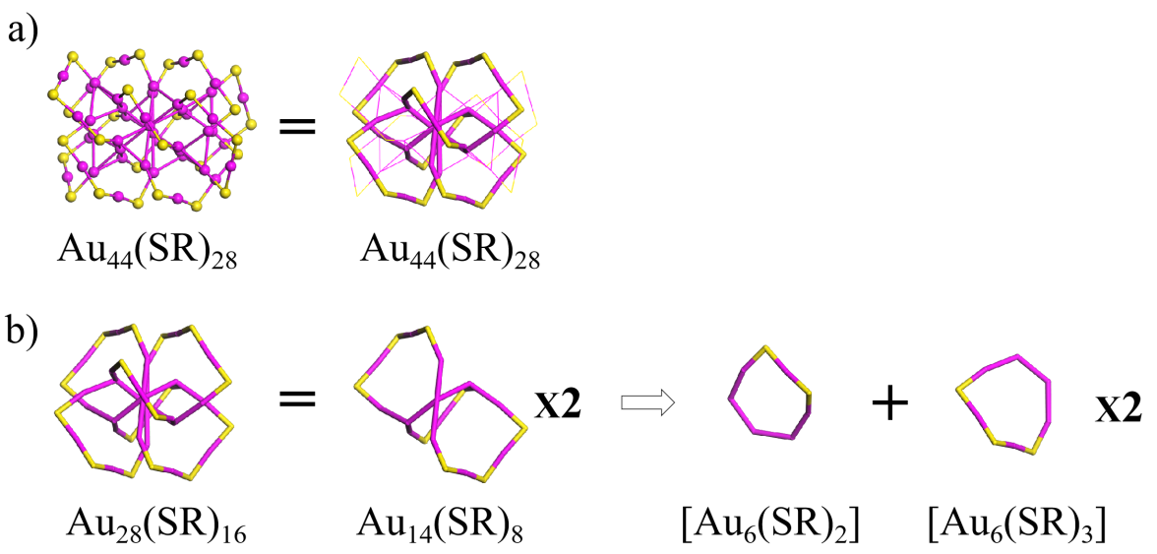
Figure S51. The structural decompositions of Au₄₄(SR)₂₈ into four [Au₆(SR)₃] and two [Au₆(SR)₂] rings. Au: wine; S: yellow. The R groups were omitted for clarity. (J. Am. Chem. Soc. 2016, 138, 3950–3953)

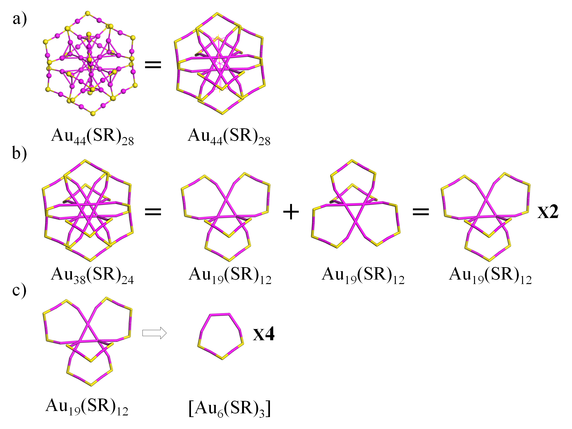
Figure S52. The structural decompositions of Au₄₄(SR)₂₈ into eight [Au₆(SR)₃] rings. Au: wine; S: yellow. The R groups were omitted for clarity. (Nat. Commun. 2020, accepted)
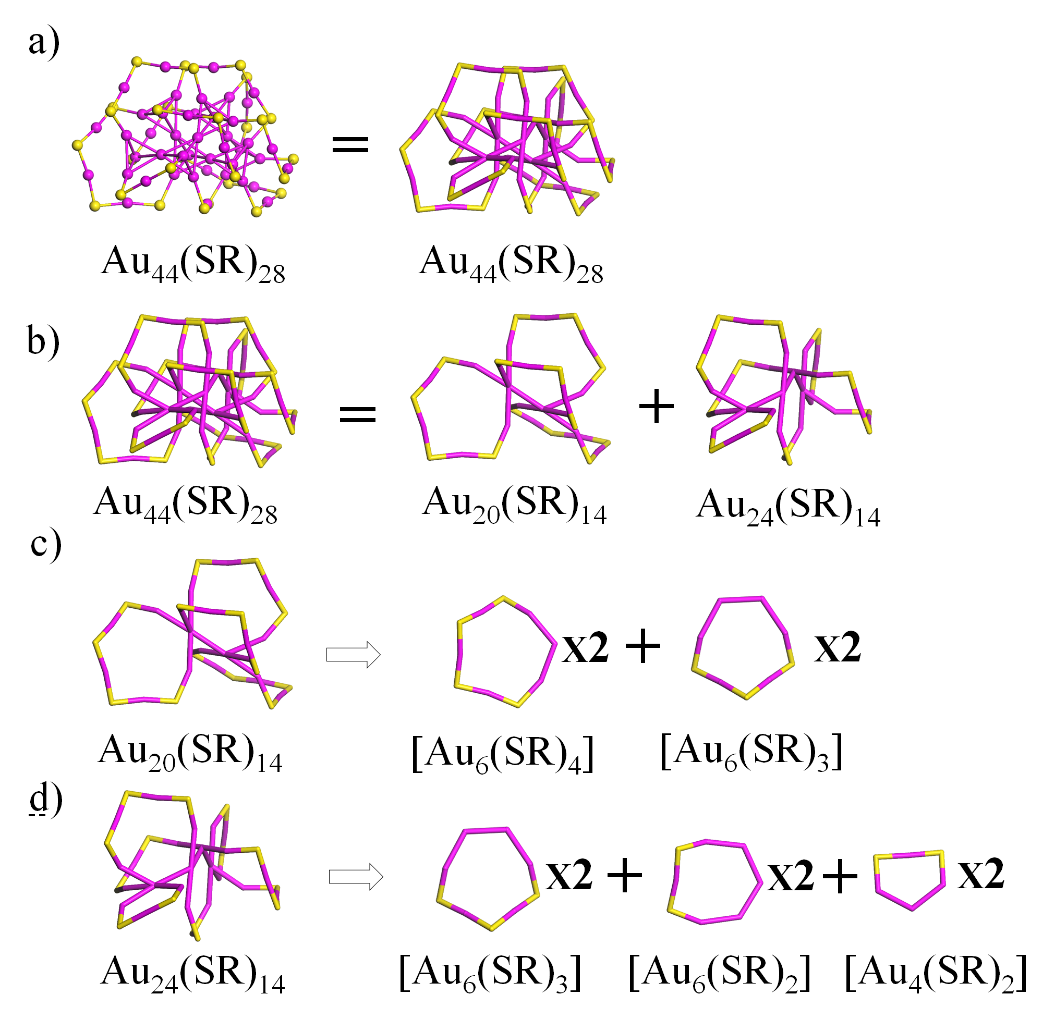
Figure S53. The structural decompositions of Au₄₄(SR)₂₈ into four [Au₆(SR)₃] rings. Au: wine; S: yellow. The R groups were omitted for clarity. (J. Phys. Chem. Lett. 2020, 11, 536−540)

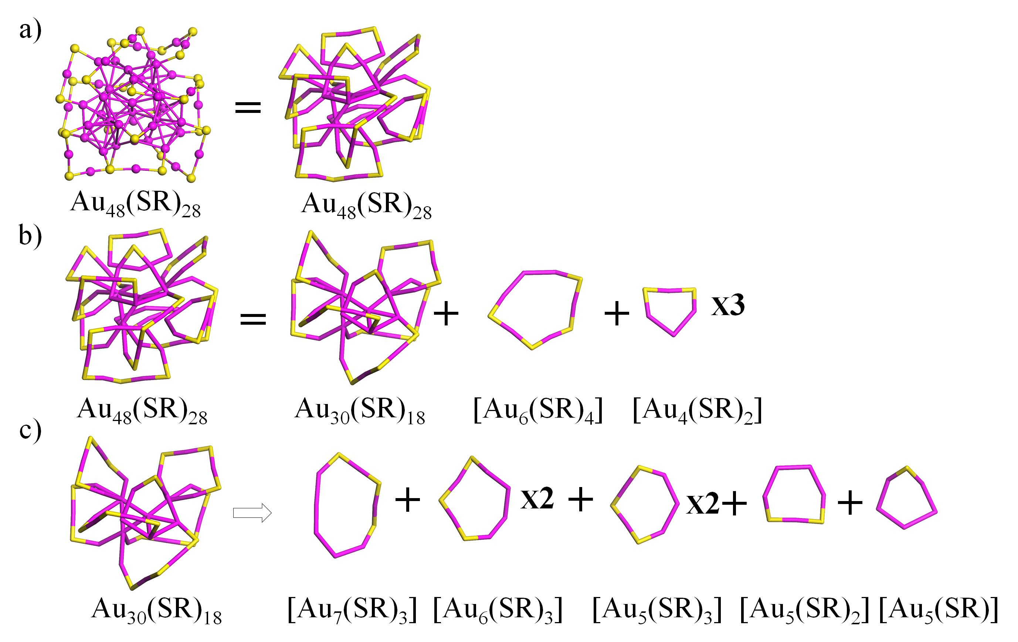
Figure S54. The structural decompositions of Au₄₈(SR)₂₈ into one [Au₇(SR)₃], one [Au₆(SR)₄], two [Au₆(SR)₃], two [Au₅(SR)₃], one [Au₅(SR)₂], and one [Au₅(SR)] rings, three [Au₄(SR)₂]. Au: wine; S: yellow. The R groups were omitted for clarity. (Angew. Chem. Int. Ed. 2018, 57, 15450−15454)
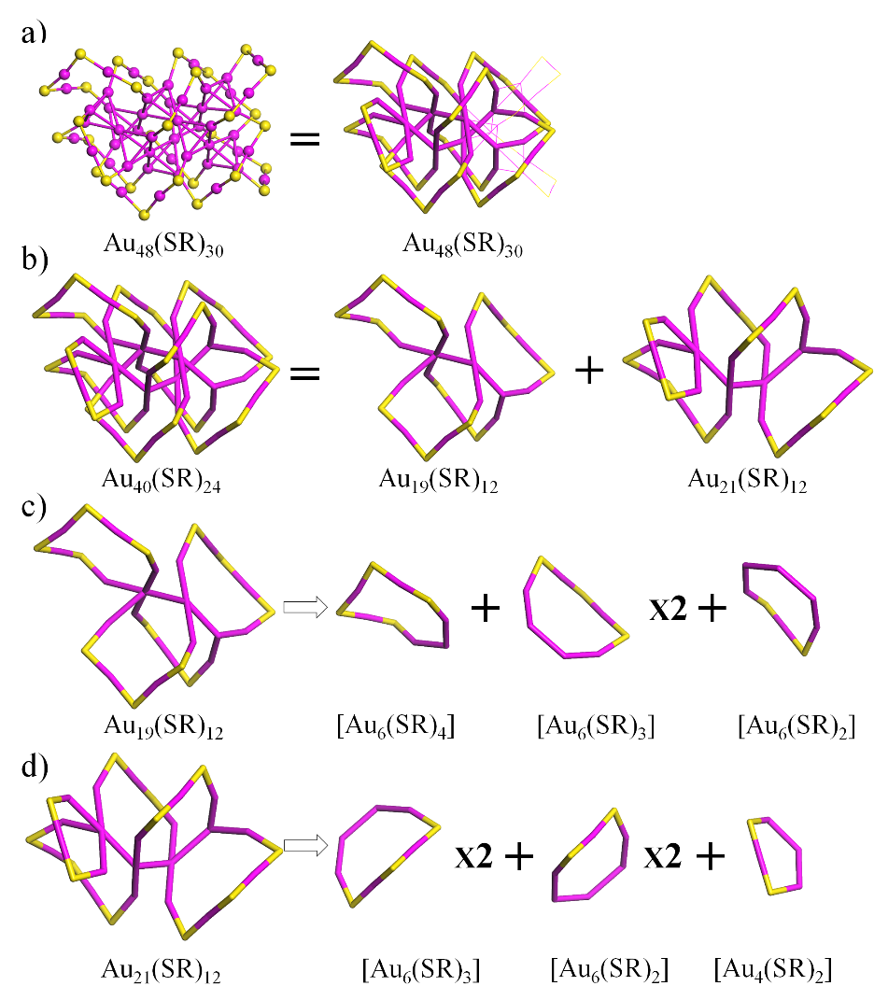
Figure S55. The structural decompositions of Au₄₈(SR)₃₀ into one [Au₆(SR)₄], three [Au₆(SR)₃], three [Au₆(SR)₂], and one [Au₄(SR)₂] rings. Au: wine; S: yellow. The R groups were omitted for clarity. (J. Phys. Chem. Lett. 2020, 11, 536−540)

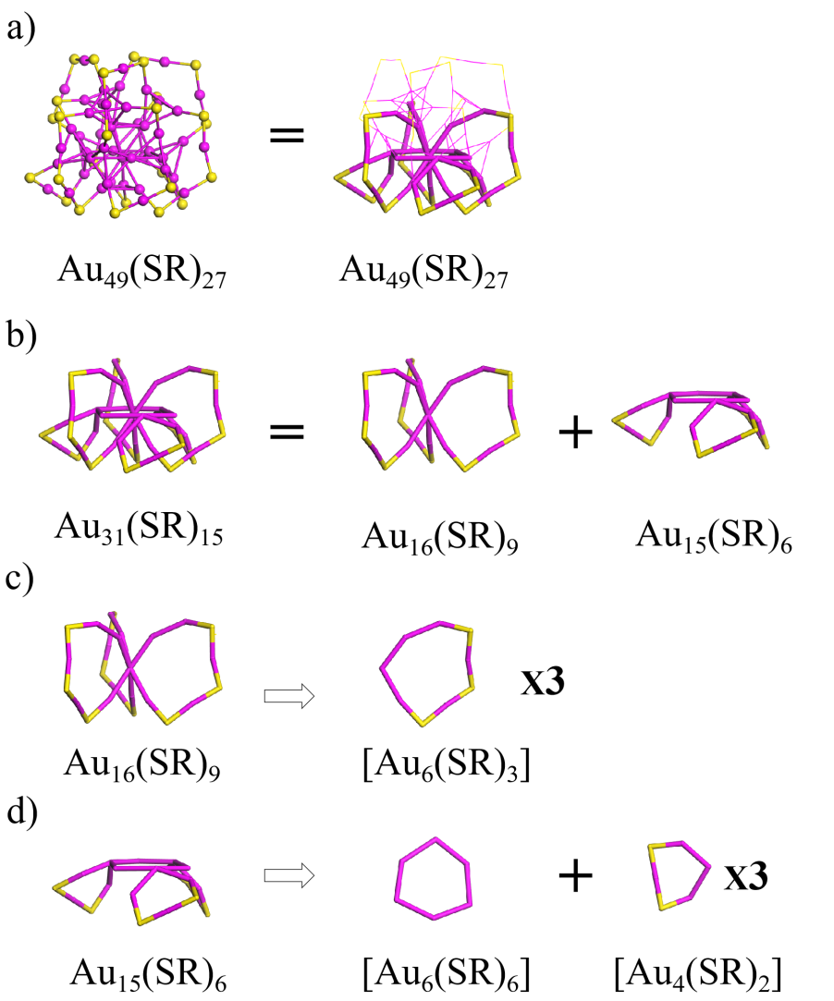
Figure S56. The structural decompositions of Au₄₉(SR)₂₇ into one [Au₆(SR)₆], three [Au₆(SR)₃], and three [Au₄(SR)₂] rings. Au: wine; S: yellow. The R groups were omitted for clarity. (Angew. Chem. Int. Ed. 2017, 56, 12644 –12648)

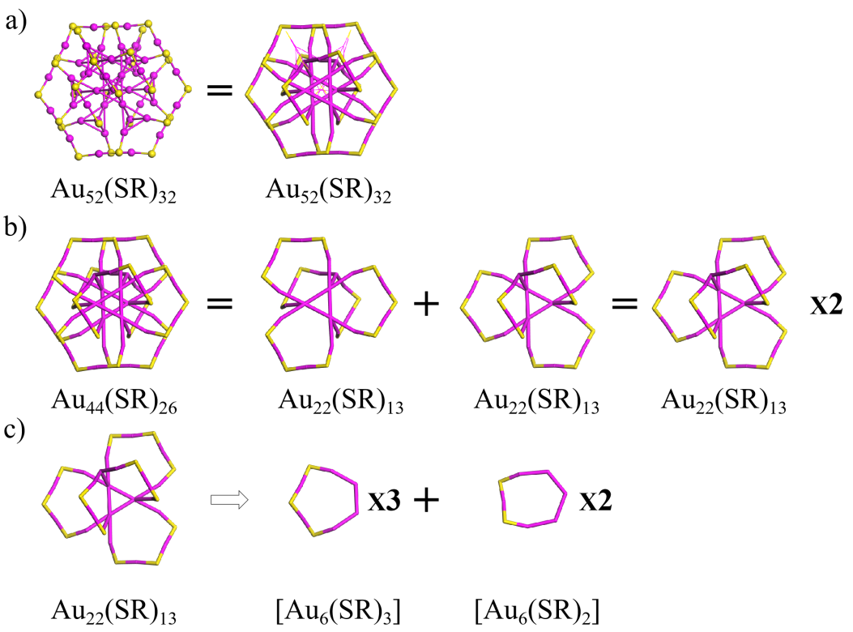
Figure S57. The structural decompositions of Au₅₂(SR)₃₂ into six [Au₆(SR)₃] and four [Au₄(SR)₂] rings. Au: wine; S: yellow. The R groups were omitted for clarity. (Nanoscale, 2017, 9, 14809)
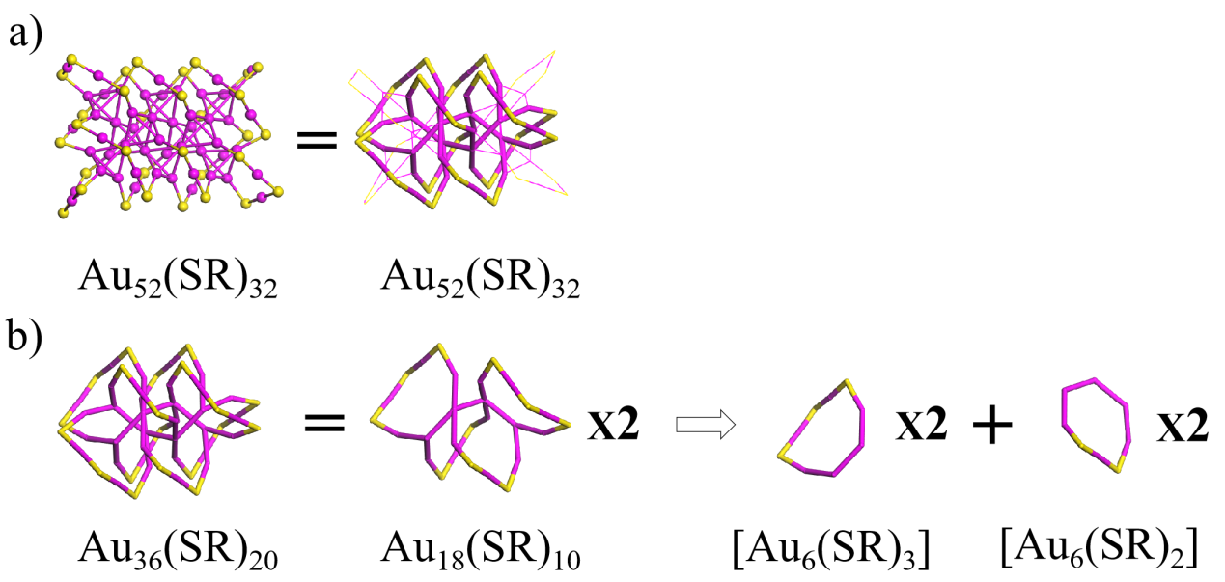

Figure S58. The structural decompositions of Au₅₂(SR)₃₂ into four [Au₆(SR)₃] and four [Au₆(SR)₂] rings. Au: wine; S: yellow. The R groups were omitted for clarity. (Sci. Adv. 2015, 1, e1500425)

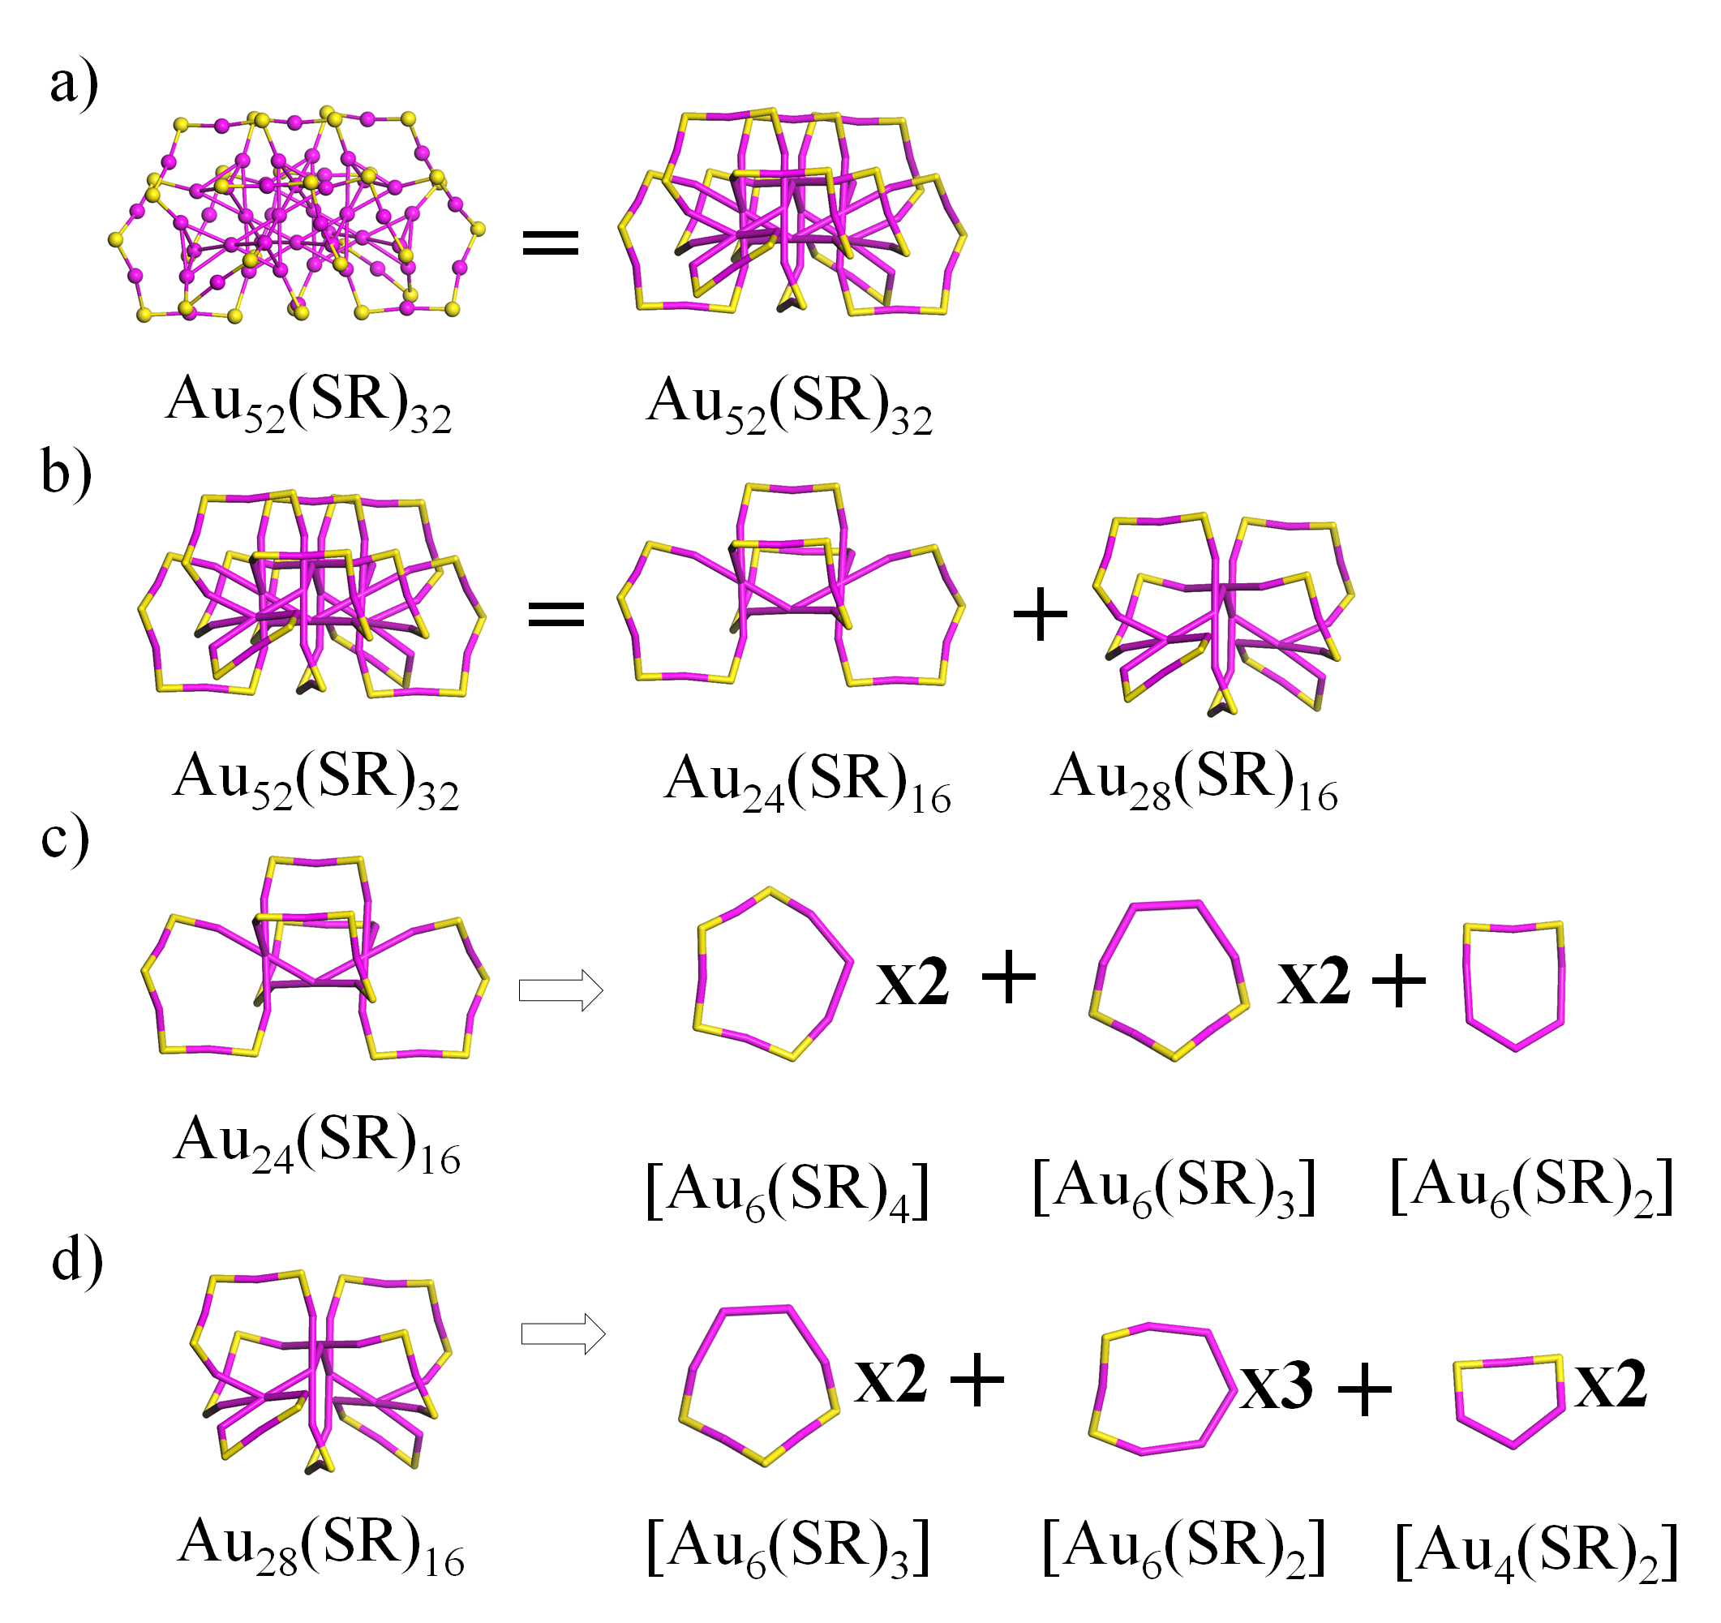
Figure S59. The structural decompositions of Au₅₂(SR)₃₂ into five [Au₆(SR)₄], four [Au₆(SR)₃], one [Au₆(SR)₂], and two [Au₄(SR)₂] rings. Au: wine; S: yellow. The R groups were omitted for clarity. (J. Phys. Chem. Lett. 2020, 11, 536−540)
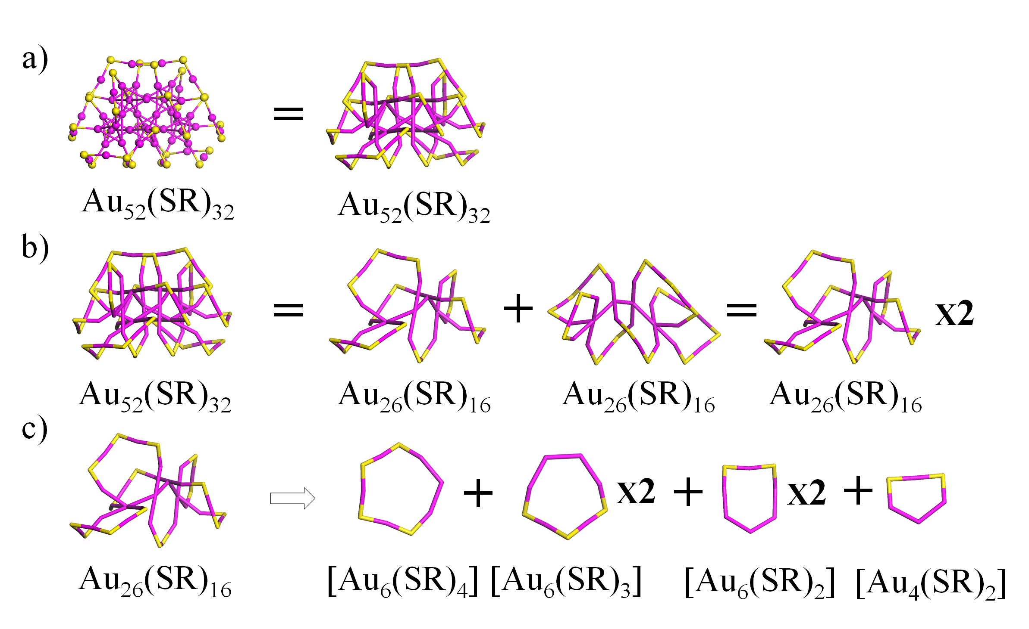
Figure S60. The structural decompositions of Au₅₂(SR)₃₂ into two [Au₆(SR)₄], four [Au₆(SR)₃], four [Au₆(SR)₂], and two [Au₄(SR)₂] rings. Au: wine; S: yellow. The R groups were omitted for clarity. (J. Phys. Chem. Lett. 2020, 11, 536−540)

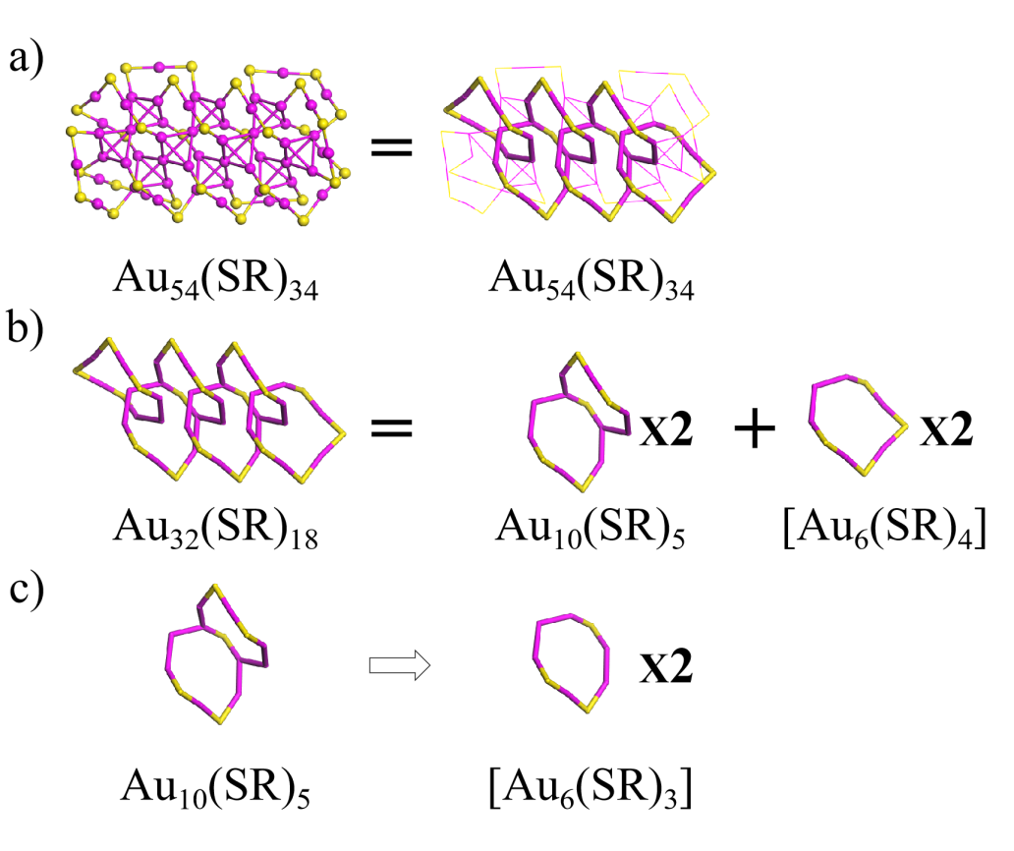
Figure S61. The structural decompositions of Au₅₄(SR)₃₄ into four [Au₆(SR)₃] and two [Au₆(SR)₄] rings. Au: wine; S: yellow. The R groups were omitted for clarity. (Nanoscale 2020, 12, 5554−5566)
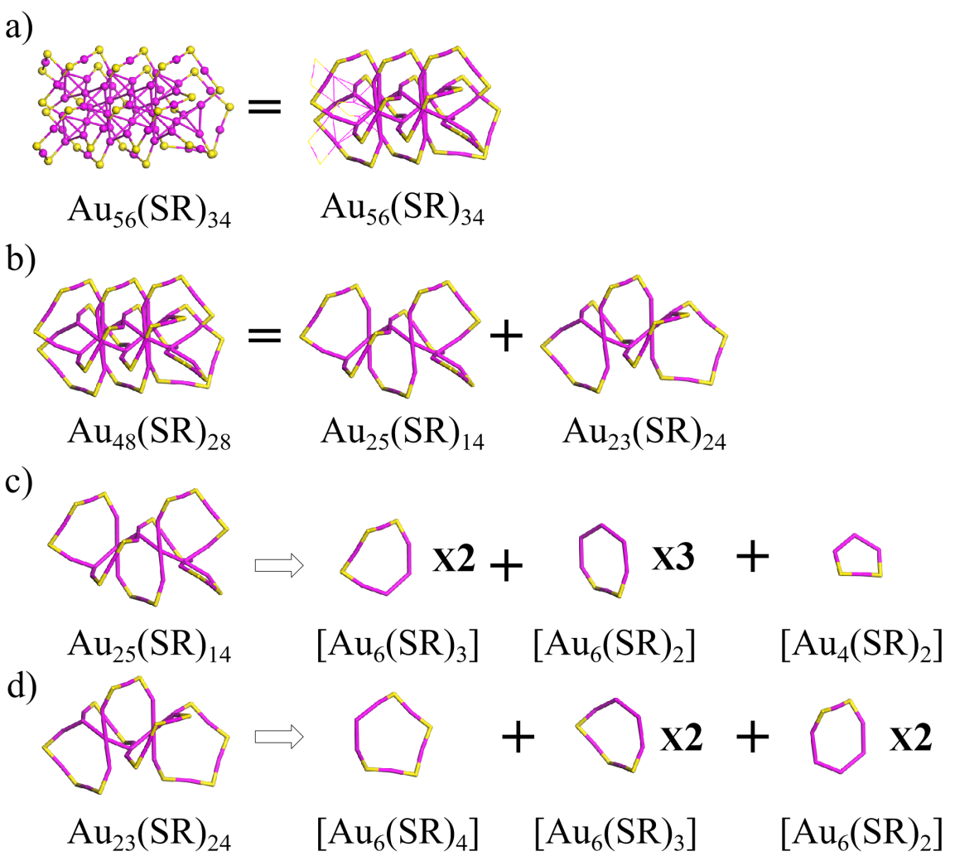
Figure S62. The structural decompositions of Au₅₆(SR)₃₄ into one [Au₆(SR)₄], four [Au₆(SR)₃], five [Au₆(SR)₂], and one [Au₄(SR)₂] rings. Au: wine; S: yellow. The R groups were omitted for clarity. (Angew. Chem. Int. Ed. 2020, 59, 731−734)

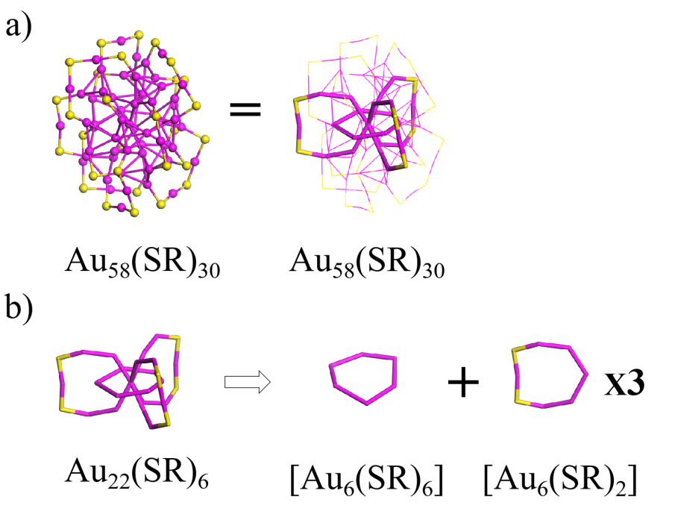
Figure S63. The structural decompositions of Au₅₈(SR)₃₀ into one [Au₆(SR)₆] and three [Au₆(SR)₂] rings. Au: wine; S: yellow. The R groups were omitted for clarity. (J. Chem. Phys. 2010, 132, 104301)
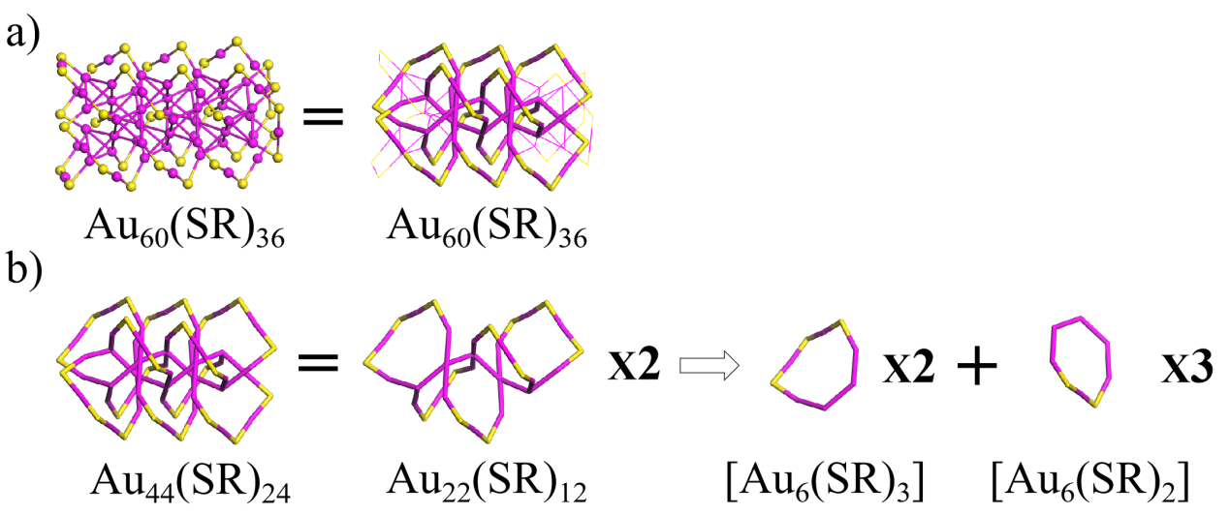
Figure S64. The structural decompositions of Au₆₀(SR)₃₆ into four [Au₆(SR)₃] and six [Au₆(SR)₂] rings. Au: wine; S: yellow. The R groups were omitted for clarity. (Nanoscale 2016, 8, 7396)

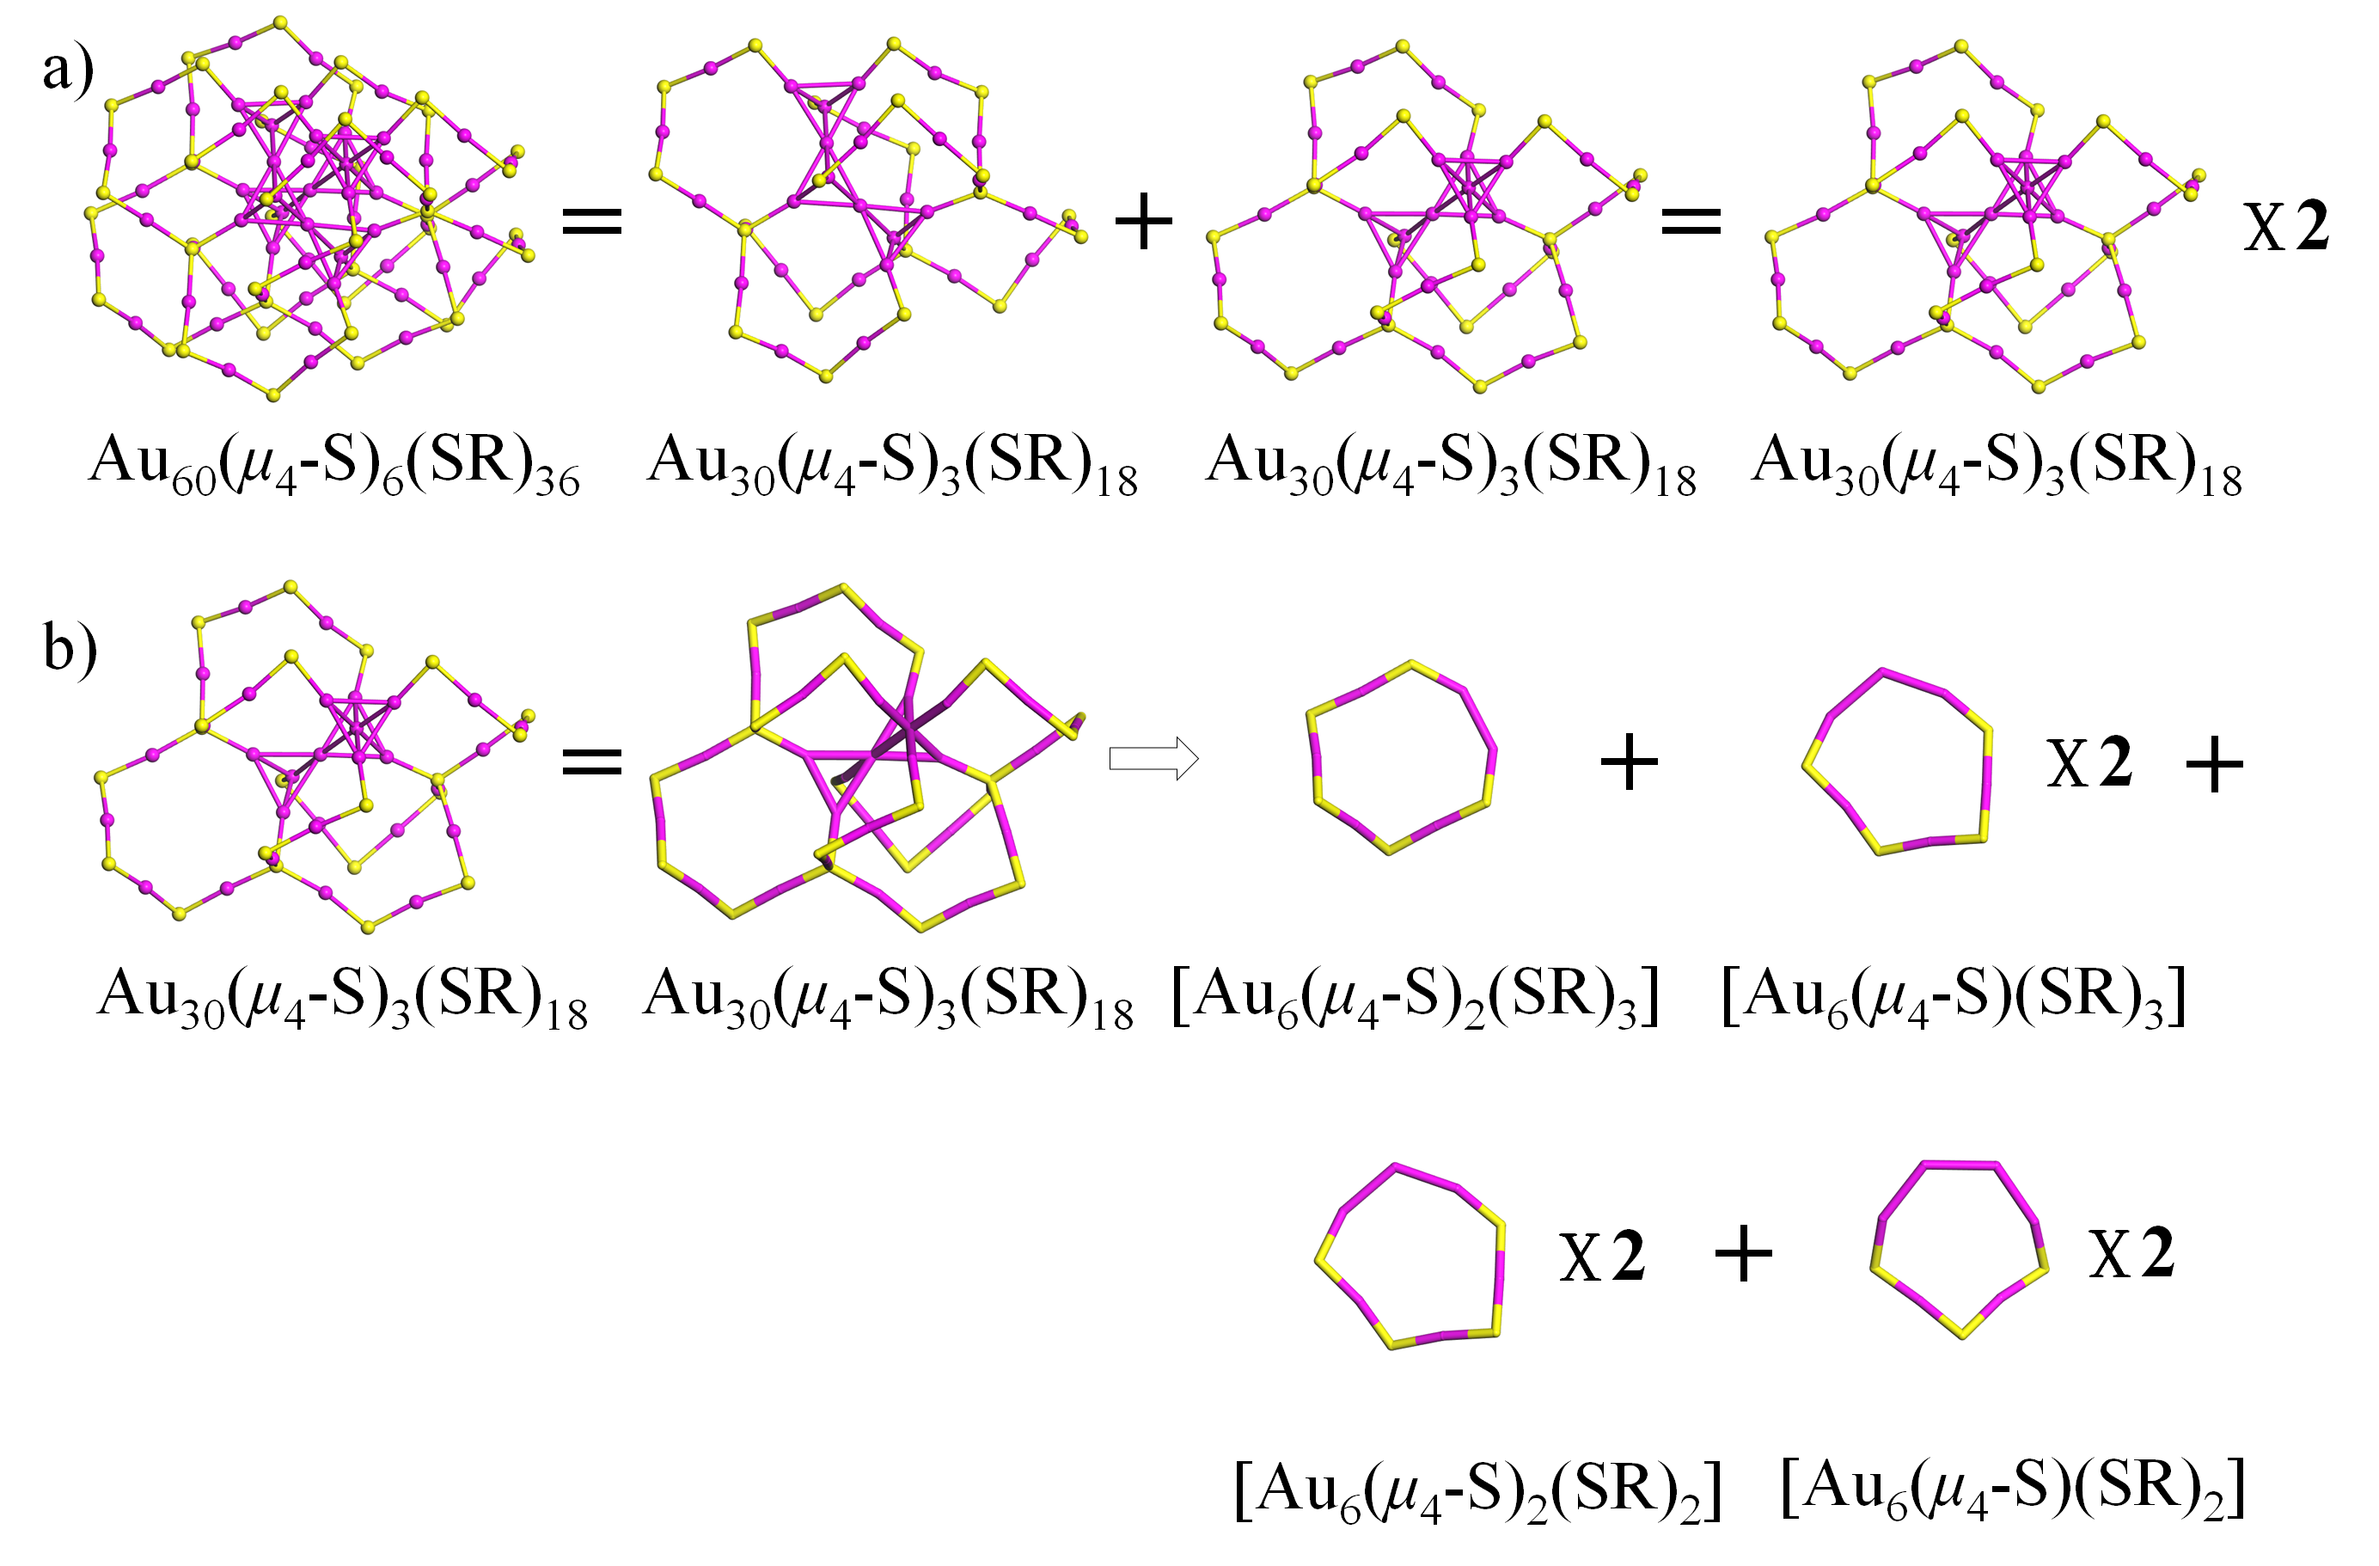
Figure S65. The structural decompositions of Au₆₀(μ₄-S)₆(SR)₃₆ into two [Au₆(μ₄-S)₂(SR)₃], four [Au₆(μ₄-S)(SR)₃], four [Au₆(μ₄-S)₂(SR)₂], and four [Au₆(μ₄-S)(SR)₂] rings. Au: wine; S: yellow. The R groups were omitted for clarity. (Nat. Commun. 2017, 8, 14739)
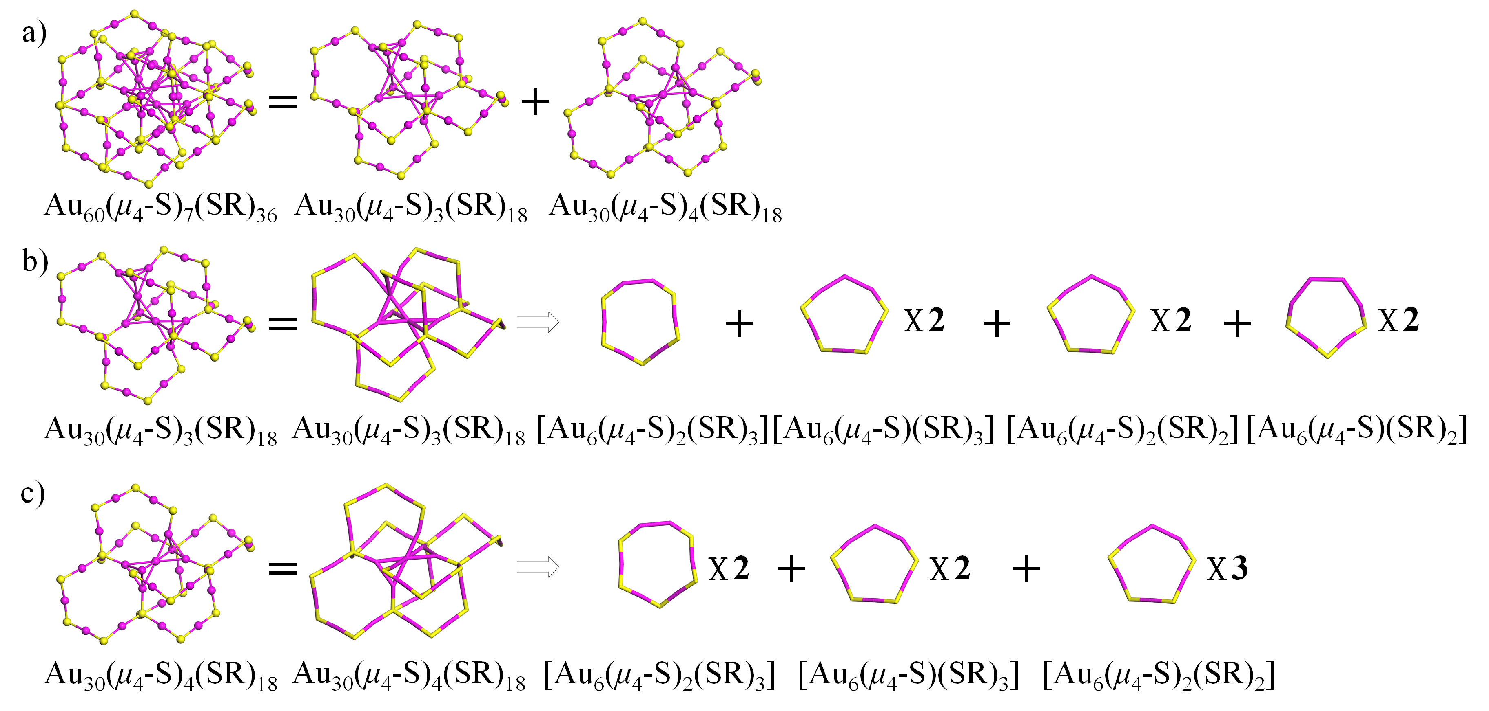
Figure S66. The structural decompositions of Au₆₀(μ₄-S)₇(SR)₃₆ into three [Au₆(μ₄-S)₂(SR)₃], four [Au₆(μ₄-S)(SR)₃], five [Au₆(μ₄-S)₂(SR)₂], and two [Au₆(μ₄-S)(SR)₂] rings. Au: wine; S: yellow. The R groups were omitted for clarity. (J. Phys. Chem. Lett. 2018, 9, 204−208)

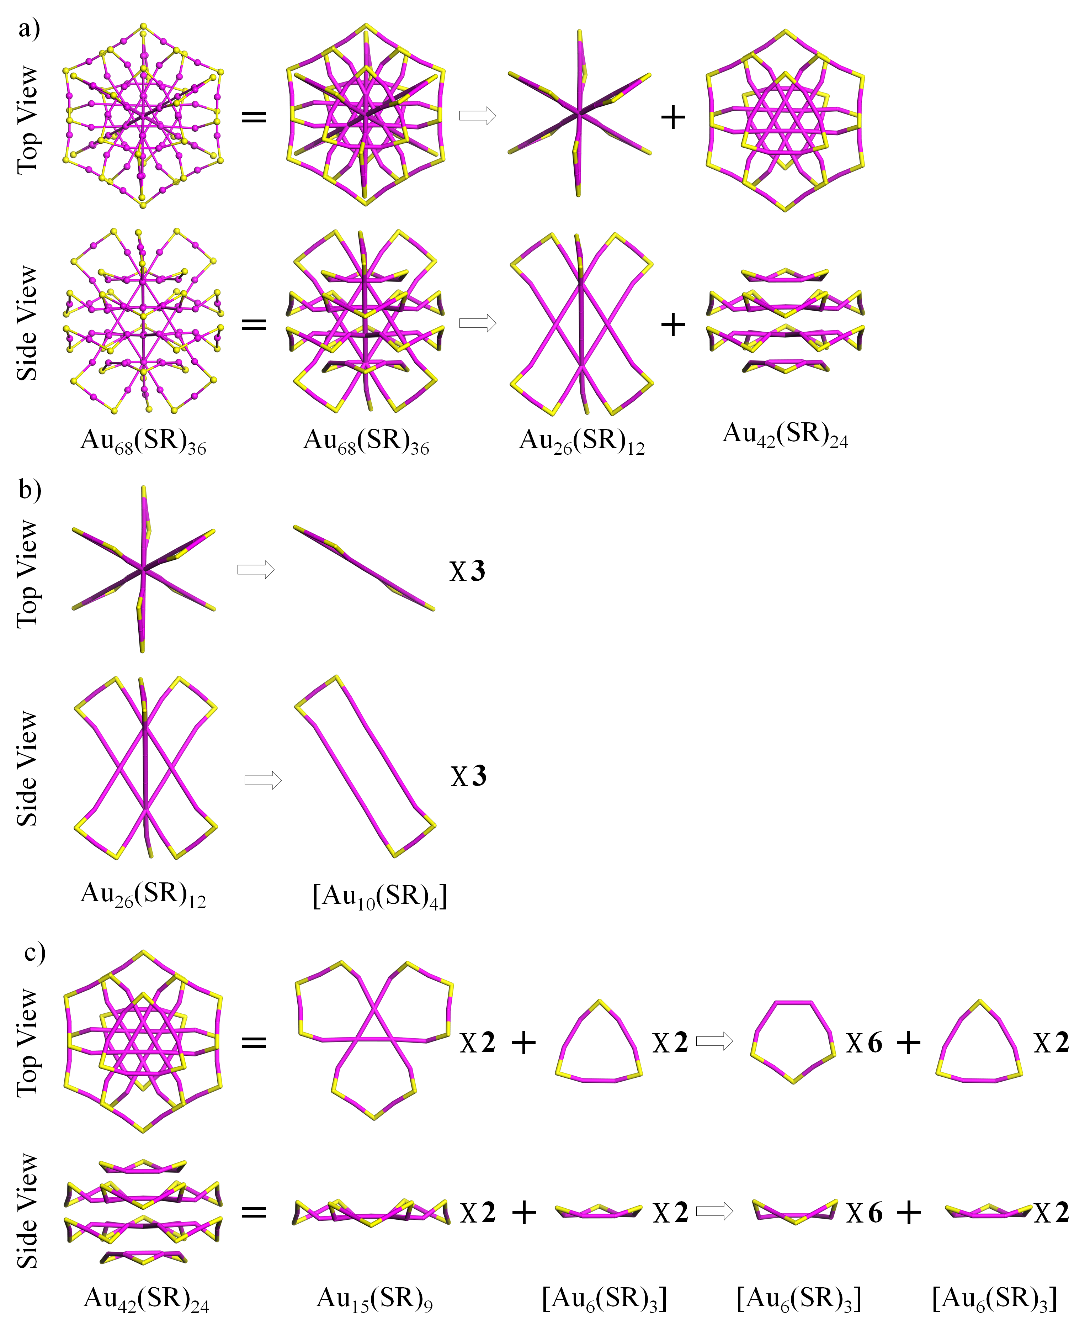
Figure S67. The top and side views of the structural decompositions of Au₆₈(SR)₃₆ into three [Au₁₀(SR)₄], eight [Au₆(SR)₃], and two [Au₆(SR)₃] rings. Au: wine; S: yellow. The R groups were omitted for clarity. (J. Phys. Chem. Lett. 2017, 8, 1248−1252)

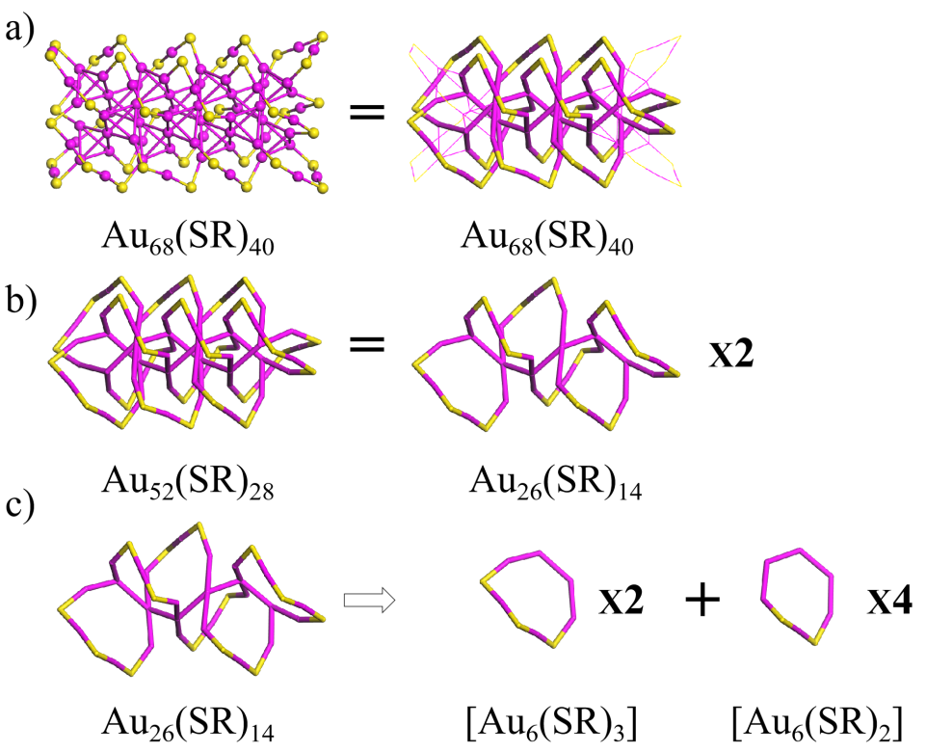
Figure S68. The structural decompositions of Au₆₈(SR)₄₀ into four [Au₆(SR)₃] and eight [Au₆(SR)₂] rings. Au: wine; S: yellow. The R groups were omitted for clarity. (Nanoscale 2016, 8, 7396)
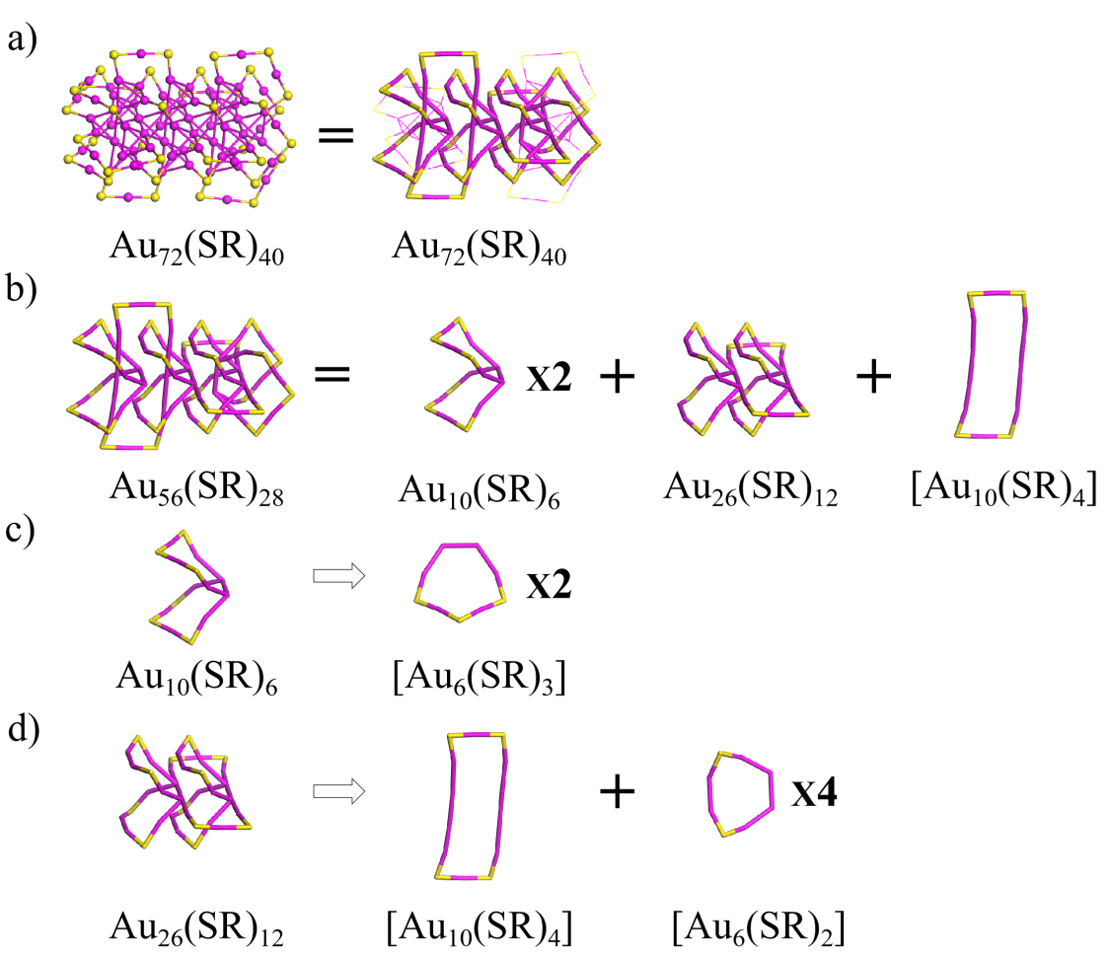
Figure S69. The structural decompositions of Au₇₂(SR)₄₀ into four [Au₆(SR)₃] two [Au₁₀(SR)₄] and four [Au₆(SR)₂] rings. Au: wine; S: yellow. The R groups were omitted for clarity. (Nanoscale 2020, 12, 5554−5566)
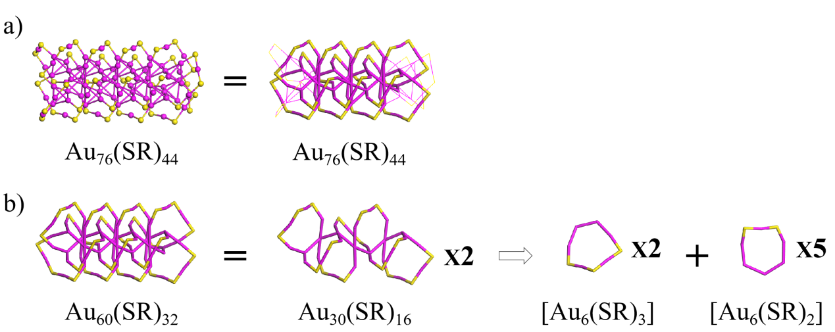
Figure S70. The structural decompositions of Au₇₆(SR)₄₄ into four [Au₆(SR)₃] and ten [Au₆(SR)₂] rings. Au: wine; S: yellow. The R groups were omitted for clarity. (Nanoscale 2016, 8, 7396)
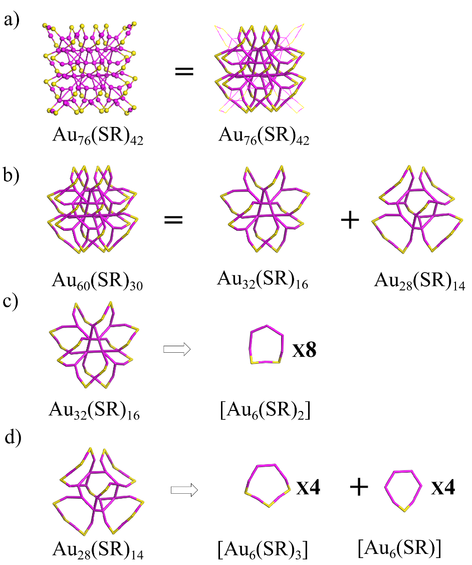
Figure S71. The structural decompositions of Au₇₆(SR)₄₂ into four [Au₆(SR)₃], eight [Au₆(SR)₂], and four [Au₆(SR)] rings. Au: wine; S: yellow. The R groups were omitted for clarity. (Nanoscale 2020, 12, 5554−5566)

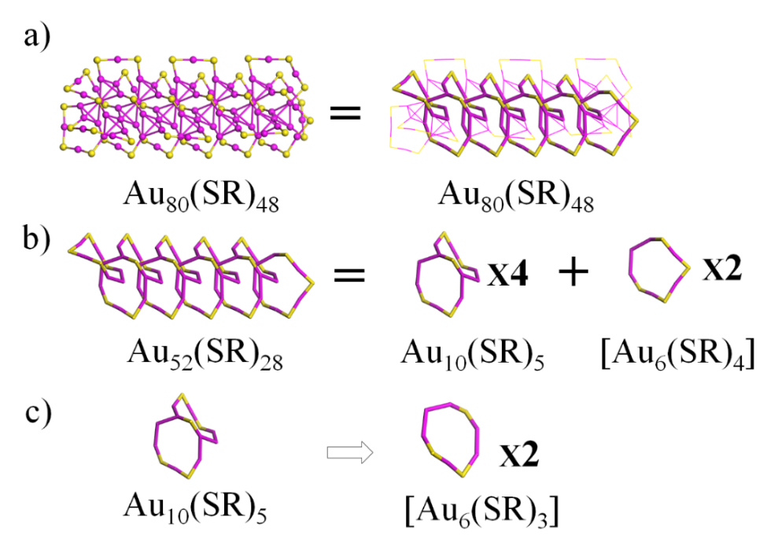
Figure S72. The structural decompositions of Au₈₀(SR)₄₈ into eight [Au₆(SR)₃] and two [Au₆(SR)₄] rings. Au: wine; S: yellow. The R groups were omitted for clarity. (Nanoscale 2020, 12, 5554−5566)
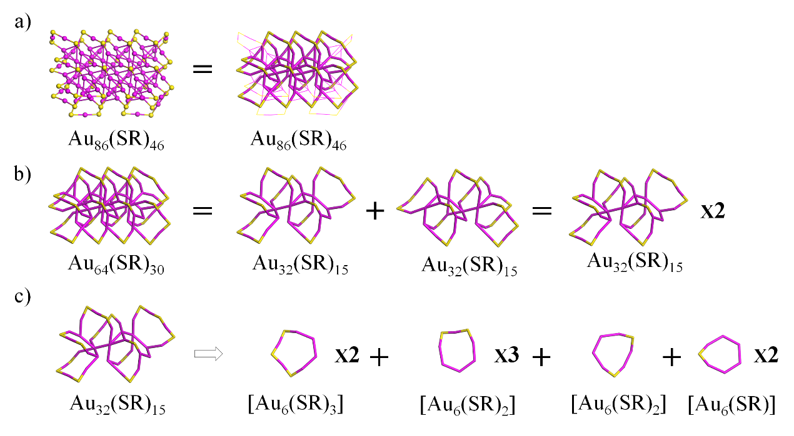
Figure S73. The structural decompositions of Au₈₆(SR)₄₆ into four [Au₆(SR)₃], eight [Au₆(SR)₂] and four [Au₆(SR)] rings. Au: wine; S: yellow. The R groups were omitted for clarity. (Nanoscale 2020, 12, 5554−5566)

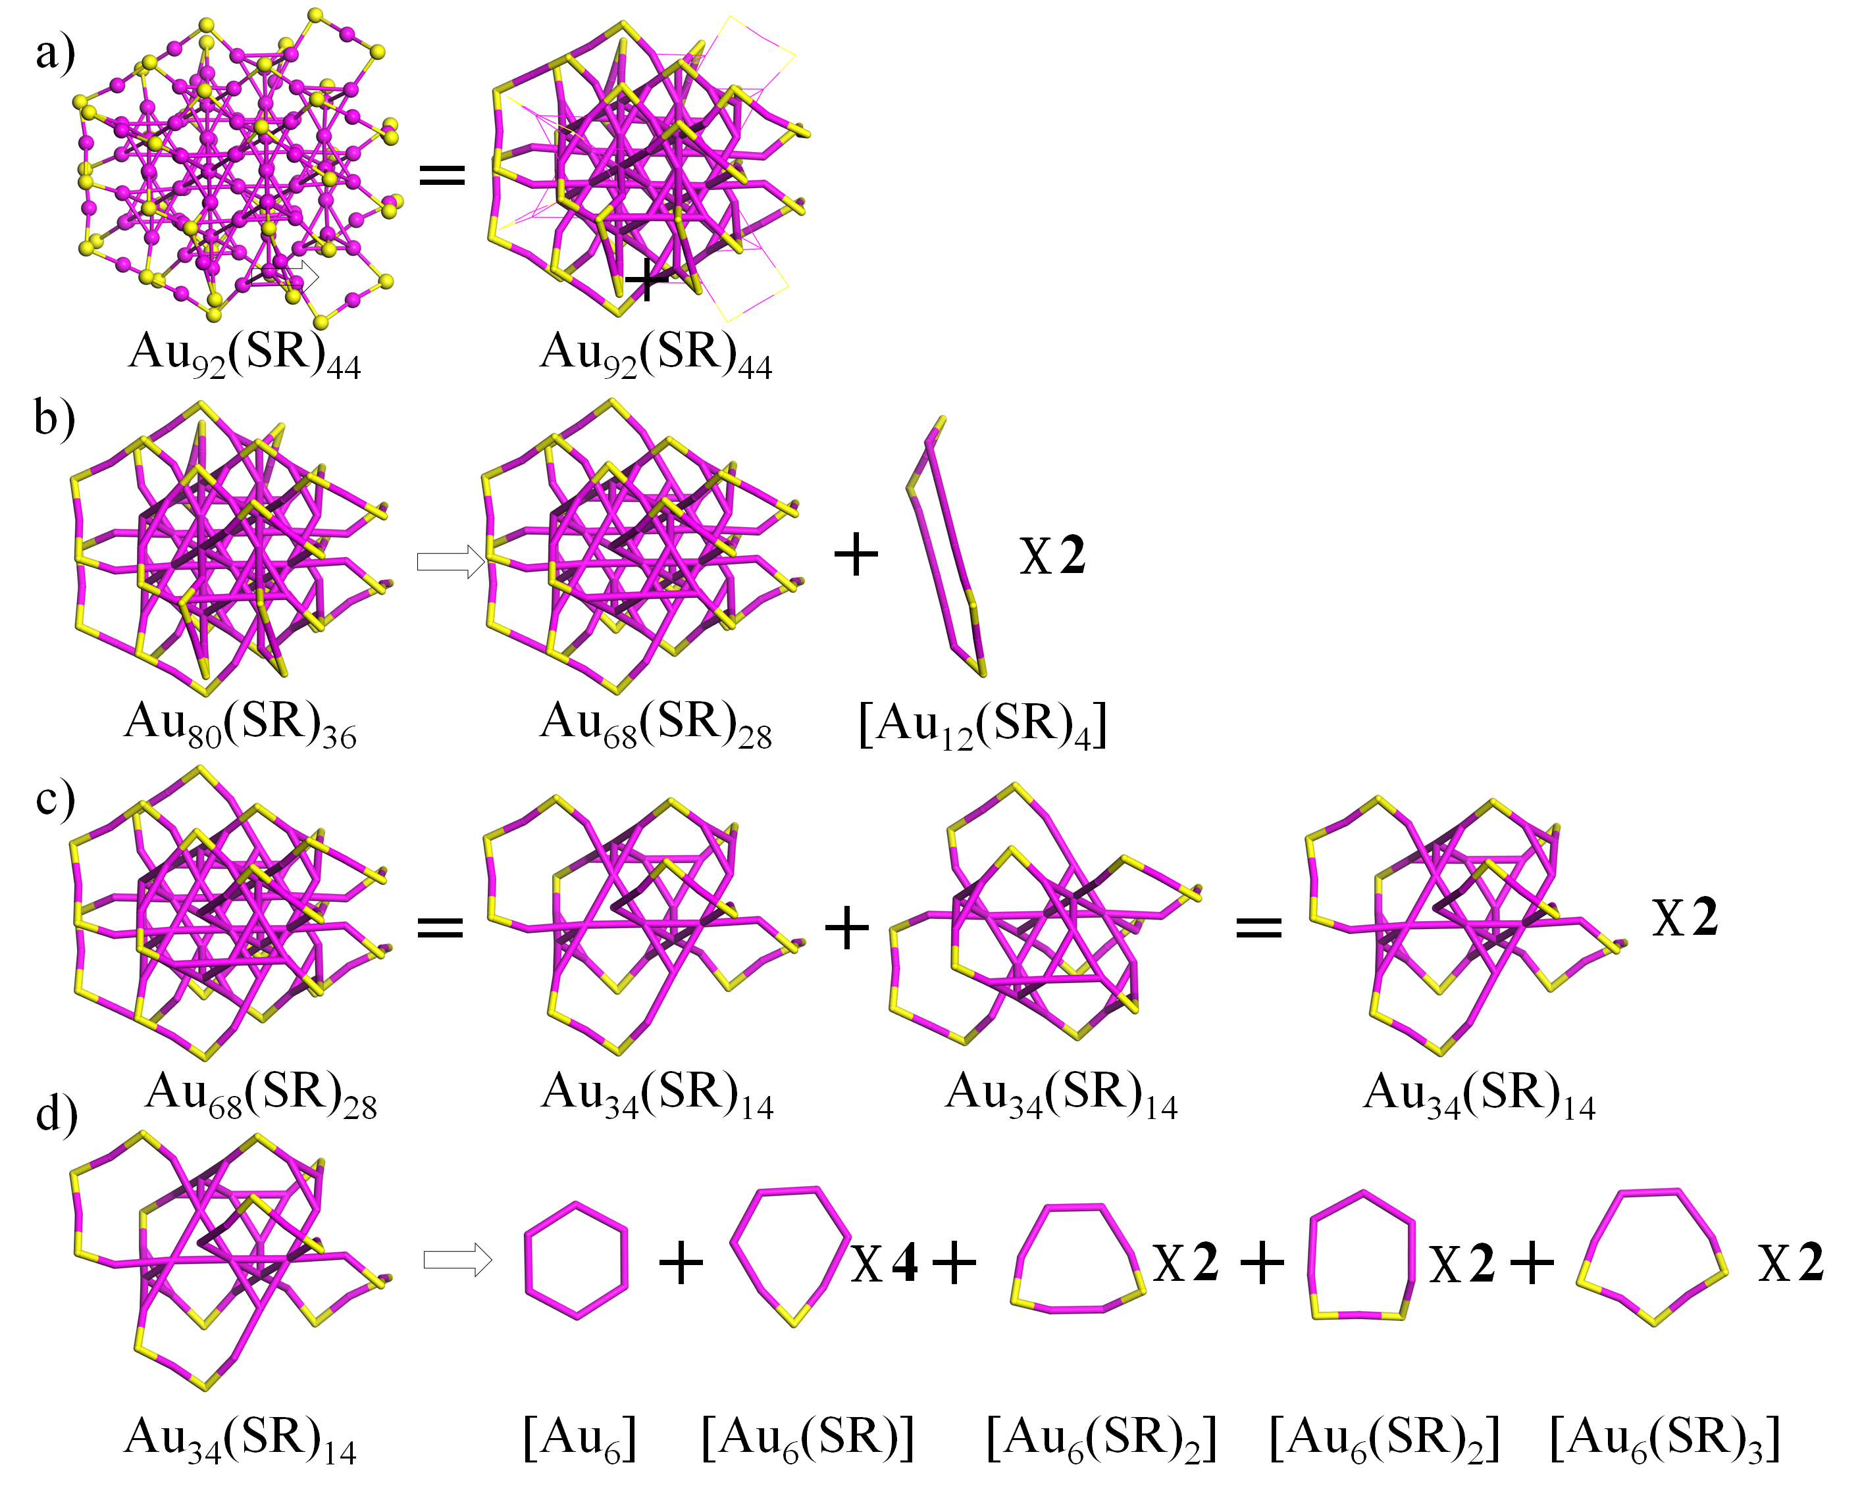
Figure S74. The structural decompositions of Au₉₂(SR)₄₄ into two [Au₁₂(SR)₄], eight [Au₆(SR)], two [Au₆], eight [Au₆(SR)₂], and four [Au₆(SR)₃] rings. Au: wine; S: yellow. The R groups were omitted for clarity. (J. Am. Chem. Soc. 2016, 138, 8710–8713)
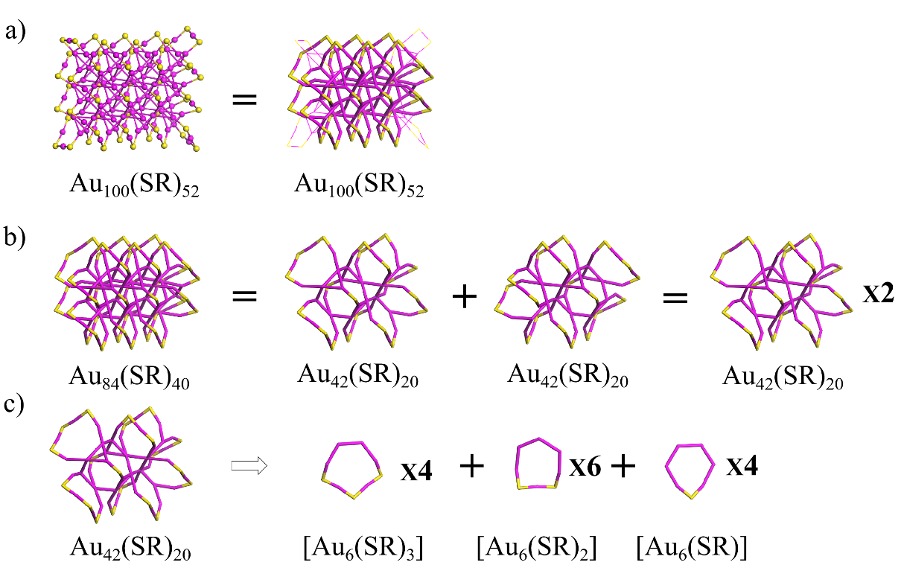
Figure S75. The structural decompositions of Au₁₀₀(SR)₅₂ into twelve [Au₆(SR)₂], eight [Au₆(SR)], and eight [Au₆(SR)₃] rings. Au: wine; S: yellow. The R groups were omitted for clarity. (Nanoscale 2020, 12, 5554–5566)

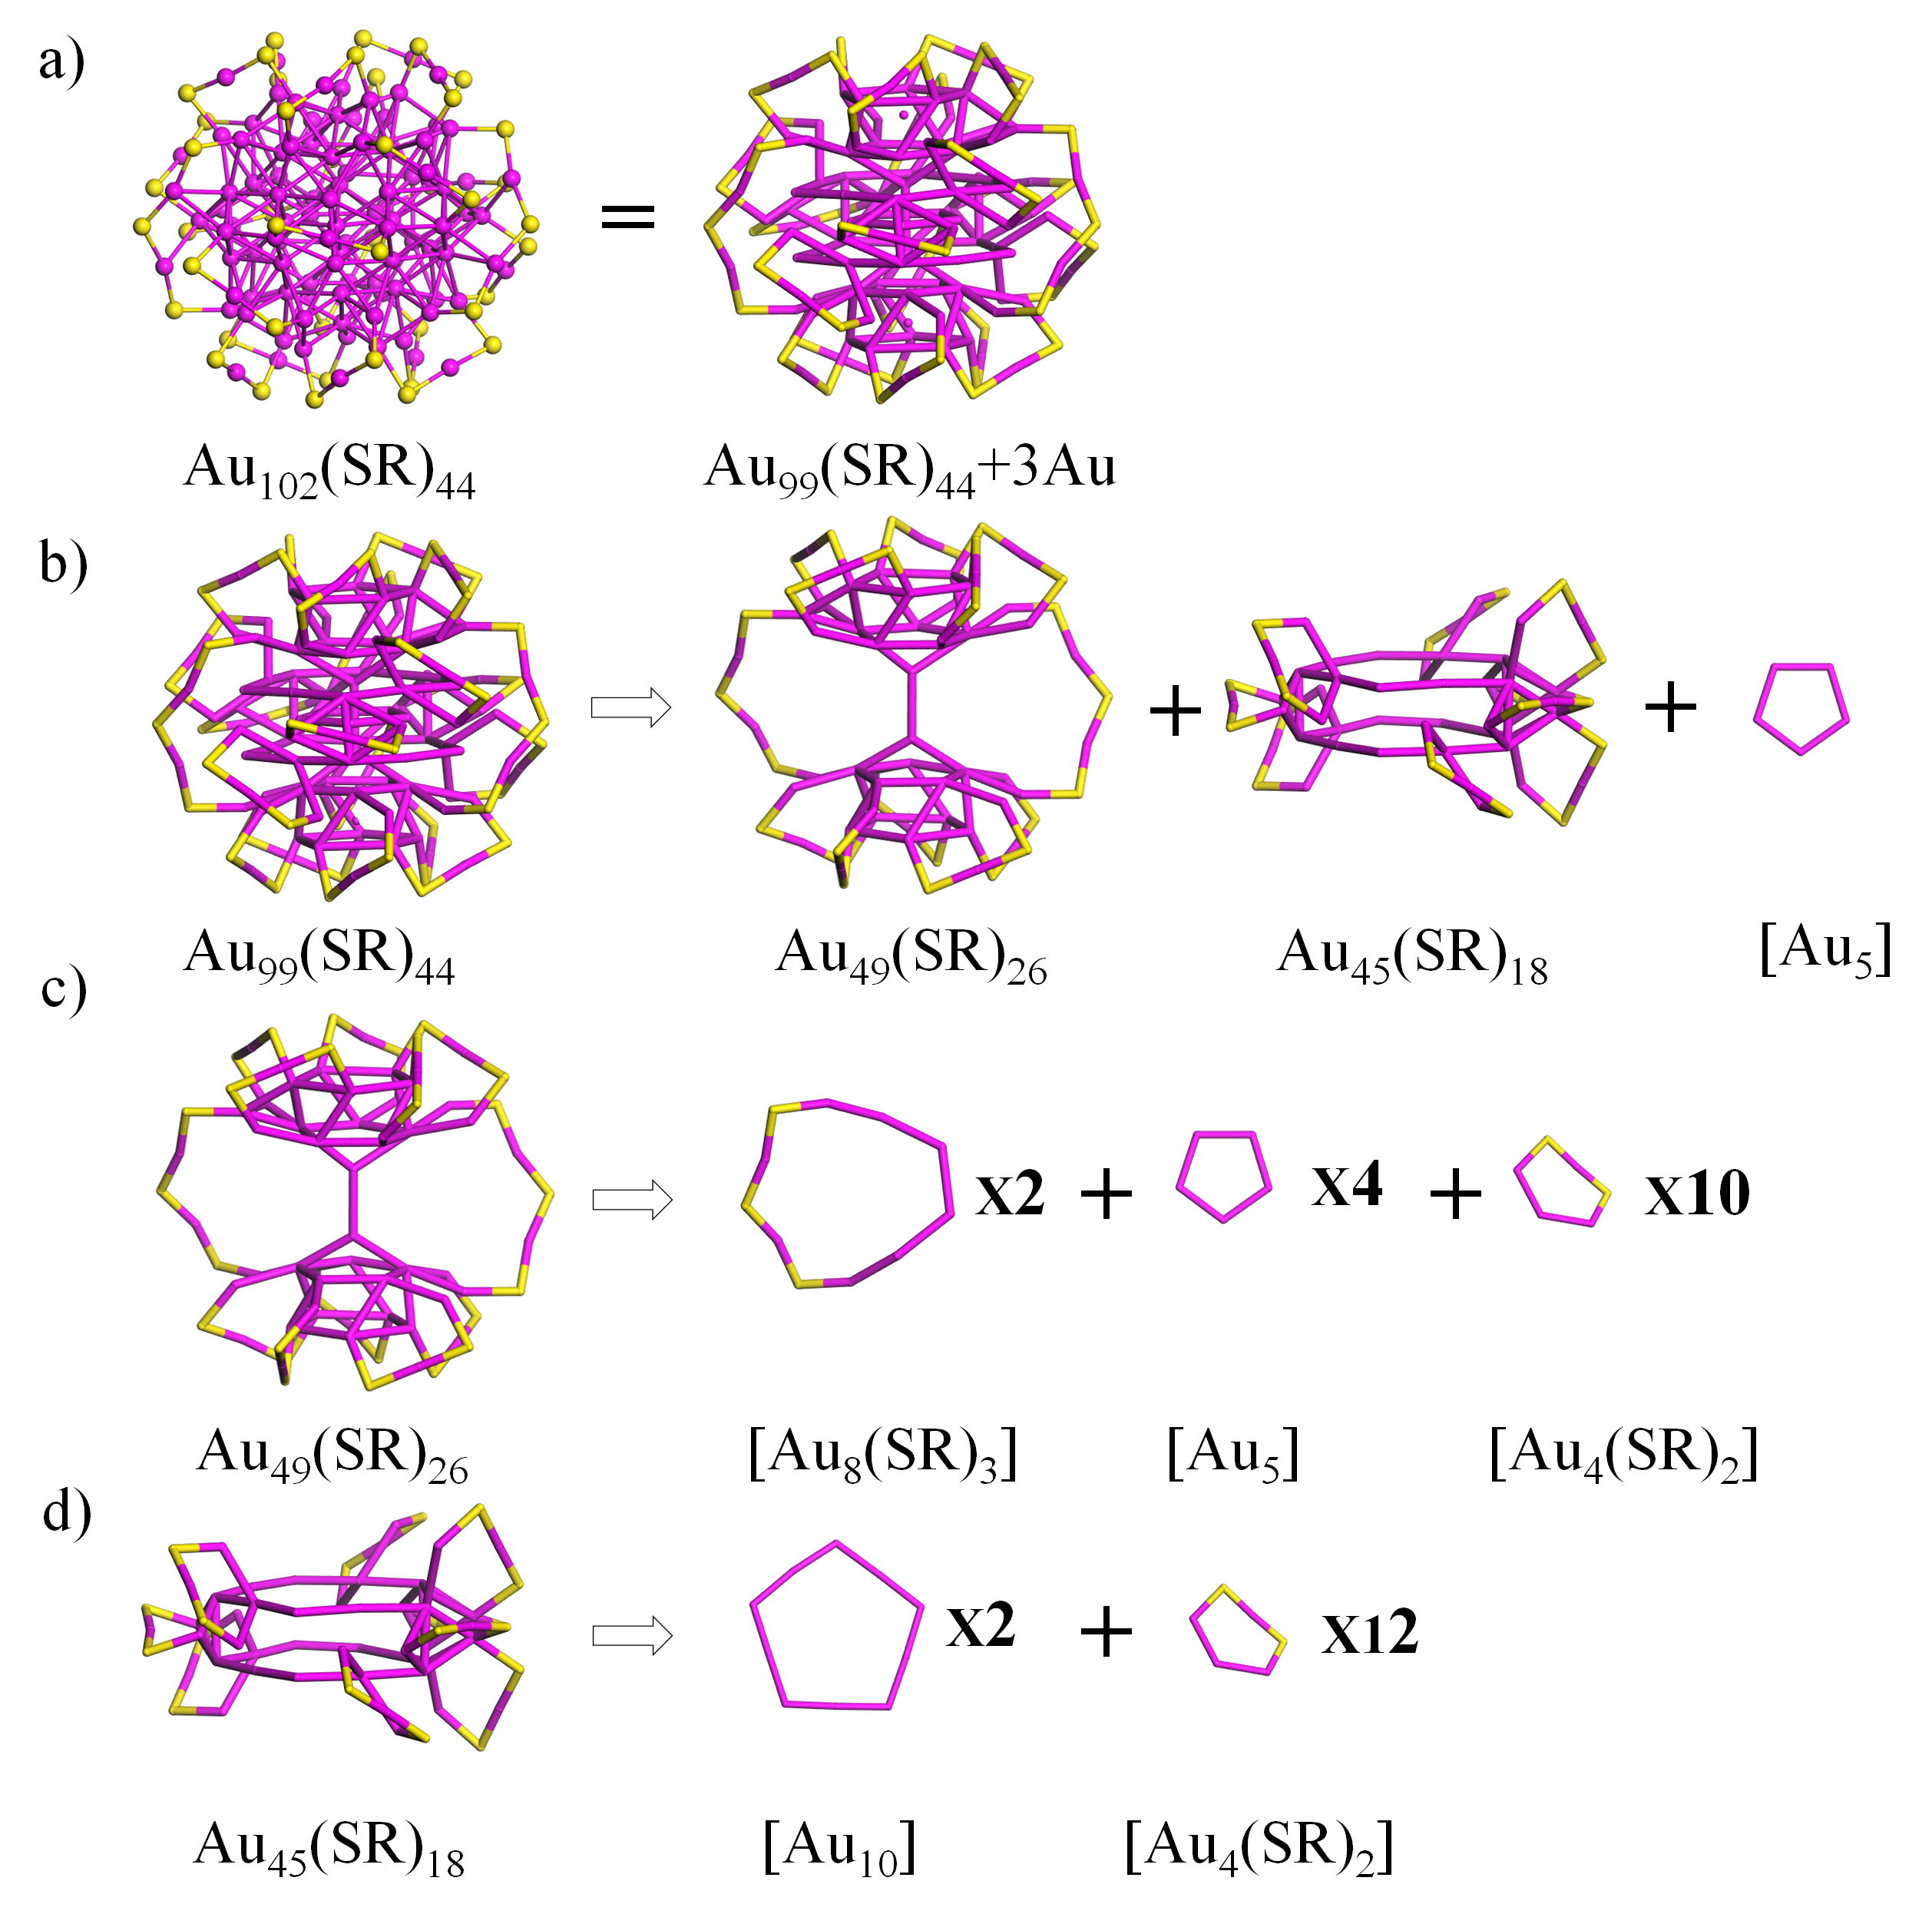
Figure S76. The structural decompositions of Au₁₀₂(SR)₄₄ into twenty-two [Au₄(SR)₂], two [Au₈(SR)₃], five [Au₅], and two [Au₁₀] rings. Au: wine; S: yellow. The R groups were omitted for clarity. (Science 2007, 318, 430–433)

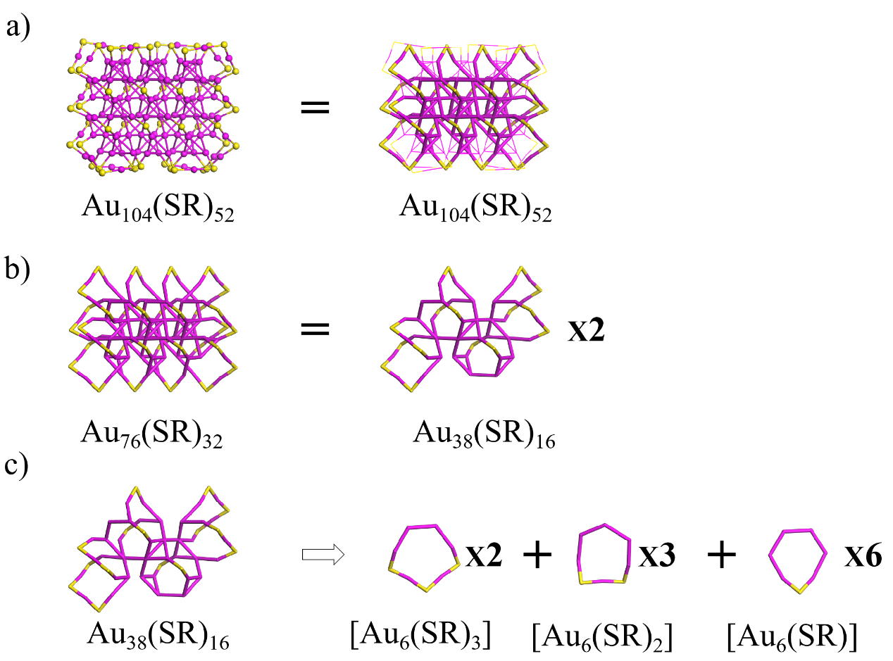
Figure S77. The structural decompositions of Au₁₀₄(SR)₅₂ into four [Au₆(SR)₃], six [Au₆(SR)₂] and twelve [Au₆(SR)] rings. Au: wine; S: yellow. The R groups were omitted for clarity. (Nanoscale 2020, 12, 5554–5566)
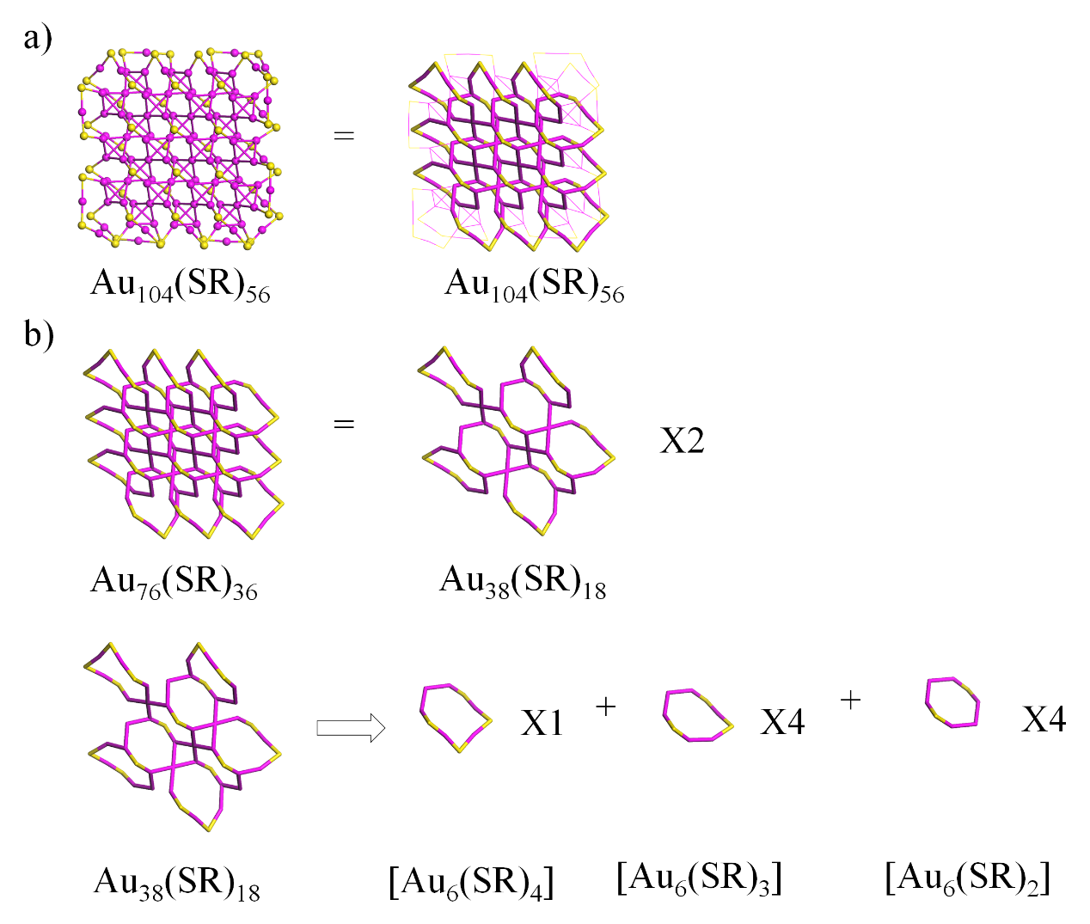
Figure S78. The structural decompositions of Au₁₀₄(SR)₅₆ into two [Au₆(SR)₄], four [Au₆(SR)₃], and four [Au₆(SR)] rings. Au: wine; S: yellow. The R groups were omitted for clarity. (Nanoscale 2020, 12, 5554–5566)

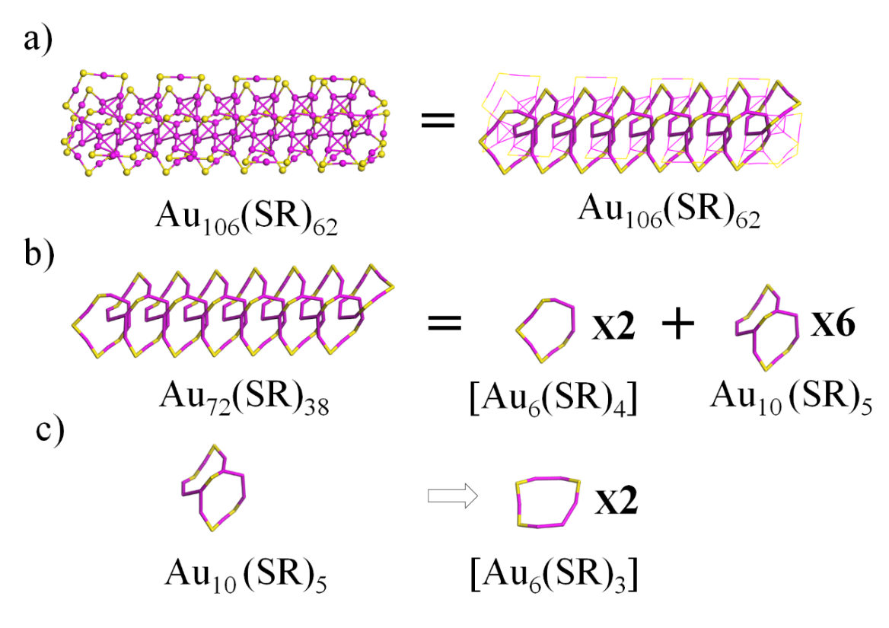
Figure S79. The structural decompositions of Au₁₀₆(SR)₆₂ into two [Au₆(SR)₄], two [Au₆(SR)₃] and six [Au₁₀(SR)₅] rings. Au: wine; S: yellow. The R groups were omitted for clarity. (Nanoscale 2020, 12, 5554–5566)
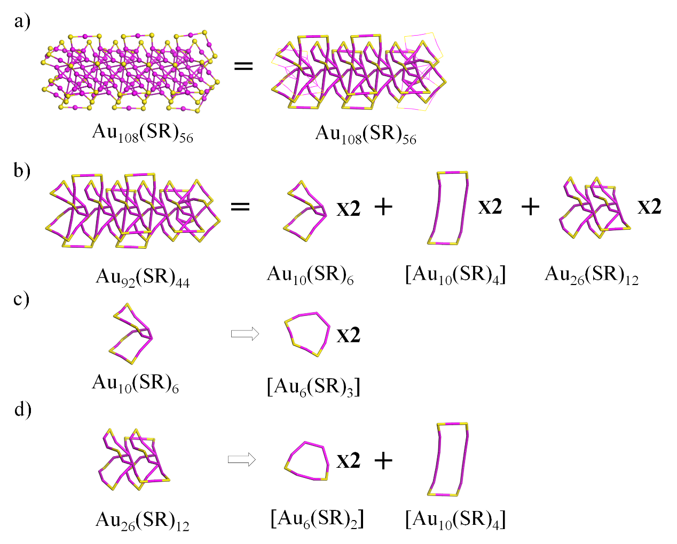
Figure S80. The structural decompositions of Au₁₀₈(SR)₅₆ into four [Au₁₀(SR)₄], four [Au₆(SR)₃] and four [Au₆(SR)₂] rings. Au: wine; S: yellow. The R groups were omitted for clarity. (Nanoscale 2020, 12, 5554–5566)

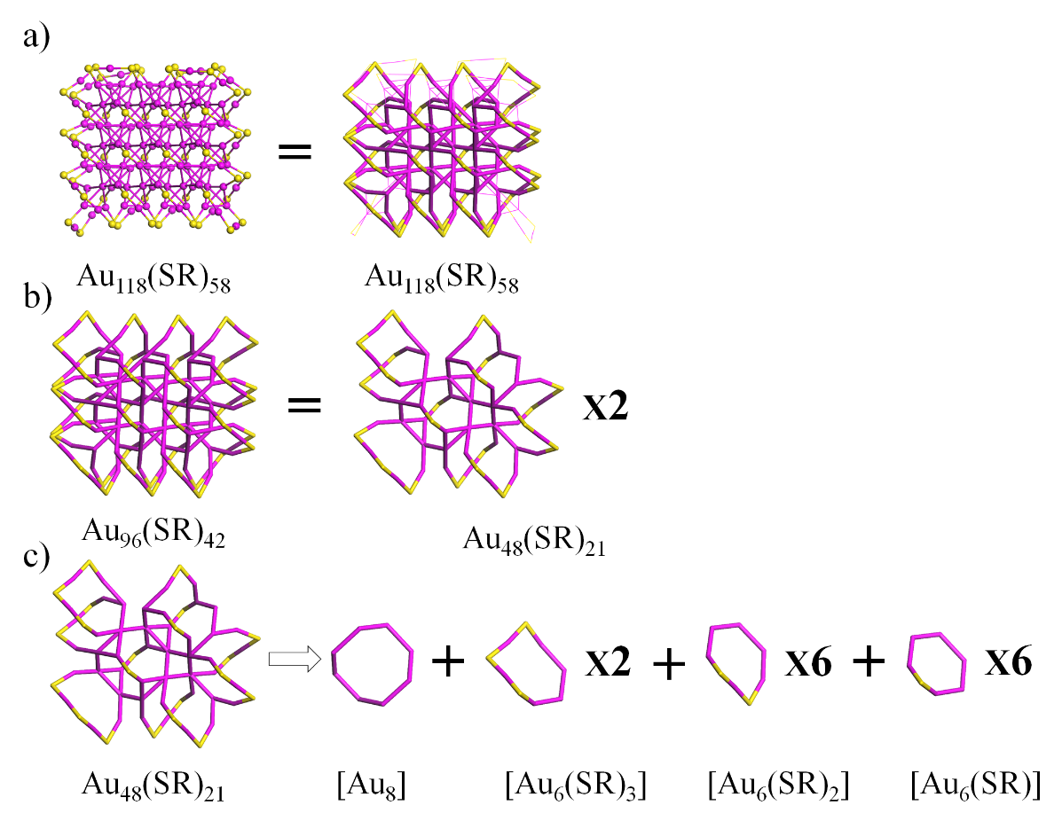
Figure S81. The structural decompositions of Au₁₁₈(SR)₅₈ into two [Au₈], four [Au₆(SR)₃], twelve [Au₆(SR)₂], and twelve [Au₆(SR)] rings. Au: wine; S: yellow. The R groups were omitted for clarity. (Nanoscale 2020, 12, 5554–5566)
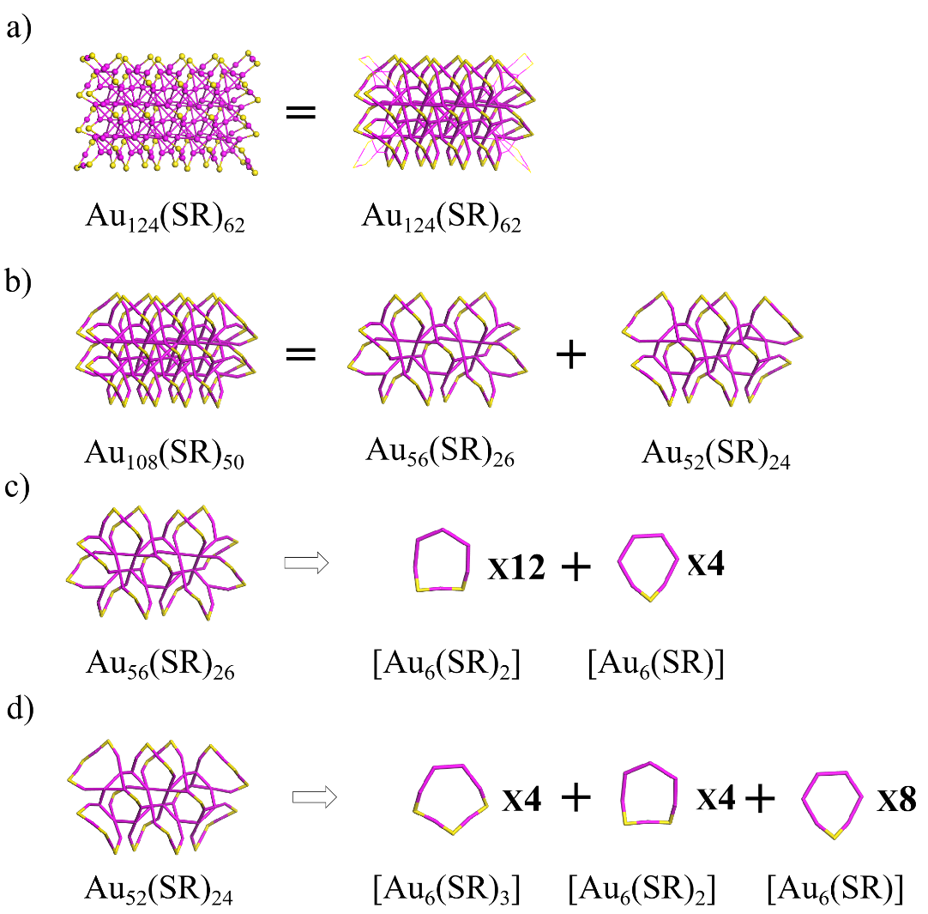
Figure S82. The structural decompositions of Au₁₂₄(SR)₆₂ into four [Au₆(SR)₃], sixteen [Au₆(SR)₂], and twelve [Au₆(SR)] rings. Au: wine; S: yellow. The R groups were omitted for clarity. (Nanoscale 2020, 12, 5554–5566)

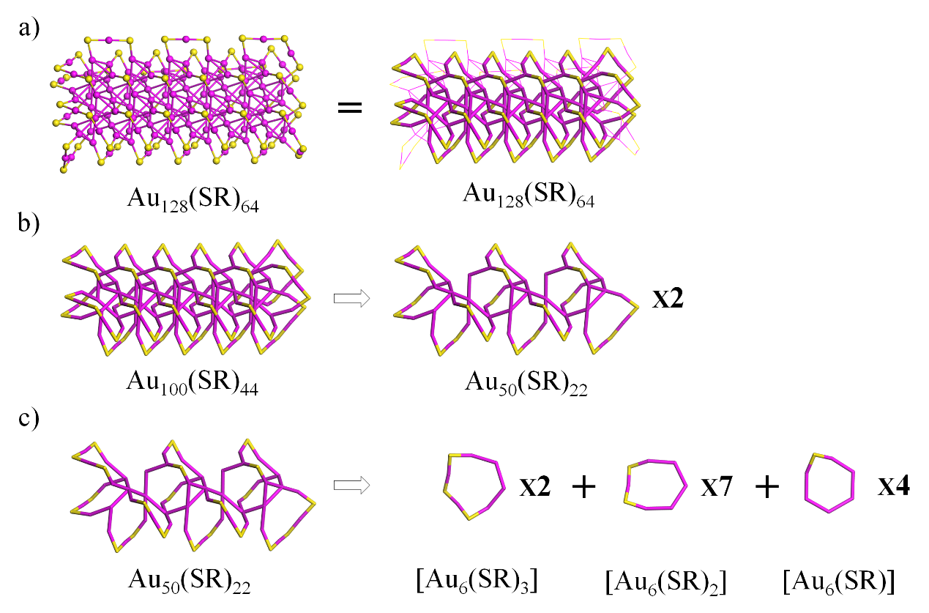
Figure S83. The structural decompositions of Au₁₂₈(SR)₆₄ into four [Au₆(SR)₃], fourteen [Au₆(SR)₂], and eight [Au₆(SR)] rings. Au: wine; S: yellow. The R groups were omitted for clarity. (Nanoscale 2020, 12, 5554–5566)
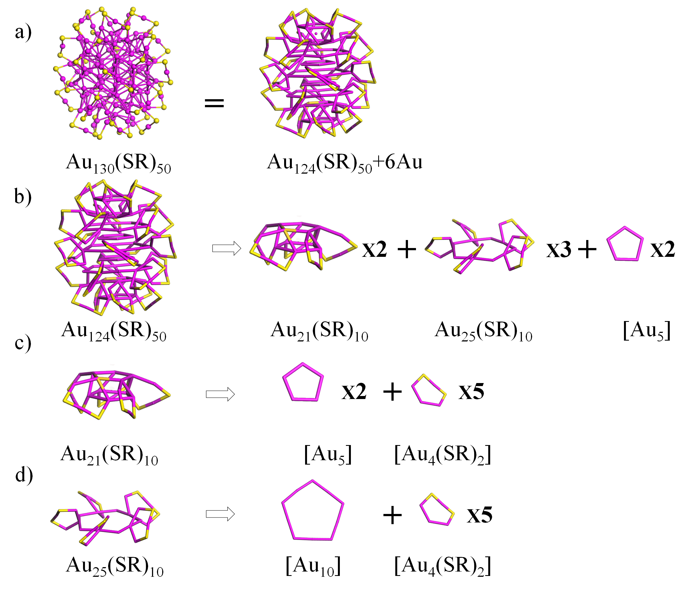
Figure S84. The structural decompositions of Au₁₃₀(SR)₅₀ into twenty-five [Au₄(SR)₂], five [Au₅], and three [Au₁₀] rings. Au: wine; S: yellow. The R groups were omitted for clarity. (J. Am. Chem. Soc. 2015, 137, 10076−10079)

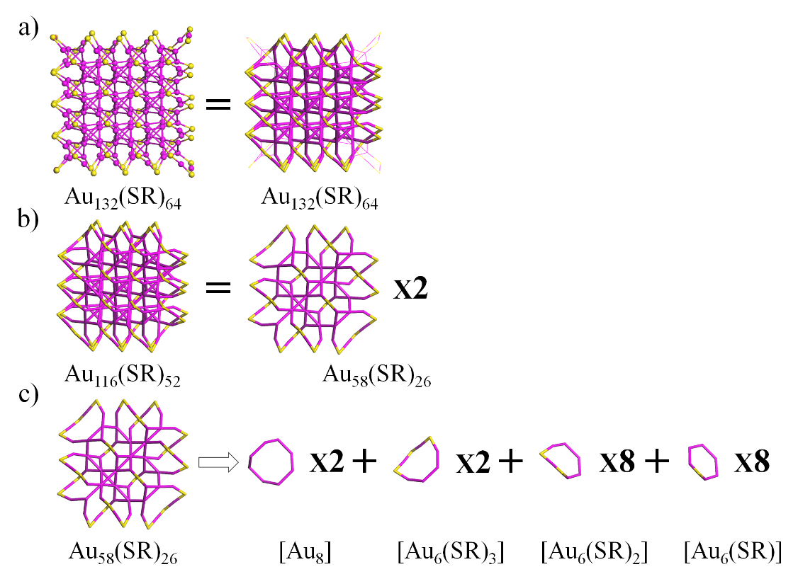
Figure S85. The structural decompositions of Au₁₃₂(SR)₆₄ into four [Au₈], four [Au₆(SR)₃], sixteen [Au₆(SR)₂], and sixteen [Au₆(SR)] rings. Au: wine; S: yellow. The R groups were omitted for clarity. (Nanoscale 2020, 12, 5554–5566)
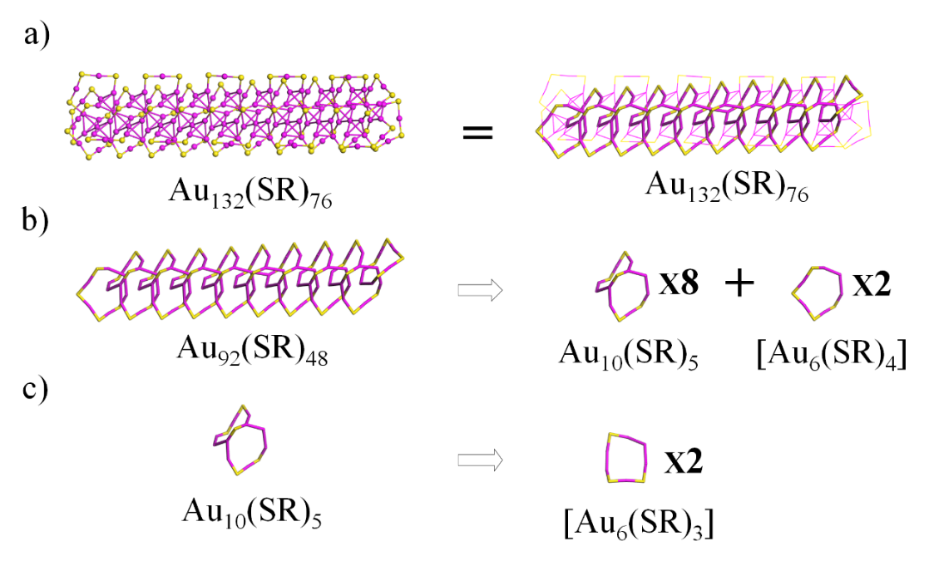
Figure S86. The structural decompositions of Au₁₃₂(SR)₇₆ into two [Au₆(SR)₄], and sixteen [Au₆(SR)₃] rings. Au: wine; S: yellow. The R groups were omitted for clarity. (Nanoscale 2020, 12,5554–556)
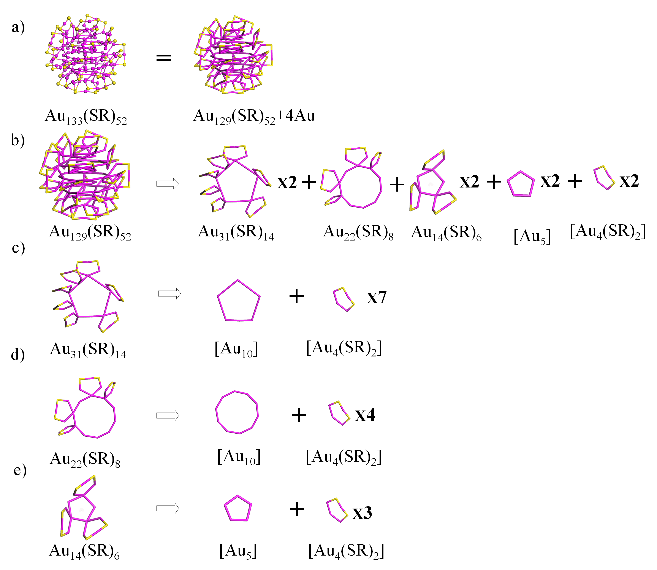
Figure S87. The structural decompositions of Au₁₃₃(SR)₅₂ into three [Au₁₀], twenty-three [Au₄(SR)₂], and three [Au₅] rings. Au: wine; S: yellow. The R groups were omitted for clarity. (Sci. Adv. 2015, 1, e1500045)
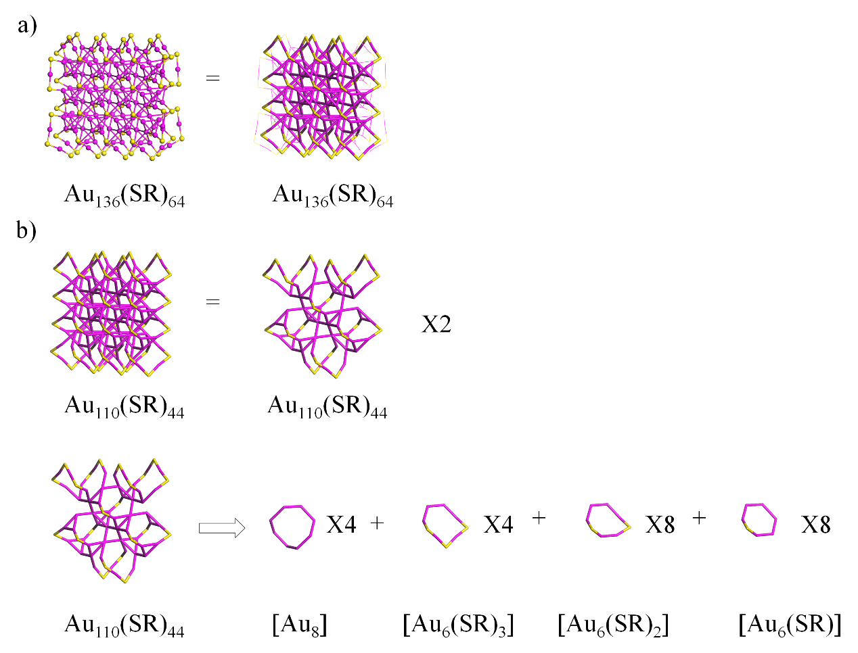
Figure S88. The structural decompositions of Au₁₃₆(SR)₆₄ into eight [Au₈], eight [Au₆(SR)₃] , sixteen [Au₆(SR)₃] and sixteen [Au₆(SR)] rings. Au: wine; S: yellow. The R groups were omitted for clarity. (Nanoscale 2020, 12, 5554–5566)

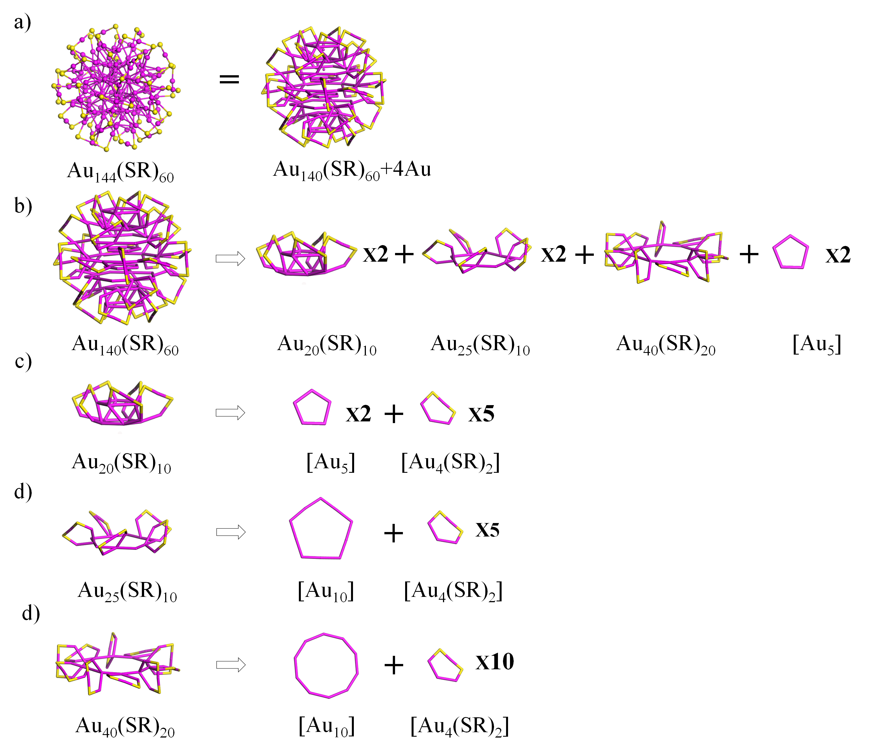
Figure S89. The structural decompositions of Au₁₄₄(SR)₆₀ into three [Au₁₀], thirty [Au₄(SR)₂] and six [Au₅] rings. Au: wine; S: yellow. The R groups were omitted for clarity. (Sci. Adv. 2019, 4, eaat7259)
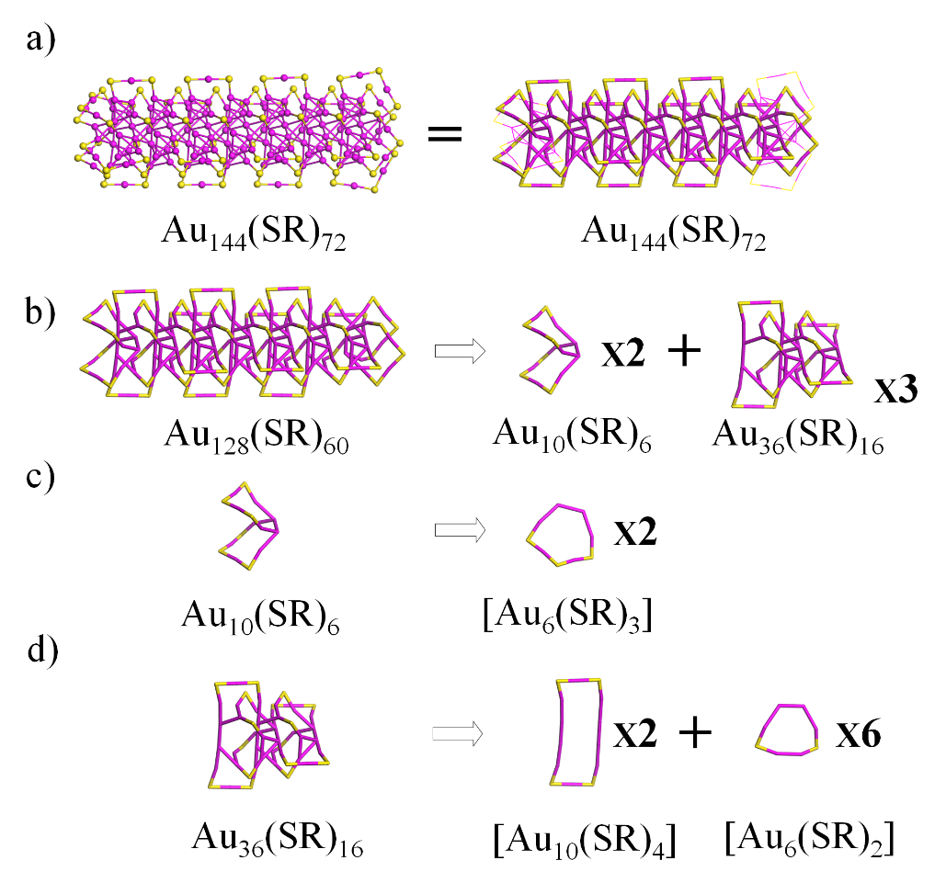
Figure S90. The structural decompositions of Au₁₄₄(SR)₇₂ into four [Au₆(SR)₃], six [Au₁₀(SR)₄], and eighteen [Au₆(SR)₂] rings. Au: wine; S: yellow. The R groups were omitted for clarity. (Nanoscale 2020, 12, 5554–5566)

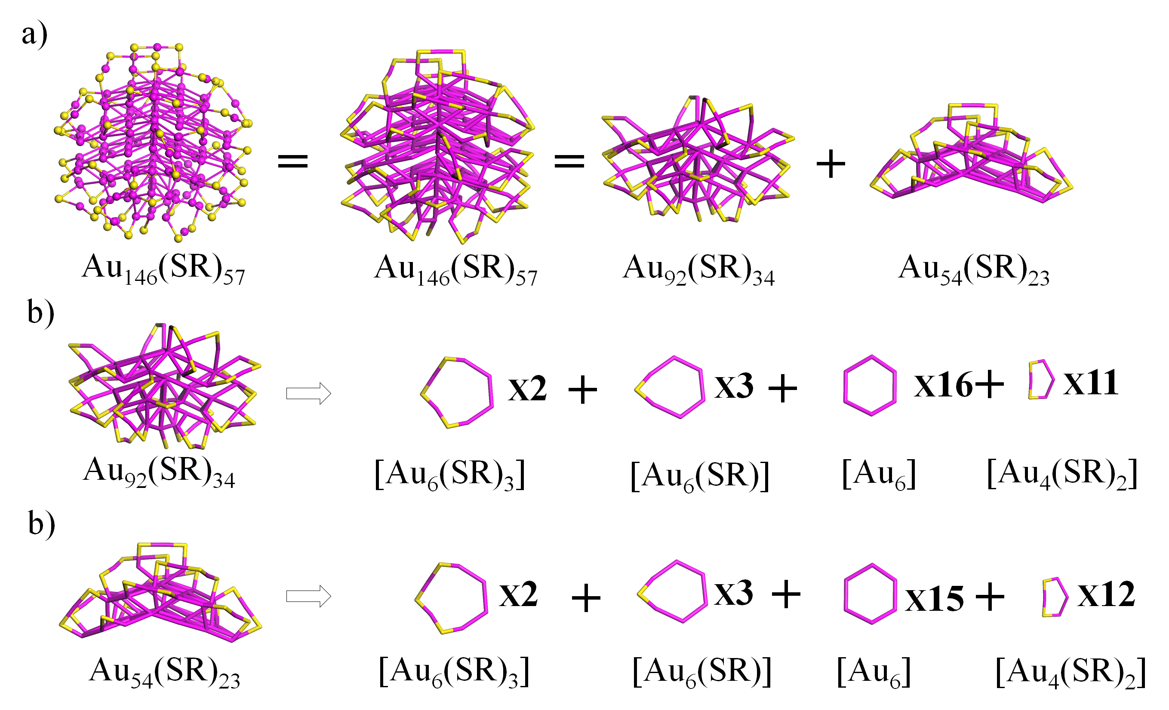
Figure S91. The structural decompositions of Au₁₄₆(SR)₅₇ into four [Au₆(SR)₃], six [Au₆(SR)], thirty-one [Au₆] and twenty-three [Au₄(SR)₂] rings. Au: wine; S: yellow. The R groups were omitted for clarity. (The Journal of Physical Chemistry Letters 2017, 8, 5523–5530)

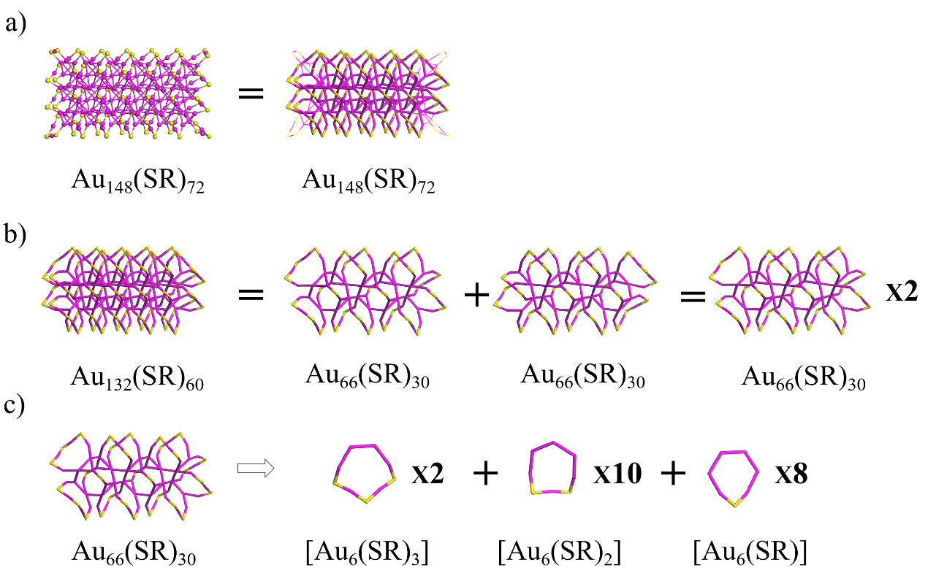
Figure S92. The structural decompositions of Au₁₄₈(SR)₇₂ into four [Au₆(SR)₃], twenty [Au₆(SR)₂] and sixteen [Au₆(SR)] rings. Au: wine; S: yellow. The R groups were omitted for clarity. (Nanoscale 2020, 12, 5554–5566)

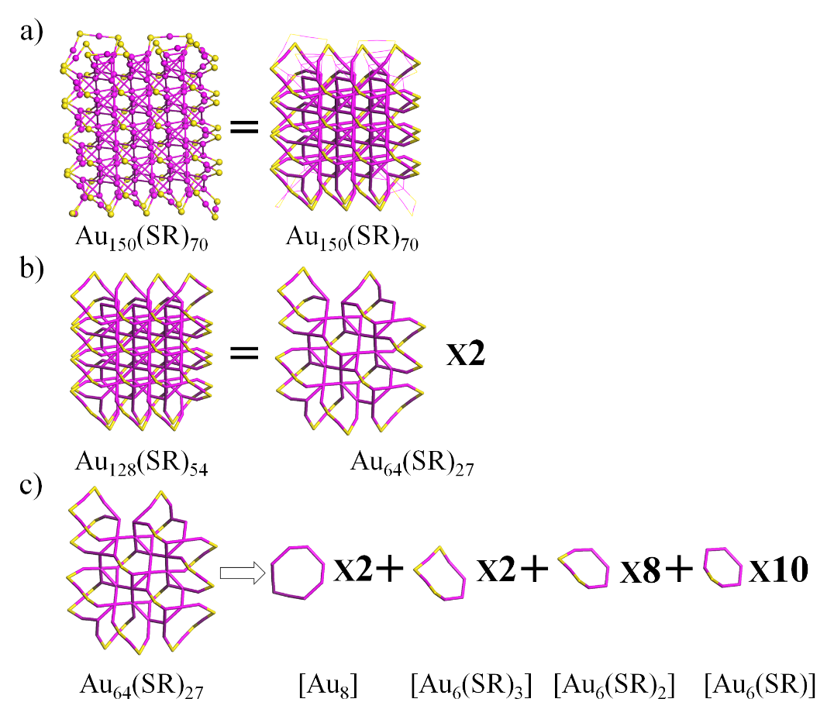
Figure S93. The structural decompositions of Au₁₅₀(SR)₇₀ into four [Au₈], four [Au₆(SR)₃], sixteen [Au₆(SR)₂], and twenty [Au₆(SR)] rings. Au: wine; S: yellow. The R groups were omitted for clarity. (Nanoscale 2020, 12, 5554–5566)

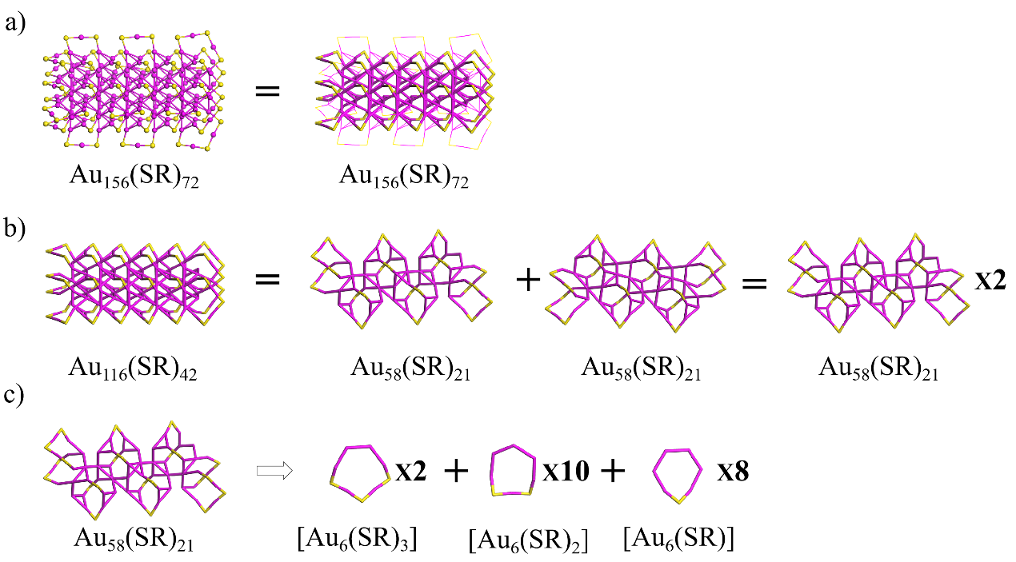
Figure S94. The structural decompositions of Au₁₅₆(SR)₇₂ into four [Au₆(SR)₃], twenty [Au₆(SR)₂] and sixteen [Au₆(SR)] rings. Au: wine; S: yellow. The R groups were omitted for clarity. (Nanoscale 2020, 12, 5554–5566)
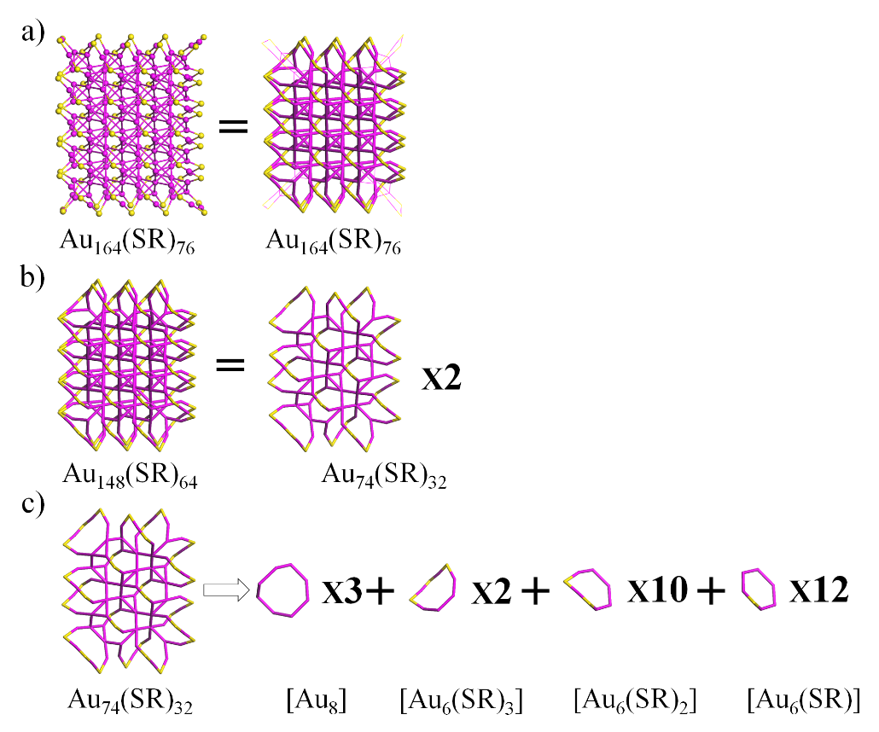
Figure S95. The structural decompositions of Au₁₆₄(SR)₇₆ into six [Au₈], four [Au₆(SR)₃], twenty [Au₆(SR)₂], and twenty-four [Au₆(SR)] rings. Au: wine; S: yellow. The R groups were omitted for clarity. (Nanoscale 2020, 12, 5554–5566)

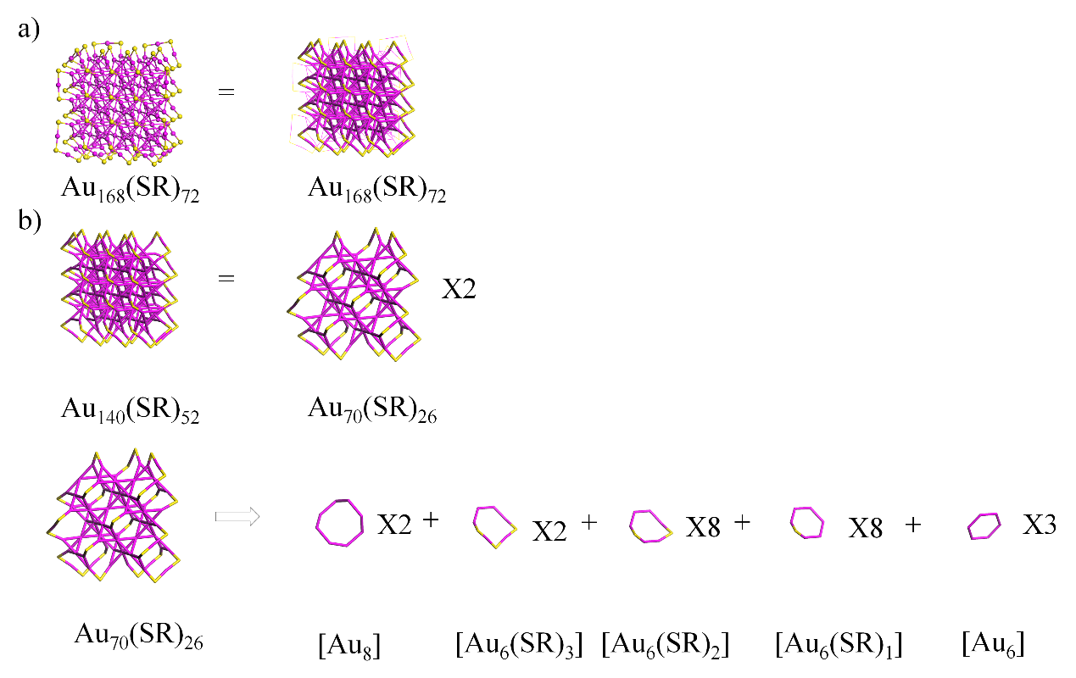
Figure S96. The structural decompositions of Au₁₆₈(SR)₇₂ into four [Au₈], four [Au₆(SR)₃], sixteen [Au₆(SR)₂], sixteen [Au₆(SR)], and six [Au₆] rings. Au: wine; S: yellow. The R groups were omitted for clarity. (Nanoscale 2020, 12, 5554–5566)
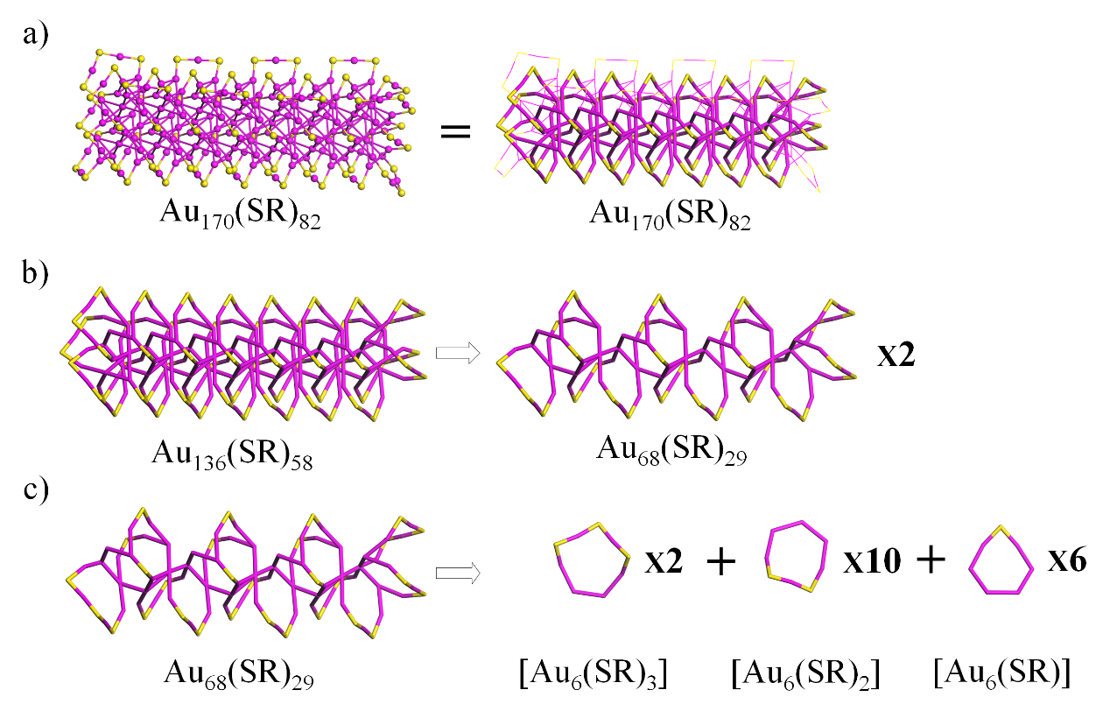
Figure S97. The structural decompositions of Au₁₇₀(SR)₈₂ into four [Au₆(SR)₃], twenty [Au₆(SR)₂], and twelve [Au₆(SR)] rings. Au: wine; S: yellow. The R groups were omitted for clarity. (Nanoscale 2020, 12, 5554–5566)

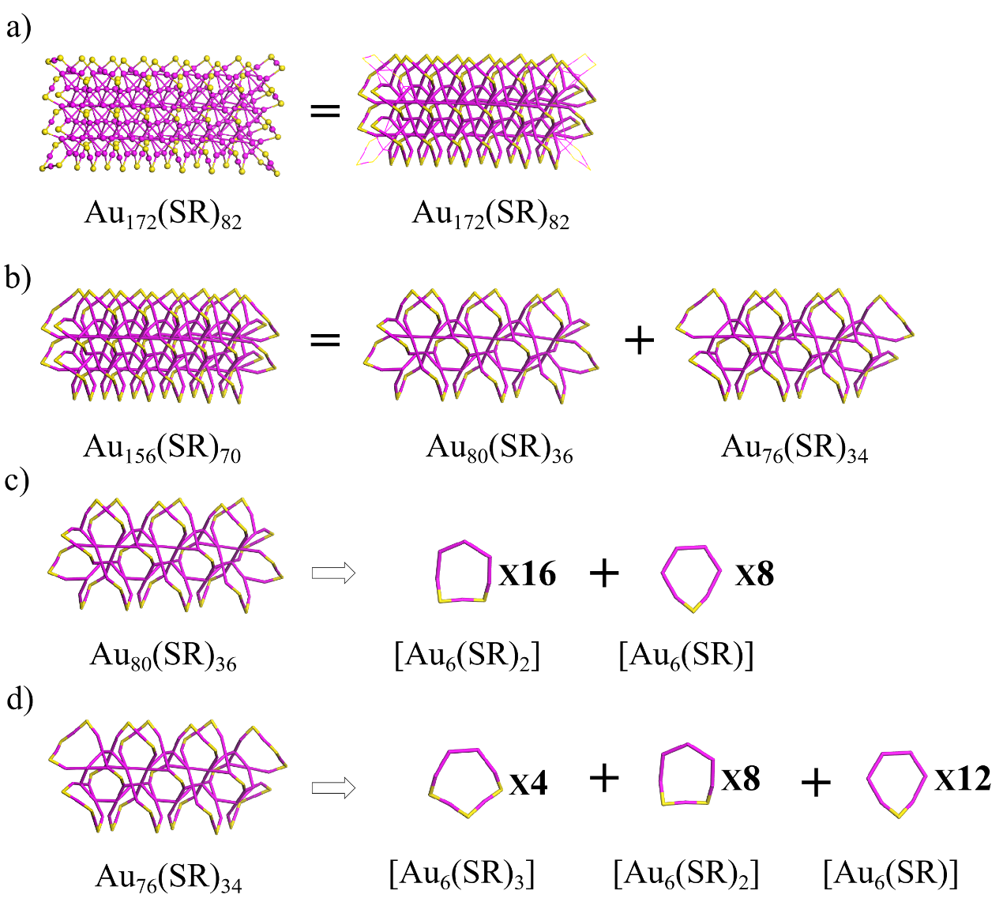
Figure S98. The structural decompositions of Au₁₇₂(SR)₈₂ into four [Au₆(SR)₃], twenty-four [Au₆(SR)₂] and twenty [Au₆(SR)] rings. Au: wine; S: yellow. The R groups were omitted for clarity. (Nanoscale 2020, 12, 5554–5566)
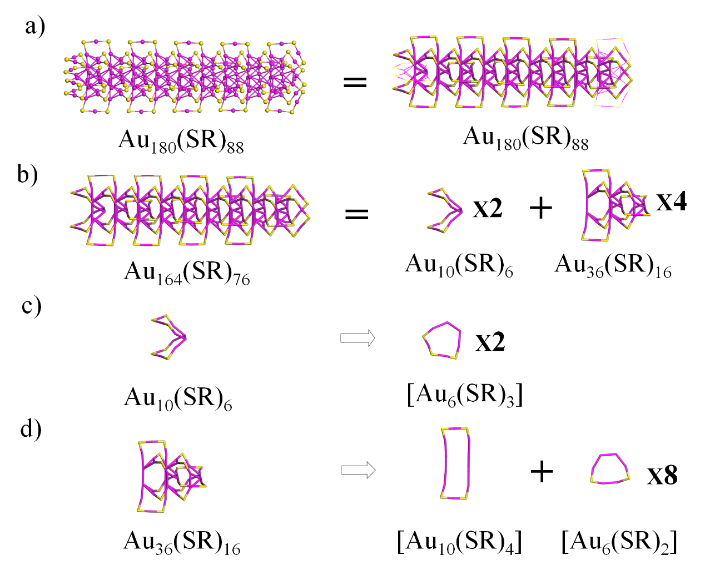
Figure S99. The structural decompositions of Au₁₈₀(SR)₈₈ into four [Au₆(SR)₃], four [Au₆(SR)₂] and thirty-two [Au₆(SR)] rings. Au: wine; S: yellow. The R groups were omitted for clarity. (Nanoscale 2020, 12, 5554–5566)

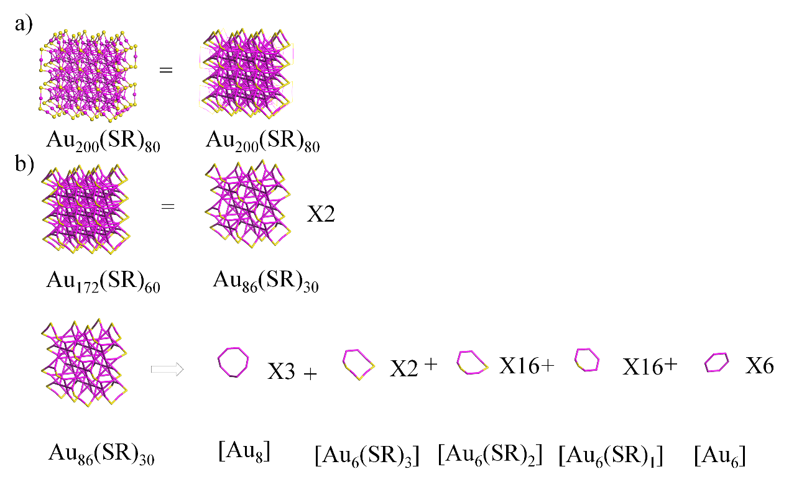
Figure S100. The structural decompositions of Au₂₀₀(SR)₈₀ into six [Au₈], four [Au₆(SR)₃] , thirty-two [Au₆(SR)₂] ,thirty-two [Au₆(SR)₂], and twelve [Au₆] rings. Au: wine; S: yellow. The R groups were omitted for clarity. (Nanoscale 2020, 12, 5554–5566)

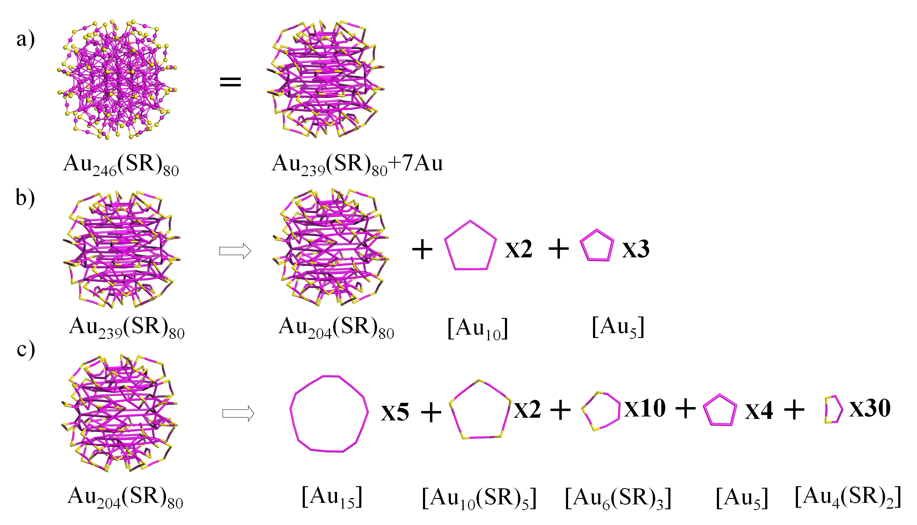
Figure S101. The structural decompositions of Au₂₄₆(SR)₈₀ into five [Au₁₅], two [Au₁₀(SR)₅], two [Au₁₀], ten [Au₆(SR)₃], seven [Au₅], and thirty [Au₄(SR)₂] rings. Au: wine; S: yellow. The R groups were omitted for clarity. (Science 2016, 354, 1580–1584)

