Online Resource 3

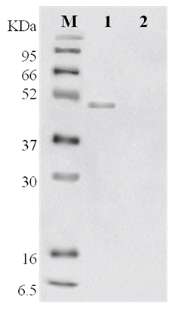
Fig. S3 Western blot analysis of pBESGULO shows protein bands of GULO at a molecular weight of 50 kDa. Lane 1: protein marker, 2: pBESGULO, and 3: wild-type B. subtilis (negative control).

