Online Resource 5
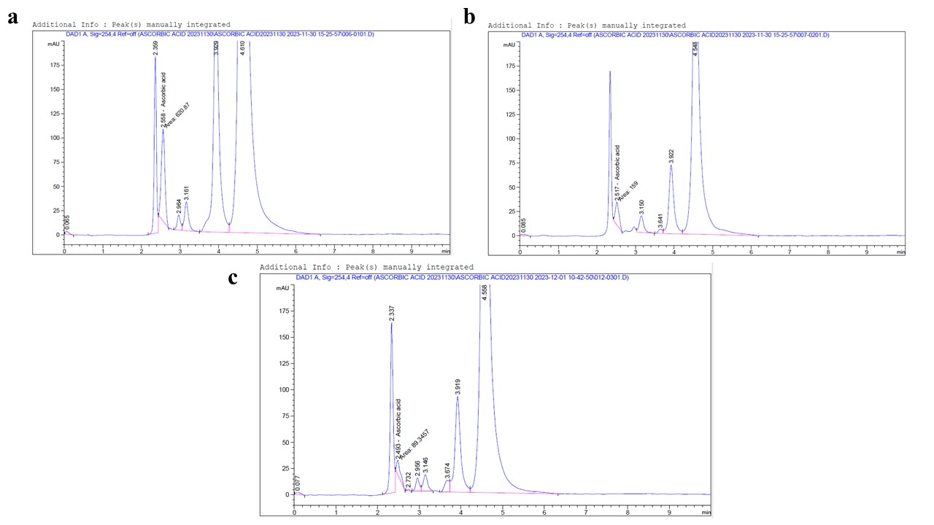
Fig. S5 HPLC chromatograms of ascorbic acid in Nile tilapia serum in the VC group (a), BS+GULO group (b), and CON group (c).

