Online Resource 4
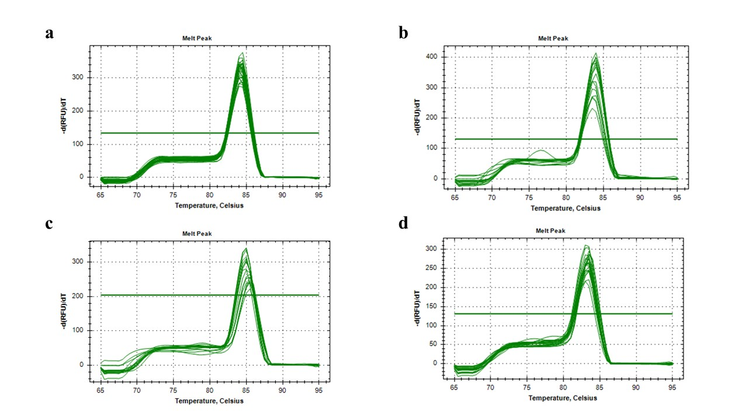
Fig. S4 Quantitative real-time PCR. Melting curve analysis reveals melting peaks of β-actin at 83.5°C (a), TNFα at 83.5°C (b), GULO at 85.5°C (c), and CC chemokine at 83.5°C (d).

