Online Resource 1
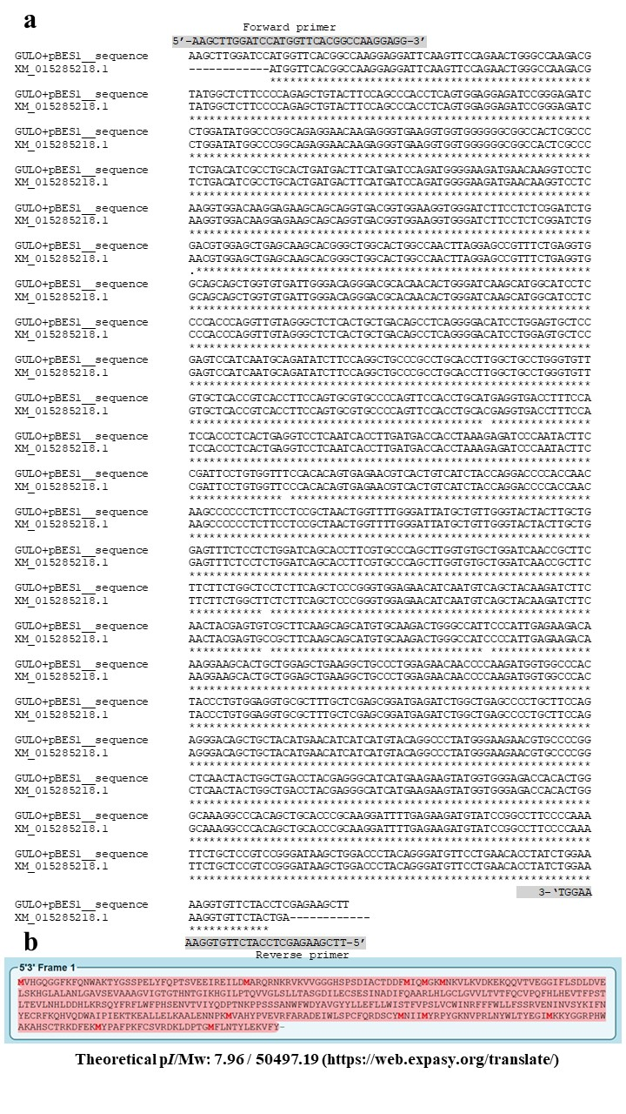
Fig. S1 Sequence alignment of G. gallus GULO cDNA after cloning into the pBES expression vector and the full-length GULO cDNA of G. gallus (accession no. XM_015285218) published on the GenBank database (a). Structural analyses of the amino acid sequences of GULO protein in G. gallus revealed that the whole protein had a molecular weight and an isoelectric point (pI) of 50.5 kDa and 7.96, respectively (b).

