Online Resource 2

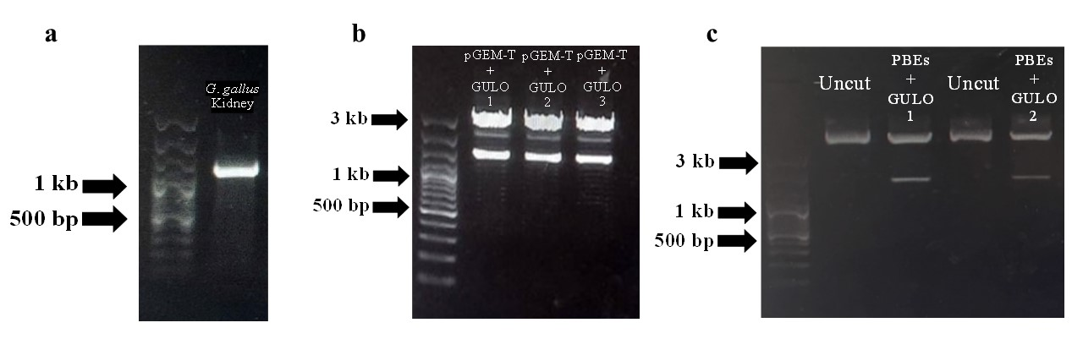

Fig. S2 Construction of probiotic B. subtilis expressing GULO. Amplification of the full-length GULO cDNA from G. gallus using semi-quantitative RT-PCR (a); Double restriction enzyme digestion result after cloning into the pGEM-T vector; 3 Kb of linearized pGEM-T and 1.2 Kb of target gene with digested with BamHI and HindIII (b). Double restriction enzyme digestion result after cloning into the pBES expression vector; 5 Kb of linearized pBES and 1.2 Kb of target gene with digested with BamHI and HindIII and compared to undigested pBES plasmid (c).

