Supplementary Material

Karen J Wang^{1,2}, Yongsong Huang^{1,2}, Tyler Kartzinel^{2,3}, Markus Majaneva⁴, Nora Richter^{1,2,5}, Sian Liao^{2,6}

- Department of Earth, Environmental and Planetary Sciences, Brown University, Providence, RI, 02912, USA
- Institute at Brown for Environment and Society, Brown University, Providence, RI, 02912, USA
- Department of Ecology and Evolutionary Biology, Brown University, Providence, RI, 02912, USA
- Norwegian Institute for Nature Research (NINA), NO-7485, Trondheim, Norway
- Department of Marine Microbiology & Biogeochemistry, NIOZ Royal Netherlands Institute for Sea Research, 1790 AB Den Burg, the Netherlands
- Department of Chemistry, Brown University, Providence, RI, 02912, USA

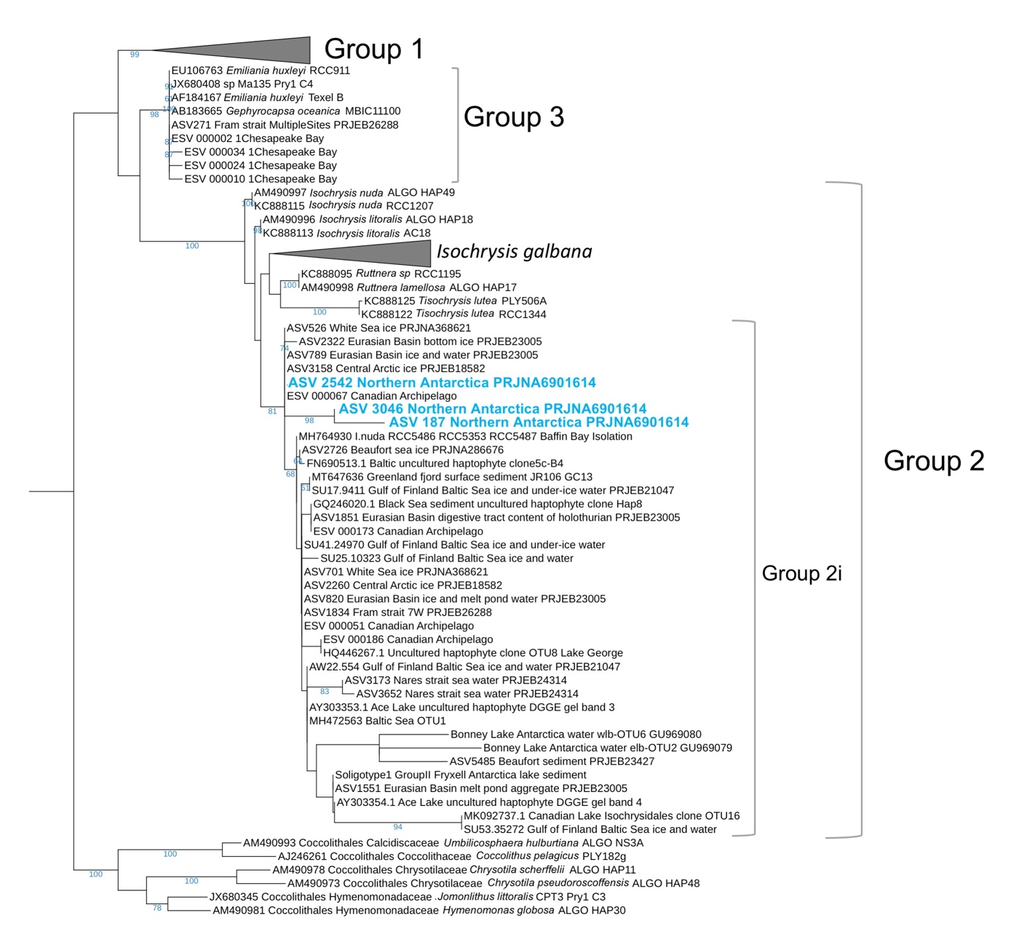
Figure S1. Phylogenetic tree of Isochrysidales 18S rRNA detected in the northern Antarctic Peninsula region¹. Bootstrap values that are >50% are shown. Liu et al.¹ collected surface water samples and water column samples in the northern Antarctic Peninsula region. Only three samples collected from water column at depth of 150m, 200m, 340m at 60.85˚S, 45.64˚W recovered Isochrysidales DNA, all three ASVs falls into Group 2i.

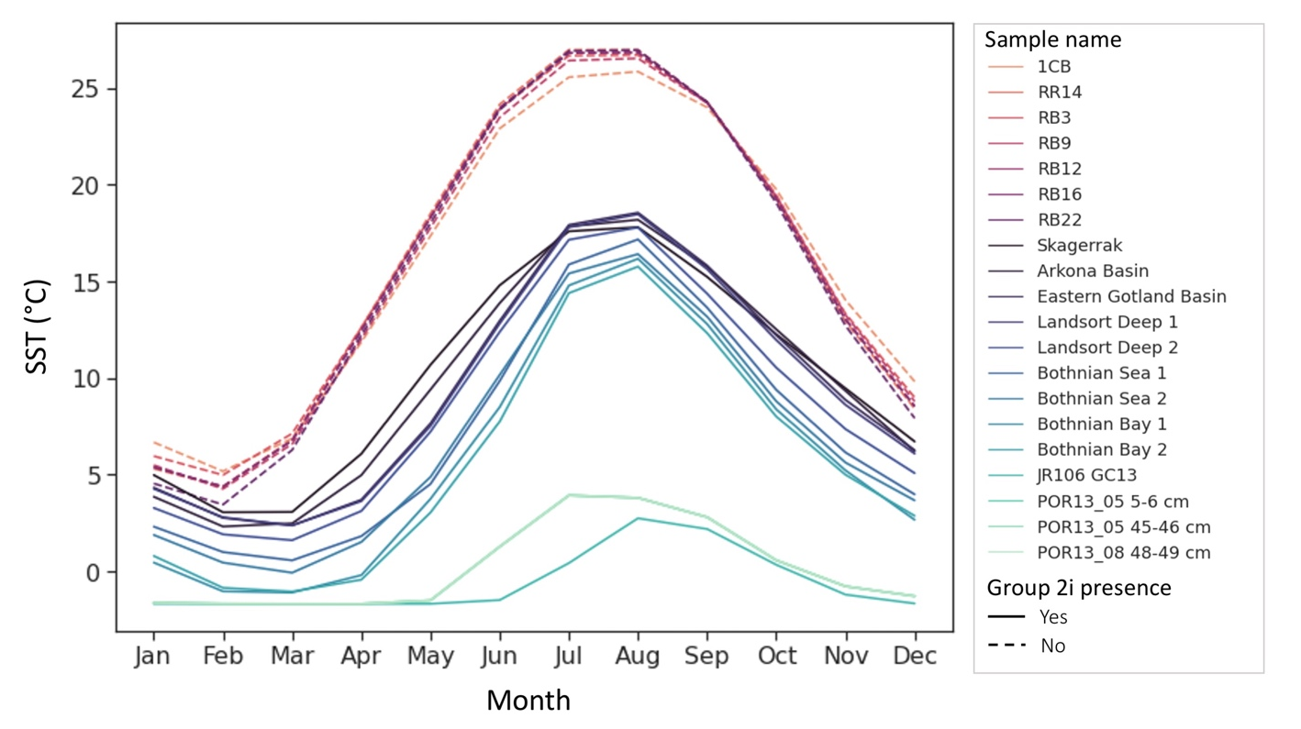
Figure S2. Monthly SST of sediment sample sites in Chesapeake Bay, Baltic Sea, and Greenland fjords. The climate data is from ERA5² monthly averaged data averaged over 2005-2015.

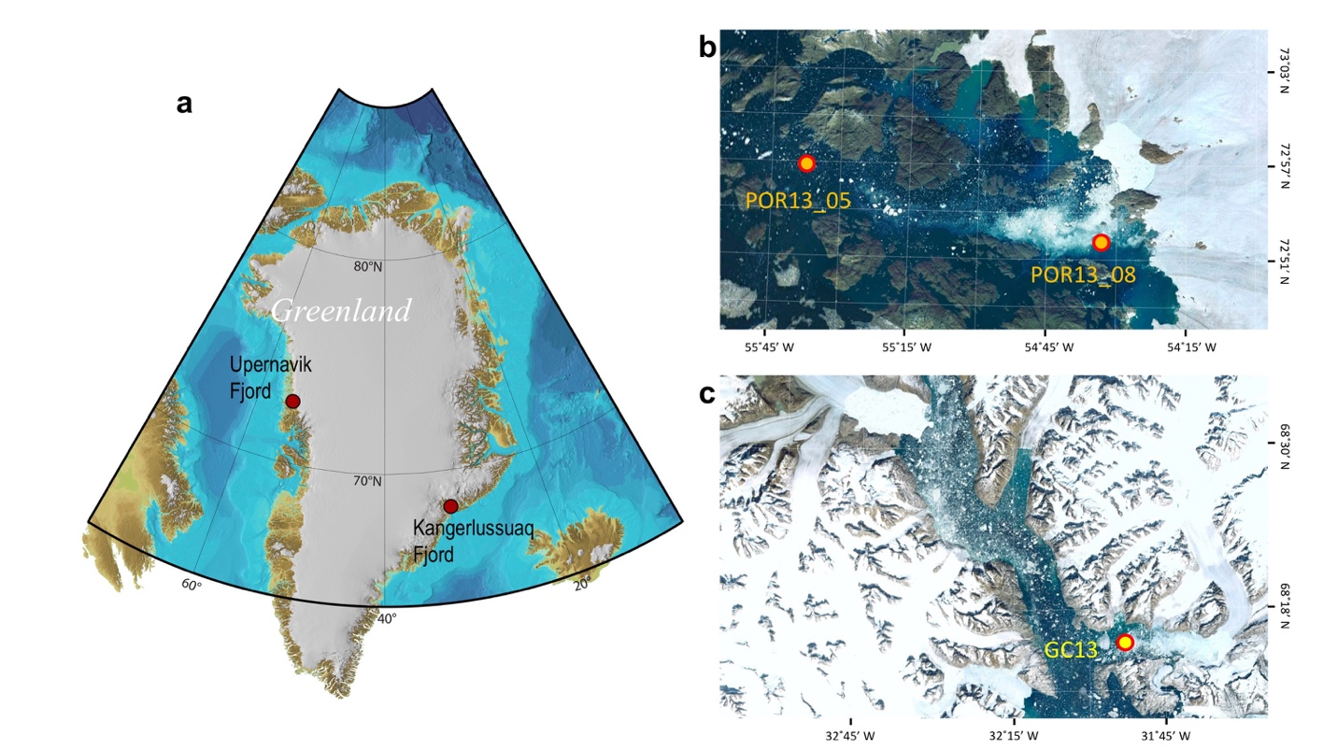
Figure S3. Maps of Group 2i detected in Greenland fjords surface and downcore sediment samples (Table 1). a) locations of Upernavik Fjord and Kangerlussuaq Fjord with bathymetry adapted from IBCAO Version 3³. b, c) Maps of Upernavik Fjord and Kangerlussuaq Fjord (Image U.S. Geological Survey, Image IBCAO, Google Earth).

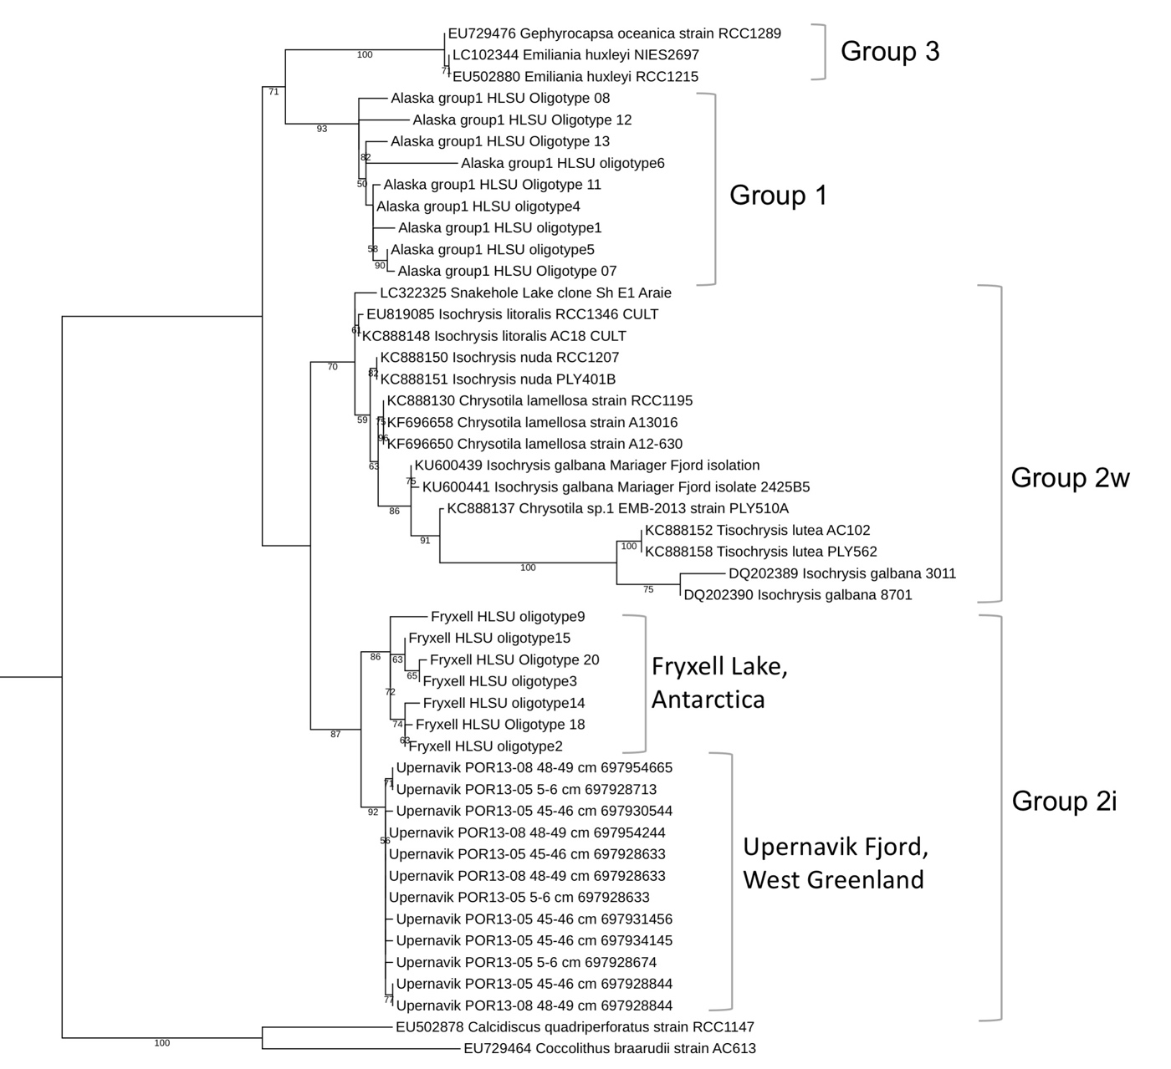

Figure S4. Phylogenetic tree of Isochrysidales 28S rRNA. Bootstrap values that are >50% are shown. Sequences found from Upernavik Fjord are clustered with Group 2i detected from Fryxell Lake.

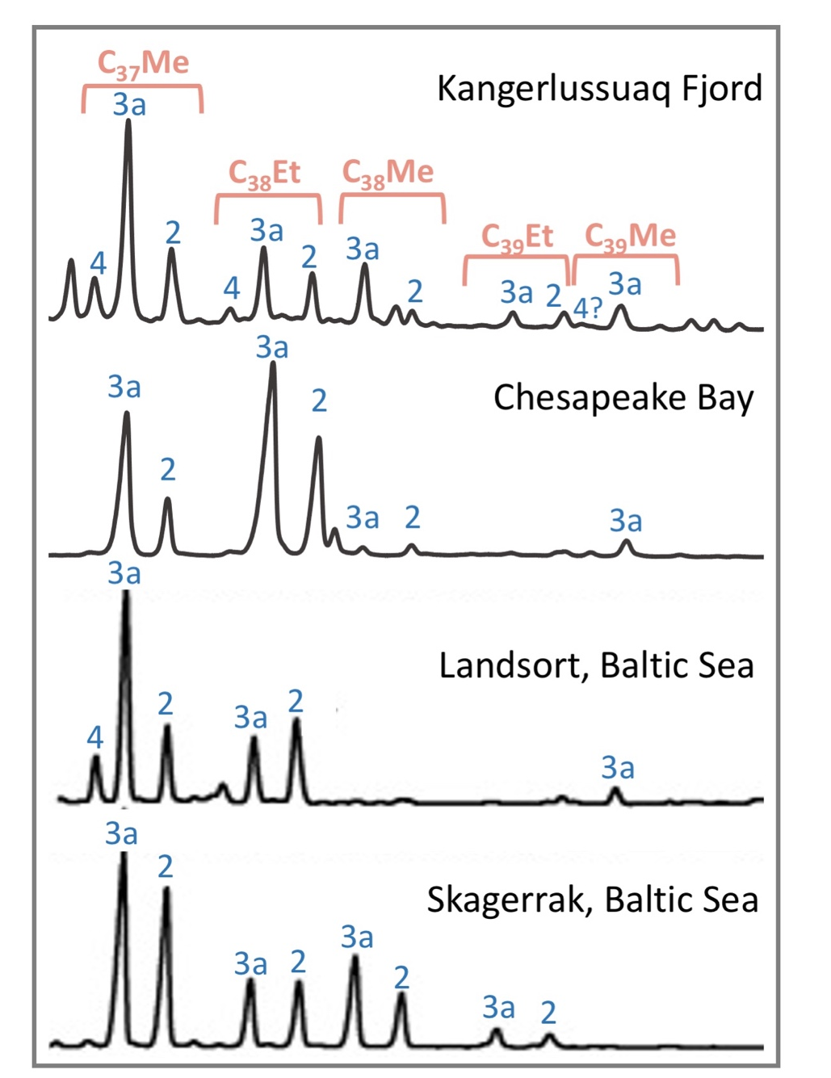
Figure S5. Representative GC-FID chromatograms of alkenones in surface sediment from Kangerlussuaq Fjord (GC13), Chesapeake Bay (RB12), central Baltic Sea (Landsort Deep), western Baltic Sea (Skagerrak)

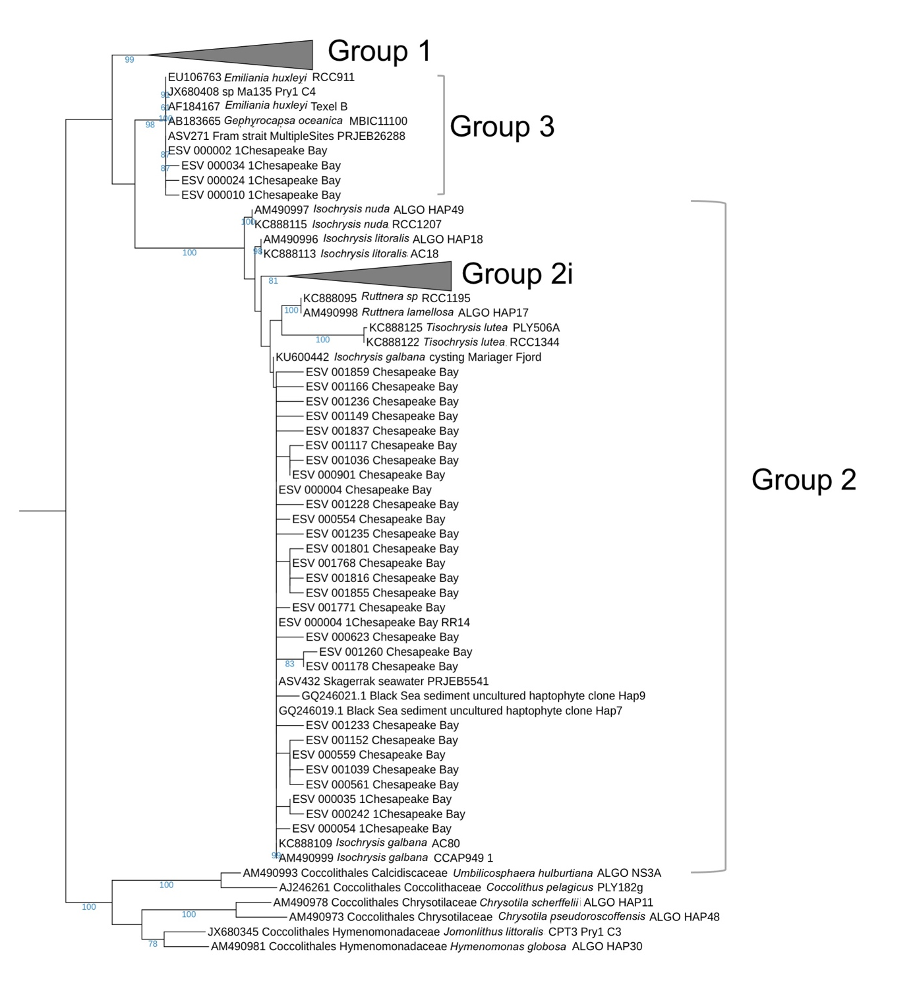
Figure S6. Phylogenetic tree of Isochrysidales 18S rRNA detected in Chesapeake Bay. View of the same phylogenetic tree with expanded Group 2i is shown in Fig. S1. Bootstrap values that are >50% are shown. Sequences from the Chesapeake Bay are clustered with cultured Emiliania huxleyi and Isochrysis galbana.

Sample ID | Region | Lat. | Lon. | Depth | Sequencing method | Group 1 | Group 2w | Group 2i | Group 3
1CB | Chesapeake Bay, USA | 36.985 | -76.166 | Surface | 528Flong and PRYM01+7; NGS | N | Y | N | Y
RR14 | Chesapeake Bay, USA | 37.774 | -76.619 | Surface | 528Flong and PRYM01+7; NGS | N | Y | N | N
RB3 | Chesapeake Bay, USA | 37.011 | -76.252 | Surface | 528Flong and PRYM01+7; NGS | N | Y | N | N
RB9 | Chesapeake Bay, USA | 37.425 | -76.109 | Surface | 528Flong and PRYM01+7; NGS | N | Y | N | N
RB12 | Chesapeake Bay, USA | 37.549 | -76.205 | Surface | 528Flong and PRYM01+7; NGS | N | Y | N | N
RB16 | Chesapeake Bay, USA | 37.653 | -76.209 | Surface | 528Flong and PRYM01+7; NGS | N | Y | N | N
RB22 | Chesapeake Bay, USA | 37.783 | -76.203 | Surface | 528Flong and PRYM01+7; NGS | N | Y | N | N
Skagerrak | Baltic Sea | 58.429 | 9.477 | Surface | Prym-429F and Prym-887R; Sanger | N | N | Y | N
Arkona Basin | Baltic Sea | 54.852 | 13.433 | Surface | Prym-429F and Prym-887R; Sanger | Y | N | Y | N
Eastern Gotland Basin | Baltic Sea | 57.083 | 19.985 | Surface | Prym-429F and Prym-887R; Sanger | Y | N | Y | N
Landsort Deep 1 | Baltic Sea | 57.267 | 19.796 | Surface | Prym-429F and Prym-887R; Sanger | Y | N | Y | N
Landsort Deep 2 | Baltic Sea | 58.641 | 18.265 | Surface | Prym-429F and Prym-887R; Sanger | Y | N | Y | N
Bothnian Sea 1 | Baltic Sea | 61.085 | 19.579 | Surface | Prym-429F and Prym-887R; Sanger | N | N | Y | N
Bothnian Sea 2 | Baltic Sea | 62.845 | 18.889 | Surface | Prym-429F and Prym-887R; Sanger | Y | N | Y | N
Bothnian Bay 1 | Baltic Sea | 63.833 | 21.583 | Surface | Prym-429F and Prym-887R; Sanger | Y | N | Y | N
Bothnian Bay 2 | Baltic Sea | 64.204 | 22.029 | Surface | Prym-429F and Prym-887R; Sanger | Y | N | Y | N
JR106 GC13 | Kangerlussuaq Fjord | 68.26 | -31.89 | Surface | 528Flong and PRYM01+7; NGS | N | N | Y | N
POR13_05 5-6 cm | Upernavik Fjord | 72.945 | -55.62 | Core, 5-6 cm | HAP LSU F, LHapto20R bis; NGS | N | N | Y | N
POR13_05 45-46 cm | Upernavik Fjord | 72.945 | -55.62 | Core, 45-46 cm | HAP LSU F, LHapto20R bis; NGS | N | N | Y | N
POR13_08 48-49 cm | Upernavik Fjord | 72.869 | -54.558 | Core, 48-49 cm | HAP LSU F, LHapto20R bis; NGS | N | N | Y | N
Table 1. Sediment samples examined in this study and the presence/absence of Isochrysidales (Y=yes, N=no).

Reference
1. Liu, C., Zhang, X. & Wang, X. DNA metabarcoding data reveals harmful algal-bloom species undescribed previously at the northern Antarctic Peninsula region. Polar Biol 45, 1495–1512 (2022).
2. Hersbach, H. et al. The ERA5 global reanalysis. Q.J.R. Meteorol. Soc. 146, 1999–2049 (2020).
3. Jakobsson, M. et al. The International Bathymetric Chart of the Arctic Ocean (IBCAO) Version 3.0: IBCAO VERSION 3.0. Geophysical Research Letters 39, n/a-n/a (2012).

