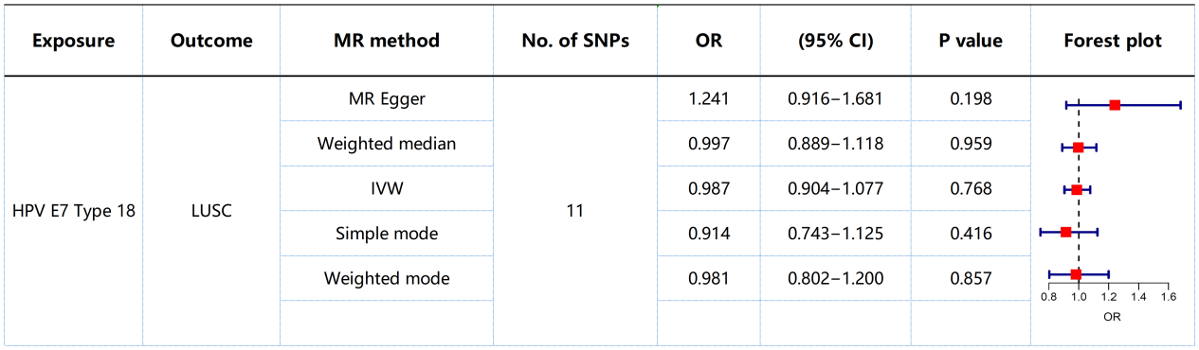
Supplementary Figure S1.The estimated causal relationship between HPV (HPV-18 E7 protein) and squamous cell carcinoma (LUSC) is represented by the odds ratio (OR) and 95% confidence interval (CI). IVW: Inverse Variance Weighted.
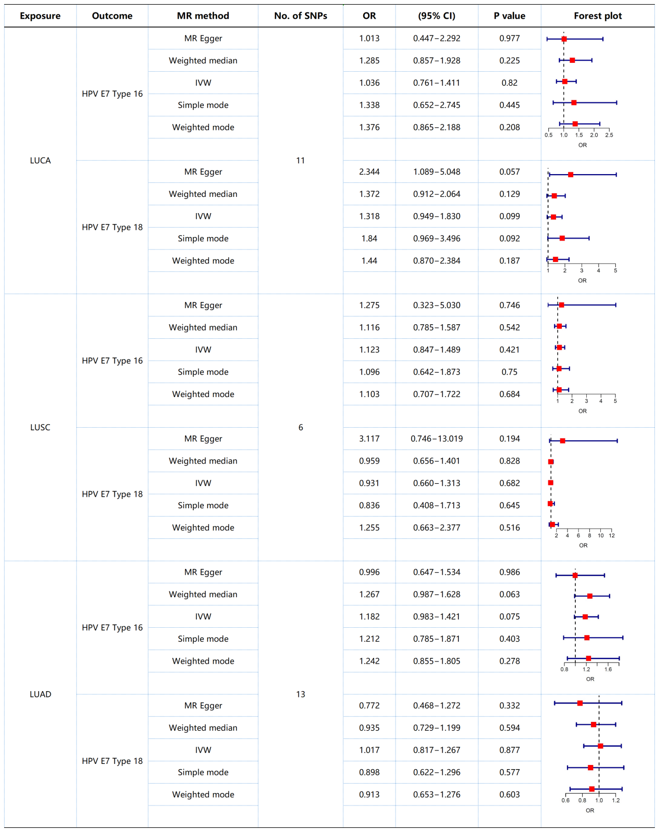
Supplementary Figure S2.The estimated causal relationship between lung cancer (LUCA) and its subtypes (squamous cell carcinoma (LUSC), adenocarcinoma (LUAD)) and HPV (HPV-16 E7 protein, HPV-18 E7 protein) is represented by the odds ratio (OR) and 95% confidence interval (CI). MR: Mendelian Randomization; IVW: Inverse Variance Weighted; LUCA, lung cancer; LUSC, squamous cell carcinoma; LUAD, adenocarcinoma.

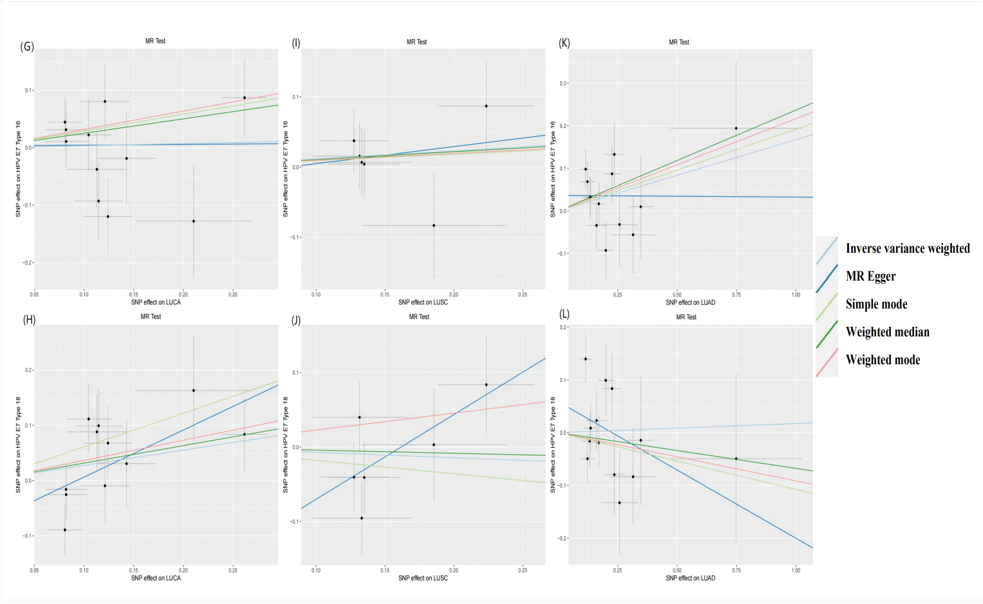
Supplementary Figure S3. Scatter plots depicting the causal relationships between lung cancer (LUCA) and its subtypes and HPV (HPV-16 E7 protein, HPV-18 E7 protein) using different Mendelian Randomization (MR) methods. (G) Causal estimation of lung cancer on HPV-16 E7 protein. (H) Causal estimation of lung cancer on HPV-18 E7 protein. (I) Causal estimation of squamous cell carcinoma on HPV-16 E7 protein. (J) Causal estimation of squamous cell carcinoma on HPV-18 E7 protein. (K) Causal estimation of adenocarcinoma on HPV-16 E7 protein. (L) Causal estimation of adenocarcinoma on HPV-18 E7 protein. The slope of each line corresponds to the causal estimation values for each method. Individual SNP effects on outcomes (dots and vertical lines) and their effects on exposure (dots and horizontal lines) are depicted in the background. LUCA, lung cancer; LUSC, squamous cell carcinoma; LUAD, adenocarcinoma.
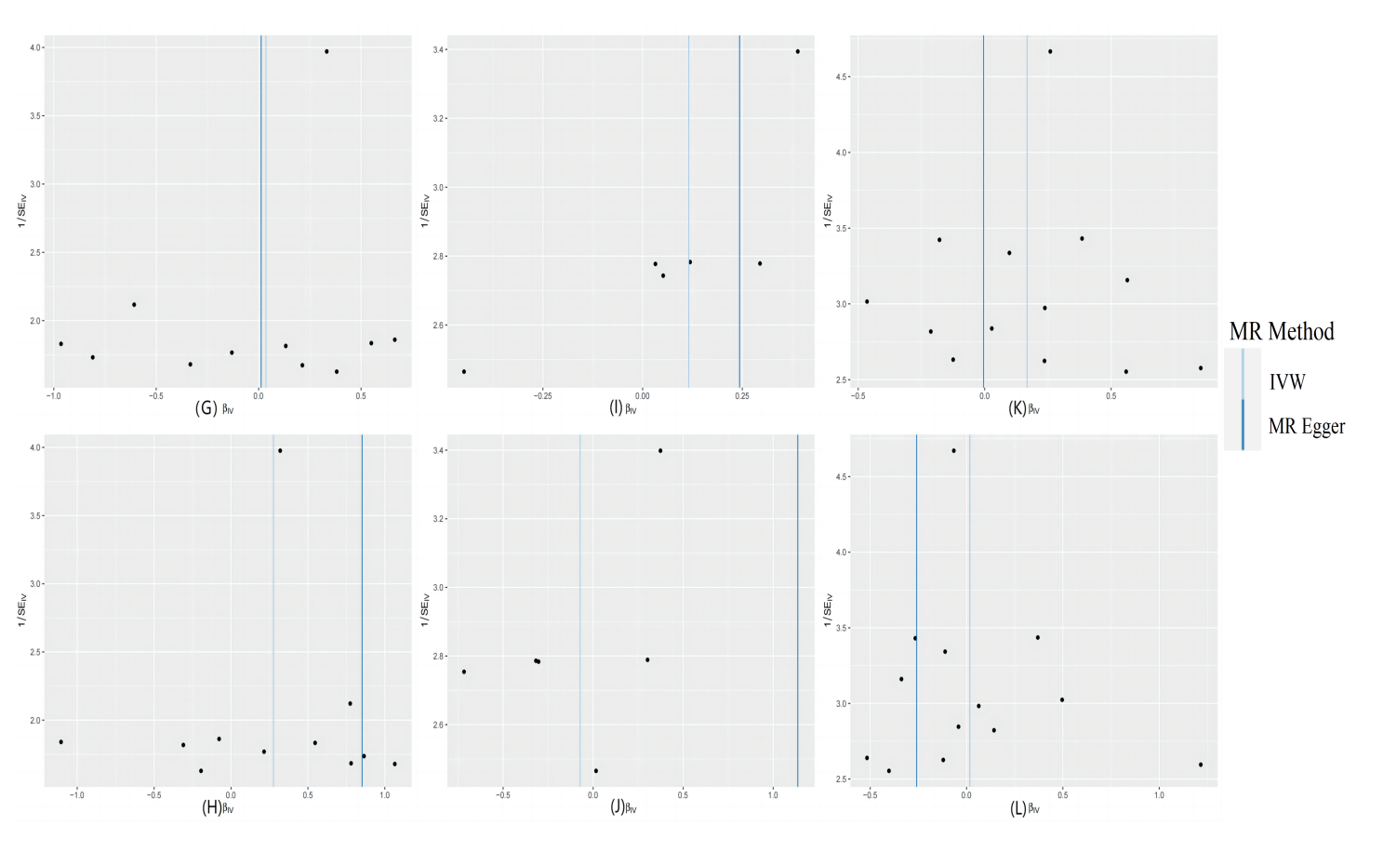
Supplementary Figure S4. Funnel plots illustrating the overall heterogeneity in Mendelian Randomization (MR) estimates of the impact of lung cancer and its subtypes on HPV (HPV-16 E7 protein, HPV-18 E7 protein). (G) Funnel plot for the causal effect of lung cancer on HPV-16 E7 protein. (H) Funnel plot for the causal effect of lung cancer on HPV-18 E7 protein. (I) Funnel plot for the causal effect of squamous cell carcinoma on HPV-16 E7 protein. (J) Funnel plot for the causal effect of squamous cell carcinoma on HPV-18 E7 protein. (K) Funnel plot for the causal effect of adenocarcinoma on HPV-16 E7 protein. (L) Funnel plot for the causal effect of adenocarcinoma on HPV-18 E7 protein. IVW, Inverse Variance Weighted.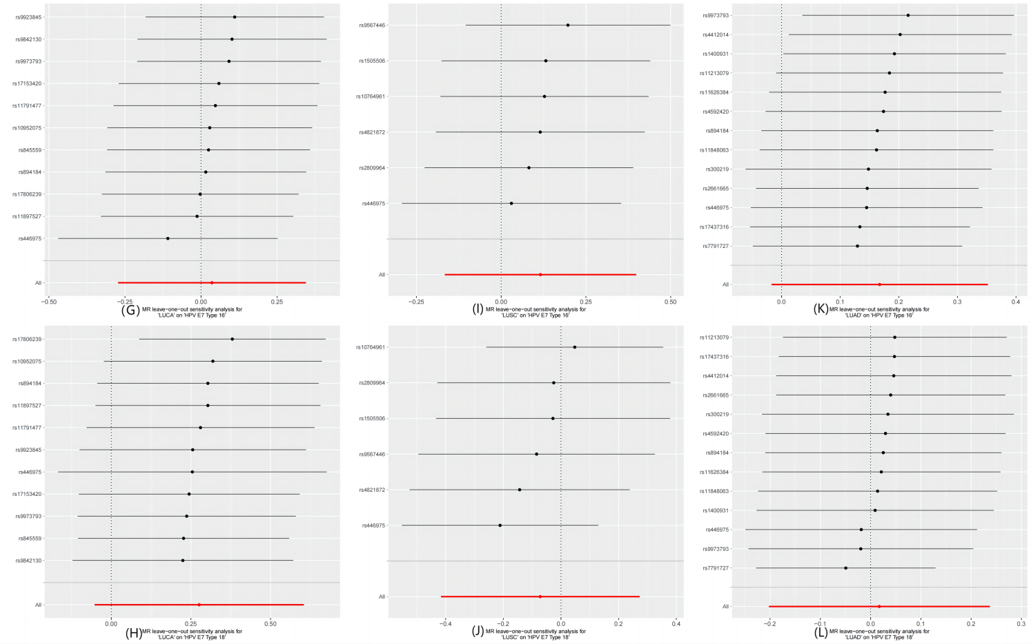
Supplementary Figure S5.
Leave-one-out analysis plots depicting the causal relationships between lung cancer (LUCA) and its subtypes with HPV (HPV-16 E7 protein, HPV-18 E7 protein). The red line represents the analysis result for the random-effects Inverse Variance Weighted (IVW) method. (G) Leave-one-out analysis for lung cancer and HPV-16 E7 protein. (H) Leave-one-out analysis for lung cancer and HPV-18 E7 protein. (I) Leave-one-out analysis for squamous cell carcinoma and HPV-16 E7 protein. (J) Leave-one-out analysis for squamous cell carcinoma and HPV-18 E7 protein. (K) Leave-one-out analysis for adenocarcinoma and HPV-16 E7 protein. (L) Leave-one-out analysis for adenocarcinoma and HPV-18 E7 protein. LUCA, lung cancer; LUSC, squamous cell carcinoma; LUAD, adenocarcinoma. IVW, Inverse Variance Weighted.
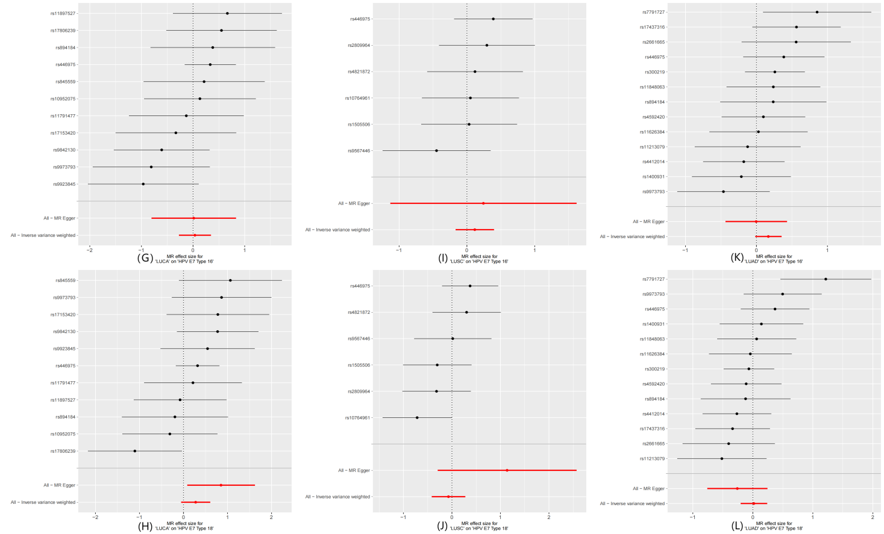
Supplementary Figure S6. Forest plots illustrating the causal effects of lung cancer and its subtypes associated single nucleotide polymorphisms (SNPs) on HPV (HPV-16 E7 protein, HPV-18 E7 protein). (G) Forest plot for the causal effect of lung cancer on HPV-16 E7 protein. (H) Forest plot for the causal effect of lung cancer on HPV-18 E7 protein. (I) Forest plot for the causal effect of squamous cell carcinoma on HPV-16 E7 protein. (J) Forest plot for the causal effect of squamous cell carcinoma on HPV-18 E7 protein. (K) Forest plot for the causal effect of adenocarcinoma on HPV-16 E7 protein. (L) Forest plot for the causal effect of adenocarcinoma on HPV-18 E7 protein. LUCA, lung cancer; LUSC, squamous cell carcinoma; LUAD, adenocarcinoma.

