Supplementary for
Seed Molecule-Guided Strategy Facilitates the Precise Identification of "Hidden" Polymer Breakdown Products

Changzhi Shi¹, Xing Chen¹, Jing Yang¹, Min Liu², Ao Guo¹, Feng Zhao¹, Ailin Zhao¹, Xiaojia Chen¹, Mengjing Wang³, Fengbang Wang⁴, Maoyong Song⁴, Zimeng Wang¹, Jianmin Chen¹*, Mingliang Fang^{1,5}*
¹ Department of Environmental Science and Engineering, Fudan University, Shanghai 200433, China
² West Coast Metabolomics Center, University of California−Davis, Davis, California 95616, United States
³ Center for Reproductive Sciences, Department of Obstetrics, Gynecology and Reproductive Sciences, University of California, San Francisco (UCSF), San Francisco, California 94143, USA
⁴ Key Laboratory of Environmental Nanotechnology and Health Effects, Research Center for Eco-Environmental Sciences, Chinese Academy of Sciences, Beijing 100085, China
⁵ School of Civil and Environmental Engineering, Nanyang Technological University, Singapore, 639798, Singapore
Email: mlfang@ntu.edu.sg; jmchen@fudan.edu.cn

This file includes:

Supplementary texts
Figures S1 to S17
Tables S1 to S6
SI References

Other supporting materials for this manuscript include the following:

Datasets S1 to S8

Contents
Texts
Details of landfill leachate sample preparation.
Chemicals and materials.
Polymer oligomer solution preparation
LC-HRMS analysis of oligomer samples
Detailed parameters of MS data pre-analysis for Oligomer-Finder
Water leaching experiments of MPs
Preparation of OLA and cell exposure assay
Protein digestion of cells exposed to OLA
Proteomics analysis
Detailed parameters for OLA modified protein analysis

Figures
S1. The details of Oligomer-Finder algorithms.
S2. MS2 spectrum of OLA_{4H,Meo} marked with rNL.
S3. (a)~(d) MS2 spectrum of OHB_{nH,OH}; (e)~(f) MS2 spectrum of OCL_{nH,OH}.
S4. (a) MS2 spectra of OLA_{13H,OH} with NCE 20%. (b) MS2 spectra of OLA_{13H,OH} with NCE 60%. (c) MS2 spectra of OLA_{5H,OH} with intensity of 1.09E9. (d) MS2 spectra of OLA_{5H,OH} with intensity of 7.58E4.
S5. (a) Chromatograms of OHB_{nH,OH} homologues; (b) Chromatograms of OHB_{nH,OH} homologues.
S6. (a) Logarithmic correlation of RT and DP for OHB_{nH,OH} (n = 2~12); (b) OCL_{nH,OH} (n = 2~8) ;(c) Logarithmic correlation of RT and ln(DP) for OHB_{nH,OH} (n = 2~12); (d) OCL_{nH,OH} (n = 2~8).
S7. (a) Information from Polymer Database and Plastic Maps to develop polymer oligomer database (PODB). (b) The SMILES, formula, mass and other information of polymers and their oligomers included in PODB, taking PLA and OLA_{4H,OH} as examples. (c) Part of the PODB is displayed.
S8. (a) Information from literatures and experimental verification to develop oligomer end group database (OEGDB). (b) The SMILES and other information of oligomer end groups included in OEGDB, taking seven kinds of OLA_{4α,ω} as examples (where α and ω represent Cyclic; H,OH; H,H; H, MeO; H,EtO; Fa,H; and Ac,H end groups, respectively). (c)~(f) MS2 spectrum of OLA_{4α,ω} (where α and ω represent Cyclic; H,H; H, MeO; H, EtO and Fa,H end groups, respectively).
S9. Probability of activating (a) androgen receptor (AR) (b) nuclear peroxisome proliferator-activated receptor gamma (PPAR-γ) in Tox21 Pathway of OLA_{4α,ω} (where α and ω represent Cyclic; H,OH; H,H; H, MeO; H, EtO and Fa,H end groups, respectively).
S10. The workflow for non-targeted analysis of oligomers in environmental sample studies.
S11. Annotation of fragment signatures in MS2 spectrum of OET_{2H,OH} and OET_{3H,OH}.
S12.MS2 spectrum for the unmodified peptide of MATHGQTCARPMCIPPSYADLGK in VDAC2.
S13. MS2 spectra with rNL of OLA-modified peptides for 4 proteins in Table S6.
S14. Annotation of fragment signatures in MS2 spectrum of OLA_{nH,OH} (n= 2, 4, 6, 10). The lower spectra all belong to the signals in sample for PLA MP leaching, and the upper spectra are from each synthetic OLA_{nH,OH}.
S15. The demo analysis result by "Seed oligomer-Finder".
S16. The demo analysis result by "Homologure-Finder".
S17. The demo analysis result by "Congener finder".

Tables
Table S1. Identified OLA homologues.
Table S2. Identified OLA congeners.
Table S3. Identified OET_{nH,OH} (n=2~5) in landfill leachate samples.
Table S4. Oligomer conjugates formed with cysteine and the modification patterns in vitro.
Table S5. Variable modification settings for OLA modified protein screening.
Table S6. Identified OLA-modified proteins in HepG₂ cells in high dose group.

Datasets
S1. Polymerization patterns with RU.
S2. Polymer oligomer database (PODB) for polymer oligomer screening.
S3. Additional information about other plastic monomers based on PlasticMAP.
S4. Polymer monomers of concern.
S5. Common interference with repeating units in LC-MS.
S6. Oligomer end group database (OEGDB) for congener screening.
S7. A supplementary end group database of potential oligomer end structures in the environment (OEGDB-env).
S8. A supplementary end group database of potential oligomer end structures in biology (OEGDB-bio).

Supplementary Text

Details of landfill leachate sample preparation
In order to minimize sample contamination, glass or PTFE consumables were utilized whenever feasible. The glassware was subjected to annealing at 450°C for a duration of 4 hours. The landfill leachate was acquired from a waste treatment facility in Jiangsu province. 10 mL of each landfill leachate sample were placed in one test tube. The samples were applied, at a rate of 1 drop s⁻¹, to an Oasis HLB (Waters 3cc/150mg) SPE cartridge that had been preconditioned sequentially by 5 mL of methanol and 5 mL of water. The loaded HLB SPE cartridge was then washed by 5 mL water. The oligomers fraction was then eluted with 5 mL of EtOAc. The eluates were evaporated to dry under a gentle stream of nitrogen and redissolved with ACN to a final volume of 100 μL. The procedural blank not containing any sample but only Milli-Q water was treated identically to control for a potential contamination.

Chemicals and materials
LC-grade methanol (MeOH), acetonitrile (ACN) and ethyl acetate (EtOAc) were purchased from Merck (Darmstadt, Germany). Formic acid (Fa) and Acetic acid (Ac) were purchased from Sigma-Aldrich (St. Louis, USA). Ultrapure water was produced by a Milli-Q® system (Millipore Corporation, 89 Billerica, MA). Cystein with a purity of 99% was purchased from Aladdin Chemical Co. Ltd (Shanghai, China). Trypsin protease (MS grade) was obtained from Shengxia Proteins Scientific Ltd (Beijing, China). Pancreatin (8xUSP) was obtained from Merck. The solid-phase extraction (SPE) HLB cartridge was supplied by Waters Corporation. The MPs used were detailed in following table.

Table. Information of MPs used in this study
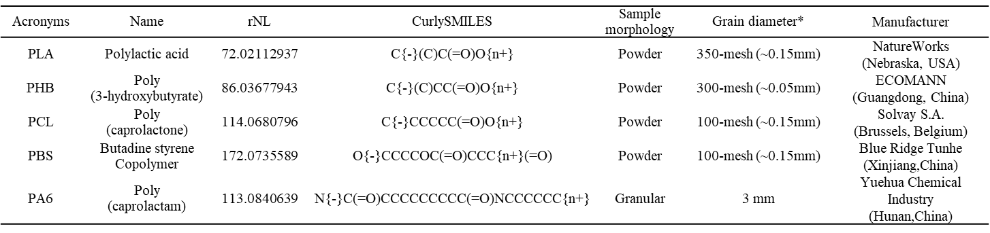
*The minimum particle size of commercially available plastic raw materials, which reaches the size level of MP particles.

Polymer oligomer solution preparation
As far as we know, there is no standard for oligomers provided commercially. To assess the LC-MS/MS behavior of oligomers and the performance of the Oligomer-Finder software, a multiple oligomer solution is needed. The method for preparing the oligomer solution was modified based on the approach to obtain soluble hydrolysis products of PLA to expedite the acquisition of oligomers through the alcoholysis method. A mixture of three biodegradable MPs (PLA, PHB, and PCL), each weighing 0.5 g, was blended and incubated with 5 mL of MeOH at 40°C for 2 hours. Prior to instrument analysis, the resulting extract was filtered through a 0.22-μm polytetrafluoroethylene (PTFE) filter to eliminate plastic particles and subsequently through an Amicon Ultra-0.5, 3 kDa MWCO filter (Millipore, USA) to remove ultra-high MW oligomers.

Incubation of MPs with cysteine
The incubation of four mixed biodegradable MPs (PLA, PHB, PCL, and PBS) with simulated small intestine medium containing porcine pancreatic lipase was conducted using a method modified from previous studies^{1, 2}. For Cys, we further diluted them from a high concentration stock in water to the low concentration (500μM) in the reaction mixture to a final volume of 200μL, containing 50 mM phosphate-buffered saline at pH 7.4, 1.6 mg/mL of the pancreatin and mixed MPs, each at a concentration of 10 mg/mL, started the reaction. We first placed the reaction mixtures on ice during sample preparation and then prewarmed them for 5 min at 37°C. After a 0.5 h incubation, reactions were terminated via an addition of 400μL of ice-cold ACN. Samples were then centrifuged at 15,000g for 30 min, and the supernatant was collected for further analysis. The reactions without lipase or without Cys were also conducted in parallel.

LC-HRMS analysis of oligomer samples
LC-HRMS system control and data handling were performed using Thermo Xcalibur software and Chromeleon software. The instrument has a resolution of up to 140,000 using TuneMix solution and factory default methods, with mass accuracy below 5 ppm. Oligomer sample solutions (5 μL) were injected sequentially onto a Waters T3 column (2.1 mm × 100 mm, 3 μm particle size). Mobile phase A consisted of water with 0.1% formic acid (FA), and mobile phase B was ACN. The gradient was as follows: 0−2 min 5% B, 2−12 min gradient to 100% B, 12−16 min 100% B, 16−18 min gradient to 5% B, followed by equilibration at 5% B for 3 min. The pump operated at a flow rate of 0.3 mL/min. HRMS was performed in Full MS/dd-MS2 modes.
The ionization source capillary voltage was set -3.2 kV in negative scanning mode. The sheath gas was set to 30 and aux gas was set to 5. The probe heater temperature was set to 300 °C and the capillary temperature was set to 320 °C. The range Data collection was done with mass detection ranges m/z 80~1000, resolution 70,000. The spectra rate was set to 1 Hz. AGC target of 1e6, and a maximum injection time of 200 ms. The MS resolution of ddMS² mode was 17,500 with precursor ions isolated using a 0.4 m/z width which could achieve the best possible balance of MS/MS coverage and quality. The stepped HCD collision energy was "10%-20%-30%". The ACG was set at 2e4 for MS2 scans. The dynamic exclusion time was 10.0s. A fixed exclusion list³ was utilized refer to the list of potential interference- or contaminant ions in modern MS. The parameter settings were modified from literatures⁴⁻⁶ and the default parameters in Xcalibur software.

Detailed parameters for MS data pre-analysis for Oligomer-Finder
In this study, the peak picking process was performed using MS-DIAL (version 4.60), utilizing functions such as Select Spectrum, Align Retention Time, Group Compounds, mat format files export, and Peak list export. MS2 data from different data acquisition methods such as DDA, data-independent acquisition (DIA), or targeted MS2 acquisition are all supported by MS-DIAL and Oligomer-Finder.
The MS-DIAL software parameters were set as follows: MS1 tolerance was 0.001 Da; MS2 tolerance was 0.05 D; Minimum peak height was 10 000; smoothing level was 3 scans; minimum peak width was 5 scans; sigma window value was 0.5; alignment tolerance was 0.05 min. Maximumm charged number was 2. Number of threads was 4. For adducts in the positive mode, [M+H]⁺, [M+Na]⁺, [M+CH₃OH+H]⁺, [M+K]⁺, [M+ACN+H]⁺, [M+H-H₂O]⁺ and [M+2H]²⁺ were suggested. For adducts in the negative mode, [M-H]⁻, [M+Cl]⁻, [M+FA-H]⁻, [M+Hac-H]⁻ and [M-2H]²⁻ were suggested. The parameter settings were based on the used LC-HRMS instrument in this work modified from literatures^{7, 8} and recommended settings⁹ provided in the tutorial by the MS-DIAL developer. The txt file with all the information of MS1 features was output from MS-DIAL. Use the MS/MS filter to obtain each mat files with the characteristics of MS/MS in the raw file. The analysis was performed on a computer with an Intel i7-13700H CPU @2.4 GHz with 14 cores, 32 GB memory, running Windows 11, and a 64-bit operating system with 20 processing threads.

Water leaching experiments of MPs
The water bath temperature was maintained at 30°C under dark conditions, accompanied by continuous shaker at a speed of 120 rpm to simulate the slight mechanical abrasion forces present in natural water. Sampling was conducted on day 0, day 1, day 3, day 5, and day 7, with 6 parallel samples collected at each time point. After the leaching experiment, the 6 mL supernatants of the reaction solutions were collected for subsequent analyses following centrifugation at 3000 rpm. The liquid was freeze-dried and redissolved with ACN to a final volume of 60 μL.

Preparation of OLA and cell exposure assay
In a conical flask containing 400 mL of methanol, PLA MP (40 g, 350 mesh) were separately added, and the mixture was heated at 20 ℃ and 60 ℃ for 2 hours. The supernatant was collected and filtered through a 0.22 μm PTFE filter membrane to remove the microplastic (MP) particles, retaining the supernatant. The obtained supernatant was mixed and added to a round-bottom flask. Pure OLA was obtained through methods such as rotary evaporation, gentle nitrogen blowing, and high vacuum impurities removal, and then stored in a -20 ℃ refrigerator under nitrogen protection.
The human hepatocellular carcinoma cell line HepG₂ from the China Centre for Type Culture Collection (CCTCC) was used as an in vitro model. The cell surface was rinsed with precooled phosphate-buffered saline, cells were scraped with phosphate-buffered saline on ice, and centrifuged to obtain the cell pellet, which was stored at -80 °C. The experiment was repeated thrice with different cell passages.

Protein digestion of cells exposed to OLA
Protein extraction, trypsin digestion, and proteomic analysis were performed following the method described in our previous report ¹⁰. Briefly, cells in 6-well plates with more than 95% coverage yielded about 140 μg protein per well. Each sample received 150 μL of 8 M urea buffer (50 mM Tris, pH 8.0, 1% protease inhibitor) and was extracted by probe sonication (3 cycles, 3s on and 3s off mode). pH was adjusted with 1 M TEAB and 500 mM TCEP (final concentration 10 mM) reduced proteins at room temperature for 20 min. Proteins were alkylated with 20 μL of 550 mM CAA in the dark at room temperature for 20 min. Urea was diluted to 2M with 400 μL of 100 mM TEAB. Proteins were digested with lysC (40:1 ratio) at 37°C for 2h, followed by trypsin (25:1 ratio) overnight. Digestion was quenched with TFA. Digested peptides were desalted using commercialized Oasis HLB columns. Desalted samples were freeze-dried, re-dissolved in 0.1% formic acid water, and diluted to the same concentration. 1μg peptide sample was used for label free proteomic analysis.

Proteomics analysis
Samples were then analyzed by the LC−MS/MS equipped with an EASY-nLC 1200 (Thermo) HPLC system and Orbitrap Exploris 480 (Thermo) mass spectrometer in a data-dependent acquisition (DDA) mode. Tryptic peptides were sequentially injected into a silica capilary column (75 μm ID and 360 μm OD), pulled to an opening of 10 μm and 18 cm length column with 1.9 μm beads (Reprosil-Pur C18-AQ, Dr. Marisch GmBH) packed for LC separation. Buffer A (2%ACN with 0.1% v/v formic acid) and Buffer B (98% acetonitrile with 0.1% formic acid) were the mobile phases. The flow rate was 300 nL/min and the gradients were: 8−20% Buffer B for 60 min; 20-30% Buffer B for 22 min; 30%−80% Buffer B for 4 min; and 80% Buffer B for 4 min.
Global setting included: ion source type, nanospray ionization; spray voltage, 2.2 kV (positive); ion transfer tube temp, 250 °C; default charge state, 2. For MS, detector type, orbitrap; orbitrap resolution, 60 000 at 400 m/z; scan range, 400−1200 m/z; S-lens RF level, 35%; AGC target, custom; maximum injection time, 50 ms; include charge state(s), 2−5; data-dependent mode, top speed; dynamic exclusion, 30 s with a 10 ppm tolerance around the precursor. For MS/MS: signal intensity threshold for parent ion selection, 5.0e4; MS/MS isolation mode, quadrupole; isolation window, 1.6; activation type, HCD; HCD collision energy, 35%; detector type, Orbitrap; Orbitrap resolution, 15 000 at 400 m/z; AGC target, custom; maximum injection time, auto.

Detailed parameters for OLA-modified protein analysis using Proteome Discoverer
Carbamidomethyl (C) and methionine oxidation (M) were chosen as variable modifications. Data were searched using the following parameters: trypsin was selected as the enzyme; peptide charge was 2+, 3+, and 4+; the precursor was set at 10 ppm; the fragment mass tolerance was set at 0.2 Da; maximum missed cleavage was 1 allowed; statistical significance was set at p < 0.05; and peptide spectral matches were validated based on q-values to 1% FDR using a percolator.
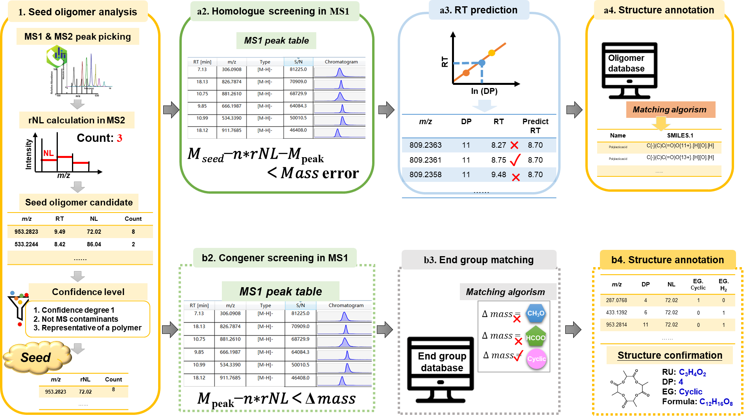

Figure S1. The details of Oligomer-Finder algorithms: (1) Seed oligomer analysis; (a2) Homologues screened in MS1; (a3) RT of homologues predicted; (a4) Structure annotation; (b2) Congeners screened in MS1; (b3) End group database search; (b4) Structure annotation.

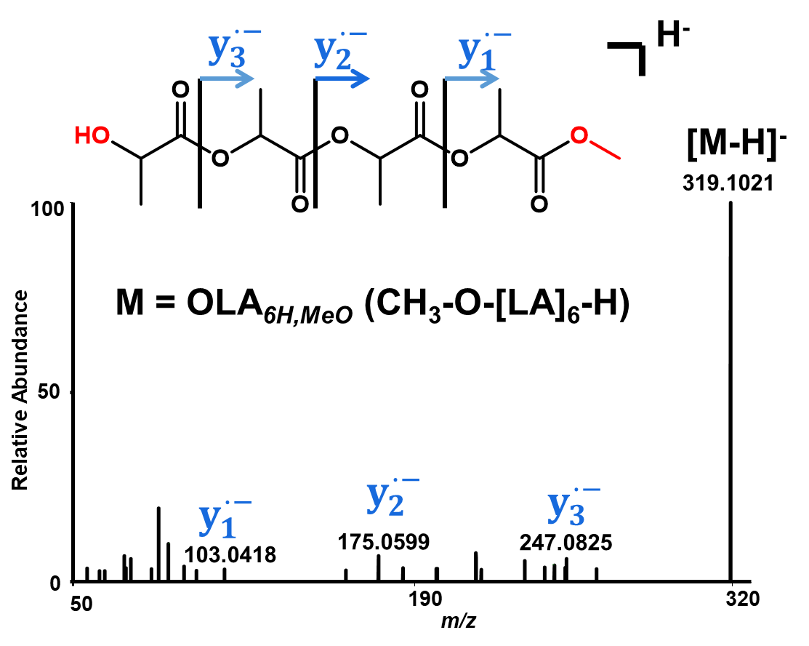

Figure S2. MS2 spectrum of OLA_{4H,Meo}
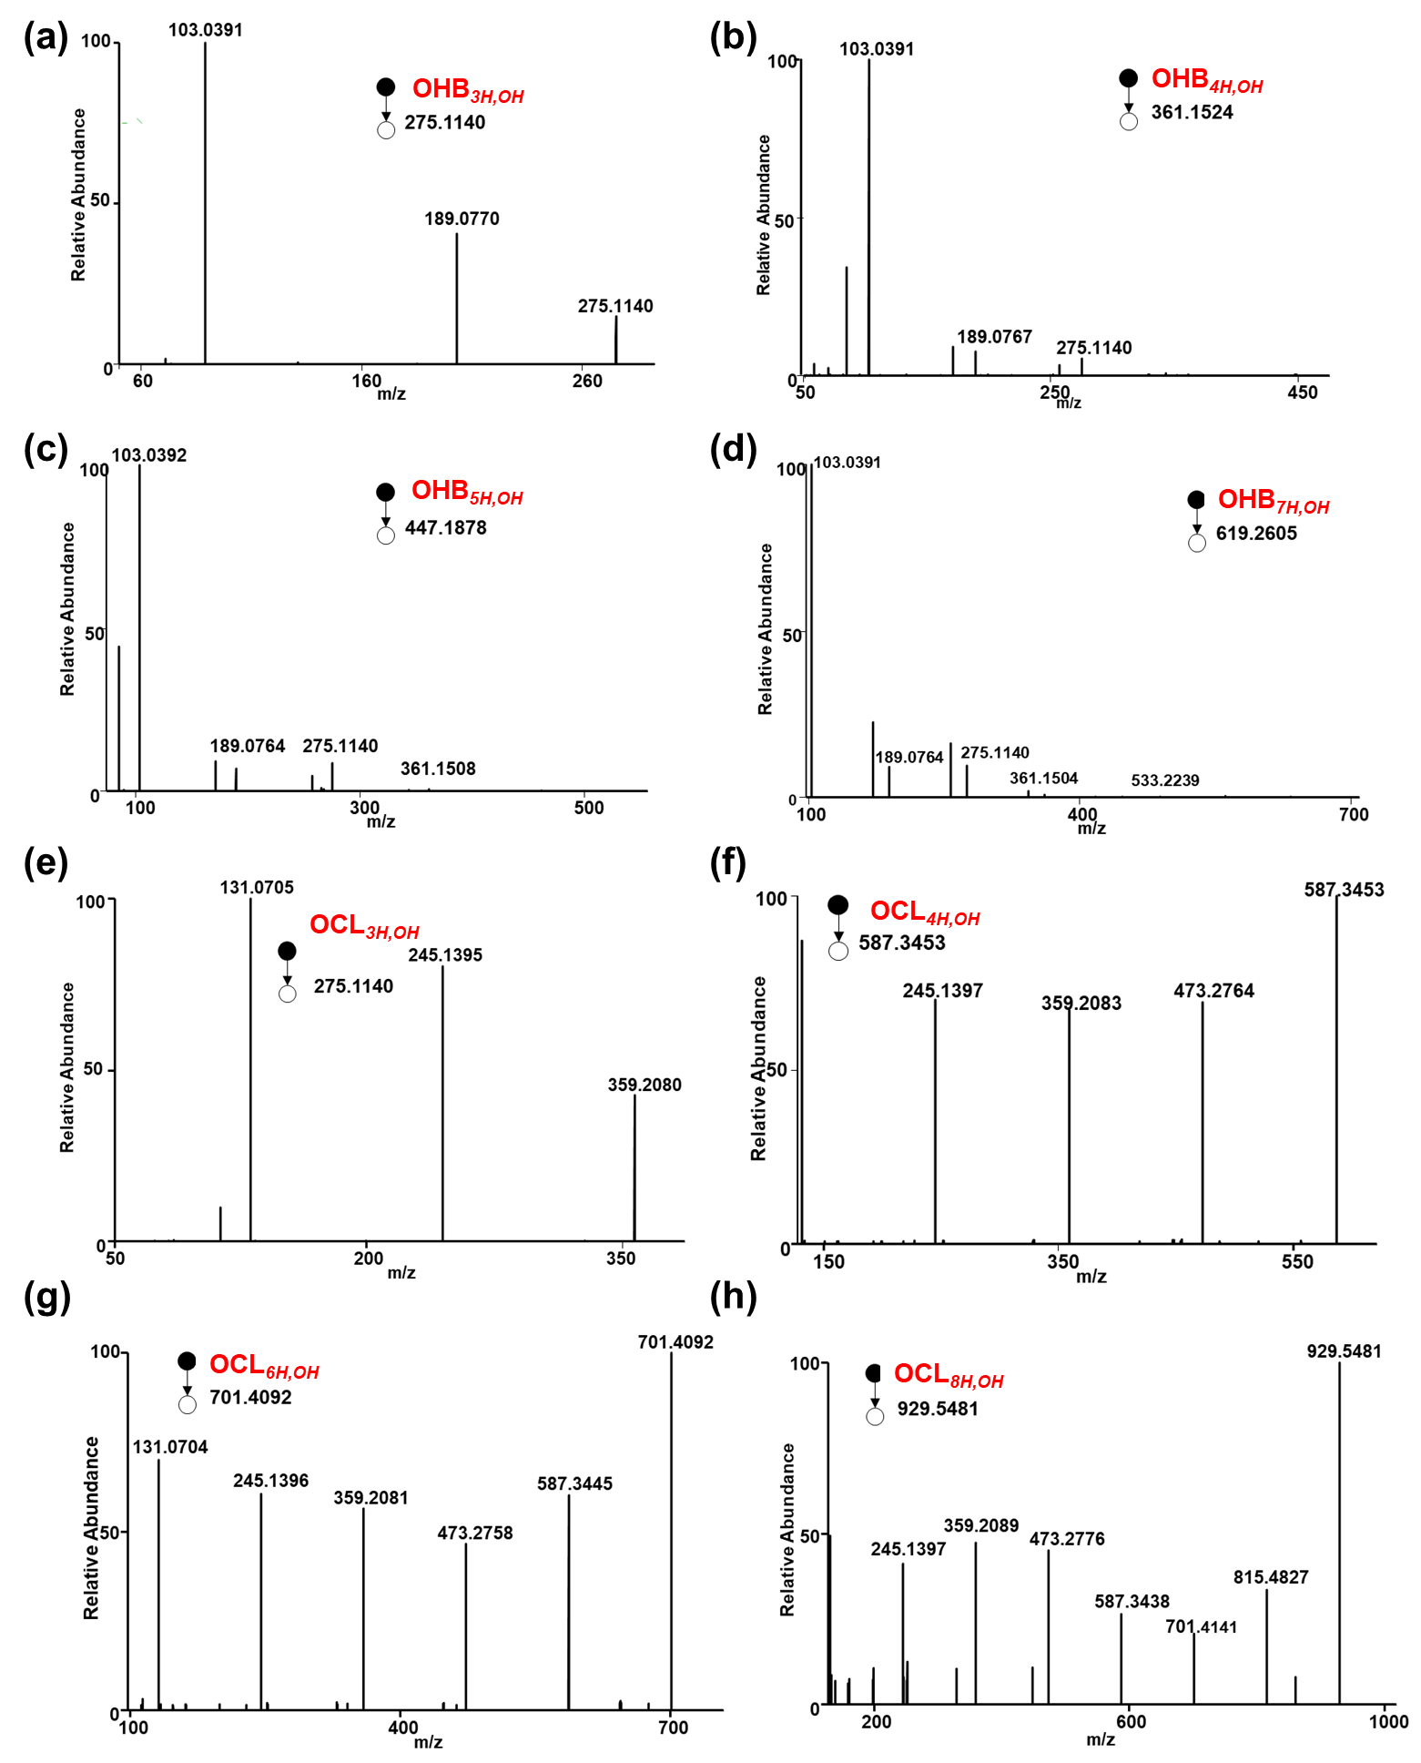

Figure S3. (a)~(d) MS2 spectrum of OHB_{nH,OH}; (e)~(h) MS2 spectrum of OCL_{nH,OH}
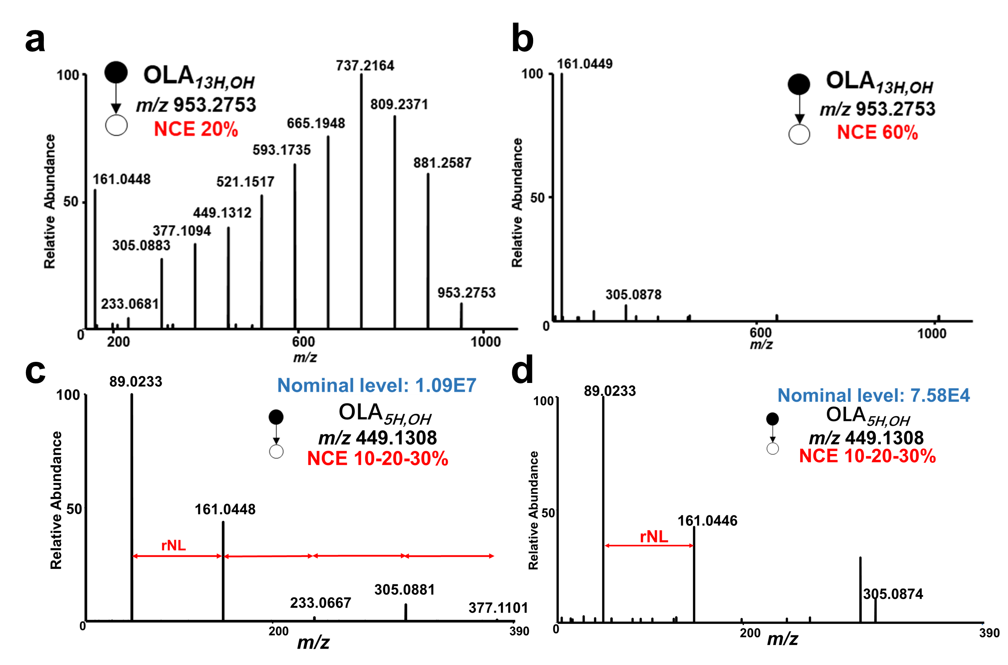

Figure S4. (a) MS2 spectra of OLA_{13H,OH} with NCE 20%. (b) MS2 spectra of OLA_{13H,OH} with NCE 60%. (c) MS2 spectra of OLA_{5H,OH} with intensity of 1.09E9. (d) MS2 spectra of OLA_{5H,OH} with intensity of 7.58E4.

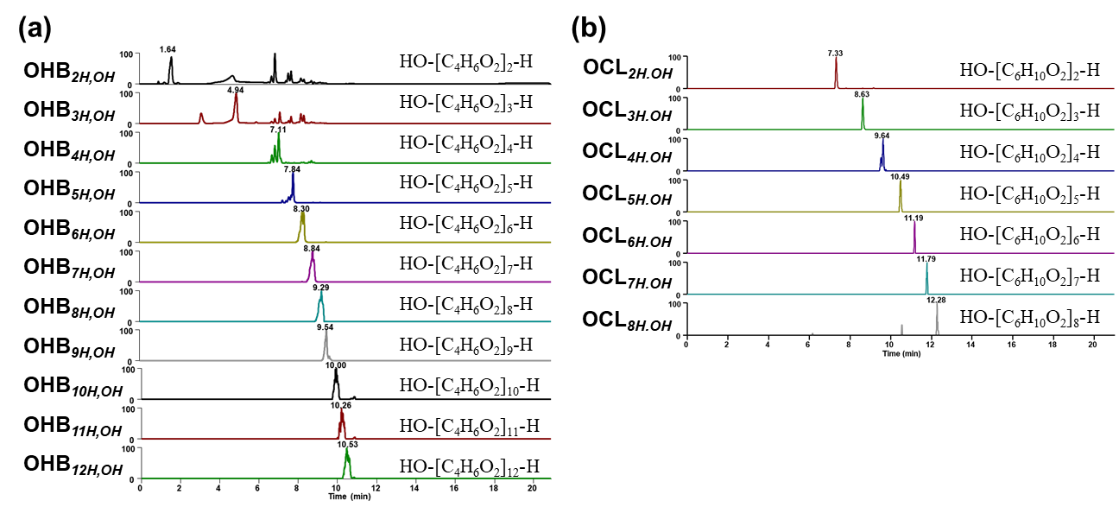

Figure S5. (a) Chromatograms of OHB_{nH,OH} homologues; (b) Chromatograms of OHB_{nH,OH} homologues.

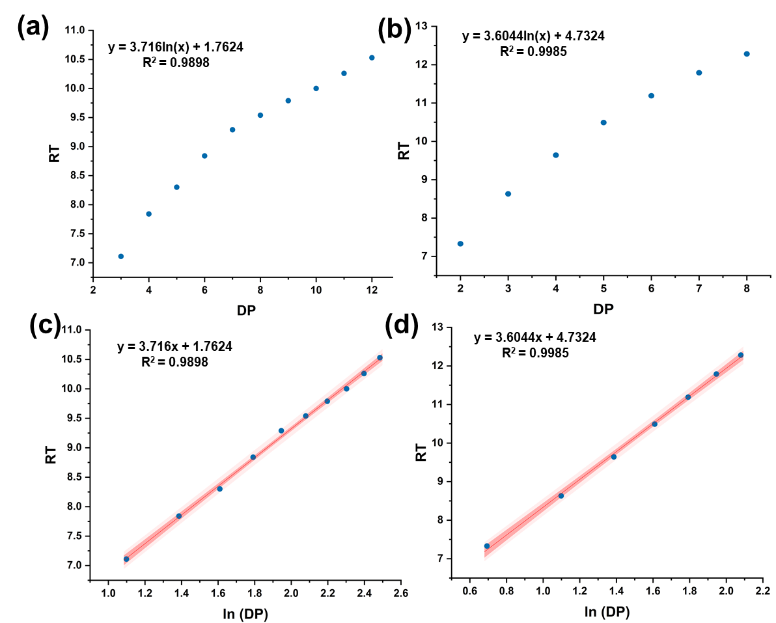

Figure S6. (a) Logarithmic correlation of RT and DP for OHB_{nH,OH} (n = 2~12); (b) OCL_{nH,OH} (n = 2~8) ;(c) Logarithmic correlation of RT and ln(DP) for OHB_{nH,OH} (n = 2~12); (d) OCL_{nH,OH} (n = 2~8).

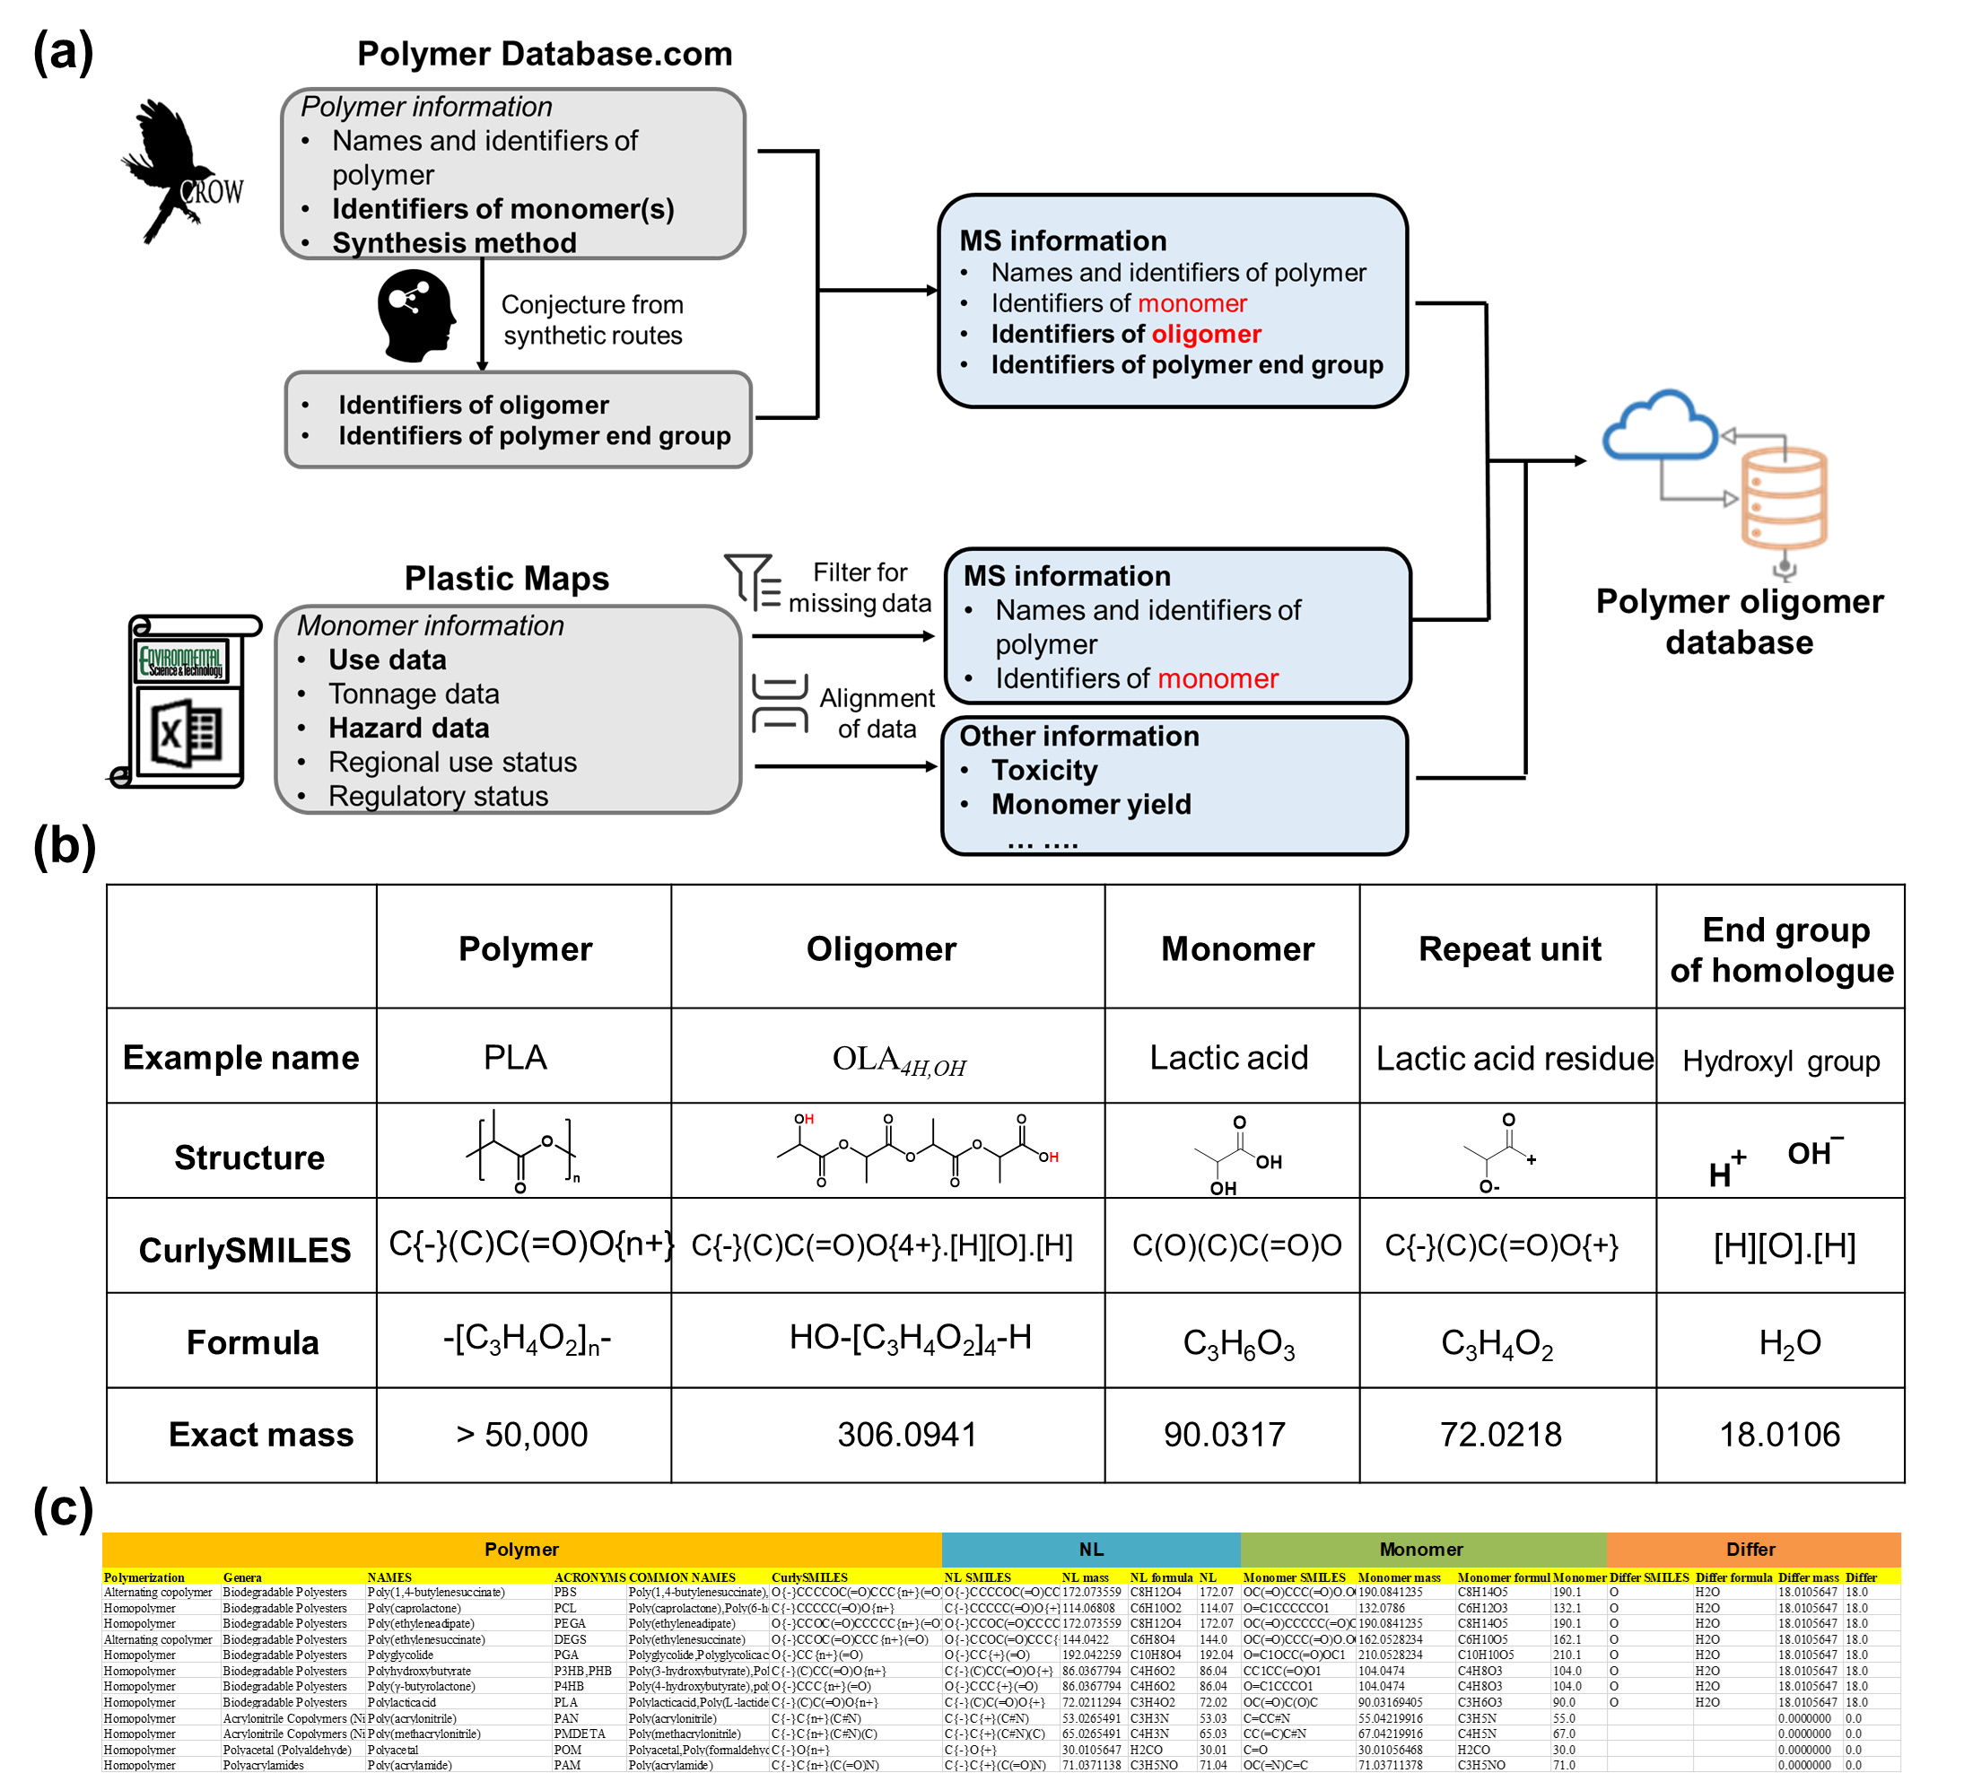

Figure S7. (a) Information from Polymer Database and Plastic Maps to develop polymer oligomer database (PODB). (b) The SMILES, formula, mass and other information of polymers and their oligomers included in PODB, taking PLA and OLA_{4H,OH} as examples. (c) Part of the PODB is displayed. It includes basic information about the polymer as well as information about the three fingerprint characteristics——NL, monomer and EG. CurlySMILES, formula, mass and mass reserved for a number of decimal places. "NL", "Monomer" and "Differ" were the result of keeping two, one and one decimal places to match the seed oligomer candidates respectively. "NL mass", "Monomer mass" and "Differ mass" were the exact mass obtained by Xcalibur software.
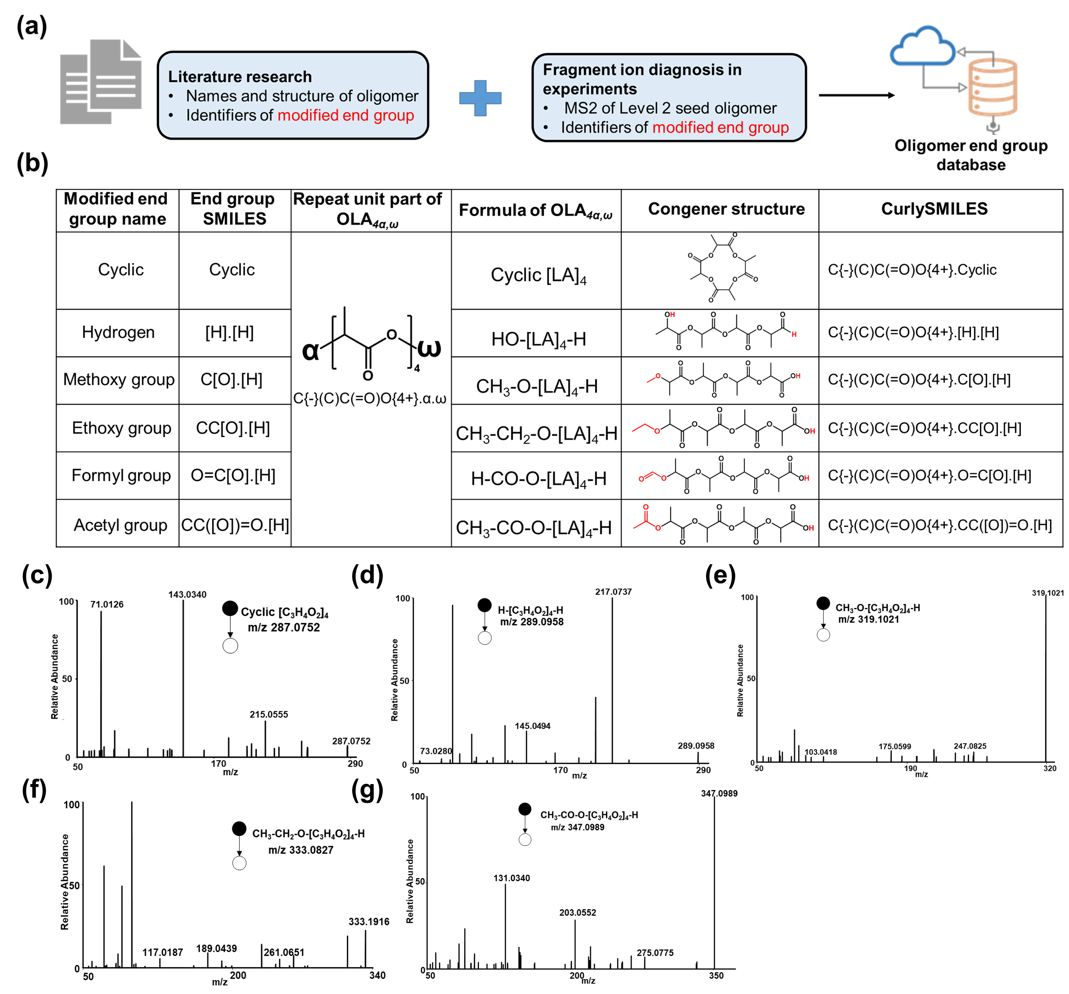

Figure S8. (a) Information from literatures and experimental verification to develop oligomer end group database (OEGDB). (b) The SMILES and other information of oligomer end groups included in OEGDB, taking seven kinds of OLA_{4α,ω} as examples (where α and ω represent Cyclic; H,OH; H,H; H, MeO; H,EtO; Fa,H; and Ac,H end groups, respectively). (c)~(g) MS2 spectrum of OLA_{4α,ω} (where α and ω represent Cyclic; H,H; H, MeO; H, EtO and Fa,H end groups, respectively).
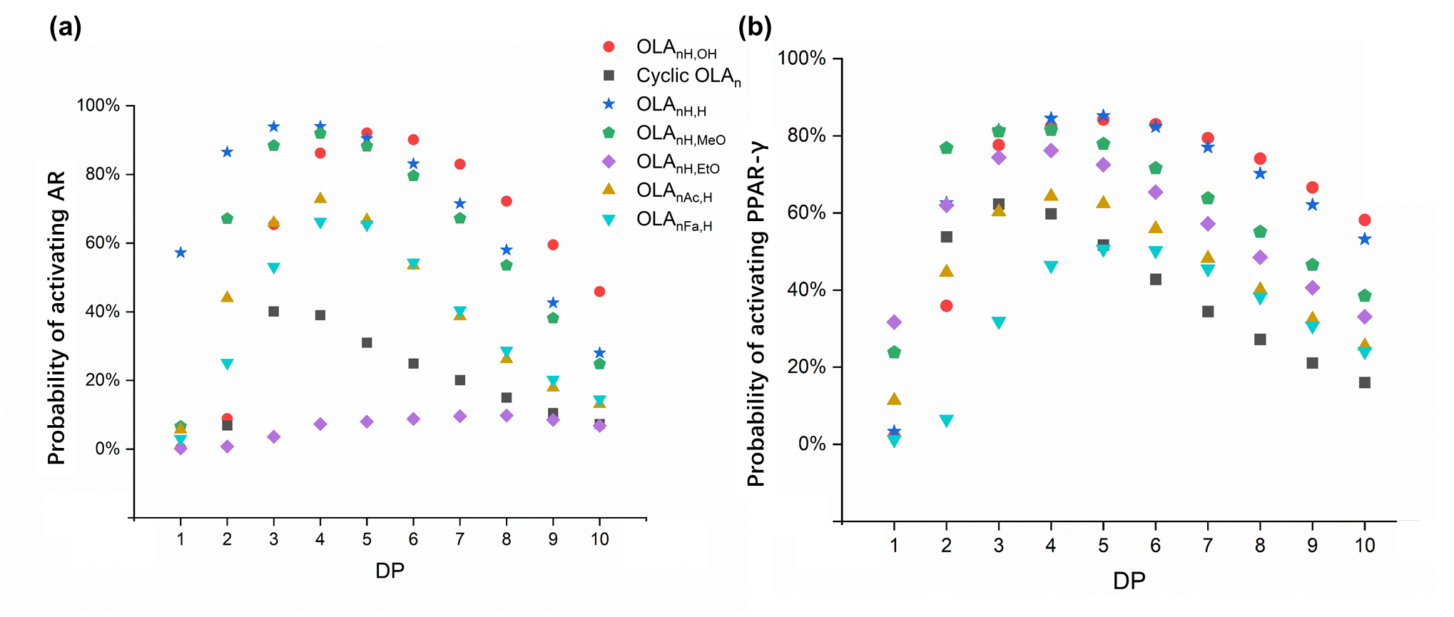

Figure S9. Probability of activating (a) androgen receptor (AR) (b) nuclear peroxisome proliferator-activated receptor gamma (PPAR-γ) in Tox21 Pathway of OLA_{4α,ω} (where α and ω represent Cyclic; H,OH; H,H; H, MeO; H, EtO and Fa,H end groups, respectively).

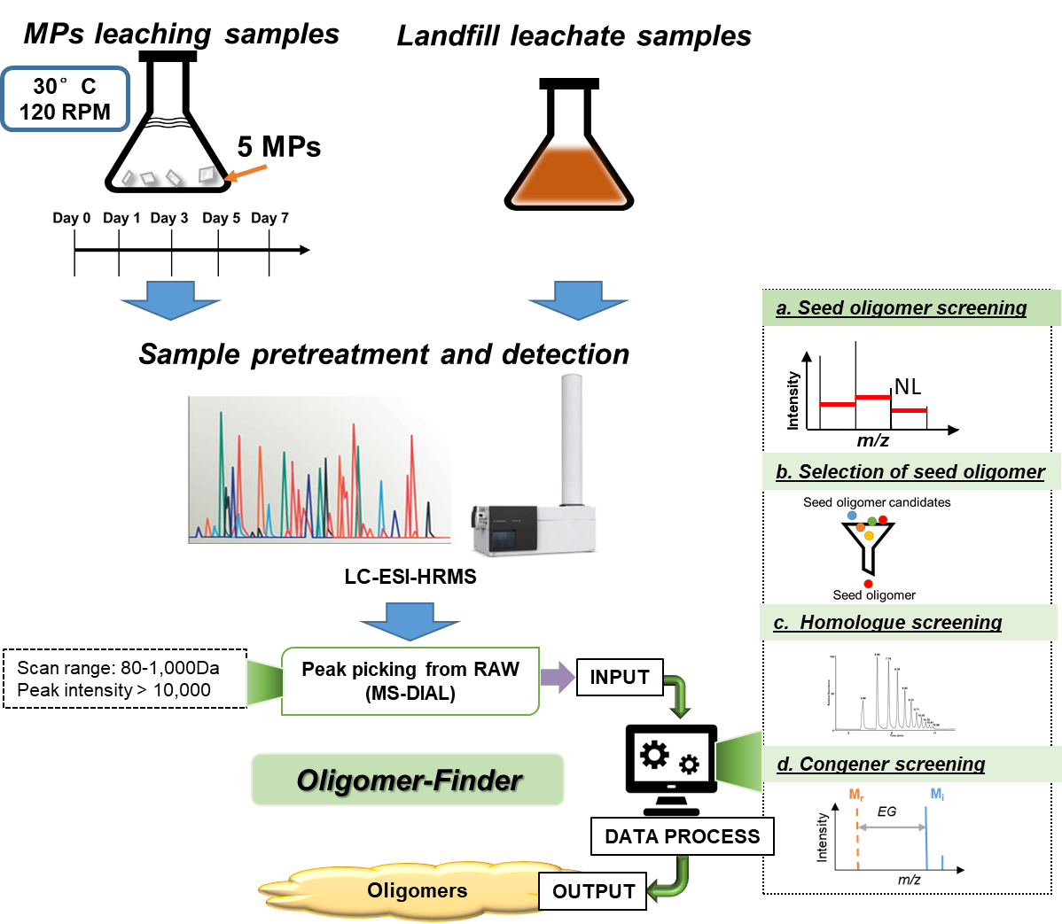

Figure S10. The workflow for non-targeted analysis of oligomers in environmental sample studies.

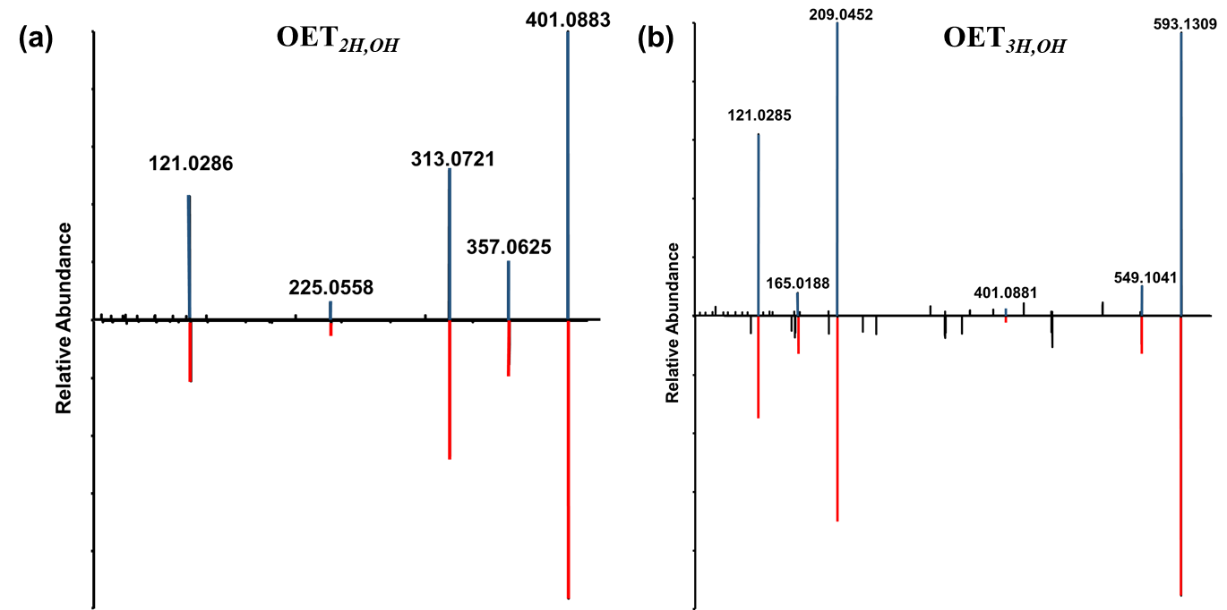

Figure S11. Annotation of fragment signatures in MS2 spectrum of OET_{2H,OH} and OET_{3H,OH}.

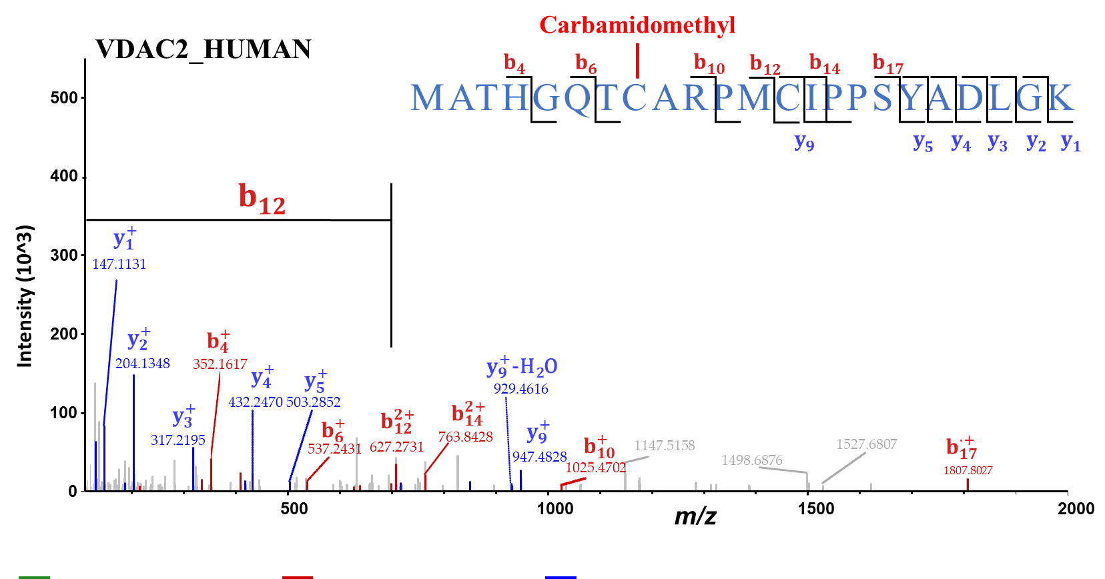

Figure S12. MS2 spectrum for the unmodified peptide of MATHGQTCARPMCIPPSYADLGK in VDAC2.

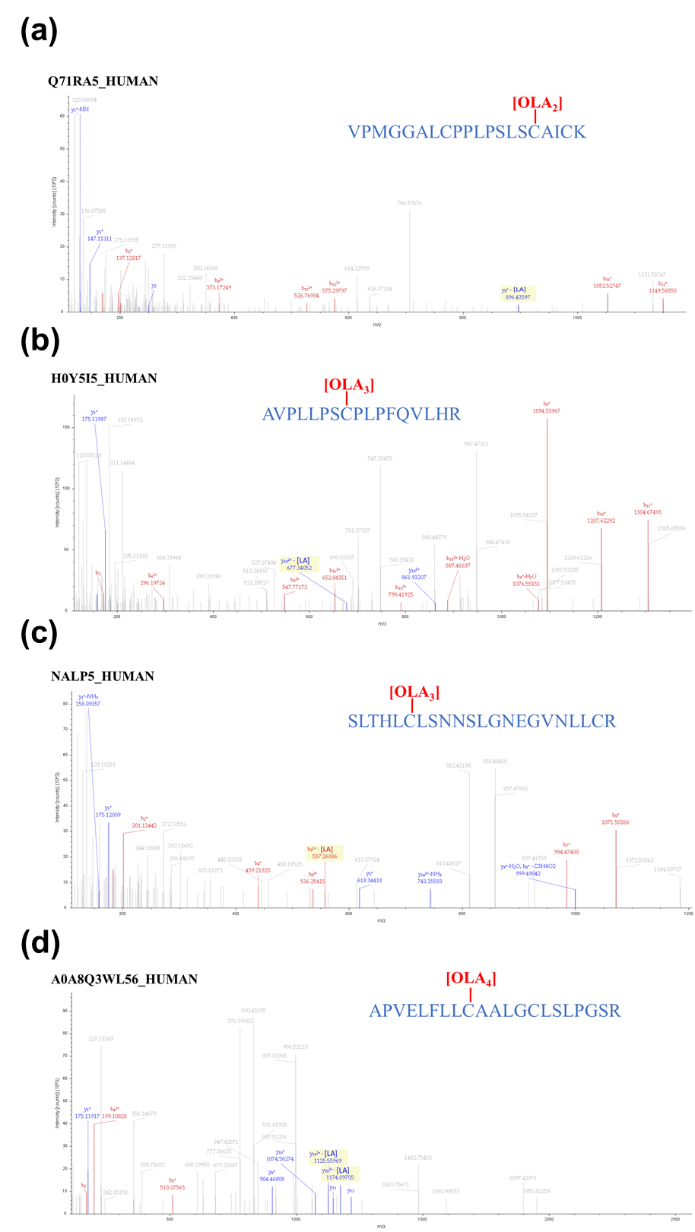

Figure S13. MS2 spectra with rNL of OLA modified peptides for 4 proteins in SI-1 Table S6.
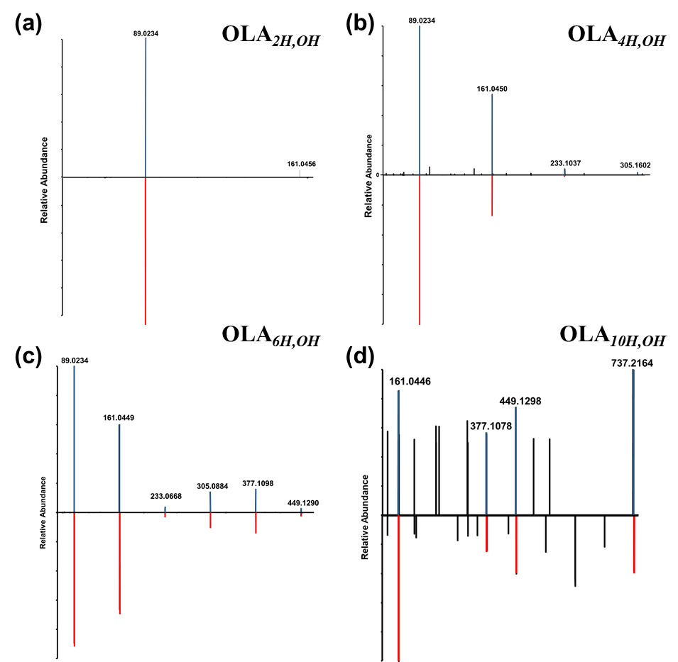

Figure S14. Annotation of fragment signatures in MS2 spectrum of OLA_{nH,OH} (n= 2, 4, 6, 10). The lower spectra all belong to the signals in sample for PLA MP leaching, and the upper spectra are from each synthetic OLA_{nH,OH}.

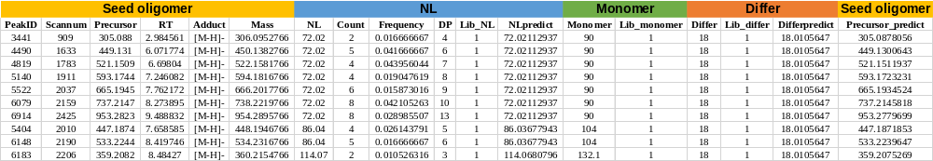

Figure S15. The demo analysis result by "Seed oligomer-Finder". 10 seed oligomers of Degree 1 were found by the "Seed oligomer-Finder. R". NL values of 72.02, 86.04, and 114.07 correspond to the three oligomer types OLA, OHB, and OCL respectively. The header column containing "lib", "Reference" or "predict" is the result of combining with the database.

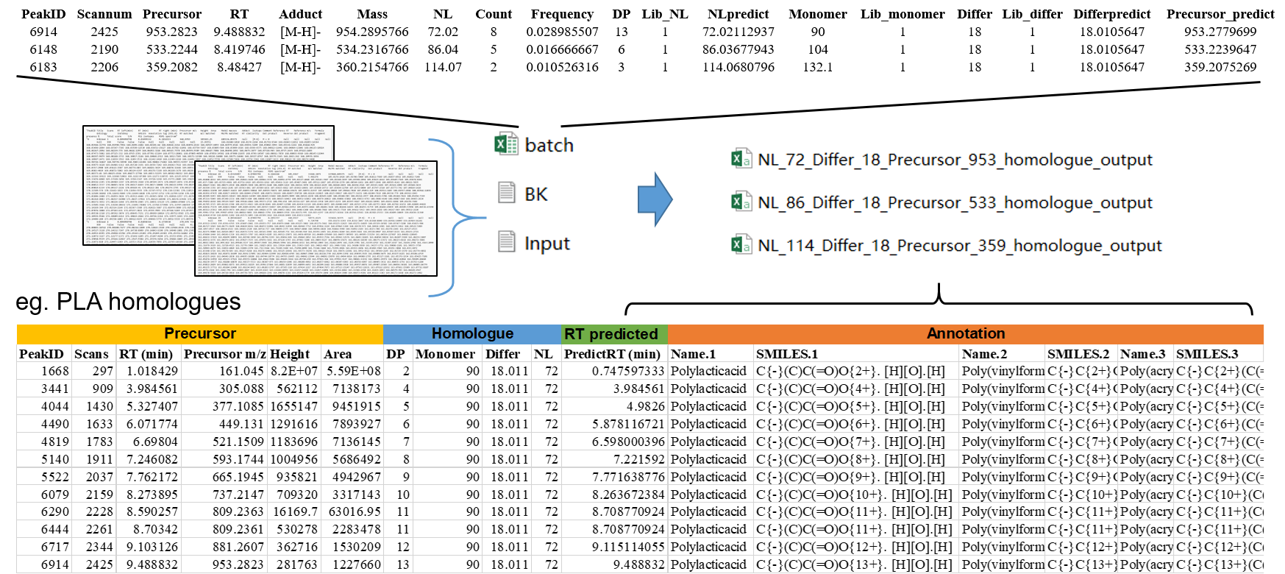

Figure S16. The demo analysis result by "Homologure-Finder". Taking OLA_{nH,OH} as example, the screening results and identification of homologues are shown. The classes of polymers that can be matched and CurlySMILES are all listed in no particular order. The data was filtered based on the predicted RT.

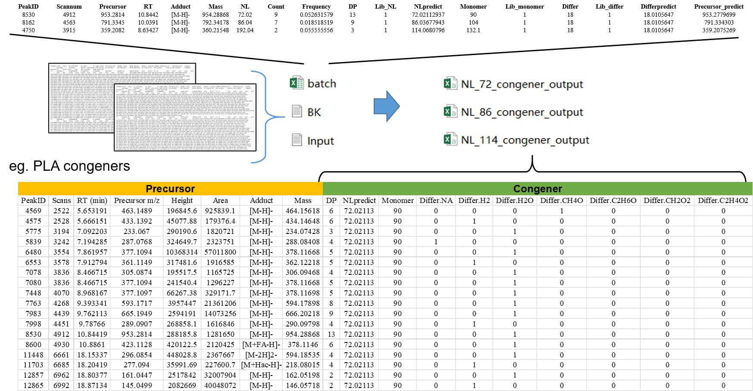

Figure S17. The demo analysis result by "Congener finder". Taking OLA_{nα,ω} as example, the screening results and identification of congeners are shown. Seven end groups in OEGDB were considered, with "1" indicating the presence of the congener in the input sample and "0" denoting its absence.

Table S1. Identified OLA homologues
No | Parent polymer | DP | Name | Retention time (min) | Molecular Formula | Calculated m/z  [M-H]- | Measured m/z [M-H]- | Mass accuracy (ppm) | Confidence level*
1 | PLA | 2 | OLA_{2H,OH} | 1.61 | C₆H₁₀O₅ | 161.0455467 | 161.0450 | -3.39 | Level 2a
2 | PLA | 3 | OLA_{3H,OH} | 3.02 | C₉H₁₄O₇ | 233.066676 | 233.0665 | -0.76 | Level 1
3 | PLA | 4 | OLA_{4H,OH} | 4.88 | C₁₂H₁₈O₉ | 305.0878054 | 305.088 | 0.64 | Level 2a
4 | PLA | 5 | OLA_{5H,OH} | 5.66 | C₁₅H₂₂O₁₁ | 377.1089348 | 377.1089 | -0.09 | Level 1
5 | PLA | 6 | OLA_{6H,OH} | 6.26 | C₁₈H₂₆O₁₃ | 449.1300641 | 449.1308 | 1.64 | Level 2a
6 | PLA | 7 | OLA_{7H,OH} | 6.9 | C₂₁H₃₀O₁₅ | 521.1511935 | 521.1509 | -0.56 | Level 1
7 | PLA | 8 | OLA_{8H,OH} | 7.43 | C₂₄H₃₄O₁₇ | 593.1723229 | 593.1744 | 3.50 | Level 2a
8 | PLA | 9 | OLA_{9H,OH} | 7.98 | C₂₇H₃₈O₁₉ | 665.1934522 | 665.1945 | 1.58 | Level 2a
9 | PLA | 10 | OLA_{10H,OH} | 8.49 | C₃₀H₄₂O₂₁ | 737.2145816 | 737.2147 | 0.16 | Level 2a
10 | PLA | 11 | OLA_{11H,OH} | 9.02 | C₃₃H₄₆O₂₃ | 809.235711 | 809.2361 | 0.48 | Level 1
11 | PLA | 12 | OLA_{12H,OH} | 9.22 | C₃₆H₅₀O₂₅ | 881.2568403 | 881.2607 | 4.38 | Level 2a
12 | PLA | 13 | OLA_{13H,OH} | 9.61 | C₃₉H₅₄O₂₇ | 953.2779697 | 953.2823 | 4.54 | Level 2a
* The confidence level assignment of small molecule referred to.

Table S2. Identified OLA congeners
No | No in Fig. 4c | Adjusted peak height in Fig. 4c | Parent polymer | End group | DP | Name | Retention time (min) | Molecular Formula | Calculated m/z [M-H]- | Measured m/z [M-H]- | Mass accuracy (ppm) | Confidence level
1 | S1,4 | *10 | PLA | Cyclic | 4 | Cyclic OLA₄ | 5.84 | C₁₂H₁₆O₈ | 287.077217 | 287.0762 | 3.54 | Level 2a
2 | S1,5 | *10 | PLA | Cyclic | 5 | Cyclic OLA₅ | 6.55 | C₁₅H₂₀O₁₀ | 359.09835 | 359.0984 | -0.14 | Level 2b
3 | S1,6 | *10 | PLA | Cyclic | 6 | Cyclic OLA₆ | 7.64 | C₁₈H₂₄O₁₂ | 431.11948 | 431.1196 | -0.28 | Level 2b
4 | S2,3 | /100 | PLA | H,H | 3 | OLA_{3H,H} | 2.85 | C₉H₁₄O₆ | 217.0717 | 217.0714 | 1.38 | Level 2b
5 | S2,4 | /10 | PLA | H,H | 4 | OLA_{4H,H} | 4.31 | C₁₂H₁₈O₈ | 289.0929 | 289.0929 | 0.00 | Level 2a
6 | S2,5 | /10 | PLA | H,H | 5 | OLA_{5H,H} | 5.23 | C₁₅H₂₂O₁₀ | 361.114 | 361.1142 | -0.55 | Level 2b
7 | S2,6 |  | PLA | H,H | 6 | OLA_{6H,H} | 6.28 | C₁₈H₂₆O₁₂ | 433.1351 | 433.1353 | -0.46 | Level 2b
8 | S2,7 | *10 | PLA | H,H | 7 | OLA_{7H,H} | 6.78 | C₂₁H₃₀O₁₄ | 505.1563 | 505.1568 | -0.99 | Level 2b
9 | S3,2 |  | PLA | H, MeO | 2 | OLA_{2H,MeO} | 2.01 | C₇H₁₂O₅ | 175.0611967 | 175.0605 | 3.98 | Level 2b
10 | S3,3 | *10 | PLA | H, MeO | 3 | OLA_{3H,MeO} | 3.33 | C₁₀H₁₆O₇ | 247.0823261 | 247.0822 | 0.51 | Level 2b
11 | S3,4 | *10 | PLA | H, MeO | 4 | OLA_{4H,MeO} | 4.99 | C₁₃H₂₀O₉ | 319.1034554 | 319.1021 | 4.25 | Level 2a
12 | S3,5 |  | PLA | H, MeO | 5 | OLA_{5H,MeO} | 6.00 | C₁₆H₂₄O₁₁ | 391.1245847 | 391.1248 | -0.55 | Level 2b
13 | S3,6 | *10 | PLA | H, MeO | 6 | OLA_{6H,MeO} | 6.66 | C₁₉H₂₈O₁₃ | 463.145714 | 463.1461 | -0.83 | Level 2b
14 | S3,7 | *10 | PLA | H, MeO | 7 | OLA_{7H,MeO} | 7.38 | C₂₂H₃₂O₁₅ | 535.1668433 | 535.1672 | -0.67 | Level 2b
15 | S4,2 |  | PLA | H, EtO | 2 | OLA_{2H,EtO} | 3.02 | C₈H₁₄O₅ | 189.0768468 | 189.0761 | 3.95 | Level 2b
16 | S4,3 |  | PLA | H, EtO | 3 | OLA_{3H,EtO} | 3.92 | C₁₁H₁₈O₇ | 261.0979761 | 261.0979 | 0.29 | Level 2b
17 | S4,4 |  | PLA | H, EtO | 4 | OLA_{4H,EtO} | 4.49 | C₁₄H₂₂O₉ | 333.1191054 | 333.1192 | -0.28 | Level 2a
18 | S4,5 |  | PLA | H, EtO | 5 | OLA_{5H,EtO} | 5.90 | C₁₇H₂₆O₁₁ | 405.1402348 | 405.1405 | -0.65 | Level 2b
19 | S4,6 | *10 | PLA | H, EtO | 6 | OLA_{6H,EtO} | 6.38 | C₂₀H₃₀O₁₃ | 477.1613641 | 477.1617 | -0.70 | Level 2b
20 | S4,7 | *100 | PLA | H, EtO | 7 | OLA_{7H,EtO} | 7.15 | C₂₃H₃₄O₁₅ | 549.1824934 | 549.1828 | -0.56 | Level 2b
21 | S5,3 |  | PLA | Ac, H | 3 | OLA_{3Ac,H} | 1.93 | C₁₀H₁₄O₈ | 261.0615906 | 261.0616 | -0.04 | Level 2b
22 | S5,4 |  | PLA | Ac, H | 4 | OLA_{4Ac,H} | 2.68 | C₁₃H₁₈O₁₀ | 333.0826965 | 333.0829 | -0.61 | Level 2a
23 | S5,5 | *10 | PLA | Ac, H | 5 | OLA_{5Ac,H} | 5.14 | C₁₆H₂₂O₁₂ | 405.1038492 | 405.1042 | -0.87 | Level 2b
24 | S5,6 | *100 | PLA | Ac, H | 6 | OLA_{6Ac,H} | 6.10 | C₁₉H₂₆O₁₄ | 477.1249785 | 477.1252 | 0.46 | Level 2b
25 | S6,2 | *10 | PLA | Fa, H | 2 | OLA_{2Fa,H} | 2.52 | C₁₁H₁₆O₈ | 275.0772407 | 275.0773 | -0.22 | Level 2b
26 | S6,3 | *10 | PLA | Fa, H | 3 | OLA_{3Fa,H} | 4.46 | C₁₄H₂₀O₁₀ | 347.09837 | 347.0989 | -1.53 | Level 2a
27 | S6,4 | *10 | PLA | Fa, H | 4 | OLA_{4Fa,H} | 5.95 | C₁₇H₂₄O₁₂ | 419.1194993 | 419.1198 | -0.72 | Level 2b
28 | S6,5 | *100 | PLA | Fa, H | 5 | OLA_{5Fa,H} | 7.02 | C₂₀H₂₈O₁₄ | 491.1406286 | 491.1411 | -0.96 | Level 2b
29 | S6,6 | *100 | PLA | Fa, H | 6 | OLA_{6Fa,H} | 7.86 | C₂₃H₃₂O₁₆ | 563.1617579 | 563.1625 | 1.32 | Level 2b

Table S3. Identified OET_{nH,OH} (n = 2~5) in landfill leachate samples
Parent polymer | DP | Name | Retention time (min) | Molecular Formula | Calculated m/z [M-H]- | Measured m/z [M-H]- | Mass accuracy (ppm) | Confidence level
PET | 2 | OET_{2H,OH} | 8.49 | C₂₀H₁₈O₉ | 401.0878053 | 401.0880 | 0.49 | Level 2a
PET | 3 | OET_{3H,OH} | 9.74 | C₃₀H₂₆O₁₃ | 593.1300639 | 593.1312 | 1.92 | Level 2a
PET | 4 | OET_{4H,OH} | 10.57 | C₄₀H₃₄O₁₇ | 785.1723226 | 785.1735 | 1.50 | Level 2b
PET | 5 | OET_{5H,OH} | 11.24 | C₅₀H₄₂O₂₁ | 977.2145812 | 977.2162 | 1.66 | Level 2b

Table S4. Oligomer conjugates formed with cysteine and the modification patterns in vitro

No | No in Fig. 6a | Oligomer conjugate | Retention time (min) | Molecular Formula | Calculated m/z [M-H]- | Measured m/z [M-H]- | Mass accuracy (ppm) | Molecular Composition | Modification pattern
1 | S1,2 | OLA_{2H,Cys} | 5.3 | C₉H₁₅NO₆S | 264.0547311 | 264.0547 | -0.12 | C₆H₁₀O₅ | Cysteine residues
2 | S1,3 | OLA_{3H,Cys} | 6.42 | C₁₂H₁₉NO₈S | 336.0758604 | 336.0758 | -0.18 | C₉H₁₄O₇ | Cysteine residues
3 | S1,4 | OLA_{4H,Cys} | 7.25 | C₁₅H₂₃NO₁₀S | 408.0969898 | 408.0976 | 1.50 | C₁₂H₁₈O₉ | Cysteine residues
4 | S1,5 | OLA_{5H,Cys} | 7.89 | C₁₈H₂₇NO₁₂S | 480.1181191 | 480.1188 | 1.42 | C₁₅H₂₂O₁₁ | Cysteine residues
5 | S1,6 | OLA_{6H,Cys} | 8.42 | C₂₁H₃₁NO₁₄S | 552.1392484 | 552.1402 | 1.72 | C₁₈H₂₆O₁₃ | Cysteine residues
6 | S1,7 | OLA_{7H,Cys} | 8.9 | C₂₄H₃₅NO₁₆S | 624.1603777 | 624.1613 | 1.48 | C₂₁H₃₀O₁₅ | Cysteine residues
7 | S2,2 | OHB_{2H,Cys} | 5.52 | C₁₁H₁₉NO₆S | 292.0860312 | 292.0863 | 0.92 | C₈H₁₄O₅ | Cysteine residues
8 | S2,3 | OHB_{3H,Cys} | 6.2 | C₁₅H₂₅NO₈S | 378.1228106 | 378.1227 | -0.29 | C₁₂H₂₀O₇ | Cysteine residues
9 | S2,4 | OHB_{4H,Cys} | 6.79 | C₁₉H₃₁NO₁₀S | 464.15959 | 464.1594 | -0.41 | C₁₆H₂₆O₉ | Cysteine residues
10 | S2,5 | OHB_{5H,Cys} | 7.29 | C₂₃H₃₇NO₁₂S | 550.1963694 | 550.1968 | 0.78 | C₂₀H₃₂O₁₁ | Cysteine residues
11 | S2,6 | OHB_{6H,Cys} | 7.62 | C₂₇H₄₃NO₁₄S | 636.2331488 | 636.2334 | 0.39 | C₂₄H₃₈O₁₃ | Cysteine residues
12 | S2,7 | OHB_{7H,Cys} | 7.99 | C₃₁H₄₉NO₁₆S | 722.2699281 | 722.2707 | 1.07 | C₂₈H₄₄O₁₅ | Cysteine residues
13 | S3,2 | OCL_{2H,Cys} | 8.02 | C₁₅H₂₇NO₆S | 348.1486315 | 348.1485 | -0.38 | C₁₂H₂₂O₅ | Cysteine residues
14 | S4,2 | OBS_{2H,Cys} | 6.79 | C₁₉H₃₁NO₁₀S | 464.15959 | 464.1595 | -0.19 | C₁₆H₂₆O₉ | Cysteine residues
15 | S4,3 | OBS_{3H,Cys} | 7.6 | C₂₇H₄₃NO₁₄S | 636.2331488 | 636.2334 | 0.39 | C₂₄H₃₈O₁₃ | Cysteine residues
16 | S4,4 | OBS_{4H,Cys} | 8.31 | C₃₅H₅₅NO₁₈S | 808.3067075 | 808.3077 | 1.23 | C₃₂H₅₀O₁₇ | Cysteine residues
17 | S4,5 | OBS_{5H,Cys} | 8.81 | C₄₃H₆₇NO₂₂S | 980.3802663 | 980.3824 | 2.18 | C₄₀H₆₂O₂₁ | Cysteine residues

Table S5. Variable modification settings for OLA modified protein screening
 |  |  | Increased mass |  | NL feature (rNL) mass
No | Oligomer conjugate | Molecular Formula | Monoisotope mass (Da) | Average mass (Da) | Monoisotope mass (Da) | Average mass (Da)
1 | OLA_{2H,OH} | C₆H₈O₄ | 144.0422586 | 144.1255609 | 72.0211292 | 72.06278049
2 | OLA_{3H,OH} | C₉H₁₂O₆ | 216.0633879 | 216.1883411 | 72.0211292 | 72.06278049
3 | OLA_{4H,OH} | C₁₂H₁₆O₈ | 288.0845173 | 288.2511216 | 72.0211292 | 72.06278049

Table S6. Identified OLA-modified proteins in HepG₂ cells in high dose group
No | Protein | Uniprot | Gene | Full name | Sequence positions | Modified peptide | Observed m/z (charge) | ppm | Binding Site | Modification type | Spectra with rNL of OLA
1 | VDAC2_HUMAN | P45880 | VDAC2 | Voltage-dependent anion-selective channel protein 2 | 1-23 | MATHGQTCARPMCIPPSYADLGK | 825.0536,3+ | 1.68 | C8 | OLA_{2H,OH} | Y
2 | Q71RA5_HUMAN | Q71RA5 |  | PP9748 | 137-156 | VPMGGALCPPLPSLSCAICK | 2117.0119,3+ | 1.44 | C16 | OLA_{2H,OH} | Y
3 | H0Y5I5_HUMAN | H0Y5I5 | ZNF687 | Zinc finger protein 687 | 637-653 | AVPLLPSCPLPFQVLHR | 2103.1340,3+ | 1.58 | C8 | OLA_{3H,OH} | Y
4 | NALP5_HUMAN | P59047 | NLRP5 | NACHT, LRR and PYD domains-containing protein 5 | 952-973 | SLTHLCLSNNSLGNEGVNLLCR | 2573.2296,3+ | 1.46 | C6 | OLA_{3H,OH} | Y
5 | A0A8Q3WL56_HUMAN | A0A8Q3WL56 | C8B | Complement C8 beta chain | 11-31 | APVELFLLCAALGCLSLPGSR | 2752.3018,3+ | 3.82 | C9 | OLA_{4H,OH} | N
6 | U5XHC8_HUMAN | U5XHC8 | LILRB3 | LILRB3 | 1-18 | MTPALAALLCLGLSLGPR | 2101.0916,3+ | 0.16 | C10 | OLA_{4H,OH} | N
7 | B3KXM9_HUMAN | B3KXM9 |  | cDNA FLJ45746 fis, clone KIDNE2018727, highly similar to Uromodulin | 1-10 | MAETCVPVLR | 1275.6203,3+ | 5.15 | C5 | OLA_{4H,OH} | N
8 | E9PH36_HUMAN | E9PH36 | F7 | Coagulation factor VII | 8-26 | LLCLLLGLQGCLAAGGSPR | 2056.0824,3+ | 5.13 | C11 | OLA_{2H,OH} | N
9 | A0A0D9SG79_HUMAN | A0A0D9SG79 | UBAP1 | Ubiquitin associated protein 1 | 1-21 | EVGLQHGGCGTGGGYGDGLAR | 2104.9368,3+ | 0.71 | C9 | OLA_{2H,OH} | N
10 | CFA47_HUMAN | Q6ZTR5 | CFAP47 | Cilia- and flagella-associated protein 47 | 2638-2657 | LTIELPKPTTMPEIQCDLGK | 2752.3018,3+ | -1.8 | C16 | OLA_{2H,OH} | N
11 | DP13A_HUMAN | Q9UKG1 | APPL1 | DCC-interacting protein 13-alpha | 173-191 | KQHQTMMHYFCALNTLQYK | 2529.1744,3+ | 0.81 | C11 | OLA_{2H,OH} | N
12 | TRFE_HUMAN | P02787 | TF | Serotransferrin | 138-212 | AVANFFSGSCAPCADGTDFPQLCQLCPGCGCSTLNQYFGYSGAFK | 4991.1080,5+ | 6.65 | C | OLA_{2H,OH} | N
13 | MT2_HUMAN | P02795 | MT2A | Metallothionein-2 | 1-20 | MDPNCSCAAGDSCTCAGSCK | 2253.7593,2+ | 2.74 | C | OLA_{2H,OH} | N
14 |  | A0A024QZN9 |  |  | 30-48 | GLESHITMCIPPSYADLGK | 2176.0358,3+ | 2.65 | C9 | OLA_{2H,OH} | N
15 |  | A0A024R228 |  |  | 103-139 | KIIPTLEEGLQLPSPTATSQLPLESDAVECLNYQHYK | 2117.0119,3+ | 1.05 | C30 | OLA_{2H,OH} | N
16 | Q76LA1_HUMAN | Q76LA1 | STB | CSTB protein | 1-24 | MMCGAPSATQPATAETQHIADQVR | 26711.2053,  3+ | 2.96 | C3 | OLA_{3H,OH} | N
17 | FHI1A_HUMAN | Q05DH4 | FHIP1A | FHF complex subunit HOOK-interacting protein 1A | 393-409 | TLIGLHCEDVMLQLVLR | 2169.1220,3+ | 3.41 | C7 | OLA_{3H,OH} | N
18 |  | A0A024RC65 |  |  | 53-73 | WMEACLGEDLPPTTELEEGLR | 2605.1923,3+ | 9.16 | C5 | OLA_{3H,OH} | N
19 | FKBP5_HUMAN | Q13451 | FKBP5 | Peptidyl-prolyl cis-trans isomerase FKBP5 | 99-121 | KGEICHLLCKPEYAYGSAGSLPK | 2752.3018,3+ | 6.91 | C9 | OLA_{4H,OH} | N
20 | A0A6Q8PF02_HUMAN | A0A6Q8PF02 | GPSM2 | G protein signaling modulator 2 | 296-317 | AVEAQSCYSLGNTYTLLQDYEK | 2784.2405,3+ | -1.42 | C7 | OLA_{4H,OH} | N
21 | A0A126GW71_HUMAN | A0A126GW71 | OR6C65 | Olfactory receptor | 234-259 | KAFSTCSSHMIVVSVSYGSCIFMCVK | 3134.3878,3+ | 0.67 | C24 | OLA_{4H,OH} | N

SI References
1. Peng, B., Liu, M., Han, Y., Wanjaya, E.R. & Fang, M. Competitive biotransformation among phenolic xenobiotic mixtures: underestimated risks for toxicity assessment. Environ. Sci. Technol. 53, 12081-12090 (2019).
2. Hu, X. et al. Covalent protein modification: An unignorable factor for bisphenol A-induced hepatotoxicity. Environ. Sci. Technol. 56, 9536-9545 (2022).
3. Keller, B.O., Sui, J., Young, A.B. & Whittal, R.M. Interferences and contaminants encountered in modern mass spectrometry. Anal Chim Acta 627, 71-81 (2008).
4. Defossez, E., Bourquin, J., von Reuss, S., Rasmann, S. & Glauser, G. Eight key rules for successful data-dependent acquisition in mass spectrometry-based metabolomics. Mass Spectrom Rev 42, 131-143 (2023).
5. Stincone, P. et al. Evaluation of Data Dependent MS/MS Acquisition Parameters for Non-targeted Metabolomics and Molecular Networking of Environmental Samples-Focus on the Q Exactive Platform. (2023).
6. Shen, X. et al. Metabolic reaction network-based recursive metabolite annotation for untargeted metabolomics. Nat Commun 10, 1516 (2019).
7. Guo, J. & Huan, T. Comparison of Full-Scan, Data-Dependent, and Data-Independent Acquisition Modes in Liquid Chromatography–Mass Spectrometry Based Untargeted Metabolomics. Anal. Chem. 92, 8072-8080 (2020).
8. Lai, Z. et al. Identifying metabolites by integrating metabolome databases with mass spectrometry cheminformatics. Nat. Methods 15, 53-56 (2018).
9. Tsugawa, H. et al. MS-DIAL: data-independent MS/MS deconvolution for comprehensive metabolome analysis. Nat. Methods 12, 523-526 (2015).
10. Wang, M. et al. Oligomer nanoparticle release from polylactic acid plastics catalysed by gut enzymes triggers acute inflammation. Nat. Nanotechnol., 1-9 (2023).

