Appendix
An example of a causal tree according to the PRISMA-medical method
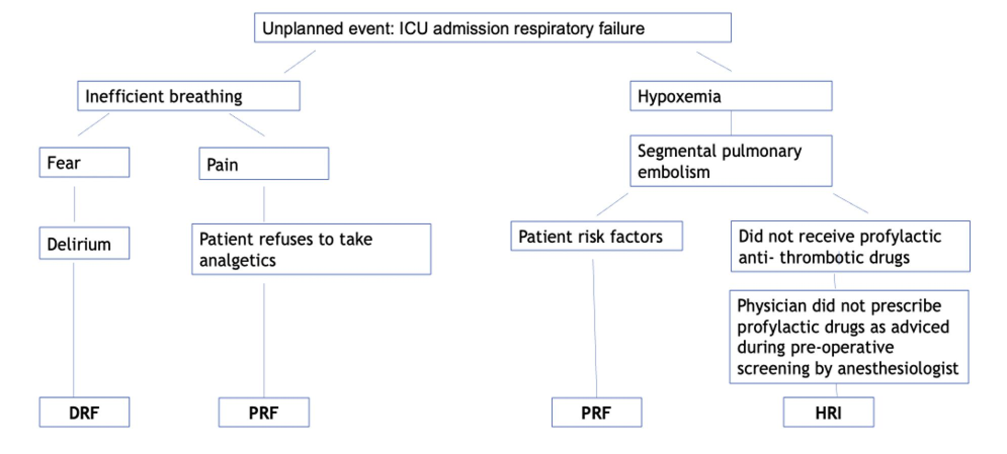
Figure A: An example of a causal tree according to the Prevention and Recovery Information System for Monitoring and Analysis (PRISMA) -medical method.
ICU= intensive care unit. DRF= disease related factor. PRF= patient related factor. HRI=human related factor.

Definitions of the Eindhoven classification model with examples.
Definitions of the Eindhoven classification model with examples
Main category | Subcategory | Code | Definition | Example
Technical | External | T-ex | Technical failures beyond the control of the organization. | -Vacuum wound pump was not working
 | Design | TD | Failures to poor design of equipment etc.
 | Construction | TC | Correct design inappropriately constructed or placed.
 | Materials | TM | Material defects not classified under TD or TC. | -Stiches broke from the abdominal drain
Organizational | External | O-ex | Failures at an organizational level beyond the control and responsibility of the investigating team.
 | Transfer of knowledge | OK | Failure resulting from inadequate measures to train or supervise new or inexperienced staff.
 | Protocols | OP | Failures relating to the quality or availability of appropriate protocols. | -Not following pain treatment protocol after surgery
 | Management priorities | OM | Internal management decisions which reduce focus on patient safety when faced with conflicting priorities. | -No bed available at ICU
 | Culture | OC | Failure due to attitude and approach of the treating organization.
Human | External | H-ex | Human failures beyond the control of the organization/department | -Impassable jejunal feeding tube as a consequence of inadequate flushing by the homecare nurse
 | Knowledge based behavior | HKK | Failure of an individual to apply their knowledge to a new clinical situation | -Physician gave another order to supply fluid despite non-responsiveness of the patient in urine production and tension.
 | Qualifications | HRQ | An inappropriately trained individual performing the clinical task
 | Coordination | HRC | A lack of task co-ordination within the healthcare team
 | Verification | HRV | Failure to correctly check and assess the situation before performing interventions
 | Intervention | HRI | Failure resulting from faulty task planning or performance | -No prescribed anticoagulation by the ward doctor like advised by anaesthesiologist
 | Monitoring | HRM | Failure to monitor the patient’s progress or condition
 | Skills-based | HSS | Failure in performance of highly developed skills | -Luxation wound catheter
Patient | Patient-related | PRF | Failures related to patient characteristics or conditions, which are beyond the control of staff and influence clinical progress | -Patient did not take prescribed medication
 | Disease-related | DRF | Failures related to the natural progress of disease which are beyond control of patient, its carers and staff | -Inflammation of the skin near the insertion of the abdominal drain,  -Biliary pancreatitis
X | Unclassifiable | X | X | -Origin of blood loss objectivated by the patient was not found
 |  | X-nrc | This root cause has no relation with the initial surgery nor rehabilitation after the initial surgery | -ER visit due to appendicitis or galstones
 |  | X-FIP | Failures related to the healthcare delivered by the family caregiver | -Detoriation or infection of wounds as a consequence of inadequate healthcare provided by the family caregiver .
Table A: Definitions of the Eindhoven classification model with examples

