Supplementary material

Molecular and cellular processes of deafferentation after plexus injury in human dorsal root ganglia

Authors: Annemarie Sodmann^{1,2, †}, Johannes Degenbeck^{1, †}, Annemarie Aue¹, Magnus Schindehütte³, Felicitas Schlott^{1,2}, Panagiota Arampatzi⁴, Thorsten Bischler⁴, Max Schneider⁵, Camelia Maria Monoranu⁶, Tom Gräfenhan⁴, Michael Bohnert⁷, Mirko Pham³, Gregor Antoniadis⁵, Robert Blum^{2,‡} and Heike L Rittner^{1,*,‡}
Affiliations:
¹University Hospital of Würzburg, Department of Anesthesiology, Intensive Care, Emergency Medicine and Pain Therapy, Centre for Interdisciplinary Pain Medicine; 97080 Würzburg, Germany.
² University Hospital of Würzburg, Department of Neurology; 97080 Würzburg, Germany.
³ University Hospital of Würzburg, Institute of Neuroradiology; 97080 Würzburg, Germany.
⁴ University of Würzburg, Core Unit Systems Medicine; 97080, Würzburg, Germany.
⁵ University of Ulm, Department of Neurosurgery, Peripheral Nerve Surgery Unit; 89312 Günzburg, Germany.
⁶ University of Würzburg, Institute of Pathology, Section Neuropathology; 97080 Würzburg, Germany.
⁷ University of Würzburg, Institute of Forensic Medicine; 97078 Würzburg, Germany.

†Annemarie Sodmann and Johannes Degenbeck share the first author position.
‡Robert Blum and Heike L. Rittner share the senior author position.
*Corresponding author: Univ.-Prof. Dr. med Heike Rittner, E-mail: Rittner_H@ukw.de

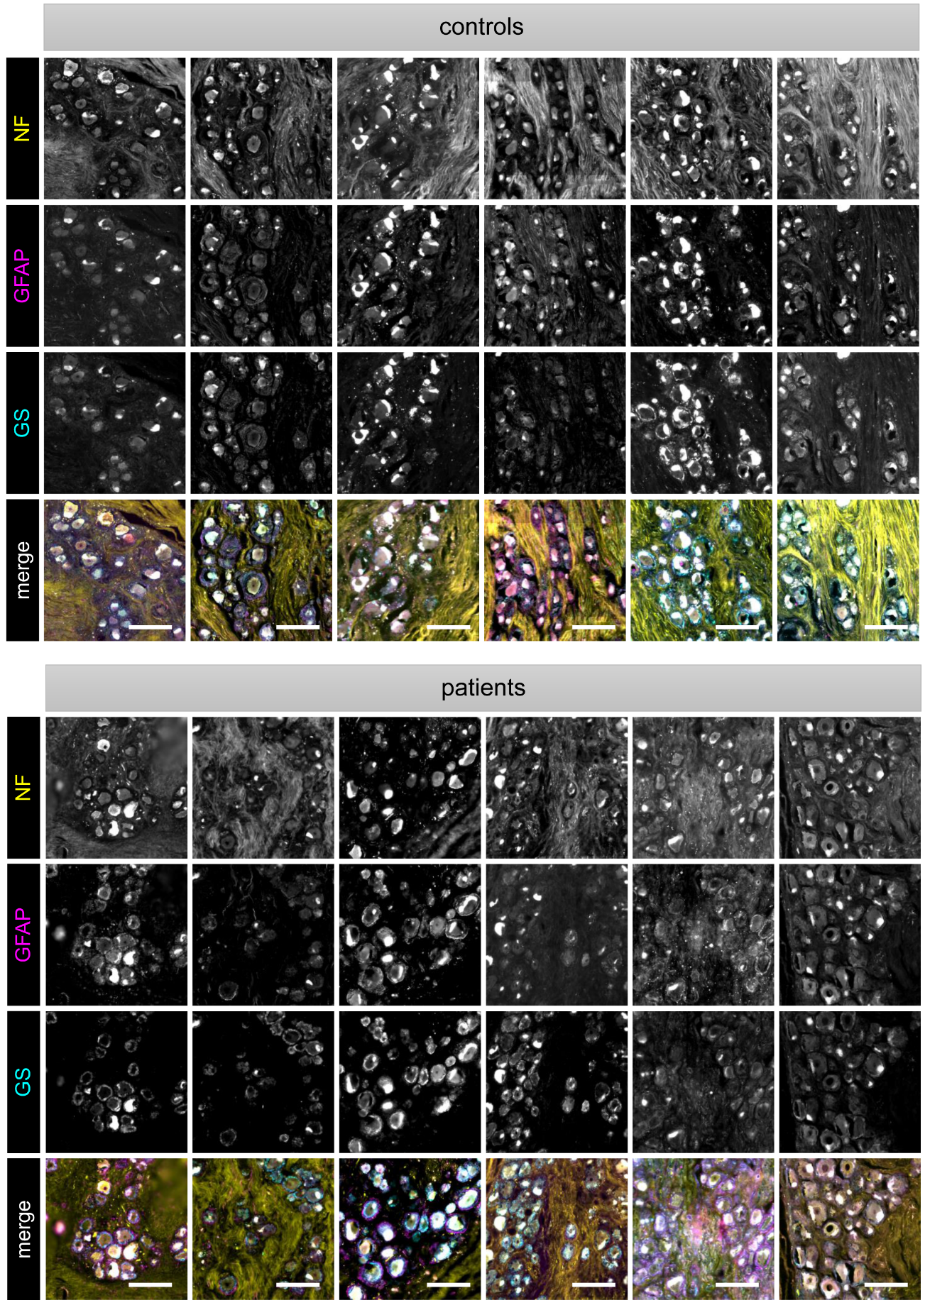
Fig. S1. Heterogeneity of immunoreactivity to GFAP and GS in human DRG slices. Sections of the six controls and six plexus injury patients from the ‘neuronal preservation’ group were stained for glial fibrillary acidic protein (GFAP) and glutamine synthetase (GS). Scale bar: 200 µm.

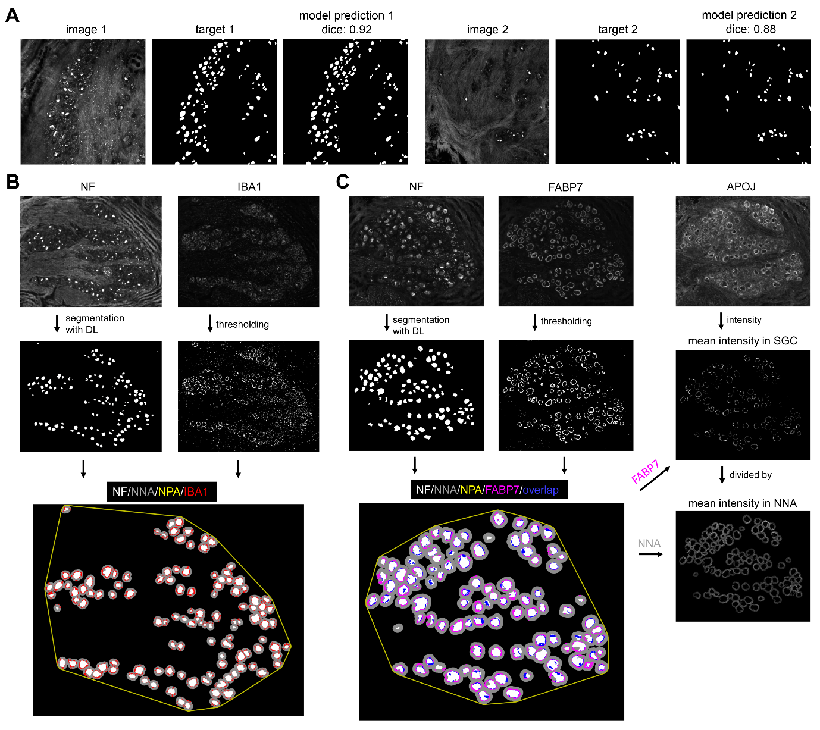
Fig. S2. Segmentation of neurons based on neurofilament stainings. (A) Performance of deep learning model ensembles for predicting neurofilament (NF) labels. Two exemplary test images are shown. Shown are NF images, their expert-annotated segmentation target (ground truth) and the corresponding model prediction. Similarity of target and model prediction was evaluated with the dice score. (B) NF in IBA1-labeled sections was segmented with the DL model ensemble. IBA1 was segmented with a thresholding method. Neurons (NF, white) were quantified in the neuronal polygon area (NPA, yellow), which was computed with a convex polygon around segmented neurons. The IBA1-positive area (red) was quantified inside and in relation to the neuron near area (NNA, grey). (C) Sections labeled for satellite glial cells (SGC) were analyzed for the FABP7-positive area and APOJ signal intensity. NF was segmented with the DL model ensemble and FABP7 with a thresholding method. NF-positive neurons (white) were quantified in relation to the neuronal polygon area (NPA, yellow). For FABP7, the signal-positive area per neuron near area (NNA) and the percentage of neurons in proximity to FABP7-positive SGC (overlap in blue), was determined. The APOJ intensity was calculated by dividing the mean intensity in FABP7-positive SGC by the mean intensity in the neuron near area (NNA).

Fig. S3: Variability in RNA expression of controls, neuronal loss, and neuronal preservation patients. (A) Principal component analysis (PCA) of all patient samples. (B-C) Expression of significantly up- and downregulated protein-coding genes. (D) Heat map showing expression levels of representative sensory neuron marker genes. RNA samples of neuronal loss patients (P13, P14). R7 (control) was excluded from detailed transcriptome analysis and histological investigations due to post-mortem tissue degradation (see Material and methods). Scale bar: Log2 TPM.

Table S1. Clinical characteristics of patients with ‘neuronal loss’ and ‘neuronal preservation’.
 | Neuronal preservation  (n = 6) | Neuronal loss  (n = 7)
Age (years) | 37.5 ± 14.3 | 32.3 ± 14.0
Sex | f: 1, m: 5 | f: 1, m: 6
Number of dorsal roots affected
Affected by all lesions | 4.5 ± 1.2 | 4.7 ± 0.5
Pain
Current pain (Numeric rating scale 0-10) | 3.7 ± 2.6 | 5.5 ± 1.6
Graded Chronic Pain Scale (GCPS) | 2.4 ± 1.5 | 3.0 ± 1.0
Disability and neuropathic pain
Disability arm, shoulder, and hand (DASH): total symptom score | 47.2 ± 21.9 | 54.6 ± 6.9
Disability arm, shoulder, and hand (DASH): work score | 68.8 ± 28.4 | 87.5 ± 15.3
Neuropathic pain symptom inventory (NPSI, 0-1) | 0.3 ± 0.3 | 0.3 ± 0.1
Psychiatric comorbidities
State-Trait Anxiety Inventory: State (STAI-S, 20-80) | 47.2 ± 15.7 | 44.1 ± 12.0
State-Trait Anxiety Inventory: Trait (STAI-T, 20-80) | 41.2 ± 17.7 | 42.1 ± 15.3
Beck depression inventory 2 (BDI, 20-63) | 15.2 ± 14.8 | 14.3 ± 14.5
Pain catastrophizing scale (PCS, 0-52) | 19.7 ± 12.1 | 24.9 ± 12.5
Treatment
Number of classes of analgesics | 1.8 ± 0.8 | 3.0 ± 1.3
Non-opioid analgesics | 4 | 7
Opioids | 1 | 3
Anticonvulsants | 4 | 5
Antidepressants | 2 | 5
Cannabinoids | 0 | 1
Both: anticonvulsants and antidepressants | 1 | 4
No analgesics | 0 | 0

Cut-offs see Table 2. Treatment refers to medication prescribed at hospital discharge after reconstructive surgery, multiple medications possible. All p > 0.05. Unpaired, two-tailed t-test or two-tailed Mann-Whitney test. All data are mean ± standard deviation.

Table S2. Postsurgical improvements.
 | T0 | T1
Current pain (Numeric rating scale 0-10) | 4.7 ± 2.3 | 3.9 ± 2.4
Disability and neuropathic pain
Disability arm, shoulder, and hand (DASH): work score, item 1 (1-5) | 5.0 ± 2.3 | 4.8 ± 2.7
Neuropathic pain symptom inventory (NPSI), item Q2 (squeezing, 0-10) | 2.3 ± 2.6 | 3.5 ± 3.2
Neuropathic pain symptom inventory (NPSI), item Q8  (pain evoked by brushing, 0-10) | 2.1 ± 3.1 | 3.7 ± 3.5
Neuropathic pain symptom inventory (NPSI), item Q12 (tingling, 0-10) | 3.8 ± 3.0 | 4.9 ± 3.6
Treatment
Number of classes of analgesics ¹ | 2.5 ± 1.2 | 1.5 ± 1.3
Functional aspects
Did you have any changes in sensitivity since surgery? (Rating scale 1-5) ² | n. a. | 2.3 ± 1.2

Cut-offs see Table 2. T0 = time point of surgery, T1 = time point of the telephone interview (10-30 months after surgery). All p > 0.05. Unpaired, two-tailed t-test or two-tailed Mann-Whitney test. All data are mean ± standard deviation.
¹ Classes of analgesics were non-opioid analgesics, opioids, anticonvulsants or antidepressants.
² 0 no improvement of sensitivity, 5 complete restorations of sensitivity

Table S3. Follow-up data of patients with ‘neuronal preservation’ and ‘neuronal loss’.
 | Neuronal preservation  (n = 6) | Neuronal loss  (n = 7)
Current pain (Numeric rating scale 0-10) | 2.6 ± 2.3 | 5.1 ± 1.8
Disability and neuropathic pain
Disability arm, shoulder, and hand (DASH): work score, item 1 (1-5) | 3.8 ± 0.9 | 3.6 ± 1.9
Disability arm, shoulder, and hand (DASH): symptom score, item 3 (Turn a key, 1-5) | 1.0 ± 0.0 | 1.0 ± 0.0
Disability arm, shoulder, and hand (DASH): symptom score, item 5 (Push open a heavy door, 1-5) | 1.3 ± 0.8 | 1.4 ± 1.1
Neuropathic pain symptom inventory (NPSI), item Q2 (squeezing, 0-10) | 3.5 ± 3.1 | 3.6 ± 3.5
Neuropathic pain symptom inventory (NPSI), item Q8  (pain evoked by brushing, 0-10) | 2.8 ± 3.4 | 4.5 ± 3.8
Neuropathic pain symptom inventory (NPSI), item Q12 (tingling, 0-10) | 5.1 ± 2.9 | 4.8 ± 4.4
Treatment
Number of classes of analgesics¹ | 1.0 ± 0.0 | 1.8 ± 1.5
Functional aspects
Did you have any changes in sensitivity since surgery? (Rating scale 1-5)² | 2.7 ± 1.4 | 2.1 ± 1.1

Treatment refers to medication prescribed at hospital discharge after reconstructive surgery, multiple medications possible. All p > 0.05. Unpaired, two-tailed t-test or two-tailed Mann-Whitney test. All data are mean ± standard deviation. Cut-offs see Table 2.
¹ Classes of analgesics were non-opioid analgesics, opioids, anticonvulsants or antidepressants.
² 0 no improvement of sensitivity, 5 complete restorations of sensitivity

Table S4. Ground truth estimation performance.
expert | average dice score | std dice score
1 | 0.945 | 0.013
2 | 0.931 | 0.015
3 | 0.856 | 0.030
mean | 0.911 | 0.019

Table S5. Model validation performance.
file | model no. | dice score | uncertainty score
0003.tif | 1 | 0.810 | 0.047
0007.tif | 1 | 0.865 | 0.042
0002.tif | 2 | 0.929 | 0.027
0009.tif | 2 | 0.930 | 0.030
0004.tif | 3 | 0.845 | 0.040
0006.tif | 3 | 0.870 | 0.039

Table S6. Primary and secondary antibodies.
Antibodies | Company | Cat. No. | RRID | Host | Concentra-tion | Dilution
Primary
Anti-APOJ | Abcam | ab39991 | AB_722878 | Goat | 0.5 mg/ml | 1:50
Anti-NFh | Millipore | AB5539 | AB_11212161 | Chicken | 0.5 mg/ml | 1:200
Anti-GS | BD Transduction | 610517 | AB_397879 | Mouse | 0.25 mg/ml | 1:200
Anti-GFAP | OriGene | DP-014 | AB_1001789 | Rabbit | N.A. | 1:100
Anti-FABP7 | Invitrogen | PA5-24949 | AB_2542449 | Rabbit | 0.29 mg/ml | 1:100
Anti-IBA1 | Fujifilm Wako | 019-19741 | AB_839504 | Rabbit | 0.5 mg/ml | 1:100
Anti-MAP2 | Sigma | M1406 | AB_477171 | Mouse | 0.5 mg/ml | 1:500
Secondary
Anti-chicken 488 | Jackson IR | 703-545-155 | AB_2340375 | Donkey | 0.5 mg/ml | 1:500
Anti-mouse Cy5 | Jackson IR | 715-175-150 | AB_2340819 | Donkey | 0.5 mg/ml | 1:500
Anti-rabbit Cy3 | Jackson IR | 711-165-152 | AB_2307443 | Donkey | 0.5 mg/ml | 1:500
Anti-goat 647 | Thermo Fisher | A21447 | AB_2535864 | Donkey | 0.89 mg/ml | 1:500

