Supporting Information
A Hollow-Tube-Like Hydrospongel for Magnetothermal-Chemo-Chemodynamic Therapies in Advanced Colorectal Cancer Patients
Tao Wu†, Tenghui Li†, Chengzhi Zhang, Yu Tian, Hao Li, Yuxin He, Xu Yan, Junhua Zhao*, Tianxing Gong*, Zhenning Wang*

¹College of Medicine and Biological Information Engineering, Northeastern University; Shenyang, China.
²Department of Surgical Oncology and General Surgery, The First Hospital of China Medical University; Shenyang, China.
³Key Laboratory of Precision Diagnosis and Treatment of Gastrointestinal Tumors, Ministry of Education, China Medical University; Shenyang, China.
⁴Department of Biomedical Engineering, Shenyang University of Technology; Shenyang, China.
⁵Department of Critical Care Medicine, The First Hospital of China Medical University; Shenyang, China.
⁶The VIP Department, School and Hospital of Stomatology, China Medical University, Liaoning Provincial Key Laboratory of Oral Diseases; Shenyang, China
*Corresponding author Email: znwang@cmu.edu.cn (Z.N.W.); tianx.gong@gmail.com (T.X.G.); jhzhao@cmu.edu.cn (J.H.Z.).
†These authors contributed equally to this work.

Table of Contents
Supplementary Experimental Procedures .............................................................. 3
Supplementary Figures .............................................................................................10
Supplementary Tables .............................................................................................. 15

Supplementary Experimental Procedures
Materials
Ferrous chloride tetrahydrate (FeCl₂·4H₂O), ferric chloride hexahydrate (FeCl₃·6H₂O), and ammonium hydroxide (NH₄OH) 25% solution were purchased from Sinopharm Chemical Reagent Co., Ltd (China). Tris (hydroxymethyl) aminomethane (Tris), dopamine hydrochloride (DA), 3,3′,5,5′-tetramethylbenzidine dihydrochloride hydrate (TMB), hydrogen peroxide solution, lysozyme (≥20000 U/mg) and 5-fluorouracil (5-FU) were obtained from Aladdin (China). Carboxylated cellulose nanofiber (CNF-C, diameter: 4−10 nm, length: 200 nm) was purchased from Macklin (China), and 1-ethyl-3-(3-dimethyl aminopropyl) carbodiimide hydrochloride (EDC) and N-Hydroxysuccinimide (NHS) were purchased from Sigma-Aldrich (U.S.A.). McCoy's 5A medium and fetal bovine serum (FBS) were purchased from Procell Life Science & Technology (China). Phosphate buffered solution (PBS) was purchased from GeneZe (China). The Cell Counting Kit-8 (CCK-8) was purchased from Dojindo Laboratories (Japan). The Total Protein Extraction Kit, bicinchoninic acid (BCA) kit, SDS-polyacrylamide gel electrophoresis (SDS-PAGE), and Annexin V-APC/PI apoptosis detection kit were purchased from KeyGen Biotech (China). Polyvinyl difluoride (PVDF) membranes were purchased from Millipore (U.S.A.). Sodium citrate buffer was purchased from MXB Biotechnologies (China). 2'7'-dichlorofluorescein diacetate (DCFH-DA) was purchased from Sigma-Aldrich (U.S.A.). Dimethyl sulfoxide (DMSO) and EDTA-free trypsin were procured from Solarbio (China). Glyceraldehyde 3-phosphate dehydrogenase monoclonal antibody (GAPDH, 60004-1-Ig) and HSP70 polyclonal antibody (10995-1-AP) were purchased from Proteintech (China). An anti-KI67 antibody (KI67, ab15580), anti-glutathione peroxidase 4 antibody (GPX4, ab125066), anti-pan Cytokeratin antibody (CK, ab7753), and hematoxylin were purchased from Abcam (U.K.). Human epidermal growth factor receptor 2 monoclonal antibody (HER2, 40419) was purchased from Signalway Antibody (U.S.A.). MutL homologue 1 monoclonal antibody (MLH1, YM0443) was purchased from Immunoway Biotechnology Company (China), and anti-Cleaved Caspase 3 antibody (Cleaved Caspase 3, 9446s) was purchased from Cell Signaling Technology (U.S.A.). Goat anti-mouse IgG antibody, goat anti-rabbit IgG antibody, 3,3 N-Diaminobenzidine Tetrahydrochloride (DAB) and ABC (Avidin-Biotin Complex) Kits were provided by Vector Laboratories (U.S.A.). Eosin solution and hydrochloric acid ethanol (HCl/EtOH) were purchased from Servicebio (China).
Synthesis of Fe₃O₄ and Fe₃O₄@PDA NPs
Fe₃O₄ NPs were synthesized using the co-precipitation method. In brief, 0.6958 g of FeCl₂·4H₂O and 1.8921 g of FeCl₃·6H₂O were added to 150 mL of deionized water and stirred at ambient temperature under a nitrogen atmosphere until completely dissolved. 10 mL of ammonium hydroxide was then rapidly added to the solution and stirred at 80°C for 1 h. After the solution was cooled to room temperature, precipitated particles were collected using a permanent magnet and washed three times with deionized water, followed by lyophilization to obtain Fe₃O₄ NPs.
The as-prepared Fe₃O₄ NPs (10 mg) were added to 50 mL of Tris-HCl solution (10 mM, pH = 8.5) and sonicated for 10 min to disperse homogeneously. Subsequently, 10 mg of DA was added to the solution and stirred in the dark. After 8 h, the NPs were collected using a magnet, washed three times with deionized water, and then lyophilized to obtain Fe₃O₄@PDA NPs. Pure PDA NPs without Fe₃O₄ were prepared using the same method.
Characterization of Fe₃O₄ and Fe₃O₄@PDA NPs
The UV-Vis spectra of nanoparticle aqueous solutions (1mg/mL) were measured by a microplate reader (CLARIOstar, BMG, Germany) to determine the absorption capacity in the near-infrared (NIR) region. The morphology of the NPs was observed using a transmission electron microscope (TEM, JEM-2100F, JEOL, Japan), and the hydrodynamic size and zeta potential were measured using a zetasizer (Nano ZS90, Malvern, UK). Fourier transform infrared spectra (FTIR) of the NPs were collected using an FTIR spectrometer (Nicolet iS50, Thermo Fisher Scientific, U.S.A.). The X-ray diffraction (XRD) patterns of NPs were recorded using an XRD spectrometer (SmartLab SE, Rigaku, Japan) using Cu Kα radiation (2θ = 5–90°). The X-ray photoelectron spectra (XPS) were acquired using an XPS spectrometer (ESCALAB 250Xi, Thermo Fisher Scientific, U.S.A.) with monochromatic Al Kα radiation. The magnetic properties of the NPs were characterized by a superconducting quantum interference device-vibrating sample magnetometer (SQUID-VSM, MPMS3, Quantum Design, U.S.A.) at the temperature of 300 K.
Reactive oxygen species (•OH) generation assessment
TMB oxidation assay was performed to evaluate the generation of •OH by the Fenton reaction between NPs and H₂O₂. In brief, 1 mg of NPs was added to 4 mL of PBS solution (pH = 6.0) containing TMB (0.5 mg/mL) and H₂O₂ (1 mM). After incubation for 60 min at 37 °C, the solution was centrifuged, and the absorbance of the supernatant at 665 nm was measured using a microplate reader. PBS solution without NPs or H₂O₂ served as the control.
Preparation of hydrospongels and HTHSG
The prepared Fe₃O₄@PDA NPs were added to 5 mL of deionized water and sonicated for 5 min. CNF-C (0.2 g), EDC (0.115 g) and NHS (0.023 g) were then added, stirred evenly, and injected into the mold (cube with 10 mm side length). All steps were carried out in an ice bath (2–4℃) to avoid rapid crosslinking reactions. The cross-linked hydrogels were swelled in deionized water for 24 h and then lyophilized at -60°C for 24 h using a vacuum freeze dryer (FD-150, Biocool, China) to obtain lyophilized hydrospongels. In addition, the lyophilized HTHSG was prepared following the same procedures except for using a 3D-printed mold.
Characterization of hydrospongels
The swelling capacity was assessed by recording the weight change of the lyophilized hydrospongels in PBS (pH=7.4) at 37°C for 1 h. The mechanical properties of the swollen hydrospongels were analyzed using a universal testing system (Instron 5944, U.S.A.), and the compressive modulus and fracture toughness were determined using the stress-strain curve. To investigate the hydrospongels' magnetothermal properties with different nanoparticle concentrations, swollen hydrospongels were placed in an alternating magnetic field (AMF, 255 kHz) for 10 min. The infrared thermal images and temperature change (ΔT) were recorded using an infrared thermography camera (FLIR ONE Edge, U.S.A.).
Characterization of HTHSG
The FTIR spectra of HTHSG were collected using an FTIR spectrometer, and the morphology of HTHSG was performed on scanning electron microscopy (SEM, Regulus 8100, Hitachi, Japan). The elemental composition and distribution of HTHSG were recorded by energy-dispersive X-ray spectroscopy (EDS, Octane Elect, EDAX, U.S.A.). The HTHSG's capacity to produce •OH by Fenton reaction was assessed using the TMB oxidation assay. Briefly, 10 mg of lyophilized HTHSG was placed into 4 mL of PBS solution (pH = 6.0) containing TMB (0.5 mg/mL) and H₂O₂ (1 mM) and incubated at 37°C and 45°C, respectively. The absorbance at 665 nm was measured at different endpoints (10, 30, and 60 min).
Degradation
The lyophilized HTHSG was weighed (W_{d}) then immersed in PBS (pH = 7.4) containing lysozyme (1 mg/mL) and incubated at 37℃. Every 2 days, the solution was replaced with a fresh one, and the HTHSG was placed in an AMF for 10 min. The remaining mass of the HTHSG was weighed (W_{s}) after freeze-drying, and the weight change was calculated by the following equation (Eq. 1):
Weight change (%) = (W_{s} – W_{d})/ W_{s} × 100% (Eq. 1)
Drug loading and release
The 5-FU solution (5 mg/mL in deionized water) was injected into a lyophilized HTHSG to obtain a drug-loaded HTHSG. The drug-loaded HTHSG was then immersed in 40 mL of PBS solution at 37°C, and the PBS solution was replaced with fresh one at different endpoints. The absorbance of the releasing medium at 266 nm was measured using a UV-Vis spectrophotometer (AQ8100, Thermo Orion, U.S.A.), and the release ratio of 5-FU was determined using a standard curve obtained by fitting the absorbances of seven known 5-FU concentrations.
Cell culture
The HCT-116 cancer cell line was purchased from KeyGen Biotech (China). HCT-116 cancer cells were cultured in McCoy's 5A medium supplemented with 10% FBS in an incubator containing 5% CO₂ at 37℃.
Cell counting kit-8 (CCK-8) assay
The CCK-8 assay was used to determine cell viability. Briefly, the HCT-116 cells were seeded in a 96-well plate with a density of 1×10⁴ cells per well. A 0.3 mg HTHSG sample was placed in each well. At different endpoints (0, 12, 24, 48, and 72 h), the CCK-8 reagent was added to the medium at a ratio of 1:10, then the optical density (OD) was determined 1 h later using a SpectraMax Absorbance Reader (Molecular Devices, U.S.A.) at a wavelength of 450 nm. Five parallel wells were analyzed in each group, and the experiment was repeated 3 times.
Flow cytometry
HCT-116 cells were cultured in a 6-well plate with a density of 1 × 10⁶ per well. A 6 mg HTHSG sample was placed in each well for 24 h. According to the manufacturer's instructions, apoptotic cells were stained using Annexin V-APC and propidium iodide. The apoptosis rate in HCT-116 cells was analyzed using a flow cytometer (Accuri C6, BD Biosciences, U.S.A.). The results were expressed as the percentage of apoptotic cells in total cells. The experiment was repeated 3 times.
DCFH-DA fluorescent staining
The cells were seeded in a 6-well plate at a density of 1×10⁶ cells/well, and a 6 mg HTHSG sample was added to the medium. After 12 h, 0.4 μL of DCFH-DA/DMSO solution (25 mg/mL) was added to the medium for cell staining. After 3 min, the cells were washed with PBS and stained with DAPI for 15 min. The fluorescence images were observed using an inverted microscope (DMi8, Leica, Germany.) at excitation and emission wavelengths of 469 nm and 525 nm, respectively.
Western blotting
Western blotting was used to detect the expression of intracellular proteins. In short, the total protein of HCT-116 cancer cells was extracted using a Total Protein Extraction kit. The protein concentration was determined using a BCA Protein Assay kit. The proteins were separated by SDS-polyacrylamide gel electrophoresis (SDS-PAGE) and transferred to a PVDF membrane. After blocked using non-fat milk (5%), the membranes were incubated with specific primary antibodies overnight at 4℃ followed by secondary antibodies at room temperature for 1 h. Finally, the membranes were imaged using AmershamTM ImageQuantTM 800 Western blot imaging systems (Cytiva, U.S.A.). The GAPDH antibody was the control for total protein input. The western blotting analysis was repeated three times. The primary antibodies used were as follows: anti-glutathione peroxidase 4 (1:1000, Abcam), anti-Cleaved Caspase 3 (1:1000, Cell Signaling Technology), anti-HSP70 (1:1000, Proteintech) and anti-GAPDH (1:1000, Proteintech).
Cell-derived xenograft (CDX) and patient-derived xenograft (PDX) model preparation
For the CDX model preparation, 2×10⁶ HCT-116 cells in 0.2 mL PBS were subcutaneously injected into the right buttock of the BALB/c nude mice. When the tumor tissue grew to 1000 mm³, it was evenly subdivided into three parts and implanted in another three mice. The mice were then divided into 3 groups: the control group, the 5-FU group, and the CFP20+5-FU group. Mice in the control group were intraperitoneally injected with 100 μL PBS (three times a week). Mice in the 5-FU group were intraperitoneally injected with 100 μL 5-FU solution (25 mg/kg, thrice a week). Mice in the CFP20+5-FU group were implanted with 15 mg CFP20+5-FU hydrospongel around the tumor tissue. All mice were exposed to AMF after anesthesia on days 1, 3, 5, 7, 9, and 11, and the temperature change at the tumor site was recorded using an infrared thermography camera. All mice were sacrificed on the 7th day after treatment and tumor volume ((length × width²)/2) and tumor weight were recorded. The tumor tissues and major organs (heart, liver, spleen, lung, and kidney) were removed and fixed in a 4% formaldehyde solution for subsequent analyses.
For the PDX model, the tumor tissues from CRC patients were preserved in an ice-cold culture medium, and 0.3 g tumor tissue was implanted subcutaneously into the right buttock of the BALB/c nude mice. The subsequent treatments were the same as in the CDX model preparation.
Immunohistochemistry and H&E staining
Fixed tissues were embedded in paraffin and cut into 4 μm thick slices for immunohistochemistry staining. Paraffin sections were heated at 67℃ for 1 h. After routine deparaffinization and rehydration in xylene and an ethanol gradient, antigen retrieval was performed in a 121℃ high-pressure boiler with a 0.01 M sodium citrate buffer. Tissue sections were blocked with 5% BSA and incubated with specific primary antibodies (CK, KI67, MLH1, HER2, GPX4, Cleaved Caspase 3, and HSP70) overnight at 4℃. Next, the tissue sections were incubated with corresponding secondary antibodies at room temperature for 1 h and stained with DAB. Finally, the tissue slices were counterstained with hematoxylin and colored with lithium carbonate. For H&E staining, after deparaffinization and rehydration, the tissue sections were first stained with hematoxylin for 2 min and then placed in an HCl/EtOH solution (v/v, 1%) for 3 s. Subsequently, the slices were stained again using eosin for 1 min and rinsed with tap water for 5 min. All stained sections were scanned using a slide scanner (Axioscan 7, ZEISS, Germany).
Supplementary Figures
Supplementary Fig. 1 | Detailed dimensions of the 3D-printed mold.

Supplementary Fig. 2 | The UV-Vis spectra of Fe₃O₄ and Fe₃O₄@PDA NPs in aqueous solution.

Supplementary Fig. 3 | The FTIR spectra of Fe₃O₄ and Fe₃O₄@PDA NPs.

Supplementary Fig. 4 | The compressive stress-strain curves of the swollen hydrospongels (n = 5).

Supplementary Fig. 5 | FTIR spectra of CNF-C, PDA, CP10, and CFP20.
Supplementary Fig. 6 | The EDS spectra of CP10 and CFP20.

Supplementary Fig. 7 | Images of the swollen CFP20 hollow tube before and after compression by weights.

Supplementary Fig. 8 | Degradation behavior of CFP20 hollow tube under different conditions over 20 d.

Supplementary Fig. 9 | UV-Vis spectra of different 5-FU solutions and the standard curve fitted according to the absorbance at 266 nm (insert).

Supplementary Fig. 10 | The release profile of 5-FU from the CFP20 hollow tube within 60 min.

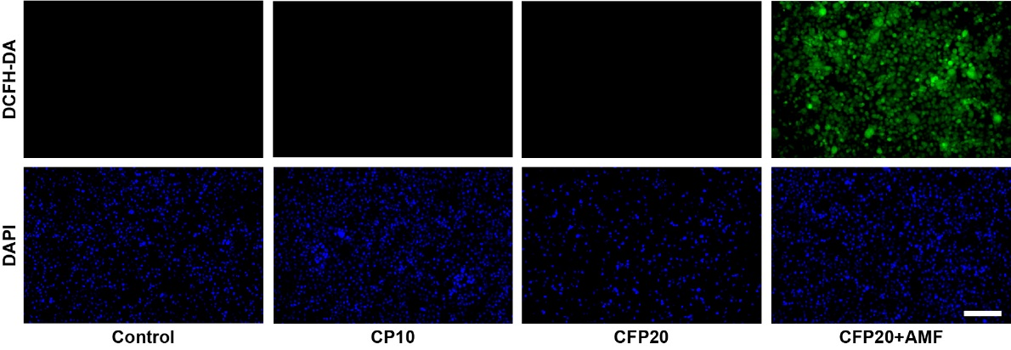
Supplementary Fig. 11. Representative images of DAPI and DCFH-DA stained HCT-116 cells to detect the intracellular •OH across control, CP10, CFP20, and CFP20+AMF groups. Scale bars: 100 μm.

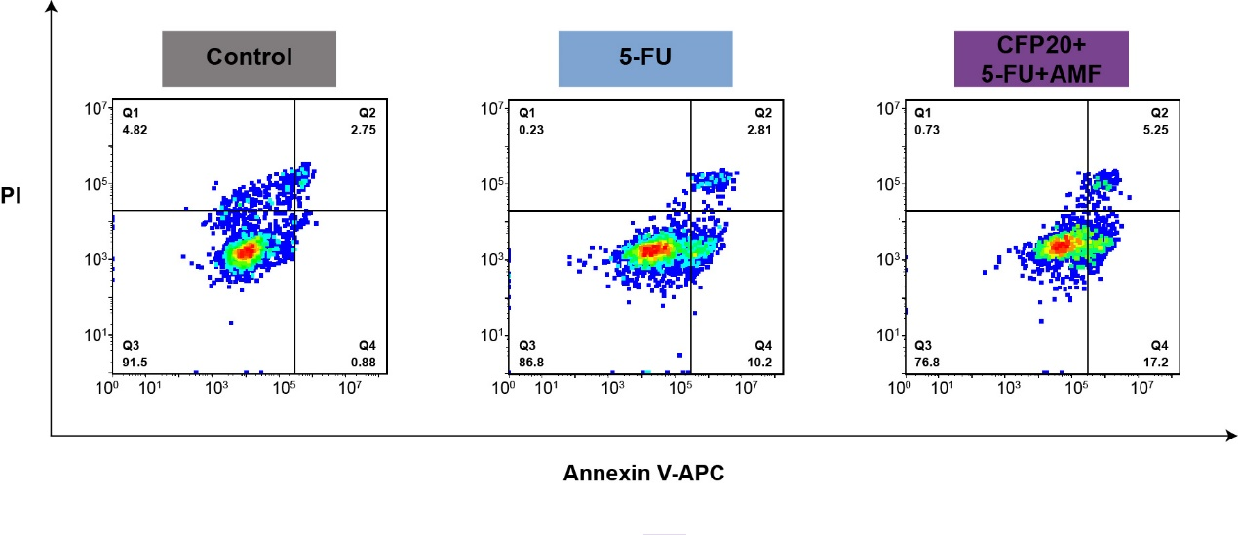
Supplementary Fig. 12 | Apoptosis of HCT-116 cells in the control group, 5-FU group, and CFP20+5-FU+AMF group was analyzed by Annexin V-APC and PI staining. The apoptosis percentage (%) is the proportion of Q2 + Q4 to total cells.
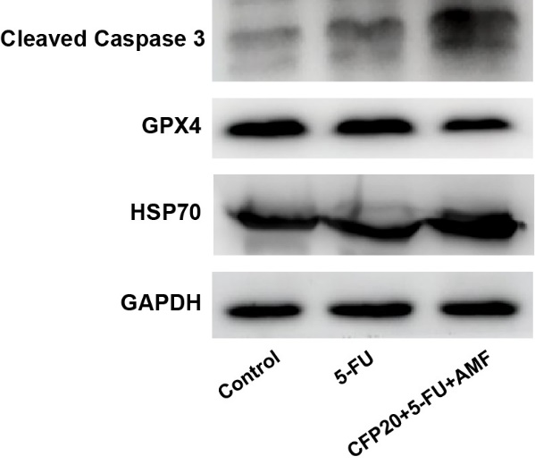
Supplementary Fig. 13 | Western blotting assay of the intracellular Cleaved Caspase 3, GPX4, and HSP70 expression in the control group, 5-FU group, and CFP20+5-FU+AMF group, respectively (n = 3).

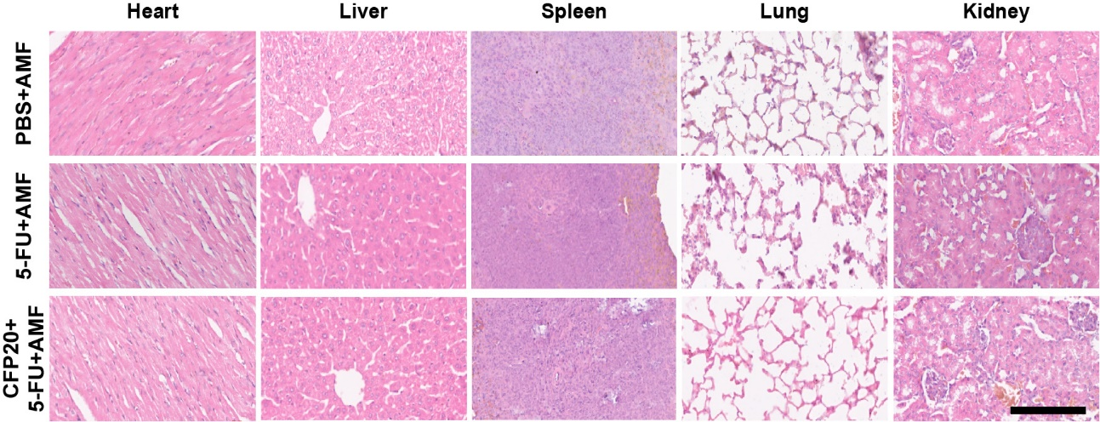
Supplementary Fig. 14 | Representative H&E staining images of major organs including heart, liver, spleen, lung, and kidney of each group in CDX tumor-bearing mice. Scale bar: 100 μm.

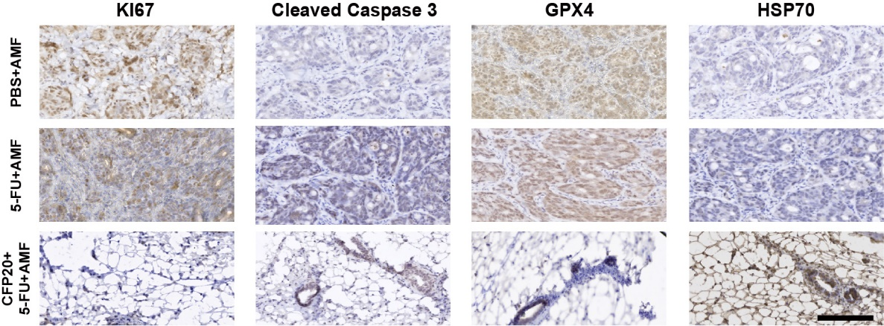
Supplementary Fig. 15 | Immunohistochemical analysis of KI-67, Cleaved Caspase 3, GPX4, and HSP70 of PDX tumor slices in different groups. Scale bar: 100 μm.
Supplementary Tables
Supplementary Table 1. Summary of patient sample information.
Patient | P1 | P2 | P3
Age | 79 | 56 | 62
Sex | Female | Female | Male
Cancer type | Colorectal cancer | Colorectal cancer | Colorectal cancer
Cancer location | Ascending colon | Sigmoid colon | Rectum
Histological type | Moderately differentiated tubular adenocarcinoma | Moderately-poorly differentiated adenocarcinoma | Poorly differentiated adenocarcinoma with moderately differentiated tubular adenocarcinoma
T stage¹ | T3 | T3 | T4a
N stage² | N0 | N0 | N0
M stage³ | M0 | M0 | M0
pathologic AJCC stage⁴ | ⅡB | IIA | IIB
Immunohistochemistry | CK-pan (+); Ki67 (+); HER2:0; MLH1 (+) | CK-pan (+); Ki67 (+); HER2:0; MLH1 (+) | CK-pan (+); Ki67 (+); HER2:0; MLH1 (+)
Note: 1. T stage: the extent of the primary tumor (for CRC and GC). 2. N stage: the extent of regional lymph node involvement. 3. M stage: the absence or presence of distant metastases in sites and/or organs outside the local tumor area and regional nodes. 4. AJCC Stages: American Joint Committee on Cancer (AJCC) TNM staging system.

