Supplementary Material.

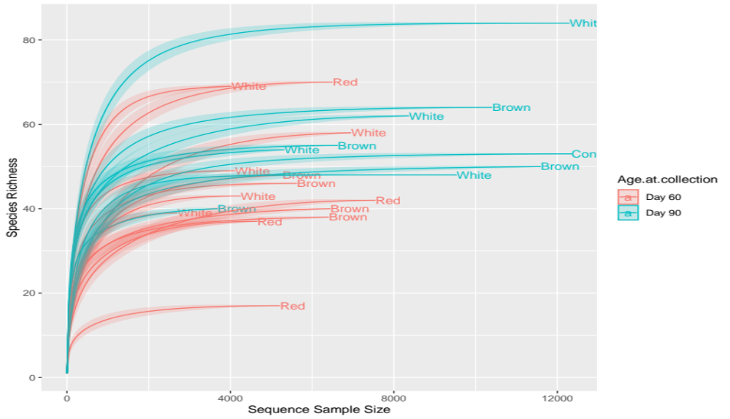
Figure S1: Abundance of bacterial present amongst chicken offered diets formulated with red, brown and white sorghum varieties at days 60 and 90.

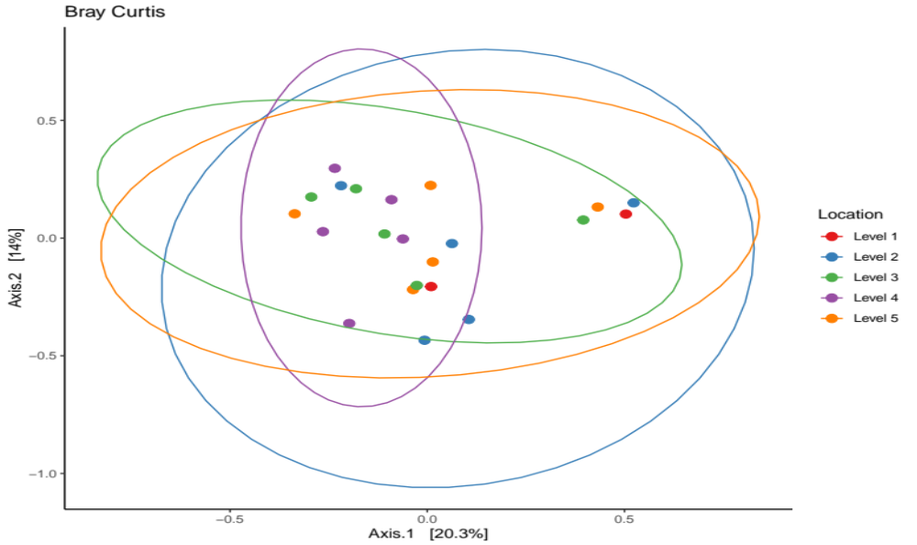
Inclusion levels

Level 1 = 0; Level 2 = 25%; Level 3 = 50%; Level 4 = 75%; Level 5 = 100%.
Figure S2: Principal coordinate analysis (PCoA) based on unweight UnFrac distances amongst Boschveld chickens fed a sorghum base diet at the inclusion levels.

