supplemental document

Experimental method
The femtosecond laser light source used is a high-performance fiber femtosecond laser developed by German Active Fiber System Company. The laser parameters are shown in Table S1. The laser processing system is mainly composed of femtosecond laser, five-axis motion mechanism, vibrating mirror system, optical system, control system and dust collection system. Table S1 shows the parameters of femtosecond laser equipment, and Fig. S1 shows the physical object and structure of femtosecond processing equipment.
(a) Physical drawing (b) Scanning electron microscope drawing
Fig. S1. Gas diffusion layer sample.
Table S1. Femtosecond Laser Equipment Parameters
subject | numerical value
laser  Laser wavelength  Maximum power  Maximum single pulse energy  pulse repetition frequency  pulse width  Energy stability  Beam quality | Activefiber  1064 nm  80 W  200 μJ  500 kHz (frequency division)  ＞10 fs  ≤ 2% rms  M2＜1.3

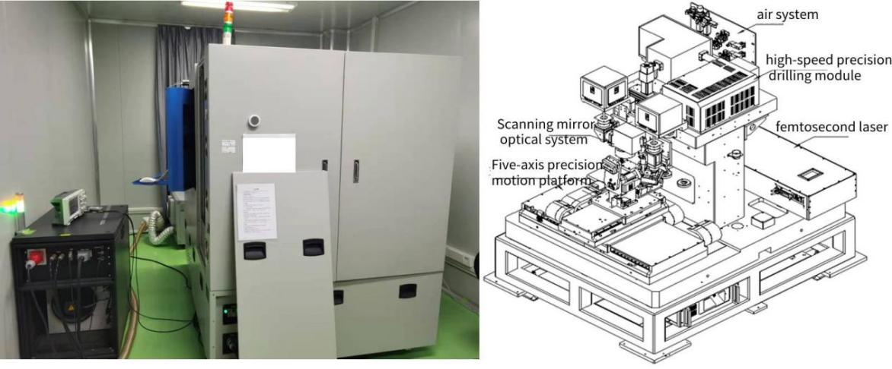
- Physical picture (b) schematic diagram
Fig. S2. Femtosecond processing Equipment.

Simulation method
The material parameters after homogenization of CFRP are shown in Table S2. The phase change model is coupled with the two-temperature model, and the evaporation rate is calculated and introduced into the deformation geometry. The schematic diagram of the model is shown in Fig. S3.
Table S2. Physical parameters related to CFRP of carbon fiber composites
Parameter | Carbon fibre | Epoxy | Homogeneous material
Volume fraction | 60% | 40% | -
Density | 1850 Kg/m^3 | 1250 Kg/m^3 | 1610 Kg/m^3
Melting point | 3000 °C | 230 °C | 1892 °C
Thermal conductivity | 50 W/(m °C) along the axial direction | 0.1 W/(m°C) | 30.04 W/(m°C)
Thermal conductivity | Vertical axis 5 W/(m °C) | 0.1W/(m°C) | 0.2427 W/(m°C)
Sublimation temperature | 3750 °C | 82 °C | 2282.8 °C
Latent heat of phase change | 43000 kJ/kg | 1000 kJ/kg | 26200 kJ/kg
Tensile strength | 3750 Mpa | 60 Mpa | 2274 Mpa
Vaporization temperature | 3500 °C | 600 °C | 2340 °C

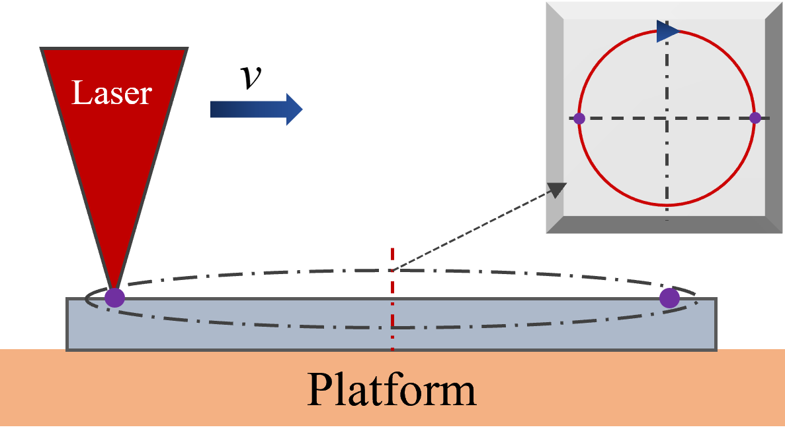
Fig. S3. Schematic diagram of the model.

Grid independence test
The moving mesh is solved smoothly by deformed geometry and hyperelastic mesh. However, the method of grid division in computational domain is directly related to the number and quality of grids in the model, and the quality of grids has a certain influence on the results of numerical simulation prediction. Therefore, in this paper, the grid independence of the calculation model is verified by investigating the laser power of 3 W, the pulse width of 270 fs, the repetition frequency of 100 kHz and the initial temperature of 300 K. The results of the maximum lattice temperature under a single pulse are shown in Table S3.

Table S3. Research on Grid Independence Test
Maximum cell size of grid /μm | Grid number | Maximum lattice temperature /K
2.4 | 727 | 4127.1
1.8 | 1186 | 4274.2
1.4 | 1939 | 4530.1
0.8 | 6038 | 4549.7
As can be seen from Table S3, when the maximum cell size of the grid is less than 1.4 μm, it has little influence on the results of the calculation model, and ensures the simulation accuracy while reducing the amount of calculation. In this paper, the grid number is 1939, in which the minimum cell size is 0.003 μm, the maximum cell size is 1.4 μm, the average cell mass of all domains is 0.9386, and the grid consists of 1939 linear triangular cells and 229 edge cells.

