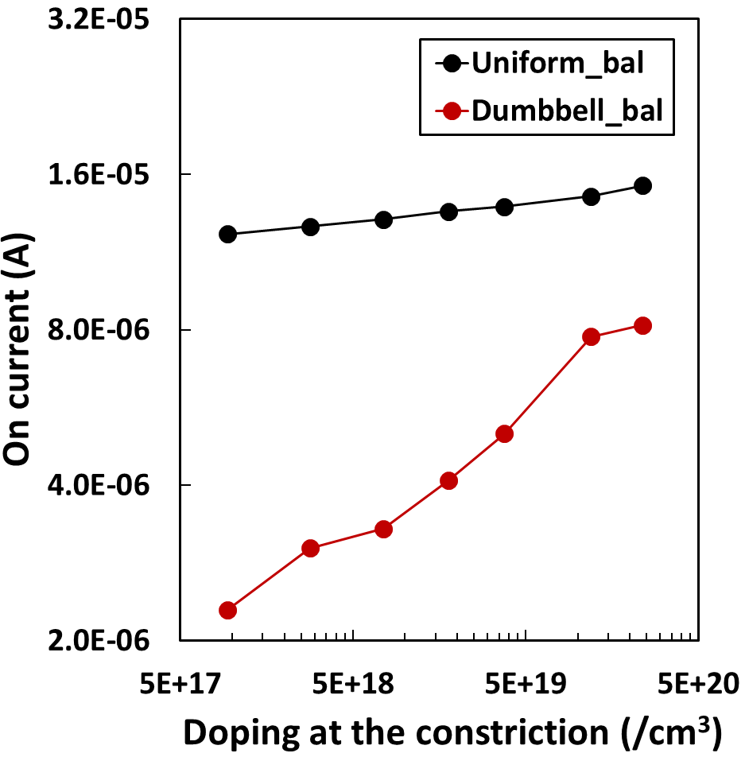
Ext.Fig.1. Ballistic current calculated with the exactly same electrostatic potential obtained from the scattering calculation. In this case, even at high constriction doping densities, there is a large on-current difference between dumbbell-shaped/uniform-shaped devices.
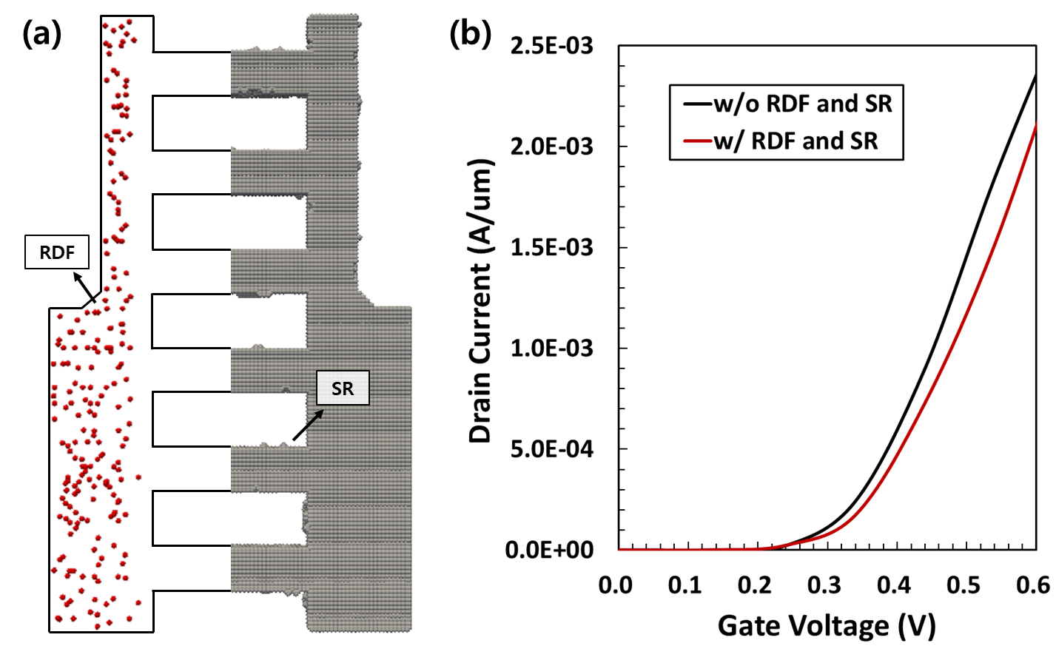
Ext.Fig.2. (a) Configuration of RDF and SR in 2.5D simulation. By applying a periodic boundary condition to the thin 2.4 nm slab, the computational time can be significantly reduced compared to a realistic three-dimensional simulation. (b) There is no significant on-current difference between including SR and RDF compared to not including them.
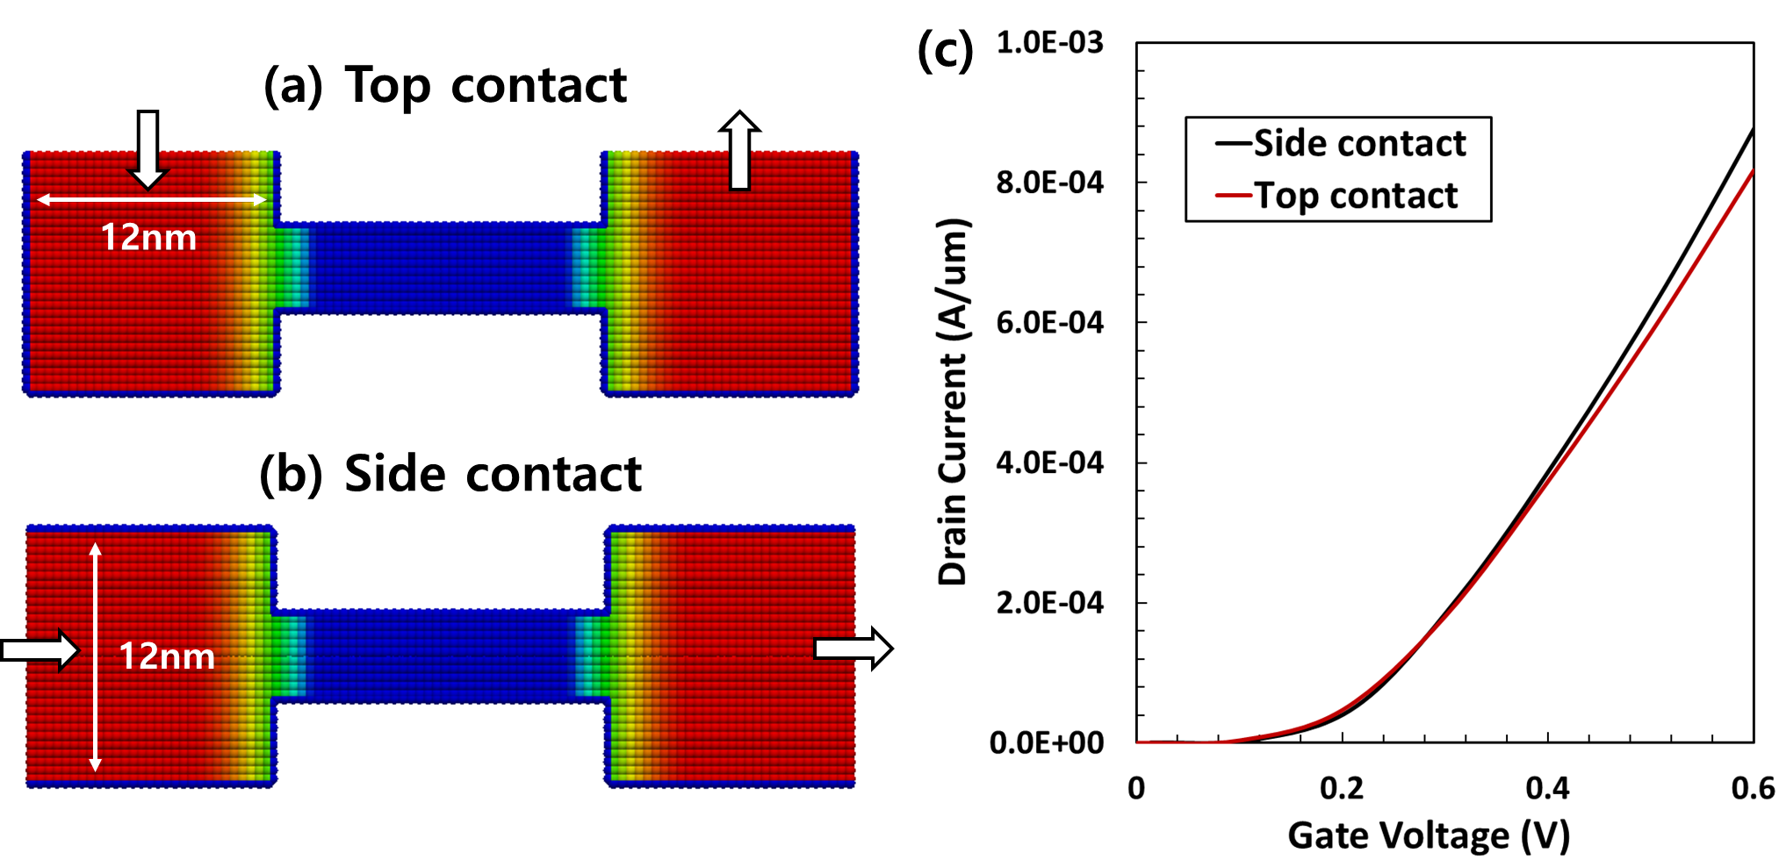
Ext.Fig.3. (a) Top contact / (b) side contact devices and (c) its drain-current vs gate-voltage characteristic (V_{DS} = 0.6V). Top contact device has lower drain current than side contact device. It clearly shows that the difference in the current path affects the parasitic resistance. To ensure the most fair comparison, the contact area was set to be the same (12nm).
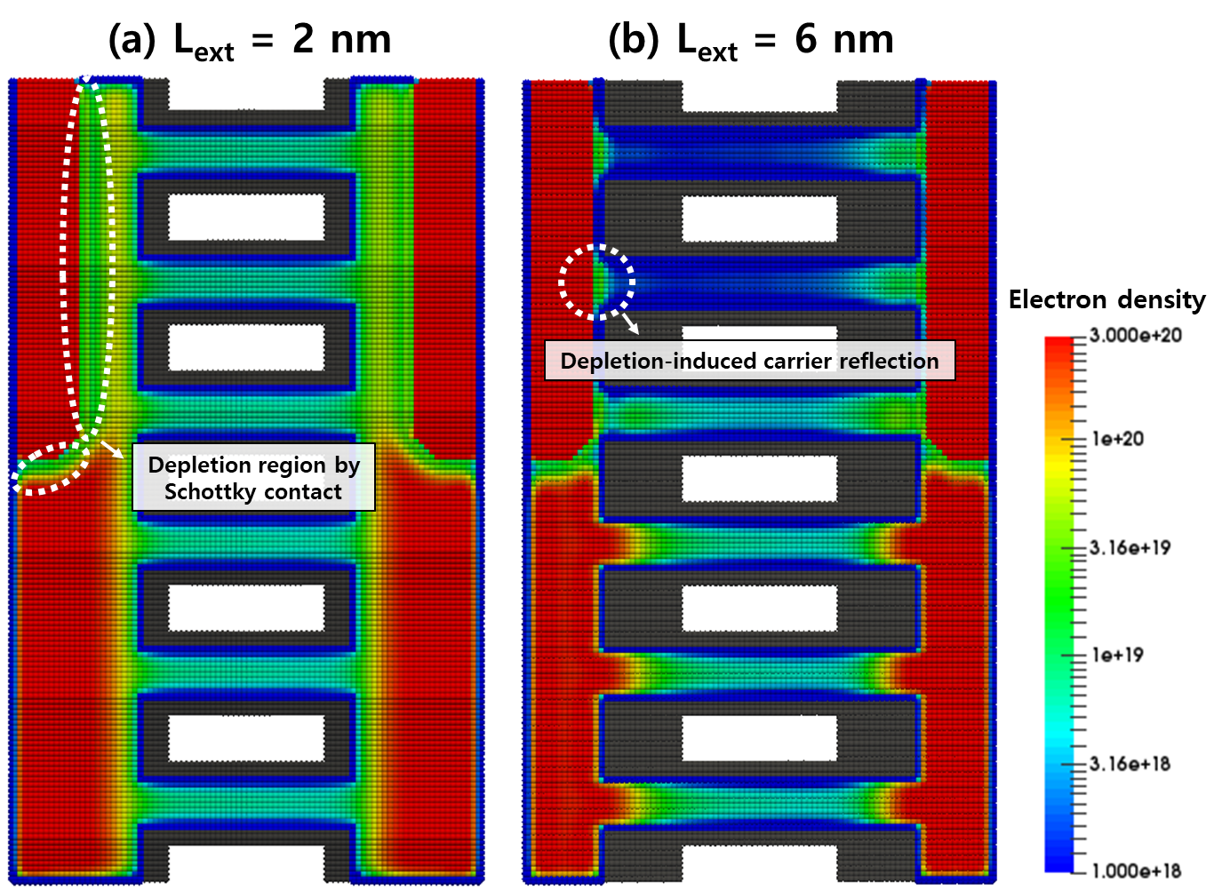
Ext.Fig.4. On-state (V_{DS}=V_{GS}=0.6V) electron density for (a) short NS extension (L_{ext}=2nm) device and (b) long NS extension (L_{ext}=4nm) device. The depletion region due to the Schottky barrier affects the carrier injection at the constriction. In particular, in long L_{ext} devices, the NS entrance is located deep in the depletion region and the carrier reflection is maximized.

