Table 2. C-reactive protein quartiles in relation to disease-free survival and overall survival in breast cancer patients
Disease-free survival
 | Person-years | Number of events | Incidence rate per 1000 person-years (95% CI) | Crude hazard ratio [95% CI] (N=2,673) | Adjusted hazard ratio [95% CI]ª (N=2,485)
Q1 | 3871 | 70 | 18.08 (14.30-22.85) | 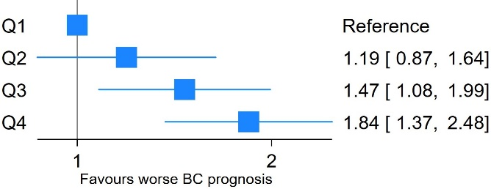 | 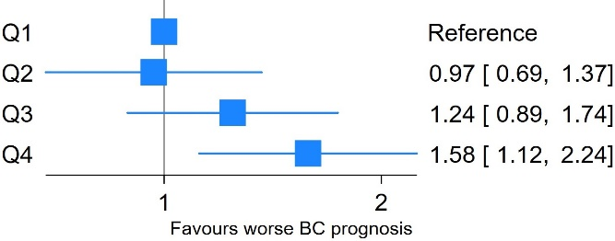
Q2 | 3854 | 83 | 21.54 (17.37-26.71)
Q3 | 3777 | 100 | 26.48 (21.76-32.21)
Q4 | 3460 | 115 | 33.24 (27.69-39.90)
Total | 14962 | 368^{b}
Overall survival
Q1 | 4044 | 39 | 9.64 (7.05-13.20) | 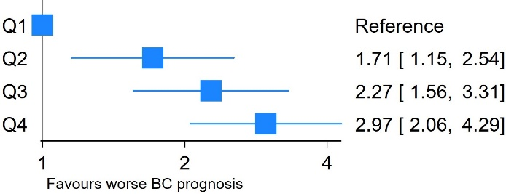 | 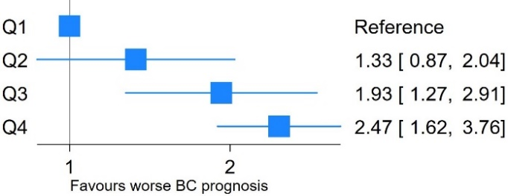
Q2 | 4067 | 67 | 16.47 (12.97-20.93)
Q3 | 3987 | 87 | 21.82 (17.69-26.93)
Q4 | 3705 | 105 | 28.34 (23.41-34.31)
Total | 15803 | 298
Abbreviations: 95% CI 95% Confidence interval; Q1 Quartile 1; BC Breast cancer.
a: Adjusted for age, menopausal state, comorbidities, body mass index, histological grade, tumor size, lymph node metastases, HER2 status, estrogen receptor status, histological classification, surgery, systemic treatment, and radiotherapy. b: 212 recurrences, 38 contralateral breast cancers, and 118 deaths.

Table 3. C-reactive protein quartiles in relation to disease-free survival in breast cancer patients across body mass index groups
 | Person-years | Number of events | Incidence rate per 1000 person-years (95% CI) | Crude hazard ratio [95% CI] | Adjusted hazard ratioª [95% CI]
Normal-weight |  |  |  | N=1,265 | N=1,245
Q1 (N=321) ($≤$0.41 mg/L) | 1898 | 31 | 16.33 (11.49-23.23) | 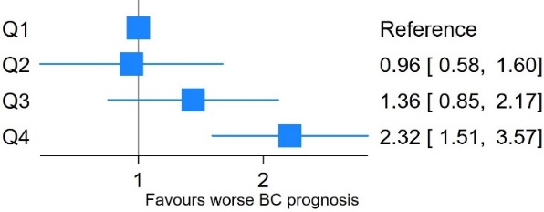 | 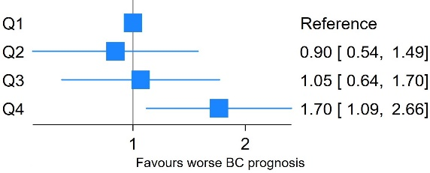
Q2 (N=314) (0.42-0.81 mg/L) | 1846 | 29 | 15.71 (10.92-22.61)
Q3 (N=315) (0.82-1.82 mg/L) | 1757 | 39 | 22.19 (16.21-30.37)
Q4 (N=315) ($≥$1.83 mg/L) | 1632 | 62 | 37.98 (29.61-48.72)
Total (N=1,265) | 7133 | 161
Overweight |  |  |  | N=818 | N=813
Q1 (N=206) ($≤$0.85 mg/L) | 1183 | 27 | 22.83 (15.65-33.29) | 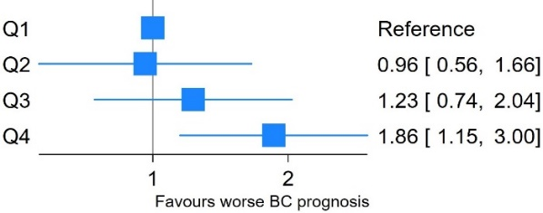 | 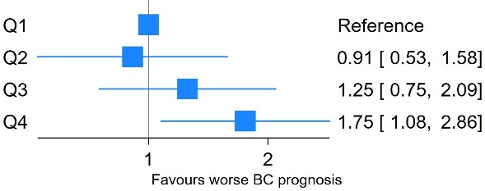
Q2 (N=203) (0.86-1.62 mg/L) | 1142 | 25 | 21.88 (14.79-32.38)
Q3 (N=206) (1.63-3.26 mg/L) | 1221 | 34 | 27.84 (19.89-38.96)
Q4 (N=203) ($≥$3.28 mg/L) | 1041 | 44 | 42.27 (31.46-56.80)
Total (N=818) | 4587 | 130
Obesity |  |  |  | N=486 | N=482
Q1 (N=122) ($≤$1.75 mg/L) | 709 | 10 | 14.10 (7.59-26.21) | 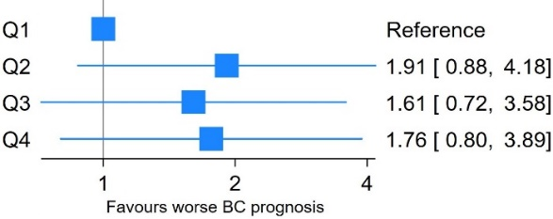 | 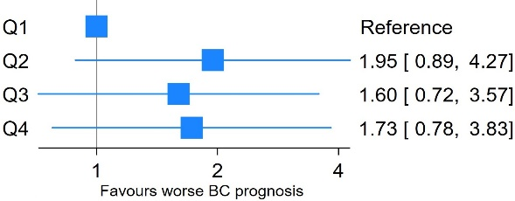
Q2 (N=121) (1.77-3.55 mg/L) | 634 | 17 | 26.82 (16.67-43.15)
Q3 (N=122) (3.56-7.02 mg/L) | 661 | 15 | 22.69 (13.68-37.63)
Q4 (N=121) ($≥$7.07 mg/L) | 643 | 16 | 24.89 (15.25-40.63)
Total (N=486) | 2647 | 58
Abbreviations: 95% CI 95% Confidence interval; Q1 Quartile 1; BC Breast cancer.
a: Adjusted for age, menopausal state, and comorbidities

Table 4. C-reactive protein quartiles in relation to overall survival in breast cancer patients across body mass index groups
 | Person-years | Number of deaths | Incidence rate per 1000 person-years (95% CI) | Crude hazard ratio [95% CI] | Adjusted hazard ratio [95% CI]ª
Normal-weight |  |  |  | N=1,265 | N=1,245
Q1 (N=321) ($≤$ 0.41 mg/L) | 1967 | 12 | 6.10 (3.46-10.74) | 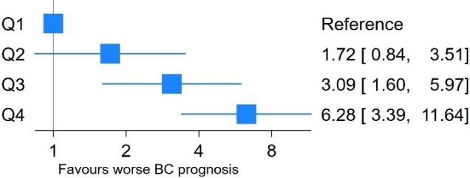 | 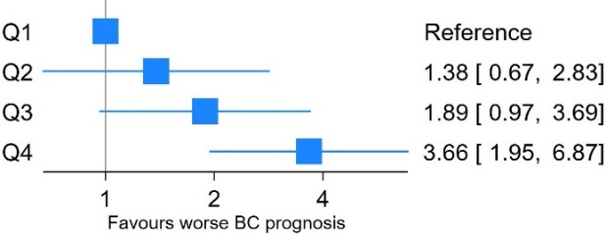
Q2 (N=314) (0.42-0.81 mg/L) | 1917 | 20 | 10.43 (6.73-16.17)
Q3 (N=315) (0.82-1.82 mg/L) | 1819 | 34 | 18.69 (13.35-26.16)
Q4 (N=315) ($≥$ 1.83 mg/L) | 1720 | 65 | 37.78 (29.63-48.18)
Total (N=1,265) | 7424 | 131
Overweight |  |  |  | N=818 | N=813
Q1 (N=206) ($≤$0.85 mg/L) | 1250 | 18 | 14.40 (9.08-22.86) | 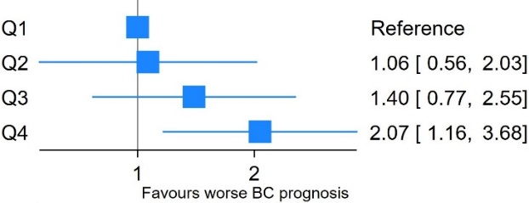 | 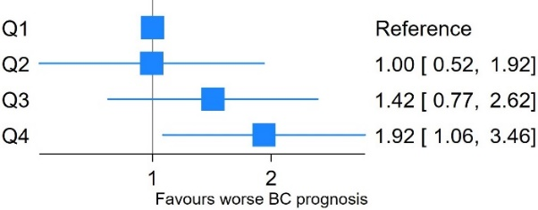
Q2 (N=203) (0.86-1.62 mg/L) | 1243 | 19 | 15.29 (9.75-23.96)
Q3 (N=206) (1.63-3.26 mg/L) | 1293 | 26 | 20.11 (13.69-29.54)
Q4 (N=203) ($≥$3.28 mg/L) | 1122 | 33 | 29.42 (20.92-41.39)
Total (N=818) | 4907 | 96
Obesity |  |  |  | N=486 | N=482
Q1 (N=122) ($≤$1.75 mg/L) | 728 | 11 | 15.10 (8.36-27.27) | 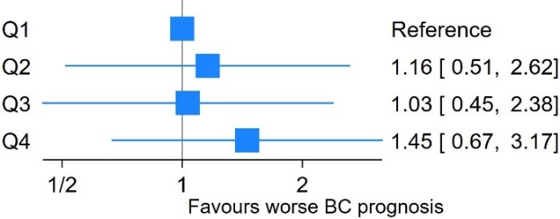 | 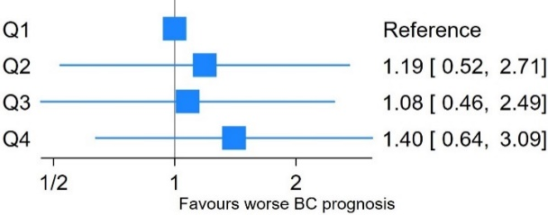
Q2 (N=121) (1.77-3.55 mg/L) | 687 | 12 | 17.47 (9.92-30.76)
Q3 (N=122) (3.56-7.02 mg/L) | 704 | 11 | 15.62 (8.65-28.21)
Q4 (N=121) ($≥$7.07 mg/L) | 685 | 15 | 21.89 (13.20-36.31)
Total (N=486) | 2805 | 49
Abbreviations: 95% CI 95% Confidence interval; Q1 Quartile 1; BC Breast cancer.
a: Adjusted for age, menopausal state, and comorbiditie

