Extended Data Figures

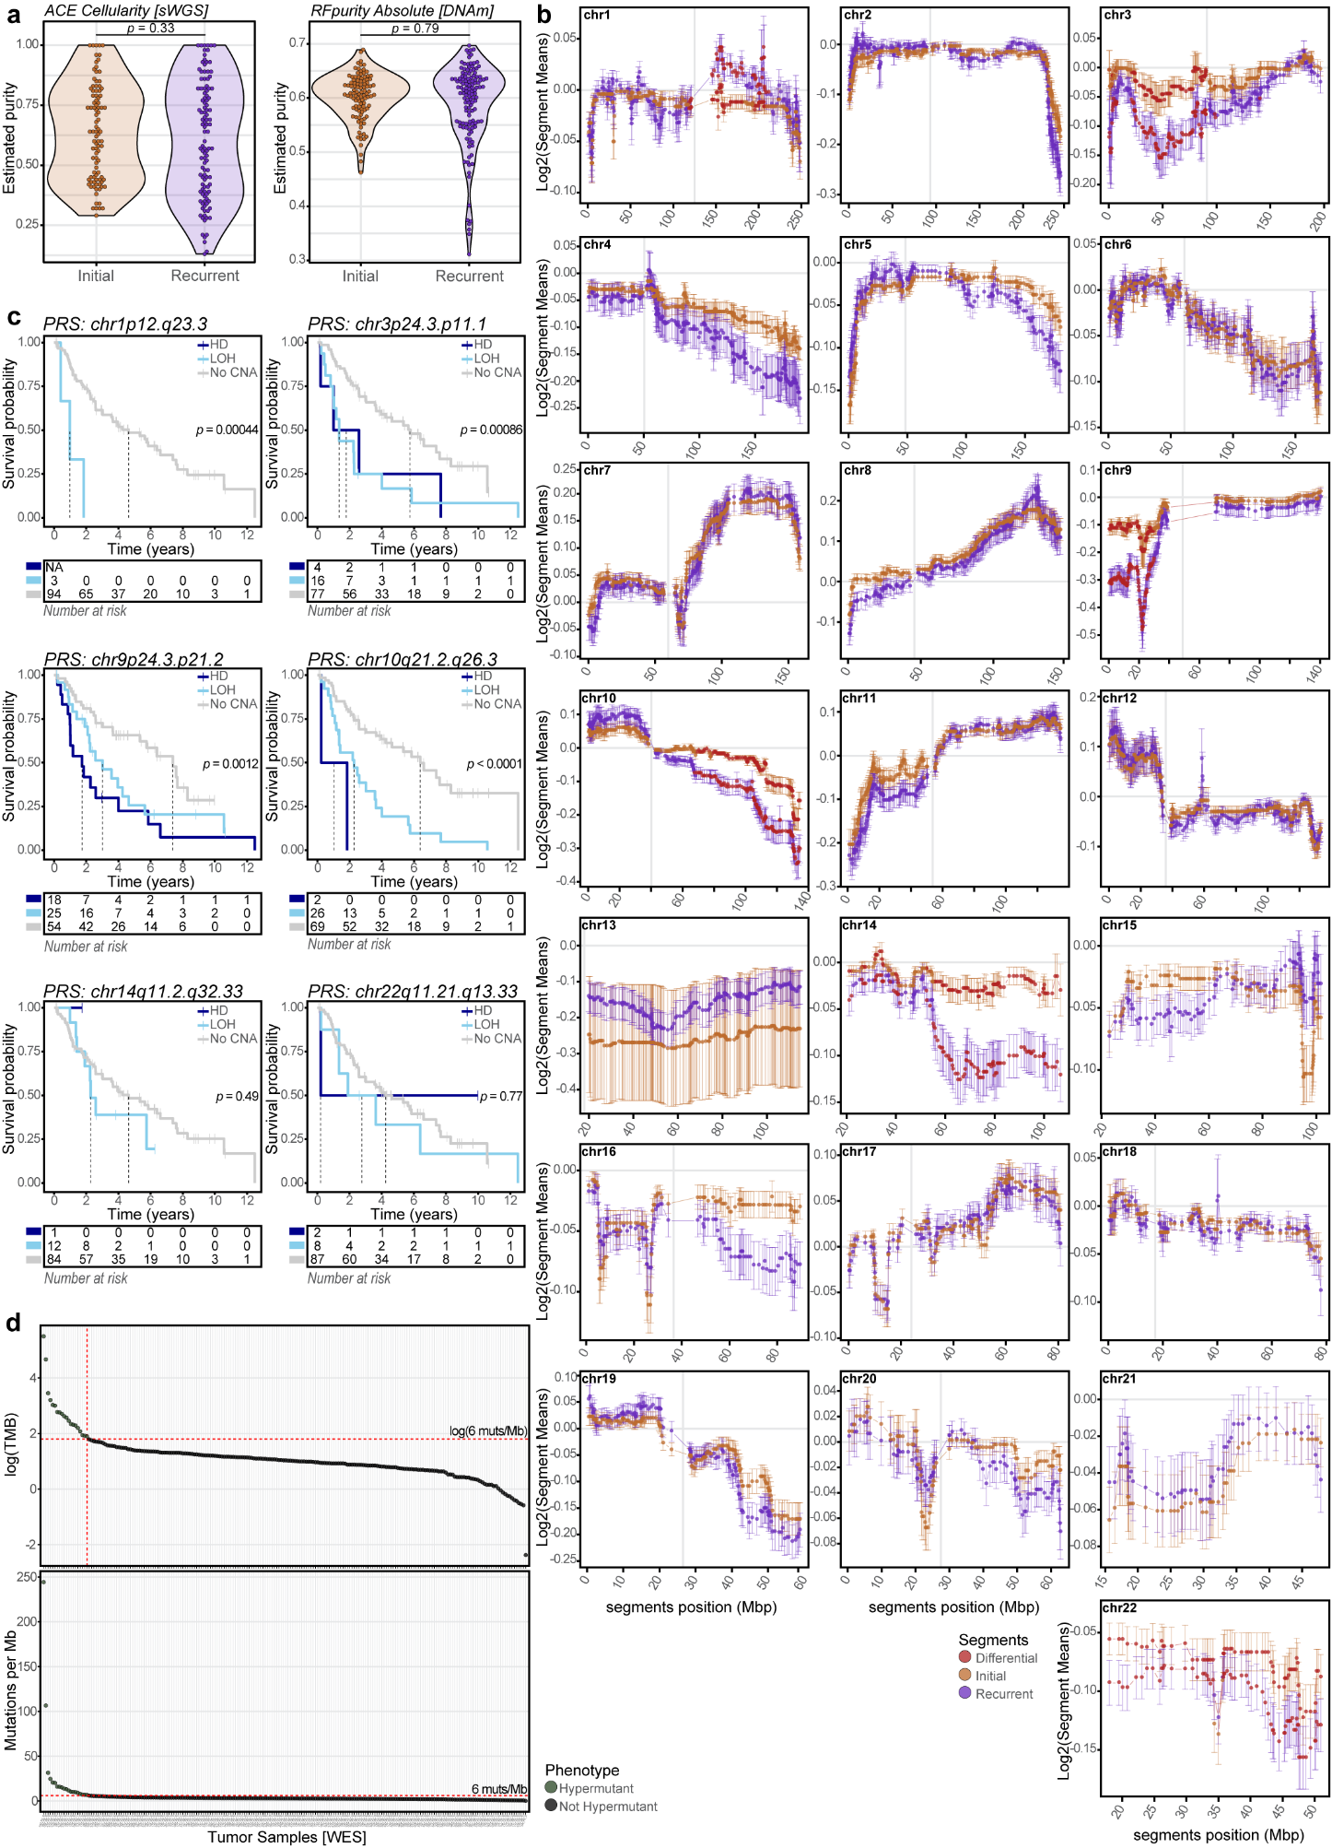
Extended Data Fig. 1: Longitudinal genomic changes
a, Difference in tumor purity between initial and recurrent tumor samples. Difference between initial and recurrent tumor samples is calculated using a Wilcoxon rank sum test for the ACE estimated cellularity based on sWGS data (left, p = 0.33) and the RFpurify Absolute estimated purity based on DNA-methylation array data (right, p = 0.79). b, Differential CNA analysis between matched initial and recurrent tumors. Each panel represents a chromosome, with on the x-axis the chromosomal position of each segment breakpoint and on the y-axis the log2(read counts), centromere is allocated with a vertical grey line. Segments mean with error bars (SE = SD/sqrt(n)) are separately visualized for initial (orange) and recurrent tumor samples (purple). Significant differential segments between initial and recurrent tumors (in red) were identified using a paired Wilcoxon signed-rank test (BH-corrected, FDR <0.05). Chromosomal regions chr1p12-q23.3, chr3p24.3-p11.1, chr9p24.3-p21.2, chr10q21.3-q26.3, chr14q11.2-q32.33, and chr22q11.21-q13.33 had significantly lower log2 read counts in recurrent tumors compared to initial tumors. c, Kaplan-Meier curves for PRS when stratifying patients on the CNA status (HD <-0.4 and LOH <-0.2 mean log2(read counts)) of differential regions (identified in Extended Data Fig. 1b) of the recurrent tumor. Compared to cases without an alteration, loss of chr3p24.3.p11.1 (LOH (n = 16): p = 7.74*10⁻⁴, HR = 2.900[1.559-5.395]; HD (n = 4): p = 0.075, HR = 2.564[0.9101-7.223]), chr9p24.3-p21.2 (LOH (n = 25): p = 0.024, HR = 2.035[1.098-3.770]; HD (n = 18): p = 6.57*10⁻⁴, HR = 3.106[1.618-5.963]) and chr10q21.3-q26.3 (LOH (n = 26): p = 8.62*10⁻⁵, HR = 2.968[1.724-5.109]; HD (n = 2): p = 0.004, HR = 8.888[2.048-38.582]) were negatively associated with PRS. d, Hypermutant cut-off value for the GLASS-NL cohort. Upper panel shows the log scale of the TMB (muts/Mb) of each tumor sample, ordered based on the log(TMB). The elbow of the curve is located at 6 mutations per Mb and marked with a horizontal red dashed line. Samples located on the left side of the vertical red dashed line are considered to be hypermutated. Lower panel depicts the TMB per sample with the cut-off of 6 muts/Mb marked with a red dashed line. Hypermutant samples are colored in green. sWGS = shallow whole-genome sequencing, CNA = copy-number alteration, PRS = post-recurrent survival, HD = homozygous deletion, LOH = loss of heterozygosity, TMB = tumor mutational burden.

Extended Data Fig. 2: snRNA validation of gene expression clusters.
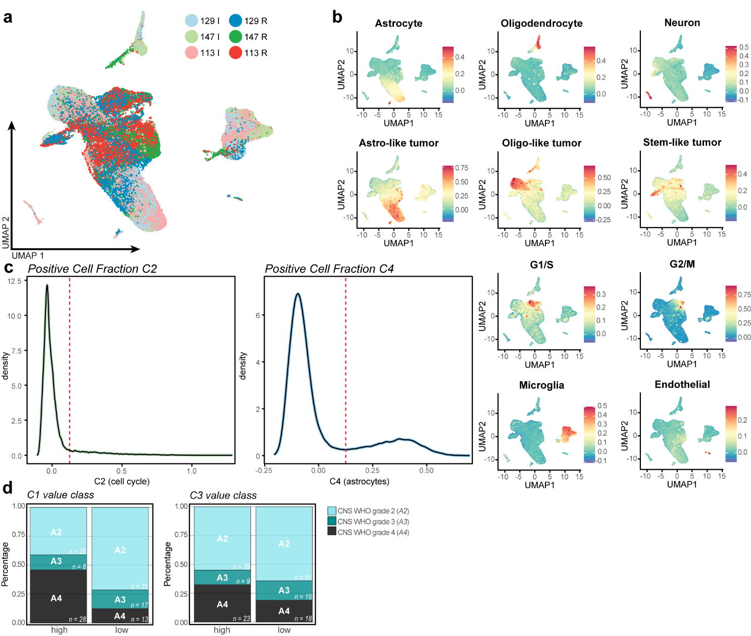
a, The integrated snRNA dataset of all snRNA samples (n = 6) from three IDH-mutant astrocytoma patients from the GLASS-NL cohort. b, UMAP projection of single nuclei of integrated dataset, colored by the enrichment score of the cell type clusters. c, Density plots of expression of gene expression cluster C2 (left) and C4 (right) by single nuclei. Dashed line indicates cutoff for cells to be marked as ‘positive’ cluster expression. d, Distributions of CNS WHO grades within the expression cluster value classes (‘high’: PC1 >0; ‘low’: PC1 <0) of C1 and C3 (graphs of C2 and C4 are found in Fig. 5d).

