Table 3: Summary of design cases
Design Case | 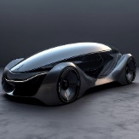 | 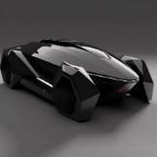 | 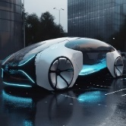 | 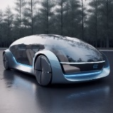
Waistline Line F1 | tensile | streamline | linear | streamline
Boundary profile F2 | linear | linear | square | Other types
Grid F3 | incorporation | incorporation | grille-free | incorporation
Door F5 | traditional door | scissor gate | traditional door | canopy gate
Headlight Styling F6 | holistic | holistic | planar | holistic
Side large circumferential section line line type F7 | mobile | mobile | mellow and full-bodied | mellow and full-bodied
Wheel F8 | regular type | closed type | regular type | closed type
Overall style F9 | science of fashion | science of fashion | science of fashion | science of fashion
Overall style F10 | overall feeling | musicality | overall feeling | overall feeling
Overall style F11 | fairing | stern | fairing | fairing
Overall style F12 | sports performance | sports performance | leisure and homely | leisure and homely
Wheelbase as a percentage of vehicle length F13 | $$>60\%$$ | $$>60\%$$ | $$>60\%$$ | $$>60\%$$
Vehicle length to height ratio F14 | $$≤3$$ | $$>3$$ | $$≤3$$ | $$≤3$$
Vehicle width-to-height ratio F15 | $$>1$$ | $$>1$$ | $$≤1$$ | $$≤1$$

design element | 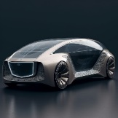 | 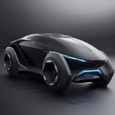 | 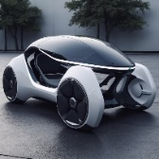 | 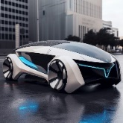
Waistline Line F1 | linear | streamline | streamline | tensile
Boundary profile F2 | square | linear | Other types | linear
Grid F3 | grille-free | grille-free | incorporation | planar
Door F5 | traditional door | traditional door | scissor gate | scissor gate
Headlight Styling F6 | planar | regular type | holistic | holistic
Side large circumferential section line line type F7 | square | tensile | mellow and full-bodied | mobile
Wheel F8 | regular type | closed type | closed type | regular type
Overall style F9 | science of fashion | science of fashion | science of fashion | science of fashion
Overall style F10 | overall feeling | overall feeling | musicality | musicality
Overall style F11 | fairing | stern | fairing | stern
Overall style F12 | leisure and homely | sports performance | sports performance | sports performance
Wheelbase as a percentage of vehicle length F13 | $$>60\%$$ | $$>60\%$$ | $$>60\%$$ | $$>60\%$$
Vehicle length to height ratio F14 | $$≤3$$ | $$≤3$$ | $$≤3$$ | $$≤3$$
Vehicle width-to-height ratio F15 | $$>1$$ | $$>1$$ | $$≤1$$ | $$>1$$

