Supplementary Material

Synthesis and evaluation of cinnamic acid derivatives as ɑ-glucosidase inhibitors
Xin Zhong ¹, Hua Zhu^{2*}
¹Dean’s office, Mianyang Teacher’s College, Mianyang, China
²School of Chemistry and Chemical Engineering, Mianyang Teacher’s College, Mianyang, China

- NMR of compounds…………………………………………………………………………..2-7

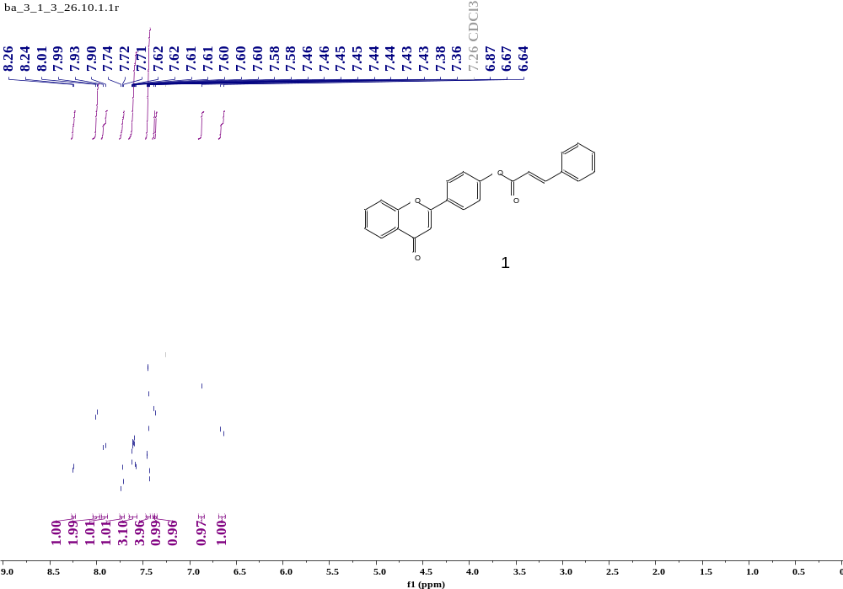
Compound 1 (¹H NMR)
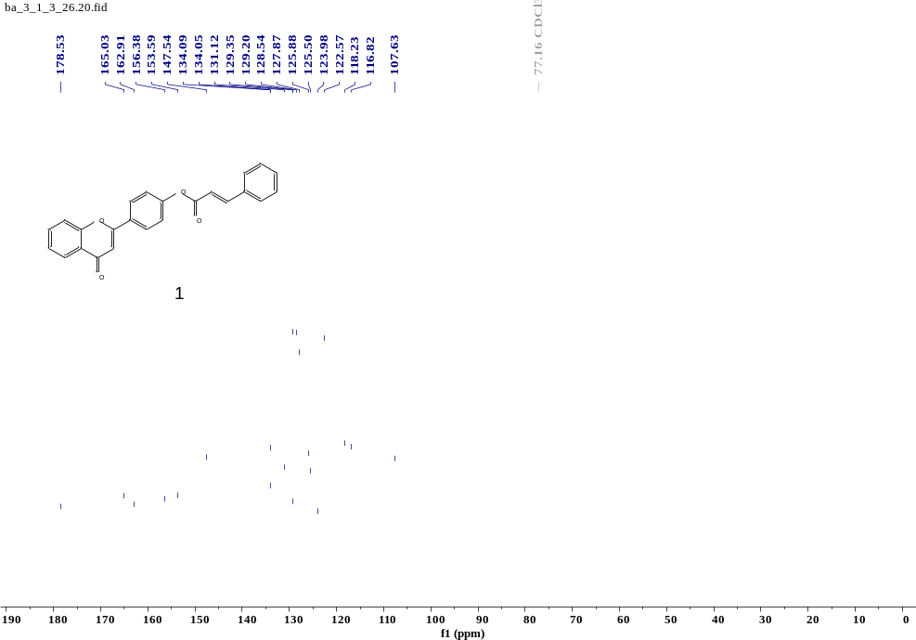
Compound 1 (¹³C NMR)
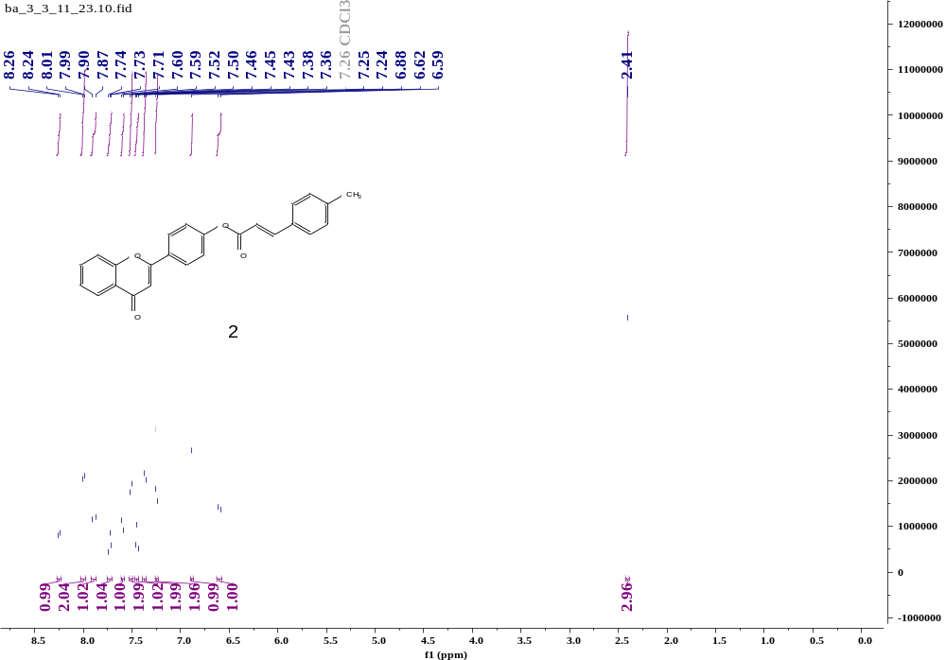
Compound 2 (¹H NMR)
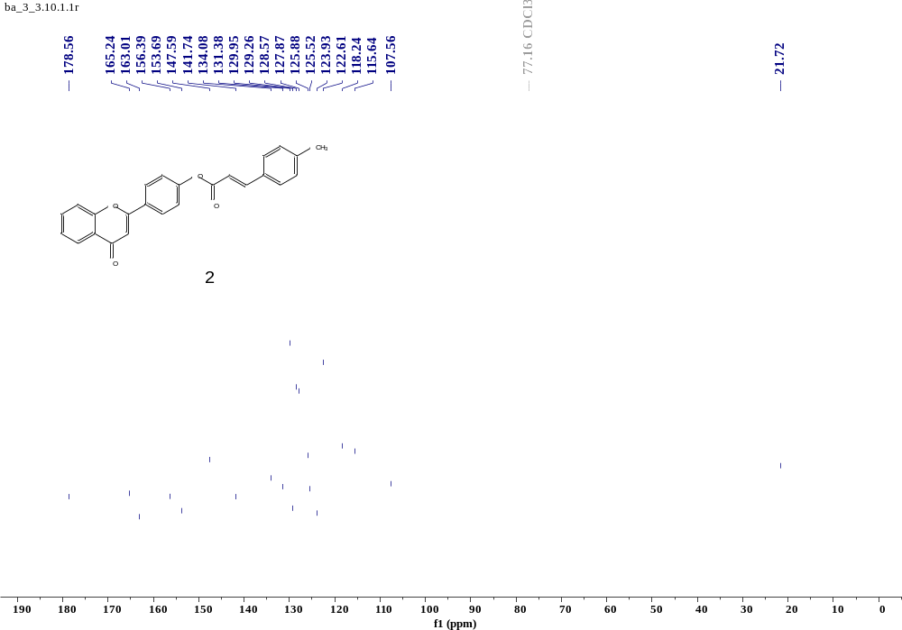
Compound 2 (¹³C NMR)
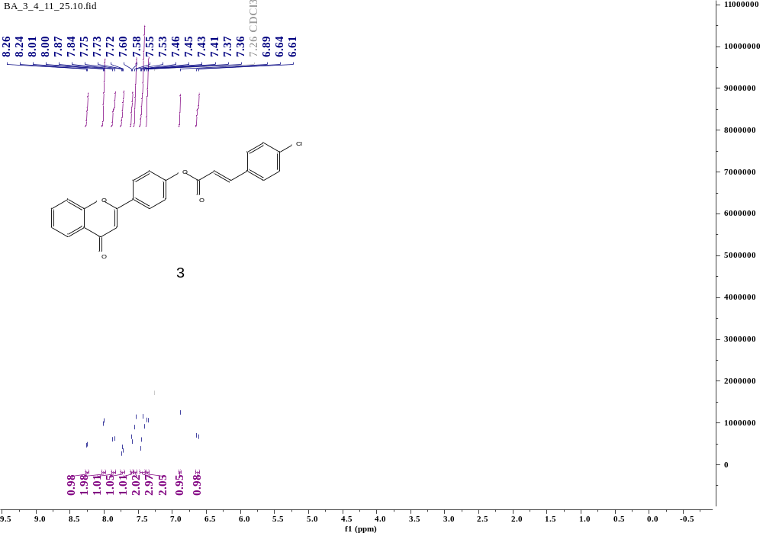
Compound 3 (¹H NMR)
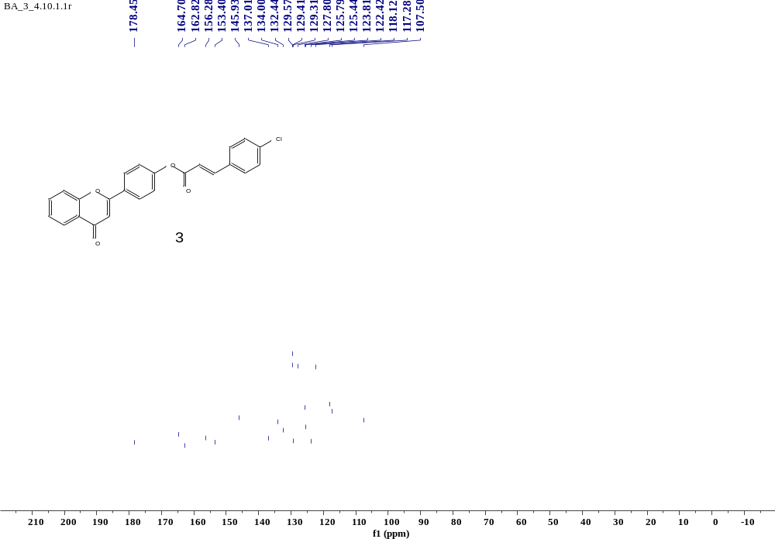
Compound 3 (¹³C NMR)
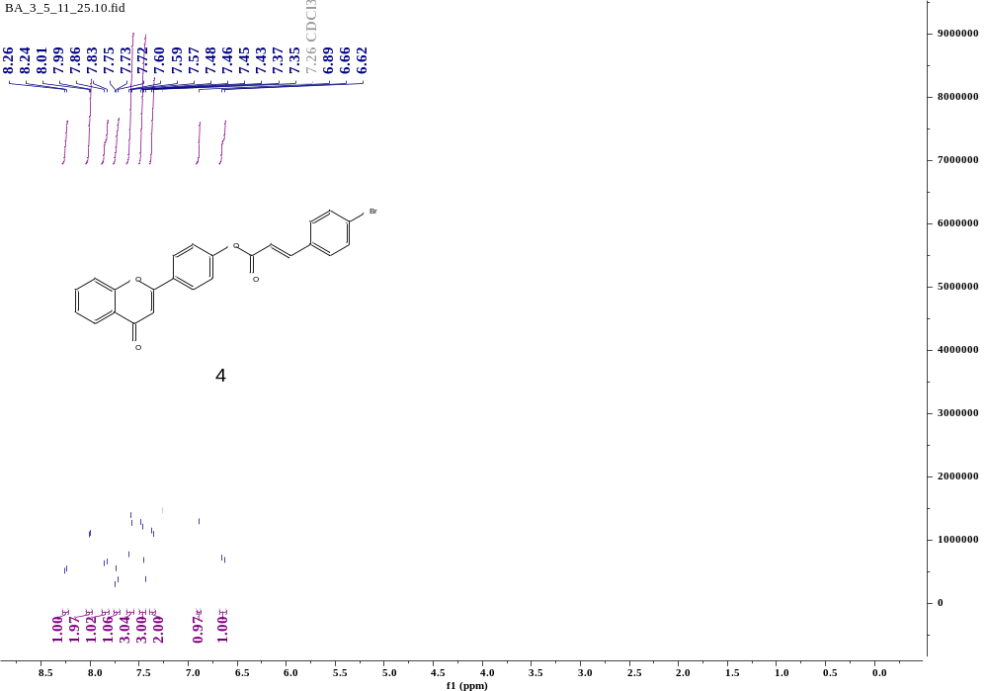

Compound 4 (¹H NMR)
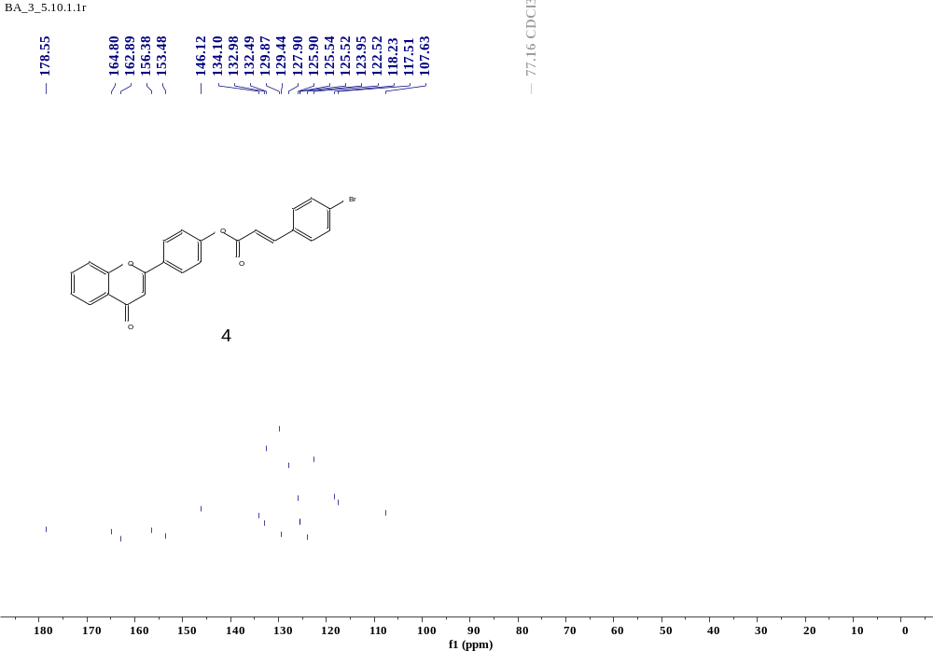
Compound 4 (¹³C NMR)
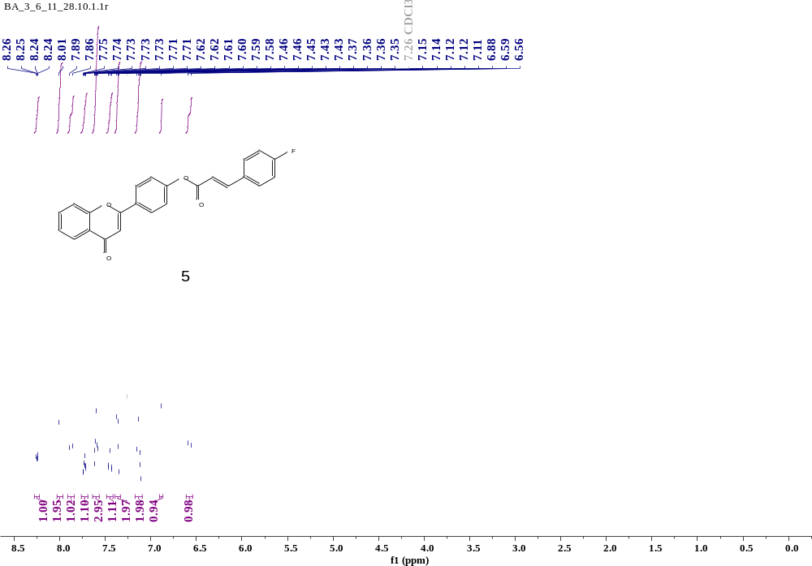
Compound 5 (¹H NMR)
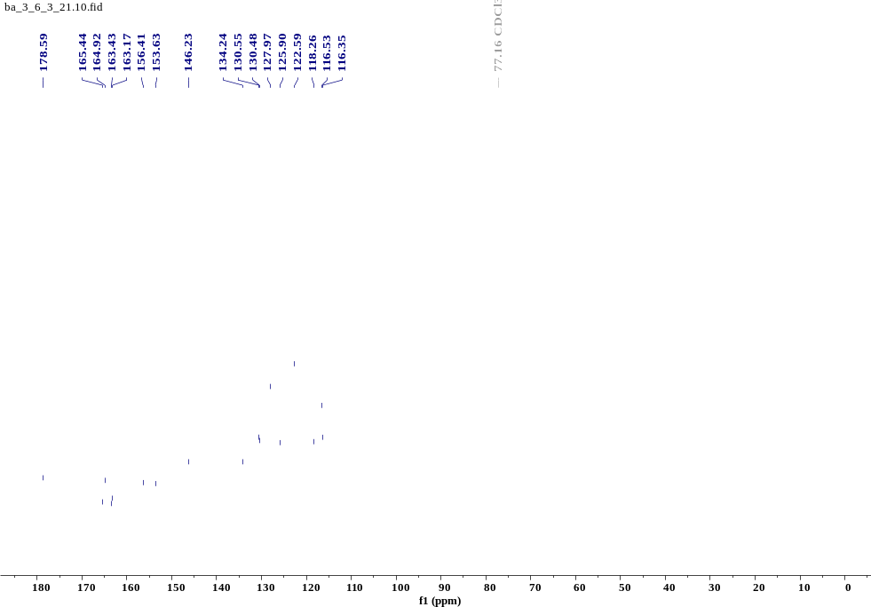
Compound 5 (¹³C NMR)
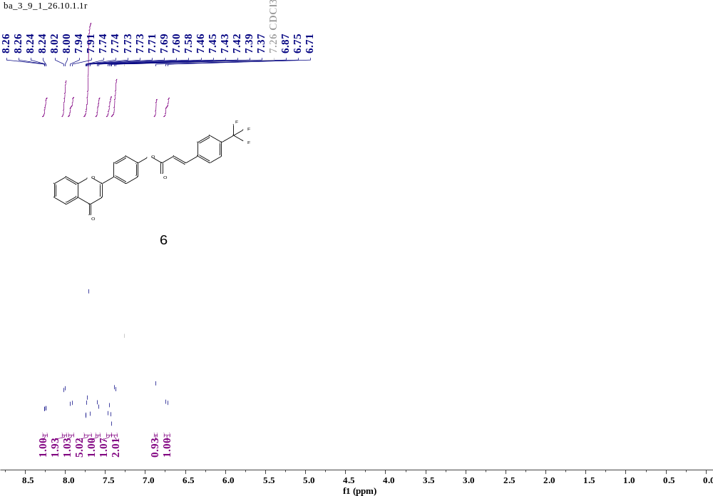
Compound 6 (¹H NMR)
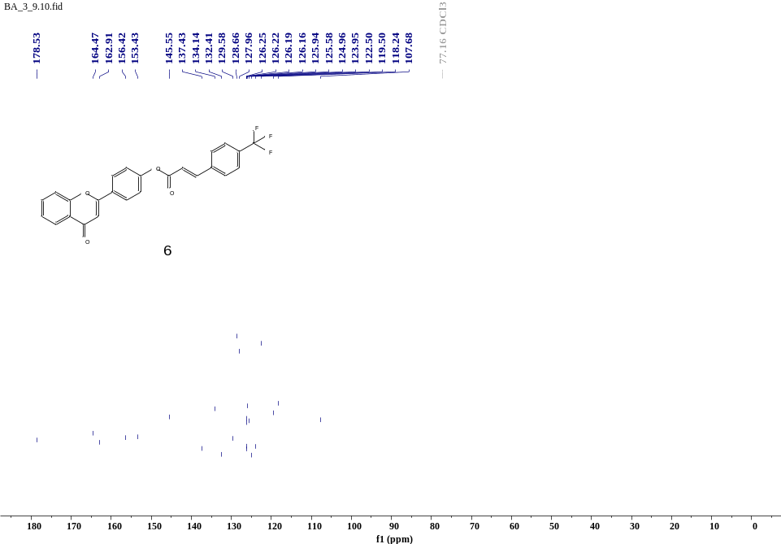
Compound 6 (¹³C NMR)

