Supplementary for

Effect of sea ice loss on Earth’s energy budget
depends on its spatial pattern
Chen Zhou^{1,*}, Qingming Wang¹, Ivy Tan², Lujun Zhang¹, Mark D. Zelinka³, Minghuai Wang¹, and Jonah Bloch-Johnson⁴
1. School of Atmospheric Sciences, Nanjing University, Nanjing, China
2. Department of Atmospheric and Oceanic Sciences, McGill University, Montreal, Canada
3. Lawrence Livermore National Laboratory, Livermore, CA, USA
4. National Center for Atmosphere Science, University of Reading, Reading, UK

*Corresponding author: Chen Zhou, Email: czhou17@nju.edu.cn

Table of contents
Supplementary Figure 1. TOA radiation change in the Abrupt4xCO2-SIC experiments, where the first year is used as the base year.
Supplementary Figure 2. Linearity check for the superposition of SST-induced and SIC-induced TOA radiation anomalies.
Supplementary Figure 3. Individual radiative effect and low cloud cover (LCC) anomalies in AMIPSIC experiments.
Supplementary Figure 4. Relationship between SIC anomalies and radiation anomalies in the AMIPSIC experiment during 1980-2020.
Supplementary Figure 5. Geolocation of patches used in the patch experiments.
Supplementary Figure 6. Sensitivity of global mean cloud cover to regional SIC reduction, normalized by the surface area of each grid box.
Supplementary Figure 7. Low cloud cover (LCC) responses to summertime SIC reduction in four illustrative locations.
Supplementary Figure 8. Relationship between SIC and surface humidity in the control experiment.
Supplementary Figure 9. Relationship between average SIC and LCC in the Arctic (50°N-90°N) and Antarctic (50°S-90°S) regions during 2003-2019.
Supplementary Figure 10. Same as Figure 3, except for April-September.
Supplementary Figure 11. Same as Figure 3, except for October-March.
Supplementary Figure 12. Sensitivity of polar annual radiation to regional SIC change, normalized by the ratio of grid-box surface area to global surface area.
Supplementary Figure 13. Reconstruction of SIC-induced radiation anomalies using the Green’s function approach in the AMIPSIC experiment (upper panel) and Abrupt4xCO2-SIC experiment (lower panel).
Supplementary Figure 14. Same as Figure 3, except for results calculated from covariant SIC-SST patch experiments.
Supplementary Figure 15. Same as Figure 1, except that the AMIPSIC experiment is driven by different SIC datasets.
Supplementary Figure 16. Relationship between ΔSIC and TOA radiation anomalies ΔR in AMIPSIC experiments performed with HadAM3.
Supplementary Table 1. Idealized experiments performed with CESM1.2.1 that are used in this study.

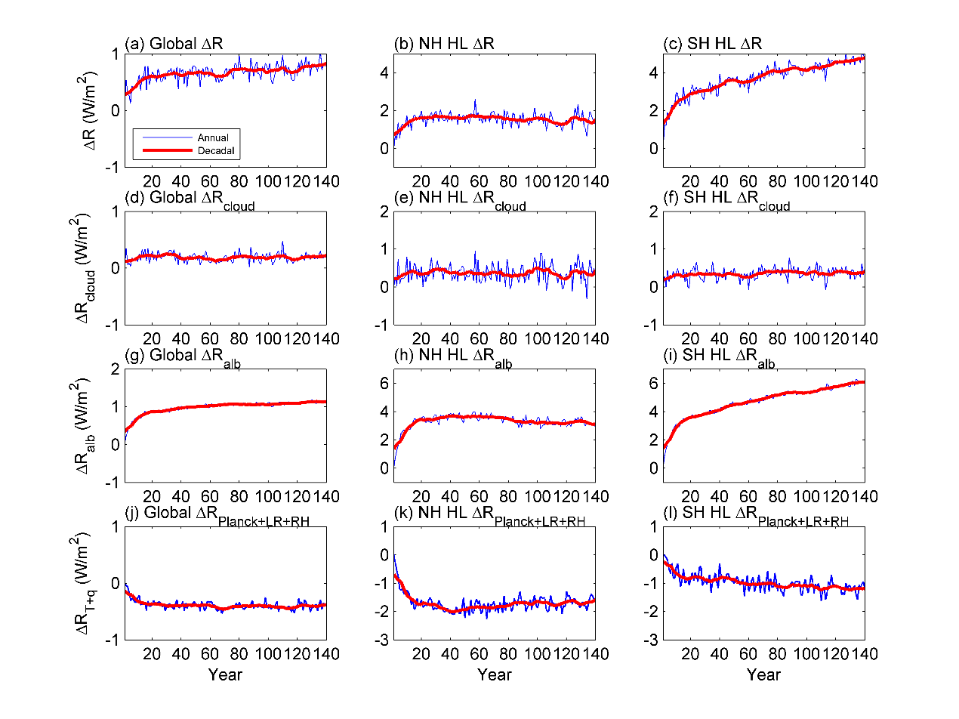
Supplementary Figure 1. TOA radiation change in the Abrupt4xCO2-SIC experiments, where the first year is used as the base year. (a-c) Net TOA fluxes. (d-f) Cloud-induced radiation anomalies. (g-i) Albedo-induced radiation anomalies. (j-l) Temperature and water vapor-induced radiation anomalies (Planck + Lapse rate + RH feedbacks). Left column is for global, middle column is for Northern Hemisphere (NH) high latitudes (HL), 50°N-90°N, and right column is for Southern Hemisphere (SH) HL, 50°S-90°S. Note that ΔR in SH high latitudes is also affected by SIC changes in NH, and vice versa.

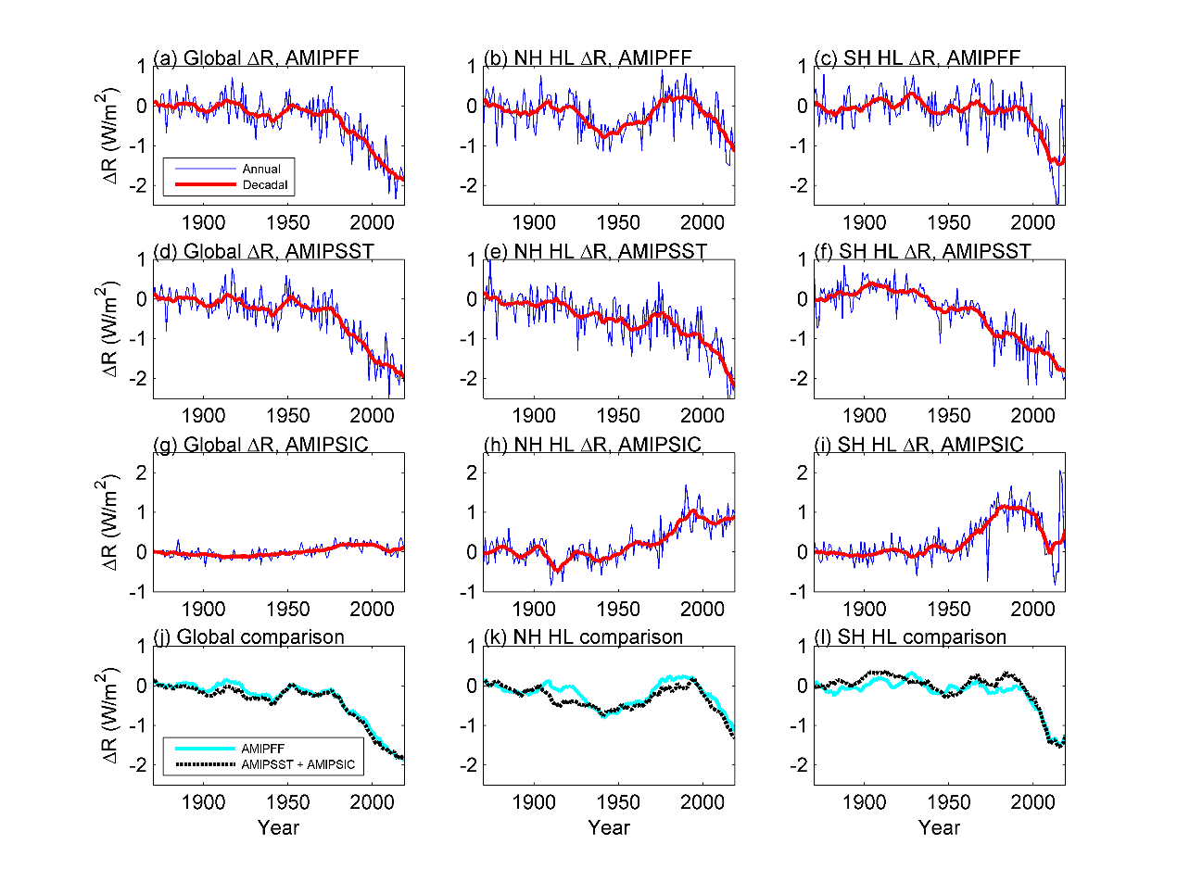
Supplementary Figure 2. Linearity check for the superposition of SST-induced and SIC-induced TOA radiation anomalies. (a-c) Change of TOA net radiation anomalies in AMIPFF experiments. (d-f) Change of TOA net radiation anomalies in AMIPSST experiments, where SST is same as observation and other variables are set to be fixed. (g-i) Change of TOA net radiation anomalies in AMIPSIC experiments, where SIC is same as observation and other variables are set to be fixed. (j-l) Comparison of radiation anomalies in AMIPFF experiments (cyan lines) and AMIPSST+AMIPSIC experiments (black dashed lines). The left column is for global mean radiation anomalies, middle column is for mean radiation anomalies in Northern hemisphere (NH) high latitudes (HL, 50°S-90°S), and the right column is for Southern Hemisphere (SH) high latitudes (50°S-90°S). The results suggest that the radiation anomalies induced by SST/SIC changes can be decomposed to SST-induced component and SIC-induced component using AMIPSIC and AMIPSST experiments.

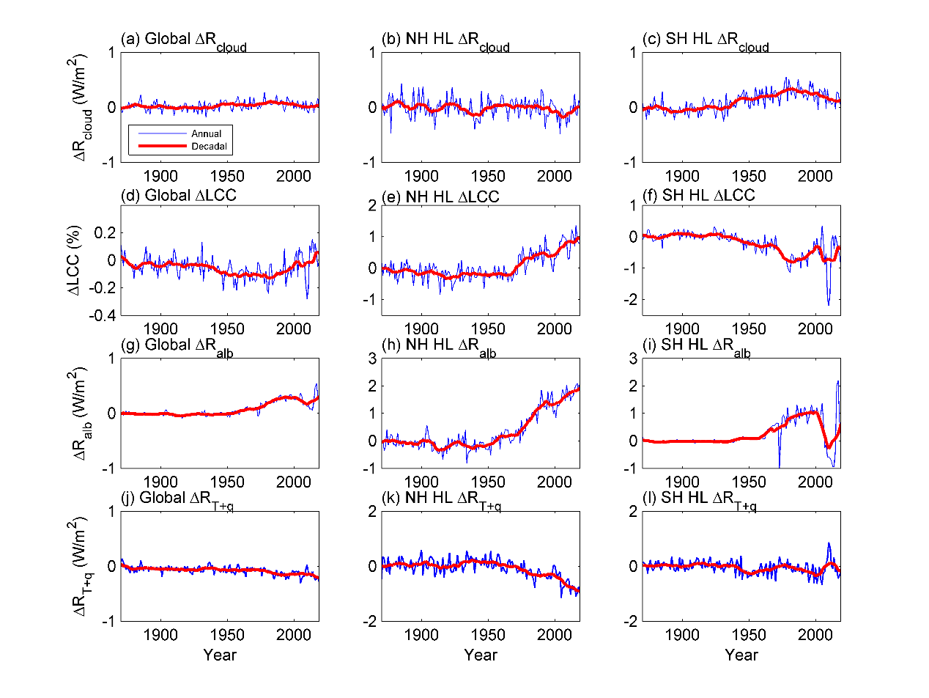
Supplementary Figure 3. Individual radiative effect and low cloud cover (LCC) anomalies in AMIPSIC experiments. (a-c) Cloud radiative effects (masking effects are removed). (d-f) LCC changes. (g-i) Albedo-induced radiation anomalies. (j-l) Temperature and water vapor-induced radiation anomalies (Planck + Lapse rate + RH). Left column is for global, middle column is for 50°N-90°N, and right column is for 50°S-90°S. The correlation coefficients between annual ΔR_{cloud} and ΔLCC are -0.43, -0.33, and -0.58 for global, 50°N-90°N and 50°S-90°S, respectively, and the correlation coefficients between decadal (11-year smoothed) ΔR_{cloud} and ΔLCC are -0.73, -0.36 and -0.87 for global, 50°N-90°N and 50°S-90°S, respectively. These results suggest that changes in LCC is important to ΔR_{cloud}, while other factors (e. g., the masking effect of low clouds over sea ice) are also important.

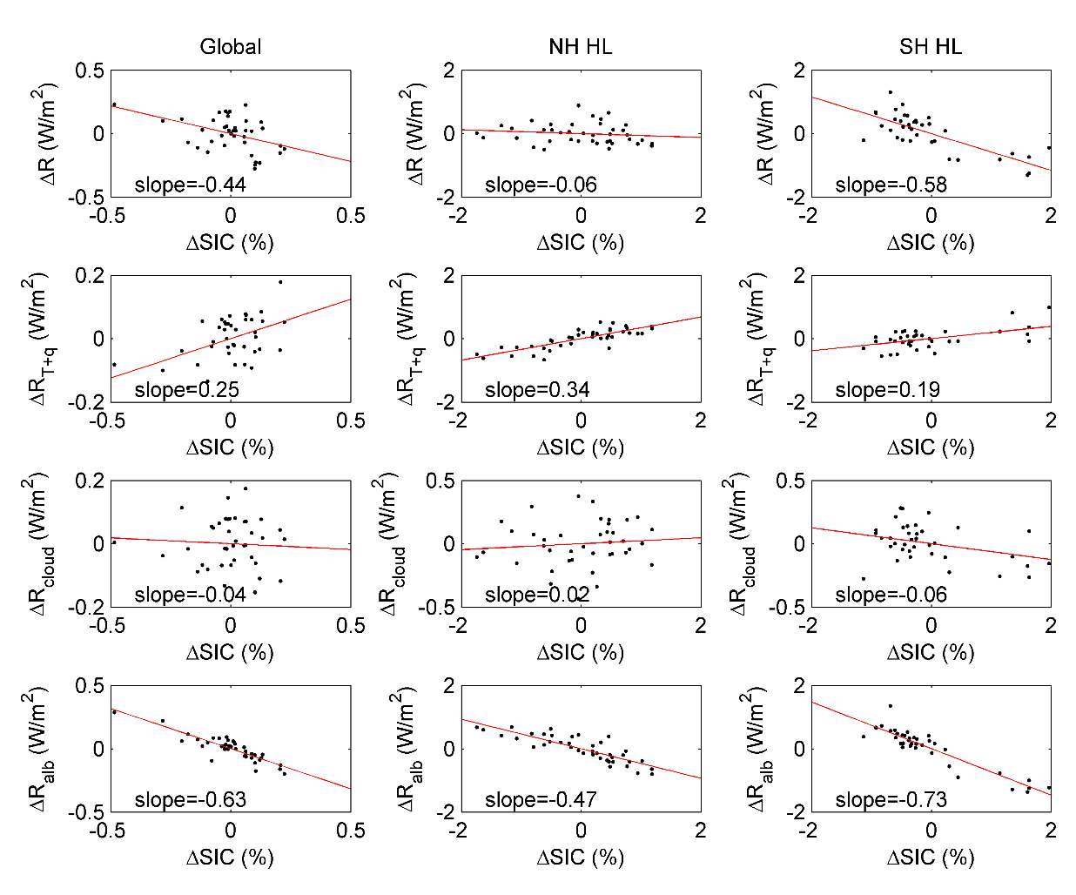
Supplementary Figure 4. Relationship between SIC anomalies and radiation anomalies in the AMIPSIC experiment during 1980-2020. The first row shows the relationship between the annual anomalies of SIC and TOA net radiation, the second row shows the relationship between SIC anomalies and temperature+water vapor-induced radiation anomalies (Planck + Lapse rate + RH), the third row shows the relationship between SIC anomalies and cloud-induced radiation anomalies, and the last row shows the relationship between SIC anomalies and albedo-induced radiation anomalies. Left column is global mean values, middle column is for values averaged over 50°N-90°N, and the right column is for 50°S-90°S. The results suggest that the sensitivity of NH ΔR to NH SIC is smaller than the sensitivity of SH ΔR to SH SIC during this period.

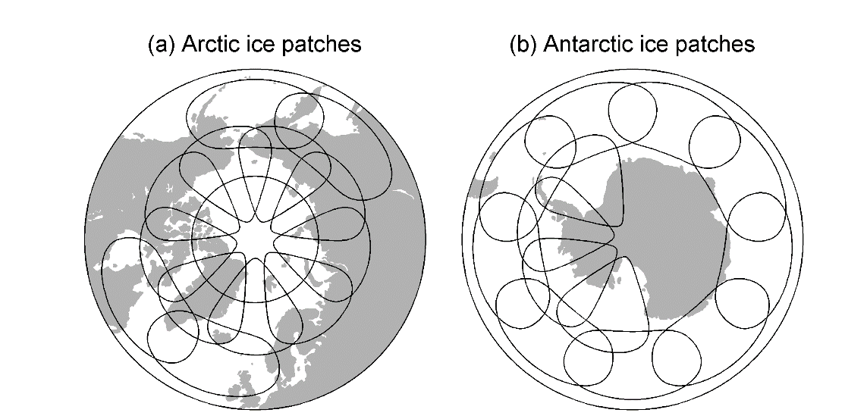
Supplementary Figure 5. Geolocation of patches used in the patch experiments. The patch size is chosen to match the SST patches in Zhou et al. (2017).

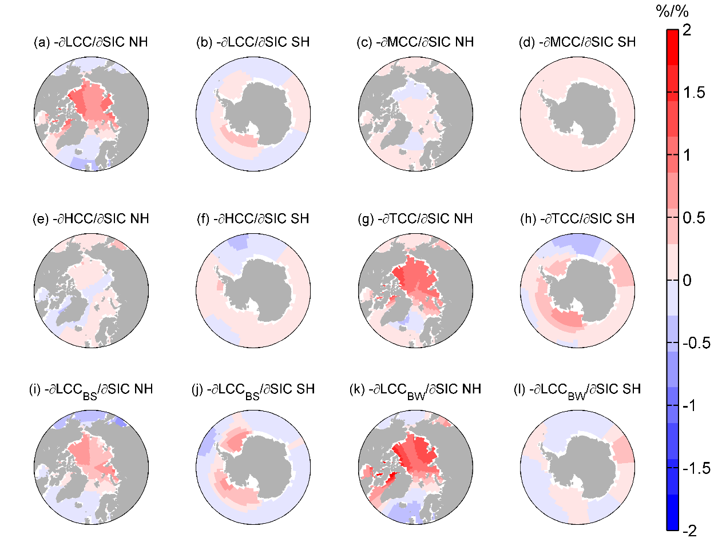
Supplementary Figure 6. Sensitivity of global mean cloud cover to regional SIC reduction, normalized by the surface area of each grid box. (a-b) Annual low cloud cover (LCC) responses. (c-d) Annual middle cloud cover (MCC) responses. (e-f) Annual high cloud cover (HCC) responses. (g-h) Annual total cloud cover (TCC) responses. (i-j) LCC responses during April-September (boreal summer). (k-l) LCC responses during October-March (boreal winter).

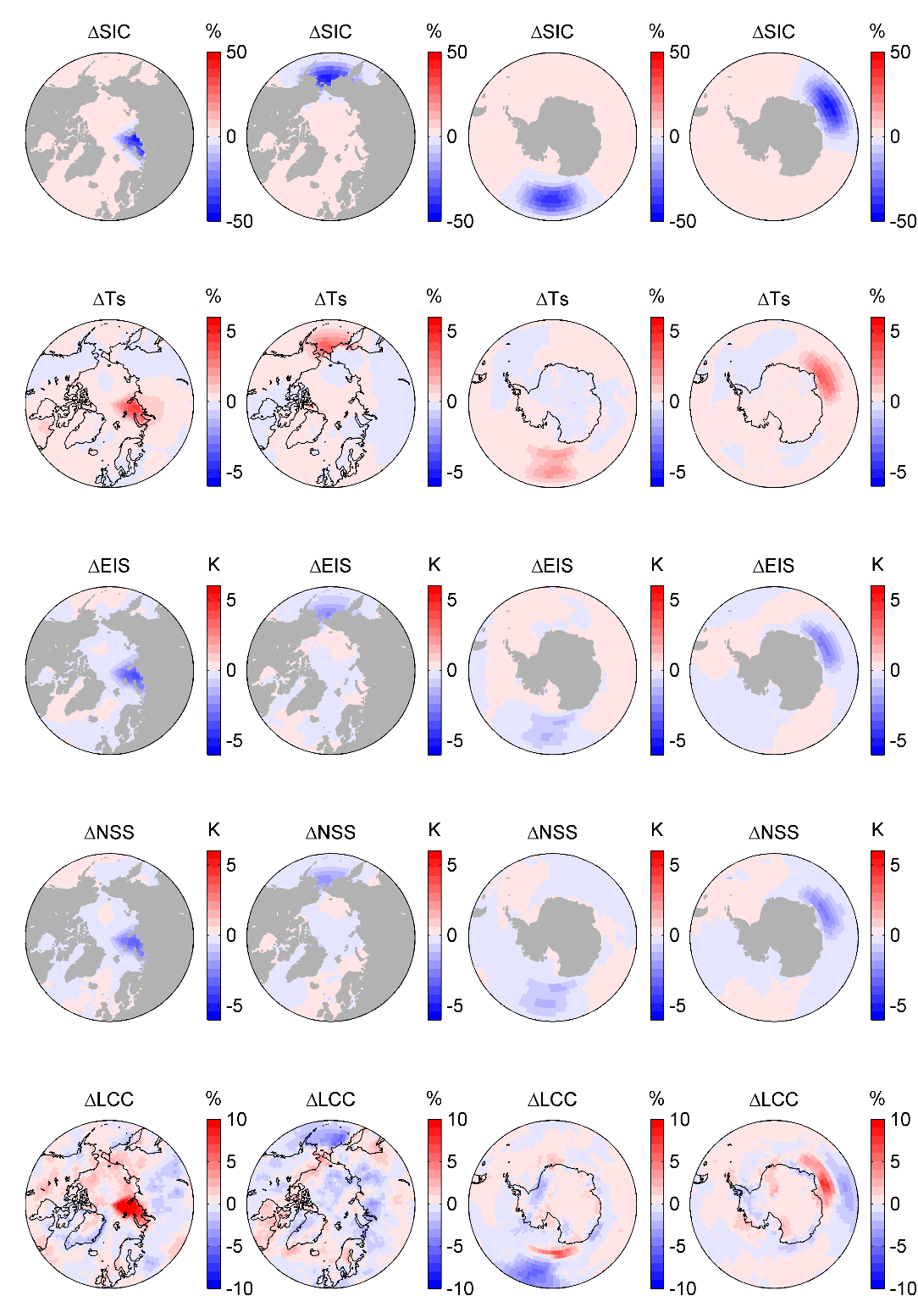
Supplementary Figure 7. Low cloud cover (LCC) responses to summertime SIC reduction in four illustrative locations. The 4 columns denote results of 4 cases representing SIC changes in 4 illustrative patches. The upper row denotes the difference between SIC in the SIC decrease and SIC increase experiment. The second row denotes the change of surface temperature in response to the SIC change in each case. The third row denotes the change in EIS. The fourth row denotes change in near-surface static stability (NSS, calculated as the difference between potential temperature at 925hPa and 1000 hPa). The bottom row denotes the change in LCC.

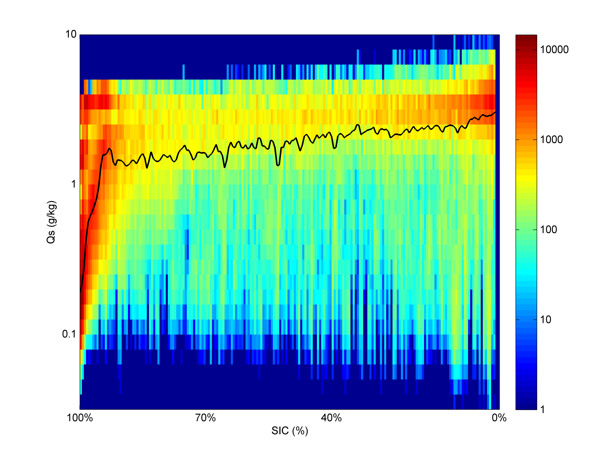
Supplementary Figure 8. Relationship between SIC and surface humidity in the control experiment. The color shading denotes the number of points in each grid box, and the black solid line denote the median q_{s} value in each SIC bin. The y-axis is in log-scale, and the results indicate that the response of Δq_{s}/q_{s} to SIC decrease is greater when the base state of SIC is larger.

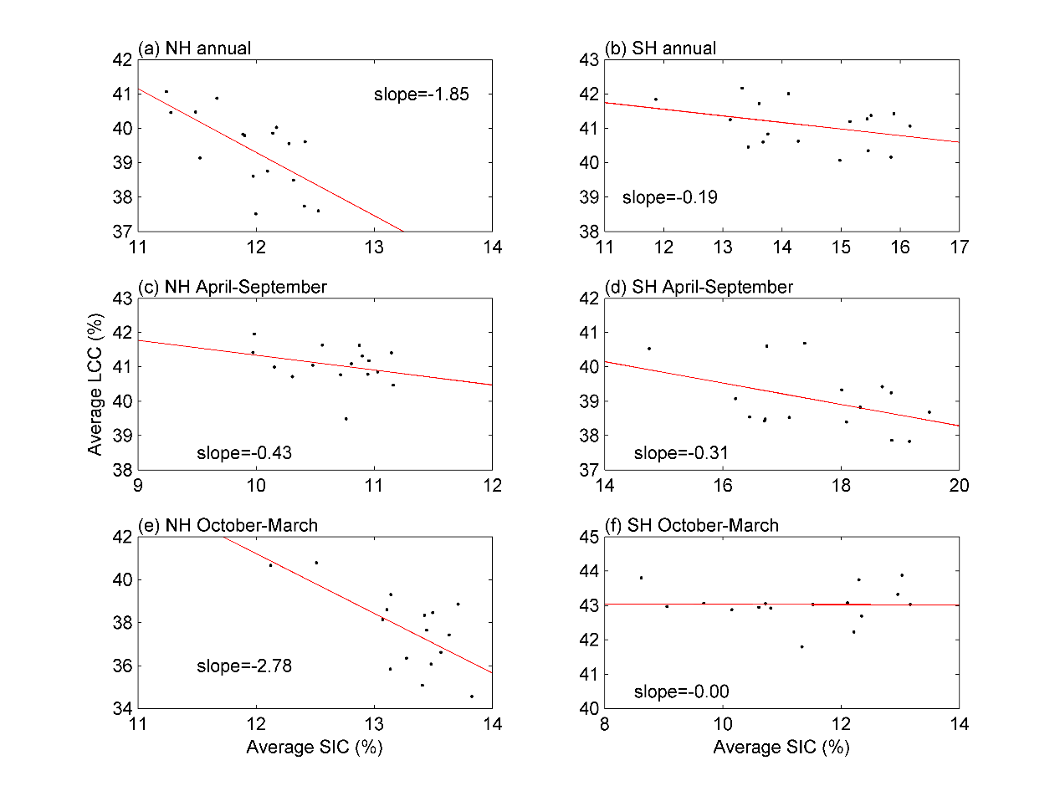
Supplementary Figure 9. Relationship between average SIC and LCC in the Arctic (50°N-90°N) and Antarctic (50°S-90°S) regions during 2003-2019. SIC is calculated using AMIP SIC data, and LCC is calculated using MODIS level-3 data. SIC is negatively correlated with LCC in NH summer (c), but the correlation between LCC and SIC is zero in SH summer (f). Note that the results are similar if CALIPSO data is used instead of MODIS in this figure.

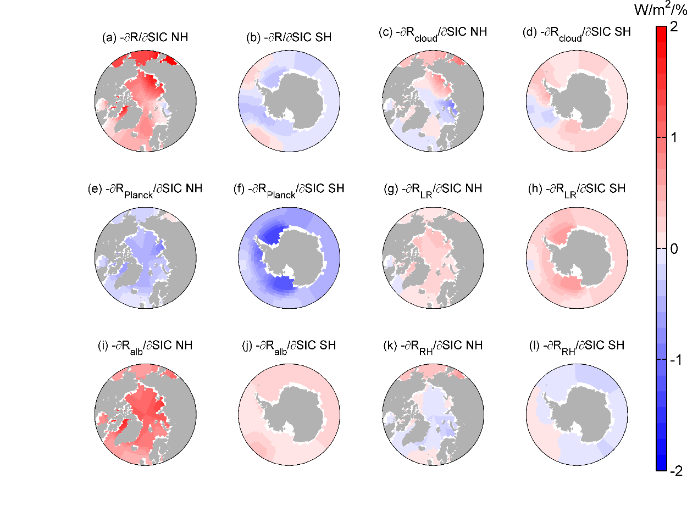
Supplementary Figure 10. Same as Figure 3, except for April-September.

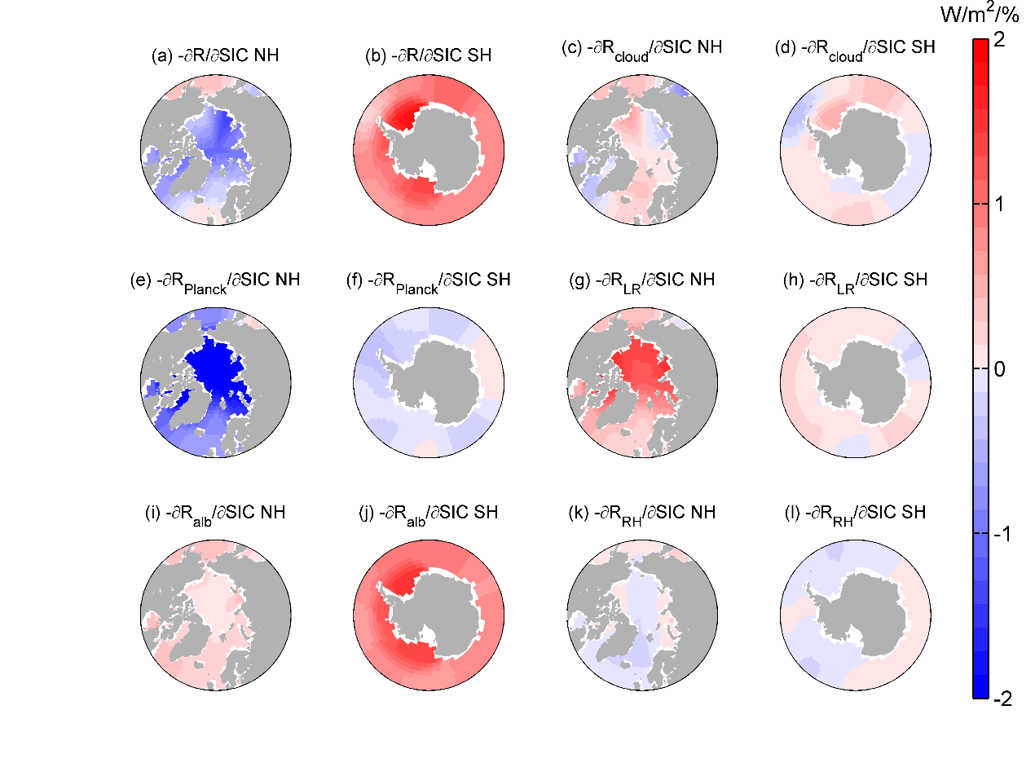
Supplementary Figure 11. Same as Figure 3, except for October-March.

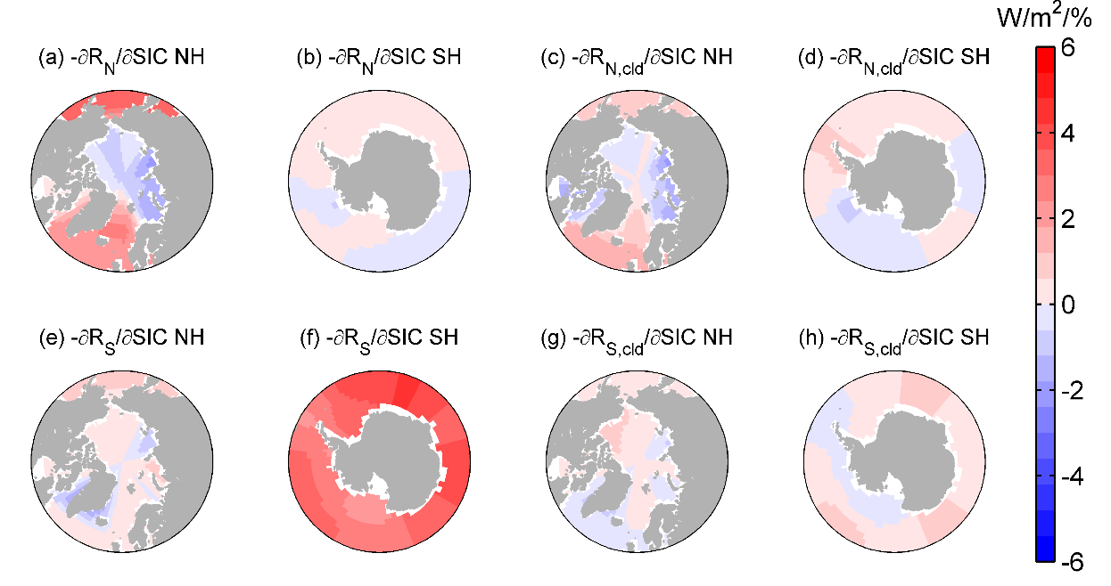
Supplementary Figure 12. Sensitivity of polar annual radiation to regional SIC change, normalized by the ratio of grid-box surface area to global surface area. (a-b) Sensitivity of TOA radiation averaged over 50°N-90°N to regional SIC change. (c-d) Sensitivity of cloud-induced radiation anomalies averaged over 50°N-90°N to regional SIC change. (e-h) are same as (a-d), but for radiation anomalies averaged over 50°S-90°S.

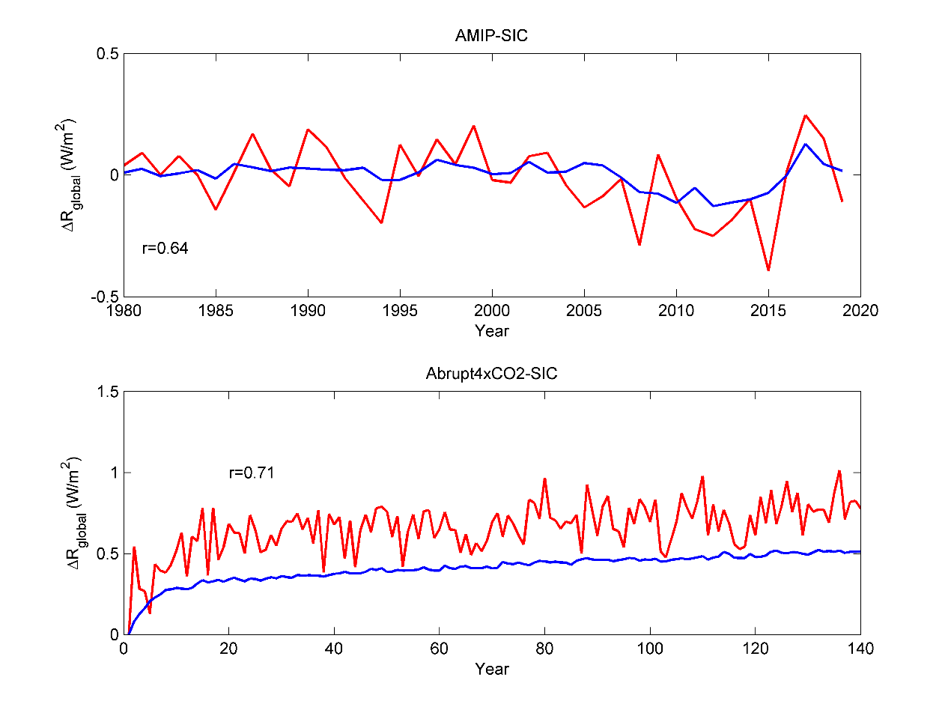
Supplementary Figure 13. Reconstruction of SIC-induced radiation anomalies using the Green’s function approach in the AMIPSIC experiment (upper panel) and Abrupt4xCO2-SIC experiment (lower panel). The red lines denote actual values. The blue lines denote Green’s function reconstructed values, i. e, $ΔR$ reconstructed using the equation $ΔR=\frac{∂R}{∂SIC}*ΔSIC+ε$. The correlation coefficient between reconstructed and actual values are shown in the figure.

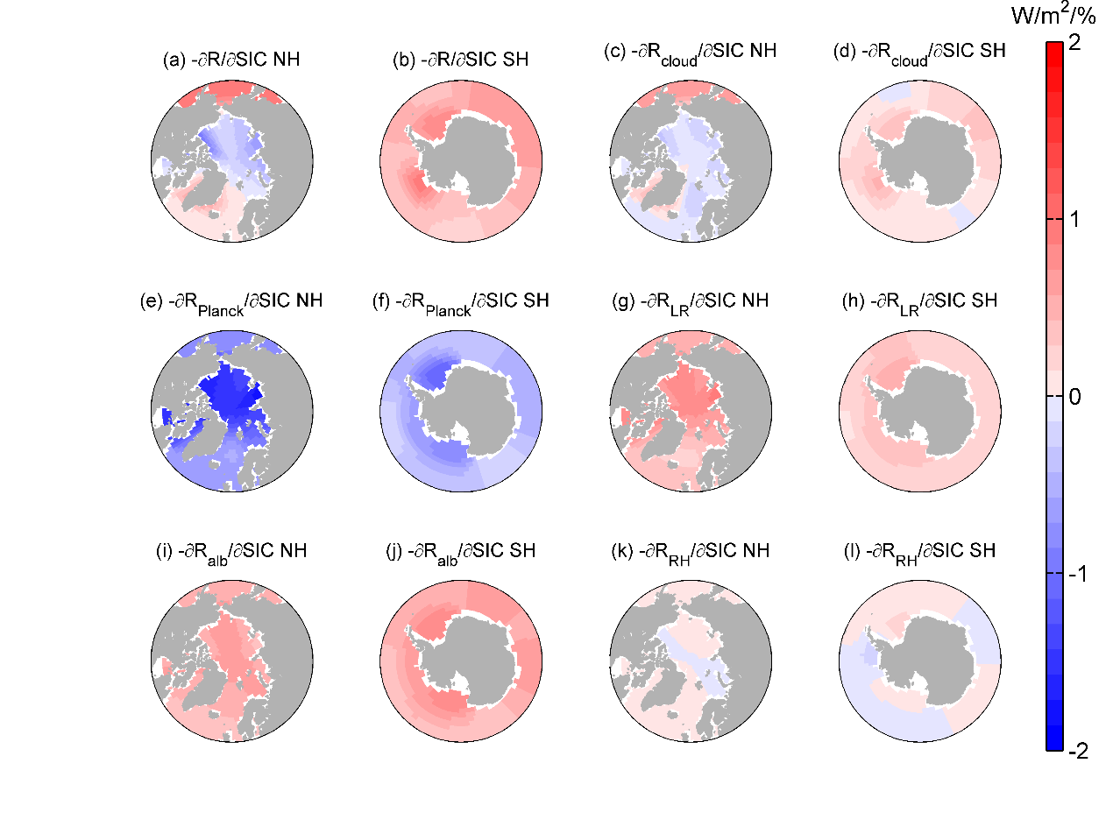
Supplementary Figure 14. Same as Figure 3, except for results calculated from covariant SIC-SST patch experiments, where SIC is same as the SIC patch experiments, but SST in each grid changes at the same time when SIC changes.

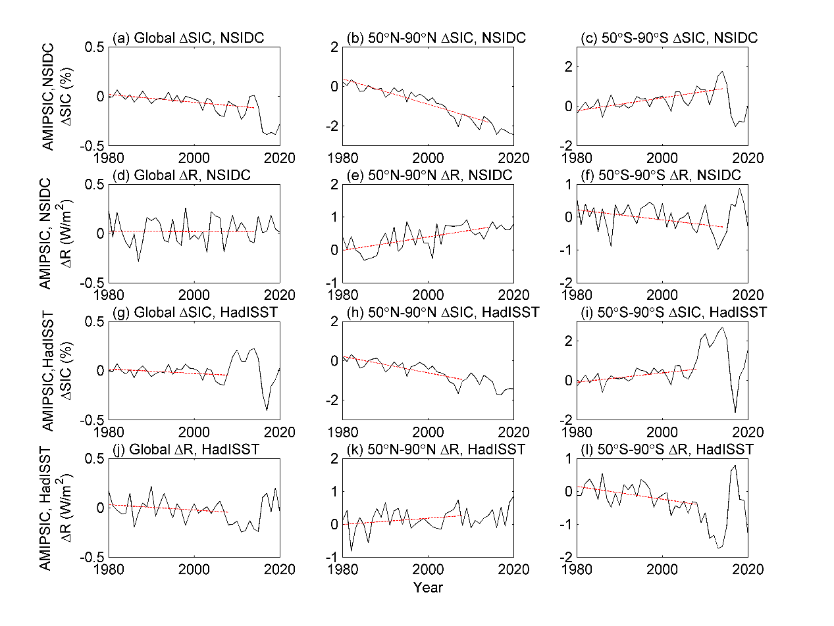
Supplementary Figure 15. Same as Figure 1, except that the AMIPSIC experiment is driven by different SIC datasets. (a-f) SIC is from NSIDC, and the red dashed lines show the trends during 1980-2014, when the trend of ΔSIC and ΔR are both negative. (g-l) SIC is from HadISST, and the red dashed lines show the trends during 1980-2008 (the global SIC trend during 1980-2010 and 1980-2014 is positive for this dataset).

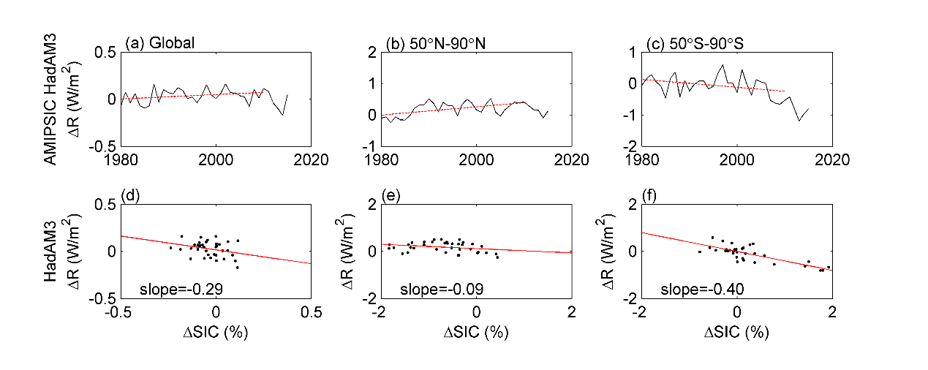
Supplementary Figure 16. Relationship between ΔSIC and TOA radiation anomalies ΔR in AMIPSIC experiments performed with HadAM3 (Pope et al., 2002). (a-c) are ensemble mean ΔR, which are similar as Figures 1(j-l). (d-f) show the sensitivity of ΔR to ΔSIC, which are similar to the upper panels of Supplementary Figure 4. The AMIPSIC HadAM3 experiment is same as AMIPSIC experiment, except that there are 8 runs and each run covers the period of 1980-2015. The trend of ΔR is different in HadAM3, indicating that the magnitude of SIC pattern effect is model-dependent, and our paper encourages further analyses on SIC pattern effect in the future. The sensitivity of ΔR to ΔSIC reduction is much stronger in SH than that in NH (consistent to Supplementary Figure 4), indicating that the mechanism that leads to SIC pattern effect in CESM1.2.1 model also applies for HadAM3.

Supplementary Table 1. Idealized experiments performed with CESM1.2.1 that are used in this study.
Experiment Name | Description | Years run
AMIPFF | The forcings are fixed at preindustrial level, while SIC and SST are prescribed using historical data (Hurrell et al., 2008). | 150 years  (1870-2019)  3 runs for each experiment
AMIPSST | The forcings and SIC are fixed at preindustrial level (i. e., repeating climatological annual cycle), while SST are historical. | 150 years  (1870-2019)  3 runs for each experiment
AMIPSIC | The forcings and SST are fixed at preindustrial level, while SIC are historical (AMIP SIC, Hurrell et al., 2008). | 150 years  (1870-2019)  3 runs for each experiment
AMIPSIC with HadISST | Same as AMIPSIC, except that SIC are from HadISST dataset. (Rayner et al. 2003) | 43 years  (1979-2021)  3 runs for each experiment
AMIPSIC with NSIDC | Same as AMIPSIC, except that SIC are from NSIDC dataset. (Meier et al. 2021) | 43 years  (1979-2021)  3 runs for each experiment
PiControl  (Coupled) | Preindustrial control run with active ocean model. | 250 years
Abrupt 4xCO2  (Coupled) | The forcing is increased suddenly at Year 100 of PI-control run, and held constant. | 150 years
Abrupt4xCO2-SIC | The forcings and SST are fixed at PI-control level (i. e., repeating climatological annual cycle of SSTs derived from the model’s piControl run), but the SIC are same as the Abrupt4xCO2 experiment. | 150 years,  3 runs
Control run for patch experiments | Prescribed SST/SIC experiment performed with present-day forcings, sea ice cover (SIC) and sea surface temperature (SST). | 40 years
SIC patch experiments | The SIC of each target region is increased/decreased relative to the control run using Eq. (2), while SST is not changed. SIC outside the target region is not changed. | 40 years for each of the 27x2 patch experiments
SIC-SST covarying  patch experiments | The SIC of each target region is increased/decreased using Eq. (2), while the SST is changed simultaneously using Eq. (5). | 40 years for each of the 27x2 patch experiments

References:
Hurrell, J. W., Hack, J. J., Shea, D., Caron, J. M. & Rosinski, J. A new sea surface temperature and sea ice boundary dataset for the Community Atmosphere Model. J. Clim. 21, 5145–5153 (2008).
Meier, W. N., Fetterer, F., Windnagel, A. K. & Stewart, S. NOAA/NSIDC Climate Data Record of Passive Microwave Sea Ice Concentration, Version 4. National Snow and Ice Data Center. http://doi.org/10.7265/efmz-2t65 (2021).
Pope, V. D., Gallani, M. L., Rowntree, P. R. & Stratton, R. A. The impact of new physical parametrizations in the Hadley Centre climate model: HadAM3. Clim. Dyn. 16 (2), 123–146 (2000).
Rayner, N. A. et al. Global analyses of sea surface temperature, sea ice, and night marine air temperature since the late nineteenth century. J. Geophys. Res. 108, 4407 (2003).
Zhou, C., Zelinka, M. D. & Klein, S. A. Analyzing the dependence of global cloud feedback on the spatial pattern of sea surface temperature change with a Green's function approach. J. Adv. Model. Earth Syst. 9 (2017).

