Table
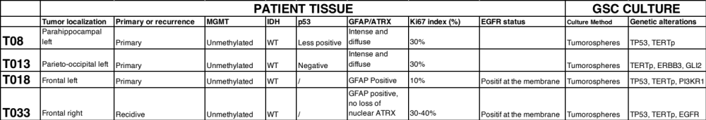
Table 1: Informations about GCS cultures.

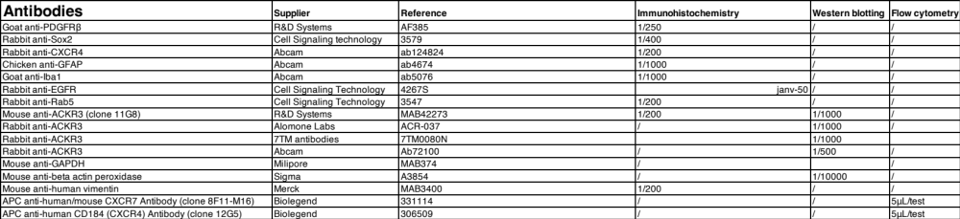
Table 2: Antibodies used for immunohistochemistry, western blotting and flow cytometry experiments.

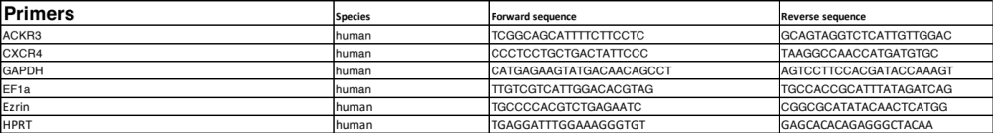
Table 3: Primer sequences used for qPCR experiments.

