ADDITIONAL FILE 1: ACKR3 detection using Western blotting or immunofluorescence. (A) Western Blot (WB) analysis of ACKR3 in protein extracts from U87, U87 ACKR3, T033 mRFP and T033 hACKR3 cells by using different commercially available antibodies (11G8 MAB42273, Ab72100, ACR-037 and 7TM0080N). (B) Immunofluorescent staining of ACKR3 (green) in U87 and U87 ACKR3 cells using Ab72100 antibodies against ACKR3. DAPI (blue) was used to counterstain nuclei. Scale bar = 50 μm.

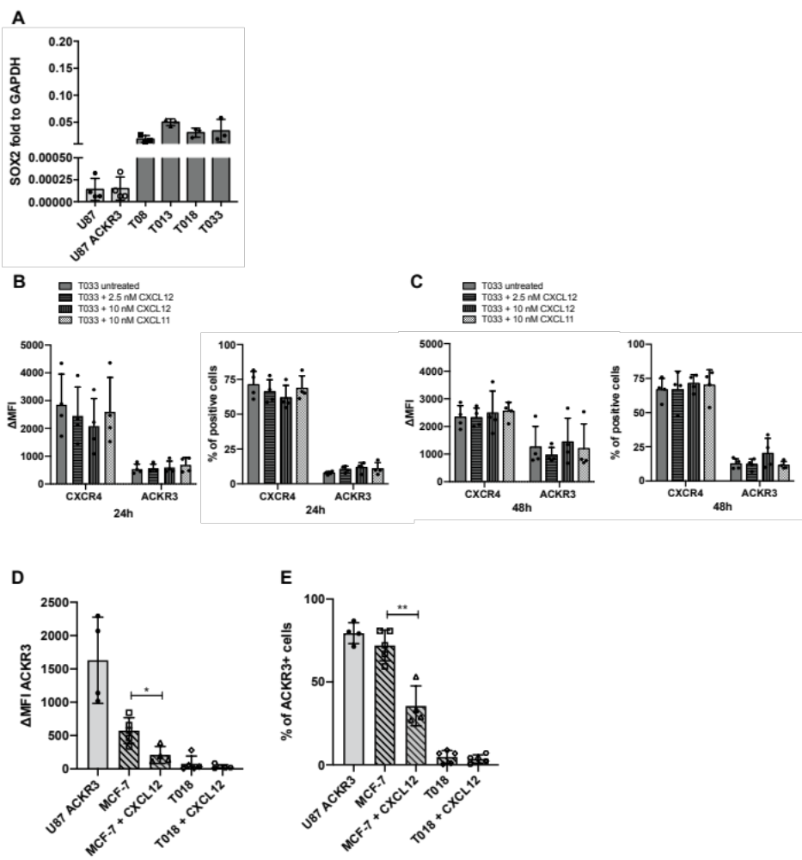

ADDITIONAL FILE 2: ACKR3 expression – additional information. (A) SOX2 mRNA expression relative to GAPDH mRNA expression in patient derived GSCs (n=3). (B-C) ACKR3 and CXCR4 fluorescence intensity (and % of positive T033 GSCs) after CXCL11 or CXCL12 stimulation for 24 or 48 hours (n=4). (D) Fluorescence intensity of ACKR3 membrane staining in the MCF-7 cell line and T018 GSCs using flow cytometry, untreated or upon 5-minute incubation with CXCL12 (n=3). Statistical significance was determined by t test (** p=0,0013). (E) Percentage of ACKR3 positive cells in the MCF-7 cell line and T018 GSCs using flow cytometry, untreated or upon 5-minute incubation with 10 nM of CXCL12 (n=3). Statistical significance was determined by t test (* p=0,0142).

