SUPPORTING INFORMATION
Immunotherapy induced by plant microRNA via ionizable Lipid Nanoparticles delivery enhances chemotherapy effects of Triple-negative breast cancer
Han-yi Yeª, Yi-fan Feng ª, Ze Wu ª, Ting-ting Zheng ª, Shu-hui Sun ª, Ying-xia Xiong ª, Meng-yao Cui ª, Shun Lv ª, Miao-miao Han ª, Bing Jin ª, Chang Liuª, Ying Li ^{a,b,c,d,e,*}, Lei Miao ^{f*}, Zheng-qi Dong ^{a,b,c,d,e,*}
ª Institute of Medicinal Plant Development, Chinese Academy of Medical Sciences, Peking Union Medical College, Beijing 100193, China
^{b} State Key Laboratory for Quality Ensurance and Sustainable Use of Dao-di Herbs, Beijing 100700, China
^{c} Key Laboratory of Bioactive Substances and Resources Utilization of Chinese Herbal Medicine, Ministry of Education, Chinese Academy of Medical Sciences, Peking Union Medical College, Beijing 100094, China
^{d} Key Laboratory of New Drug Discovery Based on Classic Chinese Medicine Prescription, Beijing 100700, China
^{e} Beijing Key Laboratory of Innovative Drug Discovery of Traditional Chinese Medicine (Natural Medicine) and Translational Medicine, Beijing 100700, China
^{f} Department of Pharmaceutics, School of Pharmaceutical Sciences, Peking University, Beijing 100191, China

Supplementary Figures
Figure S1. Dual luciferase enzyme assay of miR152 mimics. The biological repeats of the experiments (n = 3) were indicated as scatters in the plot. Data are shown as mean ± SEM.

Figure S2. (A) Uptake of LNP by 4T1 cells with different FA additions. Different formulations of LNP were prepared using C6 as a model drug (Table S2). Scale bar=10 μm. The addition of FA can significantly accelerate the uptake rate of LNP by 4T1 in vitro, and with the increase of the proportion of FA in LNP, the uptake rate of cells will also accelerate. When FA is 2 % or above, the uptake rate of cells in 4h will reach a stable and high level. (B) In vitro cell safety experiments of LNP. 375 ug/mL and below concentrations of LNP vector showed no significant toxicity to tumor cells 4T1 or normal cells NIH3T3 at 24 ~ 48 h. (C) Combining the effects of FA addition on LNP particle size and cellular uptake rate, LNP was prepared by choosing FA 2 % addition as the formulation, and co-incubated with normal cells NIH3T3 and tumor cells 4T1 for 4h (C6 was 0.29 mg/mL), to observe the affinity of mature LNP to different kinds of cells. The results suggested that LNP had stronger affinity for tumor cells under the same conditions. Scale bar=10 μm. (D) Tumor cell 4T1 or B16 survival was detected in the environment of 0 ~ 20 mM concentration of CTX, and wider cellular activity of tumor cells was observed when CTX was in the 10 ~ 20 mM concentration interval. (Cell viability of 4T1: 91 % ~ 45 %; Cell viability of B16: 65 % ~ 34 %). Data are shown as mean ± SEM.
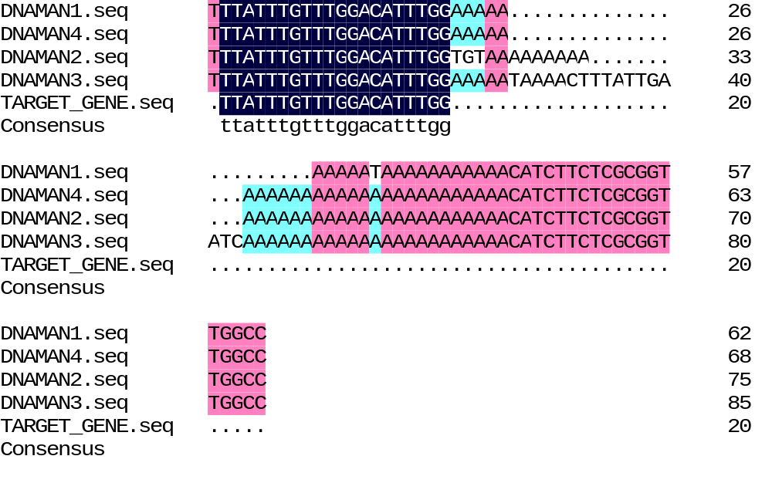
Figure S3. Sequencing results comparison. After administration of miR152 or LNP@miR152, blood and tumor tissues were taken from tumor-bearing mice, and “TTATTTGTTTGGACATT TGG” was used as the target gene for sequence comparison. DNAMAN1 or DNAMAN2 were derived from tissues or blood of miR152 group mice, and DNAMAN3 or 4 were derived from tissues or blood of LNP@miR152 group mice, respectively. Sequencing of miR152 in the blood or tumor sites of the Model group failed, and no miR152 gene fragment was detected, indicating that the miR152 sequence "TTATTTGTTTGGGACATT TGG" is not an endogenous miRNA.

Figure S4. In vitro hemolysis of LNP. Using double-distilled water as the positive control group and normal saline as the negative control group, no hemolysis was induced when the LNP concentration was 500 ug/mL and below. Biological replicates of the experiment (n = 6) were indicated as scatters in the plot. Data are shown as mean ± SEM.

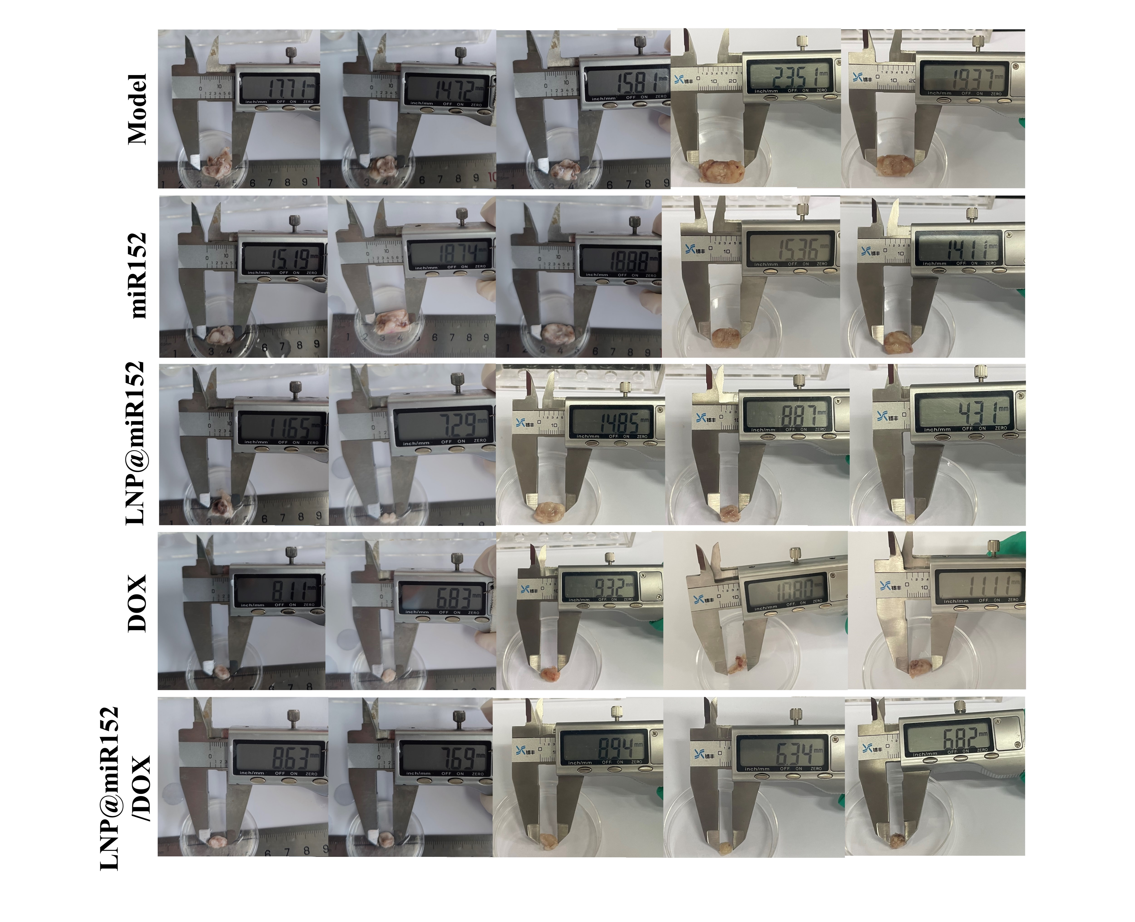
Figure S5. BALB/c mice were inoculated with 100 μL of the 4T1 cell suspension (3 × 10⁶ cells/mL) under the left breast pad. When the tumors grew to 50 ~ 90 mm³ (8 ~ 10 d), the mice were randomly divided into 6 groups of 12 mice each. The tail veins of the mice were injected with: normal saline (Model), miR152, LNP@miR152, DOX, LNP@miR152/DOX every day. After 14 days of administration, the mice were euthanized 24 h after the last dose, tumor were taken from the mice, and the tumors were measured. Significant differences were seen between large groups of tumors, with diameters from largest to smallest being Model, miR152, LNP@miR152, DOX, and LNP@miR152/DOX, respectively. It is clear that co-administration of the drug had the most pronounced effect against 4T1 tumors.

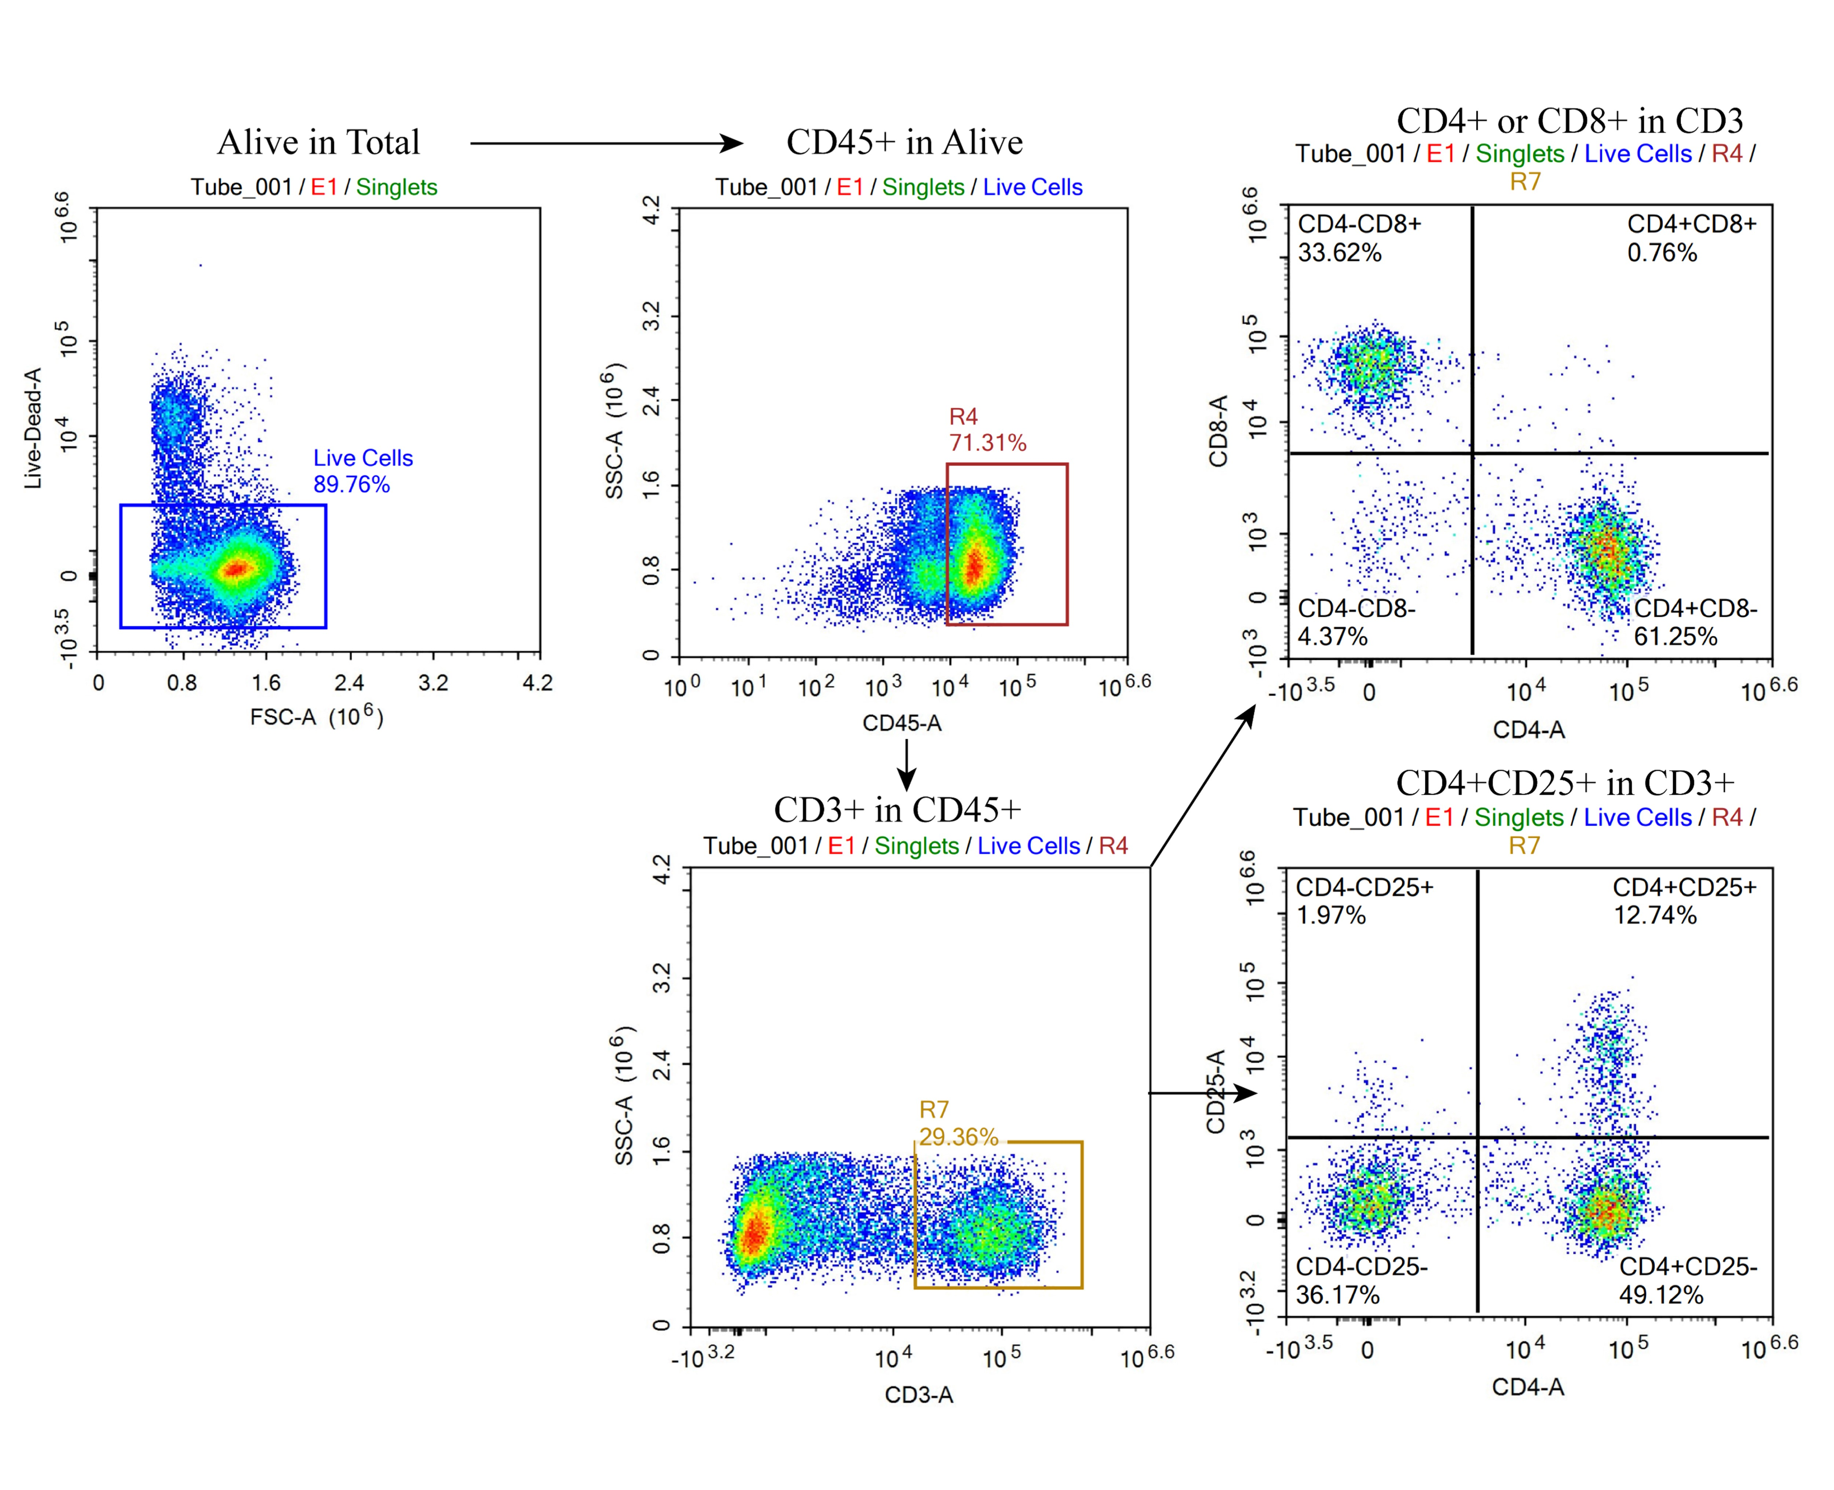
Figure S6. The trapdoor strategy of flow cytometry (FCM). CD45⁺ CD3⁺ CD4⁺ indicates CD4⁺ T cells, CD45⁺ CD3⁺ CD8⁺ indicates CD8⁺ T cells, and CD45⁺ CD3⁺ CD4⁺ CD25⁺ indicates Treg cells.

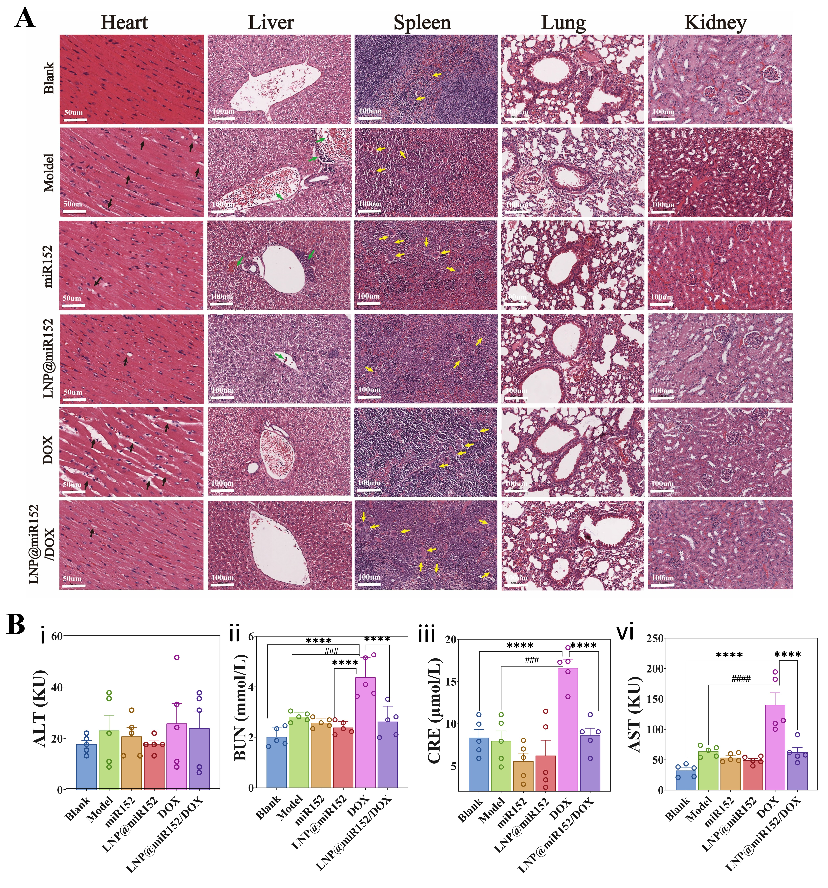
Figure S7. In vivo safety evaluation. (A) After continuous administration of drug or saline for 2 weeks in tumor-bearing mice, normal mice were used as control, and heart, liver, spleen, lung, kidney were extracted for H&E staining, and morphological features were observed microscopically. Heart, 400 × microscopic captured images; liver, spleen, lung and kidney, 200 × microscopic captured images. (The black arrow refers to broken, atrophied cardiac fibers, the green arrow refers to the inflammatory cell infiltration of liver, the yellow arrow refers to macrophages and foreign body giant cells in splenic cord) (B) At the end of the in vitro antitumor experiments, serum was prepared by blood sampling from the eyeballs of all mice, and normal mice were used as controls. The serum levels of liver and kidney biochemical indicators ALT, AST, BUN, and CRE were measured. Compared with Blank, DOX showed significant hepatic and renal injury (ii, iii, vi p < 0.0001), while concomitant administration of LNP@miR152 significantly attenuated this hepatic and renal injury (LNP@miR152/DOX), as evidenced by the return of BUN, CRE, and AST indicators to normal levels (p > 0.5).

