Supporting Information

Spectra of Chemicals Synthesized.
¹H NMR of compound 28a ¹H NMR of compound 28b
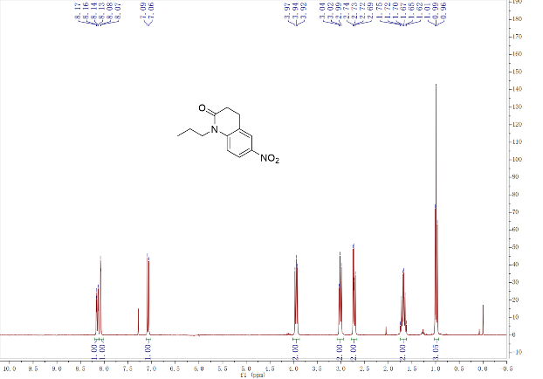
¹H NMR of compound 29a ¹H NMR of compound 29b
¹H NMR of compound 30a ¹H NMR of compound 30b

¹H NMR of compound 32 ¹H NMR of compound 33
¹H NMR of compound 34 ¹H NMR of compound QB (3)
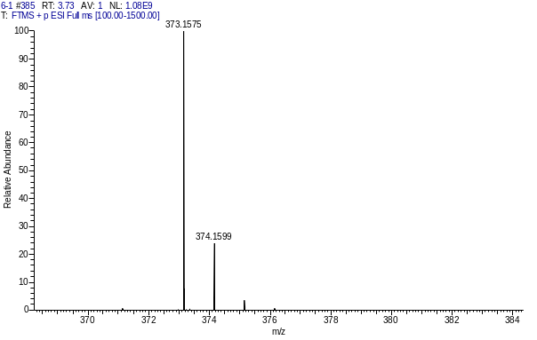
¹³C NMR of compound QB (3) HRMS of compound QB (3)
¹H NMR of compound TFQB (8) ¹³C NMR of compound TFQB (8)

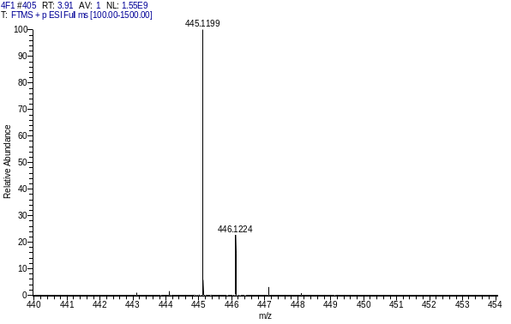
HRMS of compound TFQB (8) ¹H NMR of compound IQB (21)
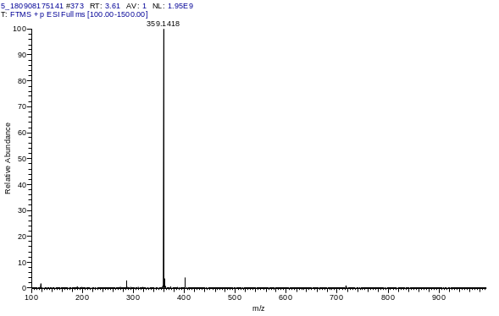
¹³C NMR of compound IQB (21) HRMS of compound IQB (21)
¹H NMR of compound TQB (22) ¹³C NMR of compound TQB (22)
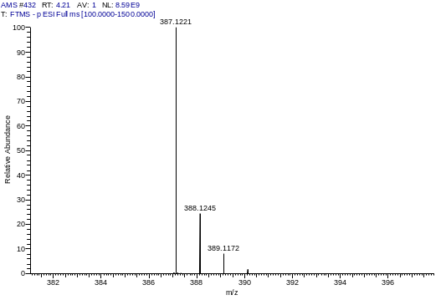
HRMS of compound TQB (22) ¹H NMR of compound DHQB (23)
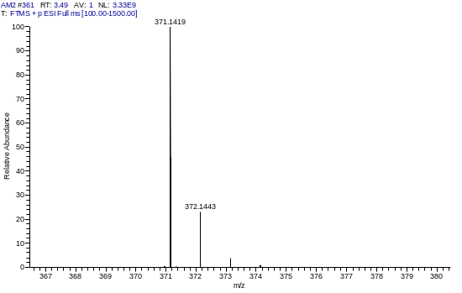
¹³C NMR of compound DHQB (23) HRMS of compound DHQB (23)
¹H NMR of compound DHTQB (24) ¹³C NMR of compound DHTQB (24)
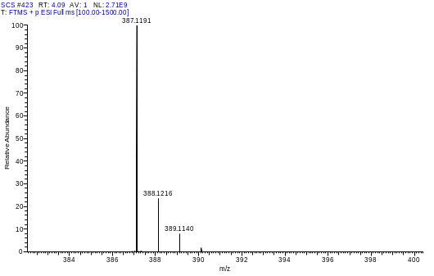
HRMS of compound DHTQB (24) ¹H NMR of compound TFTQB (25)
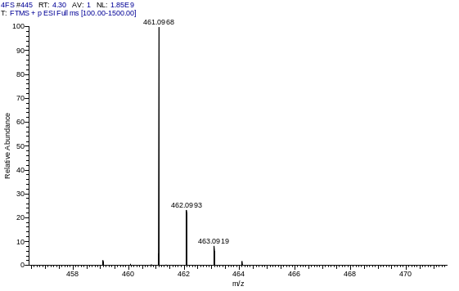
¹³C NMR of compound TFTQB (25) HRMS of compound TFTQB (25)
¹H NMR of compound iso-QB (26) ¹³C NMR of compound iso-QB (26)
HRMS of compound iso-QB (26)
Bioassays
Table S1. Average leaf surface temperature of A. thaliana
 | DMSO | ABA | QB | TFQB | IQB | DHQB | TQB | DHTQB | TFTQB | iso-QB
1 | 21.77 | 21.85 | 22.68 | 22.37 | 22.30 | 22.62 | 22.24 | 22.37 | 22.09 | 21.96
2 | 21.70 | 22.28 | 22.56 | 22.48 | 22.21 | 21.99 | 22.27 | 22.49 | 22.20 | 21.82
3 | 21.30 | 21.79 | 22.85 | 22.31 | 22.21 | 22.04 | 22.00 | 22.19 | 21.82 | 21.96
4 | 21.10 | 22.29 | 22.57 | 22.51 | 22.12 | 22.07 | 22.09 | 22.17 | 22.09 | 21.99
5 | 21.86 | 22.03 | 22.58 | 22.39 | 22.14 | 21.92 | 22.18 | 21.93 | 22.10 | 21.88
6 | 21.60 | 21.87 | 22.43 | 22.70 | 22.25 | 22.11 | 22.21 | 22.10 | 22.06 | 22.22
7 | 21.79 | 22.01 | 22.35 | 22.55 | 22.34 | 21.95 | 22.34 | 22.13 | 22.01 | 21.94
8 | 21.59 | 22.03 | 22.45 | 22.51 | 22.43 | 22.05 | 22.14 | 22.11 | 22.18 | 21.77
9 | 21.66 | 22.43 | 22.64 | 22.41 | 22.34 | 22.51 | 22.09 | 22.11 | 22.23 | 21.54
10 | 21.20 | 22.08 | 22.42 | 22.53 | 22.33 | 22.19 | 22.14 | 22.46 | 22.00 | 22.05
11 | 21.23 | 22.35 | 22.23 | 22.75 | 22.01 | 21.74 | 22.33 | 22.12 | 21.97 | 21.92
12 | 21.45 | 21.83 | 22.02 | 22.33 | 21.96 | 21.94 | 22.12 | 21.99 | 22.16 | 21.80
13 | 21.60 | 22.00 | 22.06 | 22.32 | 22.24 | 22.12 | 22.16 | 22.12 | 22.13 | 21.93
14 | 21.25 | 21.80 | 21.77 | 22.22 | 21.77 | 22.40 | 22.02 | 22.35 | 22.26 | 21.95
15 | 21.32 | 21.67 | 22.12 | 22.40 | 21.96 | 21.95 | 22.19 | 21.70 | 21.91 | 21.90
AVE | 21.49 | 22.02 | 22.38 | 22.45 | 22.17 | 22.11 | 22.17 | 22.16 | 22.08 | 21.91
SD | 0.24 | 0.23 | 0.29 | 0.15 | 0.18 | 0.24 | 0.10 | 0.20 | 0.12 | 0.15

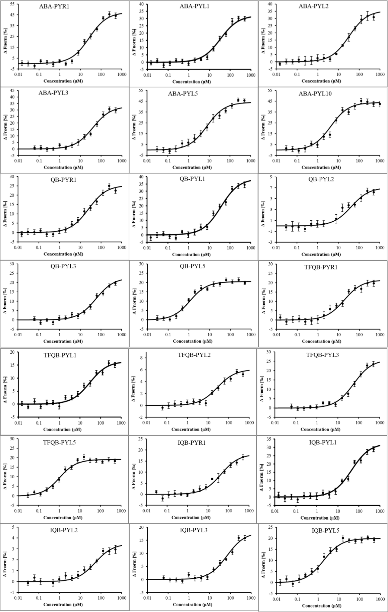
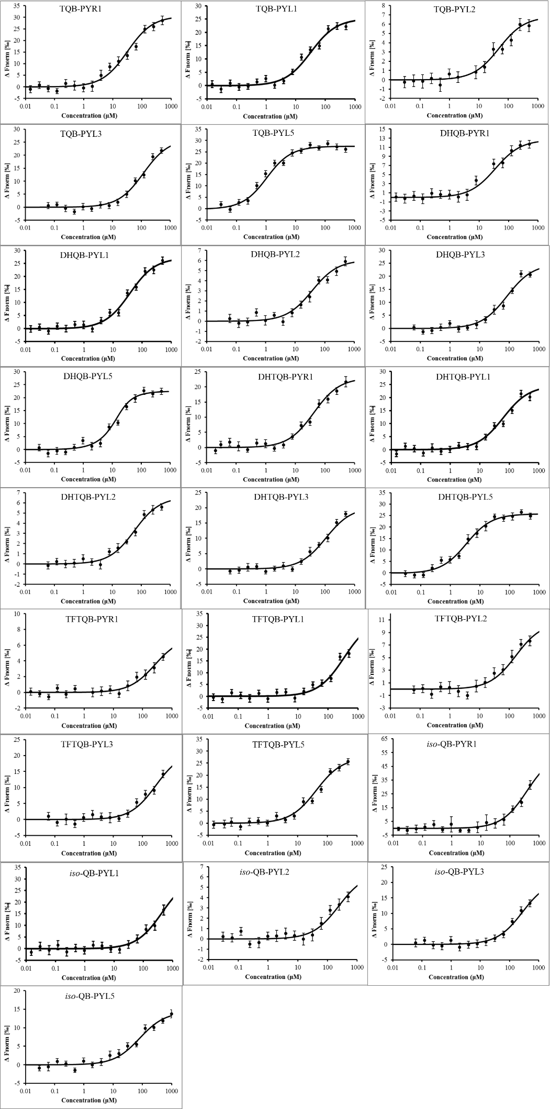
Fig. S1 Ligand-receptor binding curve.

