Assumption Tests
- P-P Plot for Attribution Scores

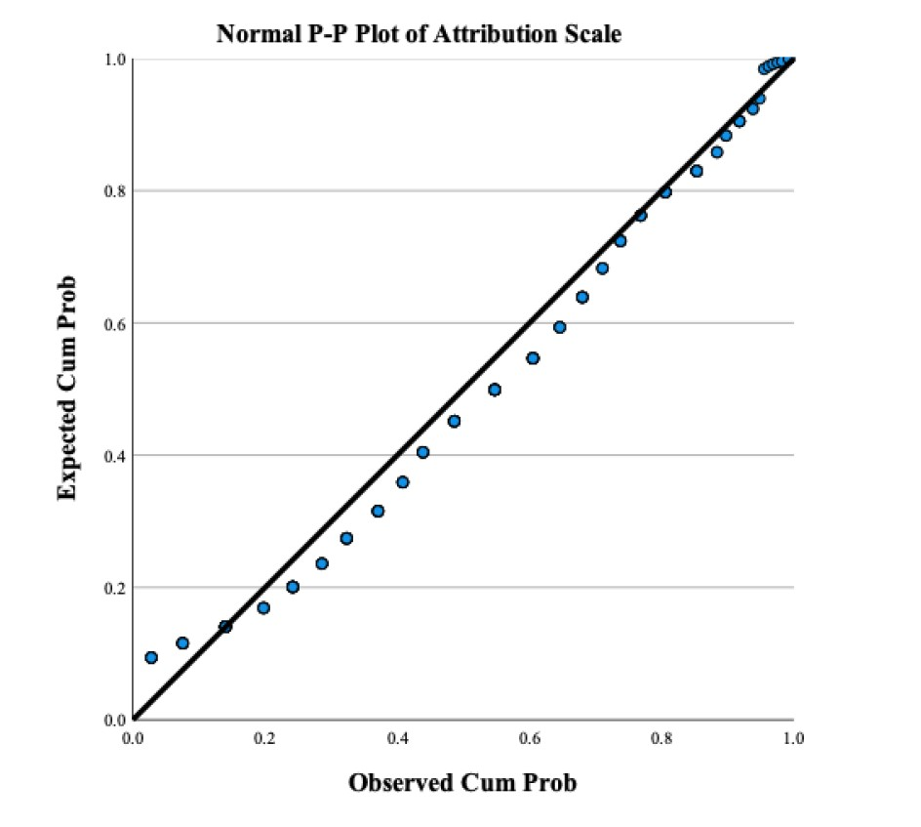

(b) P-P Plot for Stigma Scores

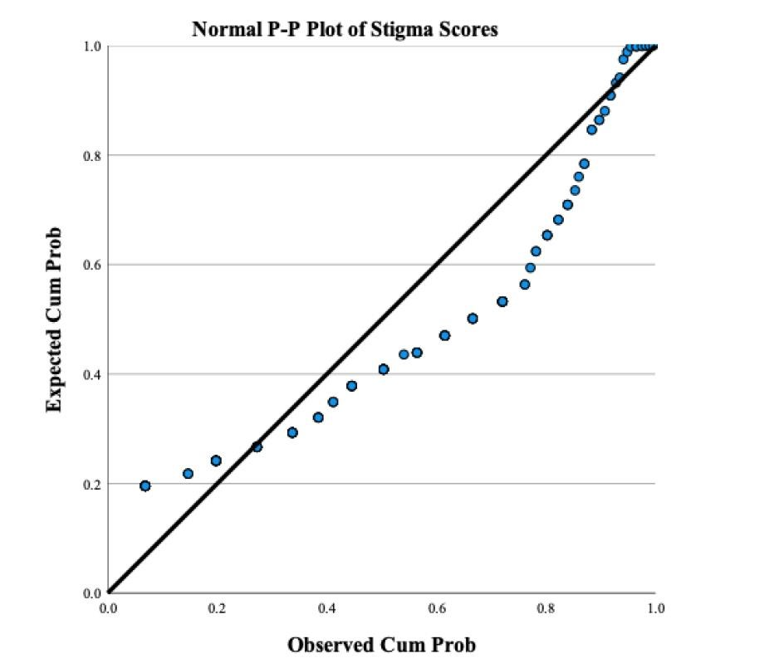

Inferential Analyses
(c) Positive correlation between causal attributions and stigma levels.

