Claims about Certification
Meeting any one of the following conditions can be regarded as certification.
YouTube
①There is a blue label beneath the video showing this account belongs to a medical school/ hospital/ association/ doctor.
For example :
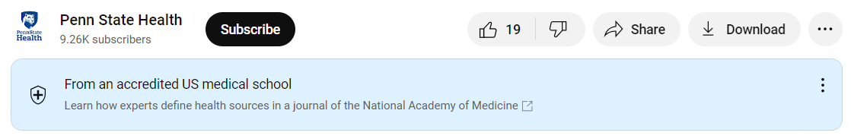

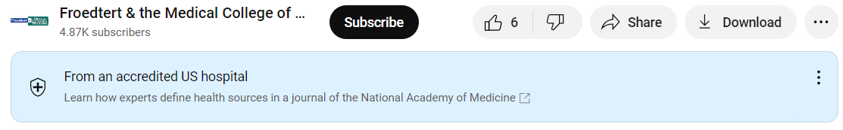

②There is a grey √ on the right of its ID.
For example :




③ Some of accounts get both the blue label and the gery √.
For example:
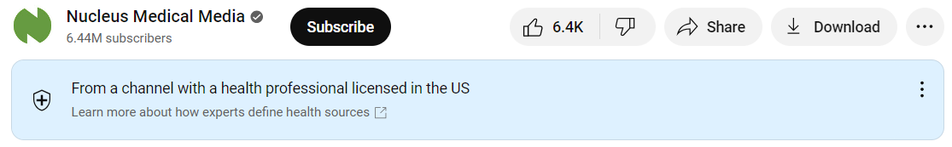

Bilibili
① Yellow flash：personal certification for a famous person/popular account.
For example:
There is a yellow flash on the lower right corner of its icon. This is a popular personal account in Bilibili with now 165 thousand fans, who often tell stories from a movie or documentary, or TV show. In our study, he edited a long documentary related to a patient with laryngeal cancer into a short video and then posted it on Bilibili.
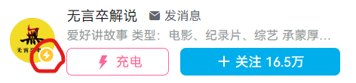

② Blue flash：certification for groups.
For example:
There is a blue flash on the right down corner of its icon. This is an account from a hospital (Central Hospital of Zibo City, Shangdong Province, China) (hosiptal in Chinese: “医院”) with now 1781 thousands fans.
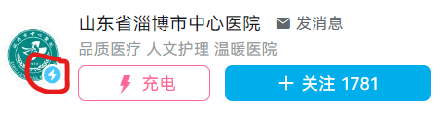

③ Gery V: personal occupational certification such as a doctor.
For example：
We can not see any yellow or blue flash on his icon. Then we click his icon, and there is a grey V on the right of his main page, which shows that he is a doctor. (doctor in Chinese: “医生” or“医师”)
In Bilibili, one who gets both a certificate of a medical practitioner in China and a certificate of incumbency in any hospital in China can apply for a grey V.



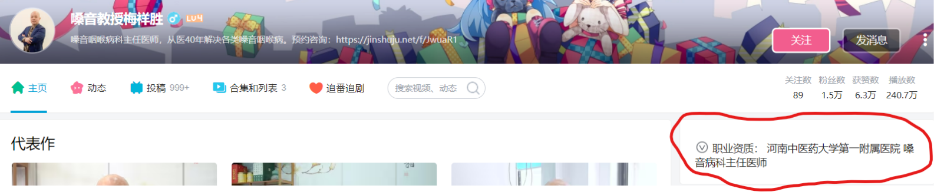

④ In theory, one account may get both the yellow flash and the grey V, but we could not find such an account in our study. In Bilibili, a doctor can apply for a grey V, but only when he gets enough followers (more than 50~100 thousands) can he apply for a yellow flash.

TikTok
- Yellow V: personal certification for a famous person/popular account/ occupation.
In TikTok, only attending/associate/chief doctors who work in a grade 3 and first-class hospital (a hospital ranking system in China, grade 3 and first-class means the top level) can apply for a grey V. Resident doctors or any doctors who do not work in the grade 3 and first-class hospital can not apply it.
For example:
There is a yellow V on the right of its ID. This is a chief doctor with now 417 thousand fans.
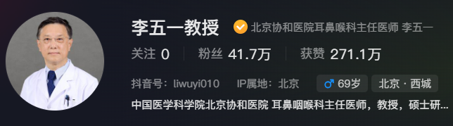
② Blue V：certification for groups.
For example:
There is a blue V on the right of its ID. This is an account from an official media, CCTV, with now 3072 thousand fans.
