Table of Contents
Supplementary Table S1. Ramachandran plot evaluation for the predicted mutant models of LDLR, APOB, and PCSK9 wild-type structures 2
Supplementary Table S2. ERRAT, Verify3D, ProSA, and QMEAN evaluation of the predicted mutant models and the wild-type structures of LDLR, APOB, and PCSK9 3
Supplermentary Figure S1. Oveview of Ser648Pro in mutatn model W.R.T wild type model LDLR 4
Supplermentary Figure S2. Overview of Ser418Pro in mutant model W.R.T wild type model of LDLR 5
Supplermentary Figure S3. Overview of Pro476Arg in mutant model W.R.T type model of LDLR 6
Supplermentary Figure S4. Overview of His583Tyr in mutant model W.R.T type model of LDLR 7
Supplermentary Figure S5. Overview of Asp589Asn in mutant model W.R.T type model of LDLR 8
Supplermentary Figure S6. Overview of Gln660Ter in mutant model W.R.T type model of LDLR 9
Supplermentary Figure S7. Overview of Ala684Thr in mutant model W.R.T type model of LDLR 10
Supplermentary Figure S8. Overview of Glu288Lys in mutant model W.R.T wild type model of LDLR 11
Supplermentary Figure S9. Overview of Cys318Arg in mutant model W.R.T wild type model of LDLR 12
Supplermentary Figure S10. Overview of Asp227Glu in mutant model W.R.T wild type model of LDLR 13
Supplermentary Figure S11. Overview of Cys104Tyr in mutant model W.R.T type model of LDLR 14
Supplermentary Figure S12. Overview of Ser130Ter in mutant model W.R.T type model of LDLR 15
Supplermentary Figure S13. Overview of Arg257Trp in mutant model W.R.T type model of LDLR 16
Supplermentary Figure S14. Overview of Val797Met in mutant model W.R.T type model of LDLR 17
Supplermentary Figure S15. Overview of Val806fs in mutant model W.R.T type model of LDLR 18
Supplermentary Figure S16. Overview of Gly844Ser in mutant model W.R.T type model of LDLR 19
Supplermentary Figure S17. Overview of Asp843Glufs*86 in mutant model W.R.T type model of LDLR 20
Supplermentary Figure S18. Overview of Arg1386Trp in mutant model W.R.T type model of APOB 21
Supplermentary Figure S19. Overview of Phe2469Cys in mutant model W.R.T type model of APOB 22
Supplermentary Figure S20. Overview of Arg4297His in mutant model W.R.T type model of APOB 23
Supplermentary Figure S21. Overview of Leu23_Gly24insLeu in mutant model W.R.T type model of PCSK9 24

Supplementary Table S1. Ramachandran plot evaluation for the predicted mutant models of LDLR, APOB, and PCSK9 wild-type structures

Proteins | Structure | Favored Regions | Allowed Regions | Outlier Regions
LDLR | Ala684Thr | 84,70% | 13,90% | 0,40%
LDLR | Asp589Asn | 86,50% | 12,10% | 0,40%
LDLR | His583Tyr | 87,20% | 11,70% | 0,40%
LDLR | Pro476Arg | 86,90% | 11,30% | 0,40%
LDLR | Ser418Pro | 88,20% | 10,70% | 0,40%
LDLR | Ser648Pro | 85,00% | 13,60% | 0,40%
LDLR | Gln660Ter | 85,30% | 13,20% | 0,40%
LDLR | 1IJQ | 84,00% | 14,20% | 0,40%
LDLR | Mean | 85,98% | 12,59% | 0,40%
LDLR | Asp168Tyr | 74,40% | 16,70% | 3,80%
LDLR | Asp227Glu | 73,10% | 14,10% | 5,10%
LDLR | Cys222Arg | 77,90% | 11,70% | 3,90%
LDLR | Glu228Lys | 76,60% | 13,00% | 3,90%
LDLR | 2LGP | 57,70% | 32,10% | 6,40%
LDLR | Mean | 71,94% | 17,52% | 4,62%
LDLR | Cys318arg | 84,50% | 12,70% | 0,00%
LDLR | Glu288lys | 78,90% | 18,30% | 0,00%
LDLR | 1XFE | 60,60% | 35,20% | 0,00%
LDLR | Mean | 74,67% | 22,07% | 0,00%
LDLR | Cys104Tyr | 62,50% | 18,80% | 3,10%
LDLR | 1LDR | 62,50% | 28,10% | 6,20%
LDLR | Mean | 62,50% | 23,45% | 4,65%
LDLR | Ser130Ter | 80% | 20,00% | 0,00%
LDLR | 2FCW | 75,00% | 15,00% | 0,00%
LDLR | Mean | 78% | 17,50% | 0,00%
LDLR | Arg257Trp | 70,60% | 23,50% | 0,00%
LDLR | 1D2J | 47,10% | 44,10% | 2,90%
LDLR | Mean | 58,85% | 33,80% | 1,45%
LDLR | Val797Met | 65,20% | 26,10% | 5,40%
LDLR | Gly844Ser | 64,50% | 26,90% | 5,40%
LDLR | Asp843Glufs86 | 64,90% | 26,00% | 7,80%
LDLR | Val806fs | 64,30% | 21,40% | 10,70%
LDLR | P01130.1.A | 62,00% | 27,20% | 7,60%
LDLR | Mean | 64,18% | 25,52% | 7,38%
APOB | Arg1386Trp | 66,40% | 29,80% | 1,80%
APOB | P04114:6 | 64,80% | 30,90% | 1,60%
APOB | Mean | 65,60% | 30,35% | 1,70%
APOB | Phe2469Cys | 83,90% | 15,40% | 0,00%
APOB | P04114:10 | 81,10% | 18,20% | 0,00%
APOB | Mean | 82,27% | 16,80% | 0,00%
APOB | His3583Leu | 71,00% | 28,00% | 0,00%
APOB | P04114:14 | 71,00% | 28,00% | 0,00%
APOB | Mean | 71,00% | 28,00% | 0,00%
APOB | Arg4297His | 82,60% | 16,70% | 0,00%
APOB | P04114:15 | 81,20% | 18,10% | 0,00%
APOB | Mean | 81,90% | 17,40% | 0,00%
PCSK9 | Leu23_Gly24insLeu | 71,20% | 20,30% | 3,40%
PCSK9 | B4DEZ9 | 78,90% | 16,00% | 2,30%
PCSK9 | Mean | 75,05% | 18,15% | 2,85%

Supplementary Table S2. ERRAT, Verify3D, ProSA, and QMEAN evaluation of the predicted mutant models and the wild-type structures of LDLR, APOB, and PCSK9
Protein | Structure | ERRAT | QMEAN | PROSA
LDLR | Ala684Thr | 75 | 0,81 | -6,79
LDLR | Asp589Asn | 76,6 | 0,81 | -6,66
LDLR | His583Tyr | 73,05 | 0,81 | -7
LDLR | Pro476Arg | 73,37 | 0,81 | -6,77
LDLR | Ser418Pro | 70,77 | 0,81 | -6,71
LDLR | Ser648Pro | 66,55 | 0,81 | -6,97
LDLR | Gln660Ter | 80,71 | -2,04 | -6,08
LDLR | 1IJQ | 93 | 0,82 | -6,55
LDLR | Mean | 76,13 | 0,455 | -6,69
LDLR | Asp168Tyr | 34,88 | 0,59 | -4,08
LDLR | Asp227Glu | 72,09 | 0,6 | -4,13
LDLR | Cys222Arg | 44,7 | 0,63 | -3,87
LDLR | Glu228Lys | 52,94 | 0,57 | -4,2
LDLR | 2LGP | 72,1 | -6,69 | -3,86
LDLR | Mean | 55,34 | -0,86 | -4,03
LDLR | Cys318arg | 77,46 | 0,57 | -3,94
LDLR | Glu288lys | 88,57 | 0,6 | -4,1
LDLR | 1XFE | 86,77 | -3,74 | -3,99
LDLR | Mean | 84,27 | -0,85 | -4,01
LDLR | Cys104Tyr | 78,79 | -4,05 | -2,28
LDLR | 1LDR | 90,62 | -2,06 | -3,62
LDLR | Mean | 84,71 | -3,05 | -2,95
LDLR | Ser130Ter | 60 | -1,57 | -2,21
LDLR | 2FCW | 47 | -2,65 | -2,37
LDLR | Mean | 53,33 | -2,11 | -2,29
LDLR | Arg257Trp | 68,75 | -1,87 | -2,89
LDLR | 1D2J | 37,5 | -2,44 | -2,94
LDLR | Mean | 53,12 | -2,15 | -2,91
LDLR | Val797Met | 100 | -8,88 | -0,67
LDLR | Gly844Ser | 100 | -8,2 | -0,47
LDLR | Asp843Glufs86 | 100 | -6,89 | -0,28
LDLR | Val806fs | 100 | 0,31 | -3,44
LDLR | P01130.1.A | 100 | -9,07 | -0,47
LDLR | Mean | 100 | -6,546 | -1,066
APOB | Arg1386Trp | 63,58 | -11,33 | -0,21
APOB | P04114:6 | 56,9 | -10,82 | -0,39
APOB | Mean | 60,24 | -11,07 | -0,3
APOB | Phe2469Cys | 82,97 | -5,76 | -1,74
APOB | P04114:10 | 85,81 | -5,58 | -1,95
APOB | Mean | 84,4 | -5,67 | -1,84
APOB | His3583Leu | 53,46 | -6,06 | -0,57
APOB | P04114:14 | 53,46 | -5,95 | -0,78
APOB | Mean | 53,46 | -6 | -0,67
APOB | Arg4297His | 92,86 | -3,98 | -5,07
APOB | P04114:15 | 93,57 | -4,3 | -5,05
APOB | Mean | 93,21 | -4,14 | -5,06
PCSK9 | Leu23_Gly24insLeu | 86,2 | -6,79 | -0,25
PCSK9 | B4DEZ9 | 81,41 | -5,99 | -2,89
PCSK9 | Mean | 83,81 | -6,39 | -1,57
Supplementary Figure
1. Structural Analysis of Mutations in LDLR
1.1. 1IJQ Structure of LDLR
Seven mutations were built homology modeling for the 1IJQ structure of LDLR, including serine residue (Ser648Pro and Ser418Pro) proline residue (Pro476Arg), histidine residue (His583Tyr), aspartic acid residue (Asp589Asn), glutamine residue (Gln660Ter) and alanine residue (Ala684Thr).
Serine residue affected by mutated positions: Ser648Pro and Ser418Pro
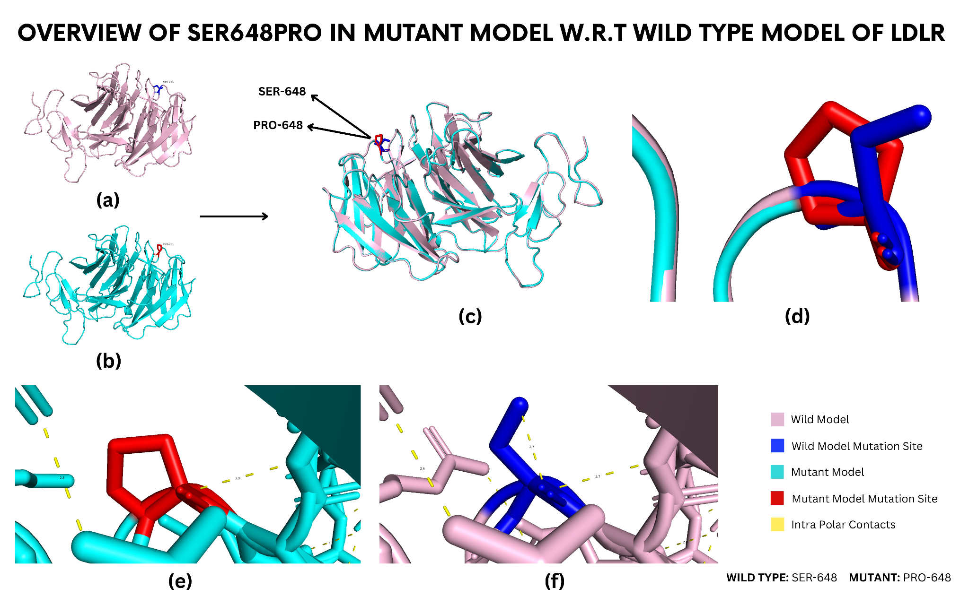

Supplermentary Figure S1. Oveview of Ser648Pro in mutatn model W.R.T wild type model LDLR

(a) The Structure in violet color represents the wild type-model (1IJQ), whereas (b) the cyan structure is of the Ser648Pro model. (c) Superimposition of wild type (1IJQ) structure and Ser648Pro mutant model shows structural variations of the mutant model with respect to wild type (d) Zoomed-in view of superimposed structures showed slight variation in mutation site. The red color indicates the mutation site in the structure. (e) Zoomed-in view of bonding interactions between residues in the mutant model. (f) Zoomed-in view of bonding interactions within a wild-type model.
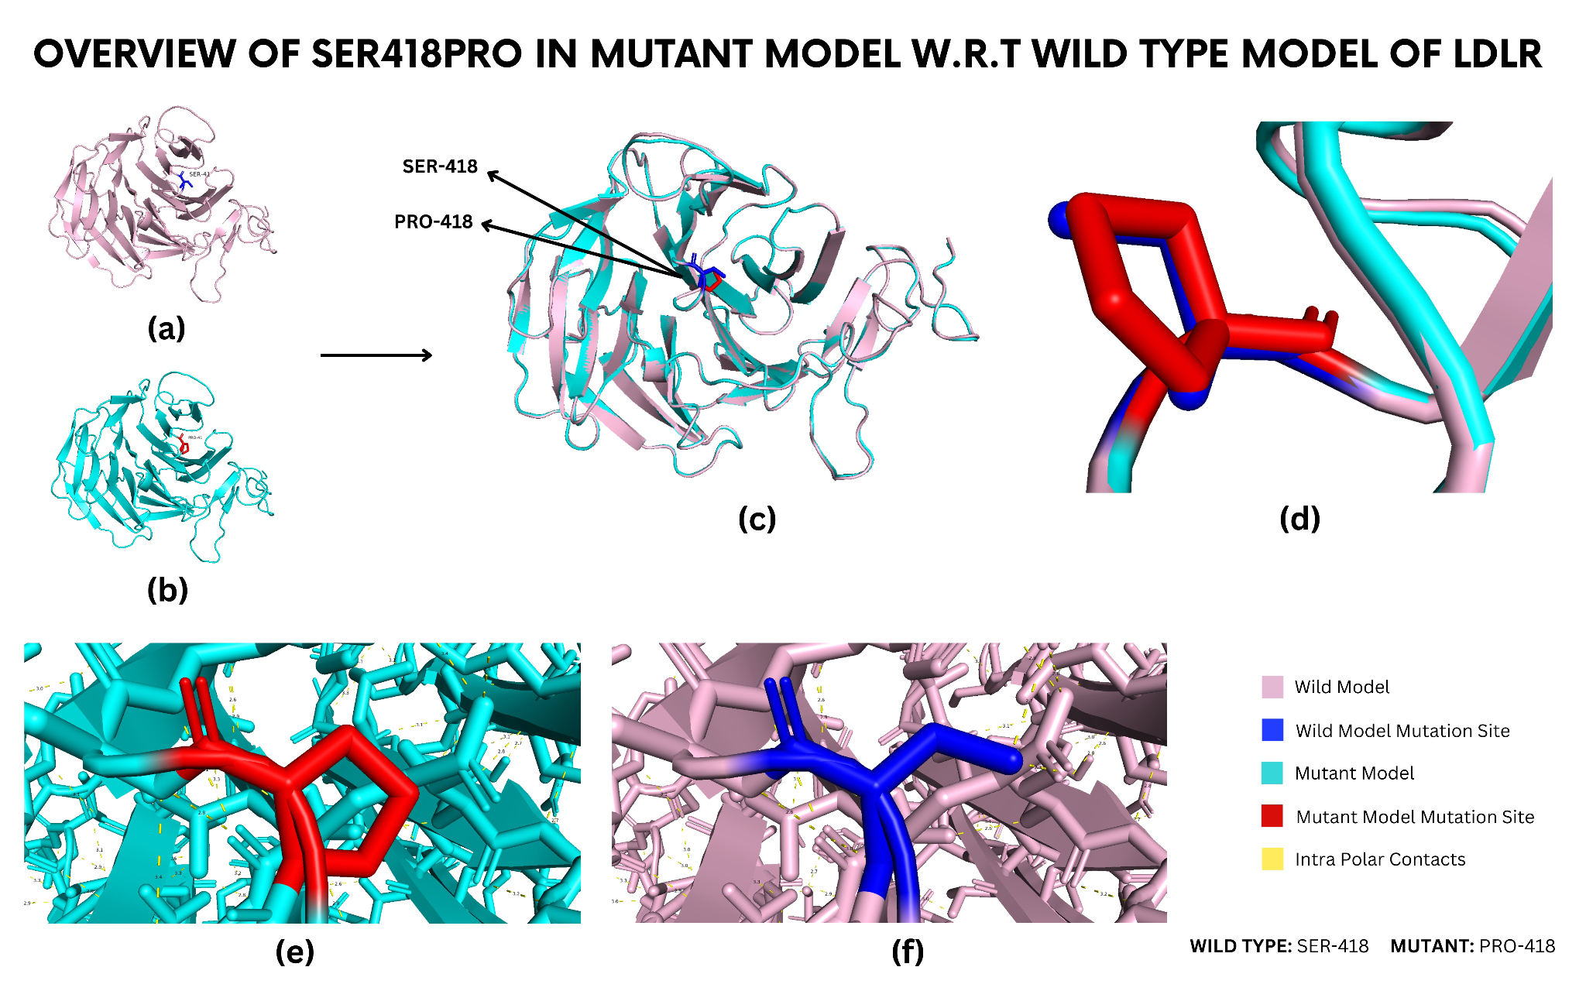

Supplermentary Figure S2. Overview of Ser418Pro in mutant model W.R.T wild type model of LDLR

(a) Structure in violet color represents the wild type model (1IJQ), whereas (b) the cyan structure is of the Ser418Pro model. (c) Superimposition of wild type (1IJQ) structure and Ser418Pro mutant model shows structural variations of the mutant model with respect to wild type (d) Zoomed-in view of superimposed structures showed slight variation in mutation site. The red color indicates the mutation site in the structure. (e) Zoomed-in view of bonding interactions between residues in the mutant model. (f) Zoomed-view of bonding interactions within wild-type structure.

Proline residue affected by mutated positions: Pro476Arg
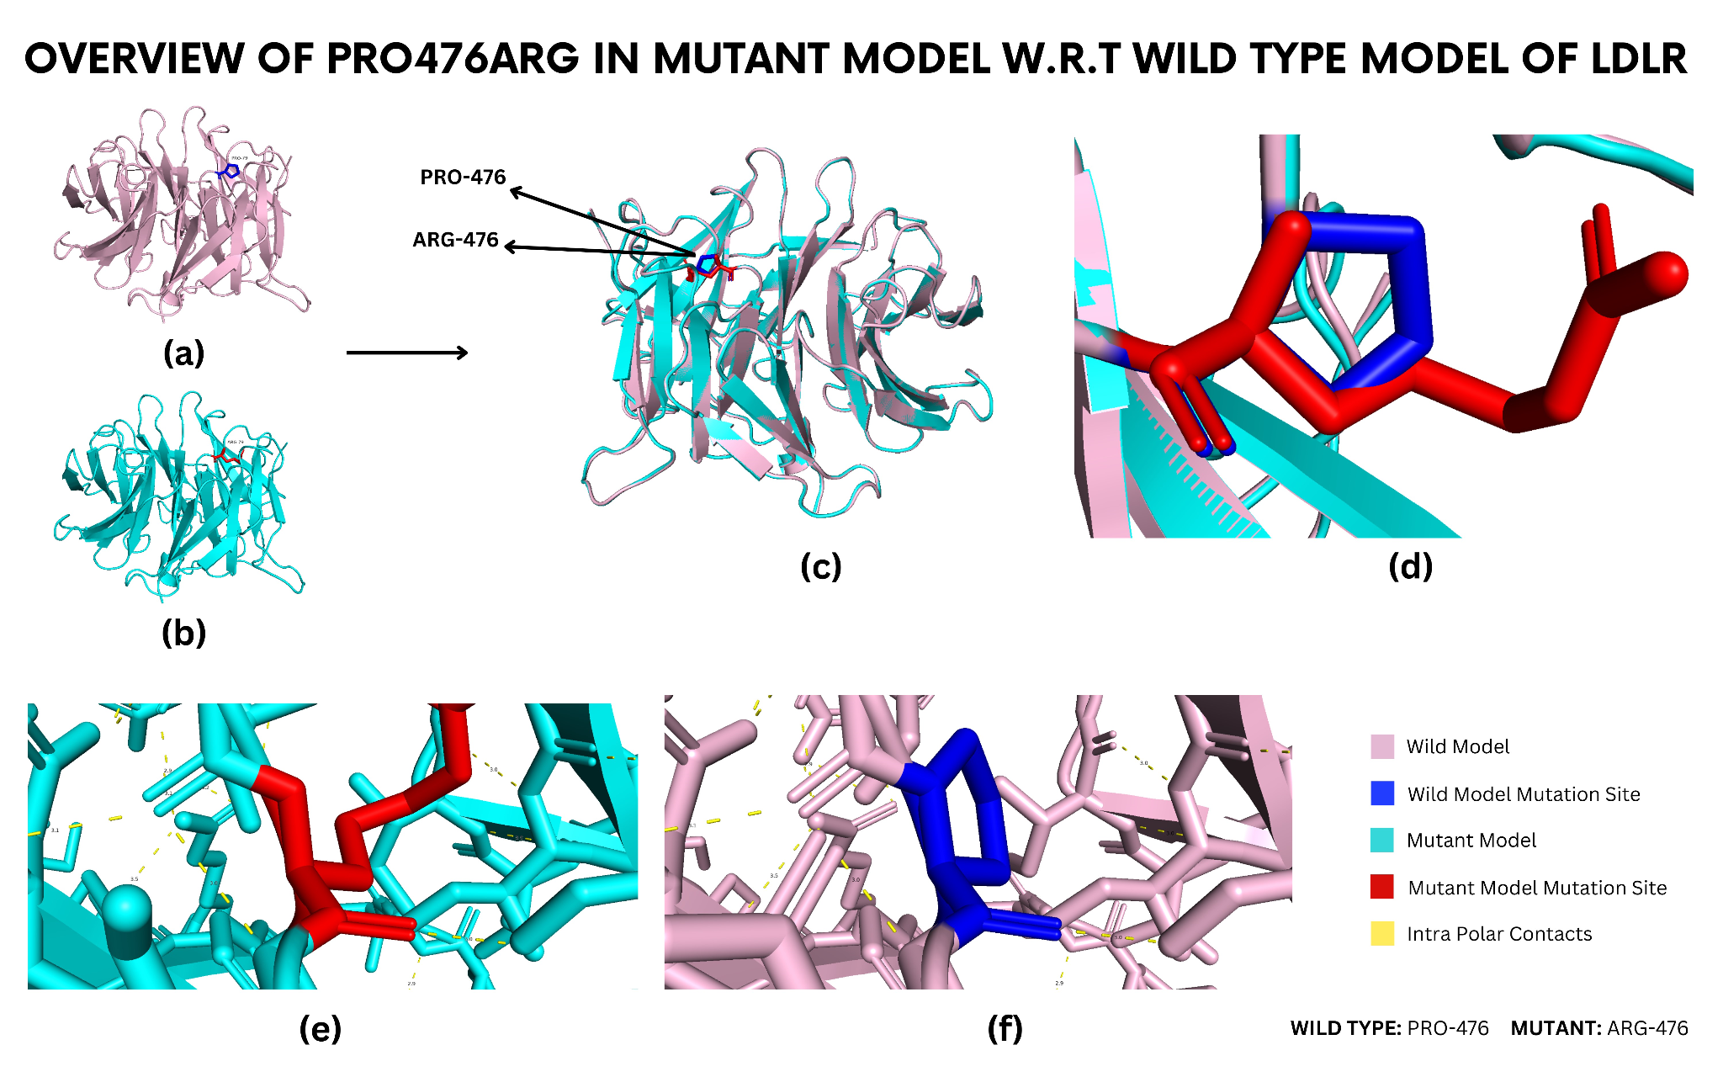

Supplermentary Figure S3. Overview of Pro476Arg in mutant model W.R.T type model of LDLR

(a) Structure in violet color represents the wild type model (1IJQ), whereas (b) the cyan structure is of the Pro476Arg model. (c) Superimposition of wild type (1IJQ) structure and Pro476Arg mutant model shows structural variations of the mutant model with respect to wild type. (d) Zoomed-in view of superimposed structures showed slight variation in mutation site. The red color indicates the mutation site in the structure. (e) Zoomed-in view of bonding interactions between residues in the mutant model. (f) Zoomed-in view of bonding interactions within a wild-type model.

Histidine residue affected by mutated positions: His583Tyr
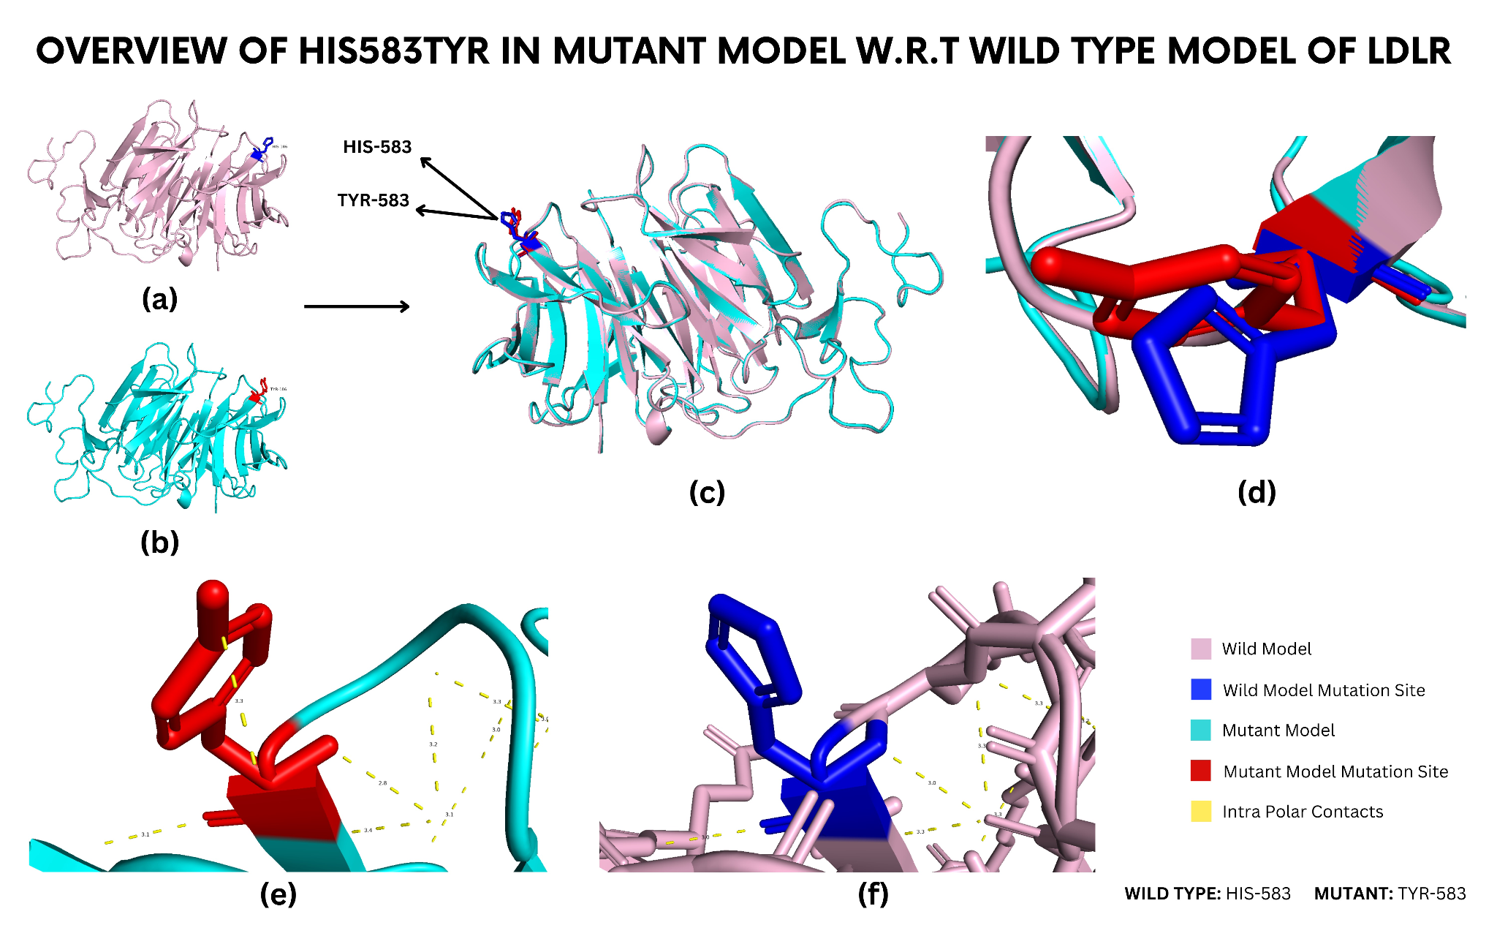

Supplermentary Figure S4. Overview of His583Tyr in mutant model W.R.T type model of LDLR

(a) The structure in violet color represents the wild-type model (1IJQ), whereas (b) the cyan structure is of the His583Tyr model. (c) Superimposition of wild type (1IJQ) structure and His583Tyr mutant model shows structural variations of the mutant model with respect to wild type. (d) Zoomed-in view of superimposed structures showed slight variation in mutation site. The red color indicates the mutation site in the structure. (e) Zoomed-in view of bonding interactions between residues in the mutant model. (f) Zoomed-in view of bonding interactions within a wild-type model.

Aspartic acid residue affected by mutated positions: Asp589Asn
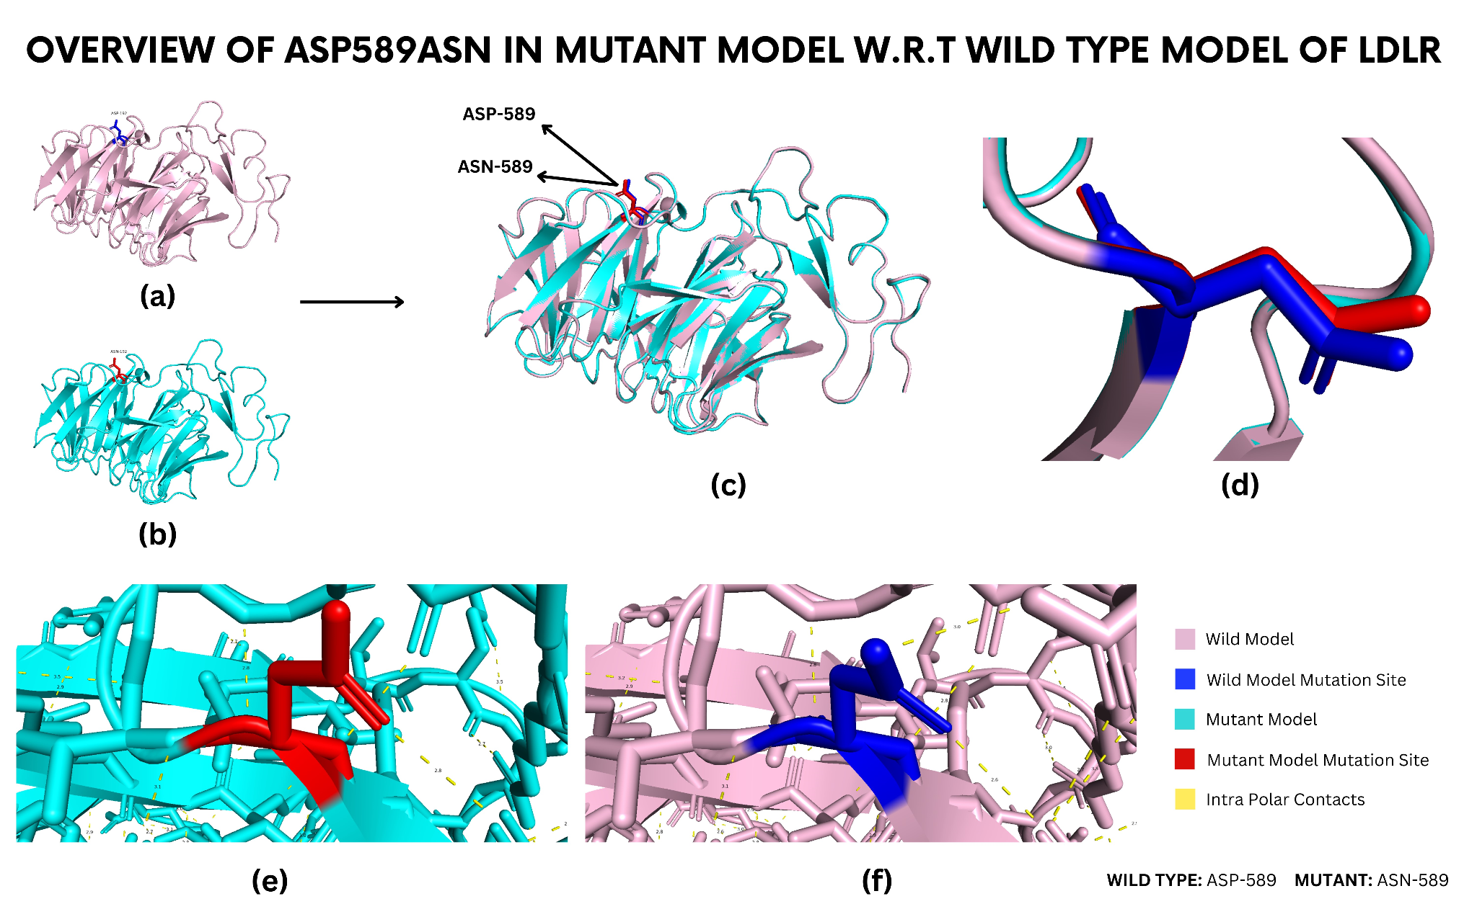

Supplermentary Figure S5. Overview of Asp589Asn in mutant model W.R.T type model of LDLR

(a) Structure in violet color represents the wild type model (1IJQ), whereas (b) the cyan structure is of the Asp589Asn model. (c) Superimposition of wild type (1IJQ) structure and Asp589Asn mutant model shows structural variations of the mutant model with respect to wild type. (d) Zoomed-in view of superimposed structures showed slight variation in mutation site. The red color indicates the mutation site in the structure. (e) zoomed-in view of bonding interactions between residues in the mutant model. (f) Zoomed-in view of bonding interactions within a wild-type model.

Glutamine residue affected by mutated positions: Gln660Ter
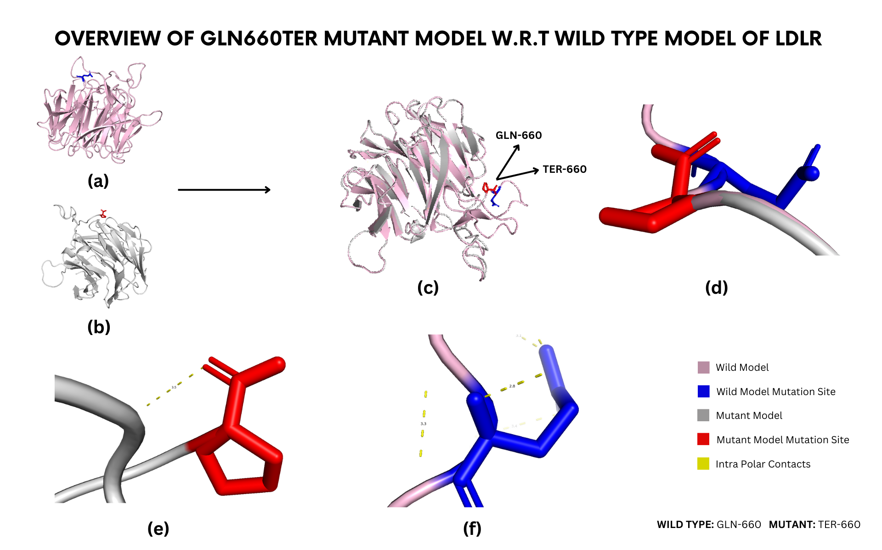

Supplermentary Figure S6. Overview of Gln660Ter in mutant model W.R.T type model of LDLR

(a) Structure in violet color represents the wild type model (1IJQ), whereas (b) the cyan structure is of the Gln660Ter model. (c) Superimposition of wild type (1IJQ) structure and Gln660Ter mutant model shows structural variations of the mutant model with respect to wild type. (d) Zoomed-in view of superimposed structures showed slight variation in mutation site. The red color indicates the mutation site in the structure. (e) Zoomed-in view of bonding interactions between residues in the mutant model. (f) Zoomed-in view of bonding interactions within a wild-type model.

Alanine residue affected by mutated positions: Ala684Thr

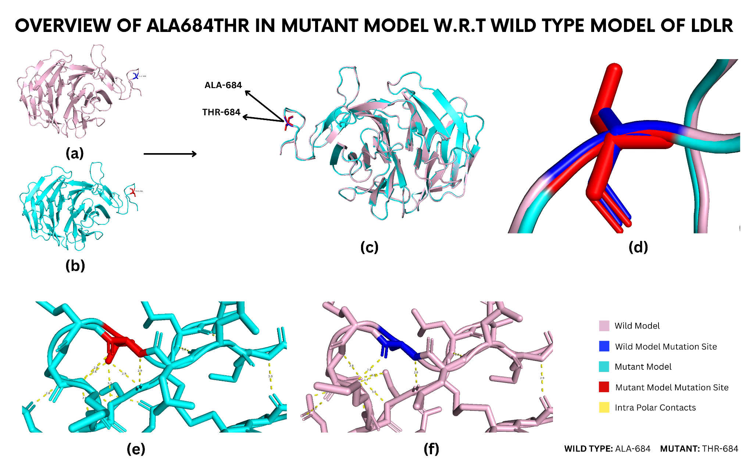

Supplermentary Figure S7. Overview of Ala684Thr in mutant model W.R.T type model of LDLR

(a) Structure in violet color represents the wild type model (1IJQ), whereas (b) the cyan structure is of the Ala684Thr model. (c) Superimposition of wild type(1IJQ) structure and Ala684Thr mutant model shows structural variations of the mutant model with respect to wild type(d) Zoomed-in view of superimposed structures showed slight variation in mutation site. The red color indicates the mutation site in the structure. (e) Zoomed-in view of bonding interactions between residues in the mutant model. (f) Zoomed-in view of bonding interactions within a wild-type model.

1.2. 1XFE Structure of LDLR
Two mutations were built homology modeling for the 1XFE structure of LDLR, including glutamine residue (Glu288Lys) and cysteine residue (Cys318Arg).
Glutamine residue affected by the mutated position: Glu288Lys
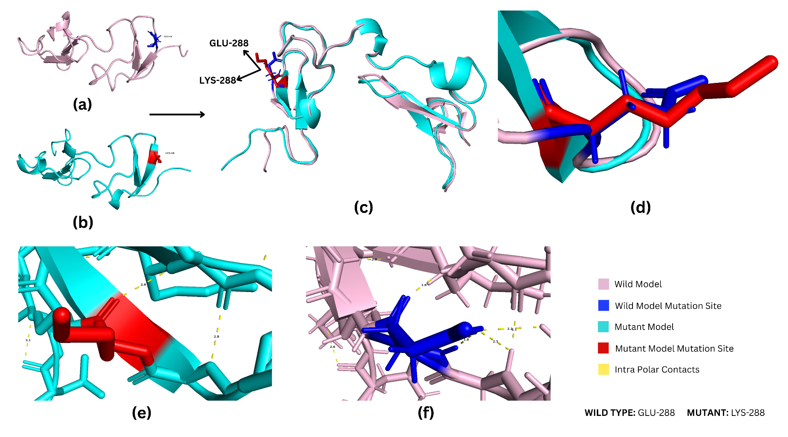

Supplermentary Figure S8. Overview of Glu288Lys in mutant model W.R.T wild type model of LDLR

(a) The structure in violet color represents the wild-type model (1XFE), whereas (b) the cyan structure is of the Glu288Lys (mutated model). (c) Superimposition of wild type (1XFE) structure and Glu288Lys mutant model shows structural variations of the mutant model with respect to wild type. (d) Zoomed-in view of superimposed structures showed slight variation in mutation site. The red color indicates the mutation site in the structure. (e) Zoomed-in view of bonding interactions between residues in the mutant model. (f) Zoomed-in view of bonding interactions within a wild-type model.

Cysteine residue affected by the mutated position: Cys318Arg
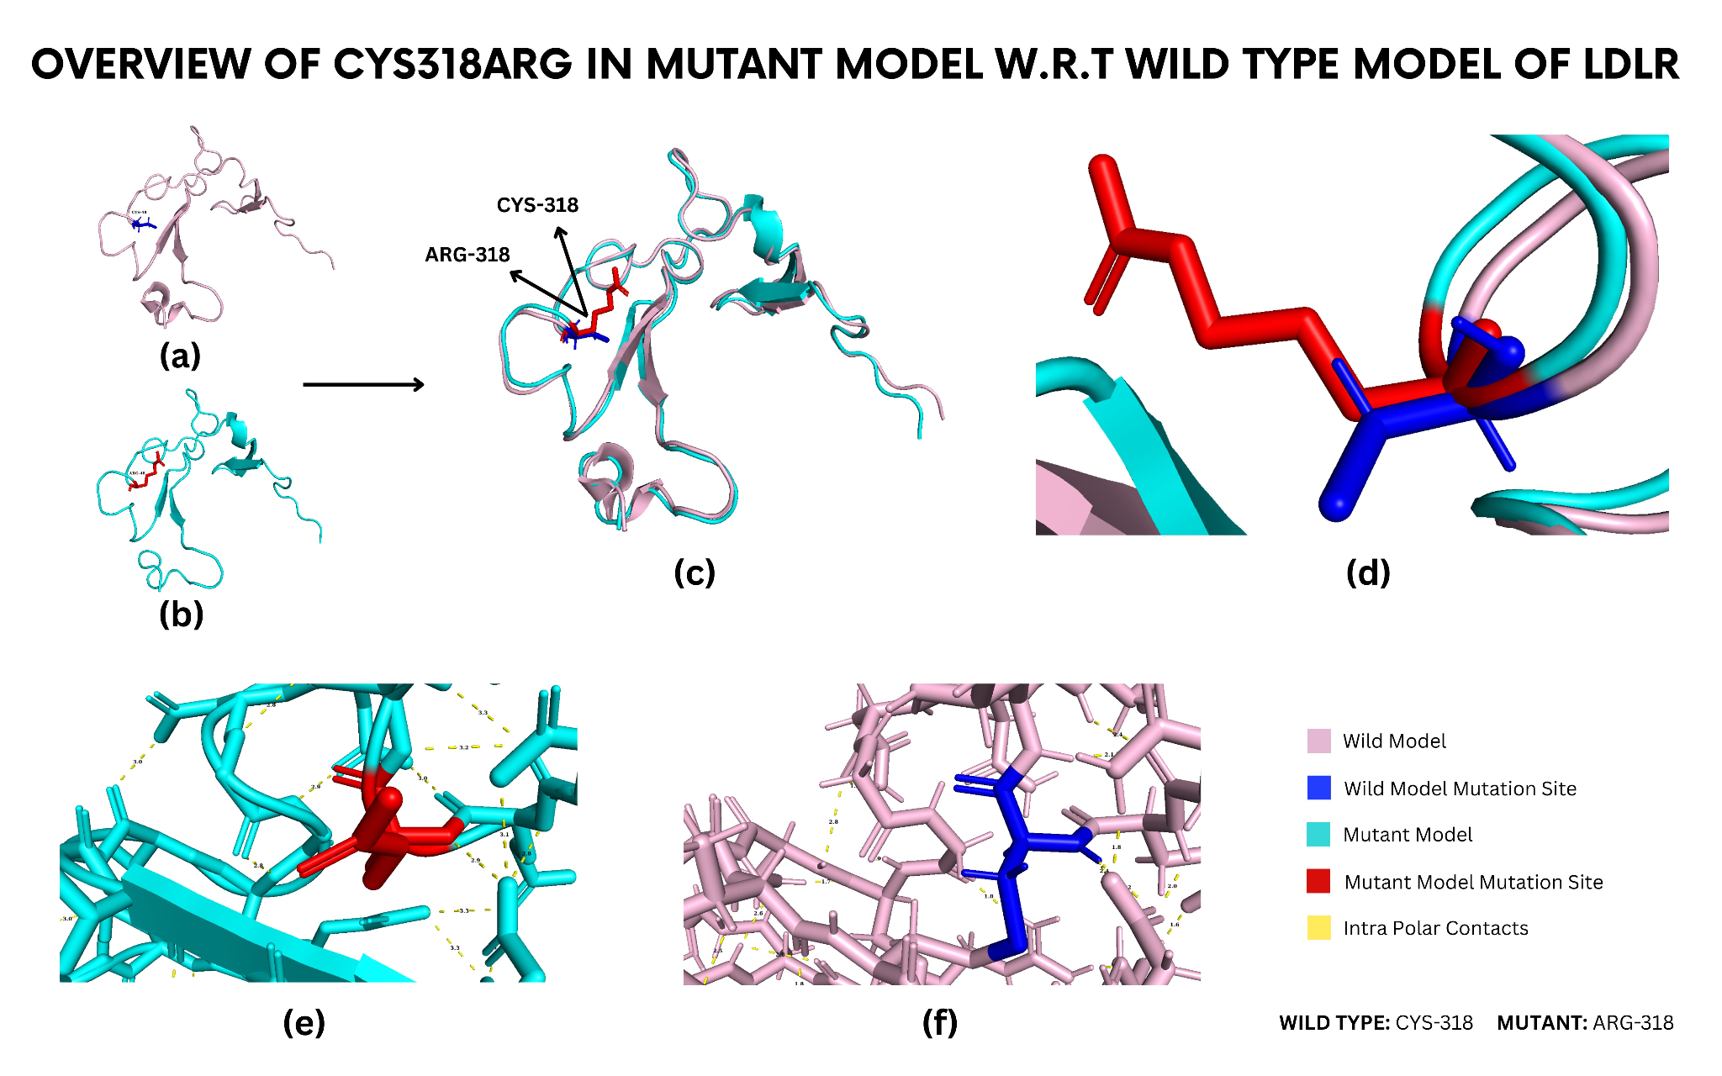

Supplermentary Figure S9. Overview of Cys318Arg in mutant model W.R.T wild type model of LDLR

(a) The structure in violet color represents the wild-type model (1XFE), whereas (b) the cyan structure is of the Cys318Arg (mutated model). (c) Superimposition of wild type (1XFE) structure and Cys318Arg mutant model shows structural variations of the mutant model with respect to wild type. (d) Zoomed-in view of superimposed structures showed slight variation in mutation site. The red color indicates the mutation site in the structure. (e) Zoomed-in view of bonding interactions between residues in the mutant model. (f) Zoomed-in view of bonding interactions within a wild-type model

1.3. 2LGP Structure of LDLR
One mutations (Asp227Glu), which is an aspartic acid residue affected by mutated positions, was built homology modeling for the 2LGP structure of LDLR.
Aspartic acid residue affected by mutated positions: Asp227Glu
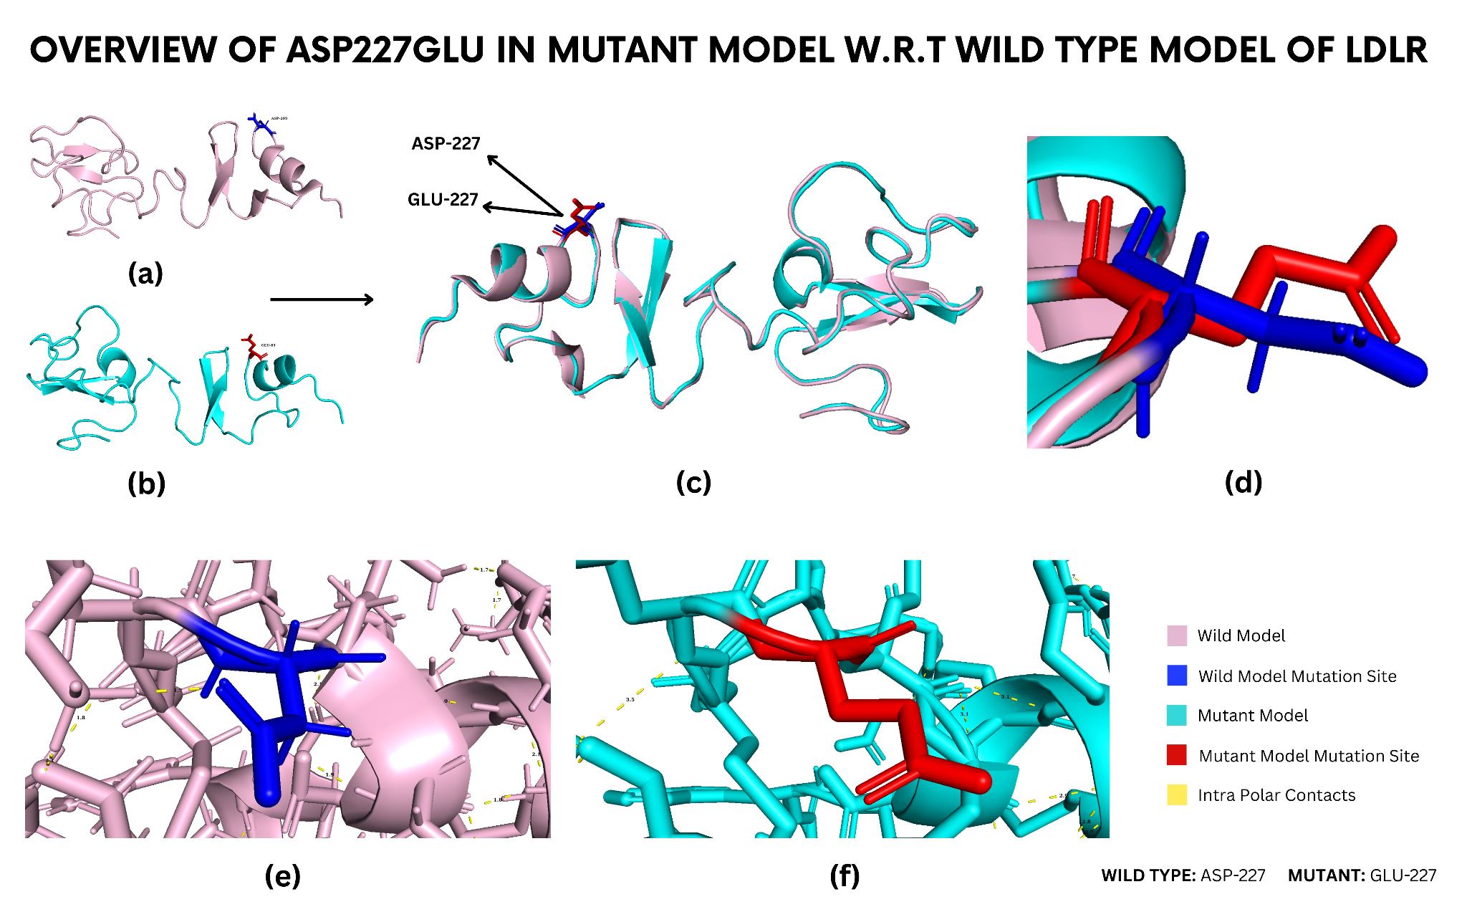

Supplermentary Figure S10. Overview of Asp227Glu in mutant model W.R.T wild type model of LDLR

(a) The structure in violet color represents the wild-type model (2LGP), whereas (b) the cyan structure is of the Asp227Glu model. (c) Superimposition of wild-type (2LGP) structure and Asp227Glu mutant model shows structural variations of the mutant model with respect to wild type. (d) Zoomed-in view of superimposed structures showed slight variation in mutation site. The red color indicates the mutation site in the structure. (e) Zoomed-in view of bonding interactions between residues in the mutant model. (f) Zoomed-in view of bonding interactions within a wild-type model.

1.4. 1LDR structure of LDLR
One mutation (Cys104Tyr) is reported in the 1LDR structure of LDLR, where cysteine residue was replaced with tyrosine residue.
Cysteine residue affected by the mutated position: Cys104Tyr
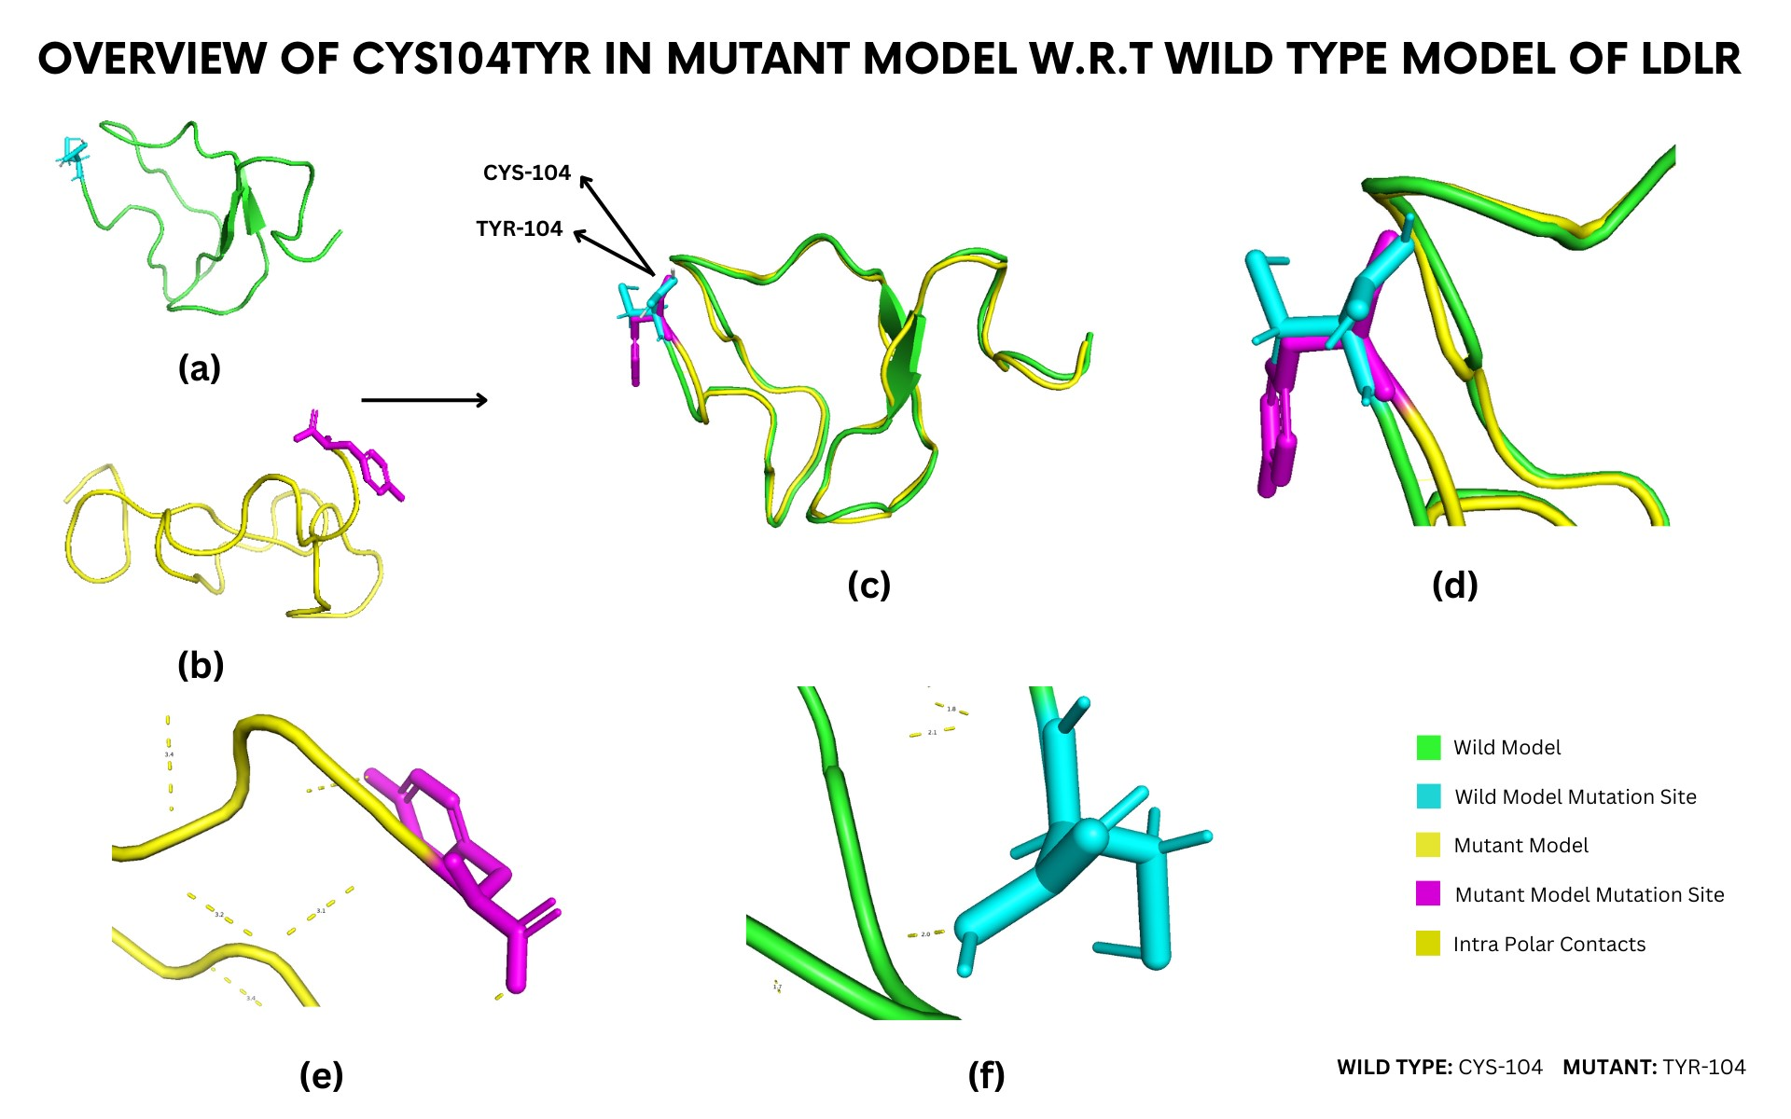

Supplermentary Figure S11. Overview of Cys104Tyr in mutant model W.R.T type model of LDLR

(a) The structure in green color represents the wild-type model (1LDR), whereas (b) the yellow structure is of the Cys104Tyr (mutated model). (c) Superimposition of wild-type (1LDR) structure and Cys104Tyr mutant model shows structural variations of the mutant model with respect to wild type. (d) Zoomed-in view of superimposed structures showed slight variation in mutation site. The purple color indicates the mutation site in the structure. (e) Zoomed-in view of bonding interactions between residues in the mutant model. (f) Zoomed-in view of bonding interactions within a wild-type model.

1.5. 2FCW Structure of LDLR
One mutations (Ser130Ter), which is an serine residue affected by mutated positions, was built homology modeling for the 2FCW structure of LDLR.
Serine residue affected by the mutated position: Ser130Ter
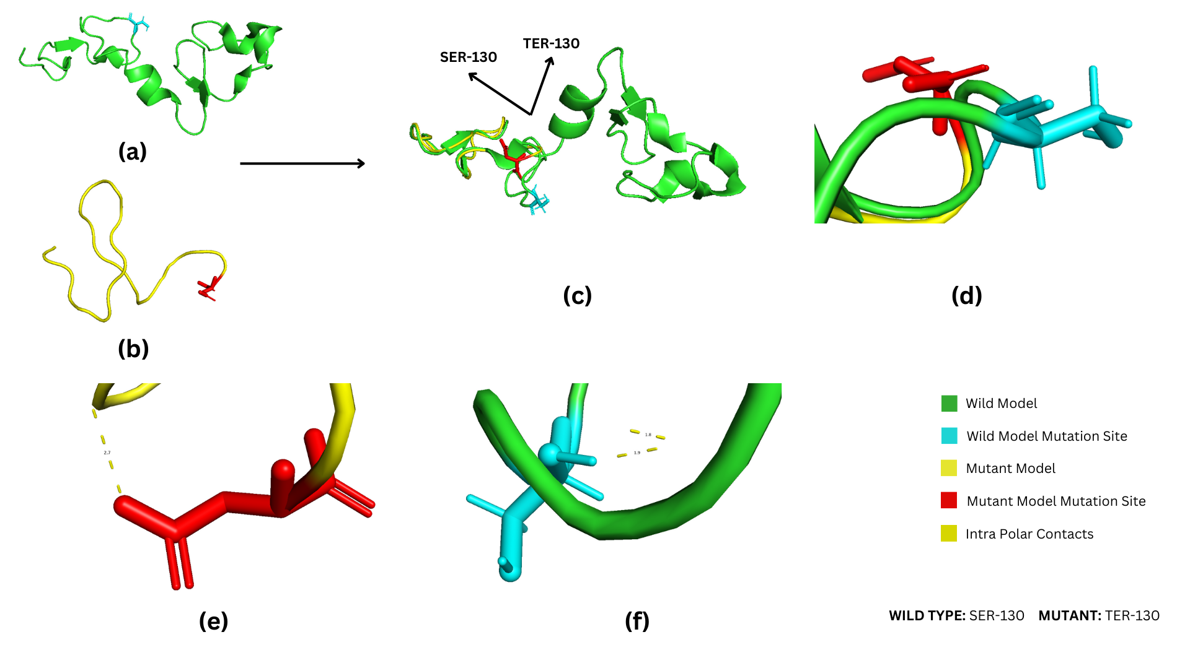

Supplermentary Figure S12. Overview of Ser130Ter in mutant model W.R.T type model of LDLR

(a) The structure in green color represents the wild-type model (2FCW), whereas (b) the yellow structure is of the Ser130Ter (mutated model). (c) Superimposition of wild type (2FCW) structure and Ser130Ter mutant model shows structural variations of the mutant model with respect to wild type. (d) Zoomed-in view of superimposed structures showed great variation because termination occurs at the mutation site (e) Zoomed-in view of bonding interactions between residues in the mutant model. (f) Zoomed-in view of bonding interactions within a wild-type model.

1.6. 1D2J Structure of LDLR
One mutations (Arg257Trp), which is an serine residue affected by mutated positions, was built homology modeling for the 1D2J structure of LDLR.
Arginine residue affected by the mutated position: Arg257Trp
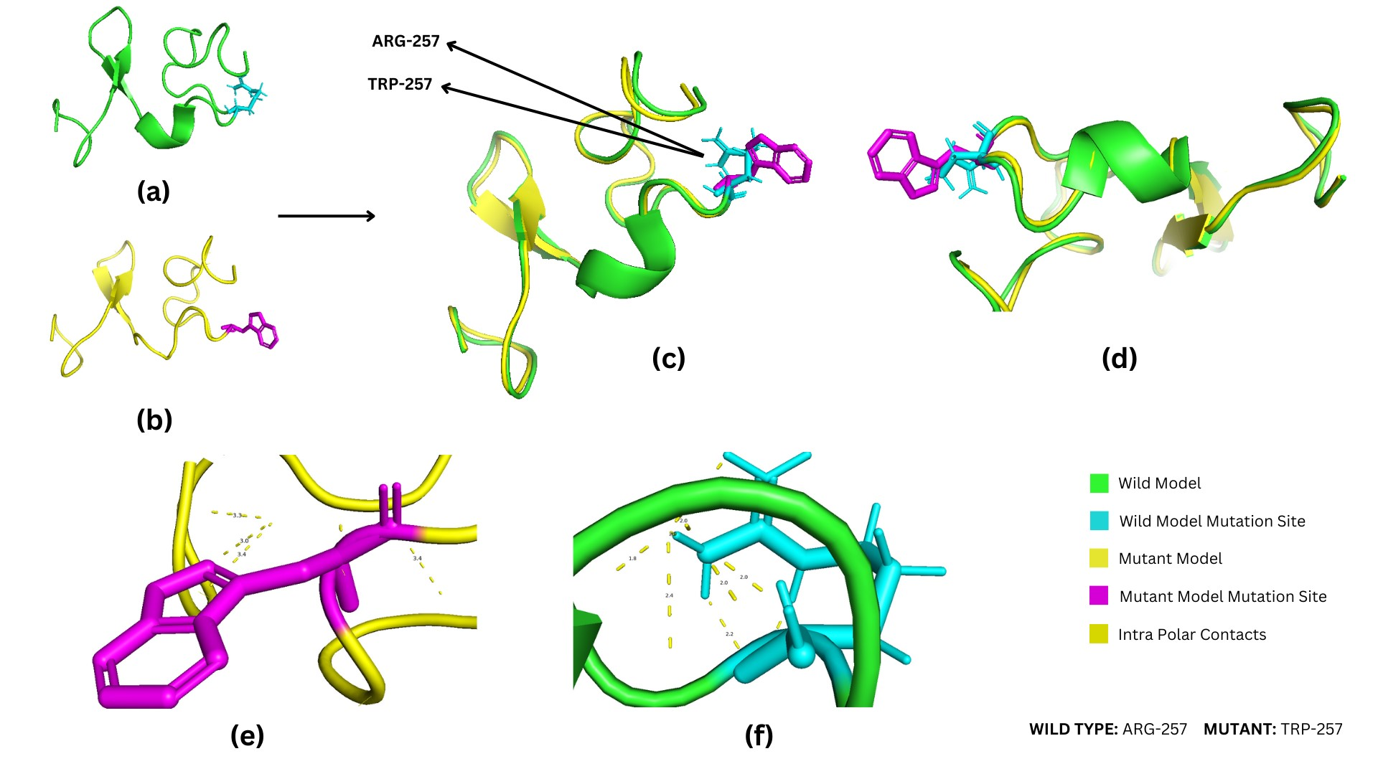

Supplermentary Figure S13. Overview of Arg257Trp in mutant model W.R.T type model of LDLR

(a) The structure in green color represents the wild-type model (1D2J), whereas (b) the yellow structure is of the Arg257Trp (mutated model). (c) Superimposition of wild-type (1D2J) structure and Arg257Trp mutant model shows structural variations of the mutant model with respect to wild type. (d) Zoomed-in view of superimposed structures showed slight variation in mutation site. The purple color indicates the mutation site in the structure. (e) Zoomed-in view of bonding interactions between residues in the mutant model. (f) Zoomed-in view of bonding interactions within a wild-type model.

1.7. P01130.1.A structure of LDLR
Four mutations were built homology modeling for the P01130.1.A structure of LDLR, including valine residue (Val797Met and Val806fs), glycine residue (Gly844Ser), and aspartic acid residue (Asp843Glufs*86).
Valine residue affected by the mutated position: Val797Met and Val806fs
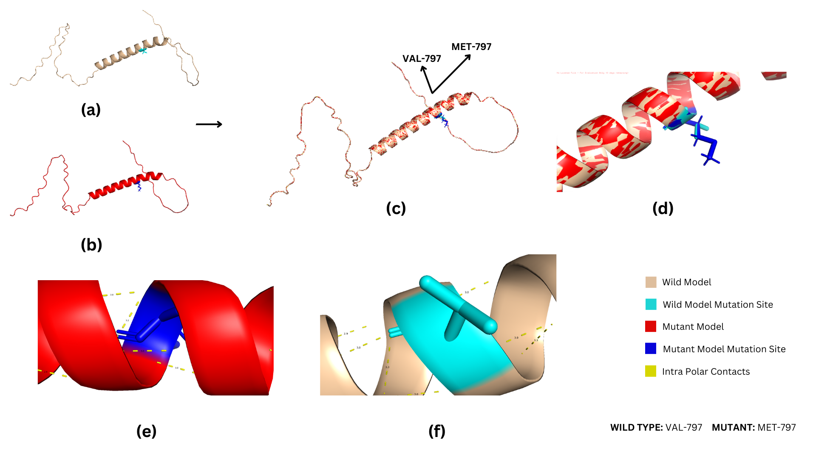

Supplermentary Figure S14. Overview of Val797Met in mutant model W.R.T type model of LDLR

(a) The structure in wheat color represents the wild-type model (P01130), whereas (b) the red structure is of the Val797Met (mutated model). (c) Superimposition of wild-type (P01130) structure and Val797Met mutant model shows structural variations of the mutant model with respect to wild type. (d) Zoomed-in view of superimposed structures showed slight variation in mutation site. The blue color indicates the mutation site in the structure. (e) Zoomed-in view of bonding interactions between residues in the mutant model. (f) Zoomed-in view of bonding interactions within a wild-type model.
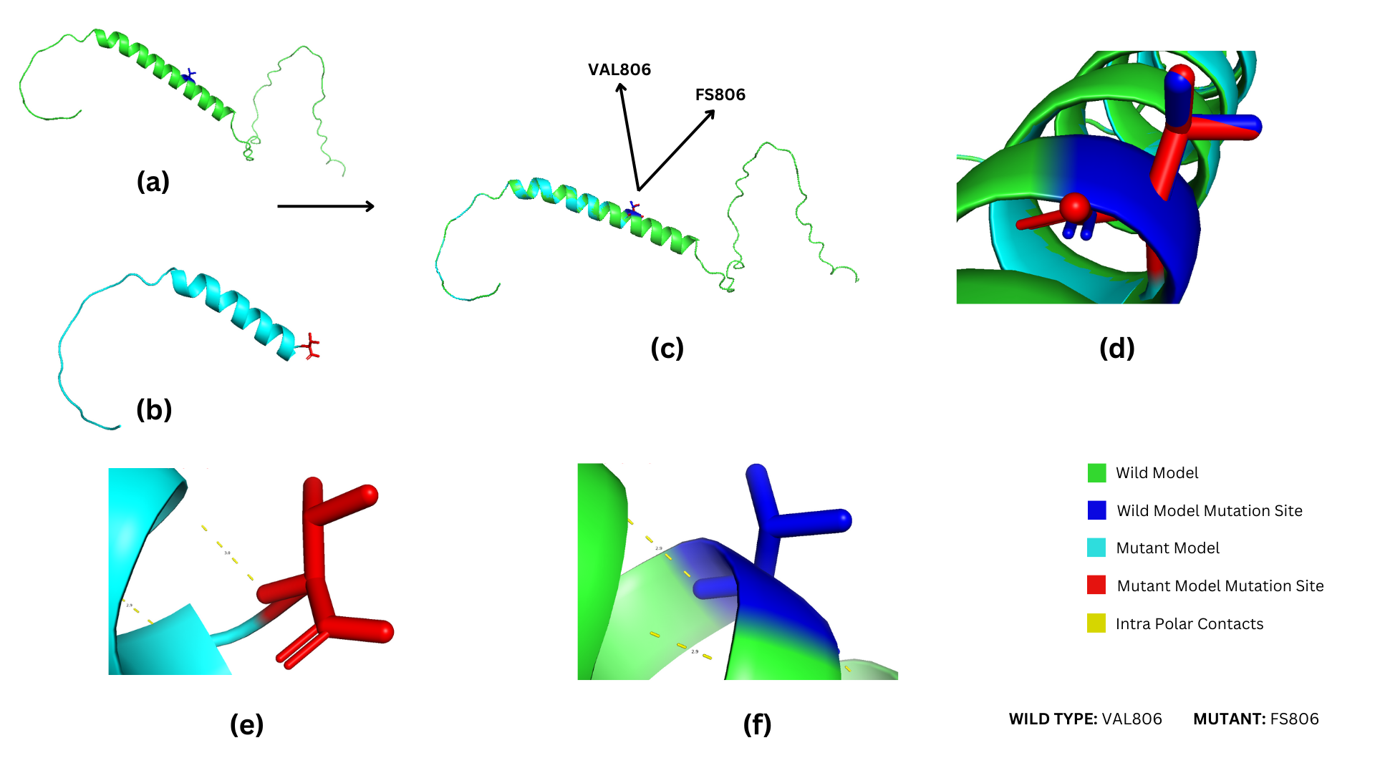

Supplermentary Figure S15. Overview of Val806fs in mutant model W.R.T type model of LDLR

(a) The structure in green color represents the wild-type model, whereas (b) the blue structure is of the Val806fs (mutated model). (c) Superimposition of wild-type structure and Val806fs mutant model shows structural variations of the mutant model with respect to wild type. (d) Zoomed-in view of superimposed structures showed slight variation in mutation site. The red color indicates the mutation site in the structure. (e) Zoomed-in view of bonding interactions between residues in the mutant model. (f) Zoomed-in view of bonding interactions within a wild-type model.

Glycine residue affected by the mutated position
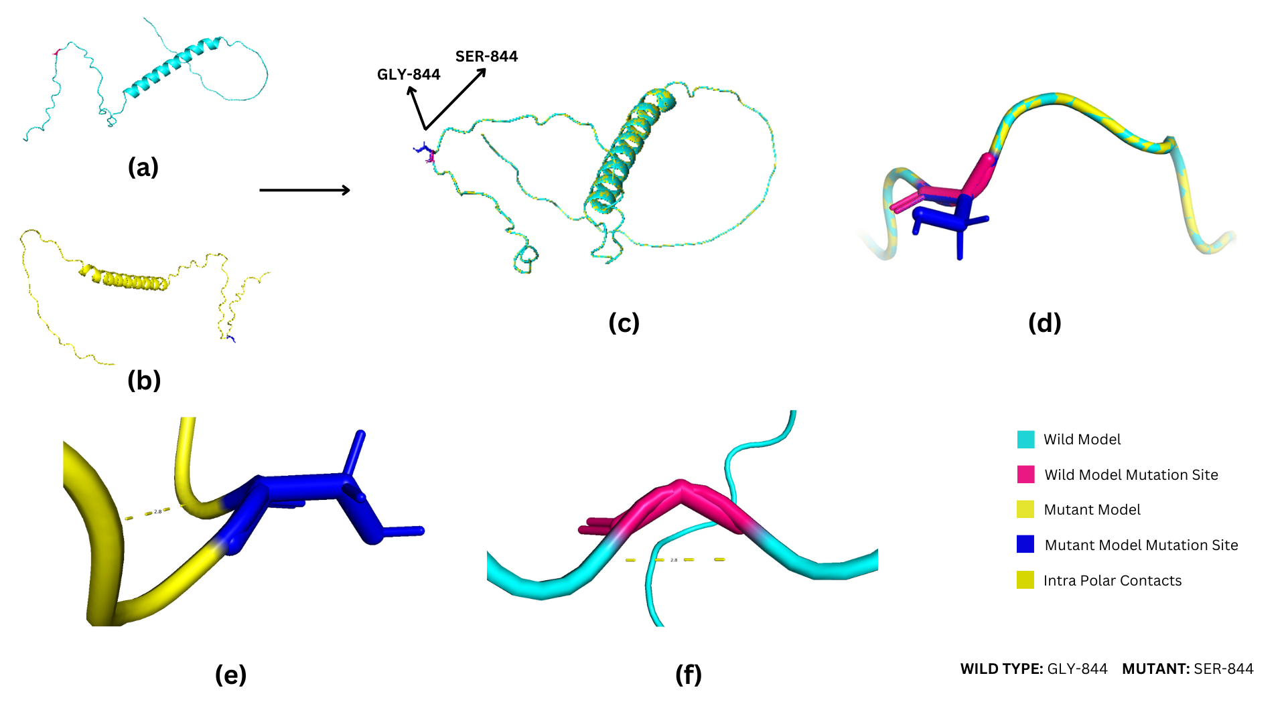

Supplermentary Figure S16. Overview of Gly844Ser in mutant model W.R.T type model of LDLR

(a) The structure in blue color represents the wild-type model (P01130), whereas (b) the yellow structure is of the Gly844Ser (mutated model). (c) Superimposition of wild-type (P01130) structure and Gly844Ser mutant model shows structural variations of the mutant model with respect to wild type. (d) Zoomed-in view of superimposed structures showed slight variation in mutation site. The blue color indicates the mutation site in the structure. (e) Zoomed-in view of bonding interactions between residues in the mutant model. (f) Zoomed-in view of bonding interactions within a wild-type model.

Aspartic acid residue affected by the mutated position
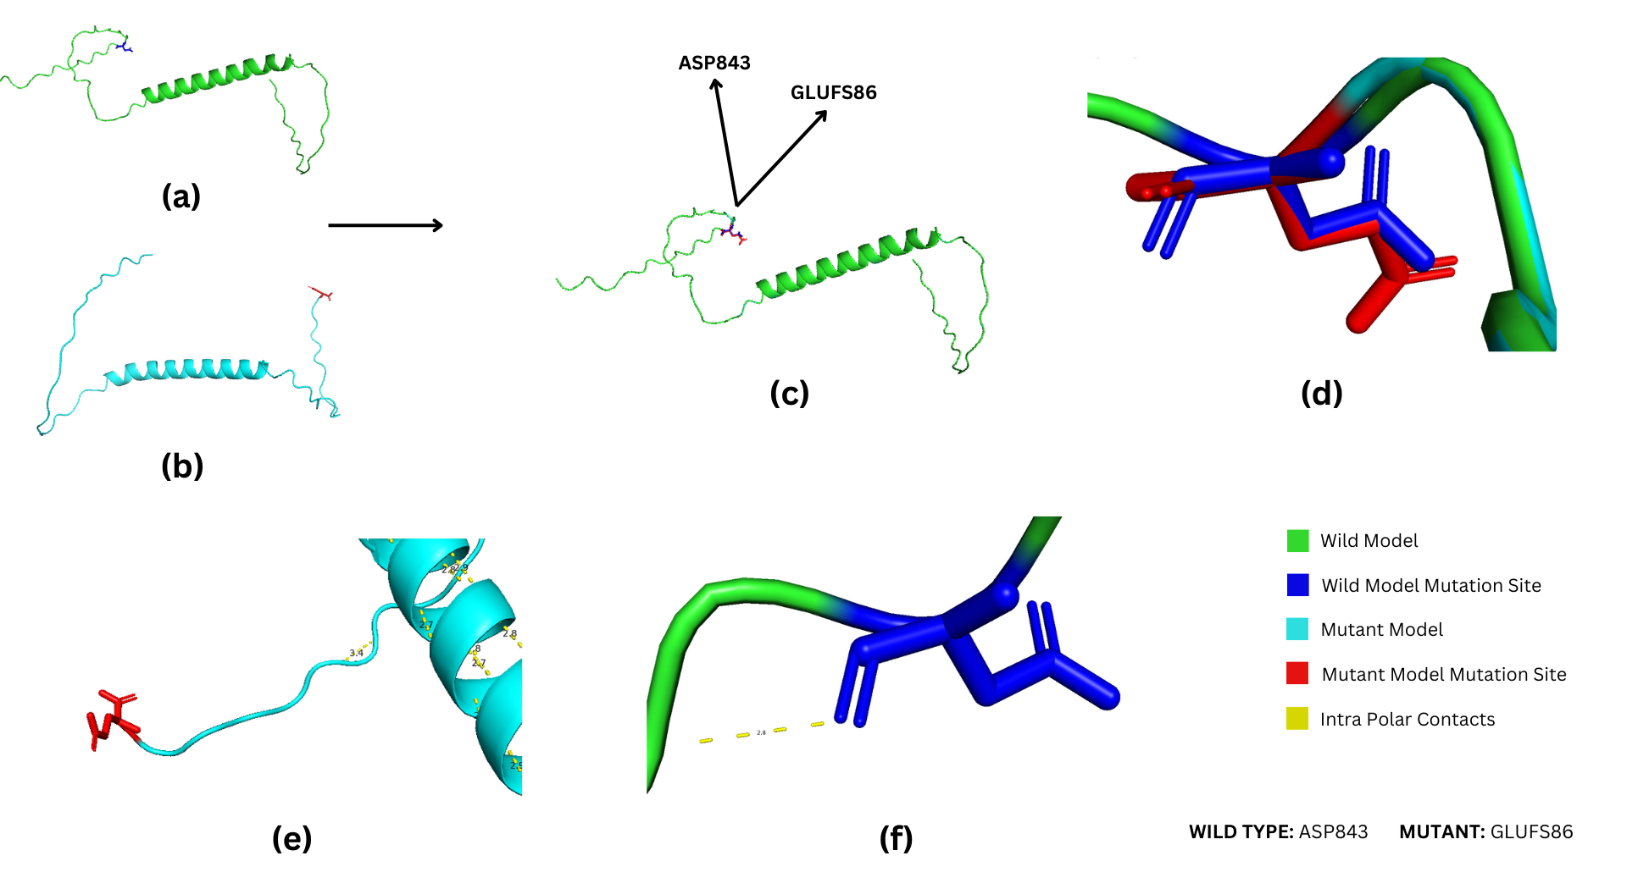

Supplermentary Figure S17. Overview of Asp843Glufs*86 in mutant model W.R.T type model of LDLR

(a) The structure in green color represents the wild-type model, whereas (b) the blue structure is of the Asp843Glufs*86 (mutated model). (c) Superimposition of wild-type structure and Asp843Glufs*86 mutant model shows structural variations of the mutant model with respect to wild type. (d) Zoomed-in view of superimposed structures showed slight variation in mutation site. The red color indicates the mutation site in the structure. (e) Zoomed-in view of bonding interactions between residues in the mutant model. (f) Zoomed-in view of bonding interactions within a wild-type model.

2. Structural Analysis of Mutations in APOB and PCSK9
2.1. P04114:6 Structure of APOB
Arginine residue affected by mutated positions: Arg1386Trp
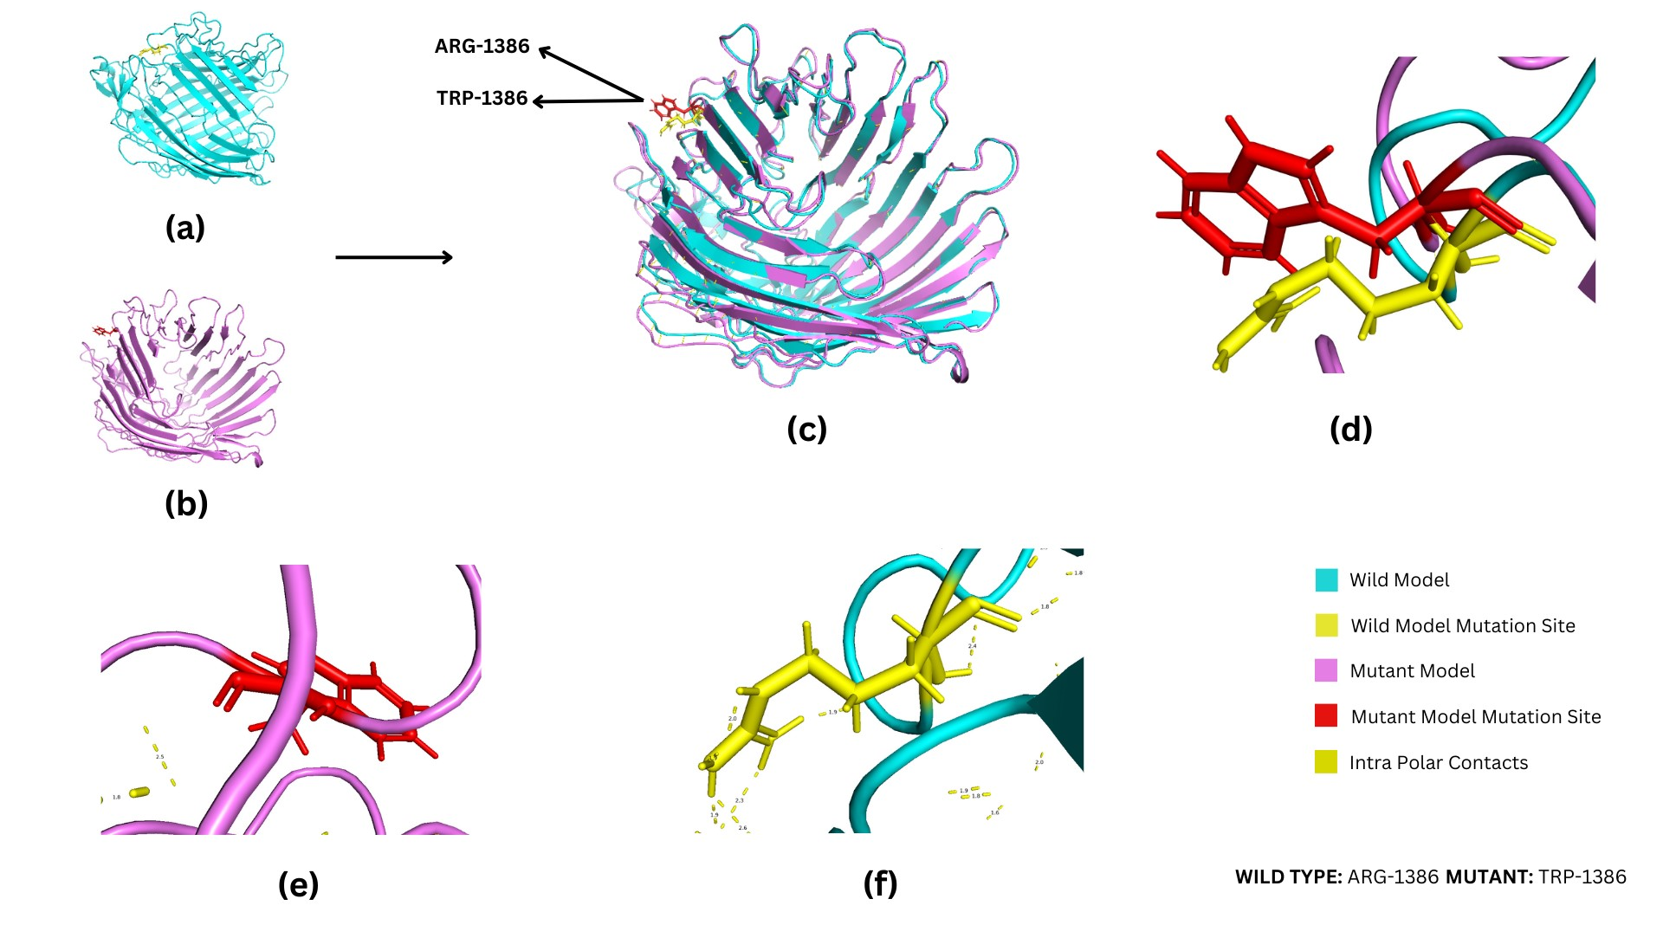

Supplermentary Figure S18. Overview of Arg1386Trp in mutant model W.R.T type model of APOB

(a) The structure in cyan color represents the wild-type (P04114:6), whereas (b) the purple structure is of the Arg1386Trp (mutated model). (c) Superimposition of wild-type (P04114:6) structure and Arg1386Trp mutant model shows structural variations of the mutant model with respect to wild-type. (d) Zoomed-in view of superimposed structures showed slight variation in mutation site. The red color indicates the mutation site in the structure. (e) Zoomed-in view of bonding interactions between residues in the mutant model. (f) Zoomed-in view of bonding interactions within a wild-type model.

2.2. P04114:10 Structure of APOB
Phenylalanine residue affected by mutated positions: Phe2469Cys
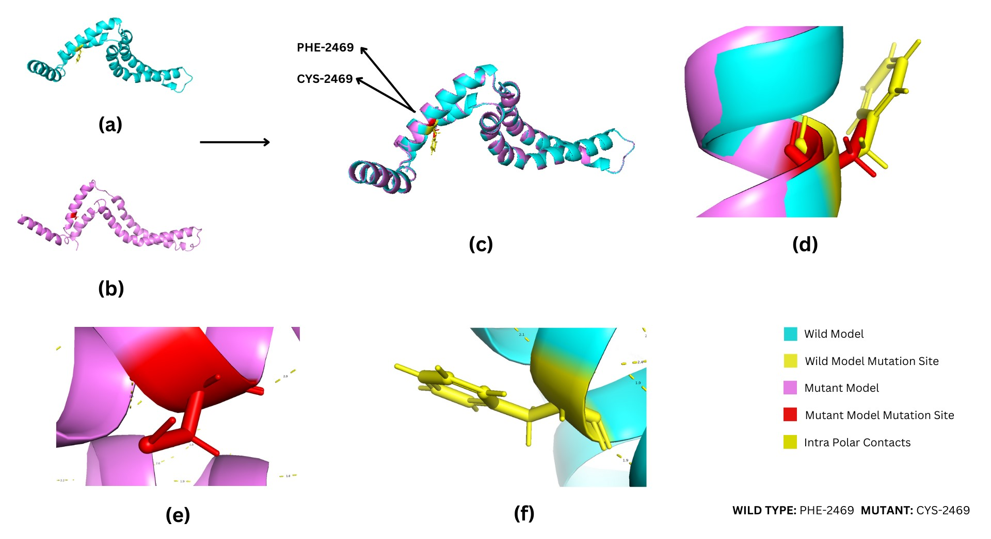

Supplermentary Figure S19. Overview of Phe2469Cys in mutant model W.R.T type model of APOB

(a) The structure in cyan color represents the wild-type (P04114:10), whereas (b) the purple structure is of the Phe2469Cys (mutated model). (c) Superimposition of wild-type (P04114:10) structure and Phe2469Cys mutant model shows structural variations of the mutant model with respect to wild-type. (d) Zoomed-in view of superimposed structures showed slight variation in mutation site. The red color indicates the mutation site in the structure. (e) Zoomed-in view of bonding interactions between residues in the mutant model. (f) Zoomed-in view of bonding interactions within a wild-type model.

2.3. P04114:15 Structure of APOB
Arginine residue affected by mutated positions: Arg4297His
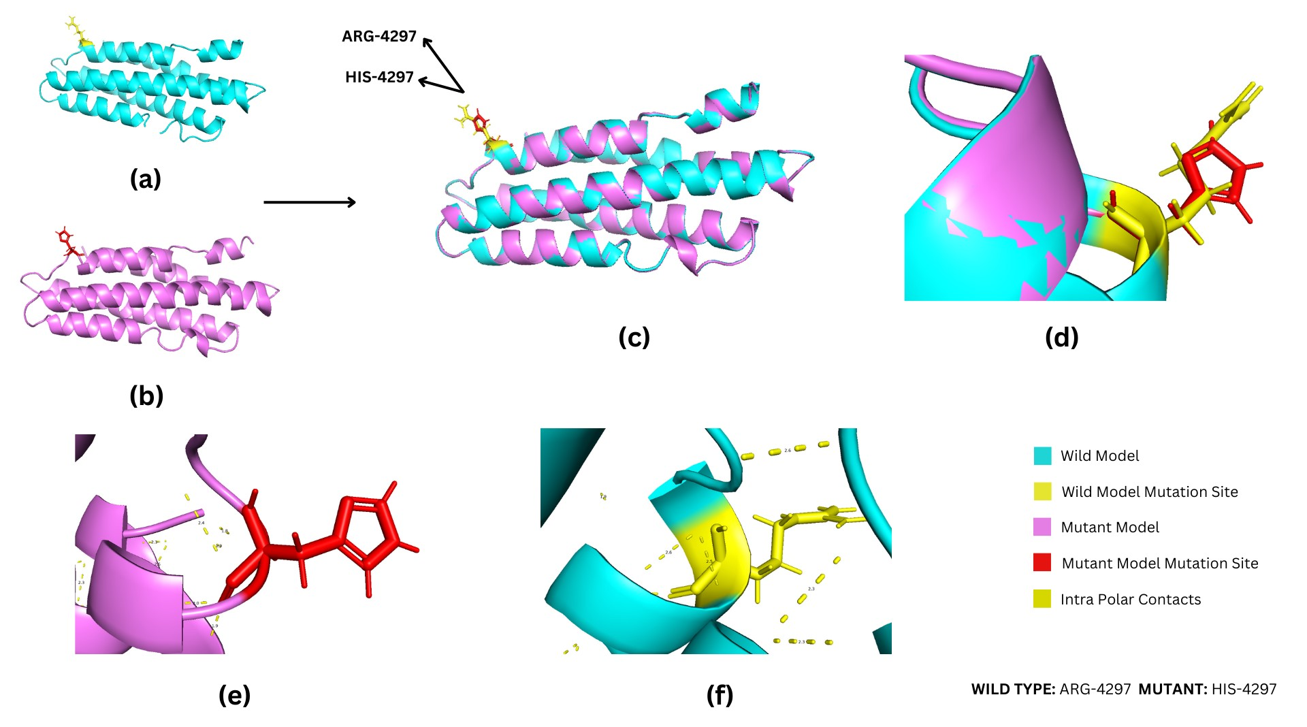

Supplermentary Figure S20. Overview of Arg4297His in mutant model W.R.T type model of APOB

(a) The structure in cyan color represents the wild-type (P04114:15), whereas (b) the purple structure is of the Arg4297His (mutated model). (c) Superimposition of wild-type (P04114:15) structure and Arg4297His mutant model shows structural variations of the mutant model with respect to wild-type. (d) Zoomed-in view of superimposed structures showed slight variation in mutation site. The red color indicates the mutation site in the structure. (e) Zoomed-in view of bonding interactions between residues in the mutant model. (f) Zoomed-in view of bonding interactions within a wild-type model.

2.4. B4DEZ9 Structure of PCSK9
Leucine and Glycine residue affected by mutated positions: Leu23_Gly24insLeu

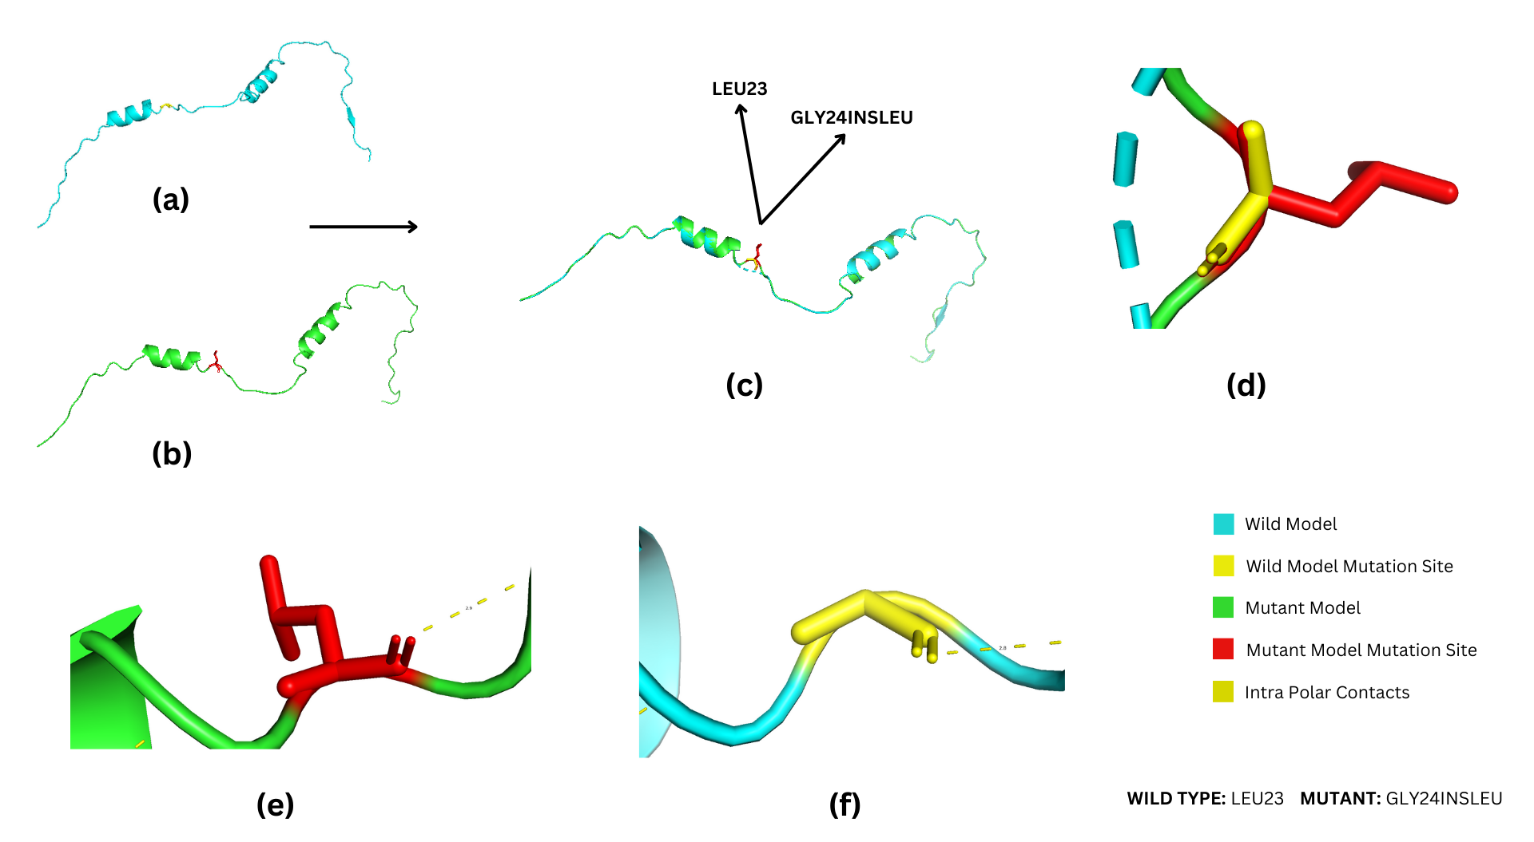

Supplermentary Figure S21. Overview of Leu23_Gly24insLeu in mutant model W.R.T type model of PCSK9

(a) The structure in blue color represents the wild-type (B4DEZ9), whereas (b) the green structure is of the Leu23_Gly24insLeu (mutated model). (c) Superimposition of wild-type (B4DEZ9) structure and Leu23_Gly24insLeu mutant model shows structural variations of the mutant model with respect to wild-type. (d) Zoomed-in view of superimposed structures showed great structural variation. The red color indicates the mutation site in the structure. (e) Zoomed-in view of bonding interactions between residues in the mutant model. (f) Zoomed-in view of bonding interactions within a wild-type model.

