primers used in the qPCR
gata1a-qPCR-F | CACGGGACCATAACGAAGC
gata1a-qPCR-R | GCACATACAATAAGCCATACAATCA
lyz-qPCR-F | GACCCACCGAGTGCGTTCA
lyz-qPCR-R | TTACCCAGCGGGACATCTTA
runx1-qPCR-F | GCCGCTCTGGTGGGCAAACT
runx1-qPCR-R | GAAGGCGATGGGCAGGGTCT
pu1-qPCR-F | ATCACATCCCTCTAACCAATCC
pu1-qPCR-F | TTTCGCAGAAGGTCAAGC
mfap4-qPCR-F | GGACGGTGATTCAGAGGAGG
mfap4-qPCR-R | TCACATTCACAACCCACAGAG
β-actin-F | CCCAGACATCAGGGAGTGAT
β-actin-R | TCTCTGTTGGCTTTGGGATT
ddb1-qPCR-F | AGCGTGAGGCAACGGTGGA
ddb1-qPCR-R | ACAGAAACATCACAATGAGGACGACT
CUEDC2-qPCR-F | AAAACCAGCCCGCAAAT
CUEDC2-qPCR-R | AGACATCAACCCAAACAACAA
kpna6-qPCR-F | TACCATAACCGTCTTCATTTCA
kpna6-qPCR-R | CACCACGAACATCCTACAACTA
ches1-qPCR-F | GGTGACTTTCTGACACGGGCTAA
ches1-qPCR-R | CTCCTTCATCTCCTCGTCCTCCT
nr1h3-qPCR-F | GACGCCCTCCACTCCTACA
nr1h3-qPCR-R | TCCACCCACGTTTCCCT
nsd2-qPCR-F | CGCACAACTACCACCACCC
nsd2-qPCR-R | AGTCTGTCAGCCCTGTCATCC
whsc1l1-qPCR-F | GCCTGTGCTGTAAAGTGGAA
whsc1l1-qPCR-R | AAGTGACAAACATACTGGTGGTG
igf2bp1-qPCR-F | TTTGTCGCACGGACTGTTA
igf2bp1-qPCR-R | TTGAGGTAGCGTTCCTAGTTATG
melk-qPCR-F | AATGACAACGCCCAACCA
melk-qPCR-R | TCTGCTGCTGTTCCACCTCT
gbp4-qPCR-F | TTACAGCAAGTCCGAGATGAGC
gbp4-qPCR-R | CGGGTTACATTAGTCTGGGTGA
fgfr3-qPCR-F | AACCATTCCGTGCCTACC
fgfr3-qPCR-R | GACTCTTATCCGAACTGTGCC
fgfr4-qPCR-F | TGCCTGGCTCACAGTCTTATC
fgfr4-qPCR-R | GCAGAGGACCACAATCACAAT
Nudt21-qPCR-F | AGGAGTAAATCAGTTCGGCAATA
Nudt21-qPCR-R | TCCAGGGAGTTTGAAGAAGGT

primers used in the WISH
gata1a-F | CCTCTGAGCCTTCTCGTTGG
gata1a-T7-R | taatacgactcactataggTGGAGCCTGGGACTGTCTTT
lyz-F | AAGAATGAAGGGCTTGATGGA
lyz-T7-R | taatacgactcactataggGCTCGGAGGCTTTGTTTGC
runx1-F | CGCTCTAACTTTCTAAAGGATACGC
runx1-T7-R | taatacgactcactataggCATGGCACTTCGCCTCAACT
pu1-F | ACATCATCCCACCCAAAGAA
PU1-T7-R | taatacgactcactataggTTTCGCAGAAGGTCAAGCAG
mfap4-F | ATGGCAATCGTGCTGTTCT
mfap4-T7-R | taatacgactcactataggCCAATGGCATGATGGGTG

Supplemental Figures

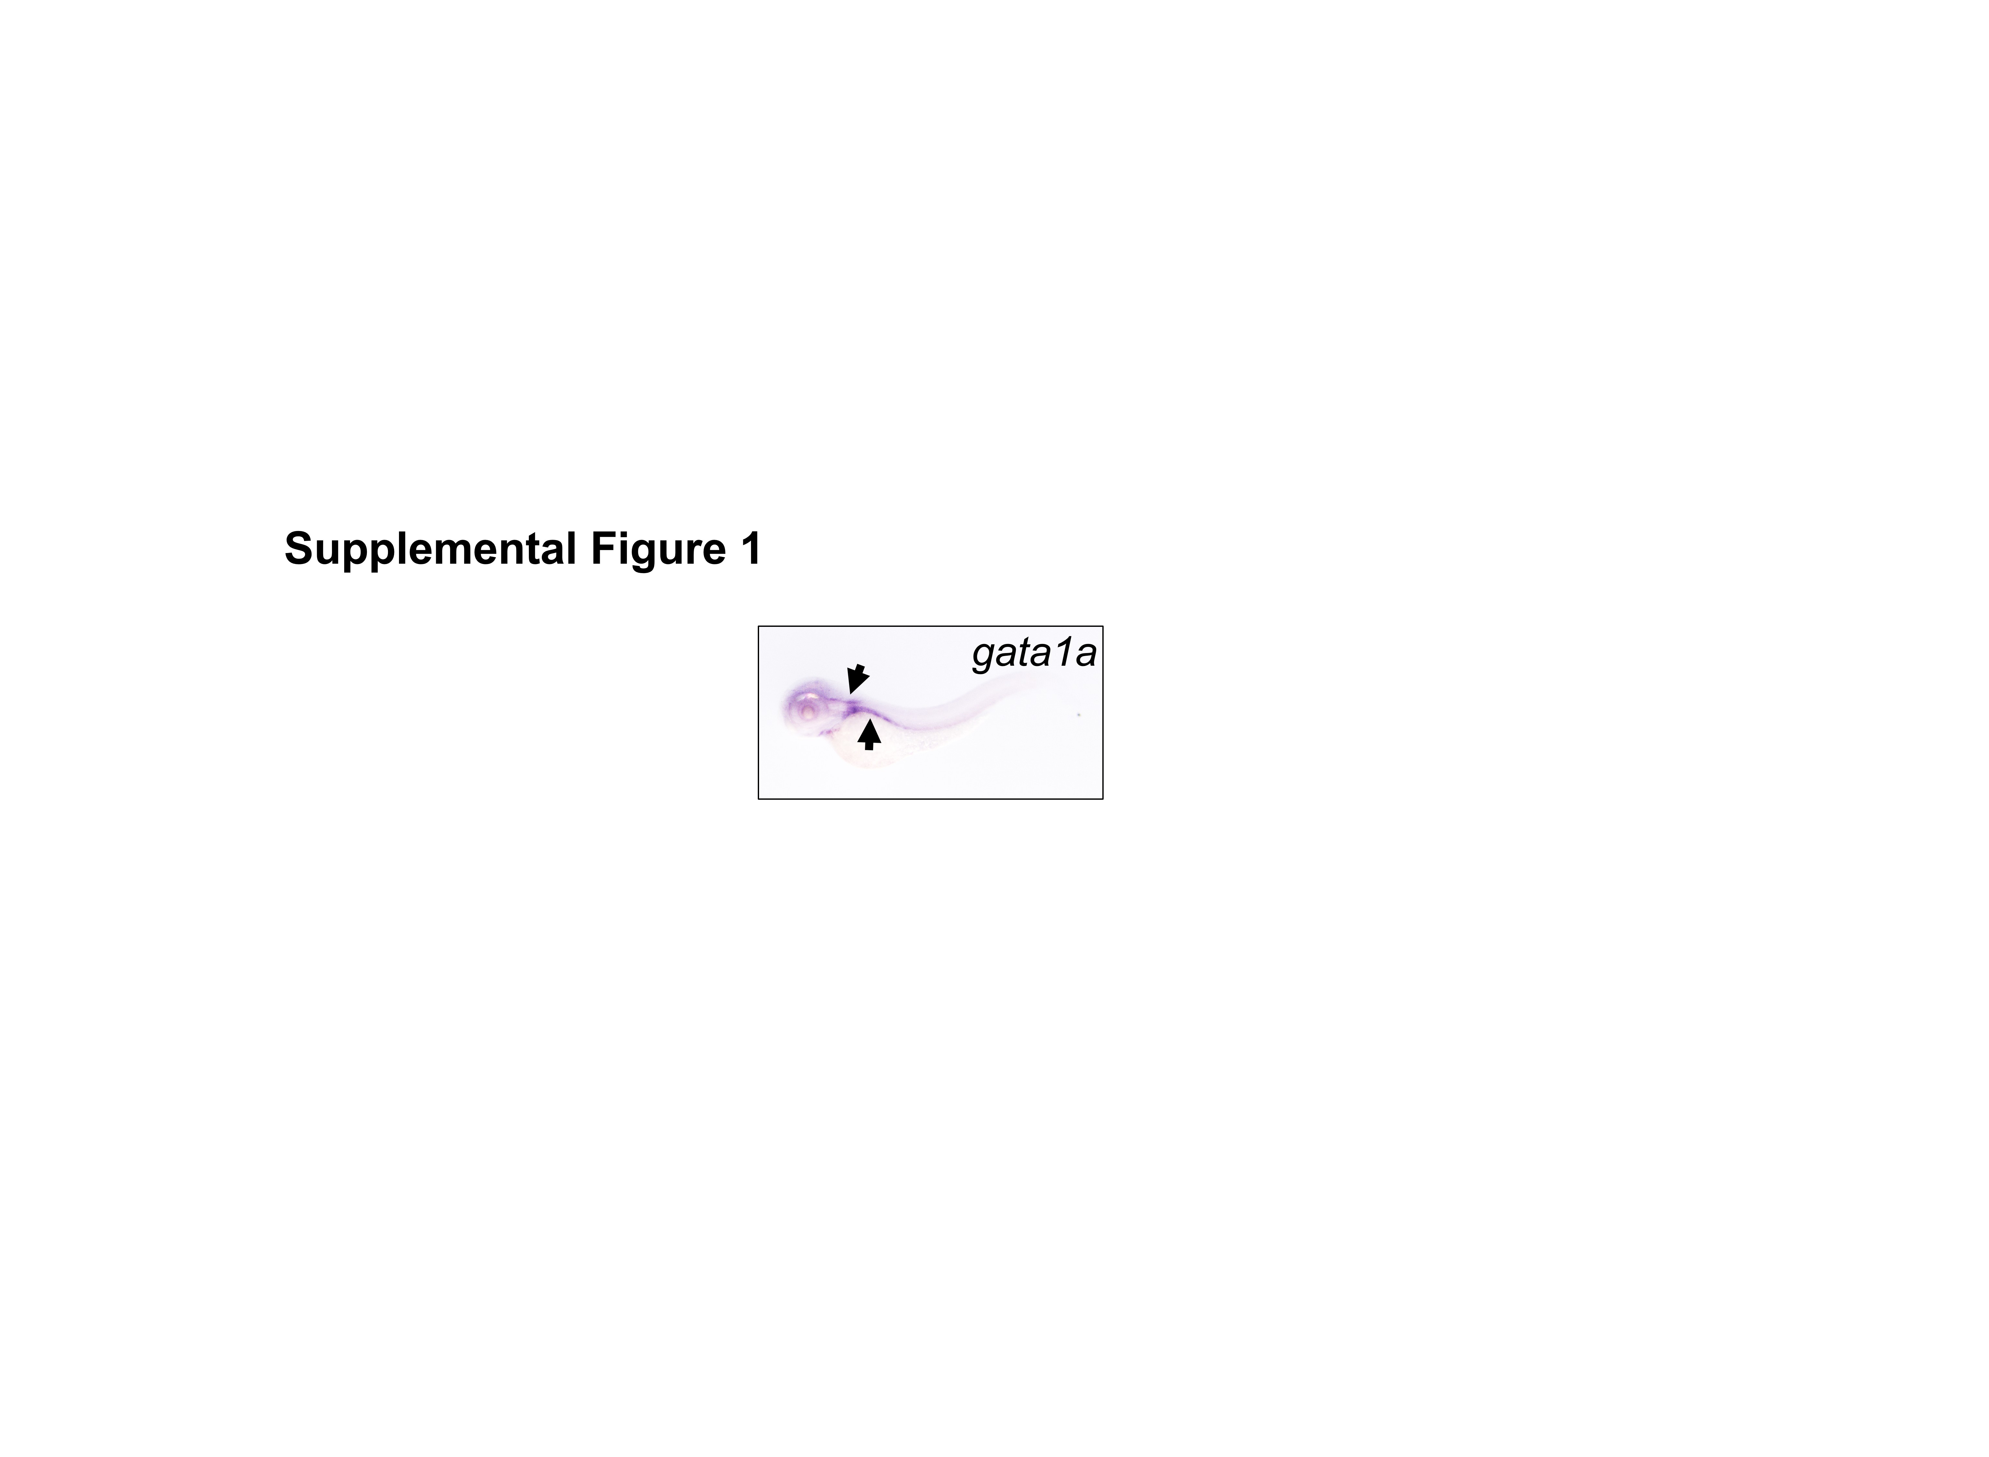

Supplemental Figure 1. Gata1a expression pattern at 48 hpf. gata1a expression detected by WISH.

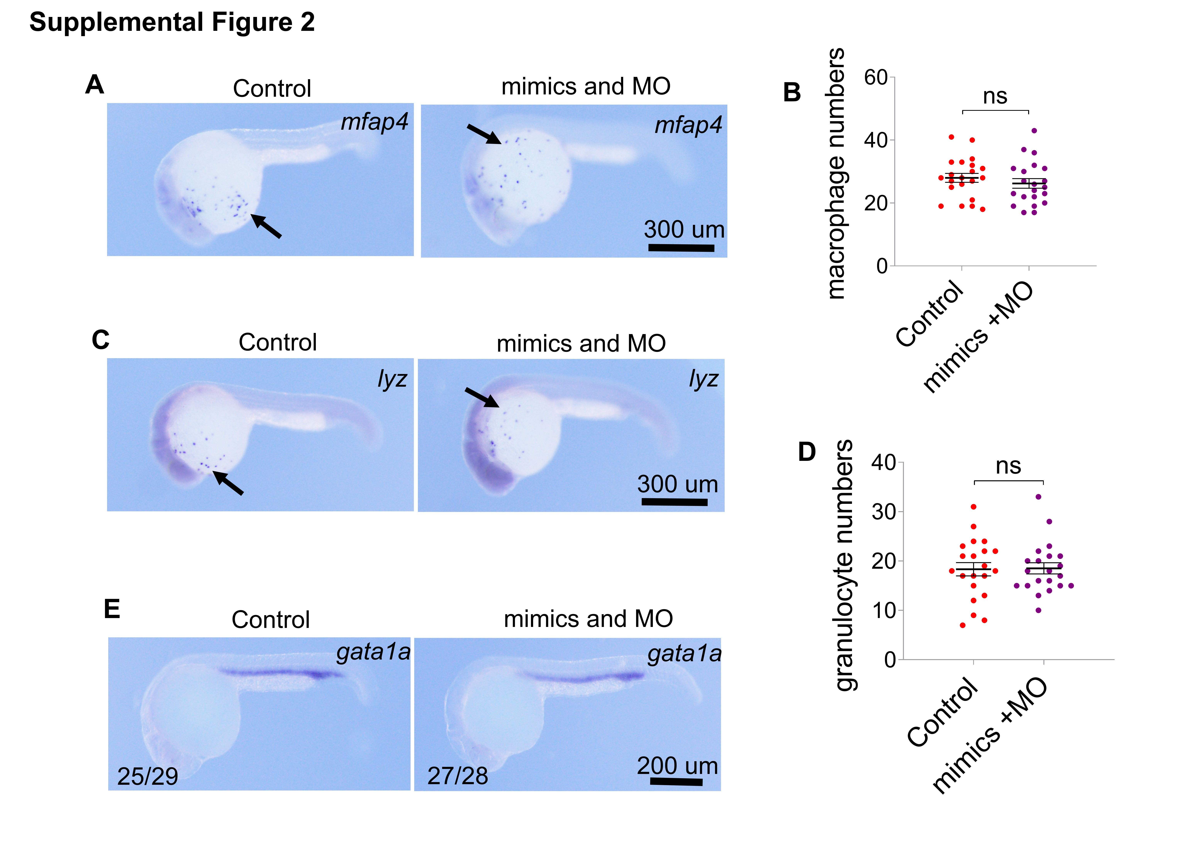
Supplemental Figure 2. Co-injection of miRNA mimics and MO rescues blood phenotype. The embryos were co-injected with 10 ng miRNA-7145 MO and 200 pg miRNA mimics at 1 cell stage, and the embryos were collected at 26 hpf stage. (A-D) Detection of myeloid cell marker expression at 26 hpf with whole mount in situ hybridization. (A) mfap4 expression, (C) lyz expression. (B) Statistics of mfap4 positive cells and (D) Statistics of lyz positive cells. (E) gata1a expression. Scale bar is shown in the Figure. *P < 0.05, **P < 0.01, ***P < 0.001.

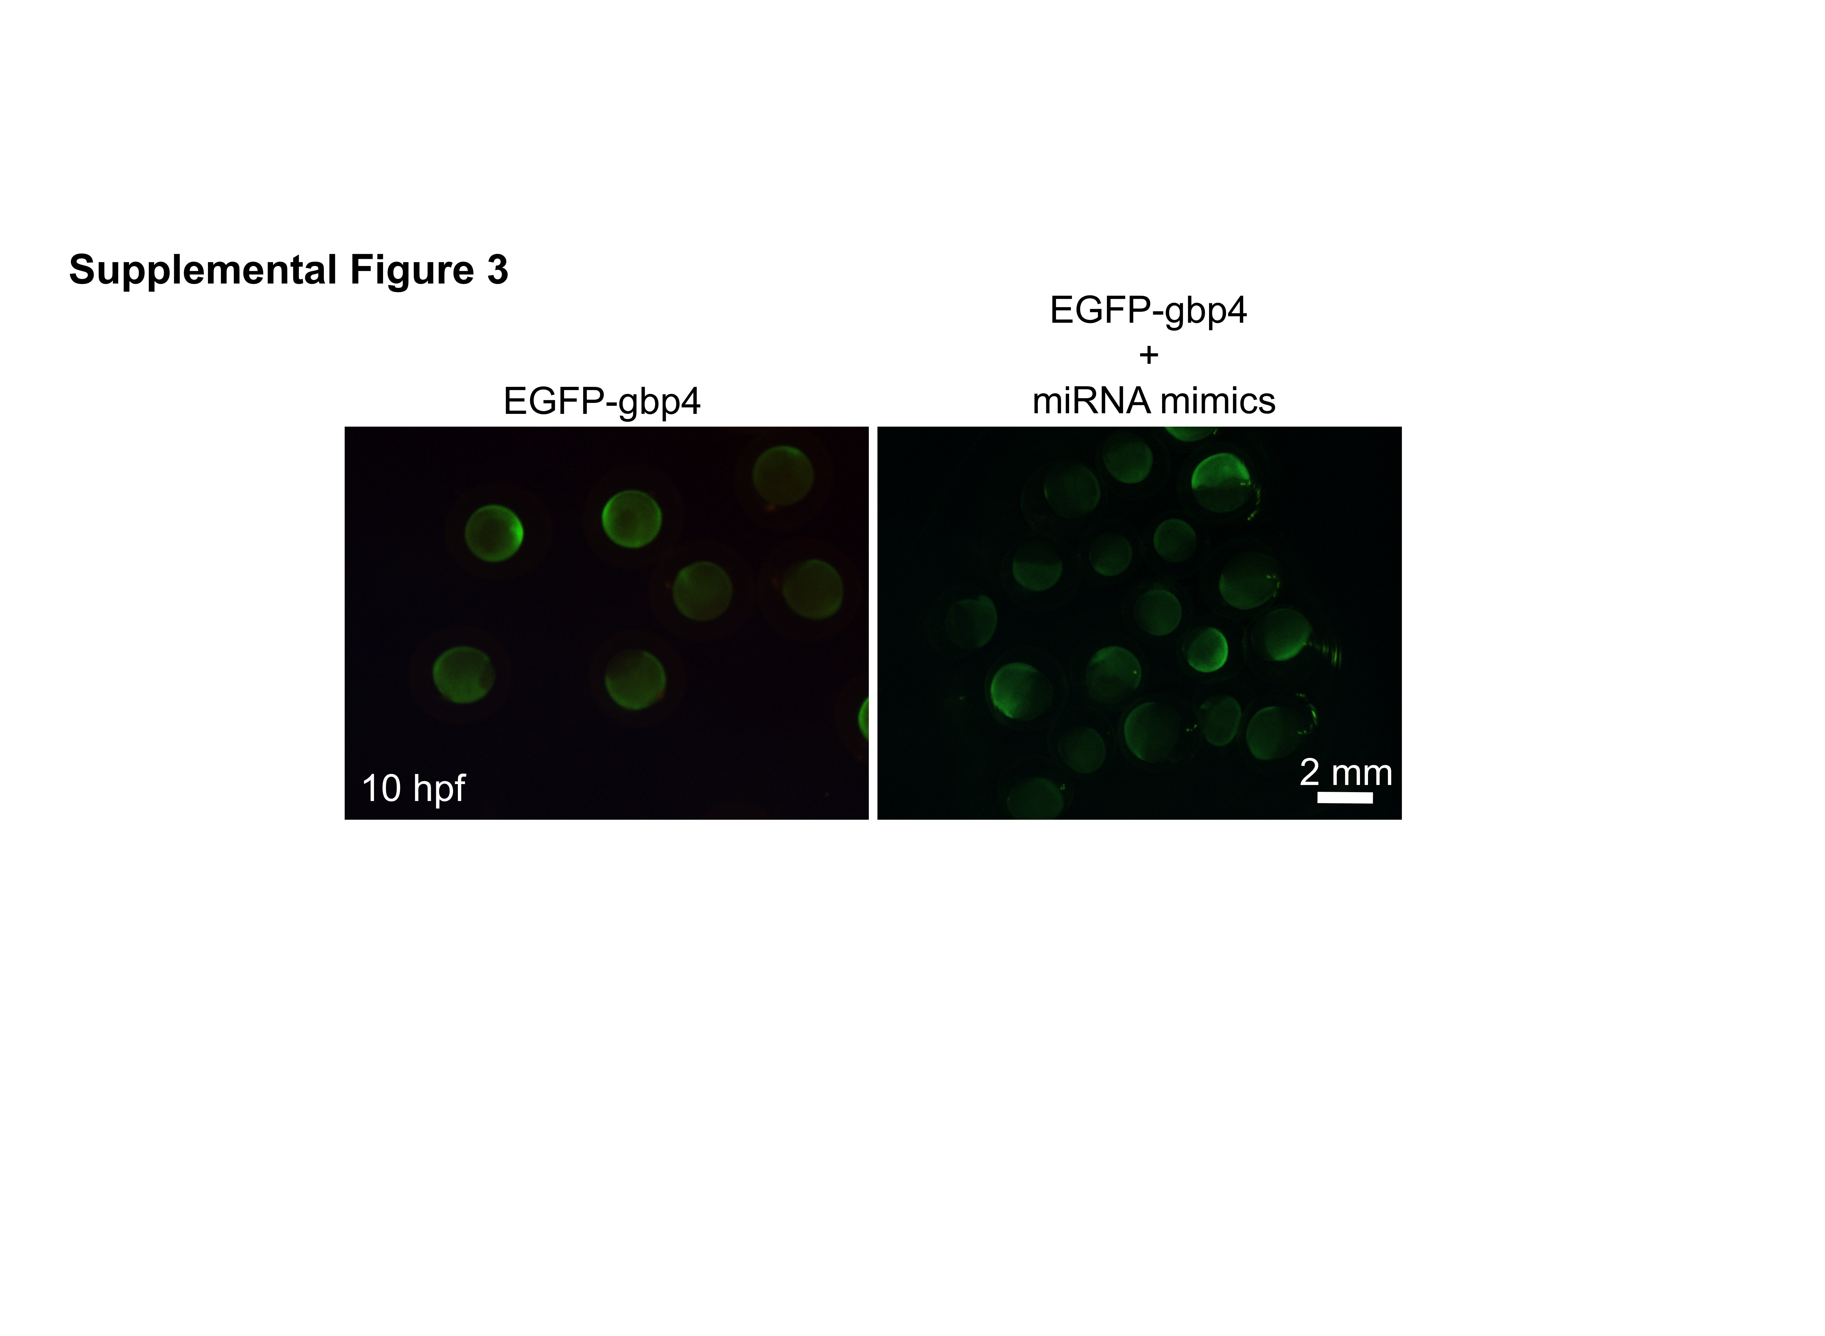
Supplemental Figure 3. Expression of EGFP and gbp4 fusion. All components were injected with 200 pg RNA at 1 cell stage. Scale bar, 2 mm.

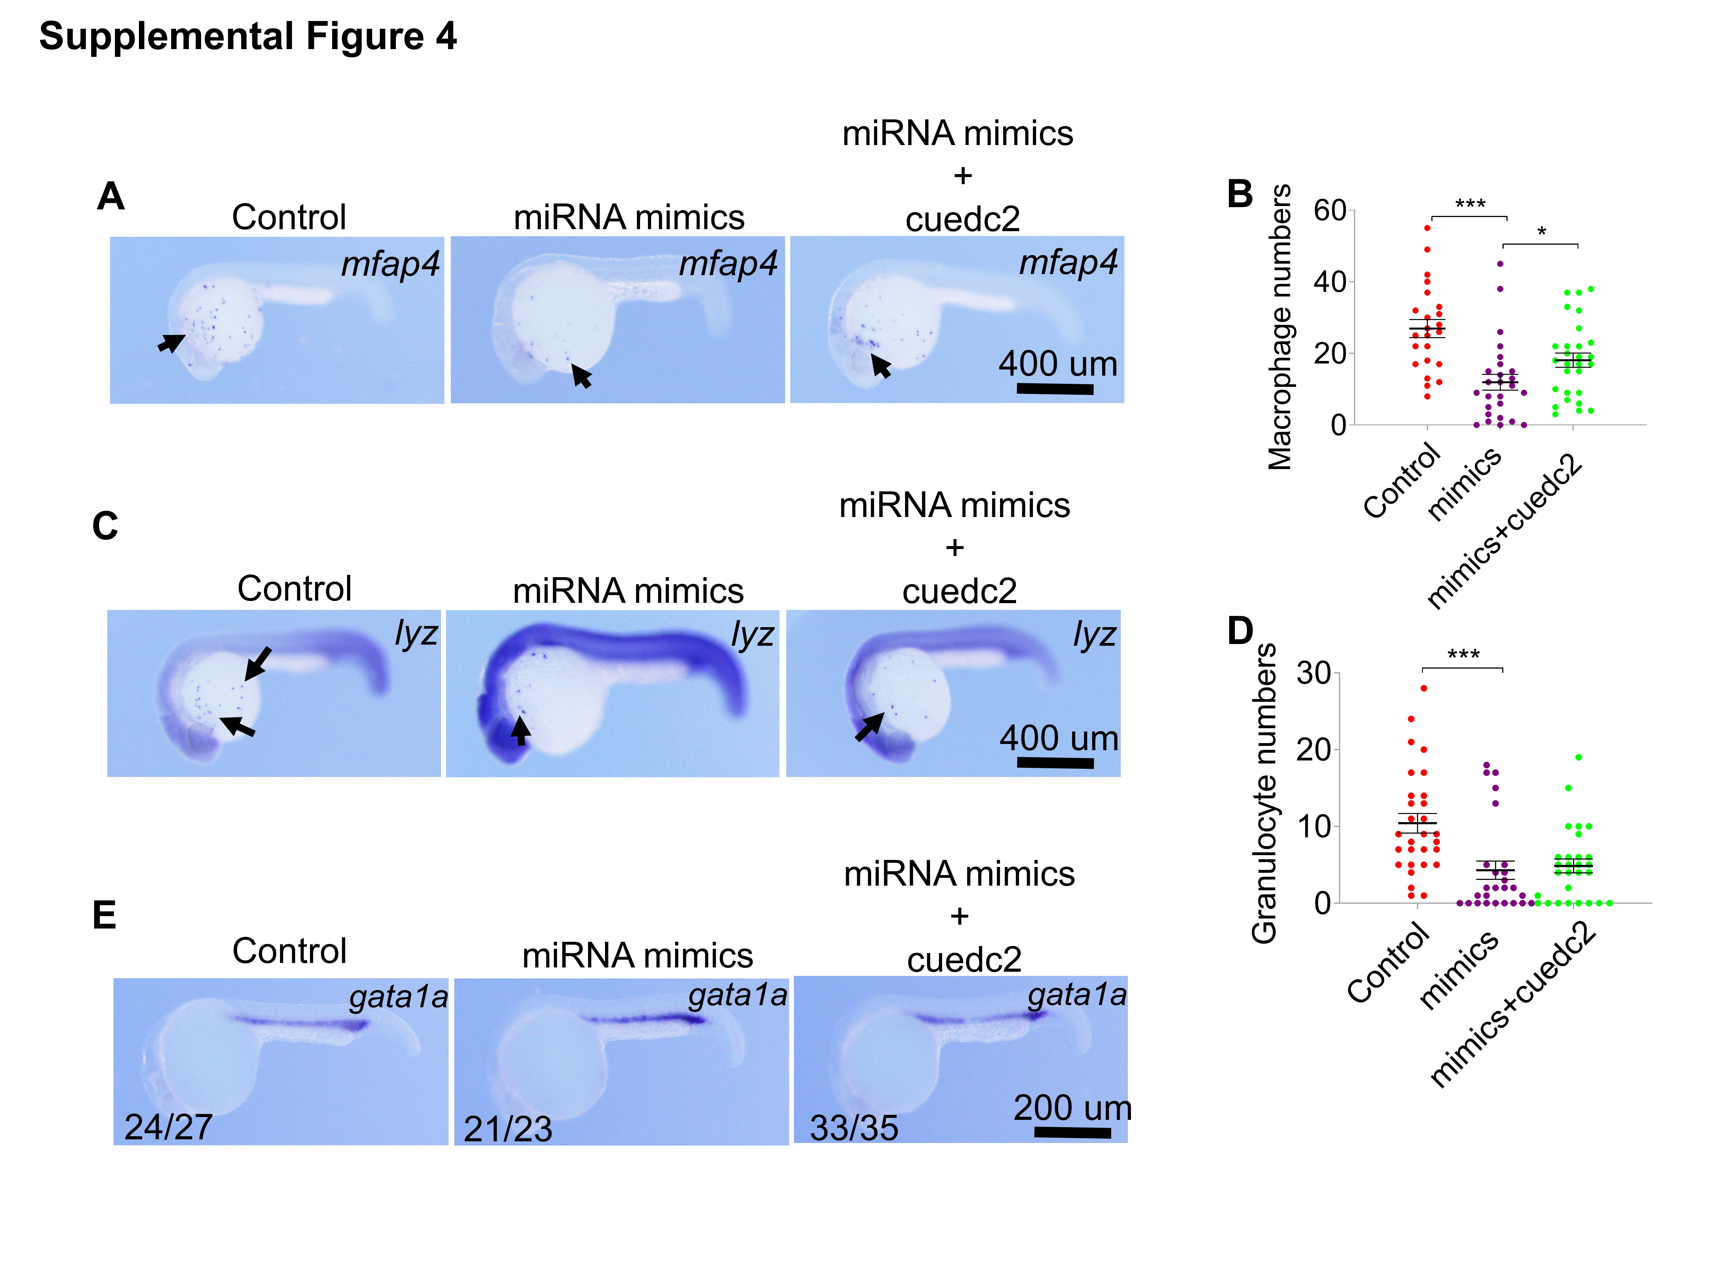
Supplemental Figure 4. miRNA-7145 over-expression combined with cuedc2 over-expression partially restores blood development. The embryos were co-injected with 200 pg miRNA-7145 mimics and 200 pg cuedc2 mRNA at 1 cell stage, and the embryos were collected at 26 hpf stage. (A-D) Detection of myeloid cell marker expression at 26 hpf with whole mount in situ hybridization. (A) mfap4 expression, (C) lyz expression. (B) Statistics of mfap4 positive cells and (D) Statistics of lyz positive cells. (E) gata1a expression. Scale bar is shown in the Figure. *P < 0.05, **P < 0.01, ***P < 0.001.

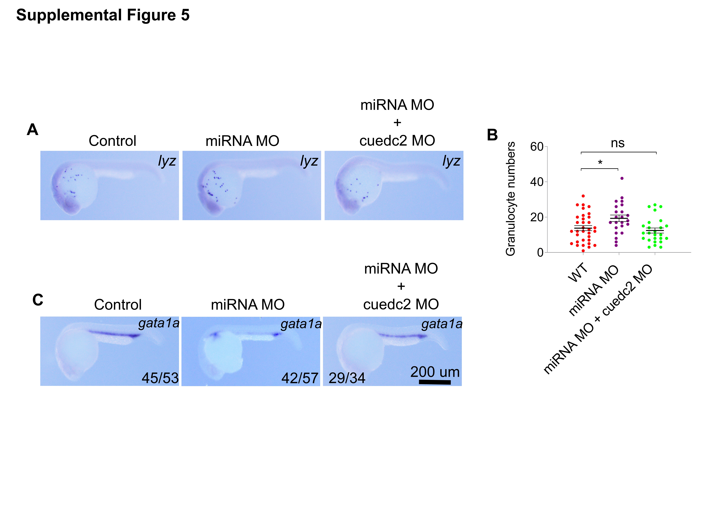
Supplemental Figure 5. miRNA-7145 knock-down combined with cuedc2 knock-down rescues the blood development. The embryos were co-injected with 10 ng miRNA-7145 MO and 10 ng cuedc2 MO at 1 cell stage, and the embryos were collected at 26 hpf stage. (A-B) Detection of lyz expression at 26 hpf with whole mount in situ hybridization. (A) lyz expression. (B) Statistics of lyz positive cells. (C) gata1a expression. Scale bar is shown in the Figure. *P < 0.05, **P < 0.01, ***P < 0.001.

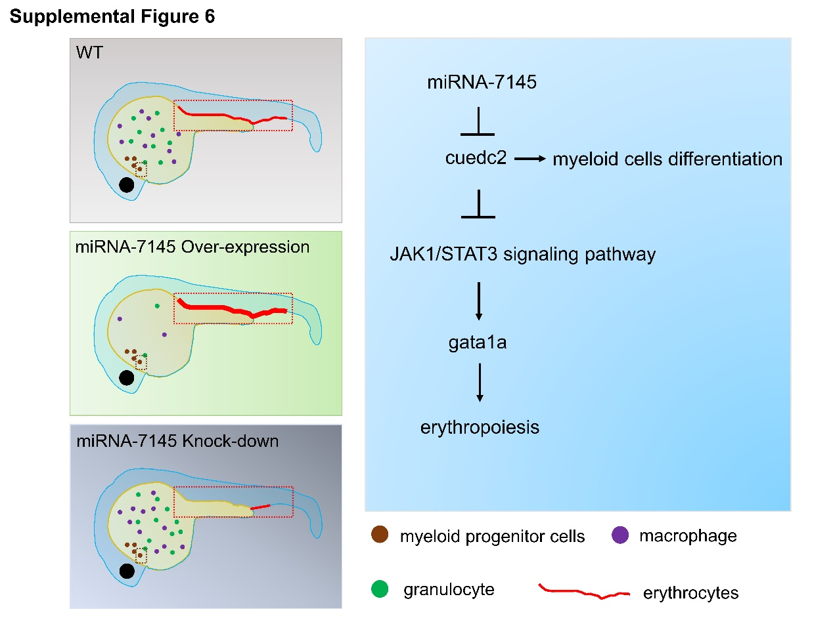
Supplemental Figure 6. Hematopoiesis regulation model of miRNA-7145. Overexpression of miRNA-7145 can inhibit the expression of cuedc2, thus inhibiting myeloid cell differentiation and promoting erythropoiesis. Knockdown of miRNA-7145 can promote the expression of cuedc2, thus promoting myeloid cell differentiation and inhibiting erythrogenesis. Cuedc2 can inhibit the JAK1/STAT3 signaling pathway that has been routinely reported to contribute to erythropoiesis.

