Annex A1 Top-down CGE Model

Our top-down energy model is patterned after GTAP model, designed and developed by the Center for Global Trade Analysis, Purdue University; see Hertel (1997. In our model, we consider 3 regions namely, Kerala, rest of India and rest of the world.
The GTAP model is impactful in performing a comprehensive evaluation of a policy or regulatory shock. On the production side, the model assumes perfect competition and constant returns to scale. The production for every sector, every region in the model is identified and represented by a Constant Elasticity of Substitution (CES) function. It also works on the basis of Armington assumption and so, each firm employs a CES composite of domestic and imported intermediate goods in fixed proportions with endowment factors or value-added commodities like land, labour, capital, natural resources, etc.
While on the demand side of the model, total income is distributed following a fixed share across households, government, and savings expenditure. The model captures supply-demand linkages and equates them by accounting for changes in production, consumption, exports, and imports.
There are five factors of production (land, capital, national resources, unskilled labour and skilled labour), three types of domestic institutions (households, enterprises and government),
The behavioural equations in the model dictate production, private consumption, exports, imports, and market-clearing conditions that equate supply with demand. Elasticities determine the substitution between various input and output parameters in the production and consumption behavioural equation.

Figure A1-1 Simplified View of the Accounting Structure of the GTAP Model
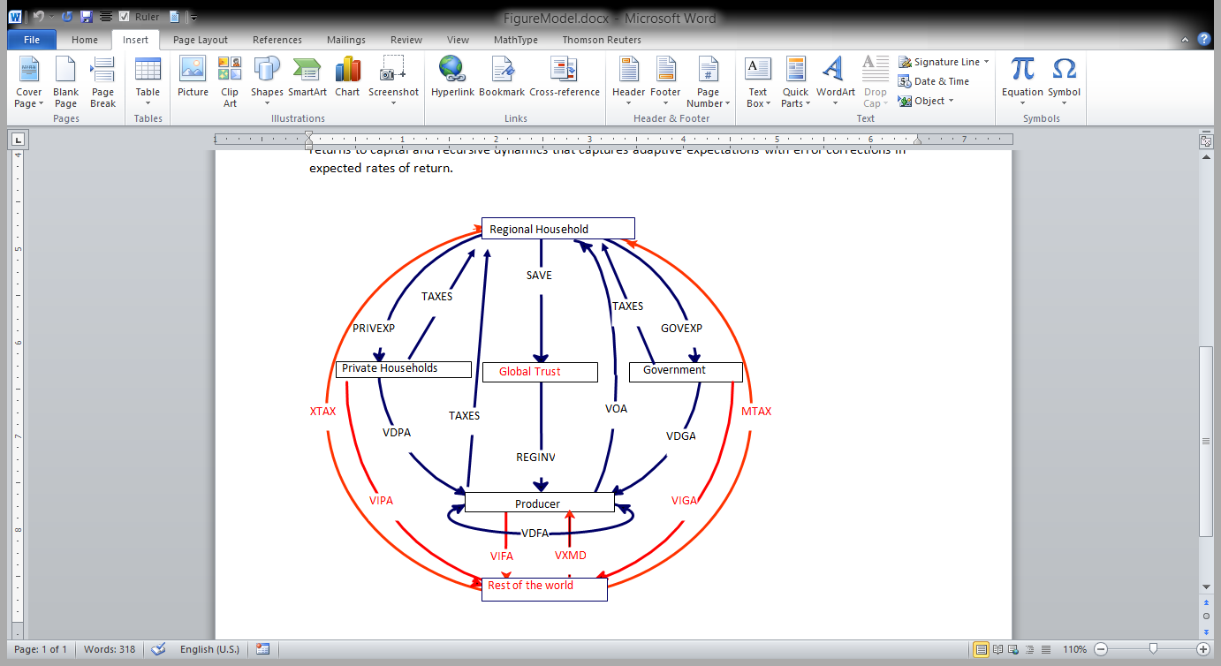

Figure A1-1 offers a simplified structure of the originally complex GTAP model. Here, the regional household receives factor payments (VOA) from different agents including private households, firms, and the government for the supply of factors like land, labour, and capital. The residual that remains after households’ expenditure on private consumption and government consumption is savings. The model is based on the Cobb-Douglas utility function that preserves the share of private consumption and government consumption. Global trust accumulates savings and then distributes them across different regions as investments and this happens based on the rate of returns. This becomes a capital input to the firms that also use factor inputs (VOA) and intermediate inputs from domestic (VDFA) as well as imported (VIFA) to produce the output. This output caters to the consumption demand of private households (VDPA), and the government (VDGA) and serves as an intermediate input to firms (VDFA). The private household and the governments can consume from the domestic output (VDPA/VDGA) as well as from imports (VIPA/VIGA), the consumption of which is governed by the Armington assumption. The international transactions in the figure are marked in red and the domestic transactions are differentiated in blue colour.
In the standard GTAP model, the electricity sector is present as an aggregate sector in terms of fuel, capital, and other production inputs, in the standard GTAP model. However, with policy and technical enhancements across different power generation technologies, it is important to account for power generated from different sources and the substitution between them. The GTAP-Power database extends the standard GTAP database by including transmission and distribution while also accounting for power generated from different sources including solar, wind, gas, oil, coal, nuclear, and hydro. The problem with electricity is that supply must instantly rise to cater to the consumption demand which in turn varies by, for example, season, work hours, day, and night.
Coal power plants cannot instantly adjust to demand while gas or solar power can cover during peaks. Also, it is unrealistic to assume that solar or nuclear power can meet all power demands given their operational constraints. Thus, based on their ability to cater to the requirements of the base and peak load, the power generation sectors are split into base- and peak-load technologies. The GTAP-Power database disaggregates electricity into 12 sectors with a transmission and distribution sector and 11 other generation sectors based on their sources and capacity to meet the consumer demand. There are seven base load technologies including ‘NuclearBL’, ‘CoalBL’, ‘GasBL’, ‘HydroBL’, ‘OilBL’, ‘WindBL' and ‘OtherBL’ and four peak load technologies covering ‘GasP’, ‘OilP’, ‘HydroP’, and ‘SolarP’. Other types of power sources include biofuels, waste, biomass, geothermal, and tidal technologies. Each of these power sources has different fuel efficiency and demands different investments.
Figure A1-2 Nested Electric Power Substitution in GTAP-E-Power Model
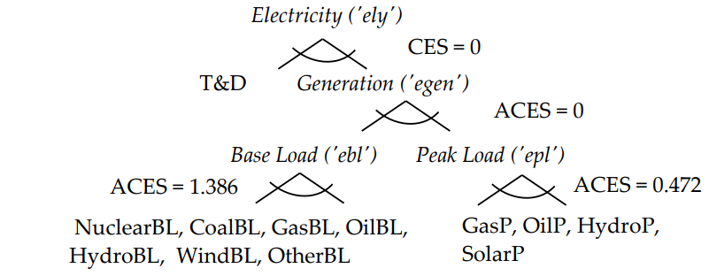
Source: Peters (2016b).

To build a GTAP-Power model for Kerala, rest of India and rest of the world, we modify the GTAP-E-Power model (Peters, 2016) which has the intricacies of GTAP-E and GTAP-Power models. In other words, it extends the GTAP-E model to include transmission and distribution as well as account for substitution between power generated from different sources. GTAP-E, an energy environmental version extends the standard GTAP model by incorporating energy substitution. It also accounts for carbon emissions from the combustion of fossil fuels and is a mechanism for international emissions trade. Energy commodities in the GTAP model include coal, oil, gas, petroleum and coal products, and electricity. In the standard GTAP model, they are treated as intermediate commodities and the substitution parameters between these sectors are preset to zero. The GTAP-E model accounts for inter-fuel substitution and fuel-factor substitution in the production structure.
The construction of the balanced database for the GTAP-power was an extensive exercise. For this exercise, we had to construct an input-output for Kerala and rest for India using the supply-use table for the year 2021. This also involved collecting various state level data, macroeconomic data for Kerala and India and, of course, electricity generation by modes for Kerala and India. Most of the supplementary information were drawn from official statistics. We have used information from official statistics of DGCIS to collate data on exports from Kerala/rest of India and inter-regional trade within India.

Annex A2 Bottom-up Energy (MESSAGEix) Systems Model of India

A3.1 Introduction
The MESSAGEix is an energy systems optimization model that optimizes the supply side of the model based on the projected energy demand provided as an exogenous input to the model. The model has 5 major sectors: residential, commercial, industry, transport and agriculture as major energy consumption sectors. The residential sector is further broken down into sub-sectors as appliances and cooking. The growth in energy demand in these sectors are directly linked to the growth of the sectors in terms of economic activity. With these projected demand as in input to the model, the model optimizes the energy system to the least cost scenario of energy activity in and around policy constraints of environment and resource availability. The optimization occurs at different levels of energy uses from useful energy demand to final and then to secondary consumption all the way up to primary and resources supply. A representation of the model in general context is shown in the Figure A2-1.
Figure A2-1 Representation of an Energy System Model in MESSAGEix

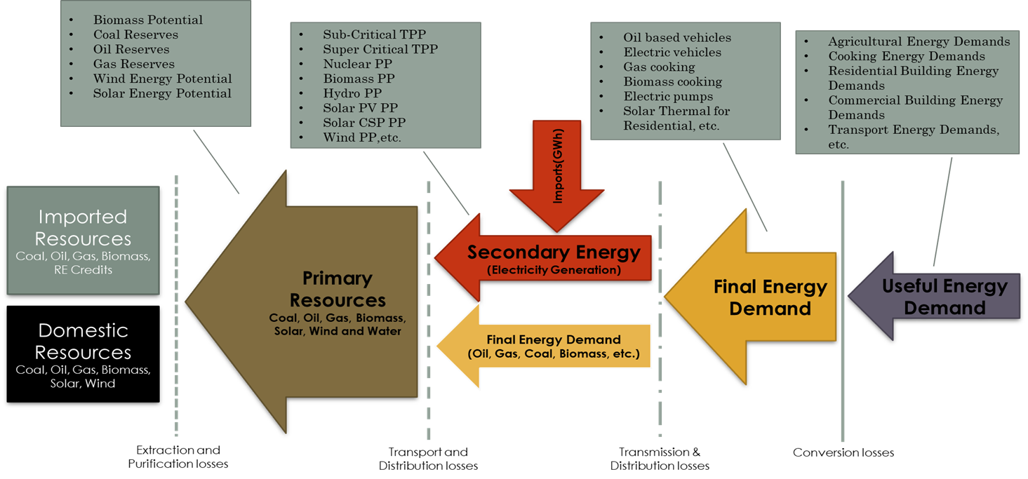

Figure A2-1 shows the granularity in the model to make a technology based decision to a low carbon pathway. Total GHG emissions, investments and electricity generation capacity expansion profile are some of the major outputs from the model. This approach brings a clear context of what alternative technology should a nation look at to decide on cutting down emissions and what will be the cost of implementation for those pathways. It also helps implement policies that look at better demand management with shift in fuel mix. But the demand information remains fixed in the model and hence at a time the scenarios can be developed only assuming one case of economic activity. To produce meaningful scenarios, the variation of demand linked with economic activity is required to represent the scenarios at different levels of socio-economic activity and thus a framework with seamless scope of looking at more insightful solutions to climate mitigation becomes key to a more suitable modelling approach where the demands can come from a CGE model (see Figure A2-2 below). MESSAGE-ix modelling framework is developed by the International Institute for Applied Systems Analysis (IIASA). It is a versatile, open-source, dynamic systems-optimization model and presents framework for representing an energy system with all its interdependencies from resource endowments and potentials to extraction rates, imports and exports, generation of electricity and conversion of fuels, transportation, transmission, and distribution, to conversion of energy for end use demand in the form of heat, light, or kinetic energy. The optimization model obtains the least-cost solution subject to constraints over pre-defined fixed time periods.
The MESSAGE model has been a crucial part of various assessment reports of Intergovernmental Panel on Climate Change (IPCC). MESSAGE-ix is a demand driven bottom-up model. As a result, estimation of energy demand is a crucial part of the modelling process. The objective is to minimize the energy system’s costs to meet given energy demands in the economy over the model horizon.

Figure A2-2 Structure of MESSAGEix Model
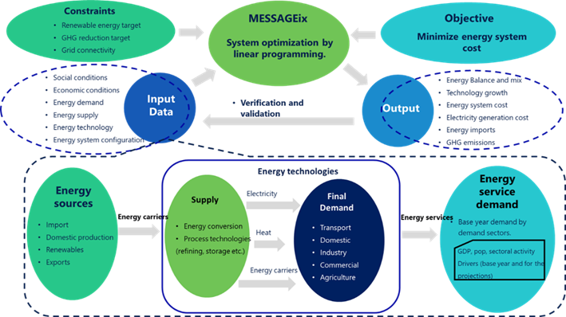

A3.2 Energy demand projection using the IM Framework
The MESSAGEix requires the demand projections as an exogenous input to the model. Based on these projected demands, the supply side to meet these demands are optimised in the MESSAGEix model at different levels of consumption and supply. Optimisation in MESSAGEix is constrained with least cost optimisation which means that the optimisation occurs for a least cost systems expansion plan to meet the future demands in and around all other policy constraints such as environmental constraints, resource constraints, capacity constraints, etc. into consideration. Hence, the supply side information is much relevant because it covers majorly most of the policy aspects. In order to make it more robust in terms of linking the energy model to an economy based on economic performance the energy demand that should be used into the MESSAGEix model as an input should be derived from a Computable General Equilibrium (CGE) Model.
Here we explain how the projected CGE model outputs at sector level will be used to derive the corresponding sectoral energy demand growth rates using the concordance mapping.

A3.2.1 Agriculture Energy Demand

Factors from CGE model outputs
CGE output on ‘grains and crop’ productivity rate is the key indicator for the agriculture sector. The productivity rate helps determine the land use change and change in agricultural tractors and irrigation pumps by increase/decrease in productivity rates.

Derived energy demand from CGE outputs
The factors are then applied to irrigation and land preparation through identification and percentage distribution between surface/ground water irrigation. Land use change is considered based on long term historical data based on national statistics.

A3.2.2 Household/Cooking Energy Demand

Factors from CGE
Direct productivity of household demand for ‘electricity and gas supply’ is obtained and applied to the base year energy demand of both household and cooking.

Derived energy demand from CGE outputs
The base year energy demand is calculated from national accounts and statistics. Cooking activity and its productivity rates are then obtained based on weightage distribution of the fuel utilization as in its historic trends.

A3.2.3 Commercial Sector Energy Demand

Factors from CGE
Intermediate demand of electricity is directly obtained by deducting household demand of energy commodity from aggregate demand.

Derived energy demand from CGE outputs
The base year energy demand is calculated from national accounts and statistics. Identification and percentage distribution between appliance use and hot-water demand of the sector is based on growth pattern of the sector.

A3.2.4 Transport (Freight & Passenger) Energy Demand

Factors from CGE
CGE provide direct intermediated growth of ‘rail transport, land, air and water transport’.

Derived energy demand from CGE Outputs
Identification of freight and passenger distribution from historical data and current national statistics. Growth parameters are identified based on sectoral demand pattern and then growth rates are directly applied.

A3.2.5 Industrial Energy Demand

Factors from CGE
For identifying the growth rate of the industry sector, growth rates are directly sourced from different manufacturing services and other industries modelled in the CGE model. Further the mean value of all the production growth of manufacturing and other Industries from CGE output is calculated which is then directly applied to the calculation of energy demand projection in industry sector.

Derived energy demand from CGE outputs
Base year energy demand is identified and direct mean growth rates are applied.

