Supplementary data

In steroid-resistant nephrotic syndrome that meets the strict definition, monogenic variants are less common than previously reported
Yuta Ichikawa¹, Nana Sakakibara¹, Yuta Inoki¹, Yu Tanaka¹, Chika Ueda¹, Hideaki Kitakado¹, Atsushi Kondo¹, China Nagano¹, Tomoko Horinouchi¹, Kazumoto Iijima^{2,3}, Kandai Nozu¹
- Department of Pediatrics, Kobe University Graduate School of Medicine, Kobe, Japan.
- Hyogo Prefectural Kobe Children's Hospital, Kobe, Japan.
- Department of Advanced Pediatric Medicine, Kobe University Graduate School of Medicine, Kobe, Japan.
Corresponding author
Yuta Ichikawa MD
Department of Pediatrics, Kobe University Graduate School of Medicine, 7-5-1 Kusunoki-cho, Chuo-ku, Kobe 650-0017, Japan
Tel: +81-382-6090; Fax: +81-382-6099; E-mail: y0gobro@med.kobe-u.ac.jp

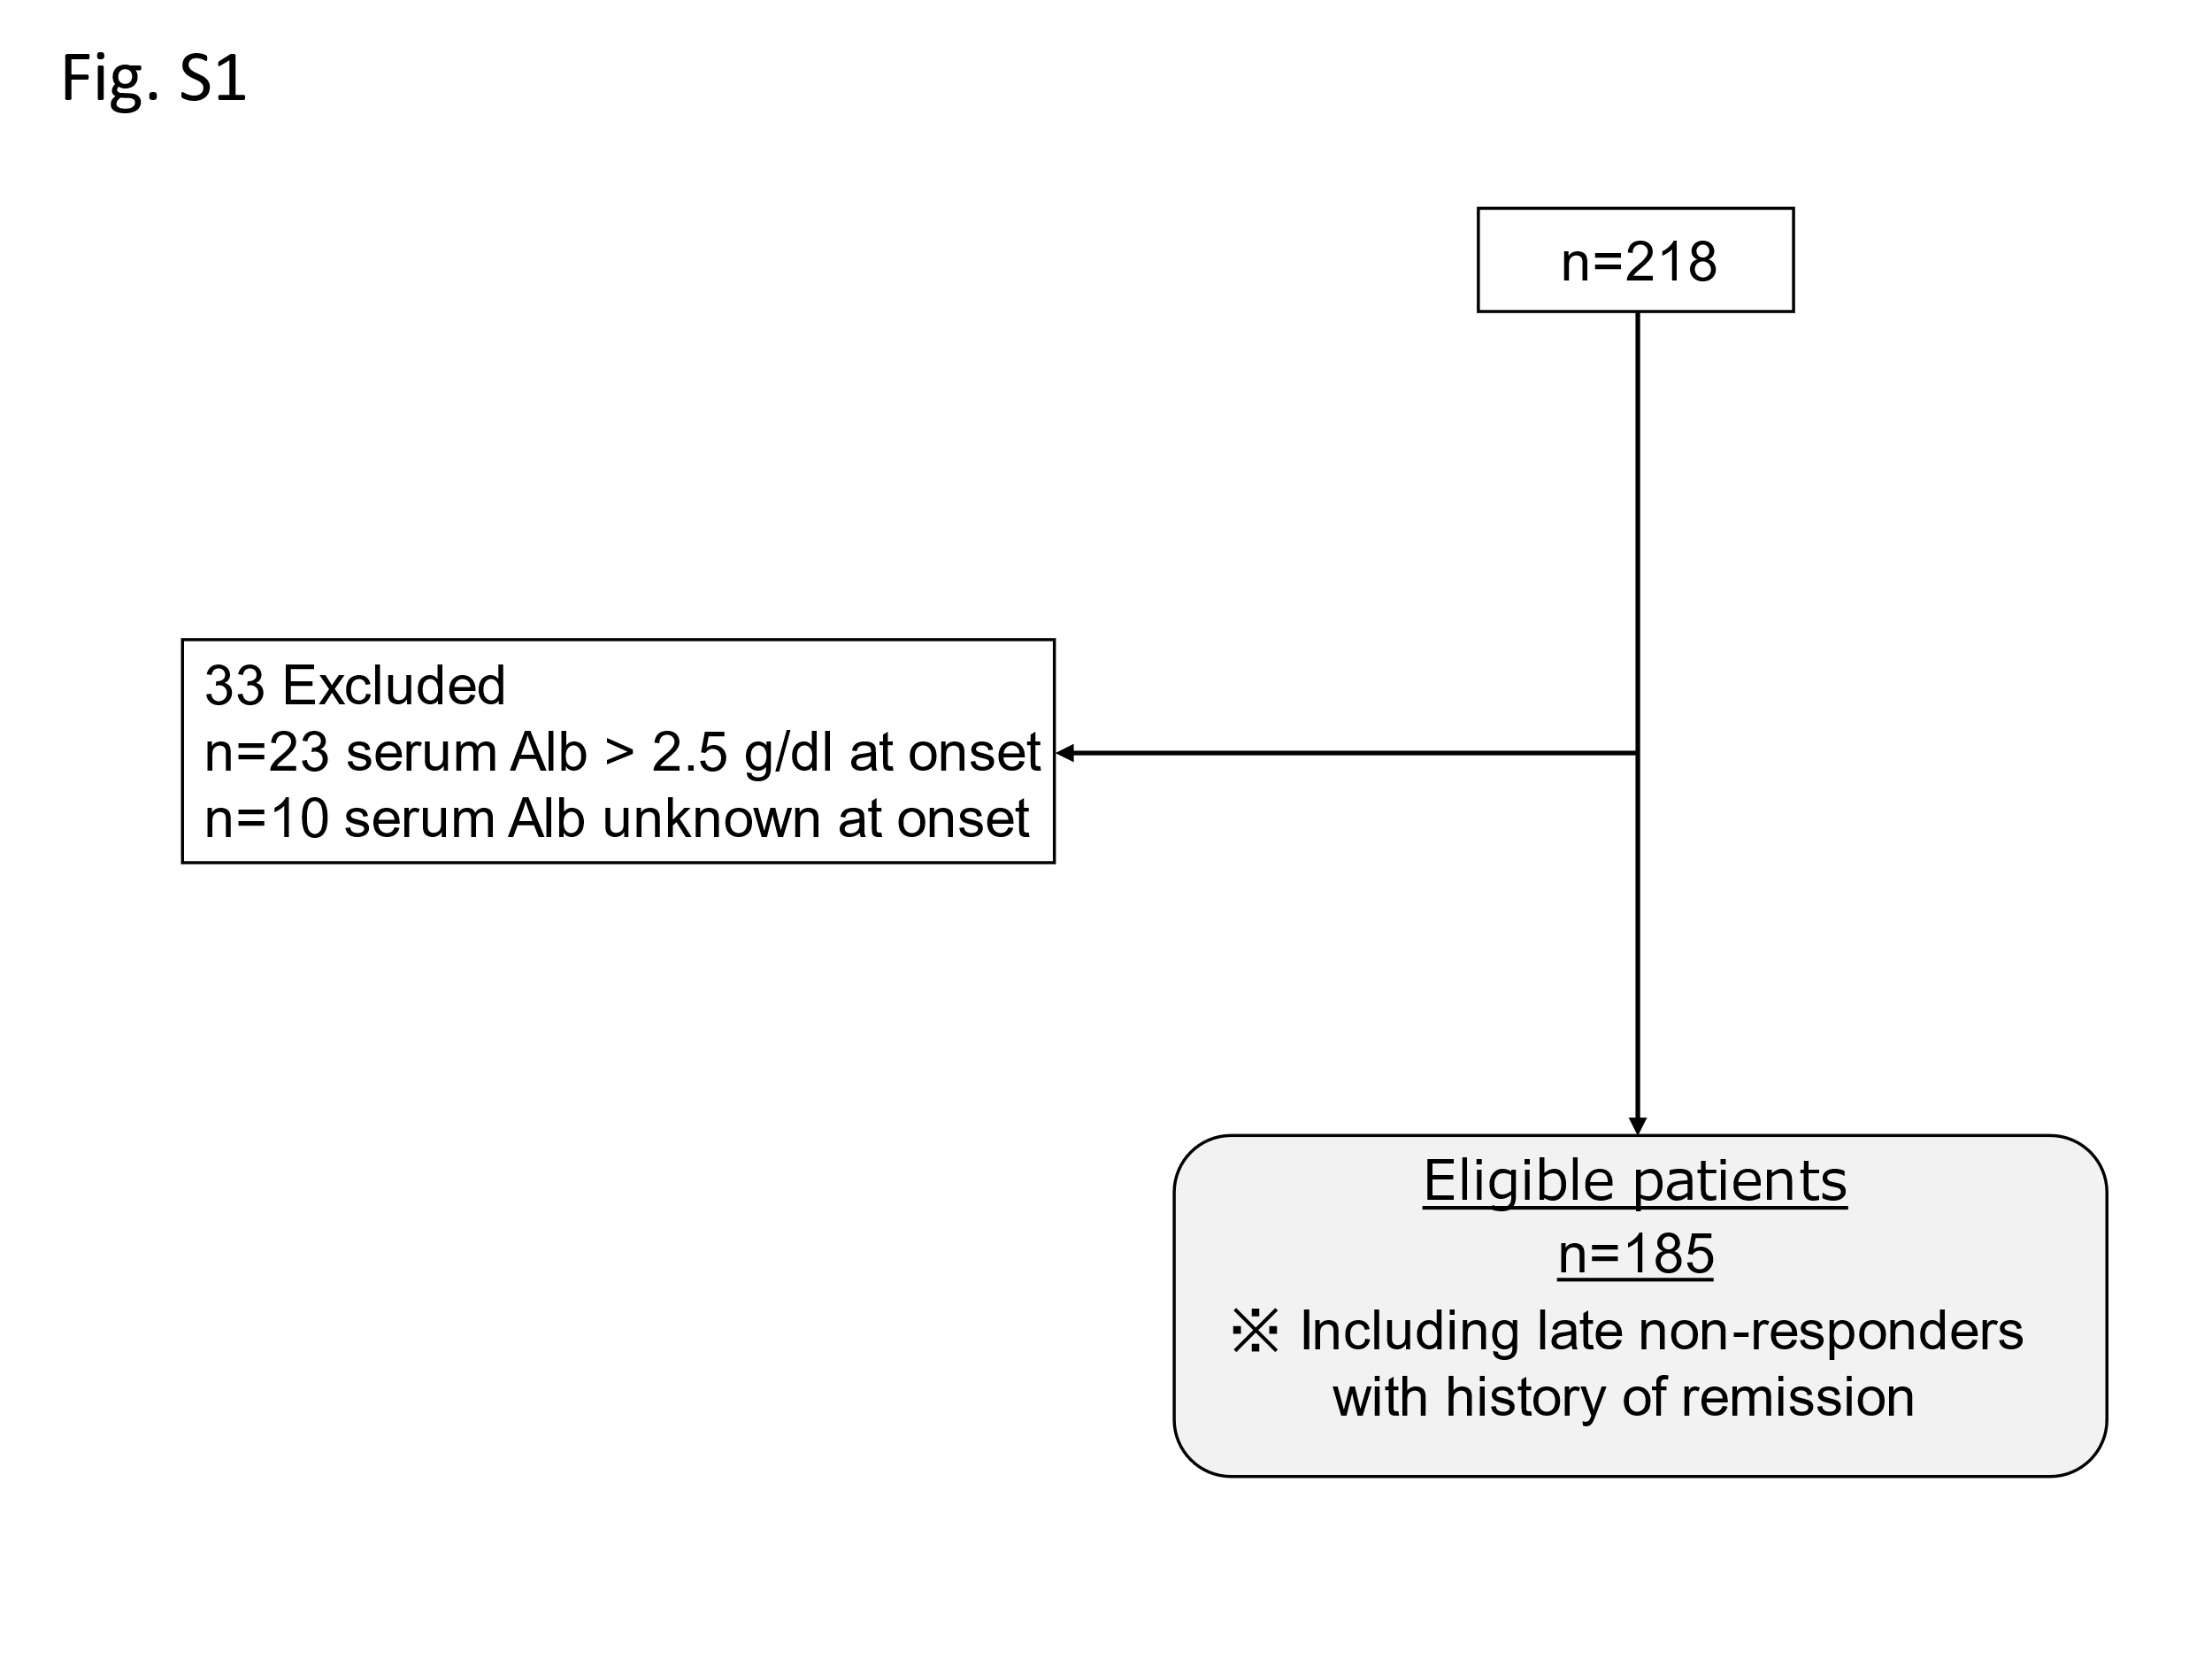 Fig. S1 This study included 218 pediatric patients diagnosed with SRNS between 1 and 18 years of age who underwent comprehensive gene screening between March 2016 and October 2022. We excluded 23 patients who started steroid therapy with serum Alb > 2.5 g/dl at onset and 10 patients with unknown serum Alb levels. Thus, data from 185 patients with a strict SRNS diagnosis were analyzed. Abbreviations: Alb, albumin; SRNS, steroid-resistant nephrotic syndrome

