Supplementary data

In steroid-resistant nephrotic syndrome that meets the strict definition, monogenic variants are less common than previously reported
Yuta Ichikawa¹, Nana Sakakibara¹, Yuta Inoki¹, Yu Tanaka¹, Chika Ueda¹, Hideaki Kitakado¹, Atsushi Kondo¹, China Nagano¹, Tomoko Horinouchi¹, Kazumoto Iijima^{2,3}, Kandai Nozu¹
- Department of Pediatrics, Kobe University Graduate School of Medicine, Kobe, Japan.
- Hyogo Prefectural Kobe Children's Hospital, Kobe, Japan.
- Department of Advanced Pediatric Medicine, Kobe University Graduate School of Medicine, Kobe, Japan.
Corresponding author
Yuta Ichikawa MD
Department of Pediatrics, Kobe University Graduate School of Medicine, 7-5-1 Kusunoki-cho, Chuo-ku, Kobe 650-0017, Japan
Tel: +81-382-6090; Fax: +81-382-6099; E-mail: y0gobro@med.kobe-u.ac.jp

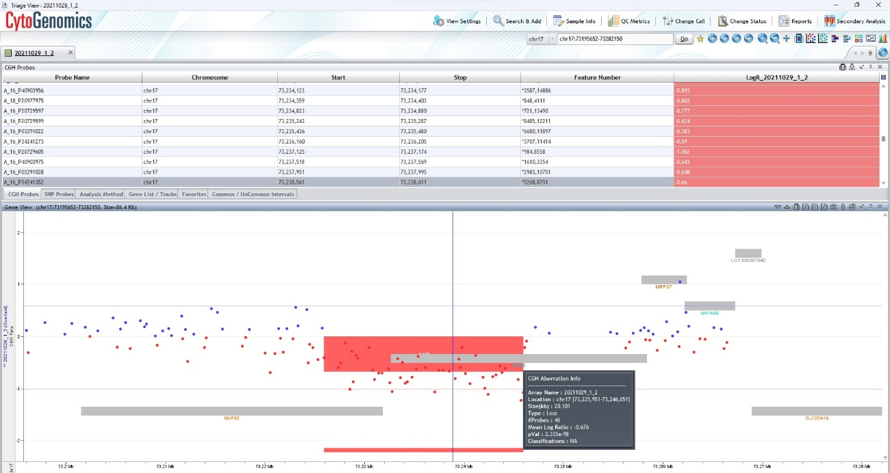 Fig. S2 Gene analysis for case Neph329. Targeted next-generation sequencing showed one novel heterozygous missense variant in NUP85 [c.1379G>A, p.(Arg460Gln)]. We also conducted Sanger sequencing and detected the same mutation in both the patient and his father. When we conducted pair analysis using the SureCall application, a copy number variant of NUP85 was suspected, so custom array comparative genomic hybridization was performed and detected that heterozygous chromosome 17 q25.1 partial deletion affected the NUP85 gene region

