Supporting Information
Title: Installation of HbG- Makassar by base editing restores hemoglobin function: a transformative therapy for sickle cell disease
Authors: Zachary Kostamo,^{1#} Manuel A Ortega^{2#}, Chavonna Xu², Patricia R. Feliciano² Daisy Lam², Elizabeth Budak², Valerie Winton², Rebecca Jenkins², Archita Venugopal², Kennedy Goldsborough,¹ Britney Hernandez,¹ Celeste K Kanne¹, Erica N. Evans,¹ Jordan Zgodny,¹ Yankai Zhang¹, Jawa Darazim¹, Ashwin Patel¹, Michael A. Pendergast¹, Adam J. Hartigan², Giuseppe Ciaramella² , S. Haihua Chu^{2*}, Seung-Joo Lee^{2*}, and Vivien Sheehan^{1*}
#These authors contributed equally to this work
*Corresponding authors
Address: ¹ Emory University School of Medicine, Department of Pediatrics, Atlanta, GA
²Beam Therapeutics, 238 Main St, Cambridge MA, 02142
Keywords: gene therapy, CD34, hemoglobin, Townes mice, X-ray crystallography, oxygen binding, HbG-Makassar, polymerization, HbS, sickle cell disease

Table of Contents
Table S 1. Sources utilized for the purification of hemoglobins 2
Table S 2. Data collection and refinement statistics. 3
Table S 3. Number of residues of α (1-141) and β (1-146) subunits visualized in the structures. 4

Figure S 1 SDS-PAGE and MS analysis of purified hemoglobins used in this study. …………………….5
Figure S2 Allelic editing outcomes in BFU-E colonies of HbSS CD34+ edited cells …………….………..6
Figure S3. Additional imaging of single edited HbSS CD34+ derived IVED clones of HbSS, HbGG and HbGS genotypes exposed to hypoxia ……………………………………………………………………….7

Supplementary Materials and Methods ………………………………………………………….…….8-9

Table S 1. Sources utilized for the purified hemoglobins
Source | Genotype | Experiments
Human blood | AA, SS | Oxygen equilibrium curves
Townes mice blood | AA, AG, AS, SS | Oxygen equilibrium curves, polymerization studies, structural characterization (oxy state)
recombinant (E. coli) | G | Structural characterization (deoxy state)

Table S 2. Data collection and refinement statistics.
Data name | T-state HbG | R2-state HbG
Ligand in the structure | NA | water bound to heme Fe
Data collection
Space group | P 21 | P 21 21 21
Cell dimensions
a, b, c (Å) | 62.625, 109.187, 82.0956 | 58.5656, 58.9625, 171.586
alpha, beta, gamma (°) | 90, 90.1089, 90 | 90, 90, 90
Wavelength (Å) | 0.9201 | 0.920105
Resolution (Å) | 41.07-2.24 (2.3-2.24)ª | 58.59-1.94 (1.99-1.94)ª
No. of unique reflections | 52302 (3801)ª | 45038 (3278)ª
Rpim | 0.140 (1.152)ª | 0.053 (0.770)ª
I/σ(I) | 3.9 (1.1)ª | 9 (1.2)ª
CC1/2 | 0.982 (0.142)ª | 0.998 (0.912)ª
Completeness (%) | 98.5 (97.7)ª | 100 (100)ª
Redundancy | 3.9 (4.0)ª | 7.4 (7.6)ª
Refinement
No. of reflections used | 52245 (5135)ª | 44726 (4364)ª
Rwork / Rfree^{b} | 0.2297 / 0.2589 | 0.1955 / 0.2210
No. of atoms
Macromolecules | 8423 | 4265
Ligands | 344 | 202
Water | 133 | 220
Average B-factors (Å2)
Macromolecules | 53.02 | 52.80
Ligands | 65.42 | 54.93
Water | 44.11 | 55.96
R.m.s deviations
Bond lengths (Å) | 0.003 | 0.006
Bond angles (°) | 0.51 | 0.81
Ramachandran analysis (%)
Favored | 98.04 | 98.58
Allowed | 1.96 | 1.42
Outliers | 0 | 0
ªHighest resolution shell is shown in parenthesis. ^{b}R_{free} was calculated with 5% of the data.
Table S 3. Number of residues of α (1-141) and β (1-146) subunits visualized in the structures.
Protein | Subunit | Chain A | Chain B | Chain C | Chain D | Chain E | Chain F | Chain G | Chain H
T-state HbG | α | 1-141 | - | 1-141 | - | 1-141 | - | 2-141 | -
T-state HbG | β-E6A | - | 2-146 | - | 2-145 | - | 2-145 | - | 2-146
R2-state HbG | α | 1-141 | - | 1-141 | - | NA | NA | NA | NA
R2-state HbG | β-E6A | - | 1-144 | - | 1-144 | NA | NA | NA | NA
Note: The first N-terminal and last C-terminal residues of alpha and beta subunits are disordered and cannot be seen in the experimental electron density.

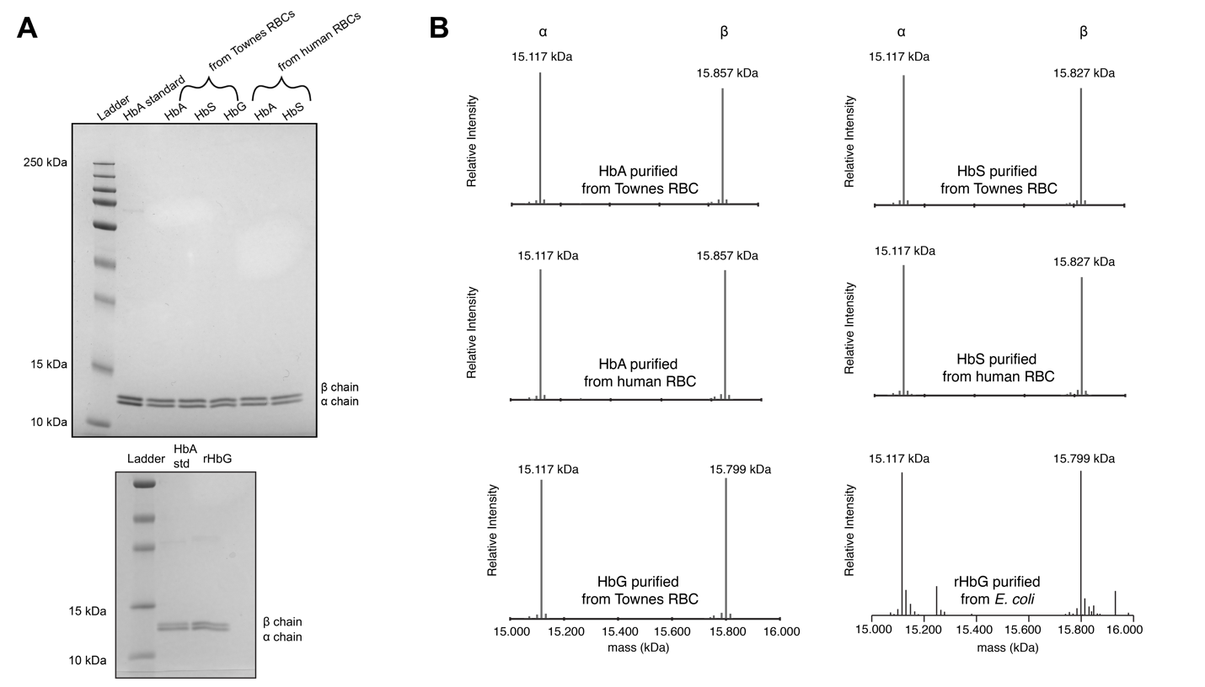
Figure S 1 SDS-PAGE and MS analysis of purified hemoglobins used in this study.
(A) SDS-PAGE analysis of purified HbA, HbG, HbS isolated from human blood and Townes mice blood (top) and recombinant HbG purified from Escherichia coli (bottom). The presence of a doublet band in the 10-15 kDa range implies the successful isolation of hemoglobin tetramers. (B) MS analysis of purified hemoglobin proteins. For all isolated hemoglobins only two peaks corresponding to the α chain (15.117 kDa) and β chain (WT 15.857 kDa, sickle 15.827 kDa, makassar 15.799 kDa) are apparent. The lack of other peaks in the MS range for the β chain suggests successful isolation of homogenous hemoglobins.

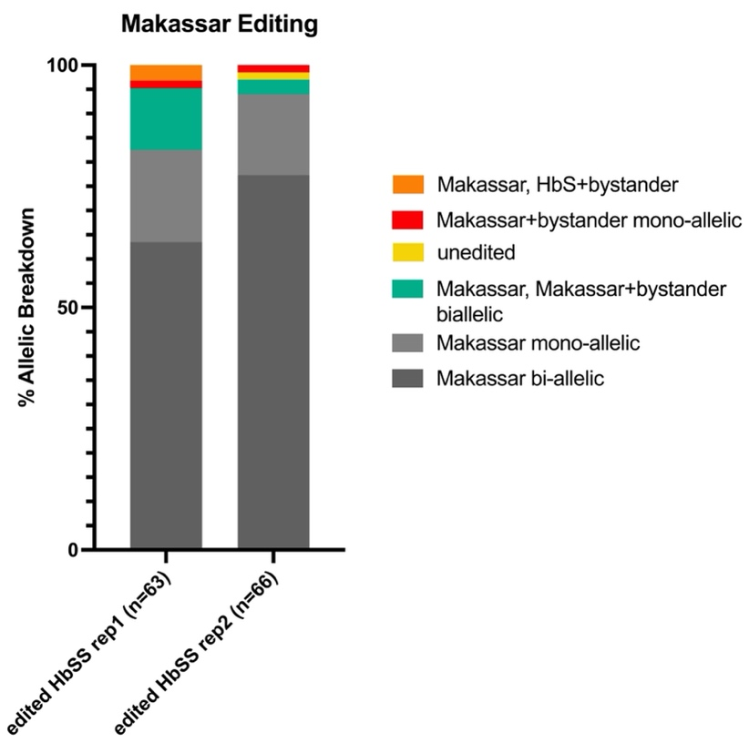

Figure S2 Allelic editing outcomes in BFU-E colonies of HbSS CD34+ base edited cells
- Allelic breakdown of editing outcomes from edited samples from single BFU-E colonies derived from editing of non-mobilized HbSS CD34+s from Figure 7. Makassar editing was determined via NGS from two replicates of n=63 and n=66 colonies from cultures that exhibited >80% editing of HbG in bulk cultures. Colonies that had editing rates that were not consistent with isolation of cells from a single colony were excluded from the final allelic editing outcome analysis.

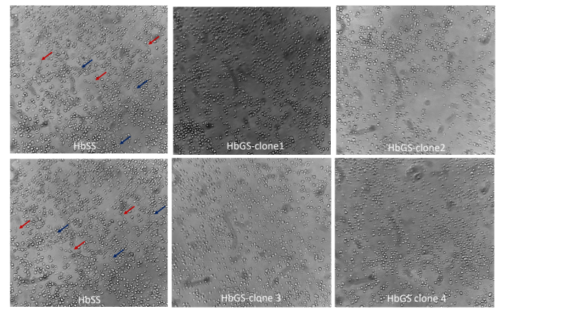
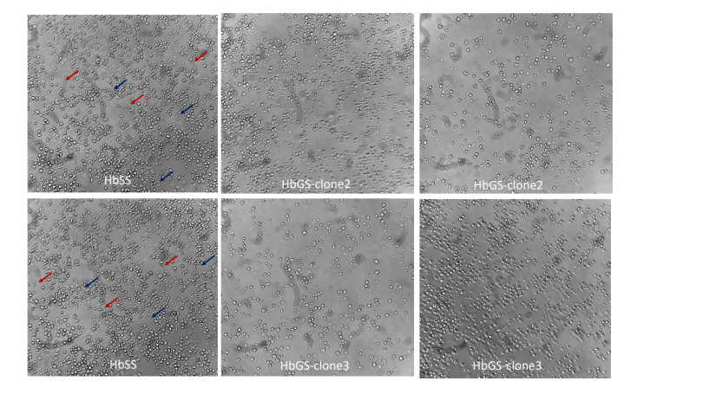
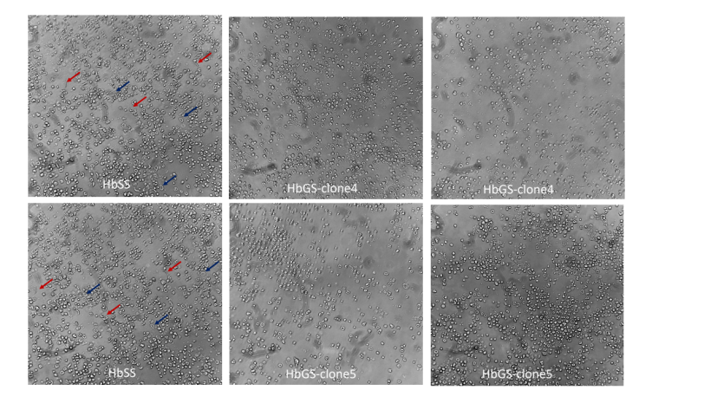
Figure S3 Additional images of single edited HbSS CD34+ derived IVED clones of HbSS, HbGG and HbGS genotypes exposed to hypoxia (related to Figure 7)
Additional images of single IVED clones subjected to hypoxic conditions of (2% O2) at 37ºC for 96 hours. Single clones were isolated from same donor used in Figure 7. Representative HbSS (unedited) images are re-used for each panel for comparison’s sake. Three representative examples of sickled cells indicated with red arrows, blue arrows representative of non-sickled red blood cells shown for unedited sample only.
Supplementary Materials and Methods:
Makassar Mouse model
Guides used for generation of the Makassar allele were as follows:
HBB_crRNA1: CATGGTGCAcCTGACTCCTG and
HBB_crRNA2: GTAACGGCAGACTTCTCCTC.
Donor oligos for crRNA1 and cRNA2 were as follows:
HBB_oligodonor1: GTAACCTTGATACCAACCTGCCCAGGGCCTCACCACCAACTTCATCCACGTTCACCTTGCCCCACAGGGCAGTAACGGCAGACTTCTCCgCgGGAGTCAGaTGCACCATGGTGTCTGTTTGAGGTTG
HBB_oligo donor2:
GGCAGAGCCATCTATTGCTTACATTTGCTTCTGACACAACTGTGTTCACTAGCAACCTCAAACAGACACCATGGTGCACCTGACTCCcGcGGAGAAGTCcGCCGTTACTGCCCTGTGGGGCAAGGTG.
Genotyping primers:
HBB_ genoF1CCAGAAGAGCCAAGGACAGG
HBB_ genoF2CAACTCCTAAGCCAGTGCCA
HBB_ genoR1AGCCTTCACCTTAGGGTTGC
HBB_ genoR2TTGAGGTTGTCCAGGTGAGC

O₂ binding measurements of purified hemoglobin variants. Oxygen equilibrium curves were measured for each purified hemoglobin variant using a HEMOX analyzer (TCS Scientific Corp.) per manufacturer’s recommendations. Each deoxy/oxy cycle was repeated three times. To reduce methemoglobin formation during data acquisition, samples were supplemented with the Hayashi enzymatic reduction system¹. Oxygen equilibration curves were analyzed using the HEMOX analyzer data software yielding p₅₀ values (partial pressure of oxygen at which hemoglobin is half-saturated) and n₅₀ (Hill coefficient).
Polymerization kinetics. Polymerization assays were performed as previously described². Briefly, 100 μL of sample at various concentrations (2, 1.5, 1.0, 0.5 mg/mL) in polymerization buffer (1.8 M potassium phosphate buffer, 5 mg/mL sodium dithionite) was dispensed on a pre-chilled 96 well plate. The plate was then loaded onto an Omega Spectrostar plate reader coupled with an atmospheric-controlled unit where hypoxic conditions (< 1% oxygen) were kept by flushing the instrument with nitrogen gas. Polymerization delay times were measured by monitoring the optical density of the samples at 37 °C and at a 700 nm wavelength as a function of time. Data was acquired for 1000 seconds. Polymerization of hemoglobin mixtures was performed as described above with slight modifications. HbAS and HbGS mixtures of hemoglobins were made at a constant 2 mg/mL total hemoglobin with HbS ratios of 0%, 25%, 50%, 75%, and 100%. Mixtures were made in polymerization buffer and polymerization delay times were measured as described above.
Intact mass measurement of hemoglobin variants by LC-MS. The intact mass and sequence identification of purified hemoglobin proteins were determined by Liquid Chromatography-Mass Spectrometry to verify its molecular identity. Purified proteins were diluted to 0.5 mg/mL and analyzed on a UHPLC system with a binary pump equipped with a 2.1 x 150 mm C18 column. Mobile phase A was 0.1% v trifluoroacetic acid (TFA) in water, and mobile phase B was 0.08% v TFA in acetonitrile, with a flow rate of 0.25 mL/min. Mass detection was performed with an in-line Q Exactive HF mass spectrometer (Thermo Fisher Scientific) acquiring intact mass data in the range from 500 to 2000 Da.

.
References
- Hayashi A, Suzuki T, Shin. An enzymic reduction system for metmyoglobin and methemoglobin, and its application to functional studies of oxygen carriers. Biochim Biophys Acta. 1973;310(2):309-16.
- Adachi K, Asakura T. Nucleation-controlled aggregation of deoxyhemoglobin S. Possible difference in the size of nuclei in different phosphate concentrations. J Biol Chem. 1979;254(16):7765-71

