Extended Data Fig. 1
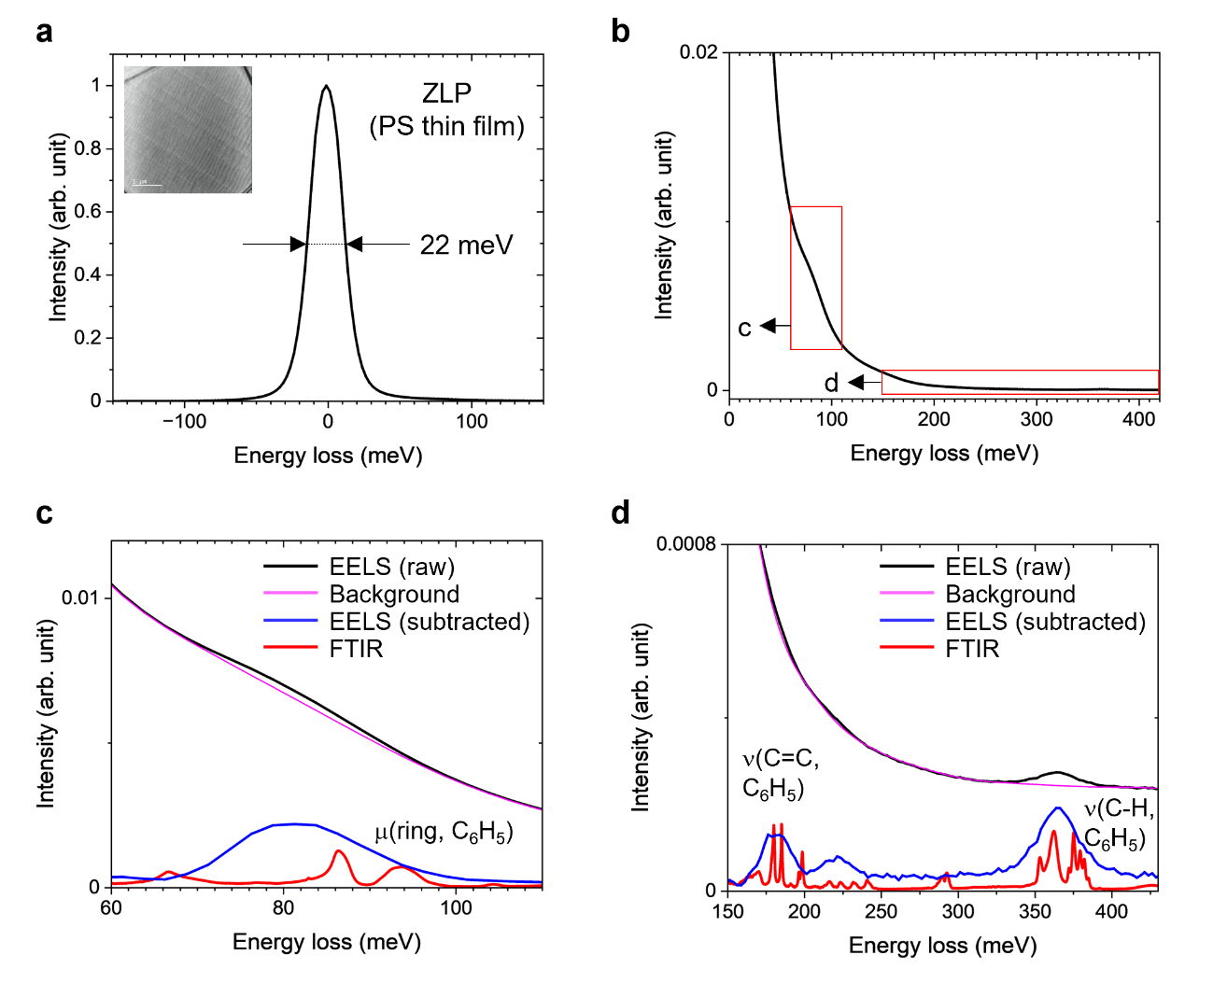
Extended Data Fig. 1| Bright-field vibrational spectroscopy of hPS compared to FTIR spectroscopy.
a,b, Quasi-elastic scattering peak and energy loss in the IR region obtained from the hPS thin film via BF-EELS. c,d, Enlargements of the spectral regions demarcated in red in (b). The signal spectrum (blue curve) is obtained by extracting the background (pink curve) from the raw spectrum (black curve). The power-law background model is applicable to energy loss higher than 300 meV. However, energy loss lower than 300 meV is barely extracted by a single power-law function, owing to the tail of the quasi-elastic scattering peak. The signal below 300 meV is derived by extracting the background interpolated using a spline curve.
Extended Data Fig. 2
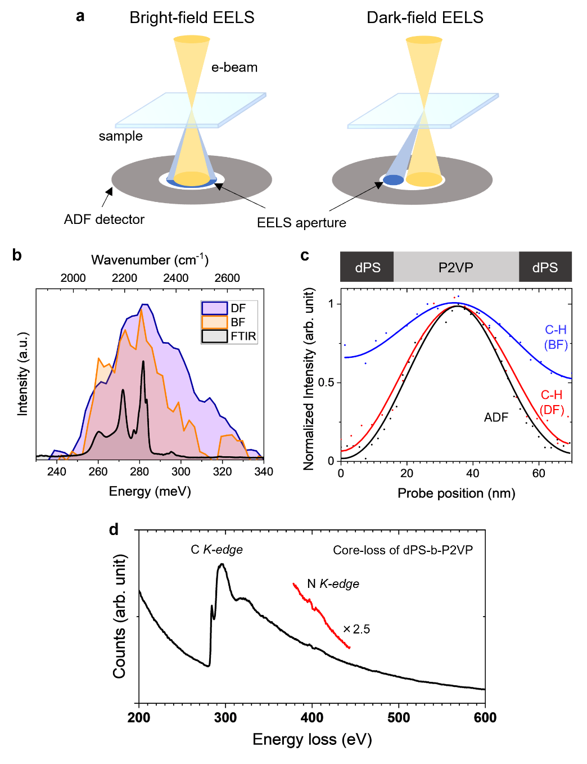
Extended Data Fig. 2| Comparison between BF- and DF-EELS for molecular vibrational spectroscopy.
a, Electron beam geometry of BF- (left) and DF-EELS (right). b, Vibrational spectra of the C–D stretches in dPS. BF- (orange) and DF- (purple) EEL spectra compared with the FTIR spectrum (black) of the same specimen. Because the specimen was not crystalline, the vibrational modes had no dispersion relationship. Therefore, the DF-EELS may reflect the optically forbidden vibrational modes that are inactive in the BF-EELS. c, Comparison of signal delocalisation between BF- and DF- EELS of the dPS-b-P2VP lamellar structure. The CCD counts of the C–H signals on the P2VP domain are normalised, whereas the ADF-STEM intensity is min-max normalised. BF-EELS detects more than 50% of the C–H signal of the P2VP domain even on the dPS domains. d, Core-loss spectrum of the dPS-b-P2VP specimen acquired in the bright field shown in Fig. 2.

Extended Data Fig. 3
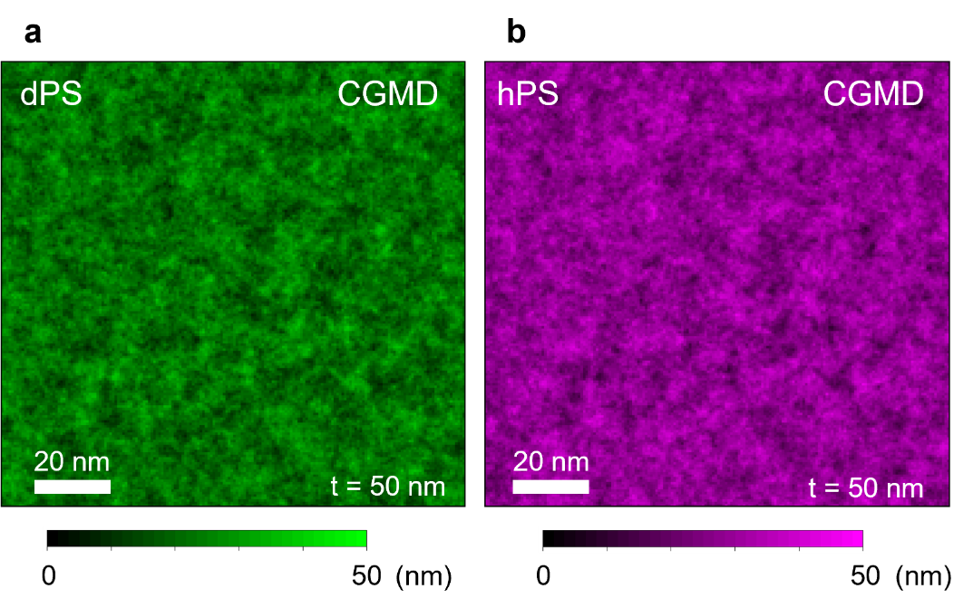

Extended Data Fig. 3| CGMD-simulated density distributions of dPS and hPS in a quenched melt of the dPS-b-hPS BCP.
a,b, Density profiles of dPS and hPS in a 50-nm-thick film simulated via the CGMD, where their contrasts indicate the thicknesses of the dPS and hPS components, respectively.

Extended Data Fig. 4
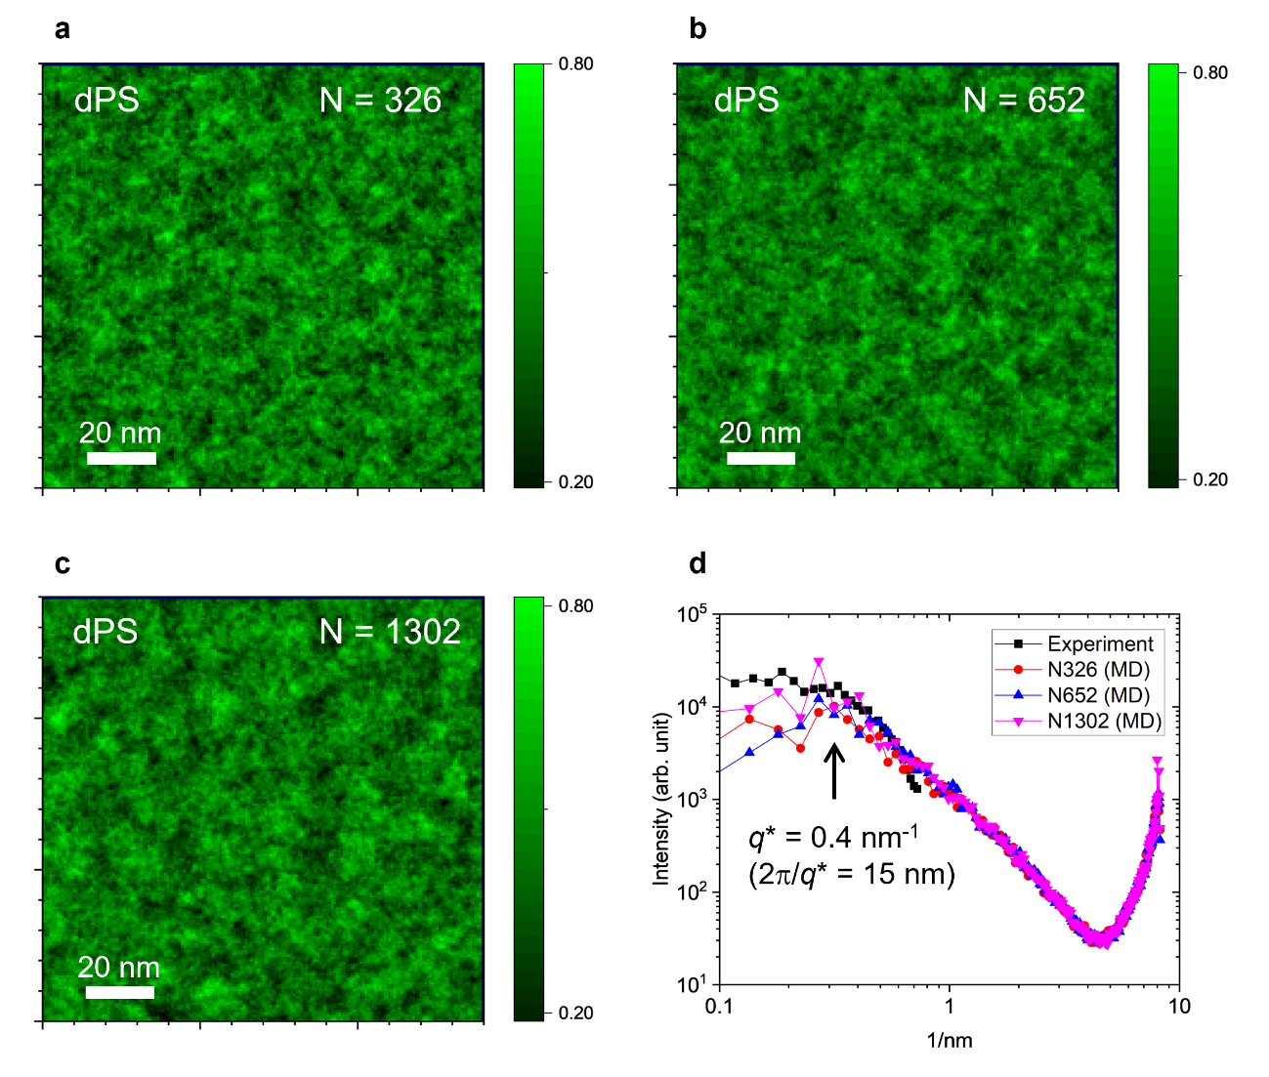
Extended Data Fig. 4| CGMD-simulated density distributions of dPS in a quenched melt of the dPS-b-hPS BCP for different chain length.
a-c, Density profiles of dPS in a 50-nm-thick film simulated via the CGMD for N = 326 (half-length), N = 651 (full-length) and N = 1302 (double-length), respectively. d, Fourier spectrum of the simulated density profiles of dPS for each chain length as well as that of the experiment obtained from Fig. 4f. The peak top position (q* = 0.4 nm^{-l}) is almost consistent with all the calculated chain lengths and the experimental result. The size obtained from this peak (2π/q* ~ 15 nm) corresponds to double the diameter of the reptation tube.

Extended Data Fig. 5
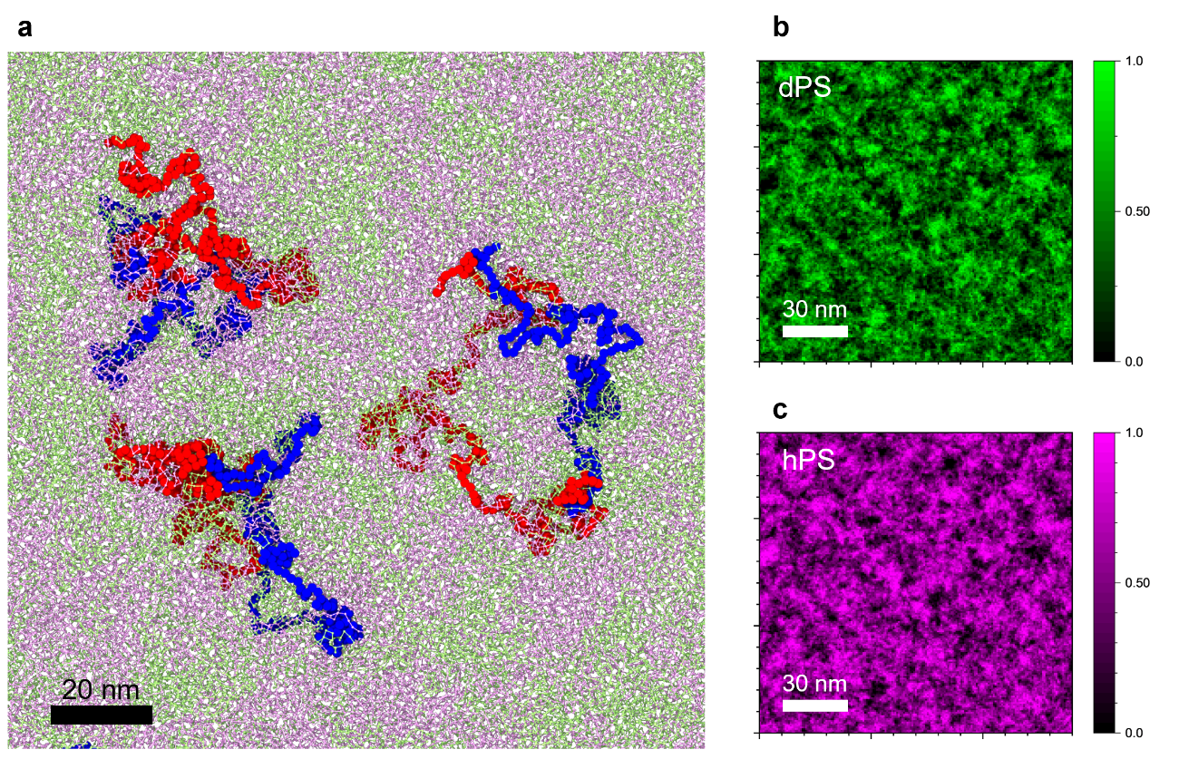

Extended Data Fig. 5| CGMD-simulated tube structures in a melt of the dPS-b-hPS BCP.
a, Melt structure of the dPS-b-hPS BCP confined to a thin film (Thickness: 7.6 nm) (left panel). 450 dPS-b-hPS chains are packed in a region of approximately 185σ × 185σ × 10σ, maintaining a density of 0.85. The rough appearance of the reptation tubes of the polymer chains (shown in red and blue) are visualised. As presented in ref. 39, superimposition of the successive snapshots would be expected to more clearly show the reptation tubes. b, c, Density profiles of dPS and hPS in the 7.6-nm-thick film.

Extended Data Fig. 6
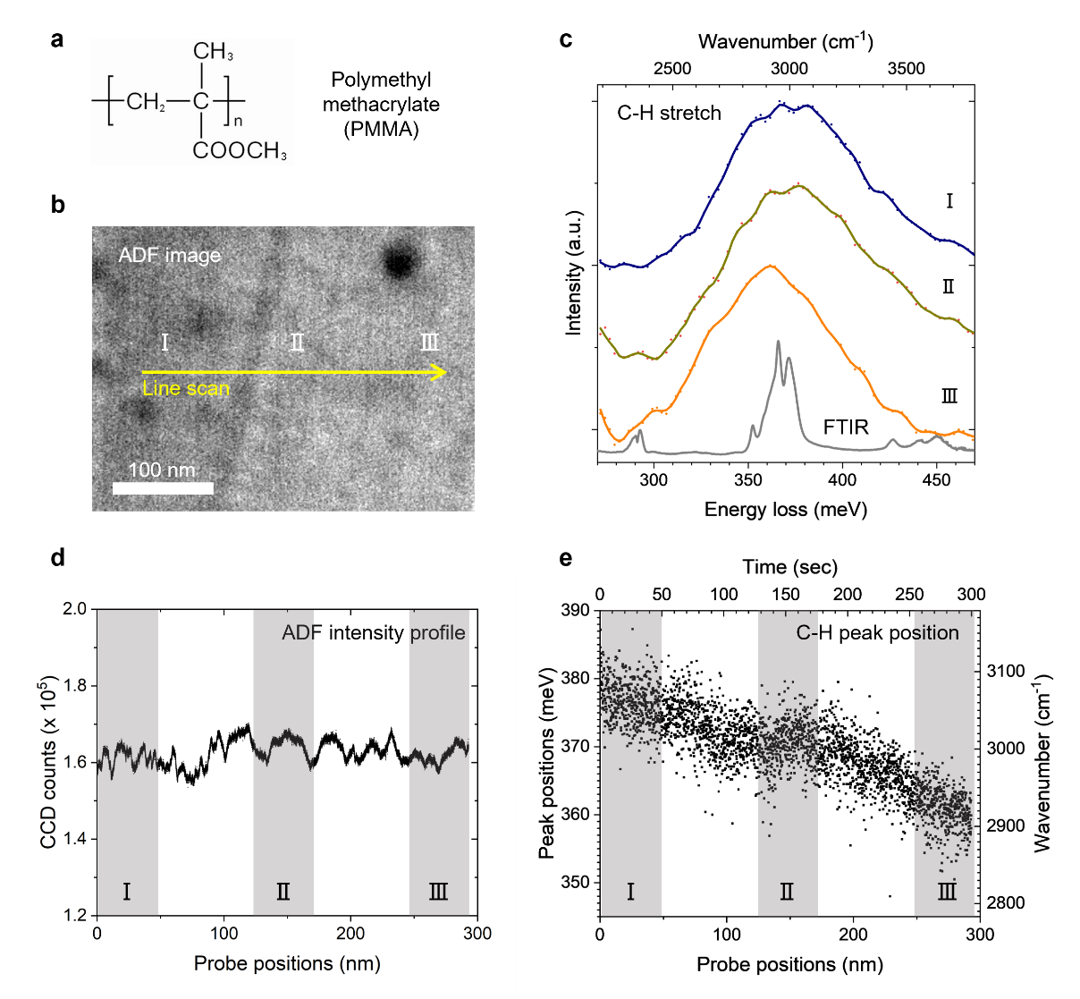

Extended Data Fig. 6| Variation in C-H stretching peak induced by electron beam damage to PMMA.
a, Chemical structure of PMMA. b, STEM-ADF images of spin-coated PMMA thin films. c, Dark-field vibrational spectra of PMMA extracted from the 1D spectral image along the yellow line in (b). The FTIR spectrum of PMMA is in grey. d, ADF intensity profile during line scan. e, Variation in the C–H peak position during the line scan, with redshift of almost 20 meV. The peak positions in (e) are extracted from Gaussian fitting.

