Supplementary Materials
Figure S1. IgG anti-S after 2 doses of BNT152b2 according to the time after vaccination. IgG antibodies were measured according to the time when the sample was collected after completing the primary schedule. IgG titers were higher on participants measured on days 4 to 9 after the second dose of vaccine, compared to those on days 49 to 44 after the vaccine.
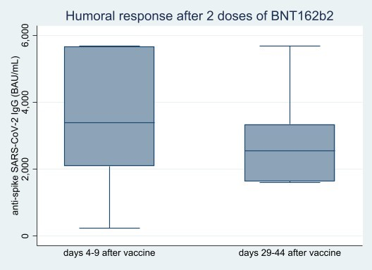

Table S4. Timing details regarding vaccine administration and SARS-CoV-2 infection relative to the sampling schedule
- Immunity to SARS-CoV-2
Sampling time by group | Days  Mean ±SD | Days  Median (IQR)
Infection induced immunity
0-7 days | 1,6 ± 2,8 | 0 (0-5)
8-21 days | 14,4 ±3,8 | 15 (11-17,5)
22-90 days | 52,7 ± 22,8 | 51,5 (30,5-74,5)
91-180 days | 129,6 ± 21,4 | 127,5 (113-148)
181-283 days | 234,5 ± 31,6 | 229 (206-266)
Vaccine-induced immunity (2BNT216b2)
Time after 2nd dose | 8,4 ± 8,3 | 7 (6-8)
Hybrid immunity (Infection + 2BNT216b2)
Time after infection | 156,5 ± 69,3 | 150 (118-221)
Time after 2nd dose | 9,5 ± 7,4 | - (6-7)

- 2BNT162b2+1mRNA-1273
A. Sampling time
Sampling time | Days  Mean ±SD | Days  Median (IQR)
Baseline (2BNT216b2) | 10,9 ± 11,3 | 7 (6-7,5)
3-4 months after 2BNT162b2+1mRNA-1273 | 115,0 ± 9,8 | 116 (114-119)
6-7 months after 2BNT162b2+1mRNA-1273 | 218,9 ± 15,9 | 219,7 (218-227)
9-10 months after 2BNT162b2+1mRNA-1273 | 306,1 ± 15,7 | - 96-321)

B. Vaccination schedules
Vaccination schedules | Days  Mean ±SD | Days  Median (IQR)
Time between 1 and 2 doses of 2BNT216b2 | 21,8 ± 5,1 | 21 (20-21)
Time between 2nd dose of BNT216b2 and 1st booster of mRNA-1273 | 267,0 ± 8,7 | 264 (263,5-265,0)

Figure S5. CD4+, CD8+ T-cell responses in participants after the mRNA-1273 booster upon different stimulus (S1, SNMO, S2N peptide pools) according to previous SARS-CoV-2 infection. CD4⁺ IFN-γ, IL-2, and IL-4 and CD8+ IFN-γ, IL-2, IL-4, and Granzyme B (GrB) cells were measured in participants with a BNT162b2 after a mRNA-1273 booster after stimulation with three peptide pools (S1, SNMO, and S2N), each according to previous COVID-19 infection. Statistical significance was measured using the Mann Whitney U test, at a significance level of 5%.

