Table S1. Wilcoxon rank sum testing results of significantly different genera from CLR transformed 16S rRNA amplicon sequencing data in relation to the incidence of anastomotic leak.
Genus | BH FDR P-value
Megasphaera | 0.0003
Lachnospira | 0.0004
Campylobacter | 0.0032
Mogibacterium | 0.0059
Gemella | 0.0063
[Eubacterium] xylanophilum group | 0.0069
Atopobium | 0.0109
Acidaminococcus | 0.0113
Lactococcus | 0.0123
Porphyromonas | 0.0144
TM7x | 0.0154
Coriobacteriaceae UCG 002 | 0.0155
Streptococcus | 0.0173
Colidextribacter | 0.0177
Pseudoflavonifractor | 0.0218
Acetanaerobacterium | 0.0223
Merdibacter | 0.0228
Candidatus Stoquefichus | 0.0232
Coprobacillus | 0.0251
Bifidobacterium | 0.0309
Anaeroplasma | 0.0330
UCG.007 | 0.0330
Mobiluncus | 0.0333
Comamonas | 0.0343
Jonquetella | 0.0343
Lawsonella | 0.0355
Candidatus Soleaferrea | 0.0373
Butyrivibrio | 0.0386
GCA 900066755 | 0.0392
Sediminibacterium | 0.0399
Lelliottia | 0.0399
Fusobacterium | 0.0425
Ileibacterium | 0.0427
Hungatella | 0.0429
Candidatus Saccharimonas | 0.0431
Meiothermus | 0.0432
Caldicoprobacter | 0.0432
Sutterella | 0.0440
Varibaculum | 0.0452
Aeromonas | 0.0463
Eikenella | 0.0471
Coriobacteriaceae UCG 003 | 0.0480
Johnsonella | 0.0490

Table S2. Significantly different PICRUSt2 MetaCyc pathways predicted by Wilcoxon rank sum testing from CLR transformed 16S rRNA amplicon sequencing data in relation to the incidence of anastomotic leak.
MetaCyc pathway | BH FDR P-value
Superpathway of geranylgeranyldiphosphate biosynthesis I (via mevalonate) | 0.003
Mevalonate pathway I (eukaryotes and bacteria) | 0.003
Chimeric Pathway: superpathway of taurine degradation | 0.005
Palmitate biosynthesis II (type II fatty acid synthase) | 0.021
Lactose and galactose degradation I | 0.032
Pyridoxal 5'-phosphate biosynthesis I | 0.033
L-lysine fermentation to acetate and butanoate | 0.033
Peptidoglycan biosynthesis V (β-lactam resistance) | 0.039
dTDP-N-acetylthomosamine biosynthesis | 0.040
Superpathway of pyridoxal 5'-phosphate biosynthesis and salvage | 0.046

Table S3. Patient characteristics for those selected for MGS. ASA: American Society of Anaesthesiologists score, BMI: Body mass index, CR: colo-rectal, AL: anastomotic leak
 | No Leak (n=8) | Leak (n=8) | P-value
Sex (M/F) | 6\2 | 5\3 | 0.999
Age (median) | 67 | 71 | 0.662
ASA | 2 | 2 | 0.7172
BMI | 25 | 29 | 0.3124
Resection type
CR | 8 | 8 | 1
Bowel preps
Mechanical | 2 | 1 | 0.529
Fleet | 6 | 7 | 0.529
Indication for surgery
Colorectal cancer | 6 | 4 | 0.999
Diverticular Disease | 1 | 2 | 0.714
Other | 1 | 2 | 0.309
Risk Factors for AL
Radiotherapy | 1 | 0 | 1
Chemotherapy | 0 | 1 | 1
Other Immunosuppression therapy | 1 | 2 | 0.999
Smoking history
Non-smoker | 3 | 3 | 0.861
Ex-smoker | 3 | 3 | 0.999
Current smoker | 2 | 2 | 0.585

Table S4. Significantly different genera predicted by Wilcoxon rank sum from CLR transformed MGS matched 16S rRNA amplicon sequencing data in relation to the incidence of anastomotic leak.
Genus | BH FDR  P-value
Intestinimonas | 0.0009
Adlercreutzia | 0.0022
[Eubacterium] xylanophilum group | 0.0022
Haemophilus | 0.0025
Senegalimassilia | 0.0051
Butyricimonas | 0.0051
Colidextribacter | 0.0084
Solobacterium | 0.0151
Anaerostipes | 0.0189
CAG.56 | 0.0189
Dielma | 0.0256
Lachnospira | 0.0260
Bacteroides | 0.0288
Coprococcus | 0.0387
Oscillibacter | 0.0426
[Eubacterium] siraeum group | 0.0426
Gemella | 0.0468

Table S5. Significantly different species predicted by Wilcoxon rank sum testing from CLR transformed MGA data in relation to the incidence of anastomotic leak.
Species | BH FDR  P-value
Lawsonibacter asaccharolyticus | 0.0001
Haemophilus sp HMSC71H05 | 0.0002
Coprobacillus cateniformis | 0.0017
Coprococcus eutactus | 0.0021
Bacteroides sp CAG 633 | 0.0030
Bacteroides coprophilus | 0.0035
Prevotella sp CAG 279 | 0.0035
Parabacteroides sp CAG 409 | 0.0035
Parasutterella excrementihominis | 0.0049
Haemophilus parainfluenzae | 0.0049
Bacteroides clarus | 0.0058
Bacteroides sp 43 108 | 0.0058
Alistipes sp CHKCI003 | 0.0058
Lactobacillus delbrueckii | 0.0058
Pediococcus pentosaceus | 0.0058
Streptococcus anginosus group | 0.0058
Streptococcus australis | 0.0058
Streptococcus sp A12 | 0.0058
Clostridium sp CAG 242 | 0.0058
Butyrivibrio crossotus | 0.0058
Klebsiella variicola | 0.0058
Hafnia paralvei | 0.0058
Blastocystis sp subtype 1 | 0.0058
Gemella sanguinis | 0.0067
Streptococcus mitis | 0.0067
Butyricicoccus pullicaecorum | 0.0067
Peptostreptococcus stomatis | 0.0067
Citrobacter portucalensis | 0.0067
Citrobacter youngae | 0.0067
Giardia intestinalis | 0.0067
Fusobacterium gonidiaformans | 0.0079
Lactobacillus paragasseri | 0.0091
Streptococcus vestibularis | 0.0091
Citrobacter amalonaticus | 0.0091
Actinotignum timonense | 0.0106
Actinomyces turicensis | 0.0122
Atopobium minutum | 0.0122
Porphyromonas uenonis | 0.0122
Gemella asaccharolytica | 0.0122
Tyzzerella nexilis | 0.0122
Clostridioides difficile | 0.0122
Anaerococcus vaginalis | 0.0122
Peptoniphilus coxii | 0.0122
Enhydrobacter aerosaccus | 0.0122
Campylobacter ureolyticus | 0.0122
Moraxella osloensis | 0.0122
Phascolarctobacterium succinatutens | 0.0186
Veillonella parvula | 0.0186
Actinomyces radingae | 0.0212
Asaccharobacter celatus | 0.0212
Citrobacter koseri | 0.0212
Alistipes shahii | 0.0241
Enterococcus faecalis | 0.0241
Clostridium sp CAG 58 | 0.0274
Eubacterium siraeum | 0.0274
Ruminococcus obeum CAG 39 | 0.0274
Parabacteroides johnsonii | 0.0310
Streptococcus sanguinis | 0.0310
Ruminococcus bicirculans | 0.0310
Bifidobacterium dentium | 0.0350
Bacteroides galacturonicus | 0.0350
Sanguibacteroides justesenii | 0.0350
Lactobacillus fermentum | 0.0350
Streptococcus infantis | 0.0350
Clostridium paraputrificum | 0.0350
Blautia hansenii | 0.0350
Clostridium hylemonae | 0.0350
Dielma fastidiosa | 0.0350
Bacteroides faecis CAG 32 | 0.0395
Paraprevotella clara | 0.0395
Gemella morbillorum | 0.0395
Streptococcus gordonii | 0.0395
Streptococcus mutans | 0.0395
Clostridium sp chh4 2 | 0.0444
Micrococcus luteus | 0.0497
Collinsella intestinalis | 0.0497
Parabacteroides merdae | 0.0497
Clostridium sp CAG 299 | 0.0497
Eubacterium dolichum CAG 375 | 0.0497
Absiella dolichum | 0.0497

Table S6. Significantly different MetaCyc pathways predicted by Wilcoxon rank sum testing from CLR transformed MGS data in relation to the incidence of anastomotic leak.
MetaCyc pathways | BH FDR  P-value
THREOCAT PWY-superpathway of L threonine metabolism | 0.0003
PWY 5005-biotin biosynthesis II | 0.0017
X3 HYDROXYPHENYLACETATE DEGRADATION PWY-4 hydroxyphenylacetate degradation | 0.0025
KDO NAGLIPASYN PWY-superpathway of-Kdo 2 lipid A biosynthesis | 0.0030
P124 PWY-Bifidobacterium shunt | 0.0049
PWY 5981-CDP diacylglycerol biosynthesis III | 0.0058
PWY0 1277-3 phenylpropanoate and 3-3 hydroxyphenyl propanoate degradation | 0.0058
PWY 7254-TCA cycle VII-acetate producers | 0.0091
GOLPDLCAT PWY-superpathway of glycerol degradation to 1 3 propanediol | 0.0106
PWY 5747-2 methylcitrate cycle II | 0.0106
PWY 7446-sulfoquinovose degradation I | 0.0106
PWY 6328-L lysine degradation X | 0.0141
HCAMHPDEG PWY-3 phenylpropanoate and 3-3 hydroxyphenyl propanoate degradation to 2 hydroxypentadienoate | 0.0162
PWY 6690-cinnamate and 3 hydroxycinnamate degradation to 2 hydroxypentadienoate | 0.0162
PWY 5855-ubiquinol 7 biosynthesis-early decarboxylation | 0.0274
PWY 8086- S-lactate fermentation to propanoate-acetate and hydrogen | 0.0274
PWY0 1221-putrescine degradation II | 0.0274
PWY 6608-guanosine nucleotides degradation III | 0.0310
PWY 6961-L ascorbate degradation II-bacterial-aerobic | 0.0310
PWY 6807-xyloglucan degradation II-exoglucanase | 0.0350
PWY 8187-L arginine degradation XIII-reductive Stickland reaction | 0.0350
P461 PWY-hexitol fermentation to lactate-formate-ethanol and acetate | 0.0395
PWY0 1338-polymyxin resistance | 0.0395
PWY 7200-superpathway of pyrimidine deoxyribonucleoside salvage | 0.0444
PWY 8190-L glutamate degradation XI-reductive Stickland reaction | 0.0444
CARNMET PWY-L carnitine degradation I | 0.0497
METHGLYUT PWY-superpathway of methylglyoxal degradation | 0.0497
PWY 6071-superpathway of phenylethylamine degradation | 0.0497
PWY0 321-phenylacetate degradation I-aerobic | 0.0497
UDPNAGSYN PWY-UDP N acetyl D glucosamine biosynthesis I | 0.0497
Table S7. Number of mice across anastomosis procedures with end points at either 3- or 7-days post-surgery. The number of mice experiencing an anastomotic leak across groups is also listed.
Model | Mice | Anastomotic leaks
Intraoperative collection
 | 20 | 2
End point
3 days post-surgery | 10 | 1
7 days post-surgery | 10 | 1

Table S8. Significantly different PICRUSt2 MetaCyc pathways predicted by Wilcoxon rank sum testing from CLR transformed 16S rRNA amplicon sequencing data in relation to the incidence of anastomotic leak in murine anastomosis model within collected intra-operative tissue samples (proximal and distal combined).
MATCH TO PATIENT FINDINGS | Metacyc pathway | P-value
MGS- Rank sum | KDO-NAGLIPASYN-PWY: superpathway of (Kdo)2-lipid A biosynthesis | 0.003287
 | PWY-4361: S-methyl-5-thio-α-D-ribose 1-phosphate degradation I | 0.004659
 | PWY-7255: ergothioneine biosynthesis I (bacteria) | 0.004659
 | PWY-7527: L-methionine salvage cycle III | 0.004659
MGS-Relative abundance | P261-PWY: coenzyme M biosynthesis I | 0.006469
 | PWY-592: superpathway of heme b biosynthesis from glycine | 0.009575
 | PWY-5022: 4-aminobutanoate degradation V | 0.010449
 | AST-PWY: L-arginine degradation II (AST pathway) | 0.020706
 | PWY0-42: 2-methylcitrate cycle I | 0.02366
 | ENTBACSYN-PWY: enterobactin biosynthesis | 0.023669
MGS-Relative abundance | METH-ACETATE-PWY: methanogenesis from acetate | 0.02436
MGS- Rank sum | PWY-5747: 2-methylcitrate cycle II | 0.025169
 | SALVADEHYPOX-PWY: adenosine nucleotides degradation II | 0.026406
 | UBISYN-PWY: superpathway of ubiquinol-8 biosynthesis (early decarboxylation) | 0.026556
 | PPGPPMET-PWY: ppGpp metabolism | 0.028644
MGS- Rank sum | PWY-5855: ubiquinol-7 biosynthesis (early decarboxylation) | 0.028915
 | PWY-5856: ubiquinol-9 biosynthesis (early decarboxylation) | 0.028915
 | PWY-5857: ubiquinol-10 biosynthesis (early decarboxylation) | 0.028915
 | PWY-6708: ubiquinol-8 biosynthesis (early decarboxylation) | 0.028915
 | P562-PWY: myo-inositol degradation I | 0.031642
MGS- Rank sum | PWY-6608: guanosine nucleotides degradation III | 0.032678
 | P281-PWY: 3-phenylpropanoate degradation | 0.034853
 | PWY-7377: cob(II)yrinate a,c-diamide biosynthesis I (early cobalt insertion) | 0.036396
 | PWY-6353: purine nucleotides degradation II (aerobic) | 0.038098
 | 0D-BIOSYNTHESIS-II | 0.038597
 | CENTFERM-PWY: pyruvate fermentation to butanoate | 0.0414
 | PWY-6590: superpathway of Clostridium acetobutylicum acidogenic fermentation | 0.0414
 | PWY-6478: GDP-D-glycero-α-D-manno-heptose biosynthesis | 0.044617
 | HEME-BIOSYNTHESIS-II: heme b biosynthesis I (aerobic) | 0.046369
 | GLYOXYLATE-BYPASS: glyoxylate cycle | 0.048131
 | P105-PWY: TCA cycle IV (2-oxoglutarate decarboxylase) | 0.048131

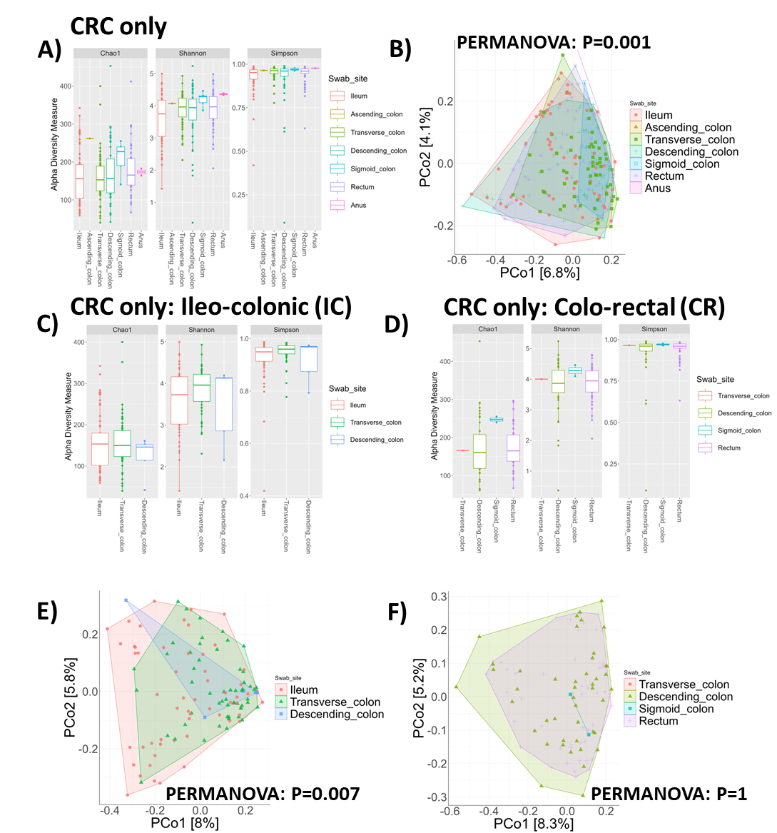
Figure S1. Excluding samples from patients given oral antibiotics, those that experienced an anastomotic leak, and only including patients which presented with colorectal cancer (CRC) for resection. A) Alpha diversity represented as Chao1, Shannon and Simpson and B) principal coordinates analysis (PCoA) for sample sites ileum (n=59 samples), ascending colon (n=1), transverse colon (n=58), descending colon (n=52), sigmoid colon (n=5), rectum (n=50), and anus (n=2). C) Alpha diversity represented as Chao1, Shannon and Simpson for ileo-colonic resection sub-type and divided by sampling site: ileum (n=57), transverse colon (n=52), and descending colon (n=5) and D) Colo-rectal resection sub-type by sample site transverse colon (n=1), descending colon (n=44), sigmoid colon (n=2), and rectum (n=47). E) PCoA for ileo-colonic resection sub-type and F) colo-rectal resection sub-type. Alpha diversity was analysed for significant difference through Wilcoxon test and beta diversity significance assessed by PERMANOVA P-values <0.05 were considered significant. Error bars represent standard deviation.

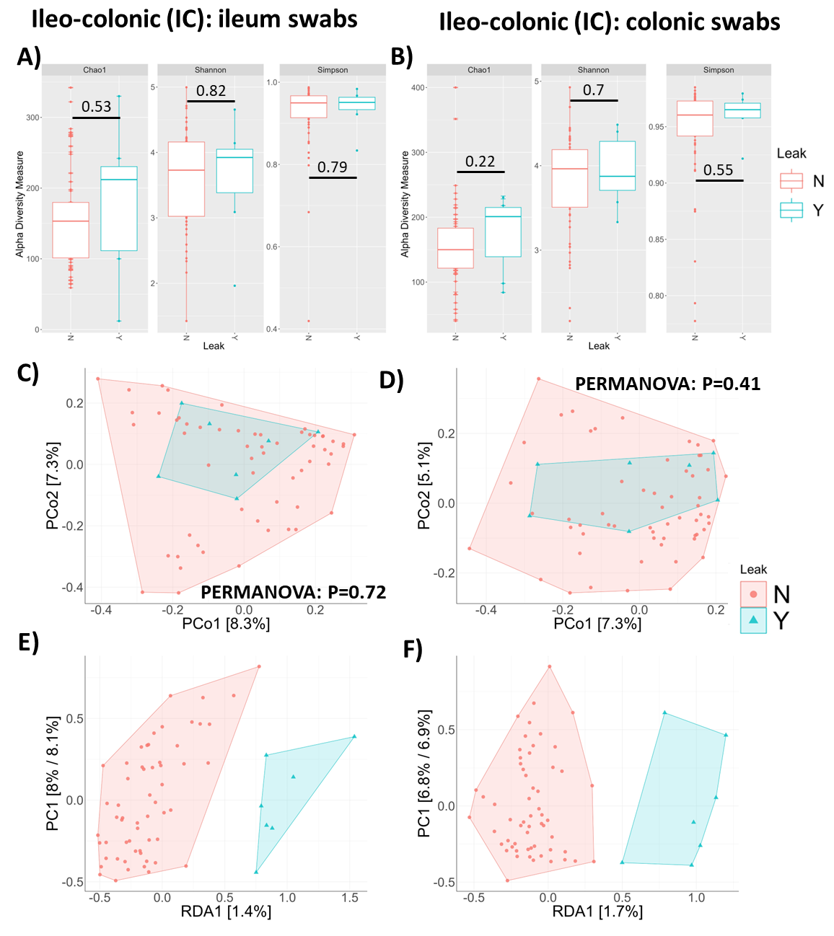
Figure S2. Investigation of the effect of anastomosis leak status (no leak = red; leak = blue) including only colorectal cancer patients and excluding samples from patients given oral antibiotics. Alpha diversity represented as Chao1, Shannon and Simpson for A) ileum proximal swabs (ileum; n=9/73 leaks) and B) colonic swabs (transverse and descending colon; n=7/64 leaks) from ileo-colonic resection types. Beta diversity was investigated with principal coordinates analysis (PCoA) C) ileum swabs and D) colonic swabs from ileo-colonic resection types. Redundancy analysis (RDA) for E) ileum swabs and F) colonic swabs from ileo-colonic resection types. Alpha diversity was analysed for significant difference through Wilcoxon test and beta diversity significance assessed by PERMANOVA P-values <0.05 were considered significant. Error bars represent standard deviation.

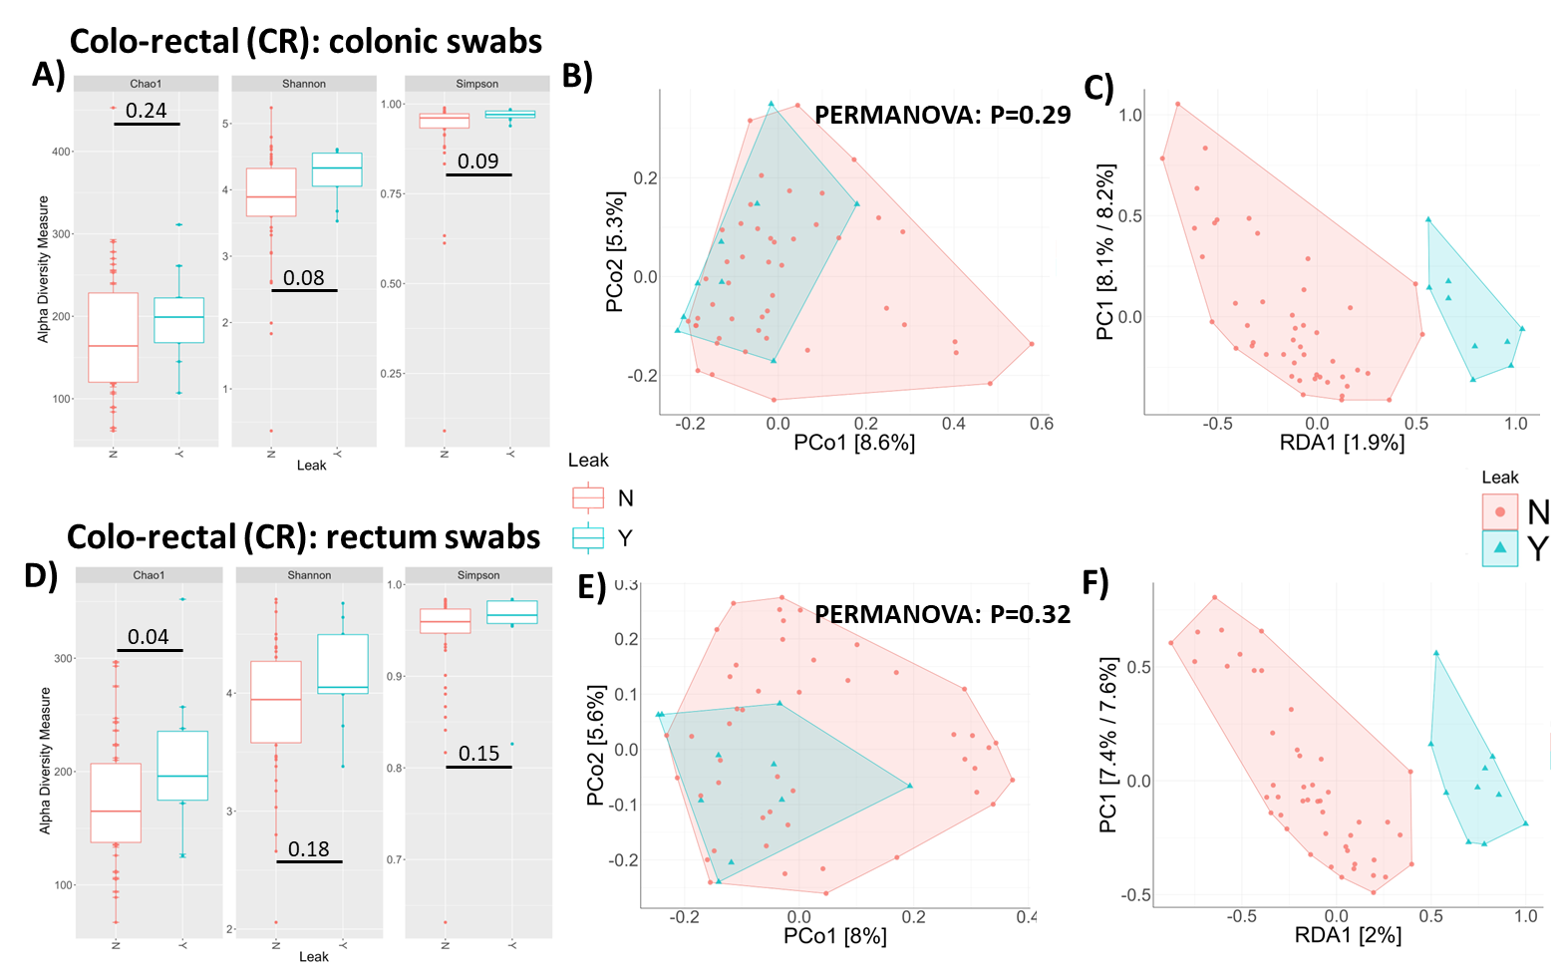
Figure S3. Investigation of the effect of anastomosis leak status for colo-rectal swab sites (no leak = red; leak = blue) including only colorectal cancer patients and excluding samples from patients given oral antibiotics. Colonic sites (transverse, descending and sigmoid colon; n=9/56 leaks) were investigated for A) alpha diversity represented as Chao1, Shannon and Simpson; B) beta diversity was investigated with principal coordinates analysis (PCoA); and C) redundancy analysis (RDA). Rectal sites (n=10/57 leaks) were investigated for D) alpha diversity represented as Chao1, Shannon and Simpson; E) beta diversity was investigated with principal coordinates analysis (PCoA); and F) redundancy analysis (RDA). Alpha diversity was analysed for significant difference through Wilcoxon test and beta diversity significance assessed by PERMANOVA P-values <0.05 were considered significant. Error bars represent standard deviation.

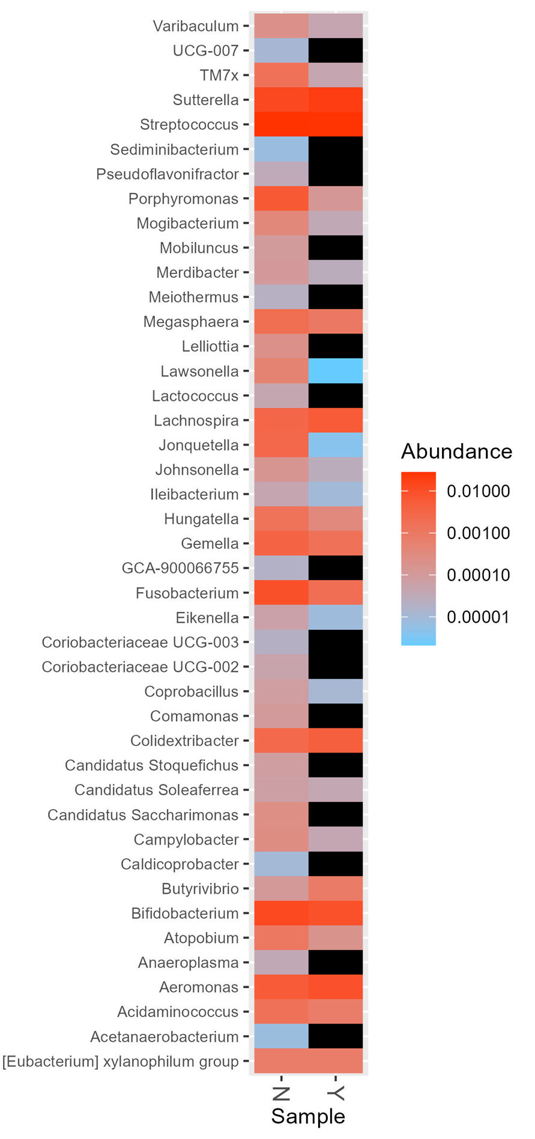
Figure S4. Relative abundance of significantly different genera identified by Wilcoxon rank sum testing from 16S rRNA amplicon sequencing data in relation to the incidence of anastomotic leak.

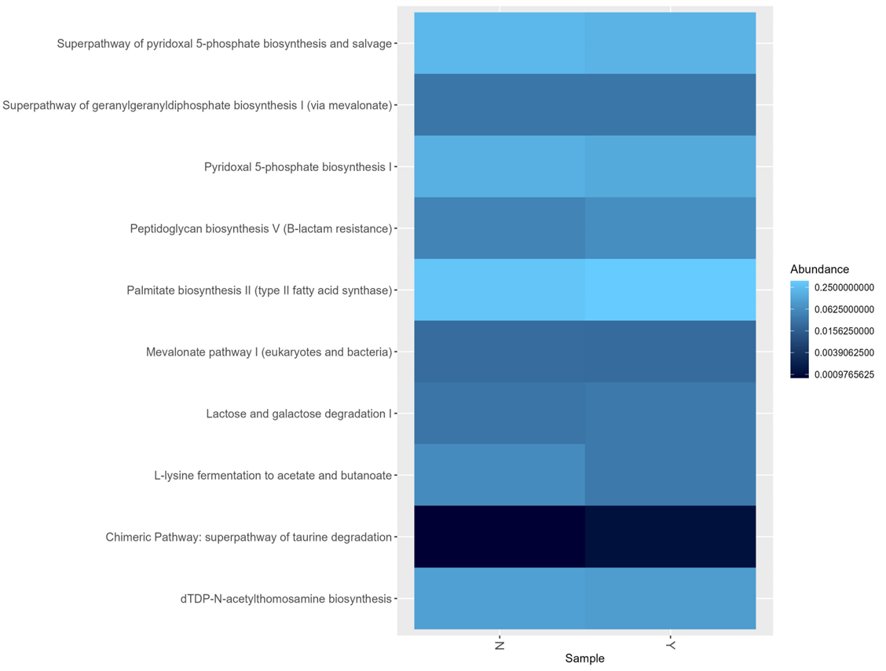
Figure S5. Relative abundance of significantly different PICRUSt2 Metacyc pathways identified by Wilcoxon rank sum testing in relation to the incidence of anastomotic leak.

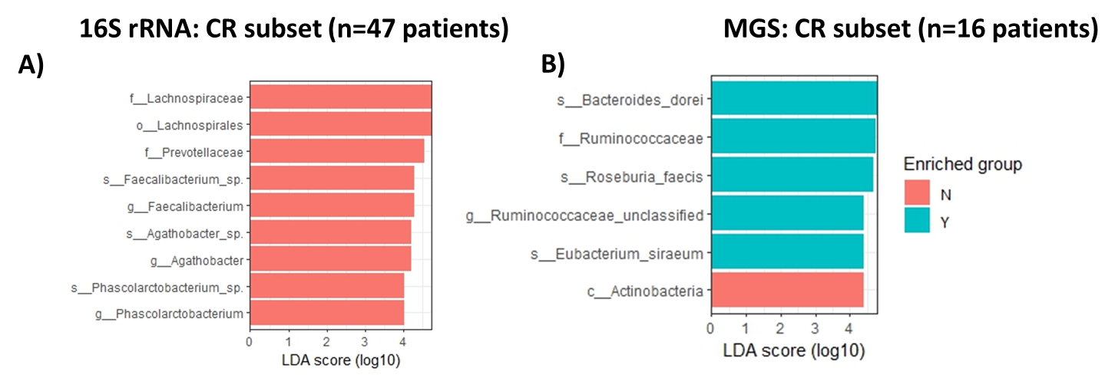
Figure S6. LEfSe analyses for anastomotic leak (blue) and no-leak (red) cases for A) 16S rRNA gene amplicon of colo-rectal (CR) resection types that presented with colorectal cancer samples (n=47) and B) metagenomic shotgun sequenced (MGS) samples (n=16).

