Supplemental Material
Backwind Trajectories
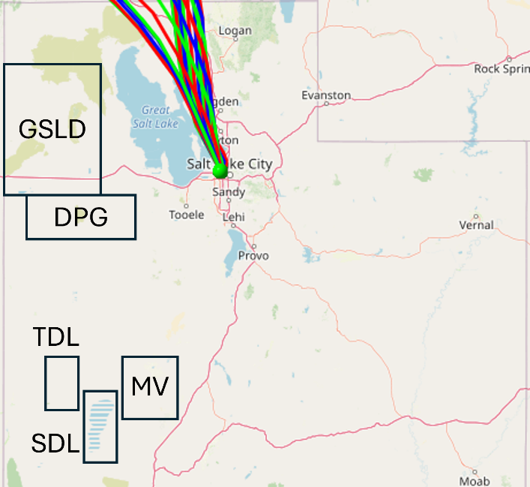
Figure S1. 12-hour backwind trajectories for each hour, each represented by its own line, of the 24-hour period that a filter was collected ending at midnight local time. This was for a “low” filter concentration from 21 December 2017. The green dot is the Salt Lake City International Airport.
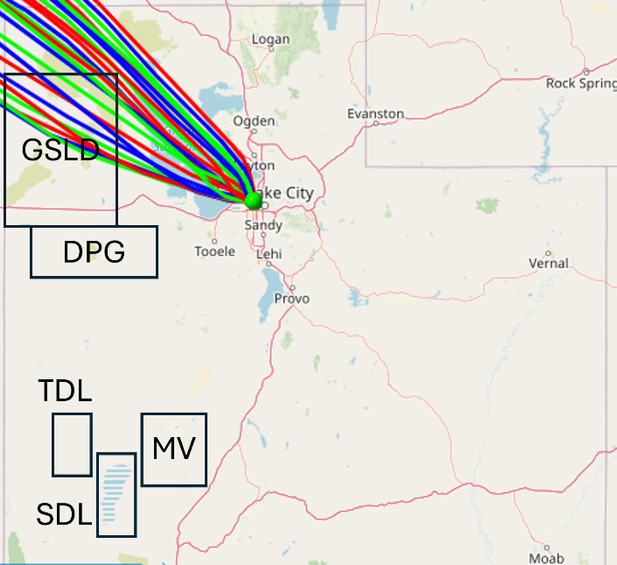
Figure S2. 12-hour backwind trajectories for each hour, each represented by its own line, of the 24-hour period that a filter was collected ending at midnight local time. This was for a “low” filter concentration from 23 April 2022. The green dot is the Salt Lake City International Airport.
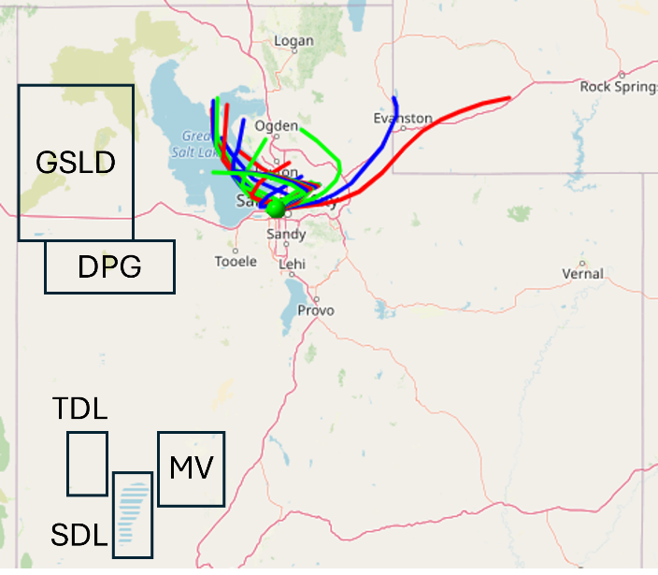
Figure S3. 12-hour backwind trajectories for each hour, each represented by its own line, of the 24-hour period that a filter was collected ending at midnight local time. This was for a “low” filter concentration from 31 May 2022. The green dot is the Salt Lake City International Airport.
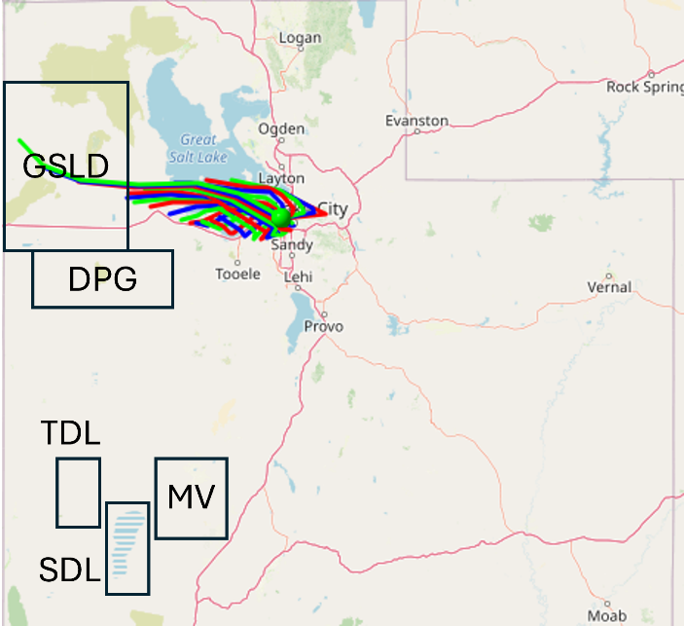
Figure S4. 12-hour backwind trajectories for each hour, each represented by its own line, of the 24-hour period that a filter was collected ending at midnight local time. This was for a “low” filter concentration from 20 June 2022. The green dot is the Salt Lake City International Airport.
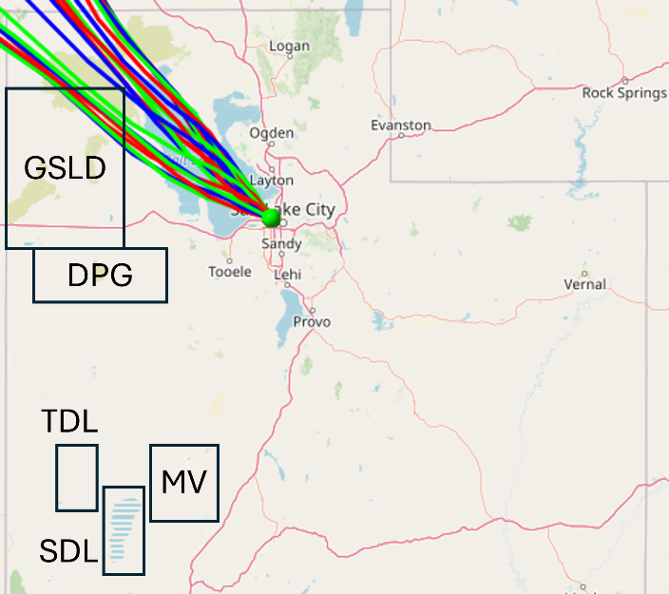
Figure S5. 12-hour backwind trajectories for each hour, each represented by its own line, of the 24-hour period that a filter was collected ending at midnight local time. This was for a “low” filter concentration from 15 April 2015. The green dot is the Salt Lake City International Airport.
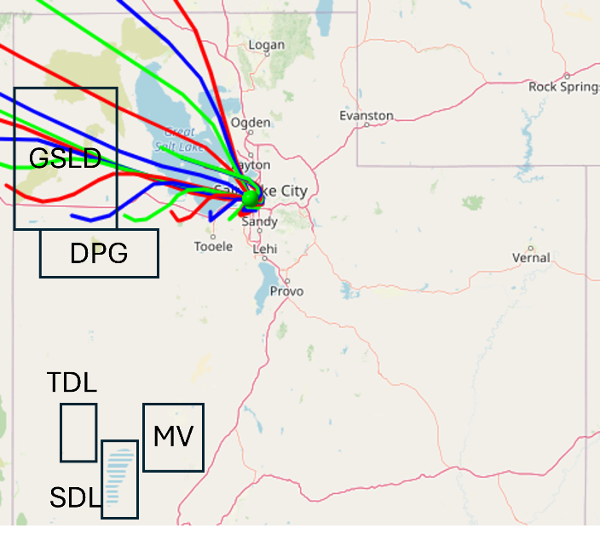
Figure S6. 12-hour backwind trajectories for each hour, each represented by its own line, of the 24-hour period that a filter was collected ending at midnight local time. This was for a “high” filter concentration from 7 September 2020. The green dot is the Salt Lake City International Airport.
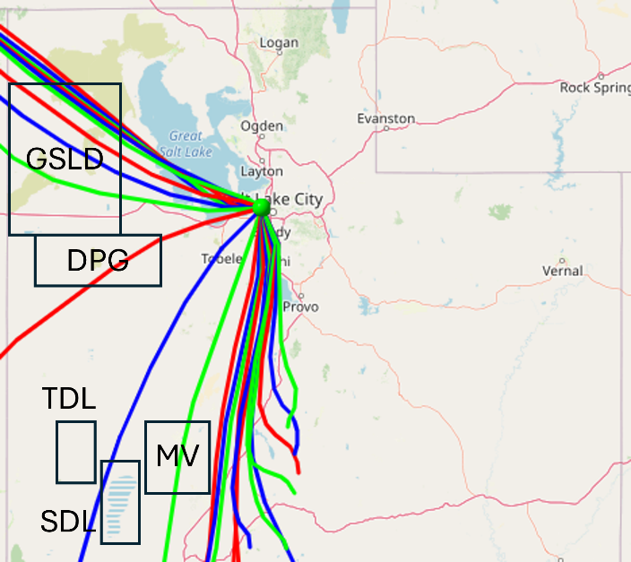
Figure S7. 12-hour backwind trajectories for each hour, each represented by its own line, of the 24-hour period that a filter was collected ending at midnight local time. This was for a “high” filter concentration from 14 April 2015. The green dot is the Salt Lake City International Airport.
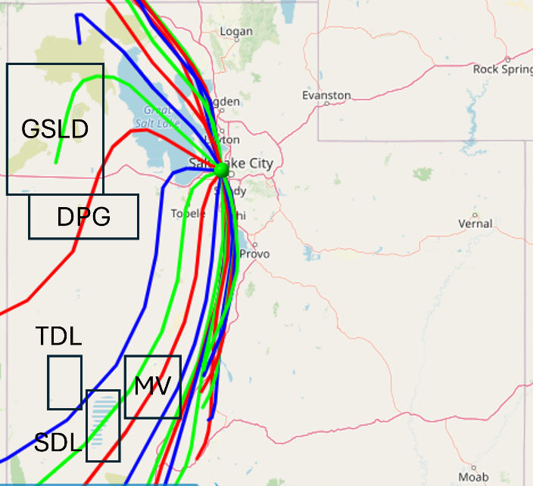
Figure S8. 12-hour backwind trajectories for each hour, each represented by its own line, of the 24-hour period that a filter was collected ending at midnight local time. This was for a “high” filter concentration from 20 December 2017. The green dot is the Salt Lake City International Airport.
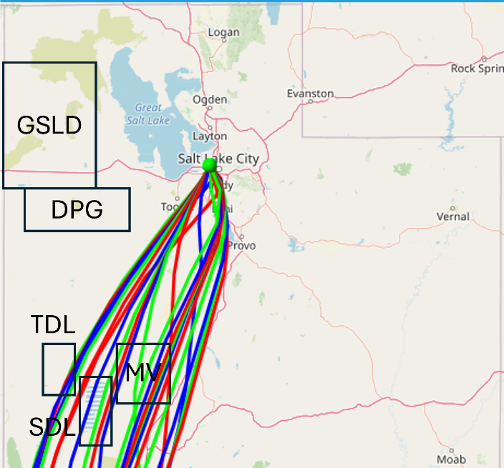
Figure S9. 12-hour backwind trajectories for each hour, each represented by its own line, of the 24-hour period that a filter was collected ending at midnight local time. This was for a “high” filter concentration from 18 June 2022. The green dot is the Salt Lake City International Airport.

