Supplemental Materials
Model Development. Cross-correlation analysis revealed high correlation between rolling average Pacific Mackerel and Jack Mackerel (R = 0.88). Candidate models were created with only Pacific Mackerel, only Jack Mackerel, and neither species. There was a moderately high correlation between rolling average Harbor Seals and Anchovy (R = -0.77), so candidate models were generated to selectively exclude these covariates as well (summarized in Table S-1). The most appropriate model was selected based on a comparison of Akike’s Information Criteria (AIC) ⁵⁴. Model 1 was automatically deemed invalid due to these high correlations but is retained in Table S-1 for reference. Initial model selection indicated that Model 3 was the winning model based on AIC - however R3 had a high VIF (38.3) -- cross-correlation indicated that Seals and Anchovies showed a high correlation (Fig. S-1), so anchovies were removed from the model and the result was Model 6, which has a lower VIF (7.9). Model selection based on AIC selected Model 6, which returned the lowest AIC value, and included the rolling average abundance of Harbor Seals and the rolling average probability of occurrence of Sardines, Pacific Mackerel, Market Squid. Model 6 returned a generalized variance inflation factor (GVIF) of 7.96, which is within tolerable limits.

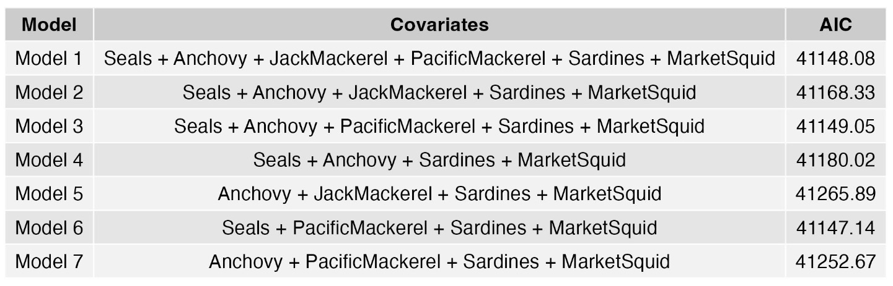
Table S-1: Candidate model summary with covariates and AIC included. All models were log-linked generalized additive models with a negative binomial distribution and k=20.

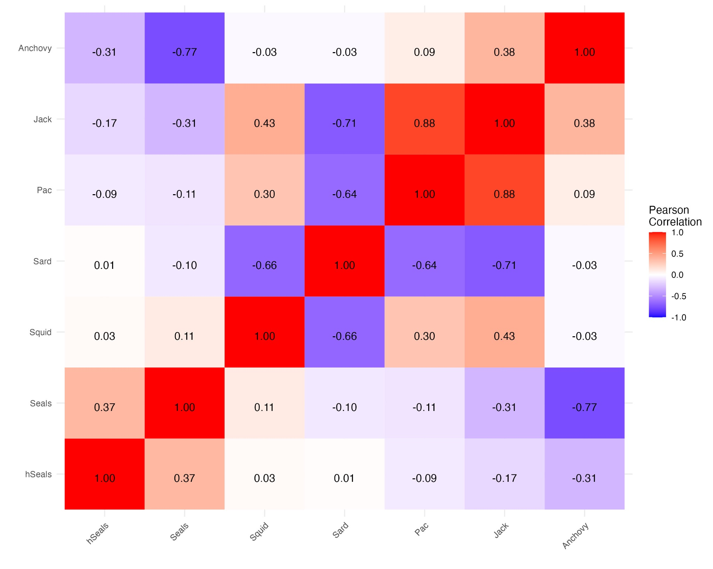
Fig. S-1: Cross-correlation analysis for all covariates.

Model Validation. Model checking and validation followed the methods of Ross ⁵⁵. The gam.check() function in the mgcv package ^{52,53} showed that the model fully converged after 3 iterations, indicating that the best solution for the model had been reached. Basis dimension (k) checking results showed a low p-value (p<0.05), indicating that residuals may not be randomly distributed, and that k may be too low. However, model validation plots indicate that residuals are generally normally distributed (below). K was iterated to maximize the p-value without inflating GVIF and the candidate models were run with k=20.

Model concurvity was assessed, and the worst scenario of concurvity returned a value of 0.012 for R6, indicating that the model has a very low risk of concurvity.

Model validation plots indicate generally appropriate distributions of residuals; however, some patterns emerge. In Fig. S-2, the residuals are generally evenly distributed around zero, as would be expected. However, there is some pattern of negative residuals. This is likely due to high-abundance outliers in the dataset that are not captured by the model. In the context of the other validation plots, this should not be a concern.

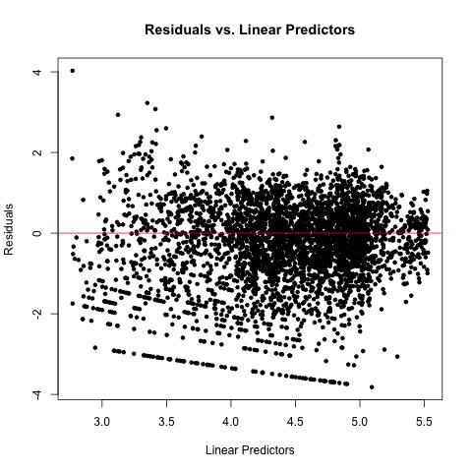
Fig. S-2: Final model plot of residuals vs linear predictors with a line (red) plotted representing the zero residual line. Values are generally evenly spaced around the zero-line, with some patterns emerging in the far negative residuals that may be explained by outliers and/or the lag of the model in tracking a rise in abundance (the model did track the rise, with a ~1-year delay, indicating that the model only captured part of the driver of the abundance change).

Fig. S-3 shows that the observed versus fitted responses generally cluster in a pattern around the 1:1 line, as expected. In this plot, we can again visualize some outliers. This is likely the result of high observed values that are not captured by the model as well as the rapid rise in abundance which is captured by the model after a ~1 year delay. However, this is minimal and does not appear to be of concern.

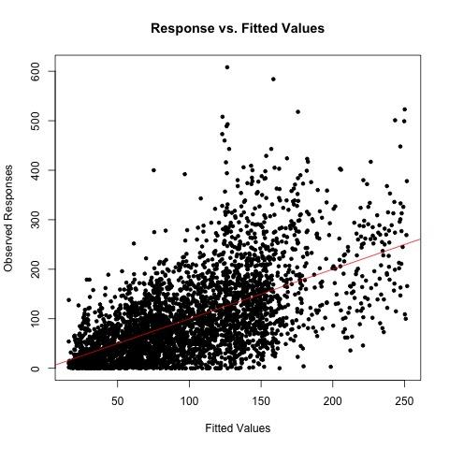
Fig. S-3: Final model plot of observed vs fitted values with a line plotted (red) representing a 1:1 curve.

Fig. S-4 shows that the residuals are generally normally and symmetrically distributed around zero, as expected.

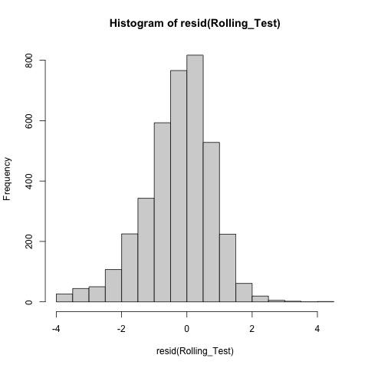
Fig. S-4: Final model histogram of residuals

Fig. S-5 indicates the model is generally well-fit, with residuals fit to a generally straight line. Again, there is some minor deviation from the straight line. This may be the result of observed outliers of high abundance, the ~1-year delay in the model capturing the rapid rise in Harbor Seal abundance, or some combination of these. This also lends confidence that the model is not overfit.

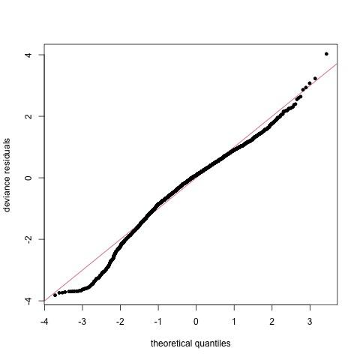
Fig. S-5: Final model Q-Q plot.

Decomposition of Harbor Seal Abundance Time Series. Fig. S-6 shows the decomposition of the time series of Harbor Seal abundance observations at the study site. Using the zoo package ³³ the observed values were decomposed, and missing values were imputed using the na.aggregate() function. The decomposition demonstrates that there is a very high and very regular seasonal variation present in the data. This is not unexpected, as the observation is of seals hauled out at the study site. This behavior is at its maximum during the pupping season and at its minimum after pups have been weaned, yielding a strong seasonal pattern. Fig. S-7 and Fig. S-8 further demonstrates this strong and regular seasonal pattern. There is also significant and irregular random variation in the observed data. This is also not surprising, as the data is collected daily and semi-systematically – typically in the mid-morning but without regard to tide or other variables. Haul-out behavior is also known to be variable, with participants reporting that some days many seals would be on the beach, with fewer the next and perhaps even more the following day. Therefore, substantial random variation in the observed data is not unexpected.
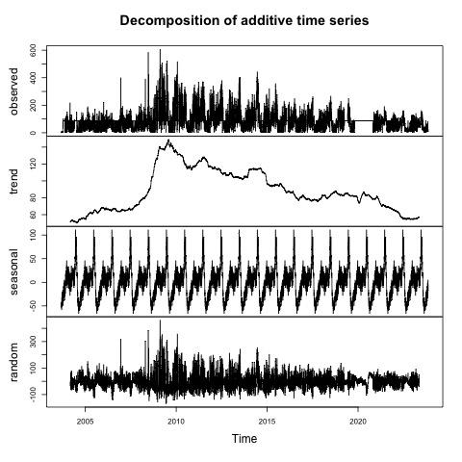
Fig. S-6: Decomposition of the additive time series of Harbor Seals hauled out on West Beach at HMS. Y-axis values represent numbers of Harbor Seals observed (top) or captured in the variability portion (seasonal or random). The trend represents observed values minus seasonal and random variability. NA Values in the dataset were imputed using the na.aggregate() function in the zoo package ³³.

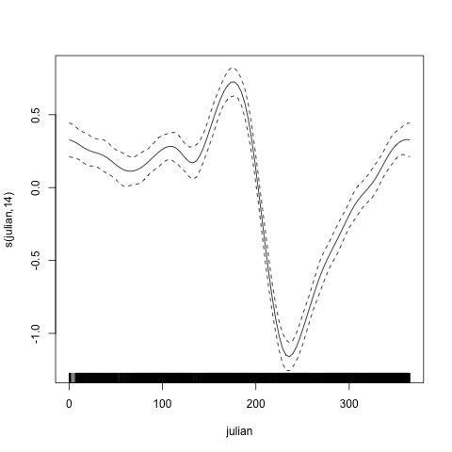
Fig. S-7: The plotted output of the Julian date smoothing function. The Julian date smoothing function was significant (p<2e-16), and the pattern accurately represents the significant seasonal fluctuation of the Harbor Seal abundance at the study site, with a minimum following the weaning of pups and a maximum during the pupping season (spring to early summer).

