Supporting Information For
Coupling Alkaline Conversion Zn Anode with Acidic Proton-insertion MoO₃ Cathode for High-voltage Aqueous Rechargeable Hybrid Battery
Pingwei Cai†, ‡, Yichun Ding†, Yangjie Liu†, and Zhenhai Wen*, †
† CAS Key Laboratory of Design and Assembly of Functional Nanostructures, Fujian Provincial Key Laboratory of Nanomaterials, Fujian Institute of Research on the Structure of Matter, Chinese Academy of Sciences, Fuzhou 350002, China
‡ University of Chinese Academy of Sciences, Beijing 100049, China
*Corresponding author (Email: Wen@fjirsm.ac.cn)

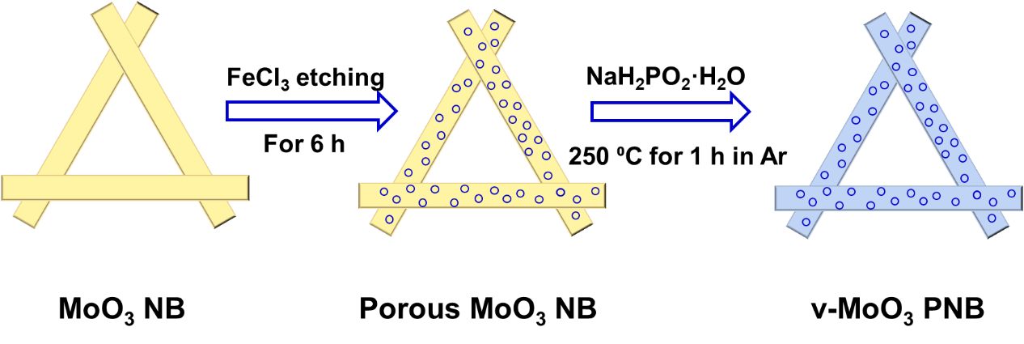
Fig. S1 Schematic diagram of the synthesis of v-MoO3 PNB.

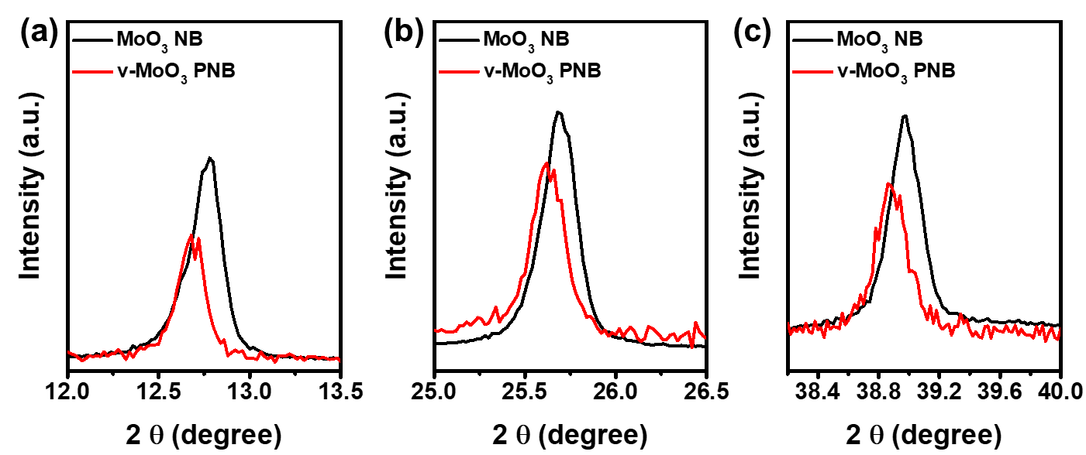
Fig. S2 XRD patterns of MoO₃ NB and v-MoO₃ PNB at a different range.

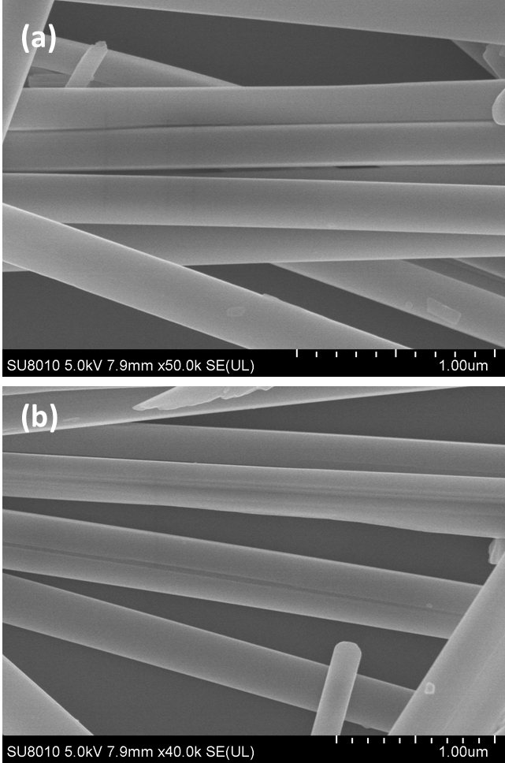
Fig. S3 SEM images of MoO₃ NB.

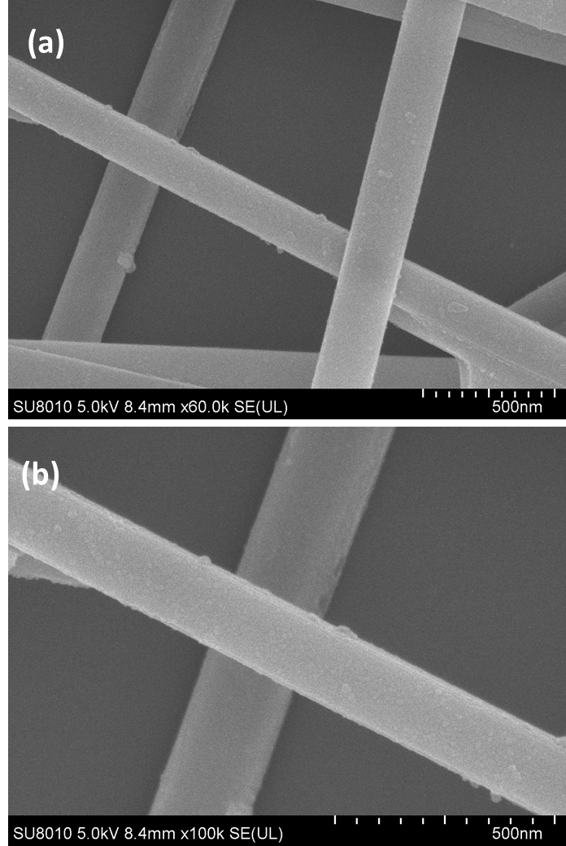
Fig. S4 SEM images of v-MoO₃ PNB.

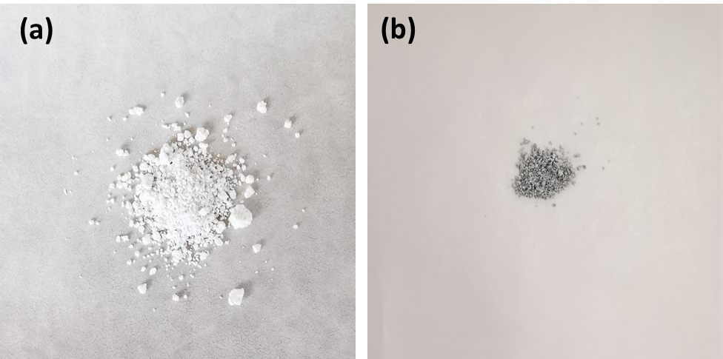
Fig. S5 Digital graph of MoO₃ NB (a) and v-MoO₃ PNB (b).

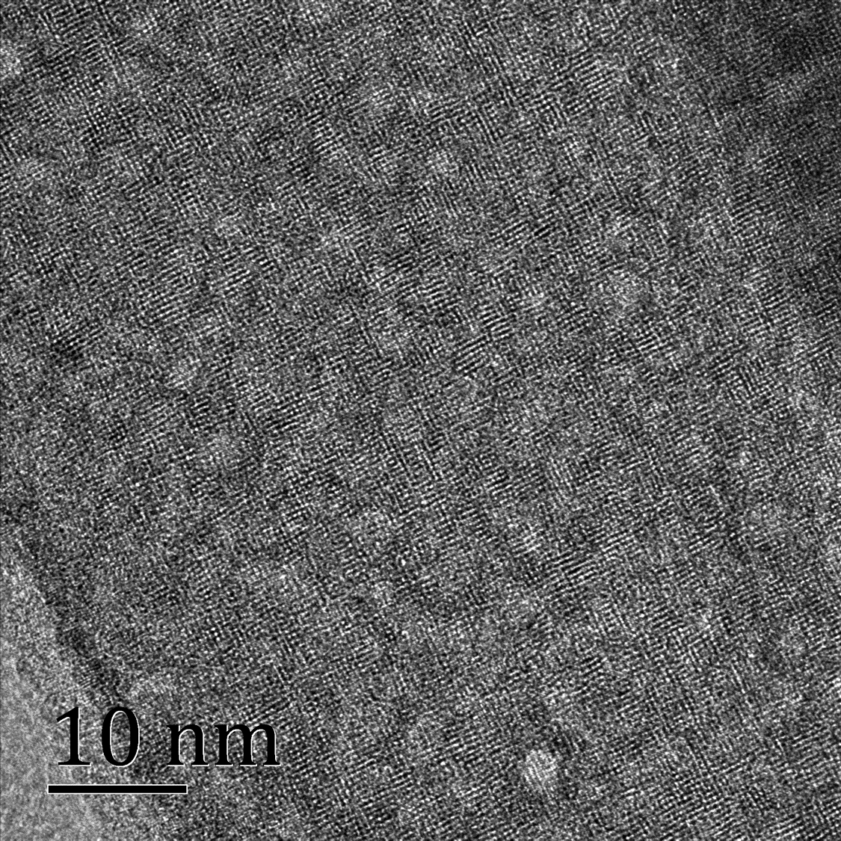
Fig. S6 HRTEM of v-MoO₃ PNB.

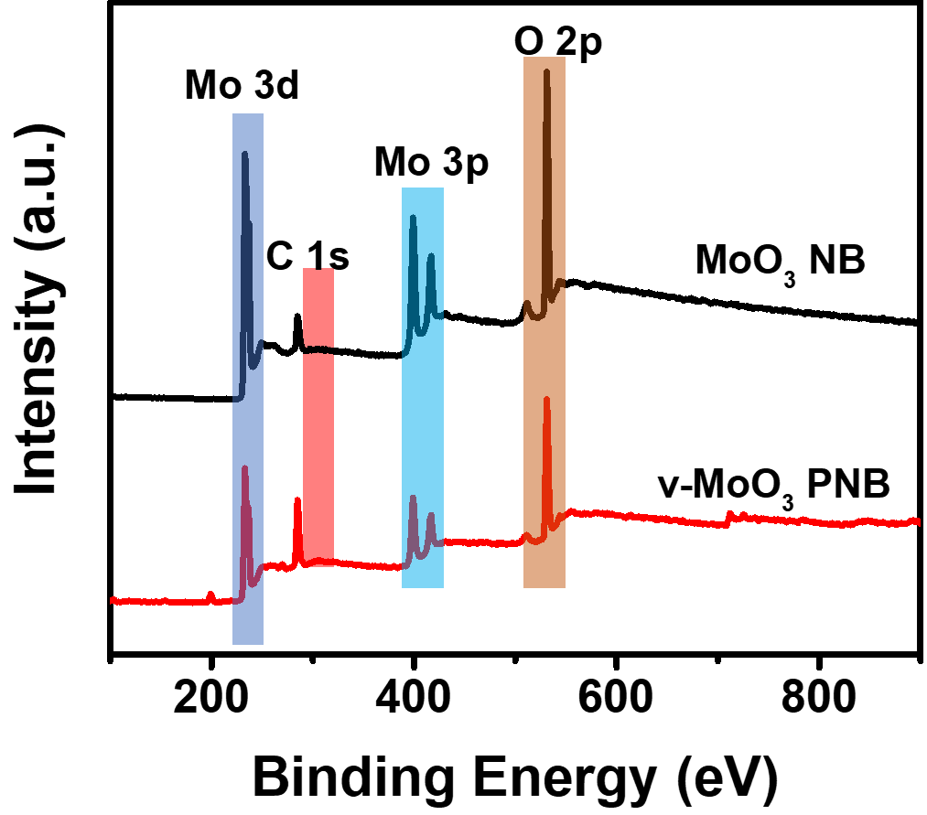
Fig. S7 XPS survey spectroscopy of MoO₃ NB and v-MoO₃ PNB.

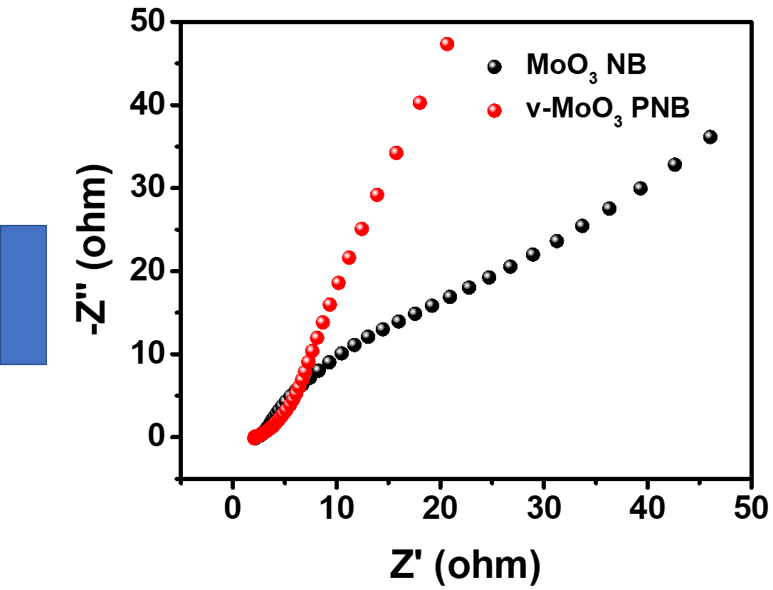
Fig. S8 EIS of MoO₃ NB and v-MoO₃ PNB recorded at open circuit potential in a three-electrode system.

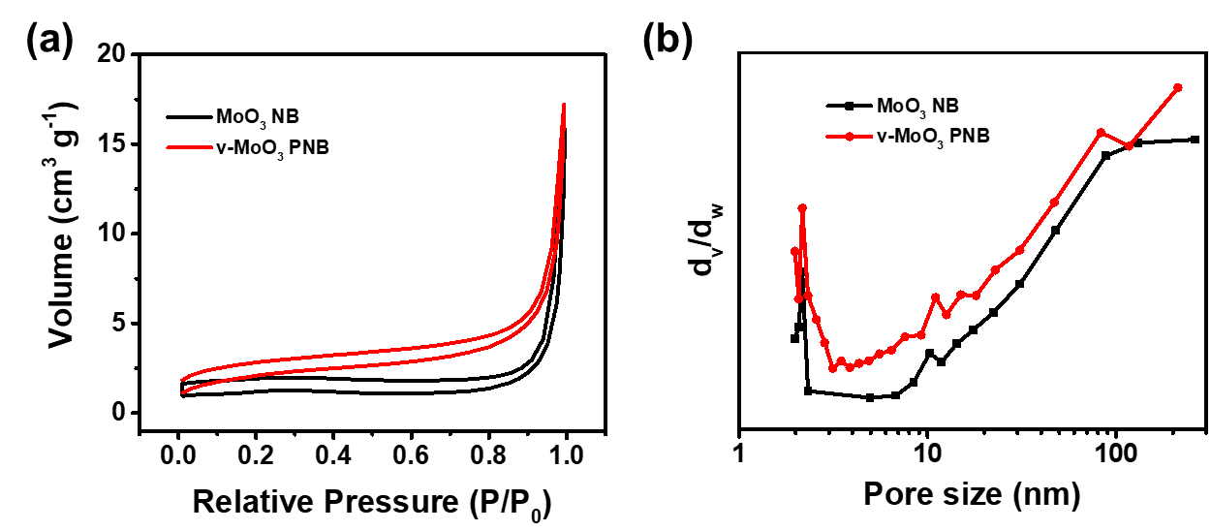
Fig. S9 (a) N₂ adsorption and desorption curves; (b) Corresponding pore size distribution curves of MoO₃ NB and v-MoO₃ PNB.

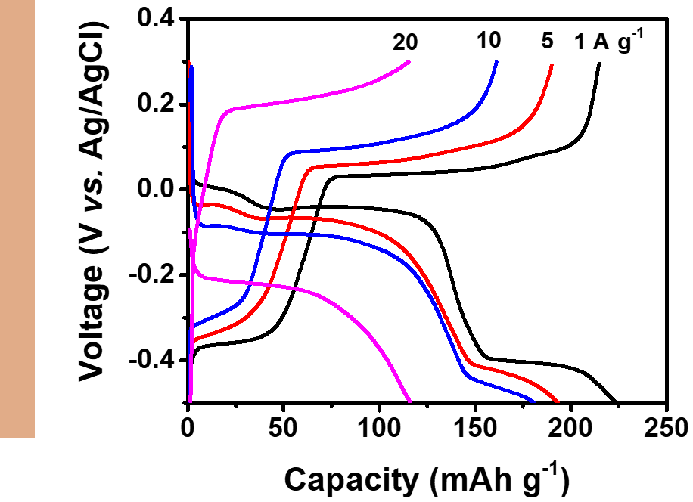
Fig. S10 Charge-discharge profiles at the different current of MoO₃ NB electrode.

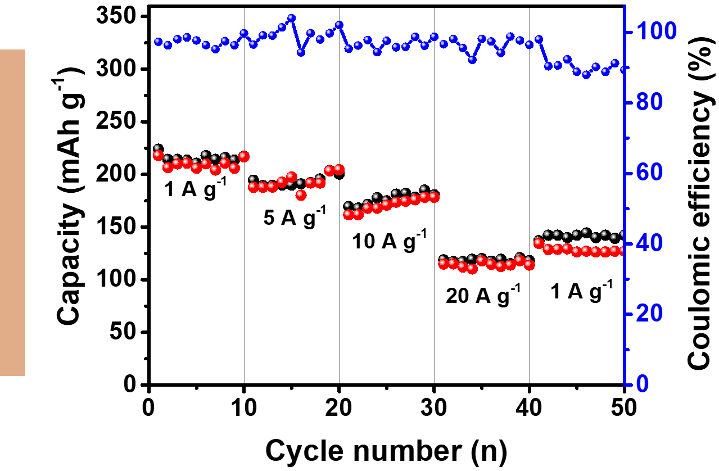
Fig. S11 Rate performance at current densities from 1 to 20 A g⁻¹ of MoO₃ NB electrode.
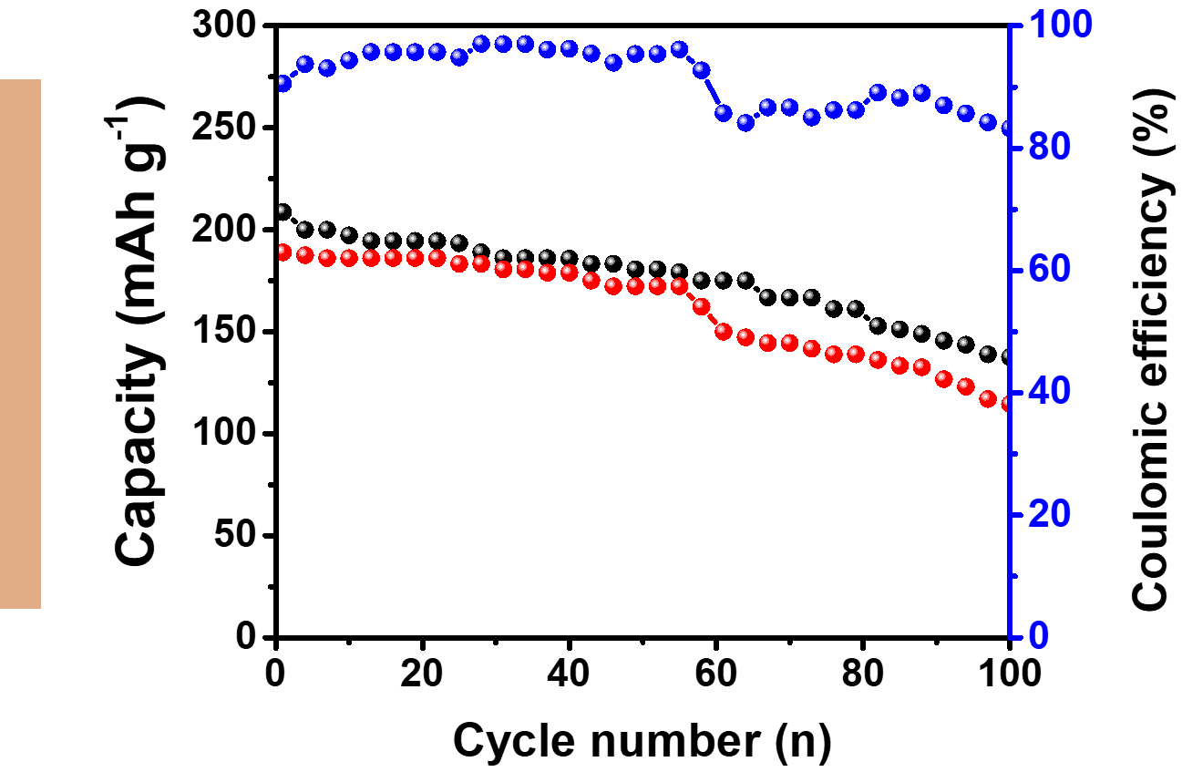
Fig. S12 Cycle performance and Coulombic efficiency at a current density of 10 A g⁻¹ of MoO₃ NB electrode.

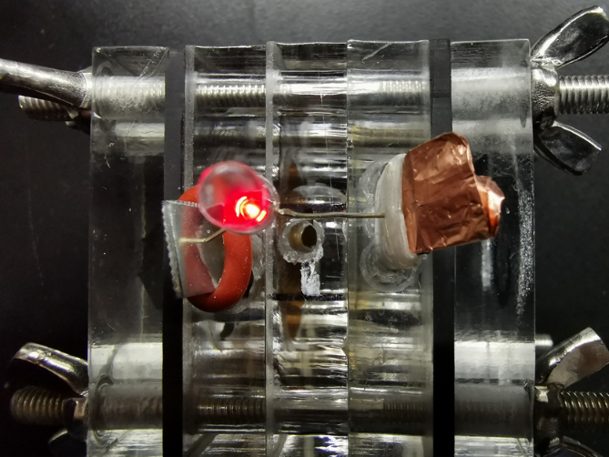
Fig. S13 Digital photograph of an alkali-acid Zn-MoO₃ hybrid battery that lighting a red LED.
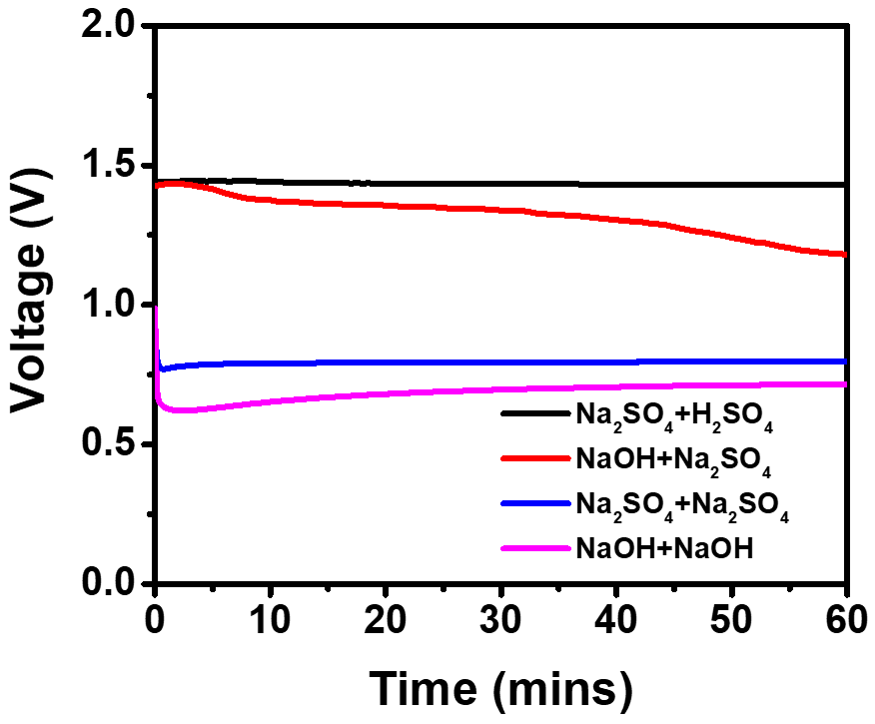
Fig. S14 OCV of Zn-MoO₃ battery with various electrolytes. Black line, 1 M Na₂SO₄ serve as anolyte and 2 M H₂SO₄ serve as catholyte; red line, 4 M NaOH serve as anolyte and 1 M Na₂SO₄ serve as catholyte; Blue line, 1 M Na₂SO₄ serve as both anolyte and catholyte; Pink line, 4 M NaOH serve as anolyte and catholyte.

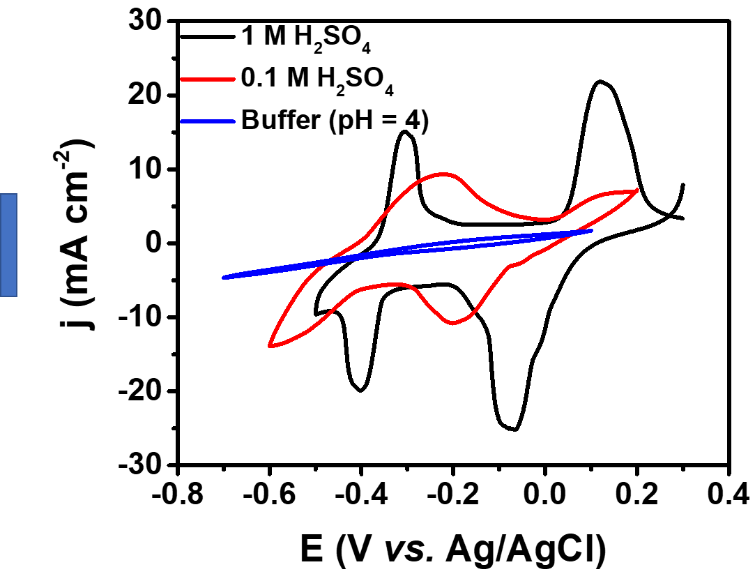
Fig. S15 CV curves of v-MoO₃ PNB with a scan rate of 50 mV s⁻¹ in different conditions.

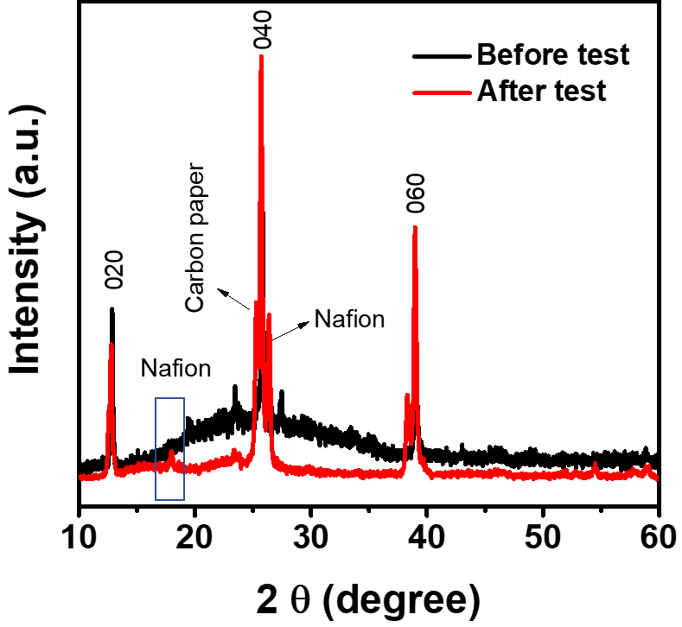
Fig. S16 XRD pattern of v-MoO₃ PNB before and after long-term stability test.

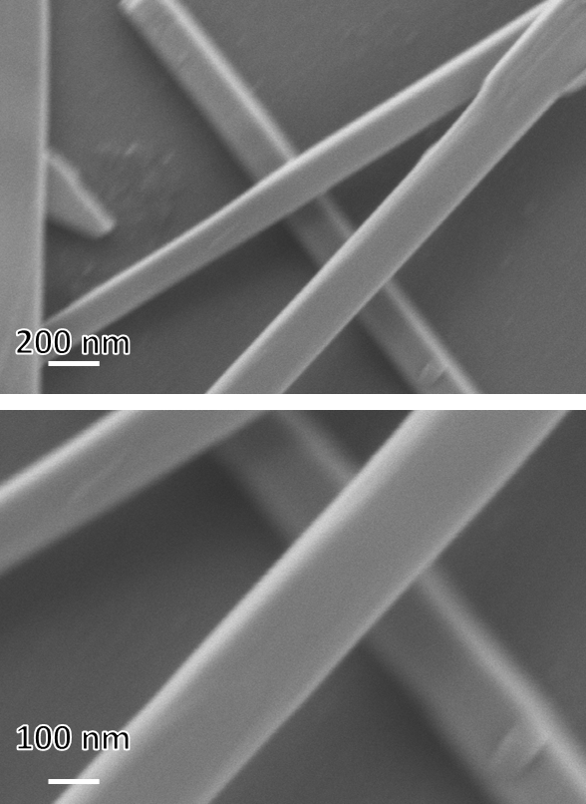
Fig. S17 SEM images of v-MoO₃ PNB after long-term stability test.

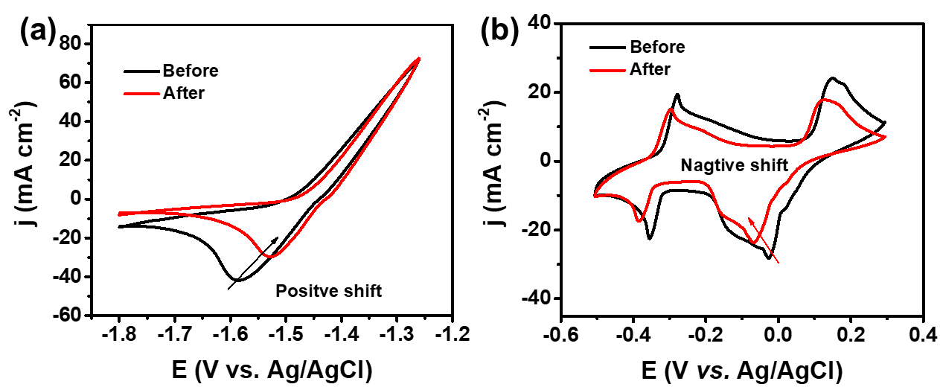
Fig. S18 (a) CV curves of Zn anode in the anolyte before and after stability test with a scan rate of 10 mV s⁻¹. (b) CV curves of v-MoO₃ PNB in the catholyte before and after stability test with a scan rate of 50 mV s⁻¹.

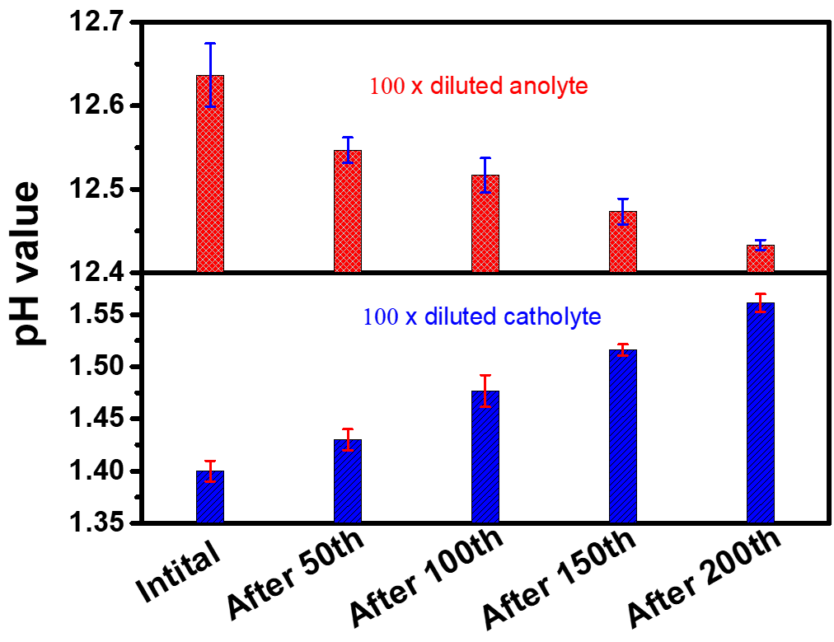
Fig. S19 The pH variation of anolyte and catholyte during the charge-discharge process alkali-acid Zn-MoO₃ hybrid battery.

