Supplementary table and figures

Supplementary table: Multivariate analysis of factors associated with development of thrombotic events (overall) in patients with COVID-19

Varibles | B | p value | OR | 95% CI
Peak D-dimer levels | 0.096 | <0.001 | 1.1 | 1.05-1.16
NIH COVID score 4 (compared to 3) | 2.254 | 0.044 | 9.5 | 1.06-85.5
SoC (compared to Anakinra) | 2.419 | 0.002 | 11.2 | 2.47-51.1

Supplementary figure 1: Dot-plot of standardized mean differences for all covariates before and after PS matching
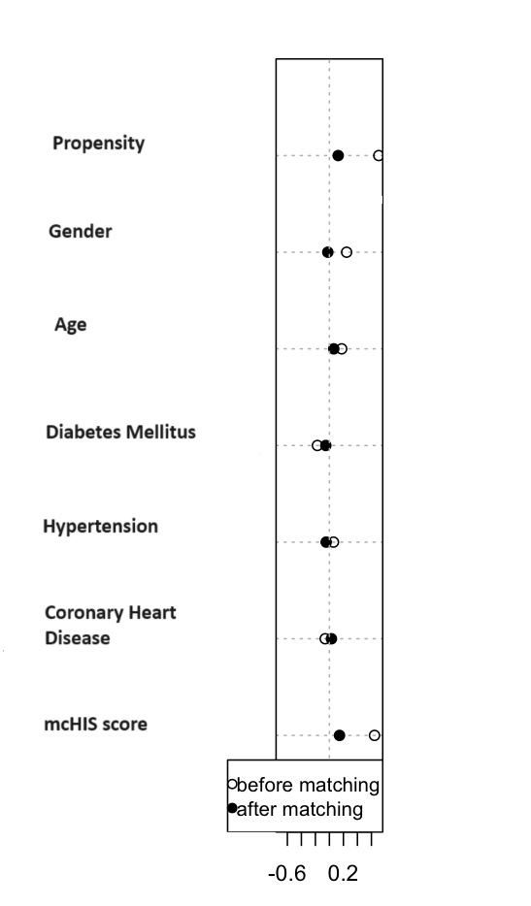

Supplementary figure 2: Jitter plots for trend scores by propensity score-matching analysis in patients with COVID-19
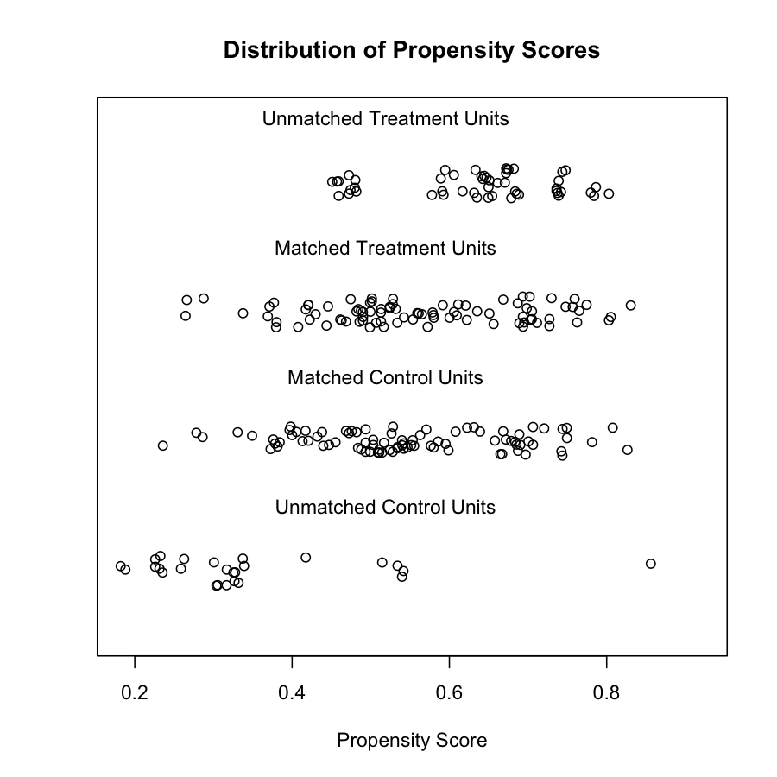

Supplementary figure 3: Line-plot of standardized differences by propensity score-matching analysis in patients with COVID-19
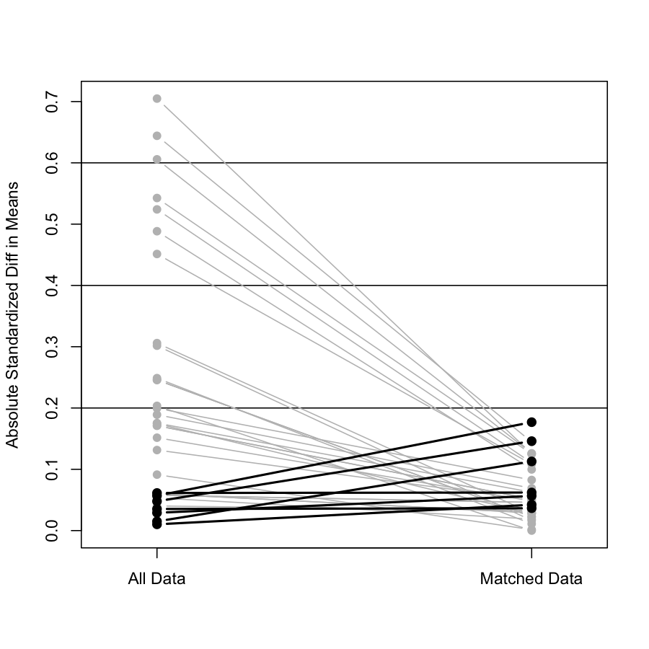

Supplementary figure 4: Development of pulmonary thromboembolism in patients with COVID-19 according to the treatment groups (Kaplan-Meier survival analysis)

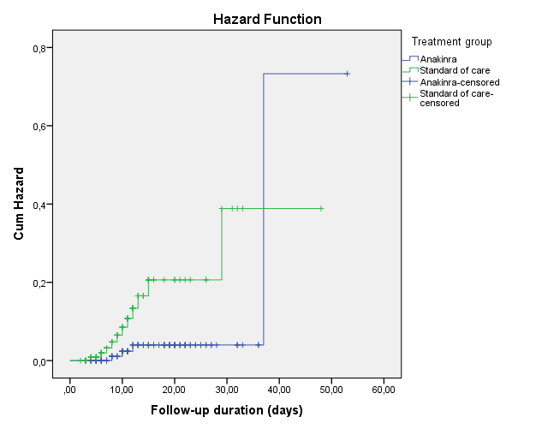

Log-Rank; p=0.003

Supplementary figure 5: Development of myocardial infarction in patients with COVID-19 according to the treatment groups (Kaplan-Meier survival analysis)

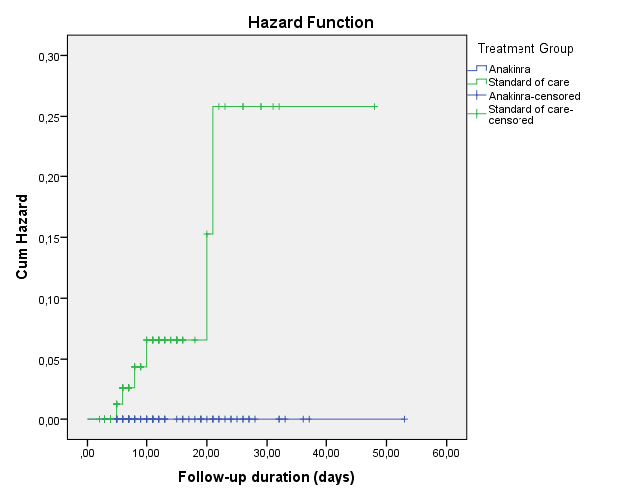

Log-Rank; p=0.007

Supplementary figure 6: Survival rate of patients with COVID-19 according to presence of pulmonary thromboembolism (Kaplan-Meier survival analysis)

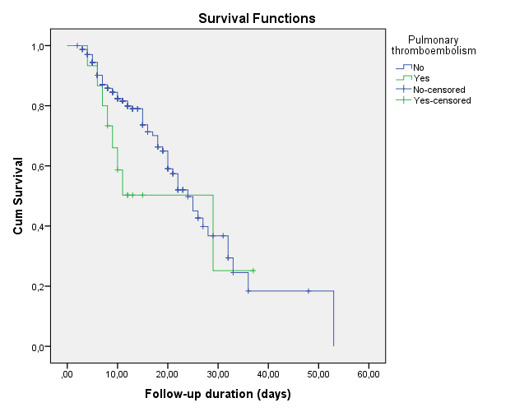

Log-Rank; p=0.15

Supplementary figure 7: ROC curve of d-dimer levels for the development of any thromboembolic event in patients with COVID-19
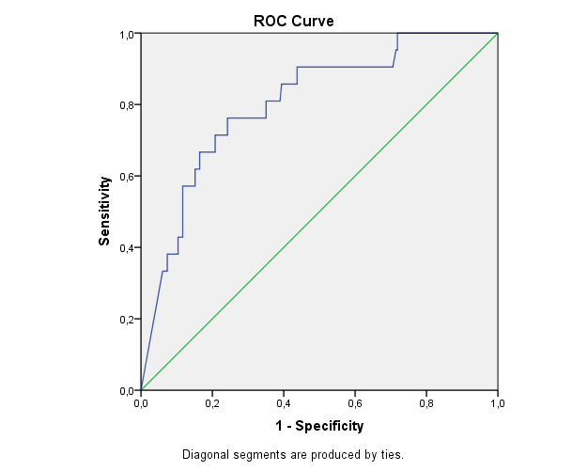

Supplementary figure 8: ROC curve of d-dimer levels for the development of pulmonary thromboembolism in patients with COVID-19

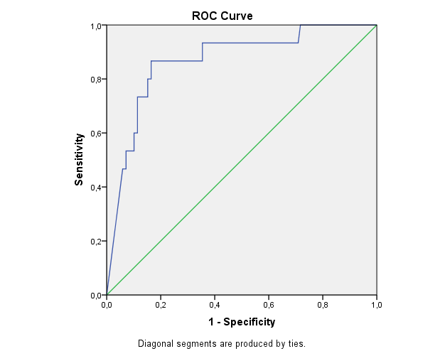

Supplementary figure 9: ROC curve of d-dimer levels for the development of myocardial infarction in patients with COVID-19

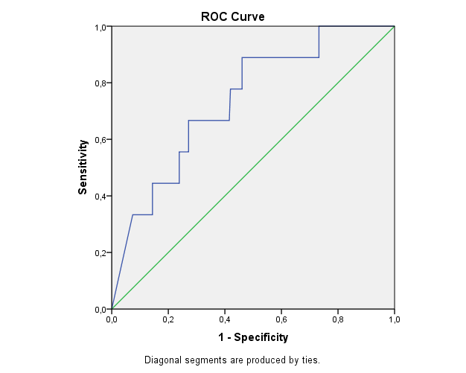

Supplementary figure 10: ROC curve of mcHIS score for the development of any thromboembolic event in patients with COVID-19

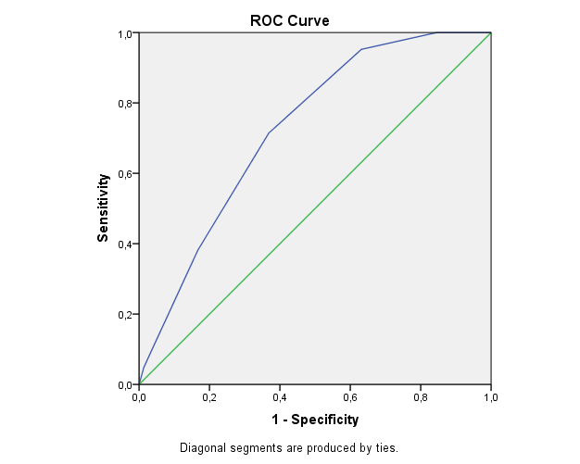

Supplementary figure 11: ROC curve of mcHIS score for the development of pulmonary thromboembolism in patients with COVID-19

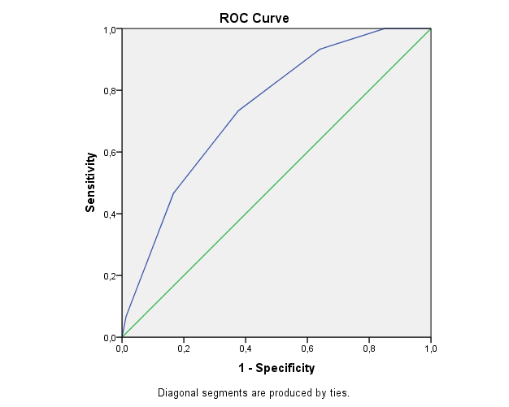

Supplementary figure 12: ROC curve of mcHIS score for the development of myocardial infarction in patients with COVID-19

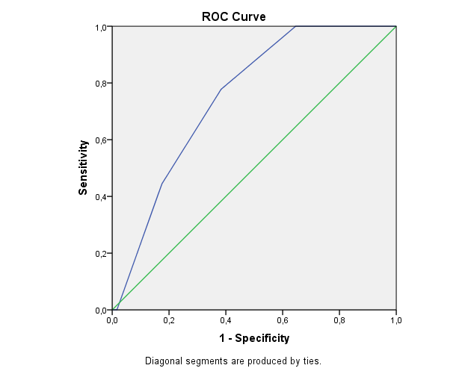

Supplementary figure 13: ROC curve peak levels of CRP for the development of any thromboembolic event in patients with COVID-19

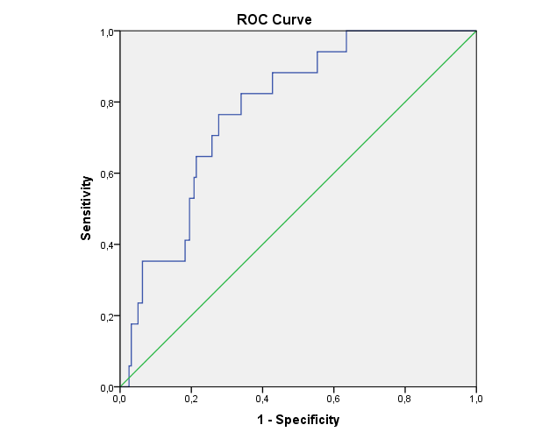

Supplementary figure 14: ROC curve peak levels of CRP for the development of pulmonary thromboembolism in patients with COVID-19

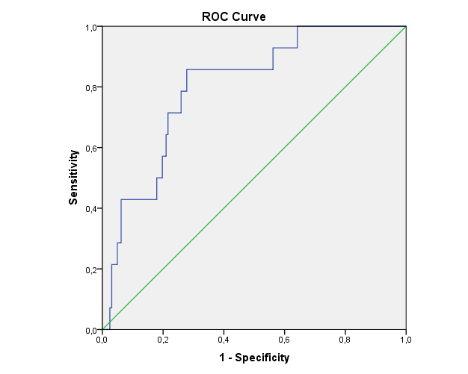

Supplementary figure 15: ROC curve peak levels of CRP for the development of myocardial infarction in patients with COVID-19

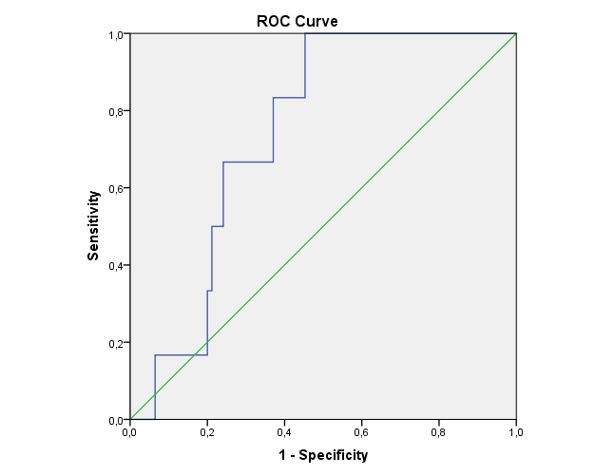

Supplementary figure 16: ROC curve peak levels of LDH for the development of myocardial infarction in patients with COVID-19

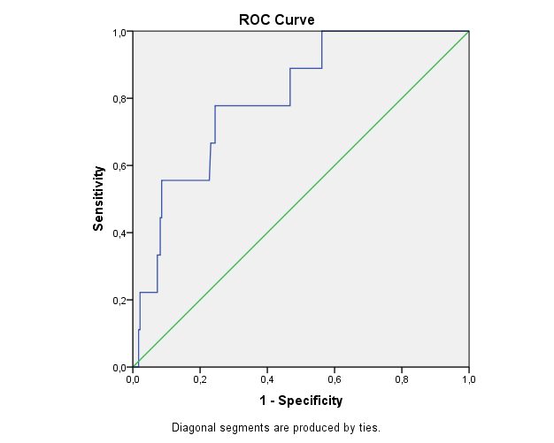

Supplementary figure 17: ROC curve peak levels of LDH for the development of any thrombotic event in patients with COVID-19

