Extended Data Tables and Figures

Dataset | Istradefylline | AzoSwitch2 | StilSwitch1 | StilSwitch2 | StilSwitch3 | StilSwitch4
Data Collection
No. crystals | 1 | 1 | 3 | 10 | 9 | 1
Space group | C222₁ | C222₁ | C222₁ | C222₁ | C222₁ | C222₁
a, b, c (Å) | 39.3, 179.4, 139.9 | 39.5, 179.6, 140.0 | 39.5, 179.7, 139.9 | 39.4, 179.4, 139.5 | 39.4, 179.1, 139.3 | 39.4, 179.1, 139.3
α, β, γ (°) | 90, 90, 90 | 90, 90, 90 | 90, 90, 90 | 90, 90, 90 | 90, 90, 90 | 90, 90, 90
Overall Statistics (High-Resolution Statistics)
Resolution (Å) | 38.42 – 1.94 (2.01 – 1.94) | 46.66 – 2.20 (2.27 – 2.20) | 41.40 – 2.25 (2.33 – 2.25) | 46.58 – 2.31 (2.39 – 2.31) | 46.44 – 2.05 (2.11 – 2.05) | 44.68 – 2.20 (2.28 – 2.20)
Total Reflections | 243,906 (23,627) | 170,441 (13,046) | 48,596 (4,806) | 857,334 (13,923) | 1,066,681 (19,680) | 170,884 (17,423)
Unique Reflections | 37,193 (3,585) | 25,908 (2,169) | 24,300 (2,405) | 22,234 (2,066) | 31,499 (2,346) | 25,516 (2,516)
<I/s(I)> | 12.3 (1.2) | 6.5 (2.1) | 9.3 (2.2) | 13.9 (1.3) | 18.1 (1.6) | 10.8 (1.3)
CC_{1/2} | 0.999 (0.479) | 0.996 (0.388) | 0.998 (0.634) | 0.997 (0.463) | 0.999 (0.617) | 0.998 (0.522)
R_{pim} | 0.045 (0.599) | 0.091 (0.704) | 0.046 (0.393) | 0.044 (0.651) | 0.027 (0.468) | 0.054 (0.614)
Completeness (%) | 99.6 (98.0) | 99.9 (99.9) | 99.9 (99.9) | 99.7 (97.3) | 99.8 (97.6) | 100 (100)
Multiplicity | 6.6 (6.6) | 6.6 (6.0) | 12.0 (2.0) | 38.6 (6.7) | 33.9 (8.4) | 6.7 (6.9)
Refinement
Resolution Range | 38.42 – 1.94 | 41.41 – 2.20 | 41.40 – 2.25 | 19.93 – 2.31 | 41.22 – 2.05 | 44.68 – 2.20
No. Reflections | 37,187 | 25,384 | 24,287 | 22,158 | 31,452 | 25,510
R_{work} / R_{free} | 0.1923 / 0.2166 | 0.1998 / 0.2346 | 0.1852 / 0.2143 | 0.1928 / 0.2414 | 0.1935 / 0.2095 | 0.1988 / 0.2267
No. Atoms
Protein | 2974 | 3047 | 3049 | 2905 | 2989 | 3002
Other | 428 | 357 | 494 | 507 | 492 | 509
Water | 120 | 74 | 112 | 74 | 102 | 81
B Factors
Protein | 34.94 | 39.44 | 37.43 | 37.25 | 43.16 | 51.47
Other | 43.54 | 46.55 | 50.99 | 46.60 | 53.37 | 60.45
Water | 38.35 | 37.63 | 40.14 | 35.05 | 43.56 | 47.13
R.m.s Deviations
Bond Lengths (Å) | 0.009 | 0.004 | 0.003 | 0.002 | 0.003 | 0.004
Bond Angles (°) | 1.047 | 0.760 | 0.696 | 0.569 | 0.725 | 0.784
Ramachandran
Favored (%) | 99.48 | 99.22 | 99.22 | 99.21 | 99.47 | 99.21
Allowed (%) | 0.52 | 0.78 | 0.78 | 0.79 | 0.53 | 0.79
Outliers (%) | 0 | 0 | 0 | 0 | 0 | 0

Extended Data Table 1: Crystallographic data and refinement statistics from cryo-datasets

Dataset | StilSwitch2 Dark | StilSwitch2 Light | StilSwitch3 Dark | StilSwitch3 Light
Data Collection
Space group | C222₁ | C222₁ | C222₁ | C222₁
a, b, c (Å) | 40.1, 179.8, 142.1 | 40.2, 180.0, 142.8 | 40.0, 179.5, 142.0 | 40.1, 179.9, 142.8
α, β, γ (°) | 90, 90, 90 | 90, 90, 90 | 90, 90, 90 | 90, 90, 90
Overall Statistics (High-Resolution Statistics)
Resolution (Å) | 142.13 – 2.45 (2.54 – 2.45) | 142.13 – 2.70 (2.80 – 2.70) | 142.13 – 2.65 (2.75 – 2.65) | 142.13 – 3.05 (3.16 – 3.05)
Total Reflections | 13,504,311 (207,471) | 6,964,676 (209,536) | 9,909,559 (333,005) | 2,595,503 (150,560)
Unique Reflections | 20,116 (1,902) | 14,678 (1,425) | 15,996 (1,508) | 10,568 (993)
<I/s(I)> | 8.89 (0.71) | 7.23 (0.70) | 7.55 (0.63) | 5.11 (0.61)
CC* | 0.998 (0.660) | 0.997 (0.666) | 0.990 (0.503) | 0.998 (0.596)
CC_{1/2} | 0.993 (0.278) | 0.990 (0.285) | 0.960 (0.145) | 0.992 (0.216)
Completeness (%) | 100 (100) | 100 (100) | 100 (100) | 100 (100)
Multiplicity | 691.8 (109.1) | 474.4 (147.0) | 638.8 (220.8) | 252.2 (151.6)
Refinement
Resolution Range | 45.64 – 2.45 | 19.94 – 2.80 | 45.64 – 2.65 | 19.94 – 3.05
No. Reflections | 20,116 | 13,606 | 15,996 | 10,568
R_{work} / R_{free} | 0.1913 / 0.2408 | 0.2713 / 0.3170 | 0.1916 / 0.2326 | 0.3085 / 0.3423
No. Atoms
Protein | 3028 | 2835 | 2915 | 2931
Other | 419 | 339 | 388 | 331
Water | 28 | 13 | 51 | /
B Factors
Protein | 71.87 | 75.68 | 88.43 | 90.99
Other | 83.56 | 84.77 | 97.38 | 90.67
Water | 53.44 | 54.59 | 73.99 | /
R.m.s Deviations
Bond Lengths (Å) | 0.003 | 0.002 | 0.006 | 0.0020
Bond Angles (°) | 0.549 | 0.481 | 1.2 | 0.478
Ramachandran
Favored (%) | 98.44 | 98.14 | 97.92 | 96.11
Allowed (%) | 1.3 | 1.86 | 2.08 | 3.63
Outliers (%) | 0.26 | 0 | 0 | 0.26

Extended Data Table 2: Serial crystallographic datasets

Extended Data Figure 1: Photostationary state and thermal relaxation of AzoSwitch2. (A) Overview of the different accessible photostationary states of AzoSwitch2. The photostationary states were achieved with LEDs (ThorLabs M420L3, ThorLabs M455L3 and ThorLabs M470L3). (B) Thermal relaxation of AzoSwitch2 at 426 nm after illumination with 470 nm. The data was fitted with a single exponential decay function.

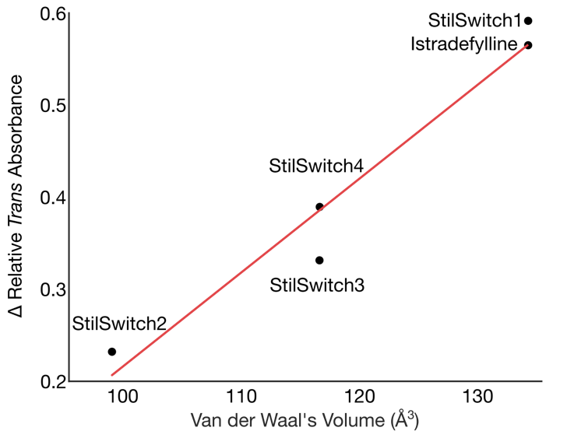
Extended Data Figure: Absorption changes in relation to the size of benzoyl groups
Comparison of van der Waal’s volume of the benzoyl group on the photoswitches (calculated using Chemaxon) and the change in relative illuminated trans peak absorbance for photoswitches in buffer and protein.

Extended Data Figure 3: Steady state absorbance & fluorescence data on StilSwitch1-4. In acetonitrile (A-C) and protein buffer (D-F). (A) Normalized absorbance spectra of the four compounds. (B) Photostationary state of all four compounds obtained with a 340 nm LED (Thorlabs). (C) Normalized fluorescence spectra of StilSwitch1-4. (D) Normalized absorbance spectra of the four compounds. (E) Photostationary state of all four compounds obtained with a 340 nm LED (Thorlabs). (F) Normalized fluorescence spectra of StilSwitch1-4.

Extended Data Figure 4: Transient absorption data of StilSwitch1-4 in acetonitrile. The transients show the dynamic of the GSB, SE and ESA. The transient data of all four measurements is normalized on the highest ESA signal for better comparability.

Extended Data Figure 5: Lifetimes of spectral features associated with StilSwitch3.
(A) Evolution associated difference spectra obtained by a global target analysis of StilSwitch3 bound to protein. (B) Transient data of Switch3 bound to protein. Three wavelengths which correspond to the main features (GSB @ 356 nm, SE @ 432 nm and ESA @ 555 nm) are shown.

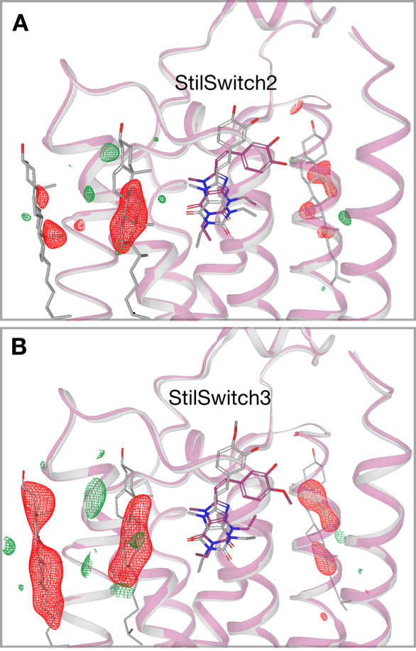
Extended Data Figure 6: Disappearance of associated cholesterol molecules.
Isomorphous difference peaks over the allosteric cholesterol molecules bound to the A_{2A}R with (A) StilSwitch2 and (B) StilSwitch3 bound. Difference electron density maps ((F_{o}(light)-F_{o}(dark), red, negative and green, positive are contoured at 3.0 sigma carved 1.0 Å around cholesterol molecules.

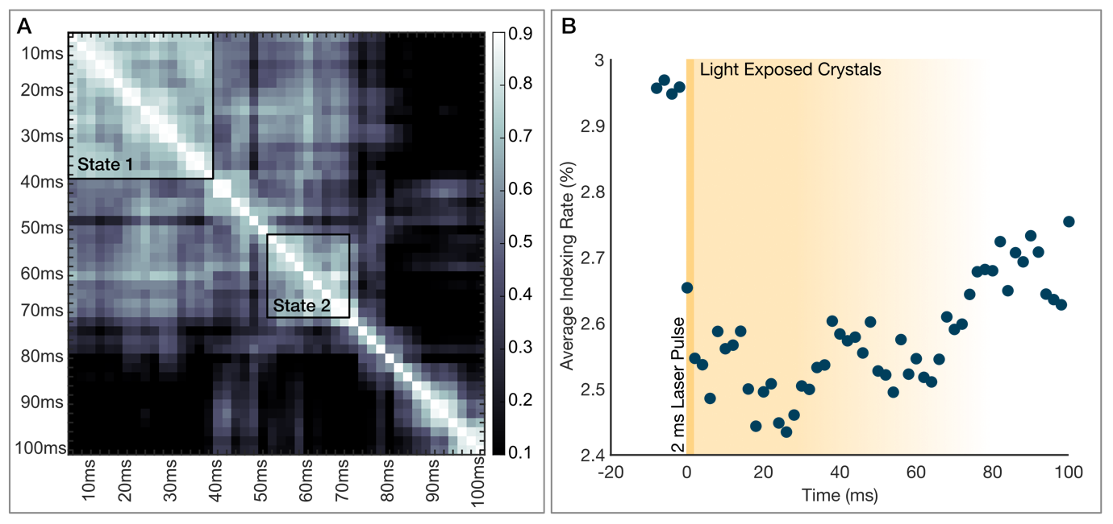
Extended Data Figure 7: Time-resolved serial synchrotron crystallography. Activation of crystals in the MaxIV data can be seen between 0 and 70 ms following activation. This can be observed in two ways: (A) the decay of laser-induced signals in isomorphous difference maps after 70 ms, evident on a Pearson correlation plot, and (B) the change in indexing rate over different time points.

