Additional Figures and Notes
Transcript and protein signatures derived from shared molecular interactions across cancers are associated with mortality
Yelin Zhao1, Xinxiu Li1, Joseph Loscalzo2, Martin Smelik1, Oleg Sysoev3, Yunzhang Wang4, AKM Firoj Mahmud1†, Dina Mansour Aly1†, Mikael Benson1†*

¹ Medical Digital Twin Research Group, Department of Clinical Science, Intervention and Technology (CLINTEC), Karolinska Institutet, Stockholm, Sweden.
² Channing Division of Network Medicine, Department of Medicine, Brigham and Women’s Hospital, Harvard Medical School, Boston, Massachusetts, USA.
³ Division of Statistics and Machine Learning, Department of Computer and Information Science, Linköping University; Linköping, Sweden.
⁴ Department of Clinical Sciences, Danderyd Hospital, Karolinska Institutet, Stockholm, Sweden.
† These contributed equally as last authors.
* Correspondence: Mikael Benson
Corresponding author at: Medical Digital Twin Research Group, CLINTEC, Karolinska Institute, Stockholm, Sweden.
E-mail address: mikael.benson@ki.se

Additional Figures
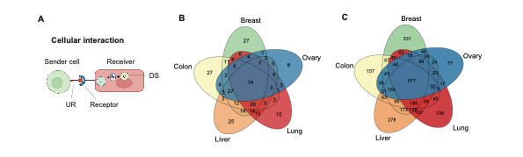
Figure S1. A) Molecular interactions between URs in any cell type and their DSs in any other cell type were predicted. B) The overlap of predicted URs among the five cancers and C) the overlap of DSs among cancers.

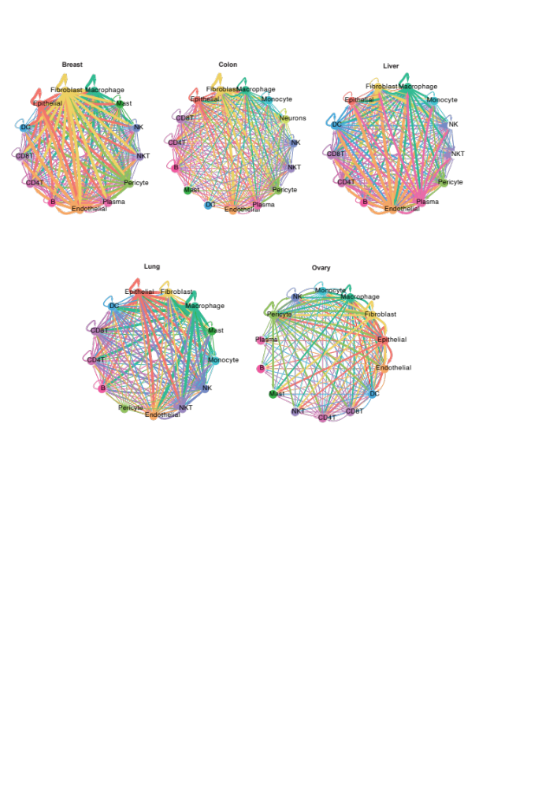
Figure S2. MCTMs for each cancer. Each dot represents one cell type, and the arrows directed interactions between cell types. The thickness of each arrow represents the number of interactions.

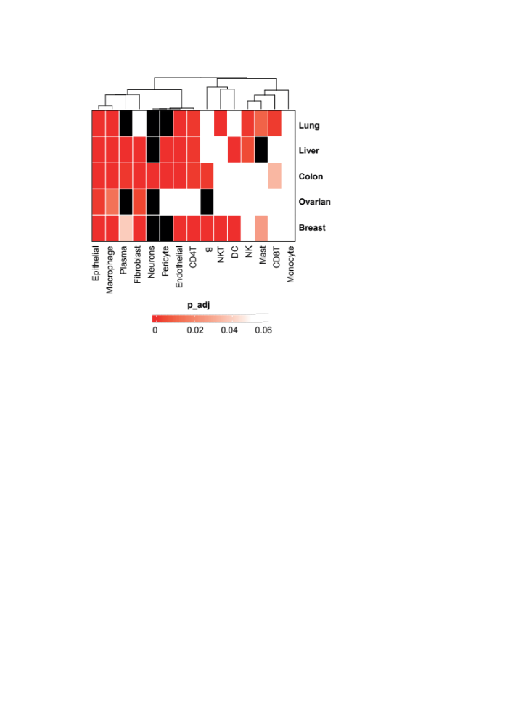
Figure S3. GWAS gene enrichment in each cell type of each cancer. White represents enrichment adjusted p-value > 0.05, and black represents no enrichment.

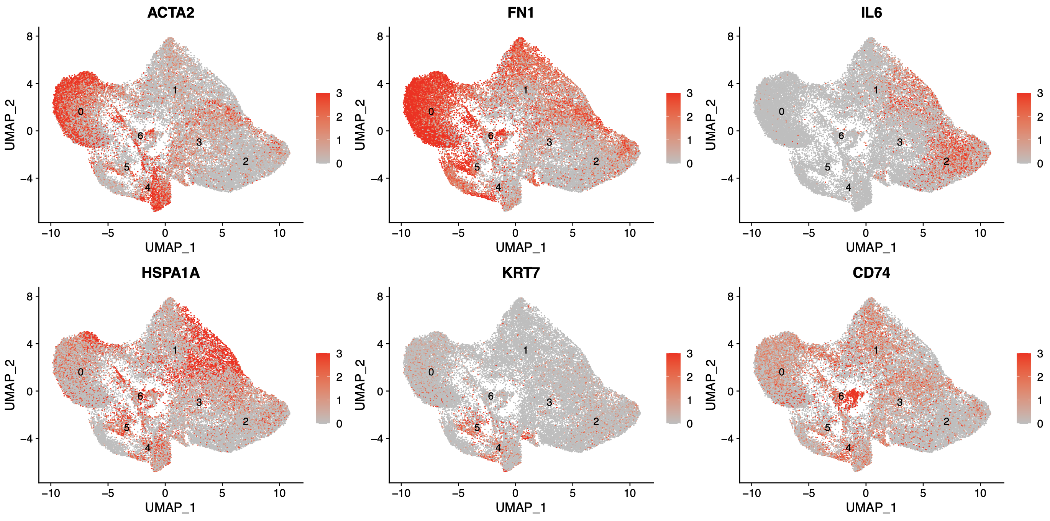
Figure S4. Feature plot for previous known CAF clusters. myCAF (C0 and C4): ACTA2^{high}IL6^{low}; iCAF (C2): ACTA2^{low}IL6^{high}; apCAF (C6): CD74; EMT-like CAF (C5): KRT7.

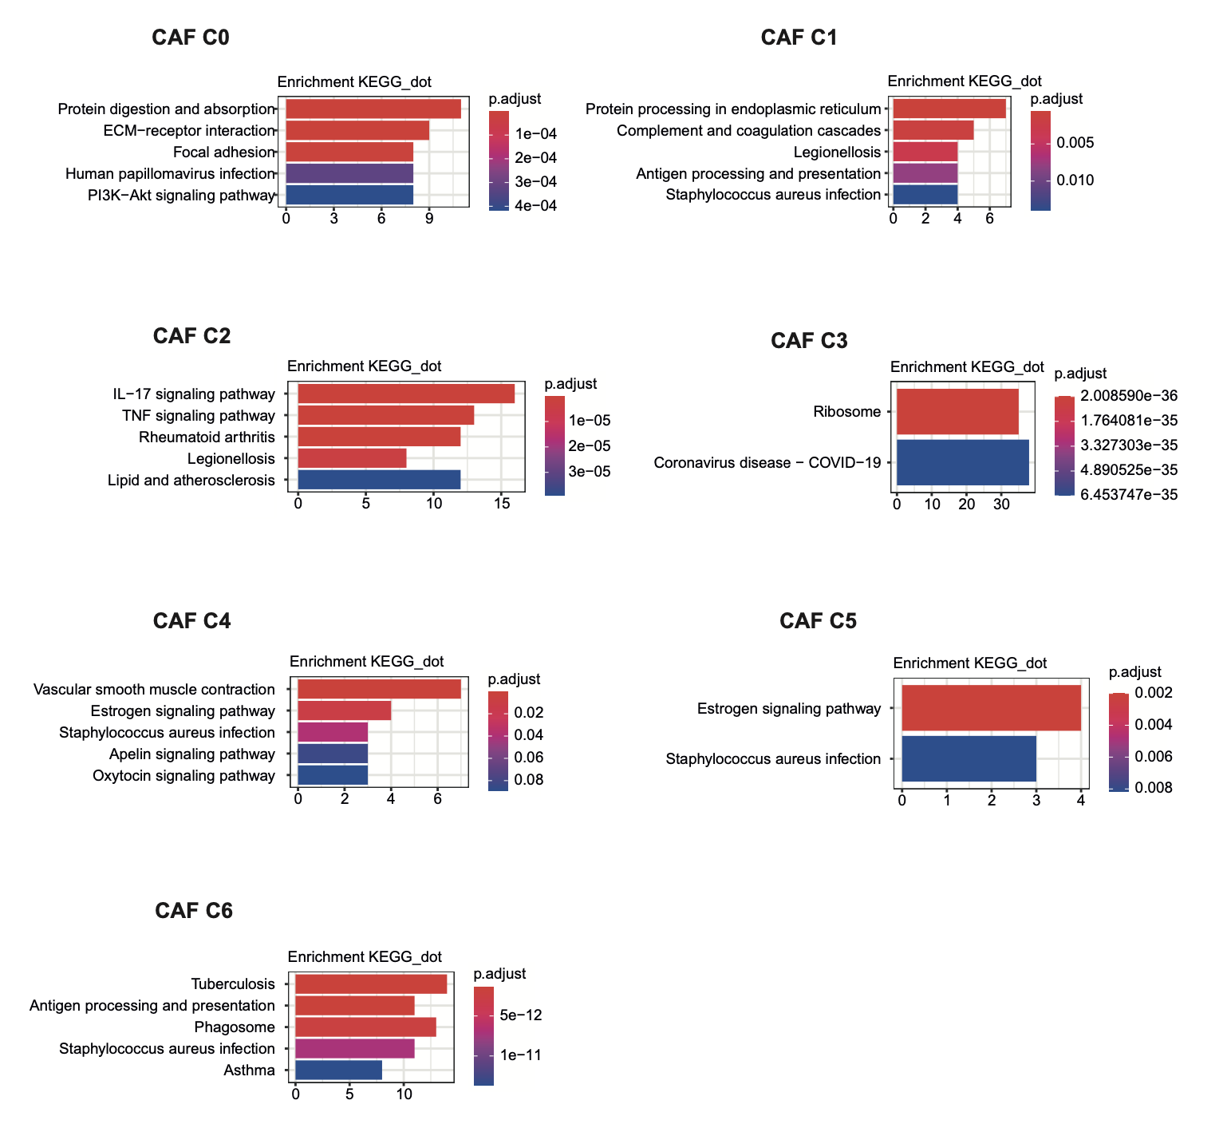
Figure S5. KEGG term enrichment of CAF subclusters.

Supplementary Notes
Additional Note 1. Identification of CAF subclusters.
All seven subclusters expressed canonical fibroblast markers such as ACTA2 (a-SMA) while each subcluster displayed distinct transcriptomic signatures (Fig. 4D) and highly diverse functions (Additional figure S5). CAF subcluster 0 was enriched with high level ACTA2 and low level of IL-6. This subcluster corresponded to known fibroblast subtype called mCAF[1]. The KEGG terms enriched for this subtype were associated with “protein digestion and absorption” and “ECM−receptor interaction”. Notably, the top signature gene of subcluster 0 (FN1 and COL1A1) were also the top shURs we identified in the previous step. Subcluster 1 was characterized by heat shock response proteins (HSPA1A, HSPA1B, HSPA6, DNAJB1), GSN, GPX3, IGFBP6, PI16 and complement system proteins (CFD) and was enriched in KEGG term “protein processing in endoplasmic reticulum” and “complement and coagulation cascade”. Thus, we designated this cluster as protein processing CAF (ppCAF). Subcluster 2 was classified as iCAF according to its high level of IL6 and low level of ACTA2 [2], it was enriched with inflammatory related pathways like “IL−17 signaling pathway”. Subcluster 3 was enriched in KEGG term “Ribosome” hence identified as rCAF. Subcluster 4, similar to subcluster 0, also characterized as subpopulation of myCAF (ACTA2^{high}IL6^{low}) [2]. However, it’s more related to “Vascular smooth muscle contraction” hence we define it as myCAF_v. Subcluster 5 agrees with previous known cluster EMT-like CAFs [2], it mainly expressed epithelium-specific marker genes such as KRT7, KRT8, KRT 18, and KRT19. Subcluster 6 expressed major histocompatibility complex II (MHC-II) genes such as CD74, HLA- DRA, HLA-DPA1 and HLA-DRB1, which consistent with a previous report CAF subtype of human pancreatic ductal adenocarcinoma (PDAC) [3]. We therefore termed them antigen-presenting CAFs (apCAFs) (Figure S2, S3).

1. Ma, C., et al., Pan-cancer spatially resolved single-cell analysis reveals the crosstalk between cancer-associated fibroblasts and tumor microenvironment. Molecular Cancer, 2023. 22(1): p. 170.
2. Han, C., T. Liu, and R. Yin, Biomarkers for cancer-associated fibroblasts. Biomark Res, 2020. 8(1): p. 64.
3. Elyada, E., et al., Cross-Species Single-Cell Analysis of Pancreatic Ductal Adenocarcinoma Reveals Antigen-Presenting Cancer-Associated Fibroblasts. Cancer Discov, 2019. 9(8): p. 1102-1123.

