Supplementary Materials
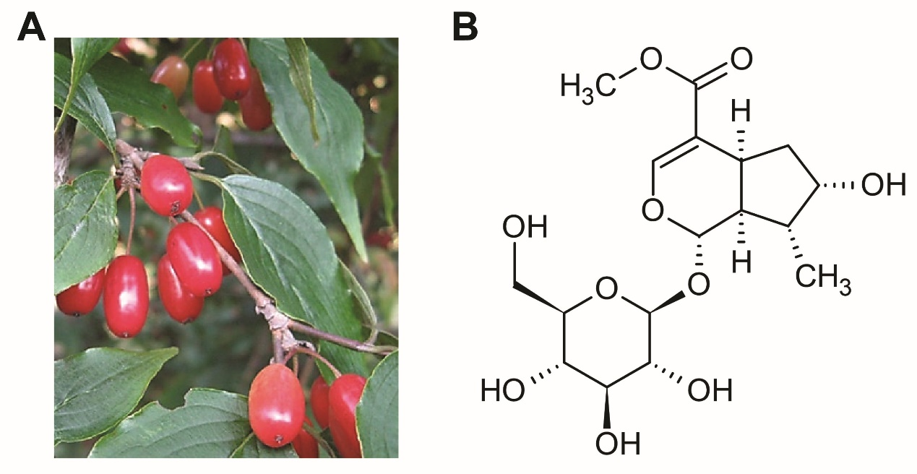
Figure. S1. Cornus officinalis plants with fruits (A) and the chemical structure of LOG (B)

