Support information

Synthesis of Metal-Free Benzimidazole-Based Catalysts and its Application in CO₂ Cycloaddition
ª Faculty of Chemical Engineering, Kunming University of Science and Technology, Kunming, 650500, PR China
*E-mail address: shansy411@163.com; zyf891123@163.com

1、FT-IR spectra of polymers
2、¹³C-MAS NMR spectra of BZI-COOH
3、XPS of BZI-COOH
4、TG curves of BZI-NH₂ and BZI-OH
5、Elemental analysis of the catalysts
6、Physical properties of different catalysts.
7、Yield and selectivity of cyclic carbonate catalyzed by BZI-OH
8、Comparison of catalytic activity between BZI-NH₂ and others.

1、FT-IR spectra of polymers

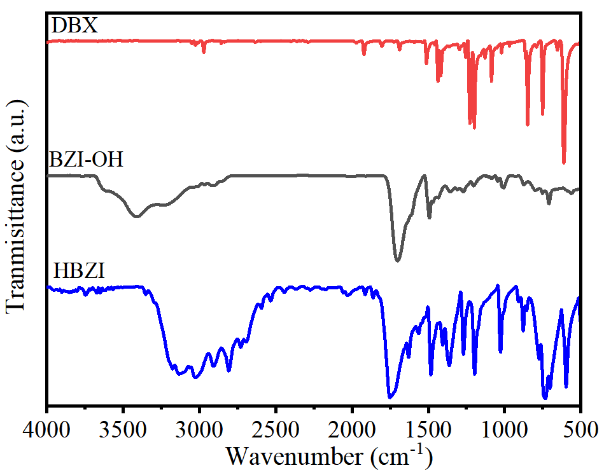
Fig. S1 FT-IR spectra of DBX, HBZI and BZI-OH.

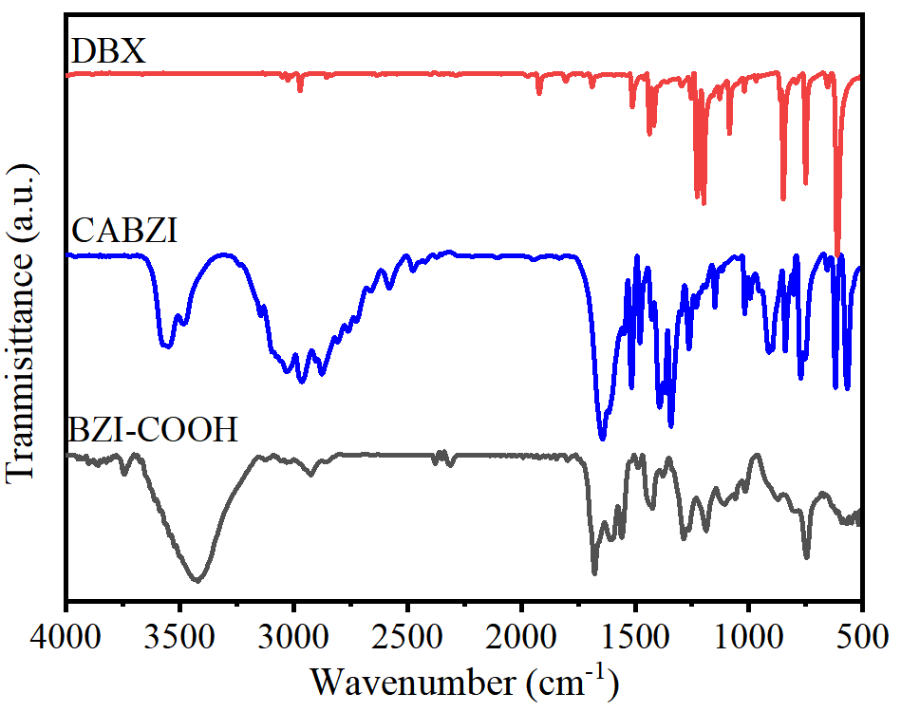
Fig. S2 FT-IR spectra of DBX, CABZI and BZI-COOH.
2、¹³C-MAS NMR spectra of BZI-COOH
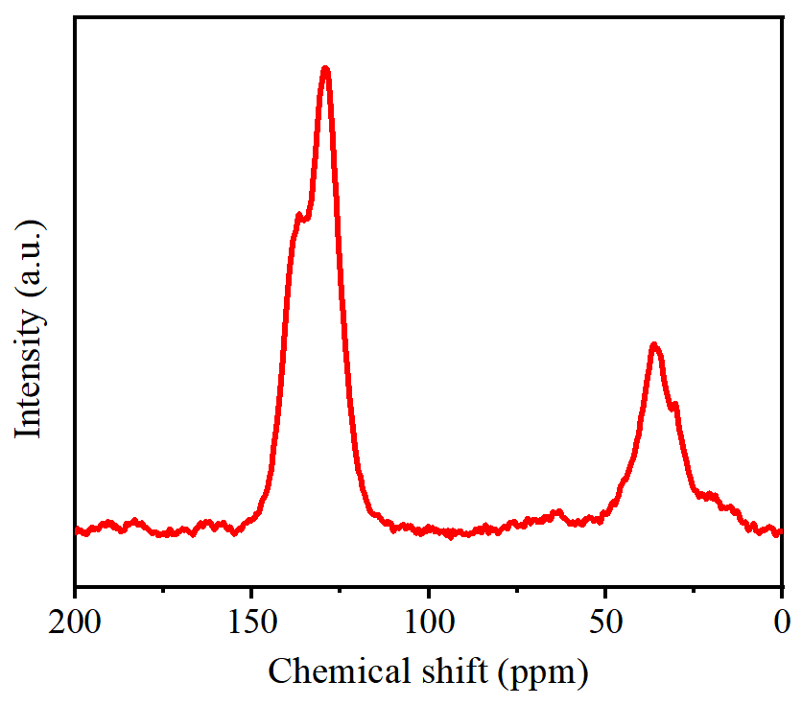
Fig. S3. ¹³C cross-polarization magic angle spinning (CP/MAS) NMR spectrum of BZI-COOH.

3、XPS of BZI-COOH
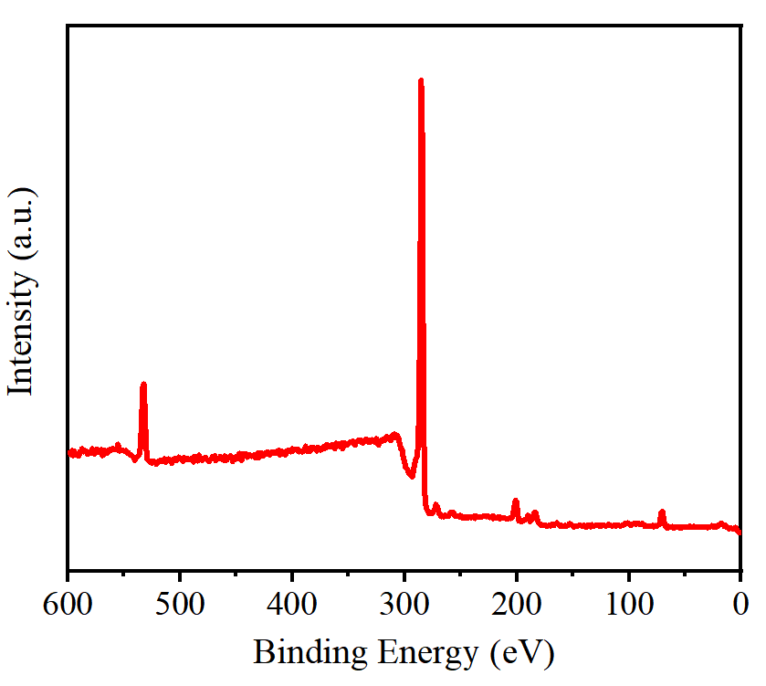
Fig. S4. Survey scan XPS of BZI-COOH.
4、TG curves of BZI-NH₂ and BZI-OH

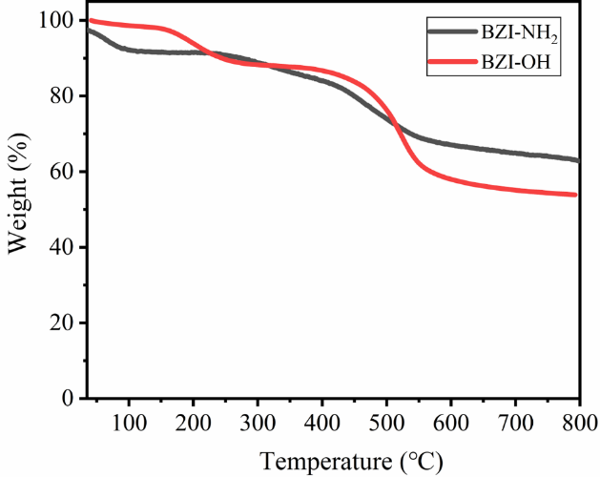
Fig. S5. TG curves of BZI-NH₂ and BZI-OH.

5、Elemental analysis of the catalysts

Table S1. Elemental analysis of the catalysts
Entry | Sample | C % | N % | H % | Br %
1 | BZI-NH₂ | 57.519 | 6.1795 | 5.913 | 1.38
2 | BZI-OH | 68.4015 | 7.5465 | 5.9765 | 2.91
3 | BZI-COOH | 72.933 | 1.504 | 4.43 | 2.49

6、Physical properties of different catalysts.

Table S2. Comparison of physical properties of different catalysts
Sample | S_{BET}(m²/g) | D_{ave} (nm) | V_{total} (m³/g) | IL contentª (mmol/g) | Ref.
BZI-NH₂ | 32 | 12.89 | 0.10 | 1.47 | This work
BZI-OH | 17 | 11.49 | 0.05 | 2.69 | This work
BZI-COOH | 370 | 3.35 | 0.31 | 0.54 | This work
HIP-Br-2 | 534 | 3.01 | 0.40 | 0.3 | [1]
HP-(BZPhIm)-Cl-DCX-1 | 763 | 5.64 | 1.08 | 0.732 | [2]
PIP-3 | 1019.29 | 0.47 | 0.85 | 2.03 | [3]
IHCP-4 | 407 | 0.14 | 0.41 | 0.39 | [4]
HPMBr0.5 | 196 | 0.05 | 0.17 | 2.13 | [5]
a Calculation based on nitrogen in IL.

7、Yield and selectivity of cyclic carbonate catalyzed by BZI-OH

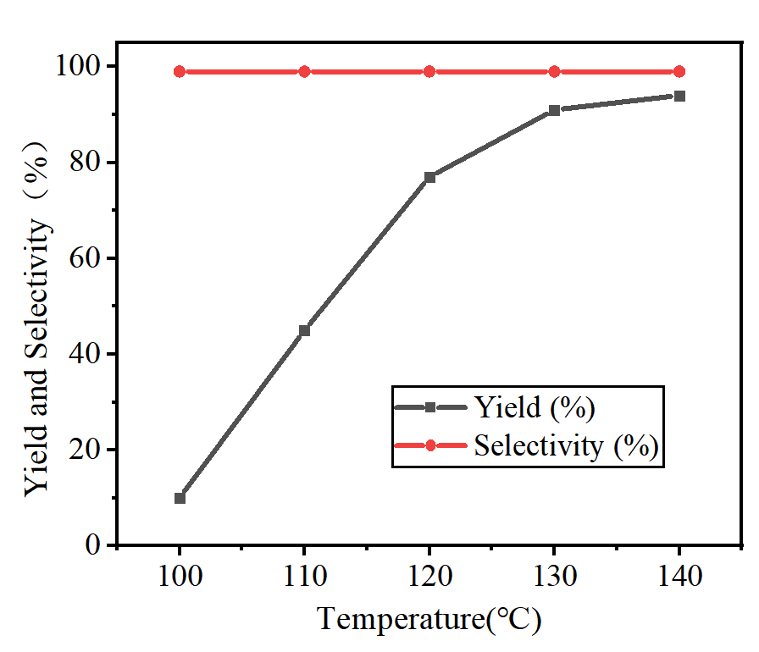
Fig. S5. Yield and selectivity of catalytic cyclic carbonates by BZI-OH at different temperatures.
8、Comparison of catalytic activity between BZI-NH₂ and others.

Table S3. Comparison of catalytic activity between BZI-NH₂ with several known metal-free heterogeneous catalysts.
Entry | Catalysts | Conditions | Yield (%) | Ref.
1 | BZI-NH₂ | 120℃, CO₂ 1.0 MPa, 7h | 97 | This work
2 | HPILs-Cl-2/TBAB | 70℃, CO₂ 0.1 MPa, 9h | 97 | [6]
3 | PIM2 | 130℃, CO₂ 1.0 MPa, 4h | 92 | [7]
4 | PDVB-HIL | 140℃, CO₂ 2.0 MPa, 3h | 97 | [8]
5 | P-HVD-2/3/5 | 140℃, CO₂ 1.0 MPa, 1.5h | 98 | [9]
6 | PDCX-OH | 70℃, CO₂ 0.5 MPa,24 h | 93 | [10]
7 | ChBr-Im (2:1) | 100℃, CO₂ 1.0 MPa, 4 h | 84 | [11]

References
1. Li J, Jia D, Guo Z, Liu Y, Lyu Y, Zhou Y, Wang J: Imidazolinium based porous hypercrosslinked ionic polymers for efficient CO₂ capture and fixation with epoxides. Green Chemistry 2017, 19:2675-2686.
2. Song H, Wang Y, Liu Y, Chen L, Feng B, Jin X, Zhou Y, Huang T, Xiao M, Huang F: Conferring poly (ionic liquid) s with high surface areas for enhanced catalytic activity. ACS Sustainable Chemistry & Engineering 2021, 9:2115-2128.
3. Cai K, Liu P, Zhao T, Su K, Yang Y, Tao D-J: Construction of hyper-crosslinked ionic polymers with high surface areas for effective CO₂ capture and conversion. Microporous and Mesoporous Materials 2022, 343:112135.
4. Gu J, Yuan Y, Zhao T, Liu F, Xu Y, Tao D-J: Ionic-containing hyper-crosslinked polymer: A promising bifunctional material for CO₂ capture and conversion. Separation and Purification Technology 2022, 301:121971.
5. Lyu H, Wang X, Sun W, Xu E, She Y, Liu A, Gao D, Hu M, Guo J, Hu K: Maximizing the ionic liquid content and specific surface area in hierarchically nanoporous hypercrosslinked poly (ionic liquid)s towards the efficient conversion of CO₂ into cyclic carbonates. Green Chemistry 2023, 25:3592-3605.
6. Sang Y, Huang J: Benzimidazole-based hyper-cross-linked poly (ionic liquid)s for efficient CO₂ capture and conversion. Chemical Engineering Journal 2020, 385:123973.
7. Wang Y, Nie J, Lu C, Wang F, Ma C, Chen Z, Yang G: Imidazolium-based polymeric ionic liquids for heterogeneous catalytic conversion of CO₂ into cyclic carbonates. Microporous and Mesoporous Materials 2020, 292:109751.
8. Dai W-L, Jin B, Luo S-L, Yin S-F, Luo X-B, Au C-T: Cross-linked polymer grafted with functionalized ionic liquid as reusable and efficient catalyst for the cycloaddition of carbon dioxide to epoxides. Journal of CO₂ Utilization 2013, 3:7-13.
9. He Y, Jiang D, Li X, Ding J, Li H, Wan H, Guan G: Efficient fixation of CO₂ into carbonates by tertiary N-functionalized poly (ionic liquids): Experimental-theoretical investigation. Journal of CO₂ Utilization 2021, 44:101427.
10. Jiang B, Liu J, Xiong W, Weng M, An J, Fan Y, Zheng L, Yang G, Zhang Z: A halogen-free hyper-crosslinked ionic polymer for efficient multi-conversion of CO₂ into carbonates under mild conditions, with a combination of theoretical study. Chemical Engineering Journal 2023, 476:146873.
11. Sheng T, Ou J, Zhao T, Yang X, Peng Y-X: Efficient fixation of CO₂ into cyclic carbonate catalyzed by choline bromide/imidazole derivatives-based deep eutectic solvents. Molecular Catalysis 2023, 536:112907.

