Supporting Information

Design and Synthesis of Novel Factor XIa Inhibitors with Bicyclic Isoquinoline and Naphthalene Fragments

Yi Zhang ^{#a}, Linjun Dai ^{#a}, Yi Tan ª, Yongpeng Yu ª, Junhao Xing ^{b}, Feng Yang ª, Boquan Ren ª, Yan-Jun Xu*, Qing Li *

ª College of Chemistry and Material Science, Sichuan Normal University, Chengdu, Sichuan 610066, China;
^{b} Department of Organic Chemistry and State Key Laboratory of Natural Medicines, China Pharmaceutical University, Nanjing, 210009, China
# Those authors contributed equally to this work.

E-mail: qingli2021@sicnu.edu.cn (Q. Li), xuyj@sicnu.edu.cn (Y. Xu)

Table of Contents

1. Figure S1. Superposition of the docking binding mode of asundexian with the crystal structure of asundexian……………S3
2. Figure S2. Docking binding mode of compound 6f in PKa…………………………………………………………………..S4
2. The IC₅₀ curves depicting the inhibitory activity of compounds against FXIa………………………………………………..S5
3. The IC₅₀ curves depicting the inhibitory activity of compounds against PKa ………………………………………………...S8
4. The IC₅₀ curves depicting the inhibitory activity of asundexian against FXIa and PKa.……………………………………...S11
5. NMR, HRMS and HPLC spectra of target compounds ………………………………………………………………….....S12

Figure S1. Superposition of the docking binding mode of asundexian (deepteal) with the crystal structure of asundexian (orange, PDB ID 8BO3). Receptors are represented in lines, and ligands are depicted in sticks.
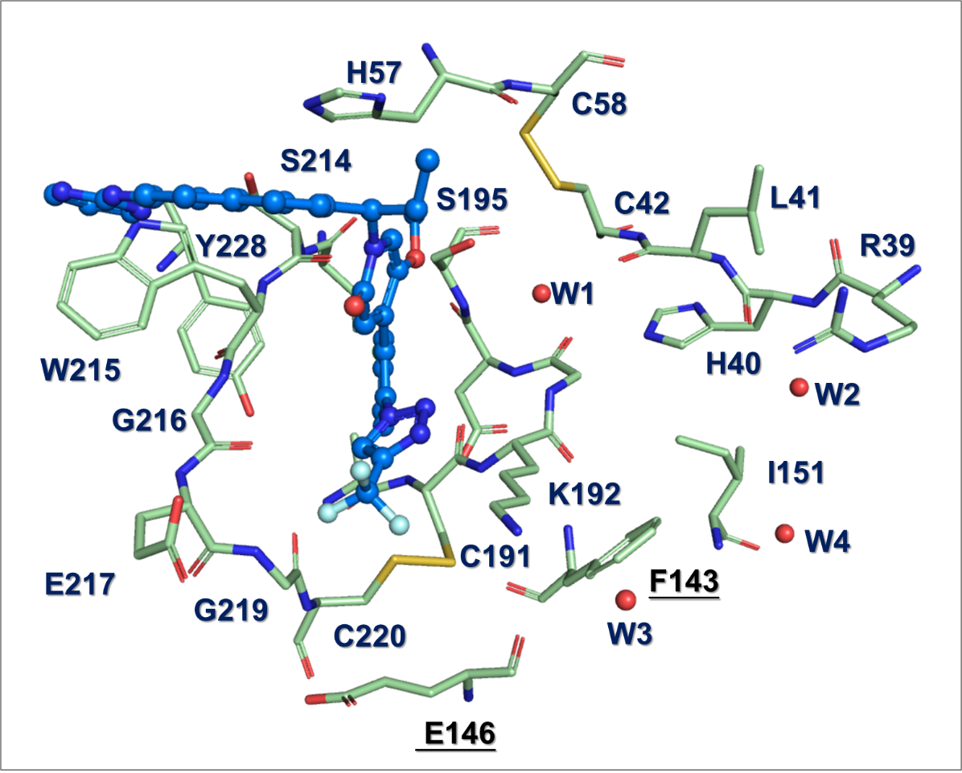
Figure S2. Docking binding mode of compound 6f in PKa. Receptors are depicted as lines, and ligands are represented in sticks.

The IC₅₀ curves depicting the inhibitory activity of compounds 5a-e against FXIa.

The IC₅₀ curves depicting the inhibitory activity of compounds 6a-g against FXIa.

The IC₅₀ curves depicting the inhibitory activity of compounds 7a-c against FXIa.

The IC₅₀ curves depicting the inhibitory activity of compounds 5a-e against PKa.

The IC₅₀ curves depicting the inhibitory activity of compounds 6a-g against PKa.

The IC₅₀ curves depicting the inhibitory activity of compounds 7a-c against PKa.

The IC₅₀ curves depicting the inhibitory activity of asundexian against FXIa and PKa.

NMR, HRMS and HPLC spectra of 5a
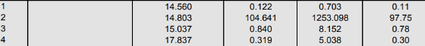
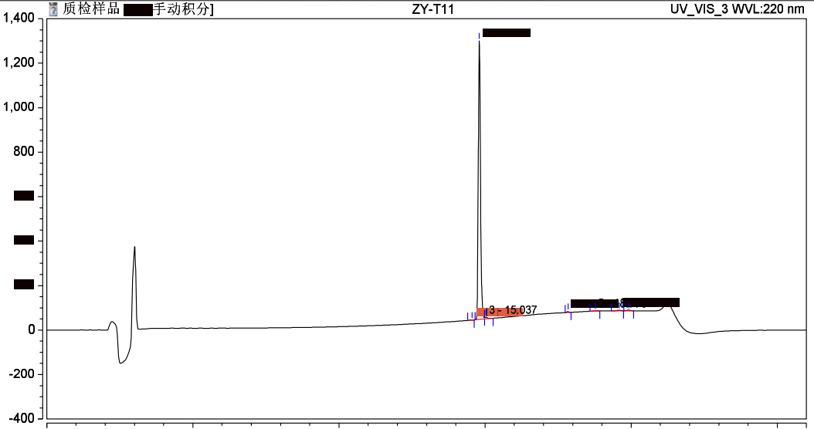

NMR, HRMS and HPLC spectra of 5b
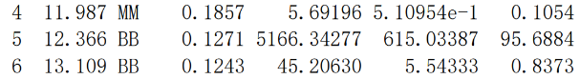
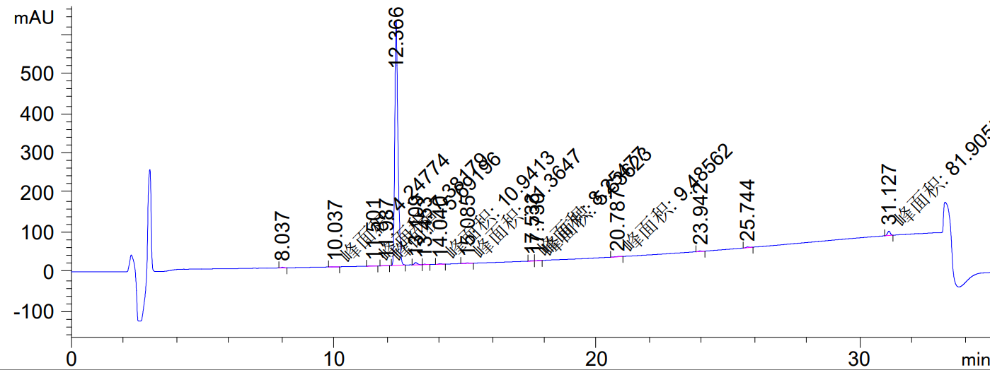
NMR, HRMS and HPLC spectra of 5c
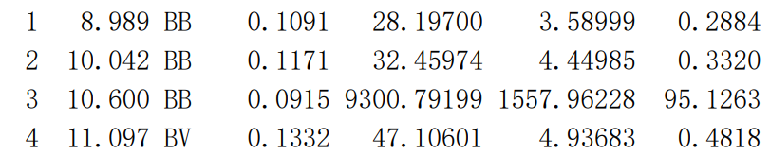
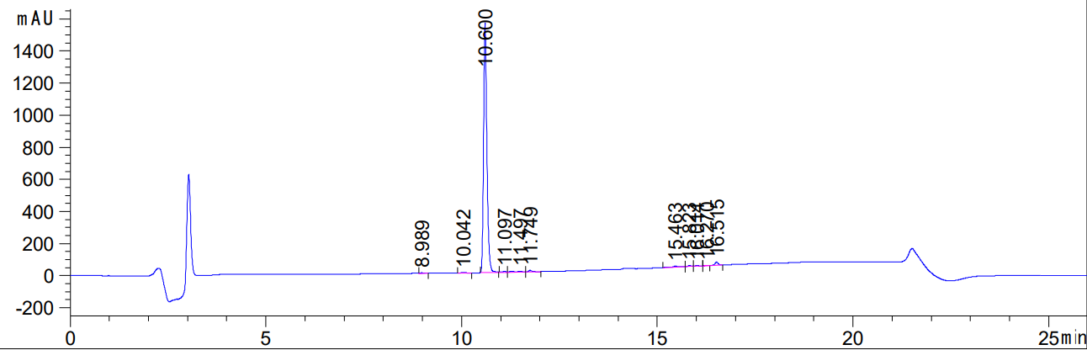
NMR, HRMS and HPLC spectra of 5d
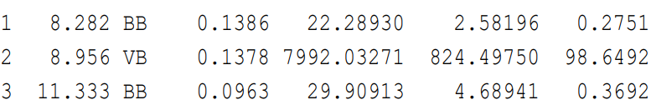
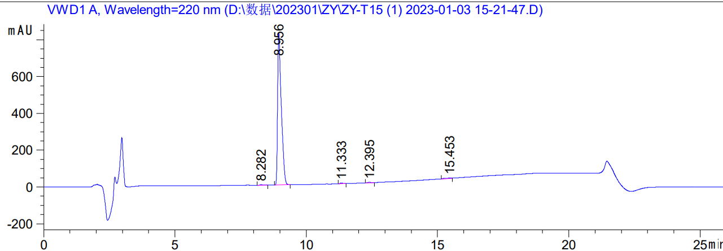

NMR, HRMS and HPLC spectra of 5e
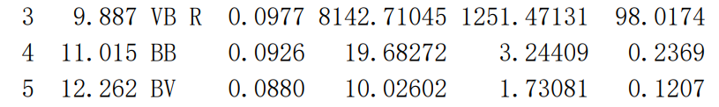
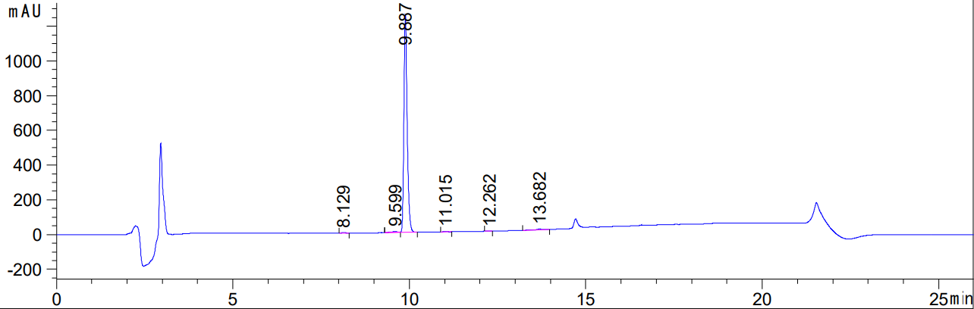
NMR, HRMS and HPLC spectra of 6a
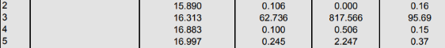
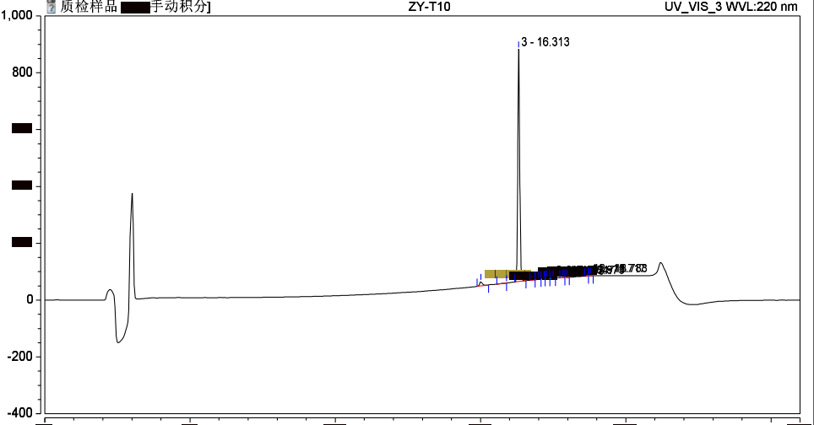

NMR, HRMS and HPLC spectra of 6b
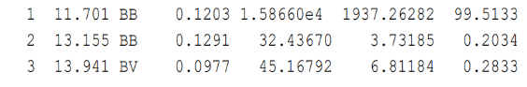
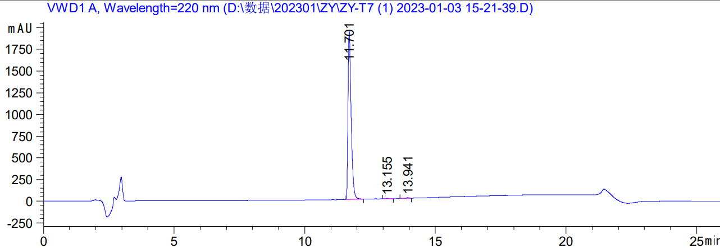

NMR, HRMS and HPLC spectra of 6c
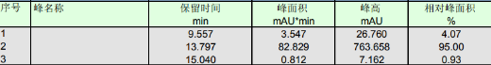
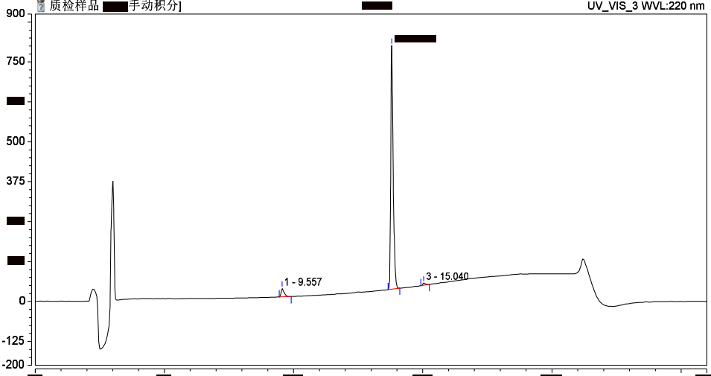

NMR, HRMS and HPLC spectra of 6d
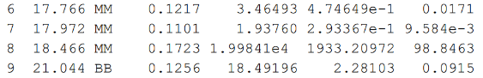
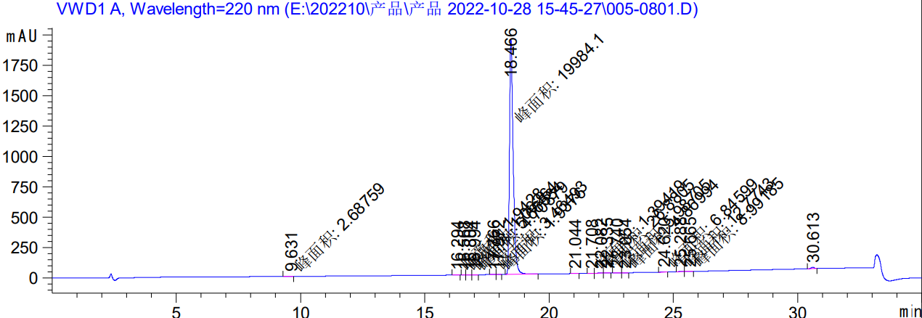

NMR, HRMS and HPLC spectra of 6e
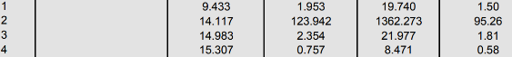
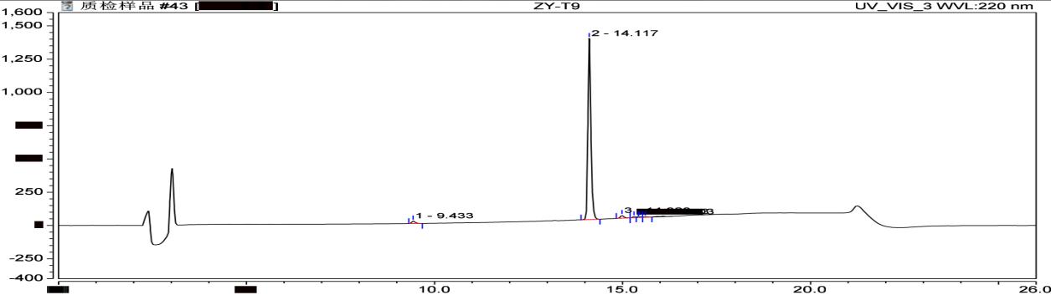

NMR, HRMS and HPLC spectra of 6f
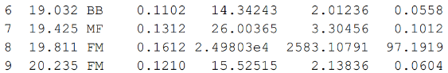
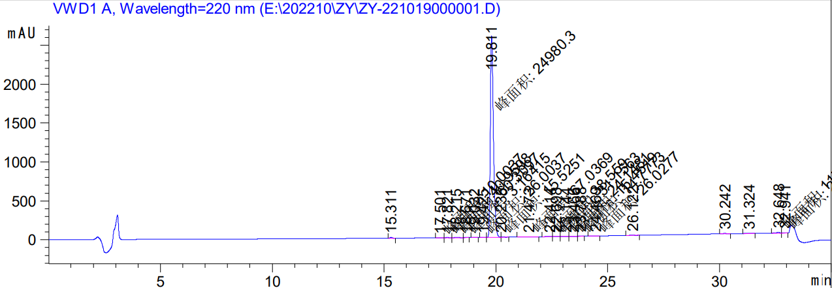

NMR, HRMS and HPLC spectra of 6g
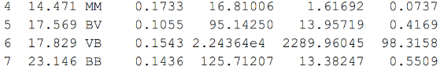
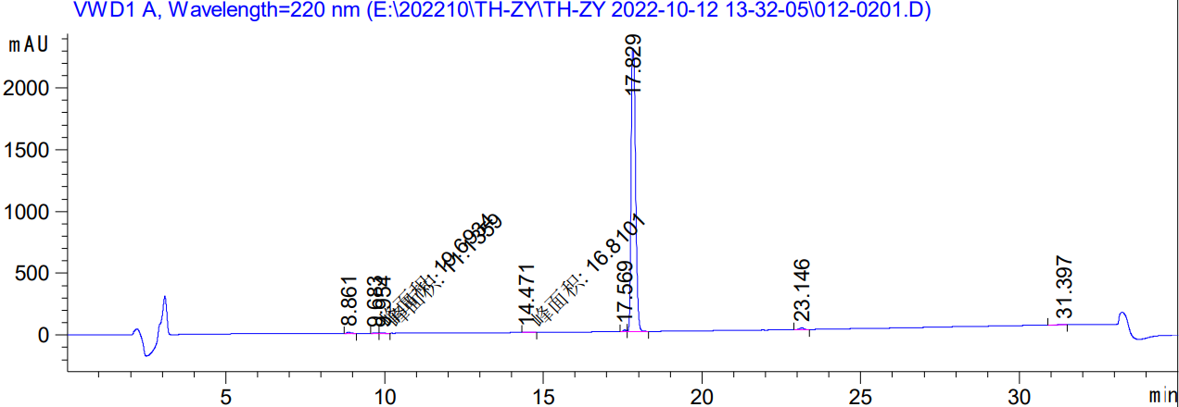
NMR, HRMS and HPLC spectra of 7a
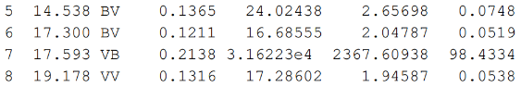
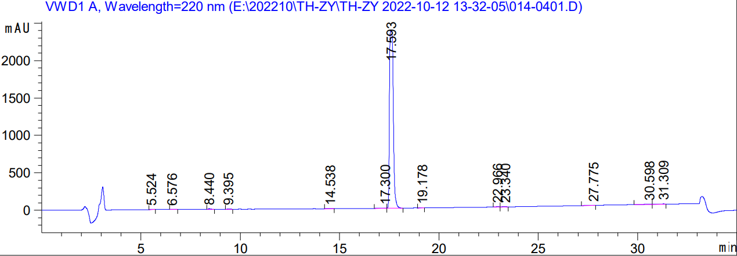

NMR, HRMS and HPLC spectra of 7b
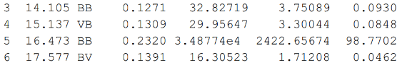
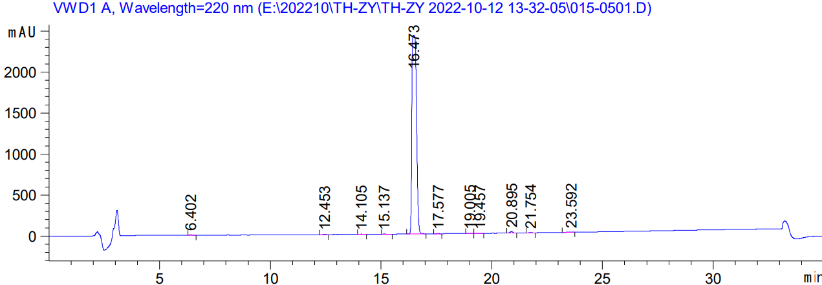

NMR, HRMS and HPLC spectra of 7c
