APPEDIX A

The following list provides examples of EI-focused training modules that were administered to the treatment group. It is important to note that this compilation is not exhaustive and is intended to illustrate a selection of the training modules employed in the study.
EI Sub-component | Training Activity  In each training session, a seasoned Special Forces soldier with extensive combat experience initiated the proceedings by sharing captivating narratives, recounting real-life situations, events, and anecdotes. These stories vividly depicted instances where the application of specific Emotional Intelligence (EI) skills played a crucial role in achieving success or ensuring survival. Conversely, the soldier also highlighted cautionary tales where the absence or neglect of these EI skills led to severe consequences, perilous situations, and even fatal outcomes.
Emotional perception (other)  Emotional perception (self) | Facial Expression Recognition:  Participants were presented with a series of images depicting various facial expressions associated with different emotions. They were then instructed to practice discerning and labeling the emotions conveyed in each image.  Tone of Voice Detection:  Participants listened to audio recordings of different individuals speaking, each with distinct tones of voice reflecting different emotions. They engaged in exercises aimed at identifying the emotional tone and labeling the specific emotions conveyed by each voice.  Non-Verbal Cues Observation:  Participants viewed videos depicting social interactions and scenarios involving individuals. They were tasked with practicing the observation of non-verbal cues, including body language, posture, gestures, and eye contact.  Emotional Aperture Detection:  Participants were shown visual imagery depicting diverse groups of people in various settings. Their objective was to identify the range of emotions present within each collective.  First Instance Sign of Stress Interoceptive Activity:  Participants were instructed to observe their initial indicators of stress and note where and how they typically experienced them. They were then asked to categorize these indicators as physical, mental, or emotional signals.  Emotional Naming: Name to Tame Activity:  Participants were prompted to document and name all the emotions they had encountered over the past week. They were then encouraged to reflect on the triggers or specific situations that elicited these emotions. Additionally, they were asked to consider the speed, direction, intensity, and duration of each emotion.  Attentional Focus Activity.  Participants took part in an attentional focus activity designed to induce anticipatory stress. Initially, they were instructed to perform the activity without any specific guidance. Subsequently, they were asked to repeat the activity while directing their attention to their breath, emotional state, and interoceptive awareness. The outcomes of both attempts were compared and analyzed.
Emotional understanding (others)  Emotional understanding (self) | Participants were presented with a variety of scenarios and were tasked with identifying the emotions they believed the characters would experience and providing explanations for their choices to demonstrate emotional contemplation and understanding.  Participants were provided with a list of descriptors and were required to determine which sentence accurately described possessing emotional understanding or lacking it.  Participants were shown unlabelled pictures of soldiers' faces taken before, during, and after combat deployment. Their objective was to match each picture with the corresponding timeframe, aiming to establish a connection between emotional perception and understanding.  Participants were presented with a grid of emotions and were instructed to predict the resulting emotion when two seemingly opposite emotions were blended together.  Participants were prompted to reflect on instances where they had encountered unexpected or unexplained emotions within themselves. They were encouraged to explore the reasons behind these emotions and engage in continuous self-reflection.  Participants received education on the potential risks associated with not considering the antecedents or consequences of their emotions. They were then invited to engage in a group discussion on their personal experiences to further explore this topic.
Emotional Facilitation (self and other) | Participants were educated on the concept that using emotional data can be a powerful tool for decision-making, problem-solving, adaptive thinking and enhancing interpersonal relationships. They were asked to recall and discuss times when they had used data to inform future behaviors.  Emotional Laddering Technique;  Participants were guided on how to intentionally influence their own emotions or the emotions of others by sequentially constructing statements that gradually shift emotions in their desired direction. They actively practiced this technique by applying it to internal emotions they wished to modify, as well as reflecting on recent interactions with individuals or groups.  To enhance their emotional vocabulary, participants were encouraged to expand their repertoire of emotion words and increase the granularity of their emotional expression. For example, if they initially described their emotion as "mad," they were prompted to generate as many synonyms as possible for the word "mad." This exercise aimed to enable participants to more precisely communicate their emotions to others, fostering improved interpersonal actions, connections, empathy, and understanding.  Participants engaged in discussions about instances where they had utilized emotional information to make decisions. They were prompted to explore the concept of predicting their future emotional state when confronted with specific circumstances. For example, they were asked to consider the potential consequences of contemplating a fight with their partner while sitting in a helicopter just before embarking on a perilous combat mission. Through these discussions, participants were encouraged to reflect on the potential impact of their emotional state on decision-making and operational outcomes.  "Using Emotions to Uncover True Values" activity; Participants were requested to disclose three negative emotions they commonly experience, such as "anger from being lied to" or "frustration at stupidity." Subsequently, they were prompted to transform these emotions by selecting an alternative emotion and its corresponding value from a set of cards. For instance, they could choose "happiness with honesty" or "feeling powerful in mastery" as their preferred emotional state and associated value.
Emotional Management (self)  Emotional Management (others) | Participants were educated on various aspects related to emotional management, including:  Understanding the stress response system, and associated physiological responses. The physiological, cognitive, emotional and behavioural consequences of unregulated emotion.  How to remain calm in challenging situations: They learned techniques and strategies to maintain composure and handle difficult circumstances with level-headedness and resilience.  The TKS; How to Manage Stress in the Moment:  (Details cannot be shared as this is a proprietary technique).  Resonant breathing training. They practiced with the McCalmBeat device 10 minutes a day twice a day for 6 weeks.  Practicing upregulating or downregulating emotions: They were taught how to harness their emotions to either increase motivation and energy levels or to calm and downregulate when necessary.  Participants were asked to identify their typical emotional management style and evaluate its adaptiveness, considering whether it was reactive, constructive, sustainable, or dissociative in nature. This exercise promoted self-reflection and encouraged participants to assess the effectiveness and long-term viability of their current emotional management approaches  Utilising mood to influence others effectively: Participants explored the ways in which their own emotional state can impact and influence the emotions and behaviours of those around them.

APPENDIX B
Stress activity 1: Stroop Shoot
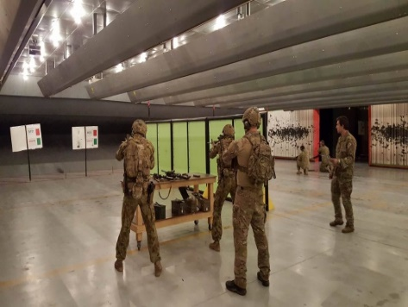
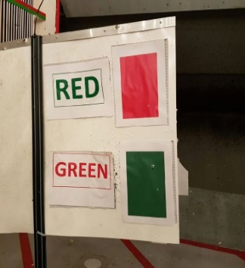

Stress activity 2: Tower rappel
