Supplementary Materials:
Supplementary Figure 1 The procedure of candidate gene knockdown stable cell lines establishment. A The design of short hairpin RNA and construction of plasmid. B pGreen plasmid were co-transfected with packaging plasmids into HEK293T cells; then the lentivirus supernatants were harvested 48 hours later. C Stable transfected K562 cells were established by infected with the lentivirus supernatants. D Stable transfected K562 cells were selected using puromycin. E The effciency of candidate gene knockdown by short hairpin RNA was detected by qRT-PCR

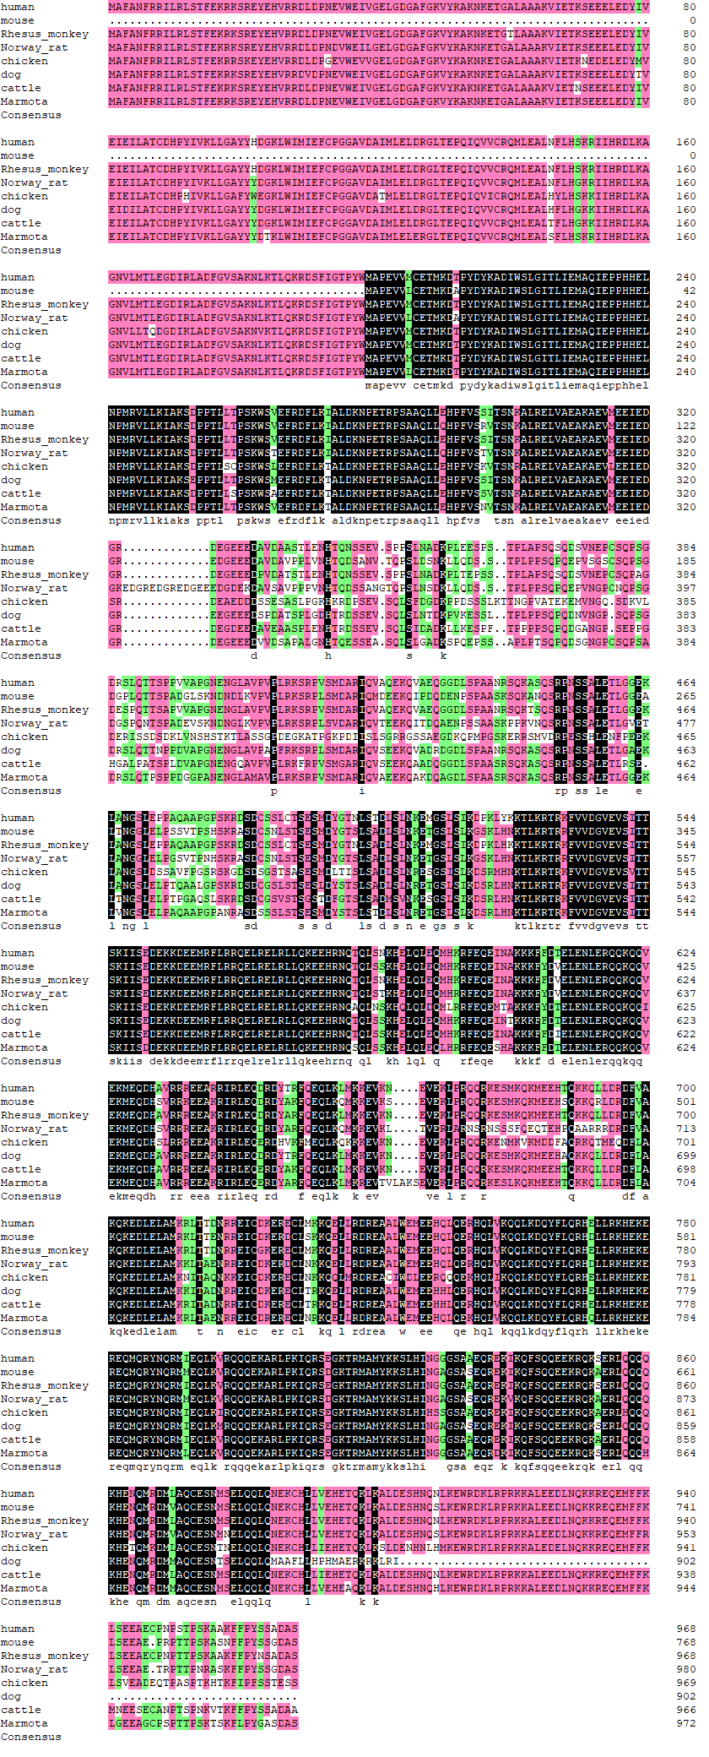
Supplementary Figure 2 Multiple sequence alignment for human STK10 and orthologs

