Supporting Information
H₂S-driven Chemotherapy and Mild Photothermal Therapy Induced Mitochondrial Reprogramming to Promote Cuproptosis
Lihong Qiao ^{1, 2, 3}, # Yijing Ou ¹, # Lin Li ¹, # Shuzhen Wu ¹, Yanxian Guo ¹, Mu Liu ¹, Dongsheng Yu ³, Qinghua Chen ³, Jianmin Yuan ³, Chuanqi Wei ³, Chiyi Ou ³, Haowen Li ³, Du Cheng ³*, Zhiqiang Yu ²* and Zhongjun Li ¹*

¹ Dongguan Key Laboratory of Major Diseases in Obstetrics and Gynecology，The Tenth Affiliated Hospital of Southern Medical University（Dongguan people's hospital），Dongguan, Guangdong 523058, People’s Republic of China.
² Department of Laboratory MedicineDongguan Institute of Clinical Cancer Research the Tenth Affiliated Hospital of Southern Medical University (Dongguan People’s Hospital) Dongguan, Guangdong 523058, People’s Republic of China.
³ Key Laboratory for Polymeric Composite & Functional Materials of Ministry of Education, School of Materials Science and Engineering, Sun Yat-sen University, Guangzhou 510275, People’s Republic of China.
# These authors contributed equally to this work.

E-mail: chengdu@mail.sysu.edu.cn; yuzq@smu.edu.cn and Zhongjun@gdmu.edu.cn.
Experimental Section
Materials: Cupric chloride (CuCl₂·2H₂O), hydrogen peroxide (30% H₂O₂), NaOH, tirapazamine (TPZ), hyaluronic acid (HA), rhodamine B, indocyanine green (ICG), 2′,7′-dichlorofluorescin diacetate (DCFH-DA), 3-(4,5-dimethyl-2-thiazolyl)-2,5-diphenyl-2-H-tetrazolium bromide (MTT), sodium hydrosulfide, and DAPI were purchased from Aladdin (China). All antibodies were purchased from Abcam. All reagents were purchased from commercial sources and used without further treatment.
Characterization: Fourier transform infrared spectra were recorded on a Bruker Vertex 70 spectrometer. UV-Vis absorption spectra were acquired using a Shimadzu UV-2450 spectrophotometer. An X-ray diffractometer (Bruker AXS D8 Focus) was operated using Cu Ka radiation (λ = 1.54056 Å). Nanoparticle zeta potential was analyzed using a Zetasizer Nano-ZS (Malvern Instruments Ltd.). Transmission electron microscopy (TEM) images were recorded with a FEI-TECNAI G2 transmission electron microscope operating at 120 kV. Electron spin resonance (ESR) spectra were conducted on an EMXplus spectrometer (Bruker, Germany). Inductively coupled plasma-mass spectrometry (ICP-MS) were carried out on an Agilent 7700x series ICP-MS instrument.

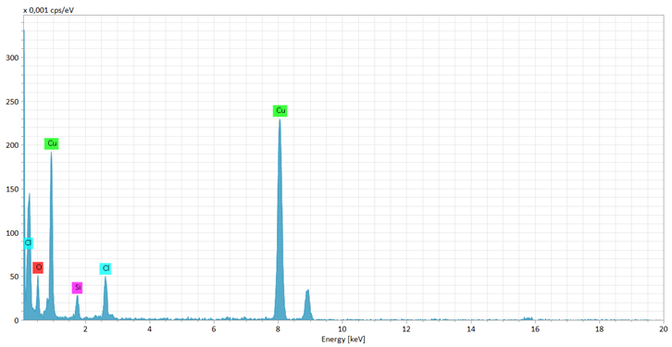
SI 1. EDS of TPZ@CuO NPs.

SI 2. TPZ loading content was recorded by UV-Vis.

SI 3. Cu 2p XPS of TPZ@CuO NPs.

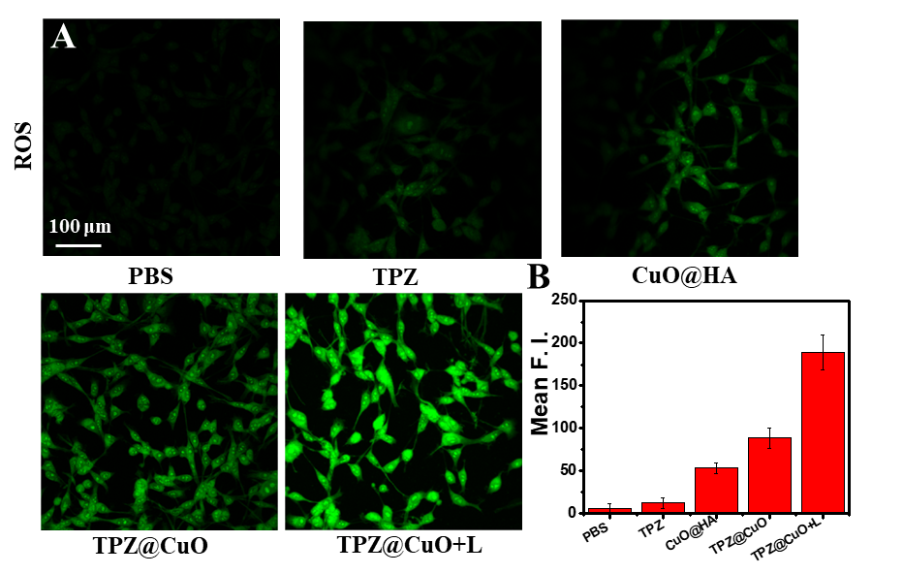
SI 4. (A) CLSM images of CT26 cells after co-incubation with PBS, TPZ, CuO@HA, TPZ@CuO, or TPZ@CuO+L for 6 h, followed by staining with the •OH fluorescence probe DCFH-DA. (B) Mean fluorescence intensity (Mean F. I.) image of •OH fluorescence probe.

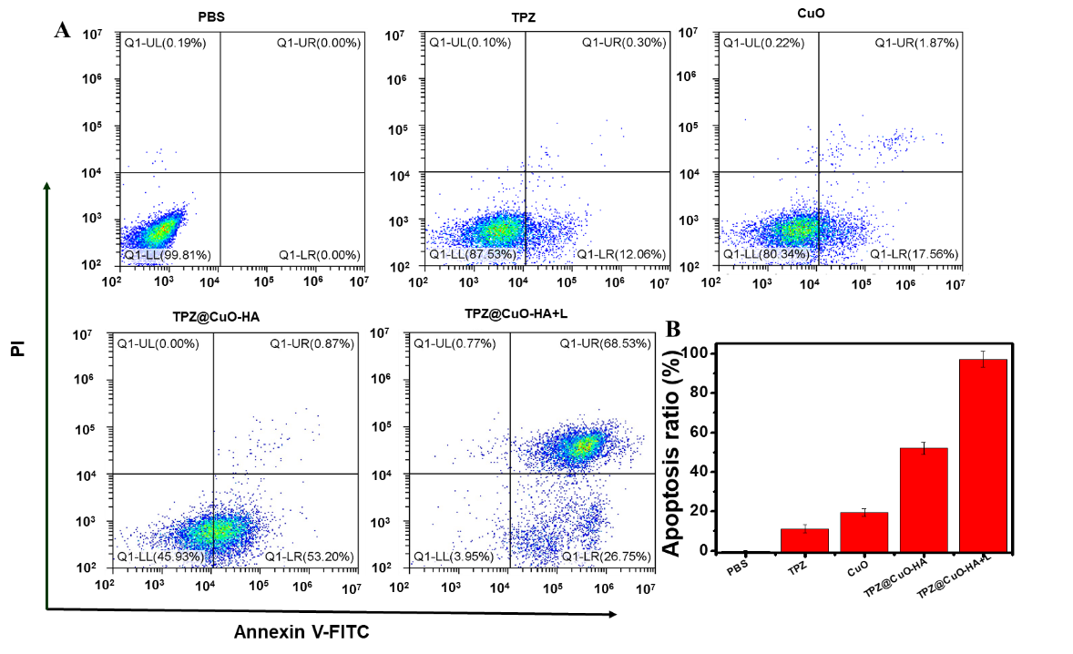
SI 5. (A) Flow cytometry analysis of apoptosis among cells co-incubated with PBS, TPZ, CuO@HA, TPZ@CuO, or TPZ@CuO+L (100 µg/mL) for 12 h. (B) Semi-quantification of apoptosis rate among CT26 cells treated with PBS, TPZ, CuO@HA, TPZ@CuO, or TPZ@CuO+L (100 µg/mL) via flow cytometry (FCM).

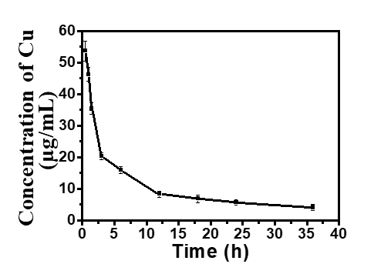
SI 6. Cu content in blood at various time points according to ICP-MS.

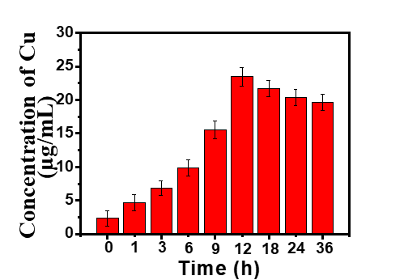
SI 7. Cu content in tumors at various time points according to ICP-MS.

SI 8. Weight (g) curves of mice were treated with PBS, TPZ, CuO@HA, TPZ@CuO, and TPZ@CuO + 1064 nm laser groups.

SI 9. In vitro tumor weight (g) comparison among all groups.

