Supplementary information for
Optimization of protoplast isolation and transient expression systems for lettuce (Lactuca sativa L.) and other important dicotyledon vegetables

Lei Xiang^{1, a}, Rui-Xin Li ^{1, a}, Qing-Jun Zheng ª, Zan-Tang Huang ^{b}, Peng-Fei Yu ª, Zhuo-Xing Shi ª, Yan-Wen Li ª, Hai-Ming Zhao ª, Quan-Ying Cai ª, Xue-Wen Hou *^{,b}, Ce-Hui Mo*^{, a}, Qing X. Li ^{c}

ª Guangdong Provincial Research Center for Environment Pollution Control and Remediation Materials, College of Life Science and Technology, Jinan University, Guangzhou 510632, China

^{b} Center for Photosynthesis and Plant Stress Biology, College of Life Sciences, South China Agricultural University, Guangzhou 510642, China.

^{c}Department of Molecular Biosciences and Bioengineering, University of Hawaii at Manoa, Honolulu, HI, 96822, USA

*Corresponding authors
E-mail: hxw1969@scau.edu.cn (Xue-Wen Hou)
tchmo@jnu.edu.cn (Ce-Hui Mo).

Lei Xiang ¹ and Rui-Xin Li ¹ contribute equally to this manuscript.

It includes
1 text
3 Figures
2 table
9 pages

Text 1. The growth conditions for the selected plants in this study
Three subtypes of lettuces (3 romaine, 1 loose-leaf, and 1 head lettuces) and other four crop species (celery cabbage, bok choy, water spinach, and Arabidopsis) were selected for plant materials in this study. All of them came from hydroponic cultivation. Briefly, seeds of the plants were respectively germinated in medium. Uniform seedlings for each variety of plant were loaded into 8 L of polypropylene boxes for hydroponic cultivation with twelve plants per box. Half concentration of Hoagland’s nutrient solution (pH = 6.0) was used in the hydroponic cultivation, which contained 2.5 mM Ca(NO₃)₂·2H₂O, 2.5 mM KNO₃, 1 mM MgSO₄·7H₂O, 0.5 mM KH₂PO₄, 0.05 mM EDTA-Fe, 23.5 μM H₃BO₃, 0.5 μM MnCl₂·4H₂O, 0.5 μM ZnSO₄·7H₂O, 0.005 μM H₂MoO₄, and 0.125 μM CuSO₄·5H₂O.
The hydroponic cultivation was performed in a greenhouse at natural temperature (25 ± 2°C). The used Hoagland’s nutrient solution was replenished, based on the evaporation capacity and change of the pH value. Five-week uniform seedlings were collected for isolation of protoplasts.
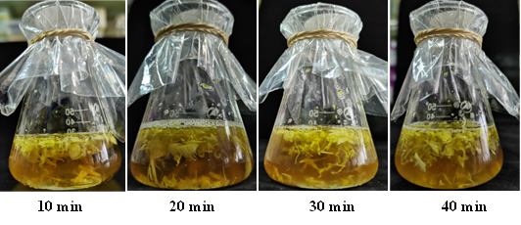
Fig. S1 The effects of vacuum time on permeation of the enzymatic hydrolysis solution.
The figure indicated that the enzymatic hydrolysis solution was not well permeated until the vacuum time at 40 min.

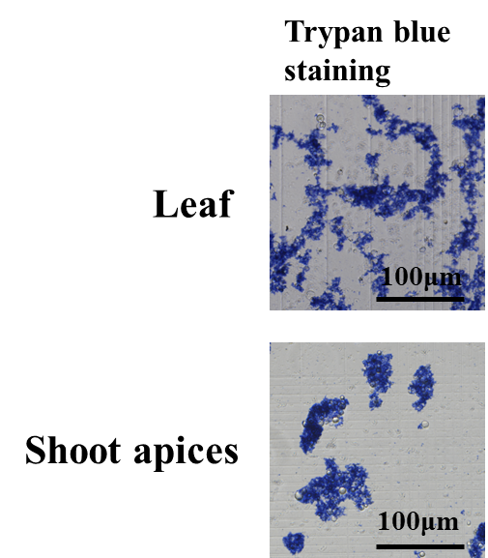
Fig. S2 Protoplasts isolation of leaves and shoot apices from lettuce based on trypan blue staining
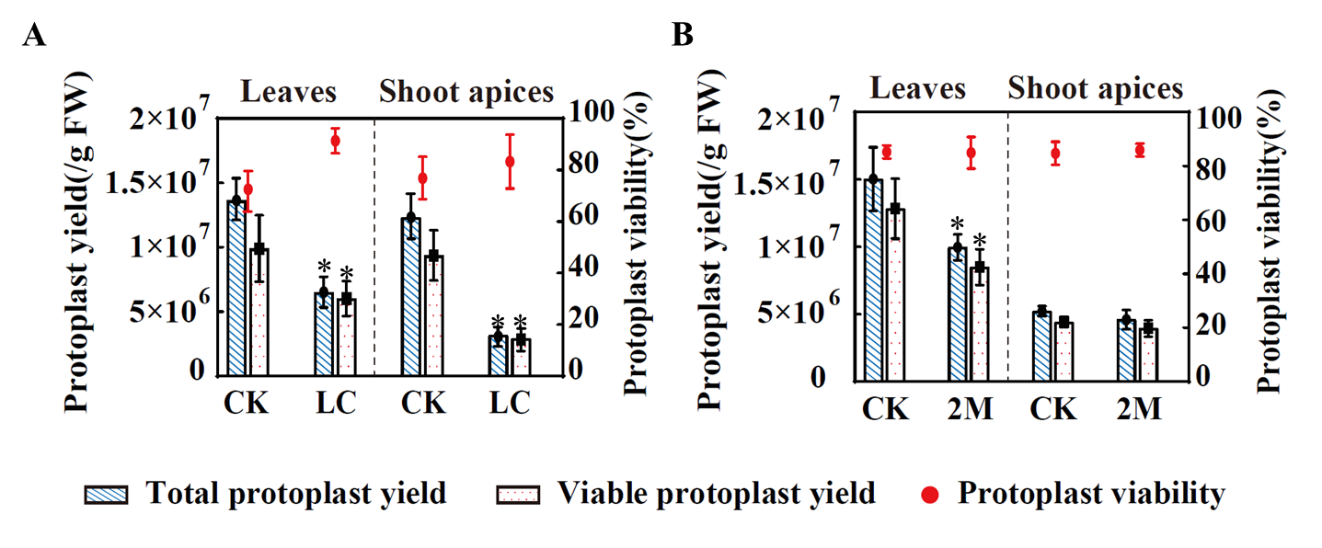
Fig. S3 Effects of L-cysteine (LC, 2.48 mM) (A) and 2-mercaptoethanol (2M, 5 mM) (B) on protoplasts yield and viability.
CK means the control treatment without addition of LC or 2M.
“*” means the significant difference between CK and LC or 2M treatment at p < 0.05.
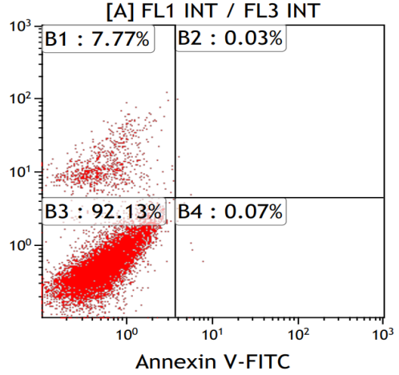
Fig. S4 The flow cytometry of shoot apex protoplasts using the optimal isolation protocol.
The flow cytometry uses double staining with propidium iodide (PI)- and fluorescein isothiocyanate-labeled Annexin V, with the results expressed as % of total cells.

Table S1 Primers used to construct transient expression vectors
Gene | Primers
LsAAP2 | ORF-1-EcoRI-F: 5′-AGAATTCATGGGTGCCGATAACGCTGCCGGA-3′
LsAAP2 | ORF-1458-BamHI-R: 5′-AGGATCCCATACATTGTCTTGAACGGCTGATAG-3′
LsALMT10 | ORF-1-EcoR1-F: 5′-AGAATTCATGGCAACATGGTTGGAAATGG-3′
LsALMT10 | ORF-1614-BamHI-R: 5′-TGGATCCCGAGAGCCAAACGGTACTGAAAGC-3′
LsOATP | ORF-1-SacI-F: 5′-AGAGCTCAATGCATGAATATTCTGAAATAAG-3′
LsOATP | ORF-1494-BamHI-R: 5′-AGGATCCCTAGCAAAGCAGAAATAGTATCTCC-3′
LsABCG22 | ORF-1-SacI-F: 5′-AGAGCTCAATGGAGAAACCGAATTCGAGTTC-3′
LsABCG22 | ORF-2217-BamHI-R: 5′-AGGATCCCCAAATGTCTCAAAGACAAGTAAGC-3′

Table S2 Comparisons in yield and viability of the isolated protoplasts between this study and the previous studies.
Species | Tissue | Protoplast yield | Protoplast viability (%) | Enzyme combination | Year | Reference | Reference
Arabidopsis thaliana | Whole aerial tissue or first true leaves | 2.0*10⁶ cells/mL | - | 1.25% C1 + 0.30% M | 2020 | Lopez-Anido et al. | [1]
Arabidopsis thaliana | Shoot apices | 1.5-2.0*10⁶ cells/ mL | - | 1.50% C1 + 1.50% M | 2021 | Zhang et al. | [2]
Arabidopsis thaliana | Primary root tips | 1.0*10⁴ cells/mL | - | 1.25% C1 + 0.10% P2 | 2021 | Ryu et al. | [3]
Arabidopsis thaliana | Mature leaves vascular | - | - | 1.00% C1 + 0.30% M | 2021 | Kim et al. | [4]
Maize | Leaf primordia | - | - | 1.50% C1 + 1.00% M + 1.50% C2 + 1.00% HC | 2020 | Satterlee et al. | [5]
Maize | Primary and seminal root tips (4-5 mm) | - | - | 1.20% C1 + 0.40% M + 1.20% C2 + 0.36% P1 | 2018 | Ortiz-Ramírez et al. | [6]
Rice | Radicle tips (1cm) | 1.5-2.0*10⁶ cells/ mL | >85.00 | 4.00%C1 + 1.50% M | 2021 | Zhang et al. | [7]
Rice | Crown roots | 1.0-1.2*10⁶ cells/ mL | >90.00 | 0.75% M + 2.00% C2 + 0.50% P1 + 1.00% HC | 2020 | Liu et al. | [8]
Rice | - | 5.0*10⁴ cells/mL | - | 1.00% M + 1.00% C2 | 2013 | Sasamoto et al. | [9]
Cymbidium orchids | Young leaves | ~3.22*10⁶/g FW | - | 1.20% C1 + 0.60% M | 2021 | Ren et al. | [10]
Cymbidium orchids | Flower pedicels | ~5.26*10⁶/g FW | - | 1.20% C1 + 0.60% M | 2021 | Ren et al. | [10]
Cymbidium orchids | Young root tips | ~7.66*10⁵/g FW | - | 1.20% C1 + 0.60% M | 2021 | Ren et al. | [10]
Coffee | Leaves | - | - | 1.00% C2 + 1.00% D | 2020 | Ogita et al. | [11]
Mucuna pruriens | Leaves | 3.0*10⁶cells/mL | - | 1.00% M + 1.00% C2 + 1.00% HC | 2013 | Sasamoto et al. | [9]
Lettuce | Cotyledons | - | - | 1.00% M + 1.00% C2 | 2020 | Ogita et al. | [11]
Lettuce | Leaf | 1.9*10⁶ cells/g | 80 | 1.5% HC + 0.5%M | 1987 | Brown et al. | [12]
Lettuce | Leaves | 2.0*10⁵cells/mL | - | 1.00% M + 1.00% C2 | 2013 | Sasamoto et al. | [9]
Lettuce | Root | 3.0*10⁴cells/mL | - | 1.00% C2 + 0.20% P1 + 1.00% D | 2013 | Sasamoto et al. | [9]
Lettuce | Leaves | 1.95*10⁷cells/mL | 91.75 | 1.50% C1 + 0.50% M | - | This study
Lettuce | Shoot apices | 1.10*10⁷cells/mL | 86.26 | 1.50% C1 + 0.50% M | - | This study
Chinese cabbage | Leaves | 1.13*10⁷cells/mL | 81.15 | 1.50% C1 + 0.50% M | - | This study
Chinese cabbage | Shoot apices | 6.90*10⁶cells/mL | 86.41 | 1.50% C1 + 0.50% M | - | This study
Chinese flowering cabbage | Leaves | 7.51*10⁶cells/mL | 88.22 | 1.50% C1 + 0.50% M | - | This study
Chinese flowering cabbage | Shoot apices | 8.92*10⁶cells/mL | 86.45 | 1.50% C1 + 0.50% M | - | This study
Water spinach | Leaves | 4.23*10⁵cells/mL | 86.19 | 1.50% C1 + 0.50% M | - | This study
Water spinach | Shoot apices | 3.57*10⁶cells/mL | 68.70 | 1.50% C1 + 0.50% M | - | This study
Arabidopsis thaliana | Leaves | 5.20*10⁶cells/mL | 89.01 | 1.50% C1 + 0.50% M | - | This study
C1, cellulase R-10 (Yakult); M, macerozyme R-10 (Yakult); C2, cellulase RS (Yakult); P1, pectolyase Y-23 (Yakult); P2, pectolyase (Sigma-Aldrich); D, driselase; HC, hemicellulose.

References:

1. Lopez-Anido C., Vatén A, Smoot N., Sharma N, Guo V, Gong Y, Anleu G. Ximena, Weimer A, Bergmann D. Single-cell resolution of lineage trajectories in the Arabidopsis stomatal lineage and developing leaf. Dev Cell. 2021; 56(7):1043-55. e4.
2. Zhang T, Chen Y, Liu Y, Lin W, Wang J. Single-cell transcriptome atlas and chromatin accessibility landscape reveal differentiation trajectories in the rice root. Nat Commun. 2021; 12(1):2053.
3. Ryu K, Huang L, Kang H, Schiefelbein J. Single-cell RNA sequencing resolves molecular relationships among individual plant cells. Plant Physiol. 2019; 179(4):1444-56.
4. Kim J, Symeonidi E, Pang T, Denyer T, Weidauer D, Bezrutczyk M, Miras M, Zöllner N, Hartwig T, Wudick MM. Distinct identities of leaf phloem cells revealed by single cell transcriptomics. The Plant Cell. 2021; 33(3):511-30.
5. Satterlee J, Strable J, Scanlon M. Plant stem-cell organization and differentiation at single-cell resolution. PNAs. 2020; 117(52):33689-99.
6. Ortiz‐Ramírez C, Arevalo ED, Xu X, Jackson DP, Birnbaum KD. An efficient cell sorting protocol for maize protoplasts. Curr Protoc plant Biol. 2018; 3(3):e20072.
7. Zhang T, Chen Y, Wang J. A single-cell analysis of the Arabidopsis vegetative shoot apex. Dev Cell. 2021; 56(7):1056-74. e8.
8. Liu Q, Liang Z, Feng D, Jiang S, Wang Y, Du Z, Li R, Hu G, Zhang P, Ma Y. Transcriptional landscape of rice roots at the single-cell resolution. Mol Plant. 2021; 14(3):384-94.
9. Sasamoto H, Murashige-Baba T, Inoue A, Sato T, Hayashi S, Hasegawa A. Development of a new method for bioassay of allelopathy using protoplasts of a leguminous plant Mucuna pruriens with a high content of the allelochemical L-DOPA. J Plant Stud. 2013; 2(2):71.
10. Ren R, Gao J, Yin D, Li K, Lu C, Ahmad S, Wei Y, Jin J, Zhu G, Yang F. Highly efficient leaf base protoplast isolation and transient expression systems for orchids and other important monocot crops. Front Plant Sci. 2021; 12:626015.
11. Ogita S, Asrori MI, Sasamoto H. Establishment of pluripotent cell cultures to explore allelopathic activity of coffee cells by protoplast co-culture bioassay method. Plants. 2020; 9(9):1170.
12. Brown C, Lucas J, Power J. Plant regeneration from protoplasts of a wild lettuce species (Lactuca saligna L.). Plant Cell Rep. 1987; 6:180-82.

