Supplementary appendix
Supplement to: Integrating clinical data and ultrasonographic imaging for non-invasive prediction of HER2 status in breast cancer

Table of Contents
Page | Item
2 | Appendix Table 1. The baseline characteristics of the enrolled patients in the training and validation cohort.
3 | Appendix Figure 1.
3 | Appendix Figure 2.
4 | Appendix Table 2. Lasso regression coefficients for radiomic feature selection in breast cancer.
4 | Appendix Figure 3.

Appendix Table1. The baseline characteristics of the enrolled patients in the training and validation cohort.
 | training cohort | validation cohort | p
 | 306 | 130
Age (year, median, IQR) | 52.0 (45.0, 58.0) | 51.5 (43.0, 59.8) | 0.941
Tumor size (mm, median, IQR) | 20.0 (15.0, 30.0) | 20.0 (15.0, 27.8) | 0.389
HER2 (%)
Negative | 238 (77.8) | 101 (77.7) | 1.000
Positive | 68 (22.2) | 29 (22.3)
Location (%)
Left lobe | 139 (45.4) | 69 (53.1) | 0.174
Right lobe | 167 (54.6) | 61 (46.9)
ER (%)
Negative | 79 (25.8) | 31 (23.8) | 0.754
Positive | 227 (74.2) | 99 (76.2)
PR (%)
Negative | 118 (38.6) | 47 (36.2) | 0.714
Positive | 188 (61.4) | 83 (63.8)
Organizational level (%)
undetected | 47 (15.4) | 17 (13.1) | 0.890
Ⅰ | 7 (2.3) | 4 (3.1)
Ⅱ | 175 (57.2) | 77 (59.2)
Ⅲ | 77 (25.2) | 32 (24.6)
Types of pathology (%)
Invasive ductal | 255 (83.3) | 112 (86.2) | 0.687
Invasive lobular | 8 (2.6) | 2 (1.5)
Other | 43 (14.1) | 16 (12.3)
BI-RADS (%)
4A | 44 (14.4) | 16 (12.3) | 0.948
4B | 74 (24.2) | 32 (24.6)
4C | 69 (22.5) | 31 (23.8)
5 | 119 (38.9) | 51 (39.2)
Ultrasound lymph nodes transfer (%)
Negative | 179 (58.5) | 77 (59.2) | 0.971
Positive | 127 (41.5) | 53 (40.8)
Pathological lymph nodes transfer (%)
Negative | 153 (50.0) | 65 (50.0) | 1.000
Positive | 153 (50.0) | 65 (50.0)
Ki - 67 (%, median, IQR) | 25.0 (10.0, 45.0) | 20.0 (10.0, 40.0) | 0.283
Radiomic score (median, IQR) | -0.1 (-0.4, 0.2) | -0.2 (-0.6, 0.2) | 0.173
Abbreviations: ER, estrogen receptor; PR, progesterone receptor; BI-RADS, Breast Imaging-Reporting and Data System.

Appendix Figure 1. Mean Squared Error (MSE) is used to select the Lasso Regression Model. The graph shows how 10-fold cross-validation is used to pick the tuning parameter (λ) in the lasso model. Plotting the MSE against log(λ) values is done. The vertical bars show the standard error of the MSE, and each red dot indicates the average MSE for a specific log(λ). The number of features chosen by the model at each λ value is indicated by the numbers at the top. The vertical lines with dots may represent the best values of λ to reduce the cross-validated MSE.
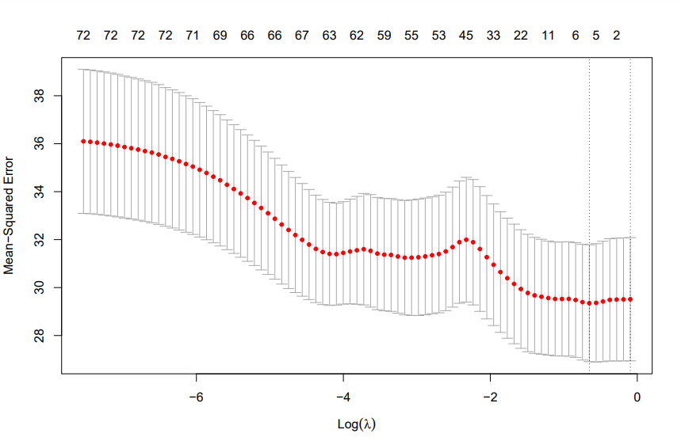
Appendix Figure 2. The plot of the Lasso Path Displays the coefficient shrinkage. The trajectory of the coefficients (with log(λ) on the x-axis) as the regularization parameter λ grows is shown in this image. Each line shows a coefficient from the lasso regression model, and its value varies with different log(λ) values. The figures above the plot show how many non-zero coefficients there are at each log(λ) level, suggesting a decrease in model complexity as λ rises. The plot demonstrates how lasso regression may be used for feature selection. As regularization increases, coefficients are driven to zero, simplifying the model by removing less significant variables.
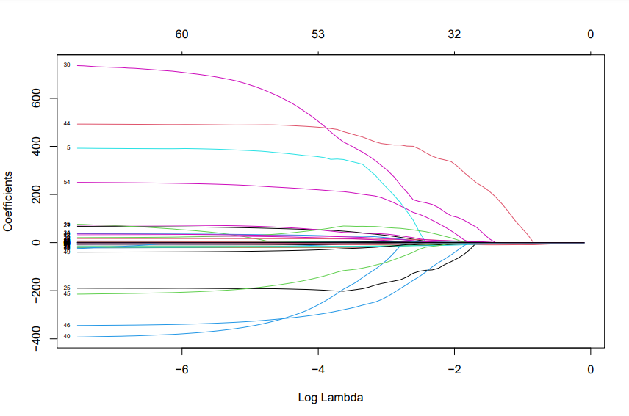

Appendix Table2. Lasso regression coefficients for radiomic feature selection in breast cancer.
Image type | Feature class | Feature name | Coefficient
Intercept |  |  | -7.7007
original | shape | Elongation | -2.2681
original | firstorder | Minimum | 0.0009
original | glszm | SmallAreaEmphasis | -6.5440
original | glszm | SmallAreaHighGrayLevelEmphasis | -0.0828
wavelet-HHL | glrlm | GrayLevelVariance | 40.9574
wavelet-LLL | firstorder | Kurtosis | 0.0336

Appendix Figure 3. Distribution of radiomic scores by HER2 Status in Training and Validation Cohorts. The left panel shows the radiomic scores for the training cohort and the right panel for the validation cohort. In both cohorts, patients are sorted by their radiomic score. Red bars represent patients with a negative HER2 status (HER2 -), while cyan bars indicate patients with a positive HER2 status (HER2 +). This visualization demonstrates the differentiation of HER2 status by the radiomic score within each cohort.
